**Discussion 2.1**WEB-340

***Why are web frameworks important?***

The reason web frameworks are important is because they create a base structure for creating web applications. They allow creators to create web applications within a “frame” that is still highly customizable without having to get too deep into coding.

***What role do web frameworks fill?***

Web frameworks fill the role of ensuring that the web app you are creating has a good foundation. It will basically give you a little head start into creating the web app by creating “shortcuts” to your desired destination.

***How does Express differ from the selected frameworks, in terms of features and functionality?***

Django

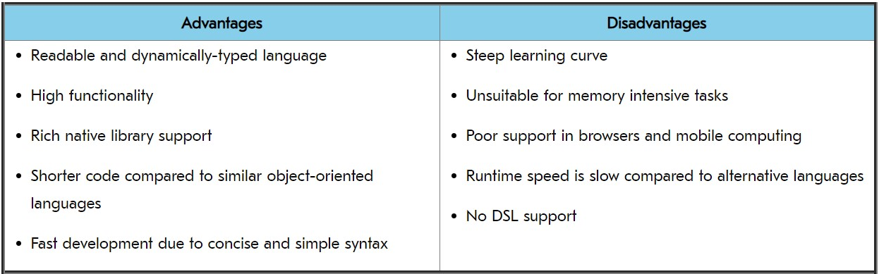

Rails



Express



***Sources:***

1. <https://www.intelegain.com/what-are-web-frameworks-and-why-you-need-them/> 1
2. <https://railsware.com/blog/python-vs-ruby-vs-node-js-which-platform-is-a-fit-for-your-project/>