**Table S1.** Inventory activities and primary data sources grouped per life cycle stage.

Quality evaluation on 3 scale basis (Q). Market specification: (n: for onshore, f: for offshore, n/f: for both). Data type: material, fuel/energy transport waste

|  |  |  |  |  |  |
| --- | --- | --- | --- | --- | --- |
| **LCS** | **Description** | | | **Primary inventory data** | **Q** |
| **Materials** |  | n/f | Nacelle | 2013 Bill of Materials (BOM) from the company’s enterprise resource planning (ERP) system. Component subparts characterized as of their main material, e.g. ‘steel-S355’ in collaboration with product development SWP engineers. Material composition identified for 97-99% of component weight. The rest has been allocated to the identified materials proportionally, e.g. for the D3 nacelle, 753 out of 1061 subparts that cover 99,9% of the nacelle weight have been characterized. | +++ |
|  | n/f | Hub |
|  | n/f | Tower |
|  | n/f | PU /TU |
|  | n/f | Blades (BOM/R&D) | Same identification as above. Data cover BOM and all R&D consumption from 3 manufacturing facilities. Allocation per blade based on weight or surface | +++ |
|  | n | Foundation | Calculation of reinforced concrete requirements based on standard site of certain friction angle, sand density and buoyancy | +++ |
|  | n/f | Onshore Cables to grid | Cable type and length identified for a typical 19 x 3.2 onshore project. Assumed the same in all plants. Material specifications for cables from supplier | +++ |
|  | n/f | Onshore substation | Data for raw materials in onshore substation on the basis of an off-shore project. No adjustment for the smaller MW output for an onshore plant | ++ |
|  | f | Foundation (monopile) | Data for type and quality of materials, from a reference project | +++ |
|  | f | Offshore cables | Cable materials identified from reference project. Offshore distances are based on expert judgment based on sales data | ++ |
|  | f | Offshore substations | Material data from reference project. Transformer data from supplier’s EPD. Data scaled for 2pc for 4.0 and 2.5 pc for 6.0 | + |
| **Manufacturing** |  | n/f | Resources in-house | Resources for manufacturing nacelles, hubs and blades (including R&D). Data collected from 3 manufacturing sites in DK. Major offices in DK are included | +++ |
|  | n/f | Resources in main suppliers | Supplier data for canopy (nacelle) and hub. For cables data are given from supplier for a reference project | ++ |
|  | n | Resources for tower man. | Data for energy, waste and direct emissions are delivered by a supplier for a reference project | ++ |
|  | n/f | Resources for transformer man. | Data from supplier for reference project | ++ |
|  | f | Resources for off. cable man. | Energy data from average project | ++ |
|  | f | Resources for monopile man. | Supplier data for energy usage per tonne tower produced | ++ |
|  | n/f | Transport from suppliers to SWP | 14 Suppliers for the heaviest components, identified for the European projects. Exact distances calculated and extrapolated to the total supplied weight | ++ |
|  | n/f | Transport during man. | Blades transported between manufacturing facilities in DK | +++ |
|  | n/f | Waste from SWP man. | Waste from manufacturing nacelle and hub and blades (including R&D waste). Waste data and corresponding treatment from three DK facilities | +++ |
|  | n/f | Waste from cable man. | Specifications for cables from supplier | ++ |
| **Installation** |  | n | Gravel road | Amount of gravel for roads and stands on wind farm site | +++ |
|  | n/f | Transport equipment | For nacelle, blades, hub, PU: Data from the company’s ERP system for all platforms except for 6.0 (was still in development). Life time and reuse rates included | +++ |
|  | n | Resources at site | Data per turbine collected from bills for a reference project and from main crane supplier. Assumed same for both plants. | ++ |
|  | f | Resources for offshore substation | Includes installation at site for both foundation, platform, topside of substation. Data from reference project | ++ |
|  | f | Resources for preassembly | Data covers start of project to commissioning in a 6 month period for a reference project. Same data for both plants | +++ |
|  | f | Resources for monopile | Energy consumption data from reference project | ++ |
|  | n/f | Transport of cables to site | Supplier data for tkm travelled from supplier to site and corresponding transport modes. Also fuel for cable laying | ++ |
|  | n/f | Transport from SWP to site | Calculated as an average of predefined reference projects used by in company experts for logistics | +++ |
|  | n/f | Transport of substation to site | Former data for amount of transport for trucks/machinery from a reference project | ++ |
|  | n | Person transport | Man-months, distances, modes of transport collected for European projects of 2013 with the same type of turbines as the ones assessed. Data adjusted to plant size | +++ |
|  | f | Transport for offshore installation | Installation Vessel (mobilization, transit to site, return from preassembly, installation at site and at the preassembly port, demobilization)  Person Transport (transfers from hotel vessels to turbines), Hotel Vessel (consumption for technicians’ accommodation). | +++ |
|  | f | Transport of monopile to site | Fuel consumption from reference project | ++ |
|  | n/f | Waste during installation | Only total amount of recyclable waste is known. Data per turbine collected from bills for reference project. Same data for both turbines | ++ |
| **op/n** |  | n/f | Service materials | Spare parts for large parts based on historical data and conservative technical evaluations. Service materials per platform for annual service | +++ |
|  | n/f | Waste from service | Assumption that service waste is the same as the material input for service | + |
|  | n/f | Transport for maintenance | Fuel for technicians’ transport based on planned and unplanned service, and transport setup for technicians and parts | +++ |
| **EoL** |  | n/f | Dismantling of turbine at site | Has been estimated as a percentage (75%) of resources used during establishment of site | + |
|  | n/f | Transport to EoL treatment | literature data for distances to disposal sites | + |
|  | n/f | EoL treatment of materials | Recycling rates from reference project within Siemens AG. Data supplemented by literature and confirmed by company expert | + |

**Table S2.** LCA results (impacts/FU) for the onshore wind power plants (the items shown are the ones contributing more than1% to climate change)

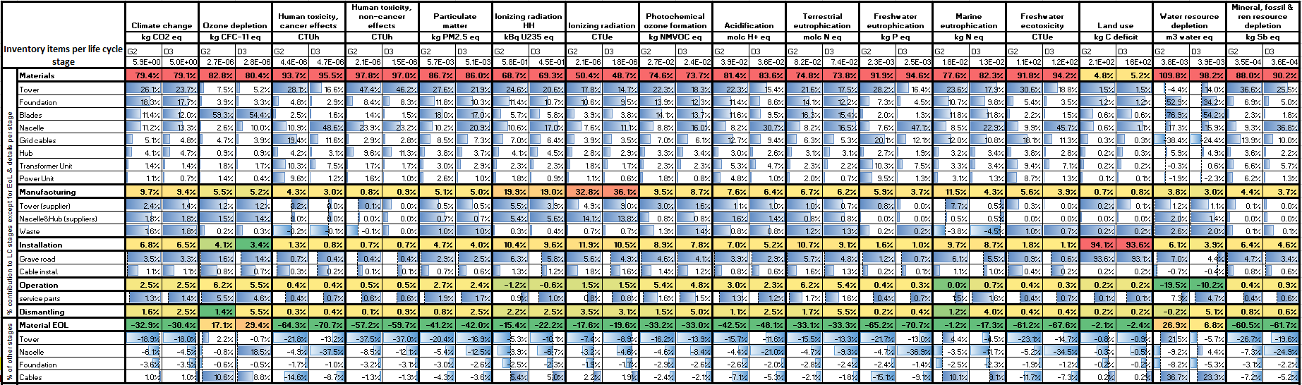



**Table S3.** LCA results (impacts/FU) for the offshore wind power plants (the items shown are the ones contributing more than1% to climate change)

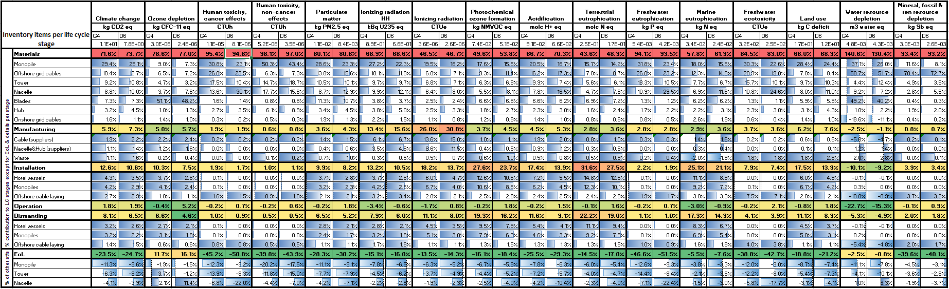



**Figure S1**. Endpoint LCA results for ecosystem damages (% contribution to species.yr)

**Figure S2.** Uncetainty analysis for the LCA results of the D3 plant via Monte Carlo (1000 runs, confidence interval 95%). Uncertainty due to inventory data only