**Supplementary material to *“Is a 100% European power system feasible by 2050?”***

William Zappa*a, Martin Jungingera, Machteld van den Broeka

a Copernicus Institute of Sustainable Development, Utrecht University, Princetonlaan 8a, 3584 CB Utrecht, The Netherlands

* Corresponding author: [w.g.zappa@uu.nl](mailto:w.g.zappa@uu.nl)

**Contents**

Appendix A Weather year selection 2

Appendix B Generator modelling 4

Appendix C Capacity credit of vRES generators 9

Appendix D Demand Response 13

Appendix E vRES capacity constraints 14

Appendix F Biomass fuel potentials and costs 18

Appendix G Demand assumptions 22

Appendix H Transmission modelling 26

Appendix I Operating reserves 30

Appendix J Indirect GHG Emissions 36

References 38

**Abbreviations**

|  |  |
| --- | --- |
| AD Anaerobic digestion  CCS Carbon capture and storage  CLC Corine Land Cover  COP Coefficient of performance  CSP Concentrating solar power  DNI Direct normal irradiance  DSM Demand-side management  ECF European Climate Foundation  ECMWF European Centre for Medium-Range Weather Forecasts  EEA European Environment Agency  EEZ Exclusive Economic Zone  ENTSO-E European Network of Transmission System Operators for Electricity  ERA-Interim European Reanalysis Interim Dataset  ETRI Energy Technology Reference Indicators  EU European Union  EV Electric vehicle  FOM Fixed operating and maintenance  GHG Greenhouse gas  HDH Heating degree hour  HP Heat pump  HVAC High-voltage alternating current | HVDC High-voltage direct current  IEC International Electrotechnical Commission  ILUC Indirect land use change  IPCC Intergovernmental Panel on Climate Change  JRC European Union Joint Research Centre  LDC Load duration curve  LoLP Loss of Load Probability  LT Long term  NAO North-Atlantic oscillation  OCGT Open-cycle gas turbine  PHS Pumped hydro storage  PR Performance ratio  PV Photovoltaic  RES Renewable energy source  RoR Run-of-river hydro  STC Standard test conditions  STO Storage hydro  TYNDP Ten-Year Network Development Plan  UCED Unit commitment and economic dispatch  VOM Variable operating and maintenance  vRES Variable renewable energy source |

##### Weather year selection

The mean annual wind speed and annual global horizontal radiation received are calculated for each year of ERA-Interim (Figure A‑1). Each year is then given a rank from 1 to 37 (1 being highest) based on the magnitude of the wind speed or radiation received in that particular year, as a proxy for the total renewable resource which would be available. By multiplying the wind speed and radiation rankings together (giving wind and solar radiation equal weighting), we arrive at a metric indicating how ‘good’ or ‘bad’ each weather year is in terms of both resources. From this analysis, we identify 2010 as the ‘worst’ (most challenging) year of those considered (Wind ranking: 37, radiation ranking: 32), and 1990 as the best year (wind ranking 1, radiation ranking 5). This selection is validated by the fact that the 2010 European winter was strongly affected by a very negative North Atlantic Oscillation (NAO), which resulted in lower wind speeds and colder temperatures [1]. Thus, we use weather year 2010 as the basis for the LT plan in our study. However, we note that at this aggregated level annual differences are quite small, with mean annual wind speed and radiation only 4% higher than the long-term (1979-2016) mean in the highest year, and 4% below the mean in the lowest year. A more detailed analysis including hourly ramps of residual load could reveal another year as more challenging, however the quantity and distribution of vRES capacity is not known until after the capacity expansion optimisation has been performed.



Figure ‑: Plot of mean annual 10-m wind speed and mean global horizontal radiation received in the study area based on ERA-Interim for weather years 1979-2015. The coloured bands indicate the inter-annual variability as ±1σ from the long-term (1979-2016) mean wind speed (4.55 m-1) and mean annual radiation (1209 kWh m-2). The axes’ scales are adjusted so that the variability bands for both parameters overlap.

Note that we do not consider variations in rainfall as mean EU+NO hydro generation between 1990 and 2015 was 462 TWh y-1, with a standard deviation of 38 TWh y-1. The minimum generation was 394 TWh in 1991, however installed capacity was 28% lower at that time [2]. Thus compared with total demand, potential wind and PV generation, inter-annual hydro variability is relatively small.

To check the validity of the weather year selection method, we perform the LT Plan optimisation for the *Base* scenario for weather years 2000 to 2015. The resulting generation portfolios (Figure A‑2) confirm 2010 as the most challenging year in this period, with 2091 GW of generation capacity installed, 139 GW (7%) more than in the best year for RES supply (2012). Looking at Figure A‑1, performing the optimisation for additional weather years (pre-2000) is unlikely to change this conclusion.



Figure ‑: Optimised generation portfolio for the *Base* scenario, optimised for all weather years 2000 to 2015 from ERA-Interim. The total capacity installed in each year is shown above the graph, confirming 2010 as a particularly challenging weather year with 2091 GW required to meet demand, 139 GW (7%) more than in the best year (2012).

##### Generator modelling

*This section outlines how each of the generator technologies is modelled. For wind and PV, the approach used was the same used by the authors in a previous paper. For further details see Zappa & van den Broek [3].*

***Wind***

Wind generation is estimated by combining wind speeds calculated from ERA-Interim [4] with assumed wind farm parameters. First, the horizontal wind speed at 10 m height from ERA-Interim is extrapolated to hub height, assuming a logarithmic vertical wind speed profile [5], with roughness lengths of 0.03 m and 0.0001 m for onshore[1] and offshore locations respectively [6,7]. For onshore wind sites, a 150 m hub height is assumed (17% higher than the average for turbines installed in 2015) in the expectation that onshore hub heights will continue to increase as investment costs decrease over time, shifting the optimum towards higher hub heights[2]. For offshore wind sites, a lower hub height of 100 m is assumed (12% higher than the 2013 average), in the expectation that offshore wind hub heights will not increase substantially as the economic penalties of increased foundation loads and tower cost will are more likely to outweigh any small energy gains from a much increased hub height [8]. In either case these assumptions are quite conservative, as any increase in hub height will likely lead to steadier wind generation with higher capacity factors.

Based on the long-term average wind speed at the hub, each grid location is classified according to IEC 61400 guidelines as either IEC class 0 (>10 m s⁻¹, or offshore), class I (≥8.5 and <10 m s⁻¹), class II (≥7.5 and <8.5 m s⁻¹), class III (≥6 and <7.5 m s⁻¹) or class IV wind site (<6 m s⁻¹). A power curve is then selected from an appropriate commercial turbine (Class 0/1: Vestas V105-3.3MW Ia, Class II: Vestas V117-3.3MW IIa, Class III/IV: Vestas V126-3.3MW IIIa) to convert wind speed to power output [9]. The multi-turbine method of Holttinen [10] is used to take into account spatial and temporal variations in wind speeds which occur across wind farms, so that the aggregated power curves better match smoother wind farm generation profiles in reality. After accounting for turbine wake losses (8%), electrical conversion (2%) and other losses (3%) [11–13], the power output values for each site are converted to hourly capacity factors by dividing by the nominal turbine output.

Offshore wind farms located within 40 km from shore are typically connected by medium voltage alternating current (MVAC) (< 35 kV) or HVAC (130 – 150 kV), while sites more than 40 km offshore are connected by HVDC (150 kV) technology in order to reduce losses [14]. However, the economic choice between HVAC and HVDC is very project specific and depends on the size of the wind farm, distance from shore, local grid strength, and water depth. In this study, we follow a simpler approach by applying linear cost multipliers (, ) taken from an earlier study [15] to the reference offshore wind investment cost ) to account for the mean distance from shore () and mean water depth () for each location (Eqs. (B1)-(B3)). This additional transmission capacity is not modelled explicitly as individual lines.

|  |  |
| --- | --- |
|  | (B) |
|  | (B) |
|  | (B) |

***PV***

PV production is based on 3-hourly total horizontal radiation data from ERA-Interim, interpolated to hourly values and split into its diffuse and direct components using the method of Erbs [16], based on the sky clearness index (the ratio of the global horizontal irradiance to the extra-terrestrial irradiance in the horizontal plane). The method of Reindl [17] is then used to calculate the total incident radiation (direct and diffuse) in the plane of the PV panels. Given that determining optimum PV mounting angles is very site specific[3], we take a simple approach and assume a fixed PV tilt angle of 35°, with all panels mounted south.

We assume lower-efficiency polycrystalline silicon modules are used utility PV, while high-efficiency monocrystalline silicon is used on rooftops to compensate for limited space. The hourly alternating current (AC) output from the PV modules, (W m⁻2), is calculated using Eqs.(B4)-(B6) where is the total incident radiation on the panel (W m⁻2), is the nominal module output at standard test conditions (STC[4]) of 1000 (W m⁻2) standard irradiation (), and is a performance ratio. The performance ratio takes into account AC conversion and other electrical losses, dust and shading effects, for which a value of 0.9 for modern systems is assumed in line with the literature [18,19]. We also include the effect of cell operating temperature on module efficiency based on a nominal operating cell temperature (), and power temperature coefficient (), taken from manufacturer data (Table B‑1). The other terms are: , the PV module back temperature (°C), , the wind speed at 10 m height (m s⁻¹),the ambient temperature (°C), as well as some empirical heat transfer coefficients () which can be found in [18].

|  |  |  |
| --- | --- | --- |
|  |  | (B) |
|  |  | (B) |
|  |  | (B) |

As with onshore and offshore wind, the hourly PV generation is converted to capacity factor profiles by dividing by the nominal module output .

Table ‑: PV module technical specifications [3]

|  |  |  |
| --- | --- | --- |
| Parameter | Rooftop PV | Utility PV |
| Manufacturer & model | Sunpower X21-345 [20] | TrinaSolar TSM-PD14 [21] |
| Technology | Monocrystalline Silicon | Polycrystalline Silicon |
| Nominal power capacity at STCa, (W) | 345 | 325 |
| Module efficiency (%) | 21.5% | 16.8% |
| Power temp coefficient,(% °C¯¹) | -0.3% | -0.41% |
| Module dimensions | 1.046 m x 1.559 m (1.63 m2) | 1.956 m x 0.992 m (1.94 m2) |
| Nominal power density at STC (W m⁻²)b | 211 | 167 |

a) Standard Test Conditions: 1000 W m⁻² irradiance, air mass coefficient 1.5, 25° C

b) Calculated from module dimensions and nominal panel capacity

**CSP**

We model CSP generators as solar tower (central receiver) plants equipped with full-tracking heliostats, using molten salt as a heat transfer fluid with 8 hour-storage capacity at nominal load. While currently more expensive than parabolic trough plants, we choose solar tower technology over other CSP technologies (e.g. parabolic trough or dish collectors, linear Fresnel reflectors) given its strong technical advantages (e.g. lower piping losses, higher operating temperature, hence higher efficiency and easier storage), better cost-reduction potential, and high prospective market share [22][5]. The solar field for each plant is sized assuming a solar multiple (SM) of 2.5 based on a design direct normal irradiance (DNI) of 800 W m-2, and nominal power block steam cycle efficiency of 40% In these calculations, we also take into account fixed losses for the heliostat field (51%), with respect to incident DNI), receiver tower (1%), piping (1%), storage (injection/withdrawal) (1%), and plant parasitics (10%) [22]. Additional storage decay losses of 2% h-1 are assumed [23].

DNI profiles for each location are also derived from the ERA-Interim dataset. At present, CSP plants require DNI levels of at least 2000 kWh m-2 y-1 to be economic [24]. However, future cost reductions will lower the minimum DNI for cost competitiveness. On this basis, we allocate CSP capacity to grid cells with average DNI levels of 1600 kWh m-2 y-1 or higher, located mainly in Spain (80%), Portugal (10%), Italy (8%), Greece (3%) and Cyprus (0.5%). The area required for CSP plants is accounted for assuming a typical capacity density of 25 MW km-2 based on plants currently in operation [25,26].

**Hydropower**

Of the approximately 200 GW of hydro capacity currently installed in Europe[6], 31% is RoR, 48% is STO, and 21% is PHS [27]. RoR plants have little or no significant storage capacity, and power generation is driven by natural river flows. STO plants utilise the potential energy difference between an upper and a lower reservoir (or river) to generate electricity when prices are high. The upper reservoir receives natural stream flows and runoff from surrounding areas and, depending on the storage volume, can store water for weeks or months. PHS plants are similar to storage plants, but can pump water from a lower reservoir back into their upstream reservoir to be used again.

Total European hydro capacity is provided by thousands of individual plants, with capacity ranging from several megawatts to more than 1 GW. Accurately modelling hydro generation is very data intensive and requires information on the type of plant, the number and capacity of turbine/pumping units, as well as hydrological data of the reservoir inflows, and associated river networks. In this study, we take a simplified approach and aggregate hydro generation capacity per country according to the three plant categories (RoR, STO, PHS), based on data from ENTSO-E and Eurostat. First, the total required capacity per country is found by subtracting the capacity of the detailed individual plants from the total hydro capacity per country reported in Eurostat [28]. This total capacity is divided into the three hydro plants types based on a detailed plant list from ENTSOE, in order to reflect the proportions of RoR, STO and PHS in each country[7]. Assuming a typical size for each hydro plant type (RoR: 70 MW, STO: 100 MW, PHS: 400 MW) based on the same ENTSOE plant list, and average specific storage capacity per hydro plant calculated from an in-house hydro database (RoR: 60 MWh MW-1, STO: 1608 MWh MW-1, PHS: 113 MWh MW-1), the number of lumped hydro plants to represent the total hydro capacity per country can be found. With these assumptions, the modelled shares of RoR, STO and PHS capacity in Europe are 26%, 47%, and 27% respectively, within the reported range [27,29]. In the absence of inflow data, the lumped RoR and STO plants have their annual capacity factors capped at historical levels for each country based on Eurostat data. For lumped PHS plants, we assume that these are closed-loop pure PHS with no natural inflow, and set the tail storage volume equal to the head storage volume.

***Flexibility constraints and part-load performance of thermal generators***

Table B‑2 shows the modelled flexibility constraints and start costs for each dispatchable generator type. The part-load efficiencies for all thermal generators are based on normalised profiles of Brouwer et al. [30], (Figure B‑1). For those generators for which specific curves could not be found, the curve for a similar generator is assumed, namely: (i) the Gas-OCGT curve is applied to Bio-OCGTs as a similar technology, (ii) the Coal-PC curve is applied to Bio-FBs with and without CCS under the assumption that burning biomass does not affect part-load performance. CSP part-load performance is much like other thermal plants (see [31]). Unfortunately, due to model functionality issues, the part-load performance of CSP plants could not be included in PLEXOS, and instead a constant power block efficiency of 40% is used.



Figure ‑: Assumed part-load performance of thermal generators, based on Brouwer et al. [30]

Table ‑: Assumed generator flexibility parameters and start costs for dispatchable generators

|  |  |  |  |  |  |  |  |  |  |  |  |  |  |
| --- | --- | --- | --- | --- | --- | --- | --- | --- | --- | --- | --- | --- | --- |
| Generator type | Minimum stable level (%)* | Max. ramp rate  (% min-1)* | Time since  offline (h) | | |  | Start-up  time (h) | | |  | Start-up cost  (€ MW-1) *c | | |
| Hot | Warm | Cold |  | Hot | Warm | Cold |  | Hot | Warm | Cold |
| Hydro (all) | - | 50% | - | - | - |  | - | - | - |  | - | - | - |
| Bio-FB b | 20% | 6% | <8 | <48 | >48 |  | 2 | 4 | 8 |  | 39 | 46 | 75 |
| Bio-OCGT b | 20% | 15% | <8 | <48 | >48 |  | ¼ | ¼ | ½ |  | 13 | 16 | 23 |
| CSP | 20% | 6% | <2 | <8 | >24 |  | ¼ | ½ | 2 |  | 27 | 39 | 57 |
| Geothermal | 20% | 4% | <8 | <48 | >48 |  | 1 | 2 | 3 |  | 27 | 39 | 57 |
| Gas-OCGT g | 20% | 15% | <8 | <48 | >48 |  | ¼ | ¼ | ½ |  | 13 | 16 | 23 |
| NGCC | 25% | 9% | <8 | <48 | >48 |  | 1 | 2 | 3 |  | 27 | 39 | 57 |
| NGCC-CCS a | 25% | 9% | <8 | <48 | >48 |  | 1 | 2 | 3 |  | 27 | 39 | 57 |
| Coal-PC | 20% | 6% | <8 | <48 | >48 |  | 2 | 4 | 8 |  | 39 | 46 | 75 |
| Coal-PC-CCS | 20% | 6% | <8 | <48 | >48 |  | 2 | 4 | 8 |  | 39 | 46 | 75 |
| Bio-FB-CCS ab | 20% | 6% | <8 | <48 | >48 |  | 2 | 4 | 8 |  | 39 | 46 | 75 |
| Nuclear | 20% | 5% | <8 | <48 | >48 |  | 3 | 8 | 20 |  | 39 | 46 | 75 |
| Sources: | Hydro: [32]  CSP: [33]  Rest: [30] | CSP: [34]  Geo:[35]  Hydro: [36]  Rest: [30](for 2030) | CSP: [33]  Rest: [37] (for 2030) | | |  | CSP: [33]  Geo: Assumed same as NGCC  Rest: [30](for 2030) | | |  | Geo,CSP: Assumed same as NGCC  Bio-FB: Assumed same as pulverised coal plant.  Rest: [30](for 2030) | | |

* In terms of installed capacity

a) CCS technology is assumed not affect flexibility compared with traditional plants [38]

b) Combustion of biomass is assumed not to affect flexibility parameters compared with fossil fuels

c) No start costs could be found for CSP or geothermal. For CSP and geothermal, costs for NGCC assumed. For Bio-FB, start costs assumed same as Coal-PC pulverised coal plants, as start costs for plants using solid fuels appear more expensive than for gaseous fuels [39].

##### Capacity credit of vRES generators

Various methods for estimating the capacity credit of vRES are reported in the literature, such as chronological reliability models and probabilistic methods, typically incorporating values for the LOLP [40–42]. These methods can be computationally intensive and are not easily integrated into the PLEXOS capacity expansion algorithm. In the case of wind power, several authors have shown that at low wind penetration, its capacity credit is close to the average production of wind power during periods of peak demand, but decreases as the penetration of wind increases due to deployment in less favourable sites [43,44].

In this study, we base our approach on the simplified approach of Milligan [43] to estimate the capacity credit of vRES as the average capacity factor observed during peak system demand hours, based on all available weather years (1979-2015). To demonstrate, we calculate the capacity factor for each vRES technology for each grid cell, for the top 0.01%, 0.1%, 1%, 5%, 10%, and 30% of the peak load hours[8]. For comparative purposes we do this not only for the Base 2015 load profile, but also for the actual load profiles from 2012-2015, as well as four future demand profile scenarios from ENTSO-E’s TYNDP (Vision 1,2,3,4). The results are shown in Figure C-1, revealing that irrespective of the demand profile considered, the capacity credit of both PV technologies is essentially zero as the sun is almost never shining during hours of peak demand. Wind capacity credit is much more variable from site to site (e.g. some sites have a capacity credit above 80% while others have zero), and from year to year. Thus, rather than taking the average capacity factors averaged across all weather years from 1979 to 2015 as the capacity credit, we take the capacity factors from the year with the lowest average capacity factor during the peak 1% of demand hours[9].

To demonstrate, Figure C-2 shows the resulting distribution of wind capacity credit across all grid cells, based on the year with the lowest average capacity factor during the top 1% of demand hours. Onshore wind capacity credit ranges from 0% to 59% with a median of 12%, and offshore wind capacity credit ranges from 0% to 56%, with a median of 10%. PV receives a capacity credit of zero in essentially all grid cells.

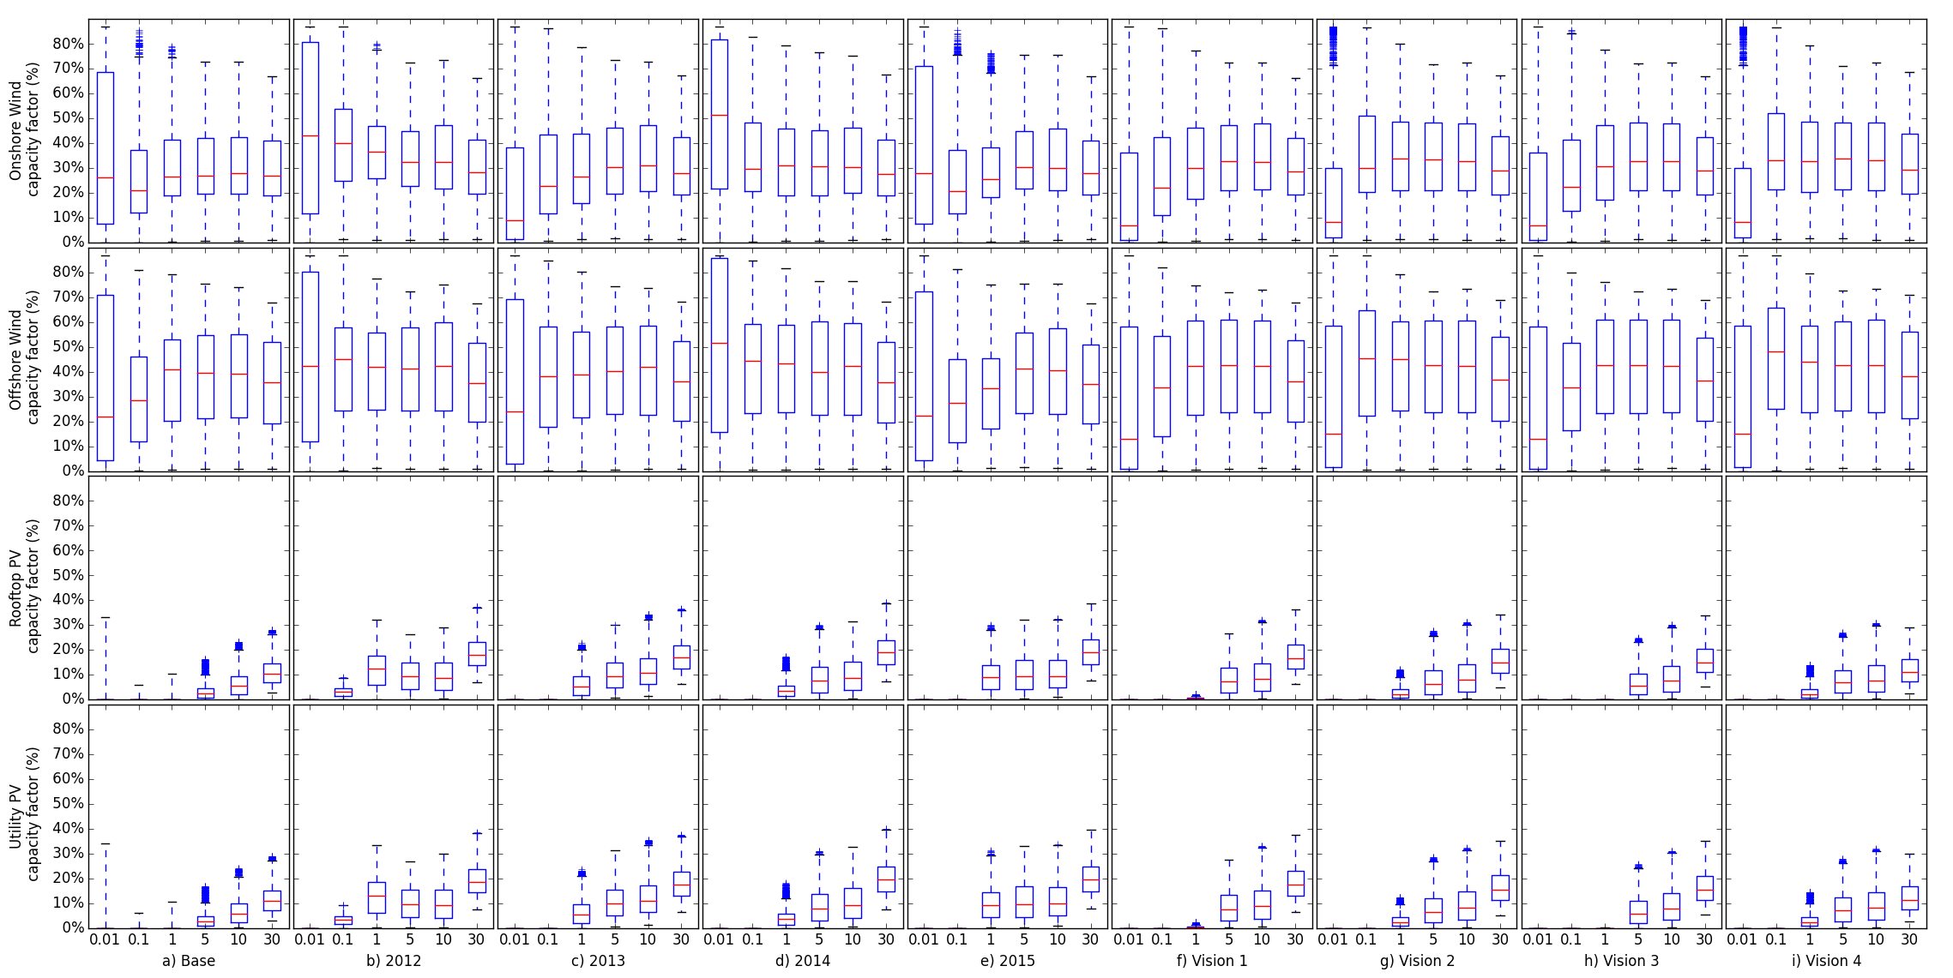

Peak load hours used to calculate average capacity factor (%)

Figure ‑: Average capacity factors for vRES technologies during the peak 0.01%, 0.1%, 1%, 5%, 10% and 30% demand hours of each year based on weather years 1979-2015, for different demand profiles: (a) Base (2015 historical demand, modified to account for HPs and EVs), (b)-(e) Actual 2012, 2013, 2014, 2015 demand from ENTSO-E [29], and (f)-(i) Vision 1-4 Demand scenarios for 2030 from ENTSO-E’s 10-Year Network Development Plan [45]. Values based on average capacity factor of all grid cells during peak Europe (total) demand hours, averaged across all weather years.



Figure ‑: Distribution of capacity credit for onshore and offshore wind across all grid cells, using the Base demand profile. The capacity credit is taken as the year with lowest average capacity factor calculated during the top 1% of demand hours.

##### Demand Response

Various studies have estimated the potential of DSM in Europe, given its ability to reduce peak demand, reduce network congestion, and provide balancing reserves. However, there are a wide range of values reported in the literature. In this study, we base the 2050 DSM potential on the work of Gils [46], as potentials are provided explicitly for each country. We aggregate the 30 different processes from Gils’ original study into 11 groups of similar processes as shown in Table D‑1, using the same grouping as Brouwer et al. [37]. A total of 16 GW of load shedding and 82 GW of load shifting is included. Load shedding can be activated freely by the model if it is cost-effective to do so; however load shifting availability is capped at 12.5% of the year for each process. Also, the potential of some shifting processes varies seasonally (e.g. no shifting potential from heating during summer or from air-conditioning during winter).

Table ‑: Assumed DSM potentials and costs by process, based on Brouwer et al. [37]

|  |  |  |  |  |  |  |  |  |
| --- | --- | --- | --- | --- | --- | --- | --- | --- |
| Sector | Process | Type | Max shift time (h) | Technical  Potential (GW) | Utilised Potential | | FOM  (€ kW-1 y-1) | VOM  (€ kWh-1) |
| % Technical | GW |
| Industry | Electrolytic metal production | Shed | ∞ | 1.5 | 90% | 1.3 | 1.1 | 1072 |
| Industry | Electric arc steel production | Shed | ∞ | 5.7 | 90% | 5.1 | 1.1 | 2144 |
| Industry | Chloralkali process | Shed | ∞ | 1.5 | 90% | 1.5 | 1.1 | 107 |
| Industry | Cement and other | Shed | ∞ | 3.6 | 90% | 3.2 | 17.1 | 750 |
| Industry | Pulp and paper production | Shed | ∞ | 5.8 | 90% | 5.3 | 14.0 | 107 |
| All | Shift 1 h load by 2 h | Shift (delay) | 2 | 26.3 | 33-90% | 12.3 | 3.2 | 0 |
| All | Shift 2 h load by 2 h | Shift (delay) | 2 | 7.5 | 33-90% | 4.5 | 3.2 | 0 |
| Tertiary & Residential | Air conditioning | Shift (advance) | 2 | 5.1 | 33-90% | 2.1 | 18.2 | 0 |
| Tertiary & Residential | Space and water heating | Shift (advance) | 12 | 154.4 | 33-90% | 55.3 | 3.2 | 0 |
| Residential | Washing machines, dryers, dishwashers | Shift (delay) | 6 | 10.5 | 33% | 3.5 | 107.2 | 0 |
| Residential | Freezers &  refrigerators | Shift (delay) | 2 | 14.1 | 33% | 4.7 | 46.1 | 0 |
| Source |  | [46] | [46] | [46] | [47] |  | [37,47] | [37,47] |

Due to computational limitations, only demand shedding is included in the long-term capacity expansion algorithm. In the short-term UCED, both demand shedding and demand shifting are included.

##### vRES capacity constraints

*The spatial grid and capacity constraints for wind and PV are based on work by the authors in a previous study. For further details see Zappa & van den Broek [3].*

Table E‑1 lists the CLC classes deemed suitable for each technology, before applying any other limitations such as protected areas or water depths. Onshore wind is assumed to be only suitable for selected agricultural areas and grasslands where turbines could be installed without having a major effect on currently land use. Offshore wind can only be installed on open water in seas or oceans. For ground-based utility PV, we assume that this technology is only suitable in relatively sparse and unforrested areas, while rooftop PV we assume can only be built on the roofs of residential and commercial buildings located in urban areas.

For onshore and offshore wind, the constraints on maximum capacity per technology per grid cell () are calculated using Eq. (B1) where is the land area per suitable CLC class per grid cell (km2), is the assumed land availability (%) and is a representative wind farm capacity density.

|  |  |
| --- | --- |
|  | (E) |

For onshore wind, we assume a land availability factor of 6% in line with [48,49], and for offshore wind we assume a uniform 20% availability irrespective of water depth or distance to shore. This is higher than values used for near-shore (< 10 km) sites but at the lower end of values used for sites further offshore [48,49]. However, given that many of Europe’s best wind sites are located in relatively shallow waters of the North and Baltic seas at sites greater than 10 km from shore [15], we believe a higher value is justified.

These values for vary between 4.2 MW km⁻² and 6 MW km⁻² depending on the IEC wind regime in that grid cell, and are based on the wind turbine technical data (rotor diameter and nominal power) assuming a typical wind farm turbine array spacing. Many studies have investigated the optimisation of wind farm turbine layouts with lower turbine spacing increasing installed capacity density, at the cost of increased array losses due to aerodynamic wake effects between turbines [50–52]. However such a detailed treatment is not possible in this study and a simplified approach assuming a regular turbine spacing of 10D x 5D (where D is rotor diameter) is used, with the literature reporting this should result in array losses below 10% [5]. Following this assumption, turbine capacity densities of 6, 4.8, 4.2 and 6 MW km⁻² are calculated for the Vestas V105, V117, V126 onshore turbines and the V164 offshore turbine respectively. Comparing these values with the available literature, a 2009 NREL study of 161 onshore wind farms reported capacities densities ranging from 1.0 to 11.2 MW km⁻² with an average of 3.0 ± 1.7 MW km⁻² [8]. In a study published in the same year by the EEA investigating Europe’s wind energy potential, capacity densities for onshore wind were given as 8 MW km⁻² in 2005 and were not expected to change until 2030 [15]. The values calculated in this study for the three onshore turbines therefore lie within an acceptable range. For offshore wind, the EEA reported a typical capacity density of 10 MW km⁻² in 2005, which was predicted to rise to 12 MW km⁻² in 2020 and 15 MW km⁻² in 2030 based on technology developments [15]. Using publically available data for 40 offshore wind farms installed around the world commissioned between 1991 and 2014 for which both installed capacity and farm area were available, 60% were found to have an

Table ‑: Assumed availabilities of CLC land classes for each technology. Empty cells indicate no suitability for any technology. Modified from [3] to include CSP.

|  |  |  |  |  |  |  |  |  |  |  |
| --- | --- | --- | --- | --- | --- | --- | --- | --- | --- | --- |
| Main Class | 1st Sub-  Class | 2nd  Sub-Class | CLC Code | Availability (%) | | | | | | |
| Wind | |  | PV | |  | CSP e |
| Onshore a | Offshore b |  | Rooftop c | Utility d |  |
| Artificial surfaces | Urban fabric | Continuous urban fabric | 111 | - | - |  | 10% | - |  | - |
| Discontinuous urban fabric | 112 | - | - |  | 6% | - |  | - |
| Industrial, commercial and transport units | Industrial or commercial units | 121 | - | - |  | 7% | - |  | - |
| Road and rail networks and associated land | 122 | - | - |  | - | - |  | - |
| Port areas | 123 | - | - |  | - | - |  | - |
| Airports | 124 | - | - |  | - | - |  | - |
| Mine, dump and construction sites | Mineral extraction sites | 131 | - | - |  | - | - |  | - |
| Dump sites | 132 | - | - |  | - | - |  | - |
| Construction sites | 133 | - | - |  | - | - |  | - |
| Artificial, non-agricultural vegetated areas | Green urban areas | 141 | - | - |  | - | - |  | - |
| Sport and leisure facilities | 142 | - | - |  | - | - |  | - |
| Arable land | Non-irrigated arable land | 211 | 6% | - |  | - | 1% |  | 6% |
| Permanently irrigated land | 212 | 6% | - |  | - | 1% |  | 3% |
| Rice fields | 213 | - | - |  | - | - |  | - |
| Permanent crops | Vineyards | 221 | - | - |  | - | - |  | - |
| Fruit trees and berry plantations | 222 | - | - |  | - | - |  | - |
| Olive groves | 223 | 6% | - |  | - | - |  | - |
| Pastures | Pastures | 231 | 6% | - |  |  | 1% |  | 5% |
| Heterogeneous agricultural areas | Annual crops associated with permanent crops | 241 | 6% | - |  | - | - |  | - |
| Complex cultivation patterns | 242 | 6% | - |  | - | - |  | - |
| Agricultural land with significant natural vegetation | 243 | 6% | - |  | - | 1% |  | 5% |
| Agro-forestry areas | 244 | - | - |  | - | - |  | - |
| Forest and semi natural areas | Forests | Broad-leaved forest | 311 | - | - |  | - | - |  | - |
| Coniferous forest | 312 | - | - |  | - | - |  | - |
| Mixed forest | 313 | - | - |  | - | - |  | - |
| Scrub and/or herbaceous vegetation associations | Natural grasslands | 321 | 6% | - |  | - | - |  | - |
| Moors and heathland | 322 | 6% | - |  | - | - |  | - |
| Sclerophyllous vegetation | 323 | 6% | - |  | - | - |  | - |
| Transitional woodland-shrub | 324 | - | - |  | - | - |  | - |
| Open spaces with little or no vegetation | Beaches, dunes, sands | 331 | - | - |  | - | - |  | - |
| Bare rocks | 332 | - | - |  | - | - |  | - |
| Sparsely vegetated areas | 333 | 6% | - |  | - | 1% |  | 50% |
| Burnt areas | 334 | - | - |  | - | - |  | - |
| Glaciers and perpetual snow | 335 | - | - |  | - | - |  | - |
| Wetlands | Inland wetlands | Inland marshes | 411 | - | - |  | - | - |  | - |
| Peat bogs | 412 | - | - |  | - | - |  | - |
| Maritime wetlands | Salt marshes | 421 | - | - |  | - | - |  | - |
| Salines | 422 | - | - |  | - | - |  | - |
| Intertidal flats | 423 | - | - |  | - | - |  | - |
| Water bodies | Inland waters | Water courses | 511 | - | - |  | - | - |  | - |
| Water bodies | 512 | - | - |  | - | - |  | - |
| Marine waters | Coastal lagoons | 521 | - | - |  | - | - |  | - |
| Estuaries | 522 | - | - |  | - | - |  | - |
| Sea and ocean | 523 | - | 20% |  | - | - |  | - |

a) Suitable CLC classes based on perceived suitability (this study), availability based on [48,49]

b) Offshore wind availability based on [48,49]

c) Availability for rooftop PV is based on the percentage of land area covered by buildings (from Table E‑2), the assumed roof area per building footprint area (1.22 m2 m-2), and assumed roof availability (30%) [53,54].

d) Suitable CLC classes based on perceived suitability (this study).

e) We assume that the suitable land types for CSP are the same as for utility PV. The availability for each land class and DNI cut-off point are adjusted until the assumed 200 GW of CSP capacity can accommodated – with a preference for non-agricultural sites to minimise disturbances. Ultimately, the 200 GW of CSP capacity can be accommodated with the assumed availability given and a DNI cut-off level of 1600 kWh m-2 y-1. Thus, the availability for CSP is not taken as a hard constraint (as with PV or wind) but indicates the area which would need to be deployed in order to accommodate 200 GW of CSP.

installed capacity density between 6 and 10 MW km⁻² with the mean and median offshore wind capacity density calculated as 8.3 and 7.6 MW km⁻² respectively [55]. These values are higher than the 6 MW km⁻² calculated for the Vestas V164, however for consistency with the turbine data the value of 6 MW km⁻² is used.

For the two PV technologies a slightly different formulation is used for by including two additional parameters as shown in Eq. (B2)

|  |  |
| --- | --- |
|  | (E) |

The first parameter is the fraction of each suitable CLC class covered by buildings. This is used to provide a bottom-up assessment of the magnitude and geographic spread of rooftop PV potential in Europe by combining building footprint data with the CLC2012 dataset. We use ArcGIS to estimate the values of for the UK and the Netherlands[10], finding that buildings cover up to 27% of land area in urban areas, and less than 1% in most agricultural areas (see Table E‑2). The average values per class are in line with other values reported in the literature [56]. We make the conservative assumption that only roofs in urban areas can be covered by PV and only include CLC codes 111, 112 and 121 as suitable for rooftop PV. We assume the average fractions of CLC classes covered by buildings in Table E‑2 apply for all countries in order to extrapolate total building footprint area in Europe. Note that for utility PV, the factor is irrelevant and set to unity.

Table ‑: Calculated fraction of CLC 2012 classes covered by buildings in the UK and the Netherlands [3]

|  |  |  |  |  |  |  |  |
| --- | --- | --- | --- | --- | --- | --- | --- |
| CLC code | Description | Fraction of CLC class covered  by buildings (%) | | |  | Share of total building footprint area per country (%) | |
| UK | NL | Average |  | UK | NL |
| 111 | Continuous urban fabric | 27.4% | - a | 27.4% |  | 2.9% | - a |
| 112 | Discontinuous urban fabric | 12.6% | 18.3% | 15.4% |  | 54.9% | 47.6% |
| 121 | Industrial or commercial units | 14.4% | 21.7% | 18.0% |  | 8.6% | 13.0% |
| 123 | Port areas | 9.0% | 11.94% | 10.5% |  | 0.43% | 1.2% |
| 211 | Non-irrigated arable land | 0.6% | 2.03% | 1.3% |  | 13.7% | 12.7% |
| 231 | Pastures | 0.6% | 1.15% | 0.9% |  | 13.9% | 9.7% |

a) The Netherlands does not contain any land designated under this class

The second additional parameter in Eq. (B2) is , which in the case of rooftop PV is the specific roof area per square metre building footprint (m2 m⁻²), or the panel to ground area ratio (m2 m⁻²) in the case of utility PV. This factor accounts for the fact that not all roofs are flat for rooftop PV, and the inter-array spacing required for ground-based utility PV systems to avoid shading. In the case of rooftop PV, apartment and commercial buildings typically have flat roofs while detached and terraced houses typically have pitched roofs. In the simple case of a building with a pitched gable roof and rectangular footprint, the ratio of total roof area to building footprint can be simply calculated as the inverse of the cosine of the pitch angle. For a roof with 30° pitch, this results in approximately 1.19 m2 of roof area per m2 of building footprint. For a 45° pitch angle this increases to 1.41 m2 m⁻². In the absence of data on the prevalence of different roof types we assume a constant value of 1.22 m2 m⁻² for for rooftop PV to be consistent with the assumed tilt angle of 35°. However, not all this roof area is available for PV installations due to area occupied by chimneys, ventilation systems, and non-optimally oriented roofs and so an availability factor of 30% is assumed for rooftop PV, in line with other studies [53,54].

In the case of ground-based utility PV we assume that only 1% of the total suitable land area is available for PV installations. The spacing between arrays of inclined panels on a flat surface is a trade-off between capacity density and shading between panels, with the latter depending on the installation azimuth angle and the solar altitude angle, which itself varies with location and the time of year. This study uses a simplified approach assuming that panels are mounted due south, and setting a minimum solar altitude angle equal to that of an intermediate latitude location (Berlin) on the winter solstice (December 21), which is 15°. Using trigonometry this value yields a panel to ground area ratio for utility PV of 0.366 m2 m⁻². The capacity density for PV technologies is based on the nominal module power density at STC calculated from the manufacturer data (see Table B‑1).

Table ‑: Available area and maximum installed vRES capacity by technology according to CLC class [3]

|  |  |  |  |  |  |  |  |  |  |  |  |  |  |  |  |
| --- | --- | --- | --- | --- | --- | --- | --- | --- | --- | --- | --- | --- | --- | --- | --- |
| CLC Code | Total suitable area (km²) | Onshore wind | |  | Offshore wind | |  | Rooftop PV | | | |  | Utility PV | | |
| Available area (km²) | Max capacity (GW) |  | Available area (km²) | Max capacity (GW) |  | Building  footprint area (km²) | Total roof area (km²) | Roof available (km²) | Max capacity a (GW) |  | Available area (km²) | Potential PV area (km²) | Max capacity a (GW) |
| 111 | 5.25E+03 | - | - |  | - | - |  | 1440 | 1756 | 527 | 111 |  | - | - | - |
| 112 | 1.44E+05 | - | - |  | - | - |  | 22145 | 27017 | 8105 | 1715 |  | - | - | - |
| 121 | 2.59E+04 | - | - |  | - | - |  | 4663 | 5689 | 1707 | 361 |  | - | - | - |
| 123 | 1.05E+03 | - | - |  | - | - |  | - | - | - | - |  | - | - | - |
| 211 | 9.88E+05 | 59307 | 251 |  | - | - |  | - | - | - | - |  | 9885 | 3331 | 558 |
| 212 | 3.36E+04 | 2014 | 8 |  | - | - |  | - | - | - | - |  | 336 | 113 | 19 |
| 221 | 3.70E+04 | 2220 | 9 |  | - | - |  | - | - | - | - |  | - | - | - |
| 222 | 2.69E+04 | 1612 | 7 |  | - | - |  | - | - | - | - |  | - | - | - |
| 223 | 4.38E+04 | 2625 | 11 |  | - | - |  | - | - | - | - |  | - | - | - |
| 231 | 3.22E+05 | 19311 | 84 |  | - | - |  | - | - | - | - |  | 3218 | 1085 | 182 |
| 241 | 5.79E+03 | 347 | 1 |  | - | - |  | - | - | - | - |  | - | - | - |
| 242 | 1.68E+05 | 10082 | 43 |  | - | - |  | - | - | - | - |  | - | - | - |
| 243 | 1.61E+05 | 9685 | 41 |  | - | - |  | - | - | - | - |  | 1614 | 544 | 91 |
| 321 | 9.10E+04 | 5462 | 23 |  | - | - |  | - | - | - | - |  | - | - | - |
| 322 | 8.74E+04 | 5242 | 23 |  | - | - |  | - | - | - | - |  | - | - | - |
| 323 | 7.72E+04 | 4632 | 20 |  | - | - |  | - | - | - | - |  | - | - | - |
| 333 | 7.96E+04 | 4775 | 21 |  | - | - |  | - | - | - | - |  | 796 | 268 | 45 |
| 523 | 6.34E+05a | - | - |  | 126810 | 754 |  | - | - | - | - |  | - | - | - |
| Total |  | 127315 | 543 |  | 126810 | 754 |  | 28248 | 34462 | 10339 | 2187 |  | 15849 | 5341 | 895 |

a) At standard test conditions (STC)

##### Biomass fuel potentials and costs

Country-specific biomass potentials and cost scenarios for 2050 are taken from a study by the JRC [57]. Of the 22 biomass commodities included in the original study, we exclude six due to a lack of data, or on the assumption that they will be used for another sector. The remaining 16 biomass types are aggregated into three categories (solid woody biomass[11], solid waste biomass, and biogas substrate) based on the form of the biomass, and its suitability for generating electricity with a particular technology. Three different levels of biomass supply are considered as shown in Table F‑1, ranging from 6 EJ y-1 to 19 EJ y-1. The medium scenario level of 10 EJ y-1 is used for all the base model runs. The supply potential for each scenario per country is shown in Table F‑2.

We allow for the free trade and transport of solid woody biomass across Europe, assuming intra- and inter-country transport costs (Table F‑3) taken from Hoefnagels et al. [58], which are added to the base feedstock costs (Table F‑2). The costs in Table F‑1 include the costs of biomass production, harvesting, transport, and pre-treatment (e.g. chipping, road-side storage) up-to the conversion gate in each country. While this is sufficient for the solid woody and waste biomass streams, the cost of producing useful biogas from substrates are not included and must be added.

Before it can be used for electricity generation, biogas substrates from municipal and agricultural wastes must be converted to biogas using anaerobic digestion (AD). The raw biogas product, which typically contains 50 – 60% methane (CH4), can then be either (i) combusted locally at the generation site (e.g. in a gas engine or gas turbine) to produce electricity which is used on site or fed into the grid, or (ii) further upgraded to biomethane (>98% CH4), injected into the gas network, and combusted elsewhere for electricity production [59]. The AD process typically results in 5% energy loss due to internal process heating requirements [60], while the losses involved in biogas upgrading, depending on the technology, are minimal [61]. Thus, assuming 95% efficiency for AD, we consider that 1 GJ substrate is equivalent to 0.95 GJ raw biogas, and 0.95 GJ biomethane.

The choice between generating electricity onsite or injecting into the gas grid is an economic one. Whether they produce electricity (and heat) or generate biomethane for grid injection, biogas plants are usually limited in size due as: i) increased transport costs for input substrates and AD residues which offset lower specific investment costs [62], ii) limited availability of local substrate resources, iii) limited economies of scale for AD and upgrading plants, irrespective of the technology used [63,64], and iv) in agricultural settings biogas is often used for combined heat and power (CHP) rather than electricity-only production, for which there must be sufficient heat demand to warrant operating the CHP plant [64]. Several studies have estimated the cost of biogas production, upgrading and injection into the gas grid, depending on the technology used (e.g. [59,63,65,66]). However, the different ways these costs are reported makes a consistent comparison difficult. In this study, we take the values from [65] and assume an additional cost of 10.4 € GJ-1 substrate for the conversion of substrates to biogas by AD, and a further 3.2 € GJ-1 to upgrade the biogas to biomethane for injection into the gas grid so it can be used in other countries. In order to avoid infeasible solutions, we model biomass supply as a soft constraint by allowing the model to draw on additional biogas supply, at the significantly higher cost of 100 € GJ-1.

Table ‑: Biomass feedstocks, costs and potentials included for 2050 by fuel type, based on [57].

|  |  |  |  |  |  |  |  |  |  |
| --- | --- | --- | --- | --- | --- | --- | --- | --- | --- |
| Sector | Biomass category | Biomass type | Commodity | Assigned fuel category | Assigned generation technology | Feedstock cost range d  (€2016 GJ-1) | Supply potential scenario for energy uses (PJ y-1) e | | |
| Low | Medium | High |
| Agriculture | Energy Crops | Sugar, starch & oil crops | Sugar beet, rape seed, starchy crops, other oil crops | Not included a | | | | | |
| Dedicated perennials- woody/ lignocellulosic biomass | Grassy crops | Solid woody biomass | Bio-FB | 2.8-8.5 | 953 | 1525 | 2528 |
| Willow | 7-14.4 | 313 | 286 | 445 |
| Poplar | 9.5-19.3 | 76 | 78 | 154 |
| Energy maize/silage | Wet/silage | Not included b | | | | | |
| Primary residues | Dry manure | Biogas | Biogas substrate | Bio-OCGT | 3.2-7.6 | 625 | 1250 | 1873 |
| Liquid/wet manure |
| Secondary residues | Olive pits | Wood-like fuel | Solid woody biomass | Bio-FB | 2.3-5.6 | 607 | 1025 | 2136 |
| Solid agricultural residues | Pruning and straw/stubble |
| Forestry | Stemwood production | Stemwood logwood | Wood-like fuel | Not included f | | | | | |
| Additionally harvestable stemwood | Wood-like fuel | Solid woody biomass | Bio-FB | 2.6-9.4 | 2082 | 2392 | 2878 |
| Primary forestry residues | Logging residues | Wood-like fuel | 1.4-6.5 | 489 | 1953 | 6038 |
| Landscape care | Wood-like fuel | 2.2-3.3 | 71 | 283 | 708 |
| Secondary forestry residues | Woodchips, pellets, sawdust and black liquor | Woodchips | 1.4-3.2 | 90 | 360 | 900 |
| Sawdust | 1.4-2.3 | 32 | 129 | 321 |
| Black liquor | Not included c | | | | | |
| Waste | Primary residues | Biodegradable waste g | Solid fuel | Solid waste biomass | Bio-FB | 6 i | 437 | 730 | 914 |
| Tertiary residues |
| Other waste h | Biogas substrate | Biogas substrate | Bio-OCGT | 6-6 | 30 | 53 | 69 |
| Total |  |  |  |  |  |  | 5803 | 10063 | 18967 |

(a) Sugar, starch and oil crops (potential 2.3 – 2.6 EJ y-1) is assumed to be reserved for liquid biofuel production in the transport sector.

(b) No supply potential data available in the original study

(c) No supply potential data available in the original study, though only relevant for countries with significant pulp and paper industries (e.g. FI, SE, DE).

(d) Original costs in €2010 corrected to €2016 based on historical inflation rates. Includes the cost of biomass production, harvesting, transport, and pre-treatment up-to the conversion gate. The costs of converting the feedstock into useful energy (e.g. anaerobic digestion for biogas) are not included. The range given indicates the cost difference between the lowest-cost country and the highest-cost country for each fuel.

(e) Supply scenarios are based on different levels of raw material demand, collection rates, recycling rates, and competing uses. For example, the Med scenario assumes 50% to 60% of primary forestry residues, secondary forestry residues, agricultural wastes and energy crops are used in other sectors.

(f) Stemwood logwood (241 – 334 PJ y-1) assumed to be reserved for domestic heating.

(g) Includes municipal solid (bio) waste, roadside verge grass, vegetable waste, shells/husks

(h) Includes sewage sludge, paper and cardboard waste, dredging spoil

(i) The original study was unclear regarding the costs for biodegradable waste. Waste streams can have zero or even negative cost, if their producer must pay for disposal. However, some wastes are traded commodities, and for these the price can be significant (e.g. waste paper and cardboard, approximately 120 € t1 or 8 € GJ-1 [57]). Wastes cost per country varied considerably from 0 € GJ-1 to 128€ GJ-1, which seems rather unreasonable. Thus, we assume a uniform cost of 6 € GJ-1 for biodegradable wastes, the same as other tertiary wastes.

Table ‑: Biomass feedstock potentials considered for the low, medium and high availability scenarios in 2050. Based on [57].

|  |  |  |  |  |  |
| --- | --- | --- | --- | --- | --- |
| Country | Solid woody biomass  (PJ y-1)  (Low / Med / High) | Solid waste biomass  (PJ y-1)  (Low / Med / High) | Biogas substrate  (PJ y-1)  (Low / Med / High) |  | Total  (PJ y-1)  (Low / Med / High) |
| AT | 147 / 249 / 491 | 6 / 11 / 13 | 3 / 9 / 15 |  | 156 / 269 / 519 |
| BE | 33 / 67 / 140 | 29 / 54 / 68 | 22 / 58 / 92 |  | 83 / 179 / 300 |
| BG | 88 / 156 / 329 | 3 / 4 / 4 | 3 / 6 / 8 |  | 93 / 166 / 342 |
| CH b | 52 / 106 / 221 | 21 / 32 / 39 | 3 / 7 / 10 |  | 76 / 144 / 270 |
| CY | 1 / 1 / 4 | 2 / 3 / 3 | 3 / 5 / 6 |  | 6 / 9 / 12 |
| CZ | 118 / 221 / 431 | 3 / 4 / 5 | 35 / 43 / 51 |  | 156 / 268 / 486 |
| DE | 668 / 1075 / 2084 | 76 / 132 / 169 | 52 / 117 / 180 |  | 797 / 1324 / 2432 |
| DK | 29 / 60 / 129 | 20 / 29 / 33 | 32 / 44 / 56 |  | 80 / 132 / 218 |
| EE | 46 / 76 / 151 | 3 / 4 / 5 | 7 / 8 / 10 |  | 55 / 88 / 165 |
| EL | 41 / 68 / 187 | 2 / 3 / 4 | 4 / 8 / 13 |  | 46 / 80 / 204 |
| ES | 385 / 633 / 1436 | 23 / 38 / 47 | 76 / 112 / 147 |  | 484 / 783 / 1630 |
| FI | 248 / 432 / 871 | 10 / 17 / 22 | 4 / 8 / 12 |  | 262 / 457 / 905 |
| FR | 632 / 975 / 1894 | 66 / 114 / 145 | 56 / 258 / 461 |  | 754 / 1347 / 2500 |
| GBa | 138 / 214 / 354 | 16 / 22 / 25 | 67 / 153 / 238 |  | 221 / 389 / 617 |
| HR | 26 / 47 / 112 | 0 / 0 / 0 | 2 / 3 / 4 |  | 29 / 51 / 116 |
| HU | 147 / 261 / 526 | 7 / 12 / 15 | 55 / 64 / 73 |  | 209 / 337 / 614 |
| IE | 31 / 54 / 105 | 2 / 3 / 3 | 4 / 18 / 33 |  | 37 / 75 / 140 |
| IT | 235 / 441 / 977 | 26 / 43 / 53 | 55 / 116 / 177 |  | 316 / 600 / 1206 |
| LT | 60 / 106 / 201 | 1 / 2 / 2 | 15 / 17 / 19 |  | 76 / 125 / 222 |
| LU | 3 / 6 / 12 | 0 / 0 / 0 | 0 / 2 / 3 |  | 4 / 8 / 16 |
| LV | 77 / 145 / 300 | 1 / 1 / 1 | 6 / 9 / 11 |  | 84 / 155 / 312 |
| NIa | 9 / 13 / 22 | 1 / 1 / 2 | 4 / 9 / 15 |  | 14 / 24 / 38 |
| NL | 29 / 42 / 79 | 37 / 68 / 89 | 26 / 49 / 73 |  | 92 / 159 / 241 |
| NO b | 95 / 184 / 390 | 20 / 33 / 42 | 1 / 4 / 7 |  | 116 / 222 / 439 |
| PL | 430 / 740 / 1389 | 20 / 33 / 41 | 73 / 96 / 118 |  | 524 / 869 / 1548 |
| PT | 80 / 144 / 317 | 10 / 18 / 23 | 13 / 25 / 36 |  | 103 / 186 / 376 |
| RO | 388 / 663 / 1209 | 7 / 10 / 12 | 15 / 21 / 27 |  | 410 / 695 / 1248 |
| SE | 388 / 683 / 1407 | 23 / 35 / 42 | 7 / 20 / 33 |  | 418 / 737 / 1482 |
| SI | 39 / 72 / 151 | 1 / 1 / 1 | 1 / 2 / 2 |  | 41 / 74 / 155 |
| SK | 50 / 95 / 191 | 3 / 5 / 6 | 9 / 12 / 16 |  | 63 / 113 / 213 |
| Total | 4711 / 8031 / 16108 | 437 / 730 / 914 | 654 / 1302 / 1942 |  | 5803 / 10063 / 18964 |

(a) Original data reported for UK only. Split between GB and NI in proportion to land area

Table ‑: Transport costs for solid woody biomass from country of origin (rows) to destination (columns) in € GJ-1 from [58]. Note: As Norway and Switzerland were not included in the original study, the values for Sweden and Austria are used as proxies.

|  |  |  |  |  |  |  |  |  |  |  |  |  |  |  |  |  |  |  |  |  |  |  |  |  |  |  |  |
| --- | --- | --- | --- | --- | --- | --- | --- | --- | --- | --- | --- | --- | --- | --- | --- | --- | --- | --- | --- | --- | --- | --- | --- | --- | --- | --- | --- |
| From / To | AT | BE | BG | CY | CZ | DE | DK | EE | EL | ES | FI | FR | UK | HR | HU | IE | IT | LT | LU | LV | NL | PL | PT | RO | SE | SI | SK |
| AT | 1.3 | 7.1 | 7.3 | 8.7 | 3.7 | 6.0 | 9.9 | 10.8 | 7.9 | 10.4 | 11.5 | 9.4 | 10.4 | 2.7 | 3.1 | 10.4 | 6.2 | 8.5 | 6.7 | 10.3 | 7.0 | 6.1 | 10.2 | 7.3 | 10.6 | 2.3 | 3.2 |
| BE | 6.6 | 1.3 | 10.8 | 9.8 | 6.3 | 3.5 | 4.2 | 5.1 | 9.4 | 7.0 | 6.0 | 4.4 | 4.5 | 9.7 | 7.7 | 4.6 | 7.8 | 7.7 | 1.4 | 5.0 | 1.8 | 6.7 | 5.7 | 11.4 | 5.1 | 9.5 | 7.6 |
| BG | 7.0 | 10.6 | 0.9 | 6.6 | 8.9 | 11.0 | 12.4 | 13.3 | 4.9 | 9.9 | 14.2 | 11.6 | 12.3 | 6.9 | 6.0 | 11.4 | 7.8 | 12.0 | 11.8 | 13.1 | 10.8 | 9.9 | 10.0 | 3.6 | 13.3 | 7.7 | 6.7 |
| CY | 7.9 | 7.1 | 4.8 | 1.0 | 10.1 | 9.3 | 8.8 | 9.8 | 2.7 | 6.2 | 10.6 | 8.1 | 8.7 | 5.5 | 8.6 | 7.8 | 4.3 | 12.4 | 9.8 | 9.6 | 7.4 | 10.9 | 6.4 | 6.0 | 9.7 | 4.9 | 9.2 |
| CZ | 2.6 | 6.2 | 7.9 | 11.7 | 1.1 | 4.2 | 7.4 | 8.1 | 10.4 | 11.5 | 8.8 | 9.7 | 9.0 | 4.8 | 3.4 | 9.3 | 9.3 | 5.7 | 6.6 | 7.6 | 5.7 | 3.2 | 10.3 | 7.6 | 8.0 | 5.0 | 2.8 |
| DE | 4.4 | 3.4 | 9.6 | 11.0 | 4.0 | 1.3 | 5.9 | 6.9 | 10.4 | 8.9 | 7.6 | 6.7 | 6.6 | 7.3 | 5.5 | 6.7 | 8.0 | 8.0 | 3.5 | 6.8 | 3.1 | 5.6 | 7.7 | 9.6 | 6.7 | 6.9 | 5.2 |
| DK | 9.0 | 3.2 | 12.5 | 10.4 | 6.6 | 4.5 | 1.4 | 4.2 | 10.0 | 7.7 | 4.9 | 6.8 | 4.9 | 11.0 | 9.5 | 5.2 | 9.1 | 6.3 | 5.7 | 4.1 | 3.2 | 5.4 | 6.3 | 12.2 | 3.9 | 11.6 | 8.3 |
| EE | 11.0 | 5.6 | 14.9 | 12.9 | 9.1 | 7.1 | 5.6 | 1.0 | 12.5 | 10.1 | 5.1 | 9.2 | 7.3 | 13.0 | 11.3 | 7.6 | 11.5 | 4.0 | 8.0 | 2.1 | 5.6 | 7.0 | 8.8 | 13.2 | 5.3 | 14.0 | 10.1 |
| EL | 7.8 | 7.9 | 3.9 | 4.2 | 10.1 | 10.0 | 9.6 | 10.6 | 1.1 | 7.1 | 11.4 | 8.9 | 9.5 | 6.1 | 7.8 | 8.6 | 5.1 | 13.0 | 10.7 | 10.4 | 8.2 | 11.1 | 7.3 | 6.2 | 10.5 | 5.5 | 8.6 |
| ES | 11.1 | 6.1 | 10.5 | 8.6 | 11.1 | 8.3 | 7.8 | 8.8 | 8.2 | 1.2 | 9.6 | 7.4 | 7.7 | 10.1 | 12.2 | 6.8 | 7.2 | 11.0 | 8.4 | 8.6 | 6.2 | 10.1 | 4.3 | 11.8 | 8.6 | 9.4 | 12.1 |
| FI | 11.9 | 6.6 | 15.9 | 13.9 | 10.0 | 8.1 | 6.5 | 5.6 | 13.5 | 11.1 | 1.3 | 10.3 | 8.4 | 14.0 | 12.3 | 8.6 | 12.5 | 8.6 | 9.1 | 5.9 | 6.6 | 8.1 | 9.8 | 14.8 | 6.1 | 15.0 | 11.1 |
| FR | 9.8 | 5.5 | 11.8 | 10.3 | 10.2 | 7.3 | 7.9 | 8.9 | 9.9 | 7.3 | 9.7 | 1.3 | 8.0 | 10.5 | 11.1 | 7.5 | 7.7 | 11.2 | 5.3 | 8.8 | 5.8 | 10.2 | 7.7 | 12.8 | 8.8 | 9.8 | 11.0 |
| UK | 9.6 | 3.7 | 12.4 | 10.5 | 8.8 | 6.0 | 5.1 | 6.1 | 10.1 | 7.7 | 6.9 | 7.0 | 1.3 | 12.0 | 10.5 | 4.7 | 9.2 | 8.5 | 6.2 | 6.0 | 3.9 | 7.6 | 6.4 | 12.9 | 5.9 | 11.6 | 9.9 |
| HR | 3.8 | 9.2 | 6.4 | 7.3 | 6.0 | 8.6 | 11.5 | 12.2 | 6.6 | 9.6 | 13.0 | 10.5 | 11.6 | 1.0 | 3.6 | 11.1 | 5.9 | 10.2 | 9.5 | 11.8 | 9.3 | 7.6 | 9.7 | 6.9 | 12.2 | 2.0 | 4.3 |
| HU | 2.3 | 7.8 | 5.9 | 10.1 | 4.0 | 6.5 | 10.0 | 10.4 | 8.8 | 12.0 | 11.1 | 10.7 | 10.9 | 2.9 | 1.0 | 11.0 | 8.3 | 7.5 | 7.3 | 9.6 | 7.6 | 5.0 | 11.8 | 5.0 | 10.4 | 3.4 | 2.0 |
| IE | 11.9 | 5.9 | 13.7 | 11.8 | 11.2 | 8.3 | 7.5 | 8.5 | 11.3 | 9.1 | 9.4 | 8.6 | 6.9 | 13.4 | 12.9 | 1.3 | 10.6 | 11.0 | 8.6 | 8.4 | 6.1 | 10.1 | 7.7 | 14.6 | 8.4 | 12.8 | 12.3 |
| IT | 7.5 | 7.1 | 7.9 | 6.1 | 9.5 | 8.3 | 9.3 | 10.3 | 5.6 | 6.6 | 11.1 | 7.3 | 9.2 | 5.6 | 8.6 | 8.4 | 1.1 | 12.6 | 8.3 | 10.1 | 7.1 | 11.1 | 6.9 | 9.1 | 10.1 | 4.9 | 9.1 |
| LT | 7.8 | 5.9 | 12.0 | 13.1 | 6.2 | 6.7 | 5.9 | 3.7 | 12.7 | 10.4 | 6.3 | 9.5 | 7.7 | 9.9 | 7.7 | 8.0 | 11.7 | 1.0 | 8.3 | 1.5 | 5.9 | 3.7 | 9.1 | 9.9 | 5.9 | 10.3 | 6.5 |
| LU | 5.8 | 2.1 | 10.7 | 11.2 | 6.3 | 3.5 | 5.7 | 6.6 | 10.9 | 8.5 | 7.4 | 4.6 | 6.0 | 9.1 | 6.8 | 6.1 | 8.5 | 9.0 | 1.3 | 6.5 | 2.6 | 7.4 | 7.1 | 11.1 | 6.5 | 8.8 | 6.8 |
| LV | 9.0 | 5.3 | 12.9 | 12.5 | 7.5 | 6.8 | 5.3 | 3.3 | 12.1 | 9.8 | 5.4 | 8.9 | 7.1 | 11.1 | 9.0 | 7.3 | 11.2 | 1.9 | 7.7 | 1.0 | 5.3 | 5.1 | 8.5 | 11.2 | 5.1 | 11.6 | 7.7 |
| NL | 5.9 | 0.9 | 10.2 | 9.2 | 5.1 | 2.4 | 3.6 | 4.5 | 8.8 | 6.4 | 5.3 | 4.8 | 4.0 | 9.0 | 6.9 | 4.1 | 7.3 | 6.9 | 2.4 | 4.4 | 1.3 | 5.6 | 5.1 | 10.8 | 4.4 | 8.9 | 6.8 |
| PL | 4.9 | 5.7 | 9.3 | 12.5 | 3.1 | 4.6 | 5.6 | 5.9 | 11.8 | 10.1 | 6.6 | 9.2 | 7.4 | 7.0 | 4.9 | 7.7 | 10.8 | 3.7 | 7.2 | 5.2 | 5.4 | 1.0 | 8.8 | 7.6 | 5.9 | 7.4 | 3.7 |
| PT | 10.7 | 5.3 | 10.7 | 8.7 | 10.3 | 7.5 | 7.0 | 7.9 | 8.3 | 4.7 | 8.7 | 7.4 | 6.9 | 10.3 | 11.9 | 6.0 | 7.4 | 10.3 | 7.6 | 7.8 | 5.4 | 9.4 | 1.1 | 12.1 | 7.8 | 9.7 | 11.5 |
| RO | 5.6 | 10.4 | 3.8 | 8.6 | 7.0 | 9.2 | 11.9 | 12.2 | 7.4 | 12.0 | 12.9 | 12.5 | 12.9 | 6.1 | 4.0 | 12.8 | 9.5 | 8.8 | 10.4 | 10.9 | 10.3 | 6.8 | 12.2 | 1.0 | 12.2 | 7.0 | 4.6 |
| SE | 10.5 | 5.2 | 14.5 | 12.5 | 8.6 | 6.7 | 4.6 | 4.6 | 12.2 | 9.7 | 5.0 | 8.8 | 6.9 | 12.6 | 10.9 | 7.1 | 11.1 | 7.3 | 7.6 | 4.7 | 5.2 | 6.7 | 8.4 | 13.4 | 1.4 | 13.6 | 9.7 |
| SI | 3.0 | 9.2 | 6.8 | 7.1 | 5.1 | 7.8 | 11.7 | 12.5 | 6.5 | 9.3 | 13.2 | 10.0 | 11.8 | 1.1 | 3.5 | 10.9 | 5.1 | 9.8 | 8.7 | 11.9 | 9.0 | 7.3 | 9.5 | 7.4 | 12.4 | 1.2 | 4.1 |
| SK | 2.9 | 7.9 | 6.7 | 11.6 | 3.3 | 5.9 | 8.4 | 8.6 | 10.1 | 12.5 | 9.3 | 11.1 | 10.2 | 4.4 | 1.9 | 10.4 | 9.8 | 5.5 | 7.7 | 7.6 | 7.6 | 3.2 | 11.5 | 5.5 | 8.7 | 4.9 | 1.2 |

##### Demand assumptions

The Base demand profile is based on hourly total load data available from ENTSO-E for 2015 for all EU28 countries as well as Norway and Switzerland [67][12]. To account for an expected increase in total demand due to EVs and HPs, we add additional demand of 800 TWh for EVs, and 500 TWh for EVs based on ECF’s Roadmap 2050 study [68]. The 800 TWh of EVS demand is split between all countries based on the total number of vehicles in 2013, assuming that the share of vehicles will not change considerably in the future. The resulting country totals are converted to hourly values using EV load profiles synthesised from a model developed by the JRC [69], incorporating driver behaviour data for six countries (UK,DE,FR,IT,ES,PL). Five types of electrical vehicles are considered based on their range and energy consumption: Small battery electric vehicles (BEVs), medium BEVs, large BEVs, medium plug in hybrid electric vehicles (PHEV) and large PHEVs. Batteries are assumed to recharge in 8 hours with normal recharging and 0.5 hours with fast recharging. The availability of recharging stations and willingness to charge is assumed the same as in the original study as shown in Table G‑1. The base load profiles are built on the assumption that recharging is not time-constrained and occurs whenever a vehicle is parked and a charging station is available. Some modifications to the original fleet assumptions are made to reflect developments in the EV market. The countries which are missing EV charging profiles are assigned a charging profile from a country deemed most similar culturally or geographically. The normalised profiles for each country are shown in Figure G‑1. The EV charging profiles are added to the base 2015 load data accounting for the correct day of the week and time zone differences. From the point of view of the power system, assuming a 100% willingness to charge in each time period is a worst-case approach as the resulting profiles are quite ‘peaky’, as the profiles do not include the impact of smart charging which could help to smooth demand by shifting demand to off-peak periods (e.g. at night).

Table ‑: Base, EV and HP demand by country EV charging and fleet assumptions (based on JRC [69])

|  |  |  |  |  |  |  |
| --- | --- | --- | --- | --- | --- | --- |
| Parking location | Charging station availability | |  | Charging preferences | | |
| Normal | Fast |  | Period (local time) | Willingness to charge | |
| Work | 50% | 0% |  | 0:00 – 6:00 | 100% |
| Open air private | 50% | 5% |  | 6:00 – 8:30 | 100% |
| Open air public | 50% | 5% |  | 8:30 – 18:00 | 100% |
| Kerbside regulated | 20% | 2% |  | 18:00 – 22:00 | 100% |
| Kerbside unregulated | 20% | 2% |  | 22:00 – 0:00 | 100% |
| Private garage | 50% | 5% |  |  |  |
| Public garage | 50% | 5% |  |  |  |
| Vehicle type | EV Range (km) | |  | Share of EV fleet (%) | | |
| JRC [69] | This study |  | JRC [69] | This study |
| Small BEV | 80 | 100 |  | 10% | 5% |
| Medium BEV | 160 | 350a |  | 25% | 50% |
| Large BEV | 200 | 500b |  | 10% | 25% |
| Medium PHEV | 20 | 50 |  | 40% | 15% |
| Large PHEV | 40 | 100 |  | 15% | 5% |

(a) Based on the range of the Tesla Model 3

(b) Based on the range of the Tesla Model X P90D

|  |  |
| --- | --- |
| (a) | (b) |
| (c) | (d) |
| (e) | (f) |

Figure ‑: Assumed hourly EV charging profiles for each day of the week for: a) UK b) Spain c) France d) Germany e) Poland, and f) Italy.

The 500 TWh of HP demand is disaggregated to each country based on current residential energy consumption for space heating. As the dynamics of heat for domestic hot water are much faster than the hourly resolution considered in this study demand patterns for showers etc. are not included. The resulting totals for each country are then distributed across the year in proportion to the number of heating degree hours (HDH) [70], calculated using the following formula where is the ambient temperature (°C) and is the threshold temperature below which heating is required to maintain a comfortable environment.

|  |  |
| --- | --- |
|  | (G) |

To reflect that heating is mainly required when people are awake and buildings are occupied, different threshold temperatures are used throughout the day. From 6am until 10pm (local time), a minimum threshold temperature of 20°C is assumed for those hours when people are awake either at home, or at work. From 10pm until 6am (when households are asleep and commercial buildings are unoccupied) we assume that thermostat set temperatures are reduced in order to save energy, and a lower threshold temperature of 15°C is assumed. An urban area-weighted average of the HDH calculated for each country is used given that heat demand will occur mostly in urban areas. The disaggregated base, EV and HP demands for each country are shown in Table G‑2.

Table ‑: Base, EV and HP demand by country

|  |  |  |  |  |  |  |  |
| --- | --- | --- | --- | --- | --- | --- | --- |
| Country | Actual 2015 demand (TWh y⁻¹) | Electric Vehicles | |  | Heat Pumps |  | Total Base profile demand  (TWh y⁻¹) |
| Additional EV demand  (TWh y⁻¹) | EV Charging profile | Additional HP demand  (TWh y⁻¹) |
| AT | 70 | 15 | DE |  | 12 |  | 96 |
| BE | 85 | 17 | FR |  | 14 |  | 117 |
| BG | 39 | 9 | PL |  | 4 |  | 52 |
| CH | 62 | 14 | DE |  | 11 |  | 86 |
| CY | 4 | 2 | ES |  | 0 |  | 6 |
| CZ | 64 | 15 | DE |  | 11 |  | 89 |
| DE | 505 | 138 | DE |  | 103 |  | 746 |
| DK | 34 | 7 | DE |  | 10 |  | 51 |
| EE | 8 | 2 | PL |  | 2 |  | 11 |
| EL | 51 | 16 | IT |  | 8 |  | 75 |
| ES | 249 | 70 | ES |  | 19 |  | 337 |
| FI | 82 | 10 | UK |  | 10 |  | 102 |
| FR | 471 | 102 | FR |  | 71 |  | 645 |
| GB | 282 | 87 | UK |  | 64 |  | 433 |
| HR | 17 | 5 | IT |  | 3 |  | 24 |
| HU | 41 | 10 | PL |  | 9 |  | 59 |
| IE | 27 | 6 | UK |  | 5 |  | 38 |
| IT | 314 | 117 | IT |  | 47 |  | 479 |
| LT | 11 | 6 | PL |  | 3 |  | 19 |
| LU | 6 | 1 | FR |  | 1 |  | 8 |
| LV | 7 | 2 | PL |  | 2 |  | 11 |
| NI | 9 | 3 | UK |  | 2 |  | 14 |
| NL | 113 | 25 | DE |  | 18 |  | 156 |
| NO | 129 | 8 | UK |  | 10 |  | 146 |
| PL | 150 | 61 | PL |  | 35 |  | 246 |
| PT | 49 | 14 | ES |  | 1 |  | 64 |
| RO | 52 | 15 | PL |  | 10 |  | 77 |
| SE | 136 | 14 | UK |  | 11 |  | 161 |
| SI | 14 | 3 | IT |  | 2 |  | 19 |
| SK | 28 | 6 | PL |  | 4 |  | 38 |
| Total | 3109 | 800 | - |  | 500 |  | 4409 |

Note: Totals of individual countries may not add up due to rounding.

The resulting Base demand profile is shown in Figure G‑1 for a typical winter and summer week. For comparison the actual 2015 demand is also shown, the original TYNDP 2016 Vision 4 demand profile, and the Alternative Demand Profile (Vision 4 demand profile scaled up to the Base 4409 TWh y-1) variants included in this study. Clearly, the Base profile is much peakier than the Vision 4 profile, mainly due to the impact of EV charging. This is because the Vision 4 profile includes the effect of EV smart charging, which shifts some demand into the night. Also, the original Vision 4 profile was for 2030, thus the penetration of EVs would be lower than in 2050.



(a) Winter



(b) Summer

Figure ‑: Comparison between the input demand profiles for a typical (a) winter and (b) summer week respectively

##### Transmission modelling

We use a ‘centre-of-gravity’ approach to model transmission flows between countries, with the urban area-weighted centres of each country serving as node terminals. Taking the existing net transfer capacity (NTC) in 2016 from ENTSO-E [29] as a starting point (approximately 60 GW total capacity) which are included exogenously in all scenarios (see Table H‑1 and Figure H‑1), the model can build new transmission capacity if this reduces total system costs. Note that for simplicity, transmission lines are modelled as fully bi-directional. The cost of transmission reinforcement is estimated by finding the shortest path distance between two country nodes, and calculating the total cost as the sum of the onshore and offshore components[13]. We assume subsea high voltage direct current (HVDC) cables are used for underwater lines and high voltage alternating current (HVAC) for land-based lines[14].

Table ‑: Assumed reference transmission capacity, reinforcement cost and losses for each transmission line [29]

|  |  |  |  |  |  |  |
| --- | --- | --- | --- | --- | --- | --- |
| Line | Reference NTCa (MW) | Line length (km) | | | Reinforcement cost  (2016 €000 MW-1) | Losses (%) |
| Land (HVAC) | Subsea (HVDC) | Total |
| CH-AT | 1200 | 520 | 0 | 520 | 408 | 3.5% |
| CZ-AT | 525 | 235 | 0 | 235 | 227 | 1.6% |
| DE-AT | 4000 | 497 | 0 | 497 | 394 | 3.4% |
| DE-BE | 0 | 369 | 0 | 369 | 313 | 2.5% |
| DE-CH | 2000 | 443 | 0 | 443 | 360 | 3.0% |
| DE-CZ | 867 | 431 | 0 | 431 | 352 | 2.9% |
| DK-DE | 585 | 463 | 153 | 616 | 830 | 5.0% |
| EL-BG | 250 | 576 | 0 | 576 | 445 | 3.9% |
| EL-CY | 0 | 0 | 1138 | 1138 | 1914 | 5.3% |
| FI-EE | 888 | 257 | 92 | 349 | 612 | 3.4% |
| FR-BE | 1850 | 438 | 0 | 438 | 357 | 3.0% |
| FR-CH | 3083 | 405 | 0 | 405 | 336 | 2.7% |
| FR-DE | 1800 | 663 | 0 | 663 | 499 | 4.5% |
| FR-ES | 450 | 945 | 0 | 945 | 680 | 6.4% |
| GB-BE | 1000b | 355 | 130 | 485 | 728 | 4.2% |
| GB-DK | 1400c | 328 | 579 | 907 | 1340 | 5.5% |
| GB-FR | 1750 | 681 | 55 | 736 | 831 | 6.1% |
| HU-AT | 300 | 358 | 0 | 358 | 305 | 2.4% |
| HU-HR | 700 | 326 | 0 | 326 | 285 | 2.2% |
| IE-FR | 0 | 662 | 513 | 1175 | 1460 | 7.6% |
| IE-GB | 500 | 258 | 180 | 437 | 736 | 3.7% |
| IT-AT | 85 | 616 | 0 | 616 | 470 | 4.2% |
| IT-CH | 1656 | 556 | 0 | 556 | 432 | 3.8% |
| IT-EL | 417 | 907 | 170 | 1077 | 1136 | 8.0% |
| IT-FR | 943 | 885 | 0 | 885 | 641 | 6.0% |
| LU-BE | 0 | 167 | 0 | 167 | 184 | 1.1% |
| LU-DE | 1700 | 282 | 0 | 282 | 257 | 1.9% |
| LU-FR | 0 | 393 | 0 | 393 | 328 | 2.7% |
| LV-EE | 462 | 234 | 0 | 234 | 226 | 1.6% |
| LV-LT | 829 | 187 | 0 | 187 | 197 | 1.3% |
| NI-GB | 500 | 533 | 56 | 590 | 739 | 5.1% |
| NI-IE | 1100 | 184 | 0 | 184 | 195 | 1.2% |
| NL-BE | 946 | 151 | 0 | 151 | 174 | 1.0% |
| NL-DE | 2258 | 336 | 0 | 336 | 292 | 2.3% |
| NL-DK | 700 | 339 | 271 | 609 | 915 | 4.5% |
| NL-GB | 975d | 294 | 235 | 529 | 837 | 4.1% |
| NO-DE | 1400e | 676 | 580 | 1256 | 1563 | 7.9% |
| NO-DK | 850 | 472 | 222 | 694 | 932 | 5.3% |
| NO-FI | 100 | 2208 | 0 | 2208 | 1484 | 14.9% |
| NO-GB | 1400f | 534 | 693 | 1227 | 1631 | 7.3% |
| NO-NL | 665 | 546 | 540 | 1086 | 1424 | 6.9% |
| PL-CZ | 567 | 342 | 0 | 342 | 295 | 2.3% |
| PL-DE | 2086 | 679 | 0 | 679 | 510 | 4.6% |
| PL-LT | 500 | 497 | 0 | 497 | 394 | 3.4% |
| PT-ES | 2954 | 492 | 0 | 492 | 391 | 3.3% |
| RO-BG | 100 | 331 | 0 | 331 | 288 | 2.2% |
| RO-HU | 300 | 480 | 0 | 480 | 383 | 3.2% |
| SE-DE | 615 | 772 | 245 | 1017 | 1155 | 7.4% |
| SE-DK | 1403 | 499 | 0 | 499 | 395 | 3.4% |
| SE-FI | 2633 | 411 | 216 | 627 | 885 | 4.8% |
| SE-LT | 0 | 430 | 401 | 830 | 1155 | 5.6% |
| SE-NO | 2837 | 386 | 0 | 386 | 323 | 2.6% |
| SE-PL | 275 | 674 | 225 | 899 | 1065 | 6.6% |
| SI-AT | 950 | 181 | 0 | 181 | 192 | 1.2% |
| SI-HR | 800 | 157 | 0 | 157 | 178 | 1.1% |
| SI-HU | 0 | 367 | 0 | 367 | 311 | 2.5% |
| SI-IT | 181 | 527 | 0 | 527 | 413 | 3.6% |
| SK-CZ | 1200 | 296 | 0 | 296 | 266 | 2.0% |
| SK-HU | 400 | 154 | 0 | 154 | 176 | 1.0% |
| SK-PL | 458 | 340 | 0 | 340 | 294 | 2.3% |

(a) Taken from ENTSO-E [29] unless otherwise stated

(b) Includes the 1 GW NEMO link (<http://www.nemo-link.com/>)

(c) Includes the 1.4 GW Viking link (<http://viking-link.com/>) (d) Includes the 700 MW Cobra cable (<http://www.cobracable.eu/>)

(e) Includes the 1.4 GW NordLink cable (<https://www.tennet.eu/our-grid/international-connections/nordlink/>)

(f) Includes the 700 MW Cobra cable (<http://www.cobracable.eu/>)

For vRES technologies, we assume that generation capacity is located at the centroid of each grid cell and calculate the shortest transmission cost-path distance (across either land or sea) to the nominal load centre (Figure H‑2). This additional transmission cost (in € MW-1) is then added to the base investment cost, making capacity installed at more remote sites relatively more expensive. These notional ‘reinforcement lines’ are not modelled explicitly as part of the transmission network, and only serve to include the cost of bringing electricity from vRES sites to load centres in the spatial capacity optimisation.

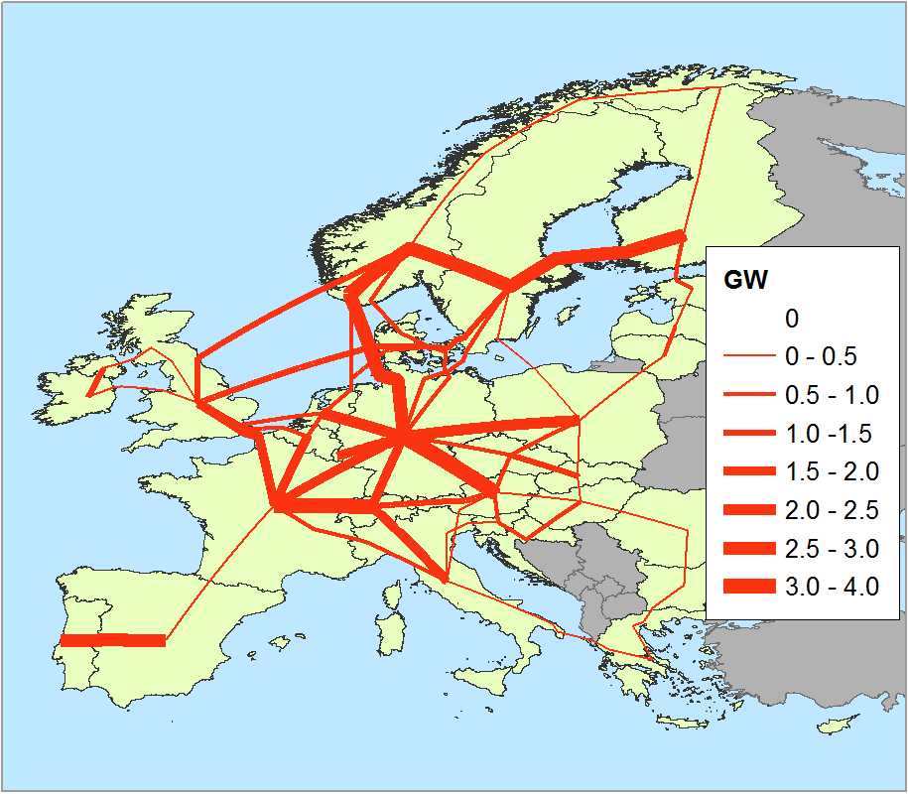

Figure ‑: Reference transmission capacity included in the model. Data from Table H‑1.

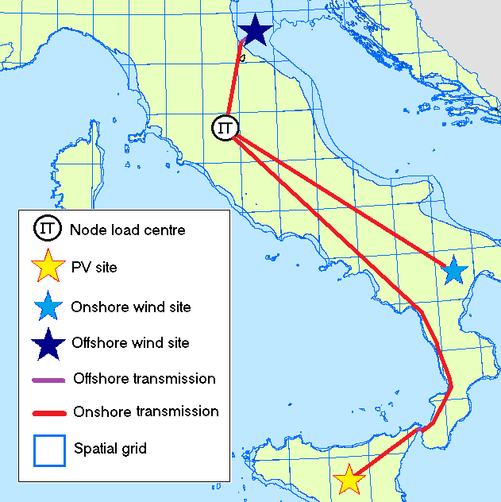

Figure ‑: Example of the approach used to estimate grid reinforcement costs for wind and PV

##### Operating reserves

Operating reserves are required to balance out mismatches between demand and generation due to (i) demand forecast errors, (ii) vRES forecast errors, and (iii) unplanned generator outages. These reserves take the form of additional (non-dispatched) generation capacity which can be made available when required at short notice. The provision of these reserves results in additional costs; therefore, in a power system with a heavy reliance on vRES, it is important to ensure sufficient (but not excessive) reserve capacity is available.

There is no standard method used to determine the required reserve size. In this study, we follow the approach of Brouwer et al. [37] by considering three types of reserves:

* Spin-up: fast-responding spinning (within 5 minutes) up-regulation reserves, based on 1h-ahead forecast errors of wind and PV generation, available for 15 minutes;
* Spin-down: fast-responding spinning (within 5 minutes) down-regulation reserves, also based on 1h-ahead forecast errors of wind and PV generation, available for 15 minutes; and
* Stand-up: slower-responding standing reserves (available within 60 minutes), based on day-ahead forecast errors of wind and PV generation, available for 15 minutes.

In addition to the vRES forecast errors, we also account for demand forecast errors and unplanned generator outages in the spinning reserves (see Figure I‑1).

**Demand**

**forecast errors**

**Unplanned generator outages (N-2 criterion)**

**Spin-down reserves**

**Spin-up reserves**

**Stand-up reserves**

**vRES** forecast errors

**Wind forecast errors**

**PV forecast errors**

**Day-ahead wind forecast errors**

**1h-ahead wind forecast errors**

**Day-ahead PV forecast errors**

**1h-ahead PV forecast errors**

Figure ‑: Operating reserve sizing approach

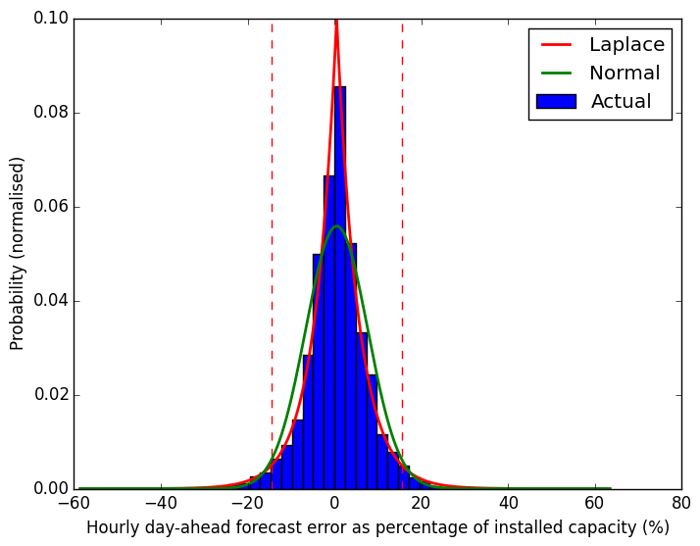

(b) Offshore wind

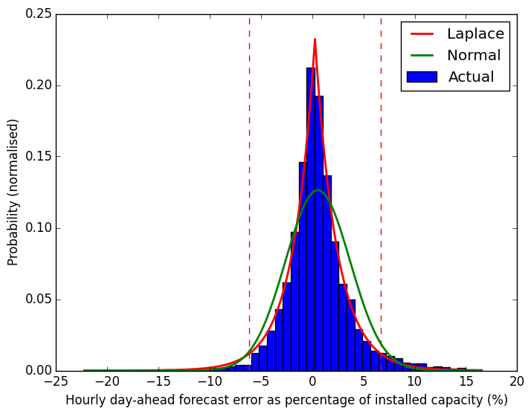

(a) Onshore Wind

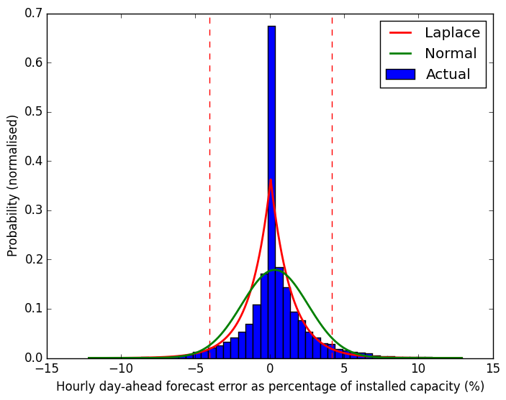

(c) PV

Figure ‑: Probability density plots of hourly forecast errors from day-ahead predictions for (a) onshore wind (b) offshore wind and (c) PV in Germany for the year 2016, based on ENTSO-E data [29]. Forecast errors are expressed as a percentage of total installed capacity (Onshore wind 41.4 GW, offshore wind 3.3 GW, PV 38.6 GW) using 50 bins. The original data at 15-min resolution is averaged to match the coarser hourly temporal resolution used in our study. Errors are fit to both the Normal and Laplace distributions, revealing the Laplace distribution as a better fit in agreement with Morbee [71]. The vertical red lines indicate 95% of all forecast errors based on the fitted Laplace distributions. Note that for PV, we exclude hours in which either predicted or actual PV generation is zero.

There are two main approaches to estimate vRES forecast errors: (1) determine typical errors for existing forecast methods, or (2) synthesise forecasts for each generation technology, and determine the errors. For the stand-up reserve requirement, we use the first approach and assume that the day-ahead vRES forecasts reported by ENTSO-E [29] are representative of the best forecasting methods available. Calculating the day-ahead forecast errors for each hour of 2016 for Germany[15], we fit these data to Laplace distributions following the approach of Morbee et al. [71] (see Figure I‑2). These graphs show that as a share of installed capacity, day-ahead forecast errors for onshore wind are better than for offshore wind. Also, we see that the Laplace fit is poorer for PV than for wind, due mainly to the large number of hours with very low PV generation, and hence concomitantly small forecast areas. Rather than determining a fixed annual reserve size from these graphs which would overestimate the required reserves, we use the dynamic reserve sizing method of Lew et al. [39] (also used by Brouwer et al. [37]) to estimate hourly reserves by binning vRES forecast errors into tranches, according to a limited number of variables. For each technology, we use eight three-hour bins for the period of the day (12am – 3am UTC … 9pm – 12pm UTC), and eight generation bins, giving a total of 64 tranches. Fitting the tranche errors to Laplace distributions, we calculate the forecast error in each tranche as a share of installed capacity (e.g. see Figure I‑3 for an example). The standing reserves are then calculated by multiplying our vRES generation profiles by these typical day-ahead error tranches, assuming reserves must cover 95% of day-ahead forecast errors.

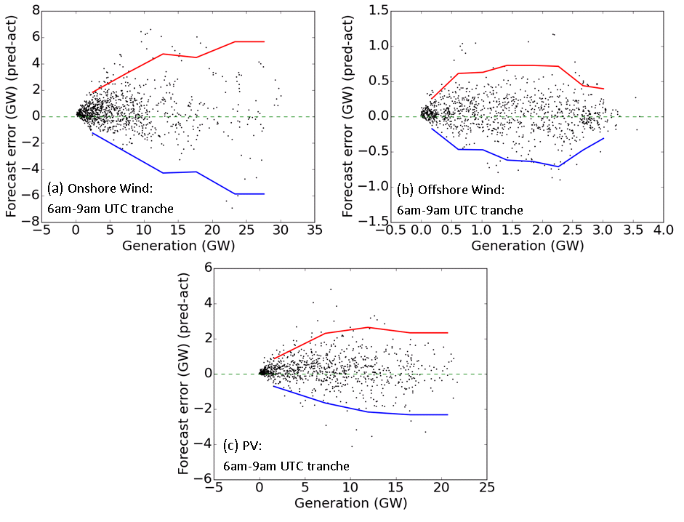

Figure ‑: Calculated day-ahead vRES forecast errors as a function of actual generation for a) onshore wind, b) offshore wind, and c) PV production for Germany in 2016 for the 6am – 9am time-of-day tranche. The red and blue lines indicate the 95% confidence limits for each generation level tranche, assuming the errors are Laplace distributed.

For spinning reserves, no publicly available historical hour-ahead vRES forecasts could be found to estimate typical hour-ahead forecast errors. Instead, we take the second approach and generate our own hour-ahead persistence forecasts from the ‘actual’ generation patterns to estimate wind and PV forecasts errors, again following the method of Lew et al. [39] and Brouwer et al. [37][16]. However, as our persistence forecasts are likely to be less accurate than the advanced methods used by TSOs, slightly different variables and binning methods are used for PV and wind as explained below:

* For solar PV (both rooftop and utility), simple hour-ahead persistence forecasts often lead to significant positive forecast errors in the morning as the sun rises, and negative forecast errors in the evening as the sun sets [39]; however, these diurnal generation patterns can be accurately predicted without the need for complex weather models by using solar position calculations, assuming clear-sky conditions. Thus, we improve the simple persistence forecast to account for the predictable diurnal pattern of PV by calculating the forecast generation (MW) at a given hour using the equation below [39], where is the actual PV generation (MW), is the expected power generation under clear sky conditions (calculated using the same method for PV described in Appendix B, but assuming a constant clear-sky value of 0.8 for [16]), and is the solar power index – the ratio between actual generation and clear-sky generation which reflects the level of cloud cover. As future SPI is not known, we take the persistence of SPI ()

|  |  |
| --- | --- |
|  | (I) |

We use eight three-hour bins for the period of the day (12am – 3am UTC, 3am – 6am UTC … 9pm – 12pm UTC), and eight (equally spaced) generation level bins for in each period, giving a total of 64 tranches. By assuming the forecast errors in each tranche also follow a Laplace distribution (as we found for day-ahead errors), we determine upper and lower confidence limits which cover 95% of forecast errors. For tranches with fewer than 10 members and therefore difficult to fit to a reliable distribution, we maintain the upper and lower limits of the previous tranche.

* For onshore wind, we find that hourly persistence forecasts also lead to a diurnal bias, with positive forecast errors in the morning and negative forecast errors in the evening – most likely due to the effects of morning sea breezes and afternoon land breezes (see Figure I‑4). While these biases could be accounted for with regression or improved forecast methods, this is beyond the scope of this paper and by using the same period-of-day and generation level bins as for PV, we account for the different spin-up and spin-down requirements throughout the day. For offshore wind, we find no diurnal bias in forecast errors, but maintain the same 64 tranches for time-of-day and generation level for consistency.

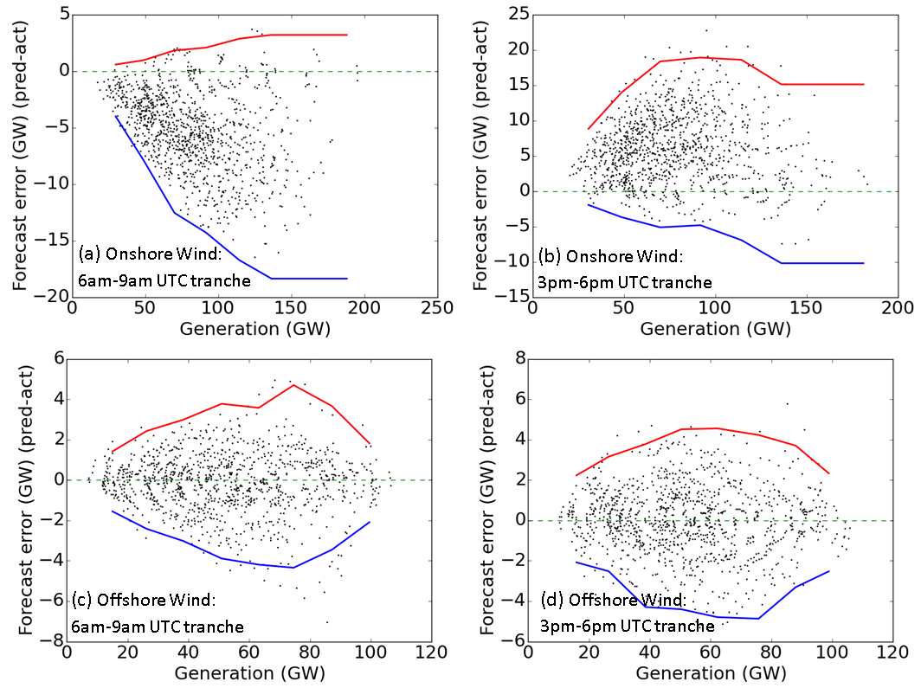

Figure ‑: Hour-ahead forecast errors as a function of actual generation for the Base scenario capacity distribution for onshore (a - b) and offshore (c – d) wind, for a morning and evening period tranche. The actual generation and persistence forecasts are based on ERA-Interim weather year 2010. The spin-up and spin-down requirements are based on the upper and lower 95% confidence limits, shown in red and blue respectively.

Assuming that for short time steps individual forecast errors are uncorrelated, the combined spin-up reserve requirement is calculated as the geometric sum of the reserve requirements to cover wind forecast errors, PV forecast errors, load forecast errors, and a system wide N-2 generator contingency of 3 GW [37].

##### Indirect GHG Emissions

Although all the 100% RES scenarios we model result in no direct GHG emissions, RES generation technologies can also result in indirect GHG emissions arising not from the generators themselves, but from upstream activities such as mining, and fuel transport. Performing rigorous environmental life-cycle analysis is beyond the scope of this study; however, we can make a rough estimate and comparison of the indirect GHG emissions of our 100% RES scenarios, using indirect emissions factors available from the JRC given in Table J‑1 [72][17]. The results are given in Figure J‑1, showing that most 100% RES scenarios result in indirect emissions of approximately 250 Mt CO2eq y-1, a 100 Mt CO2eq y-1 (71%) increase from the current indirect emissions of about 150 Mt CO2eq y-1. While this is a significant relative increase, it should be kept in mind that the 100% RES scenarios also result in a saving of 1100 Mt CO2eq y-1 of direct GHG emissions compared with 1990 levels. Furthermore, this 100 Mt CO2eq y-1 could be offset by replacing approximately 16 GW of the Bio-FB capacity with Bio-FB-CCS[18].



Figure ‑: Estimated indirect GHG emissions from the 2050 power system scenarios from this study, based on calculated generation in the worst weather year 2020. Estimated emissions from the current power system (2015) are also shown as a comparison. Indirect GHG emission factors are taken from [72].

Biomass is the largest source of indirect emissions due to cultivation, harvesting and transport. Note that while emissions from indirect land use change (ILUC) are not considered above, they are unlikely to be significant as almost all the biomass used by the model derives from agricultural and forestry industry residues and wastes, not from dedicated energy crops which would displace existing forests. Furthermore, forested areas are completely excluded from the list of suitable locations for the deployment of vRES capacity.

Table ‑: Indirect GHG emission factors for electricity production [72]

|  |  |
| --- | --- |
| Technology | Indirect greenhouse gas emissions  (t CO2eq GWh-1 generated) |
| Onshore Wind | 7 |
| Offshore Wind | 11 |
| Rooftop PV | 32 |
| Utility PV | 38 |
| CSP | 35 |
| Geothermal | 92 |
| Hydro (all) | 6 |
| Biomass (all) a | 146 |
| Gas-OCGT | 100 |
| Gas-NGCC | 65 |
| Gas-NGCC-CCS | 77 |
| Nuclear | 15 |
| Coal-PC | 89 |
| Coal-PC-CCS | 115 |

(a) No value is available for biogas, thus we use the same value as for Bio-FBs.

##### References

[1] A.N. Commin, A.S. French, M. Marasco, J. Loxton, S.W. Gibb, J. McClatchey, The influence of the North Atlantic Oscillation on diverse renewable generation in Scotland, Appl. Energy. 205 (2017) 855–867. doi:10.1016/j.apenergy.2017.08.126.

[2] Eurostat, Supply, transformation and consumption of electricity - annual data (nrg_105a), (n.d.). http://ec.europa.eu/eurostat/web/energy/data/database (accessed May 4, 2017).

[3] W. Zappa, M. van den Broek, Analysing the potential of integrating wind and solar power in Europe using spatial optimisation under various scenarios, Renew. Sustain. Energy Rev. 94 (2018) 1192–1216. doi:10.1016/j.rser.2018.05.071.

[4] ECMWF, Reanalysis datasets: ERA-Interim, (n.d.). http://www.ecmwf.int/en/research/climate-reanalysis/era-interim (accessed May 26, 2016).

[5] J.F. Manwell, J.G. McGowan, J.G. Rogers, Wind Energy Explained, 2nd ed., Wiley, Chichester, 2009. doi:10.1017/CBO9781107415324.004.

[6] I. Troen, E. Lundtang Petersen, European wind atlas, RisØ National Laboratory, Roskilde, 1989. http://orbit.dtu.dk/files/112135732/European_Wind_Atlas.pdf.

[7] J. Silva, C. Ribeiro, R. Guedes, Roughness length classification of Corine Land Cover Classes, in: Proc. Eur. Wind Energy Conf., Milan, 2007. doi:10.1017/CBO9781107415324.004.

[8] R. Lacal-Arántegui, J. Serrano González, 2014 JRC Wind Status Report, European Commission Joint Research Centre, Petten, 2015. doi:10.2790/676580.

[9] Vestas, Vestas Turbines, (2017). https://www.vestas.com/en/products/turbines/ (accessed October 13, 2017).

[10] P. Norgaard, H. Holttinen, A Multi-Turbine Power Curve Approach, in: Nord. Wind Power Conf. March 1-2 2004, Gothenburg, 2004.

[11] A. Myhr, C. Bjerkseter, A. Ågotnes, T.A. Nygaard, Levelised cost of energy for offshore floating wind turbines in a life cycle perspective, Renew. Energy. 66 (2014) 714–728. doi:10.1016/j.renene.2014.01.017.

[12] R. McKenna, S. Hollnaicher, W. Fichtner, Cost-potential curves for onshore wind energy: A high-resolution analysis for Germany, Appl. Energy. 115 (2014) 103–115. doi:10.1016/j.apenergy.2013.10.030.

[13] R.A. Rivas, J. Clausen, K.S. Hansen, L.E. Jensen, Solving the Turbine Positioning Problem for Large Offshore Wind Farms by Simulated Annealing, Wind Eng. 33 (2009) 287–297. doi:10.1260/0309-524X.33.3.287.

[14] C. Vázquez Hernández, T. Telsnig, A. Villalba Pradas, JRC Wind Energy Status Report 2016 Edition., European Commission Joint Research Centre, Petten, 2017. doi:10.2760/332535.

[15] EEA, Europe’s onshore and offshore wind energy potential. Technical report No 6/2009., Copenhagen, 2009. doi:10.2800/11373.

[16] D.G. Erbs, S.A. Klein, J.A. Duffie, Estimation of the diffuse radiation fraction for hourly, daily and monthly-average global radiation, Sol. Energy. 28 (1982) 293–302. doi:10.1016/0038-092X(82)90302-4.

[17] D.T. Reindl, W.A. Beckman, J.A. Duffie, Evaluation of hourly tilted surface radiation models, Sol. Energy. 45 (1990) 9–17. doi:10.1016/0038-092X(90)90061-G.

[18] T. Dierauf, A. Growitz, S. Kurtz, J.L.B. Cruz, E. Riley, C. Hansen, Weather-Corrected Performance Ratio. NREL Technical Report NREL/TP-5200-57991, National Renewable Energy Laboratory (NREL), Golden, 2013. http://www.nrel.gov/docs/fy14osti/60204.pdf.

[19] Fraunhofer ISE, Photovoltaics Report, Fraunhofer ISE, Freiburg, 2016. https://www.ise.fraunhofer.de/de/downloads/pdf-files/aktuelles/photovoltaics-report-in-englischer-sprache.pdf.

[20] SunPower, X-Series Solar Panels, (2014). https://us.sunpower.com/sites/sunpower/files/media-library/data-sheets/ds-x21-series-335-345-residential-solar-panels-datasheet.pdf (accessed September 17, 2016).

[21] TrinaSolar, The Tallmax Module, (2016). http://www.trinasolar.com/HtmlData/downloads/us/US_PD14_Datasheet.pdf (accessed September 23, 2016).

[22] H.L. Zhang, J. Baeyens, J. Degrève, G. Cacères, Concentrated solar power plants: Review and design methodology, Renew. Sustain. Energy Rev. 22 (2013) 466–481. doi:10.1016/j.rser.2013.01.032.

[23] J. Jorgenson, P. Denholm, M. Mehos, C. Turchi, Estimating the Performance and Economic Value of Multiple Concentrating Solar Power Technologies in a Production Cost Model, (2013).

[24] IRENA, Renewable Energy Technologies: Cost Analysis Series. Concentrating Solar Power. Volume 1: Power Sector, Issue 2/5, International Renewable Energy Agency, Bonn, 2012. https://www.irena.org/documentdownloads/publications/re_technologies_cost_analysis-csp.pdf.

[25] NREL, Concentrating Solar Power Projects: SolarPACES Project, (2017). https://www.nrel.gov/csp/solarpaces/ (accessed September 30, 2017).

[26] IRENA, Concentrating Solar Power: Technology Brief, 2013. https://www.irena.org/DocumentDownloads/Publications/IRENA-ETSAP Tech Brief E10 Concentrating Solar Power.pdf.

[27] T. Mennel, H. Ziegler, M. Ebert, A. Nybø, F. Oberrauch, C. Hewicker, The hydropower sector’s contribution to a sustainable and prosperous Europe, DNV GL, KEMA Consulting GmbH, Bonn, 2015. http://www.thehea.org/macro-economic-study-on-hydropower/.

[28] Eurostat, Energy Statistics - Infrastructure - electricity - annual data (nrg_113a), (2017). http://ec.europa.eu/eurostat/web/energy/data/database (accessed July 31, 2017).

[29] ENTSO-E, ENTSO-E Transparency Platform, (2017). https://transparency.entsoe.eu/ (accessed August 28, 2015).

[30] A.S. Brouwer, M. van den Broek, A. Seebregts, A. Faaij, Operational flexibility and economics of power plants in future low-carbon power systems, Appl. Energy. 156 (2015) 107–128. doi:10.1016/j.apenergy.2015.06.065.

[31] I. Llorente García, J.L. Álvarez, D. Blanco, Performance model for parabolic trough solar thermal power plants with thermal storage: Comparison to operating plant data, Sol. Energy. 85 (2011) 2443–2460. doi:10.1016/j.solener.2011.07.002.

[32] ACIL Allen Consulting, Report to Australian Energy Market Operator: Fuel and Technology Cost Review, ACIL Allen Consulting, 2014. http://www.aemo.com.au/Electricity/Planning/Related-Information/Planning-Assumptions.

[33] E. Yildiz, J. Dersch, C. Rau, N. Schmidt, S. Heide, CSPBankability Project Report: Draft for an Appendix D - Power Block to the SolarPACES Guideline for Bankable STE Yield Assessment, 2017. http://www.dlr.de/sf/Portaldata/73/Resources/dokumente/linienfokusssyst/cspbank-solarpaces-guideline/CSPBankProjectReport_Draft_for_AppendixD_PowerBlock_170109.pdf.

[34] T. Fichter, The Joint German-Jordanian Workshop 2012 Amman February 27th – 29th: Optimized integration of CSP plants into Jordan’s power plant portfolio, DLR, 2012. http://elib.dlr.de/75168/1/Amman_2012_Fichter_with_backup.pdf (accessed September 14, 2017).

[35] B. Matek, Geothermal Energy Association Issue Brief : Firm and Flexible Power Services Available from Geothermal Facilities, Geothermal Energy Association, Washington, 2015. http://geo-energy.org/reports/2015/Firm and Flexible Power Services from Geothermal.pdf.

[36] Black & Veatch, Cost and Performance data for Power Generation Technologies, Black & Veatch, 2012. https://www.bv.com/docs/reports-studies/nrel-cost-report.pdf.

[37] A.S. Brouwer, M. Van den Broek, W. Zappa, W.C. Turkenburg, A. Faaij, Least-cost options for integrating intermittent renewables in low-carbon power systems, Appl. Energy. 161 (2016) 48–74. doi:10.1016/j.apenergy.2015.09.090.

[38] AEMO, National Transmission Network Development Plan (NTNDP) database, (n.d.). http://www.aemo.com.au/Electricity/National-Electricity-Market-NEM/Planning-and-forecasting/National-Transmission-Network-Development-Plan/NTNDP-database (accessed September 14, 2017).

[39] D. Lew, G. Brinkman, E. Ibanez, A. Florita, M. Heaney, B. Hodge, et al., The Western Wind and Solar Integration Study Phase 2, National Renewable Energy Laboratory, Golden, 2013. https://www.nrel.gov/docs/fy13osti/55588.pdf.

[40] IEA, Modelling the capacity credit of renewable energy sources, IEA/OECD, Paris, 2011. https://www.iea.org/media/weowebsite/energymodel/Methodology_CapacityCredit.pdf.

[41] M. Amelin, Comparison of capacity credit calculation methods for conventional power plants and wind power, IEEE Trans. Power Syst. 24 (2009) 685–691. doi:10.1109/TPWRS.2009.2016493.

[42] C. Ensslin, M. Milligan, H. Holttinen, M. O’Malley, A. Keane, Current Methods to Calculate Capacity Credit of Wind Power, IEA Collaboration, in: Pap. Present. IEEE Power Energy Soc. 2008 Gen. Meet. July 20-24, 2008, Pittsburgh, PA, USA, Pittsburgh, 2008: pp. 133–150.

[43] M. Milligan, B. Parsons, A comparison and case study of capacity credit algorithms for wind power plants, Wind Eng. 23 (1999) 159–166.

[44] H. Holttinen, The impact of large scale wind power production on the Nordic electricity system, Helsinki University of Technology, 2004. Doctoral thesis.

[45] ENTSO-E, Ten Year Network Development Plan 2016, (2016). http://tyndp.entsoe.eu/ (accessed August 16, 2017).

[46] H.C. Gils, Assessment of the theoretical demand response potential in Europe, Energy. 67 (2014) 1–18. doi:10.1016/j.energy.2014.02.019.

[47] J. Bertsch, C. Growitsch, S. Lorenczik, S. Nagl, Flexibility options in European electricity markets in high RES-E scenarios, EWI, Cologne, 2012. http://www.ewi.uni-koeln.de/fileadmin/user_upload/Publikationen/Studien/Politik_und_Gesellschaft/2012/Flexibility_options_in_the_European_electricity_markets.pdf.

[48] Y. Deng, M. Haigh, W. Pouwels, L. Ramaekers, R. Brandsma, S. Schimschar, et al., Quantifying a realistic, worldwide wind and solar electricity supply, Glob. Environ. Chang. 31 (2015) 239–252. doi:10.1016/j.gloenvcha.2015.01.005.

[49] K. Bruninx, D. Orlic, D. Couckuyt, N. Grisey, B. Betraoui, T. Anderski, et al., e-Highway 2050 Project: Deliverable 2.1 Data sets of scenarios for 2050, 2015. http://www.e-highway2050.eu/fileadmin/documents/Results/D2_1_Data_sets_of_scenarios_for_2050_20072015.pdf.

[50] O. Rahbari, M. Vafaeipour, F. Fazelpour, M. Feidt, M.A. Rosen, Towards realistic designs of wind farm layouts: Application of a novel placement selector approach, Energy Convers. Manag. 81 (2014) 242–254. doi:10.1016/j.enconman.2014.02.010.

[51] Y. Eroĝlu, S.U. Seçkiner, Wind farm layout optimization using particle filtering approach, Renew. Energy. 58 (2013) 95–107. doi:10.1016/j.renene.2013.02.019.

[52] S.D.O. Turner, D.A. Romero, P.Y. Zhang, C.H. Amon, T.C.Y. Chan, A new mathematical programming approach to optimize wind farm layouts, Renew. Energy. 63 (2014) 674–680. doi:10.1016/j.renene.2013.10.023.

[53] K. Mainzer, K. Fath, R. Mckenna, J. Stengel, W. Fichtner, F. Schultmann, A high-resolution determination of the technical potential for residential-roof-mounted photovoltaic systems in Germany, Sol. Energy. 105 (2014) 715–731. doi:10.1016/j.solener.2014.04.015.

[54] B. Śliż-Szkliniarz, Energy Planning in Selected European Regions, Fakultät für Bauingenieur-, Geo- und Umweltwissenschaften, Karlsruher Institut für Technologie, 2012. Doctoral thesis.

[55] Lindø Offshore Renewables Centre (LORC), Offshore Wind Farms List – global database | LORC Knowledge, (n.d.). http://www.lorc.dk/offshore-wind-farms-map/list (accessed May 11, 2016).

[56] A.C. Hansen, P. Thorn, PV potential and potential PV rent in European regions. ENSPAC Research Papers on Transitions to a Green Economy 01/13, The Department of Environmental, Social and Spatial Change ENSPAC, Roskilde University, Roskilde, 2013. http://www.reshaping-res-policy.eu/downloads/D10_Long-term-potentials-and-cost-of-RES.pdf.

[57] P. Ruiz, A. Sgobbi, W. Nijs, F.D. Longa, T. Kober, The JRC-EU-TIMES model . Bioenergy potentials for EU and neighbouring countries, European Commission Joint Research Centre, 2015. doi:10.2790/39014.

[58] R. Hoefnagels, G. Resch, M. Junginger, A. Faaij, International and domestic uses of solid biofuels under different renewable energy support scenarios in the European Union, Appl. Energy. 131 (2014) 139–157. doi:10.1016/j.apenergy.2014.05.065.

[59] H. Hahn, B. Krautkremer, K. Hartmann, M. Wachendorf, Review of concepts for a demand-driven biogas supply for flexible power generation, Renew. Sustain. Energy Rev. 29 (2014) 383–393. doi:10.1016/j.rser.2013.08.085.

[60] S. Lensink, J. Cleijne, eds., Final advice on base rates SDE+ 2017, Energy research Centre of the Netherlands, Petten, 2017. https://www.ecn.nl/collaboration/sde/sde-2017/.

[61] Q. Sun, H. Li, J. Yan, L. Liu, Z. Yu, X. Yu, Selection of appropriate biogas upgrading technology-a review of biogas cleaning, upgrading and utilisation, Renew. Sustain. Energy Rev. 51 (2015) 521–532. doi:10.1016/j.rser.2015.06.029.

[62] AEBIOM, A Biogas Road Map for Europe, European Biomass Association, Brussels, 2009. https://www.4biomass.eu/document/news/AEBIOM_Biogas_Roadmap.pdf.

[63] F. Bauer, C. Hulteberg, T. Persson, D. Tamm, Biogas upgrading – Review of commercial technologies, Swedish Gas Technology Centre, Malmo, 2013. http://vav.griffel.net/filer/C_SGC2013-270.pdf.

[64] L. Skovsgaard, H.K. Jacobsen, Economies of scale in biogas production and the significance of flexible regulation, Energy Policy. 101 (2017) 77–89. doi:10.1016/j.enpol.2016.11.021.

[65] E.J. Hengeveld, W.J.T. van Gemert, J. Bekkering, A.A. Broekhuis, When does decentralized production of biogas and centralized upgrading and injection into the natural gas grid make sense?, Biomass and Bioenergy. 67 (2014) 363–371. doi:10.1016/j.biombioe.2014.05.017.

[66] R. Muñoz, L. Meier, I. Diaz, D. Jeison, A review on the state-of-the-art of physical/chemical and biological technologies for biogas upgrading, Rev. Environ. Sci. Biotechnol. 14 (2015) 727–759. doi:10.1007/s11157-015-9379-1.

[67] ENTSO-E, Hourly load values for all countries for a specific month (in MW), (2016). https://www.entsoe.eu/db-query/consumption/mhlv-all-countries-for-a-specific-month (accessed May 26, 2016).

[68] ECF, Roadmap 2050: a practical guide to a prosperous, low-carbon Europe. Policy Recommendations, European Climate Foundation, Brussels, 2010. http://www.roadmap2050.eu/project/roadmap-2050.

[69] G. Pasaoglu, D. Fiorello, L. Zani, A. Martino, A. Zubaryeva, C. Thiel, Projections for Electric Vehicle Load Profiles in Europe Based on Travel Survey Data Contact information, European Commission Joint Research Centre, 2013. doi:10.2790/24108.

[70] W. Bobenhausen, Simplified Design of HVAC Systems, John Wiley & Sons, Inc., New York, 1994.

[71] J. Morbee, J. Driesen, K. De Vos, R. Belmans, Impact of wind power on sizing and allocation of reserve requirements, IET Renew. Power Gener. 7 (2013) 1–9. doi:10.1049/iet-rpg.2012.0085.

[72] JRC, ETRI 2014: Energy Technology Reference Indicator Projections for 2010-2050, European Commission Joint Research Centre, Petten, 2014. doi:10.2790/057687.

[73] Fachagentur Windenergie an Land, Ausbausituation der Windenergie an Land im Jahr 2015, Berlin, 2016. http://www.fachagentur-windenergie.de/aktuell/detail/ausbausituation-der-windenergie-an-land-im-jahr-2015.html.

[74] E.D. Mehleri, P.L. Zervas, H. Sarimveis, J.A. Palyvos, N.C. Markatos, Determination of the optimal tilt angle and orientation for solar photovoltaic arrays, Renew. Energy. 35 (2010) 2468–2475. doi:10.1016/j.renene.2010.03.006.

[75] M. Šúri, T.A. Huld, E.D. Dunlop, H. a. Ossenbrink, Potential of solar electricity generation in the European Union member states and candidate countries, Sol. Energy. 81 (2007) 1295–1305. doi:10.1016/j.solener.2006.12.007.

[76] M. Mehos, C. Turchi, J. Vidal, M. Wagner, Z. Ma, C. Ho, et al., Concentrating solar power Gen3 demonstration roadmap, National Renewable Energy Laboratory (NREL), Golden, 2017. https://www.nrel.gov/docs/fy17osti/67464.pdf.

[77] Ordnance Survey, Ordnance Survey: Britain’s mapping agency, (2016). https://www.ordnancesurvey.co.uk/ (accessed March 20, 2016).

[78] ESRI, Basiskaarten | ArcGIS Content | Esri Nederland, ArcGIS Ned. Content. (2016). http://www.esri.nl/producten/content/content/basiskaarten (accessed April 25, 2016).

1. This is typical for natural grasslands and agricultural pastures, which is where we assumed most
2. This is a conservative estimate as some current wind turbines already exceed this value, including a 3.3 MW wind turbine with a hub height of 164 m approved in Q1 2016 in Germany [73].
3. A general rule of thumb is that panels are installed at a tilt angle equal to the latitude of the site, representing the average solar altitude angle and thus maximizing the direct radiation component. However, shadowing from location terrain and surrounding buildings can reduce direct irradiance making a flatter tilt angle more favourable in mountainous, built-up and high latitude locations, thus the optimum angle is not always straightforward, or achievable [74,75].
4. Standard Test Conditions (=1000 W m⁻² irradiance, air mass 1.5, 25° C)
5. As of 2017, solar tower technologies represent two-thirds of new CSP capacity that has been announced, is under development, or under construction [76]. Ultimately, either technology could be used in the modelling.
6. This value includes Turkey
7. A detailed list of generators per country is available from [29] under *‘Installed generation capacity per unit [14.1.B]’*. The list does not include all hydro plants, but the shares of RoR, STO and PHS capacity in the list are assumed to reflect reality.
8. The unmet demand in the peak hour of residual demand (demand – vRES generation) dictates the required system capacity and would ideally be used for this calculation. However, before performing the capacity expansion optimisation it is not known where and how much solar PV and wind is installed, thus we use raw demand values as a proxy, as higher raw demand hours are more likely to be high residual demand hours. Given this uncertainty, and the fact that demand shedding and shifting can also impact the peak residual demand hour, we average over several peak load hours.
9. Based on the total demand aggregated across all countries. For example, if the average wind capacity factor in one grid cell during the top 0.1% demand hours was 12% in 2004, 15% in 2005, and 9% in 2006, the wind capacity credit for that cell would be taken as 9%. This is a simplification as there is no guarantee that the hours of total peak demand will also be the hours with peak residual demand. However, the higher absolute demand makes this more likely. This approach also ensures that the reliability of vRES across all years it taken into account.
10. The only two countries for which publicly available building footprint data could be found [77,78].
11. Included in this category are grassy and agriculture fuels which are not strictly ‘woody’ (lignocellulosic), but we use this term loosely as ‘wood-like’ to distinguish between fuels which are solid and relatively clean, as opposed to waste-based solid fuels, and biogas substrates which may be in slurry or liquid form, contain significant impurities, and not suitable for direct combustion.
12. No hourly demand profile was available for Malta which was instead estimated based on that of Cyprus, scaled down based on 2013 total power consumption from Eurostat.
13. For lines crossing the sea (e.g. DK-NO, GB-IE), we follow the path of existing cables. For lines connecting the load centres of two land neighbours the shortest straight line distance is used, unless this path would cross water or other countries (e.g. BG-EL, NO-FI), in which case the path is adjusted to match that of the existing transmission network as closely as possible.
14. This is a simplification as large countries (e.g. Germany) are also building HVDC lines to overcome internal grid constraints. Also, HVDC may also be chosen for long underground cables to reduce losses. However, without detailed data of the full transmission network infrastructure, this simplification is necessary.
15. While forecast accuracy may vary for different countries, we take Germany as the country with the highest installed capacity of both wind and PV in Europe, and thus more likely to utilize the best forecasting methods available.
16. The ‘actual’ generation patterns are formed by combining the optimised vRES capacity distribution from PLEXOS’ capacity expansion algorithm with the capacity factor profiles built from ERA-Interim. As the distribution of vRES capacity is not known until the capacity expansion problem has been solved, reserves cannot be included in the capacity expansion problem, but they are included in the detailed hourly UCED calculations.
17. The original source does not describe in detail exactly which types of emissions are included within the scope of indirect emissions; thus, in the absence of more detailed data, the values are taken ‘as is’.
18. Installing CCS would reduce the capacity and efficiency of the Bio-FB plant, requiring some additional generation capacity which we do not account for in this simple calculation.