**Laboratory 3: Creating a sprite based game**

**Introduction:** It is autumn, so let us create a sprite-based game with this as a theme. You may not understand every aspect of the code in this handout. The aim of the laboratory is to allow you witness the thought processes of a competent programmer as they assemble a bigger program. You will also learn to use the tools to work on larger programs.

A sprite is a 2D bitmap object (image) that can be moved around the screen. Many popular games make use of sprites, these include

Mario, Pacman  , Space Invader , Angry-birds 

**Figure 1:** Famous sprites

It is possible to animate sprites to give an impression of movement. It is also possible to use sprites to create 3D effects without having to embrace advanced graphics concepts.

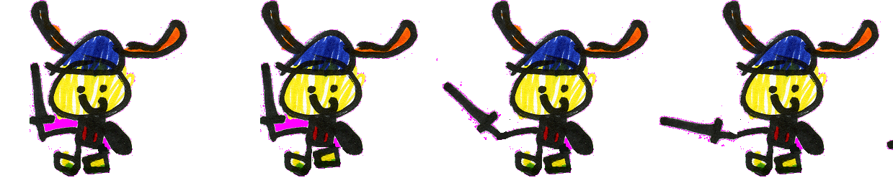

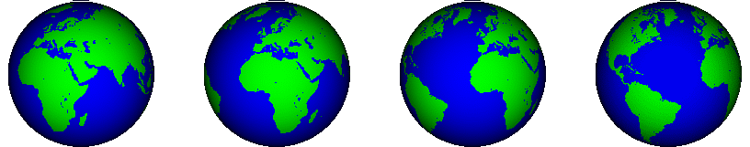

**Figure 2:** Animation sheet for a “Happy Viking” and for 3D effect of the world turning.

**Part 1:** Setting up the project folder

If you have an X:\ drive account, you should save project there so that you can revisit the code at a later stage (from any computer in any lab). To do this open the windows file explorer (press the Windows key, , and “e” at the same time to launch this). Create a new folder on the X:\ drive called *CS171* and a subfolder within this called *Lab3*.

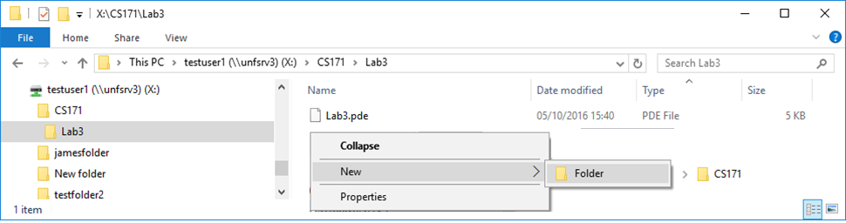

1: Right click

New folder

4: Lab3.pde

3: Lab3

2: CS171

**Figure 3:** Creating a folder on the X drive called CS171 with a sub folder Lab3.

Open a new Processing project, name it (e.g. Lab3.pde), and save it to this new folder.

Download (from Moodle) the pictures and music that we are going to use in the game and copy the files to the folder that contains your Processing program (i.e. Lab3.pde). The files are called “assets” or “content” in graphics programing environments such as Unity.

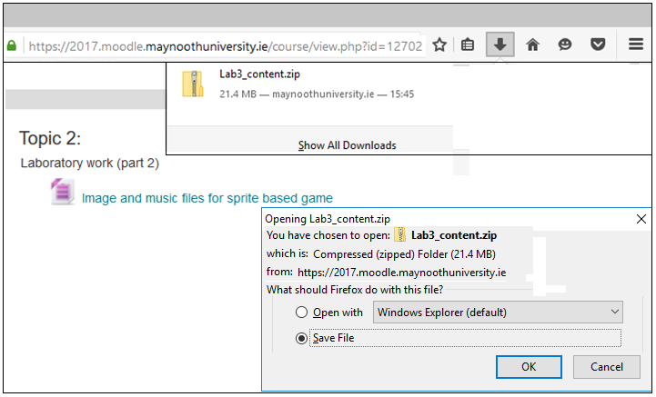

8: Click

7: Click

6: Click

5: Click

**Figure 4:** Download and locate the zip file containing image and music files.

To copy the files, open the windows file explorer (press the Windows key, , and “e” at the same time to launch this), navigate to the zip file (This PC-Downloads), click on the zip file called *Lab3_content.zip*. Highlight the files one at a time using (hold down ctrl + left click mouse on each file), select copy (right click mouse) and then open the destination folder and paste them (right click) into your project folder.

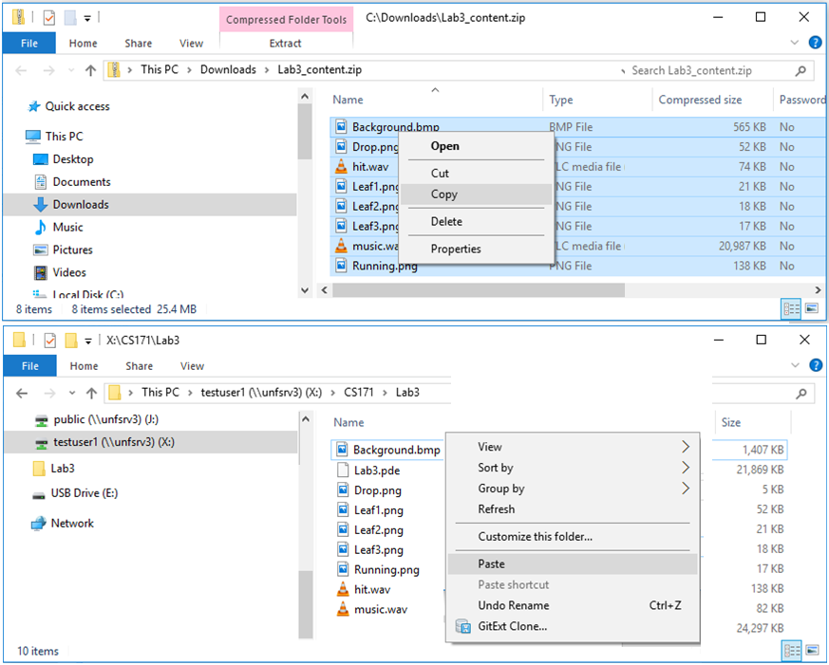

13

12

11

10: Select files

9

**Figure 6:** Copy files from the zip file in the download folder to your working folder on the X drive.

**Part 2:** Setting up an arena in which to play

Using PowerPoint clip-art images for grass, a tree, the sun and a cloud were arranged around the slide area. The slide area was then displayed full screen and (shift Print Screen) was used to capture the image. This image was pasted into MS Paint (or Paint.NET) and saved as bitmap called *Background.bmp*.

**To do:** Add the following lines of code to your *Lab3.pde* file and run the program to see the image in your run time window. You may find that your laptop has a graphics card incapable of displaying the image, if this happens using Processing 2.0 will work. Look at the error messages if it does not work. Of course, you could use any drawing package to create your own background image. Use the image provided for now.

PImage scene; // Variable to store information about an image

void **setup**() // Entry point (start of program), runs once

{

  size(800,600,P2D); // Create a Window, must be same size as scene

  scene = loadImage("Background.bmp"); // load image and data into scene data structure

}

void **draw**()

{

  background(scene); // Display background image referenced by scene

}

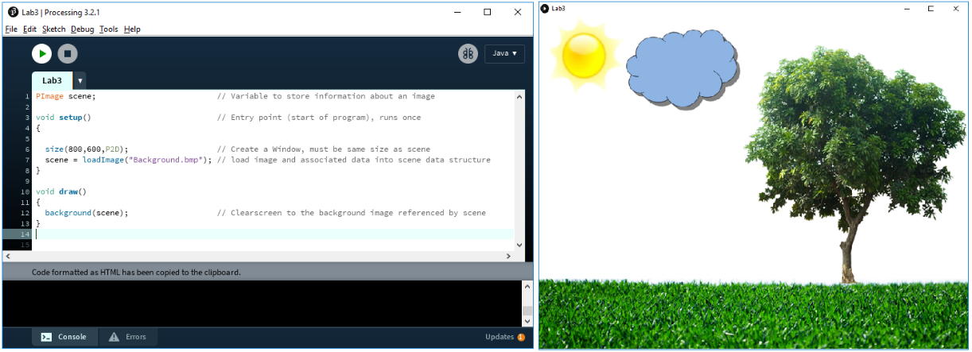

**Figure 7:** Code to create a Window with a background image.

**To do:** We can now extend the code to draw a raindrop on the screen.

PImage scene,drop; // Variables to store information about images

int drop_x,drop_y,drop_count; // Variables to store (x,y) position of drop

void **setup**() // Entry point (start of program), runs once

{

  ...

  drop = loadImage("Drop.png"); // load image of rain drop into the GPU

  textureMode(NORMAL); // Scale texture Top right (0,0) to (1,1)

  blendMode(BLEND); // States how to mix a new image with the one behind it

  noStroke(); // Do not draw a line around objects

  drop_x=166+(int)random(200); // Choose drop starting position

  drop_y=90;

}

void **draw**()

{

  background(scene); // Clear screen to the background image, scene

  pushMatrix(); // Store current location of origin (0,0)

  translate(drop_x,drop_y); // Change origin (0,0) for drawing to (drop_x,drop_y)

  beginShape(); // Open graphics pipeline

  texture(drop); // Tell GPU to use drop to texture the polygon

  vertex( -20, -20, 0, 0); // Load vertex data (x,y) and (U,V) texture data into GPU

  vertex(20, -20, 1, 0); // Square centred on (0,0) of width 40 and height 40

  vertex(20, 20, 1, 1); // Textured with an image of a drop

  vertex( -20, 20, 0, 1);

  endShape(CLOSE); // Tell GPU you have loaded shape into memory.

  popMatrix(); // Recover origin(0,0)means top left hand corner again.

}

**To do:** Run the code and check that a raindrop appears on the cloud.

Stop and think:

1/ The pushMatrix()allows us to store the current origin used for drawing an object on the Window. At the start of the program this is set to (0,0) representing the top left hand corner of the screen, so we can push this location on the stack to save it. We can then move the origin to where we would like to draw the water drop using translate(drop_x,drop_y). This means that we don’t have to add the drop (x,y) position to every co-ordinate used to draw the object (as we have been doing so far). When we have drawn the drop we can return the origin back to the top left hand corner using popMatrix(). Stacks are very effective data structure for temporary storage of information, “push” to save, “pop” to restore.

2/ A square (shape) described using 4 vertices is entered into the GPU pipeline between the beginShape()and the endShape() instructions.

3/ For each vertex (corner of the square on screen) we need an additional texture co-ordinate (U,V). The texture coordinates locates a point in the texture that will map image data to the vertex. The GPU can interpolate the correct image data for the space between the vertices. This allows us to cover the surface of an object with an image. The texture coordinates are always floating point numbers in the range [0,1] that map to the original bitmap (whatever its size is in pixels).

Texture coordinates (u,v)

Vertices (x,y)

20, -20

-20,-20

0, 1

1, 1



Shape

drop.bmp

-20,20

20, 20

1, 0

0, 0

**Figure 8:** UV mapping of a texture on to a square defined by 4 vertices.

4/ Things are not draw immediately, the code in the *draw()* method pushes what is to be drawn into the graphics card. Your code is telling the computer what to draw at the next opportunity. You can consider that the graphics card only displays what you have drawn when you get to the “}” at the end of *draw()*, not as you draw it.

**To do:** Now we can add code to make the drop move down the screen until it hits the grass. When it hits the grass, a new starting position in the cloud is identified and the variable *drop_count* is increased by one.

  popMatrix(); // Recover the origin, (0,0) now means top left hand corner again,

  drop_y+=2;       // Make "drop" move down the screen (two pixels at a time)

  if(drop_y>475) // If y value is entering the grass line

  {

    drop_x=166+(int)random(200); // Restart the drop again in the cloud.

    drop_y=90;

  }

} // End of draw

**To do:** Although a bit repetitive, we can now do the same again for a leaf on the tree.

PImage scene,drop,leaf; // Variables to store information about images

...

int leaf_x,leaf_y,leaf_count; // Variables to store (x,y) position of leaf

void **setup**() // Entry point (start of program), runs once

{

  ...

  drop = loadImage("Drop.png"); // load image of rain drop into the GPU

  leaf = loadImage("Leaf3.png"); // load image of leaf into the GPU

  ...

  float radius=random(128); // Chose leaf starting position

  float angle=random(2*PI); // Random position inside circle

  leaf_x=584+(int)(radius*cos(angle)); // of radius 128 centered on (584,216)

  leaf_y=216+(int)(radius*sin(angle));

}

void **draw**()

{

  background(scene); // Clear screen to the image referenced by scene

//.. draw drop

  pushMatrix(); // Draw leaf

  translate(leaf_x,leaf_y);

  rotate((float)frameCount/10);

  beginShape(); // Draw Leaf

  texture(leaf);

  vertex( -20, -20, 0, 0);

  vertex(20, -20, 1, 0);

  vertex(20, 20, 1, 1);

  vertex( -20, 20, 0, 1);

  endShape(CLOSE);

  popMatrix();

//.. move drop

  leaf_y+=1;        // Make leaf "move" down the screen

  if(leaf_y>475)

  {

    float radius=random(128); // Chose leaf starting position

    float angle=random(2*PI);

    leaf_x=584+(int)(radius*cos(angle));

    leaf_y=216+(int)(radius*sin(angle));

  }

}

**To do:** Run the new code and verify that you now have leaves and water drops falling down the screen.

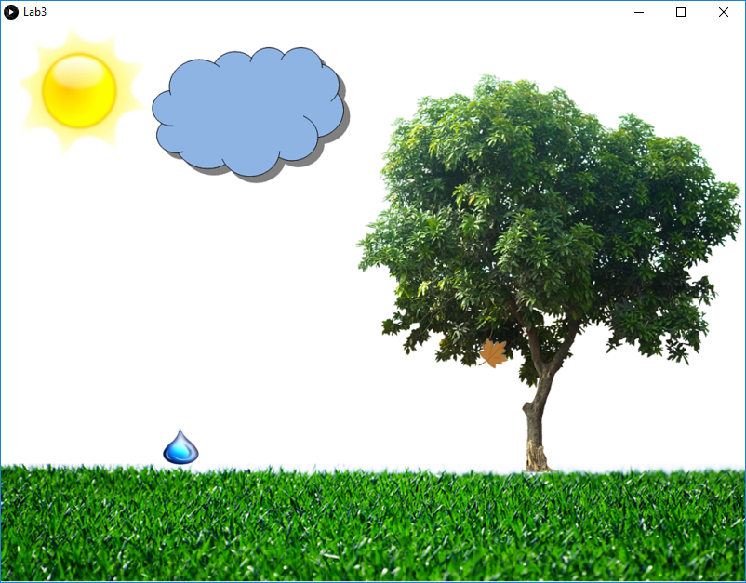

**Figure 9:** Leaf and drop moving on the screen.

We would now like to create an animated character under user control that can run back and forth along the grass line. To create the animation you use a sprite sheet that contains separate frames that when played back in sequence makes the sprite appear to move.



**Figure10:** Running.bmp sprite sheet used to create and animated character.

There are 16 separate images in the sprite sheet. To display the image belonging to a specific frame you use the following UV mapping.

Texture coordinates (u,v)

Vertices (x,y)

(frame+1)/16, 1

frame/16, 1

124,124

124,0

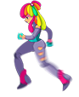

Shape

Running.bmp

0,0

0, 124

(frame+1)/16, 0

frame/16, 0

**Figure 11:** UV mapping of a texture on to a square defined by 4 vertices, 1/16th of the sprite sheet.

**To do:** Add the following code to your program and run it to verify that the character appears on screen.

PImage scene,drop,leaf,player; // Variables to store information about images

...

float frame=0; // Start on frame 0 of the sprite sheet

int player_x=400; // Start player in middle of screen

void **setup**() // Entry point (start of program), runs once

{

  size(800,600,P2D); // Create a Window, must be same size as scene

  ...

  player = loadImage("Running.png"); // load sprite sheet for player

...

}

void **draw**()

{

  background(scene); // Clear screen to the background image

  float left =frame/16;

  float right=(frame+1)/16;

  pushMatrix(); // Draw player

  translate(player_x,360);

  beginShape();

  texture(player);

  vertex( 0, 0, left, 0);

  vertex(124, 0, right, 0);

  vertex(124, 124, right, 1);

  vertex( 0, 124, left, 1);

  endShape(CLOSE);

  popMatrix(); // Restore origin (top left 0,0)

...

}

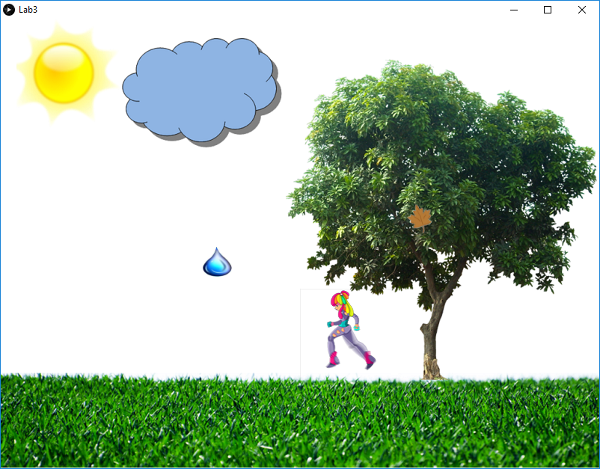

**Figure 12:** Player appears on the screen.

The player now need to change position and animate at the same time. The value in frame continuously increases up to 15 and returns to 0 after 15. The position can be adjusted in either direction in response to the keyboard.

**To Do:** Add the following code to provide keyboard control of the sprite, at the end of *draw()* before the final “}”.

    leaf_y=216+(int)(radius*sin(angle));

  }

  // Move player

   if (keyPressed == true)

   {

     if(keyCode == RIGHT)

     {

       player_x+=8;          // Increase X position move right

       frame++;              // Every step advance the frame

       if(frame>16) frame=0; // If frame is 16 reset it to 0

     }

     if (keyCode == LEFT)

     {

       player_x-=8;          // Decrease X position move left

       frame++;

       if(frame>16) frame=0;

     }

   }

}

**To do:** Run the program, the player should run correctly to the left but “moonwalk” to the right. To solve this problem we need to introduce a variable to store direction information and flip the sprite when moving right. The code to this is as follows.

...

int player_x=400; // Start player in middle of screen

int direction=0;

void **draw**()

{

...

  float left =frame/16;

  float right=(frame+1)/16;

  if(direction==1) // Swap left and right UV values

  {                                 // to reverse direction sprite is facing

    float temp=left;

    left=right;

    right=temp;

  }

  pushMatrix(); // Draw player

  translate(player_x,360);

  beginShape();

  ...

  // Move player

   if (keyPressed == true)

   {

     if(keyCode == RIGHT)

     {

       direction=1;          // Set direction to the right

       player_x+=8;          // Increase X position move right

       frame++;              // Every step advance the frame

       if(frame>16) frame=0; // If frame is 16 reset it to 0

     }

     if (keyCode == LEFT)

     {

       direction=0;          // Set direction to the left

       player_x-=8;          // Decrease X position move left

       frame++;

       if(frame>16) frame=0;

     }

   }

}

Nearly there, well done. To make it a game we need to add some game logic. We could lose a life each time a leaf or drop hits the grass, so when this occurs a variable called “*lives”* decrease by one. The player can stop them hitting the grass by running into them. The game terminates when you lose all your lives. You get a new life if you catch five drops or five leaves. The code for this logic is shown below.

...

int score=0,lives=3; // Set initial score and number of lives

int quit_flag=0; // This is set to 1 when game is over

void **setup**() // Entry point (start of program), runs once

{

  ...

}

void **draw**()

{

  background(scene); // Clear screen to the background image

...

  drop_y+=2;       // Make "drop" move down the screen (two pixels at a time)

  if(drop_y>475) // If y value is entering the grass line

  {

    drop_x=166+(int)random(200); // Restart the drop again in the cloud.

    drop_y=90;

    lives--;        // lost a life

  }

  leaf_y+=1;        // Make leaf "move" down the screen

  if(leaf_y>475)

  {

    float radius=random(128); // Chose leaf starting position

    float angle=random(2*PI);

    leaf_x=584+(int)(radius*cos(angle));

    leaf_y=216+(int)(radius*sin(angle));

    lives--;        // lost a life

  }

...

  if ((drop_y>368)&&(drop_y<470)) // If drop is on same level as player

  {

    if(abs((drop_x+10)-(player_x+62))<25) // And drop is near player

    {

      drop_count++;                  // Increase drop count by one (caught)

      drop_x=166+(int)random(200); // Restart a new drop in the cloud

      drop_y=90;

    }

  }

  if ((leaf_y>368)&&(leaf_y<470)) // If leaf is on same level as player

  {

    if(abs((leaf_x+10)-(player_x+62))<25) // And leaf is near player

    {

      leaf_count++;                // Increase leaf count by one (caught)

     float radius=random(128); // Chose leaf starting position

     float angle=random(2*PI);

     leaf_x=584+(int)(radius*cos(angle));

     leaf_y=216+(int)(radius*sin(angle));

    }

  }

  textSize(18); // Display score information on the screen

  fill(0,0,255);

  text("Drop:"+drop_count, 540, 20);

  fill(0,255,0);

  text("Leaf:"+leaf_count, 620, 20);

  fill(255,0,0);

  text("Lives:"+lives, 700, 20);

  fill(0,0,0);

  text("Score:"+score, 620, 60);

  // Scoring and game logic

  if (lives<1) text("Game over", 120, 300); // Score of 0 display game over

  score++;

  if(leaf_count>5) // Every five leaves increase lives by one

  {

    leaf_count-=5;

    lives++;

  }

  if(drop_count>5) // Every five drops increase lives by one

  {

    drop_count-=5;

    lives++;

  }

  if(quit_flag==1) // Wait five seconds before exiting

  {

   delay(5000);

   exit();

  }

  if (lives<1) // All lives lost so game over but

  {              // return to draw one more time to

    quit_flag=1; // allow "Game Over to be displayed.

  }

  // Screen only drawn by graphics card at this point

  // not immediately after they are entered into GPU pipeline

}

**To Do:** Run the program one more time to see if it plays correctly.

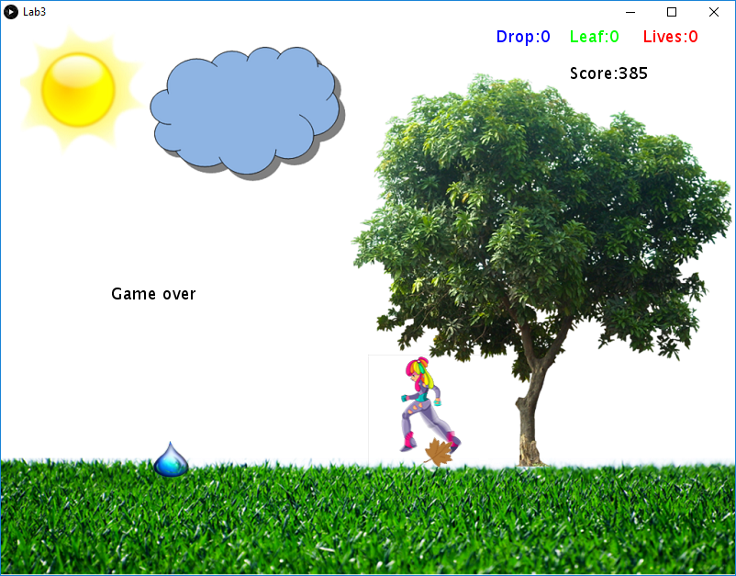

**Figure 13:** Final game with a low score (you could go on and add sound, see later)

**Aside:** Alpha blending

The pixels in the textures contain image information in R,G and B values. In addition, a fourth value known, as alpha is included. This sets the transparency of the pixel. The sprite sheets we used had alpha values equal to zero around there edges so the background would show through. Without alpha blending every sprite would appear as a solid rectangle with a picture on it.

(RGB)*Screen* = (1-A*sprite*)*(RGB)*Background* + (A*Sprite*)*(RGB)*Sprite*

A*= 0 New frame buffer pixel solely the existing frame buffer value*

A*= 1 New frame buffer pixel solely the texture/source buffer value*

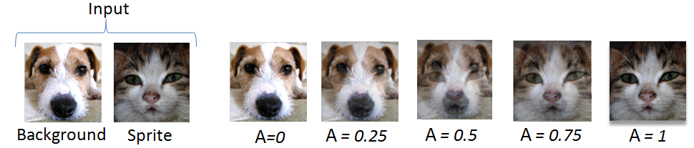

**Figure 14:** Alpha blending values changing from 0 (transparent) to 1 (opaque).

**To Do:** Finally, if you would like to add sound then you will need to add the sound library to Processing (this has not been done on your laboratory machine).

Select Sketch-Import Library-Add Library and select the Minim sound library.

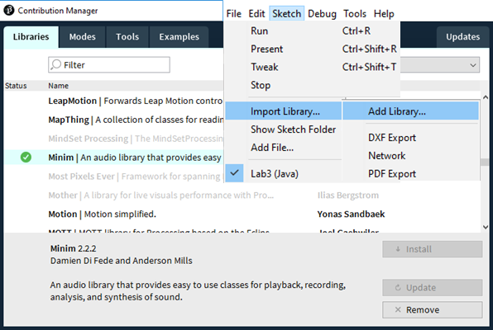

**Figure 15:** Installing the Minim sound library

Assuming there is a file called *music.wav* in the same folder as the Project file *Lab3.pde* then you only need to add the following highlighted code to produce sound.

//SoundFile file;

import ddf.minim.analysis.*;

Add code at start of program

import ddf.minim.*;

Minim       minim;

AudioPlayer jingle;

PImage tex,back,leaf,drop;

...

void **setup**()

{

  size(800,600,P2D);

  // Load a soundfile from the data folder of the sketch and play it back in a loop

  minim = new Minim(this);

  jingle = minim.loadFile("music.wav"); // load the music file into memory

  jingle.loop(); // play the file on a loop

  tex  = loadImage("Running.png");

Add code after size();

You could investigate playing the ‘hit.wav’ file each time a drop or leaf is not caught.

CM/TL/JT Oct 2016

Full listing (for reference)

