From Atmel Data sheet for AT24C256, pages 10-11

So 7 bit device address as shown in figure 1 run from 0x50 to 0x53. Or if we were speaking in terms of the full 8 bits the addr will range from 0xA0 to 0xA7 in pairs – Dev0 (A0,A1) Dev1(A2,A3), Dev2(A4,A5),Dev3(A6,A7), where even is write addr, and odd is read addr (R/W\*).

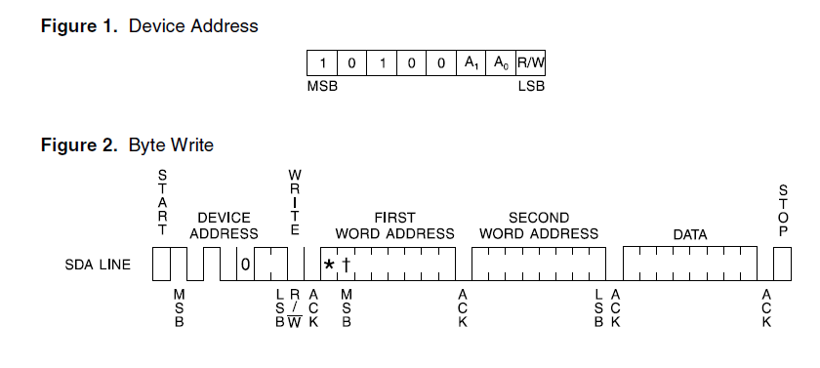

Note: Star is don’t care bit for 256Kbit part, Star and dagger are don’t care bits for 128Kbit part.

