Technical Note,
Updated for version 3.7
March 29, 2007

TRACK – a Code for Beam Dynamics Simulation in Accelerators and Transport Lines with 3D Electric and Magnetic Fields1

P.N. Ostroumov, V.N. Aseev, B. Mustapha
Argonne National Laboratory, Physics Division
E-mail: ostroumov@phy.anl.gov

Argonne National Laboratory, Argonne, IL, U.S.A.

****************************************************************************************************************
SOFTWARE COPYRIGHT NOTIFICATION

****************************************************************************************************************
© COPYRIGHT 2007 UChicago Argonne, LLC

THIS SOFTWARE DISCLOSES MATERIAL PROTECTED UNDER COPYRIGHT LAW AND FURTHER DISSEMINATION IS PROHIBITED WITHOUT PRIOR WRITTEN CONSENT OF THE PATENT COUNSEL OF ARGONNE NATIONAL LABORATORY.

****************************************************************************************************************

ARGONNE NATIONAL LABORATORY, WITH A FACILITY IN THE STATE OF ILLINOIS, IS OWNED BY THE UNITED STATES GOVERNMENT, AND OPERATED BY UCHICAGO ARGONNE, LLC UNDER PROVISION OF A CONTRACT WITH THE DEPARTMENT OF ENERGY.

***************************************************************************************************************

GOVERNMENT LICENSE AND DISCLAIMER

****************************************************************************************************************

NOTICE: This data was produced by UChicago Argonne, LLC under Contract No. DE-AC02-06CH11357 with the Department of Energy. For 5 years from March, 2007, the Government is granted for itself and others acting on its behalf a nonexclusive, paid-up, irrevocable worldwide license in this data to reproduce, prepare derivative works, and perform publicly and display publicly, by or on behalf of the Government. There is provision for the possible extension of the term of this license. Subsequent to that period or any extension granted, the Government is granted for itself and others acting on its behalf a nonexclusive, paid-up, irrevocable worldwide license in this ﻿data to reproduce, prepare derivative works, distribute copies to the public, perform publicly and display publicly, and to permit others to do so. The specific term of the license can be identified by inquiry made to UChicago Argonne, LLC or DOE.

THIS SOFTWARE IS SUPPLIED "AS IS" WITHOUT WARRANTY OF ANY KIND.

Neither the United States GOVERNMENT, nor the United States Department of Energy, NOR uchicago argonne, LLC, nor any of their employees, makes any warranty, express or implied, or assumes any legal liability or responsibility for the accuracy, completeness, or usefulness of any information, data, apparatus, product, or process disclosed, or represents that its use would not infringe privately owned rights.

****************************************************************************************************************

LICENSING INQUIRIES MAY BE DIRECTED TO THE OFFICE OF TECHNOLOGY TRANSFER AT ARGONNE NATIONAL LABORATORY.

Table Of Content

1. Introduction 4
2. Code verification 5
3. Three-dimensional electromagnetic field distribution 5
4. Launching the code MWSread 6
4.1 Input Data 6
4.2 Output Data 9
5. TRACK Input Files 10
5.1 Track.dat 11
5.2 Sclinac.dat 15
5.3 Fi_in.dat 15
5.4 Solenoid.#01: Data file for 1D solenoid field profile 15
5.5 Stripper.#01: Data file for stripper parameters 16
5.6 RFQ.#01: Data file for RFQ parameters. 17
5.7 Graph.cfg: Data file for graphics output. 17
5.8 Maximum size of arrays in the code. 18
6. Beam line elements supported by TRACK 19
6.1 RF devices 19
6.2 Magnetostatic devices 21
6.3 Electrostatic devices 27
6.4 Drift space and other elements of the beamline 29
6.5 Misalignments, errors and beam steering correction 33
7. Launching the code TRACK 38
8. TRACK Output data 38
9. Acknowledgements 42
10. References 43
Appendix 1. Simulation of element misalignments and field errors 44
A1.1 Main Cycle for generation of different accelerator seeds 48
Appendix 2. Optimization of the corrector fileds 50
Appendix 3. Acceptance calculation 54
Appendix 4. Potential expansion in a multi-cell RFQ 55
A4.1 Regular accelerating cells 56
A4.2 Transition cell 57
A4.3 Entrance and exit radial matchers 59
Appendix 5. Particle simulation in dipole magnets 63
A5.1 Structure line for the element “rounded DIPOLE” 67
Appendix 6. Creation of user defined initial distribution. 68
Appendix 7. A short manual for longitudinal corrections using TRACK 70

1. Introduction

The code TRACKv37 for Windows PC simulates beam dynamics of multi-component ion beams in linear accelerators and has the following features:
- multiparticle simulation of multiple component ion beams in 6D phase space;
- 3D electromagnetic fields in rf resonators are obtained with the CST MWS in rectangular mesh;
- Fringing fields of magnets and multipoles are approximated using Enge coefficients as in the RAYTRACE code;
- Realistic fields in solenoids;
- Integration of equations of motion by 4th order Runge-Kutta method;
- Misalignments and random errors;
- Two-dimensional (for dc beams) and three-dimensional space charge calculation. The test runs indicate that the space charge routine works well.
- Calcualtion of first and second order matrices of all elements.

Elements supported by TRACKv35:
- Any type of accelerating resonator with realistic 3D fields.
- Radio Frequency Quadrupole (RFQ) accelerators;
- Soft&hard edge solenoids;
- Bending magnets with the fringing fields;
- Electrostatic and magnetic multipoles (quadrupoles, sextupoles etc. ) with fringing fields;
- Hard edge quadrupoles;
- Multi-harmonic bunchers;
- Axial-symmetric electrostatic lenses;
- Entrance and exit of the HV deck;
- Transverse beam steering “thin” elements;
- Stripping foils&films.(Currently the stripping elements are implememted for the RIA accelerators only.)
- Horizontal & vertical slits.
- Misalignment of bending magnets;
- Automatic multi-component beam center steering in transverse phase space;
- Automatic multi-component beam energy correction to compensate static errors of rf fields.

The following capabilities will be added soon:
- Built-in optimization of envelope matching in transverse and longitudinal phase space in realistic fields of solenoids and rf cavities.
- Combined SC magnet containing solenoid and dipole steering coils with realistic field distribution. This option existed in TRACKv21 but has to be properly incorporated into TRACKv35;
- Beam neutralization (This may be important in the LEBT);

The simulation includes two main steps:
- Preparation of field maps. This step requires extensive use of the code Microwave studio (MWS) and Electromagnetic studio (EMS). The field maps can be also prepared using other codes.
- Prior to the final multi-particle simulation, the elements of the transport system and accelerator must be defined by using first and higher order optimization codes. TRACK can also be used in some cases.
- Tracking of large amount of multi-particles.

2. Code verification
Important Note. This code is constantly being modified and verified. We realize that this manual has significant room for improvement. Please contact us to report any kind of problems encountered while running TRACKv37.

Currently TRACKv37 does not support the following:
- Space charge calculations in the transport system with “hard edge” solenoids, multipoles and bending magnets.
- Space charge of bunched beams in bending magnets.
We have verified TRACKv35 calculations for common types of elements against other simulation codes such as LANA, DYNAMION and ELEGANT. The transport element calculations with fringing fields have been verified using the codes COSY, GIOS and TRANSPORT.
Depending on the complexity of the task, TRACKv35 can compile up to a total of 10⁶ particles on a regular desktop PC. For 10⁴ particles of the 200 driver linacs of RIA, it takes about 70 hours using a 1.7GHz processor speed. (This is more than 1200 elements including ~400 rf resonators and 16 bending magnets.) The multiprocessor version of the TRACKv35 simulates 10⁶ particles for ~360 linacs with randomly seeded errors.

3. Three-dimensional electromagnetic field distribution

3D electromagnetic fields of resonators are extracted from CST MWS (or any other electrodynamics code) as ASCII files field_e.txt, field_h.txt. For example, MWS can extract 3D fields in the meshes of the aperture area as a Microsoft EXCEL *.xls files. The EXCEL file should be saved as a MS DOS txt file field_e.txt or field_h.txt. In TRACKv35, the transport of a charged particle is described by the equation of motion:

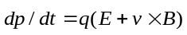,
(1)
where is the particle momentum and q is its charge, 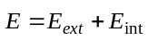 and 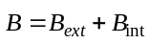 are the sums of the external and internal electric and magnetic fields, is the particle velocity. TRACKv35 integrates the equations of motion of all the tracked particles for a short distance and calculates the space charge fields. In TRACKv35, particle motion through each ion-optical device can generally be described in three different Cartesian coordinate systems(CCS). Two CCS correspond to the entrance and exit of each ion-optical element. The third CCS is used for the definition of the electromagnetic field distribution in the element as is seen from Fig.A5-1 (Appendix 5). Depending on the geometry and the type of element, external fields in the code can be defined using any of the following formats:
1. Three-dimensional tables of the fields and in the element’s CCS which are generated with the help of external codes. For calculation of the field value at the particle location, a quadratic interpolation routine is used.
2. Two-dimensional tables in the (r,z)plane for elements with axial symmetry such as solenoids or Einzel lenses. These elements can be also described by 3D fields.
3. Two dimensional tables of the B_{y} component of the magnetic field in the median plane {x,z} for rectangular dipole magnets. The off-median component B_{y} and components B_{x} and B_{z} are evaluated using the method described in ref. 4 of Appendix 5.
4. The fringe field falloff for dipole and multipole elements is described by a six-parameter Enge function [see ref. 5-6 in Appendix 5]:
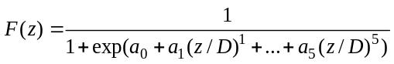
where z is the distance along the line which is perpendicular to the effective field boundary, D is the full air-gap of the element.

4. Launching the code MWSread

The code MWSread.exe is a result of significant modifications of the code TRANFORM.EXE. The latter has been written to support earlier versions of the TRACKv35. Both the codes TRACKv37.exe and MWSread.exe must be compiled with equal number of meshpoints NXmax, NYmax, NZmax. Typical numbers are NXmax= Nymax=25 and NZmax=201. The latter can be a larger number if necessary. The code MWSread.exe performs the following:
a) Reads ASCII files produced by EM codes in the region of beam-device interaction. If spatial symmetry conditions are applicable for the field calculations in the EM and MWS codes, use them. For the best accuracy of simulations, meshpoints in the beam-device interaction area of the EM or MWS model should be larger than NXmax, NYmax, NZmax. However, the code accepts lower number of mesh-points too.
b) Interpolates the field in order to produce Ex,Ey,Ez,Hx,Hy,Hz fields on regular mesh to be used by TRACKv35. The output field file is named as eh_MWS.#01 for RF devices or eh_EMS.#01 for static devices. They are unformatted binary FORTRAN files.
c) Code MWSread.exe produces four auxiliary output files: output.dat, egarm.dat, bgarm.dat and check_field.dat.

For each device one should have three (for static electric or magnetic device) or four (for electromagnetic and static combined field devices) files in the same directory: MWSread.exe, input.dat and two ASCII-files of electric and magnetic fields for RF or static electromagnetic devices or ASCII-file of electric field for electrostatic device or ASCII-file of magnetic field for magnetostatic device. Make a separate directory for each device. This directory consists of the executable file MWSread.exe which should be run prior to the code TRACKv35.EXE.
Launch the code MWSread.exe.

4.1 Input Data

Note: 1) The file input.dat prepared for the code transform.exe (previous version of MWSread.exe) is compatible with MWSread.exe only for RF cavities.
2) In the earlier versions of TRACK (earlier than version 34), the ‘TRACK+TRANSFORM’ array for electrostatic devices was generated assuming artificial zero magnetic field array. An artificial zero electric field array was generated for magnetostatic devices. The full geometry of the device without any spatial symmetry had to be defined. Only under these restrictions, static field files eh_EMS.#** created by transform.exe are compatible with any version of the TRACK code.
3) It is recommended to redefine all field files generated by the file transform.exe for static devices.

The file input.dat contains a string namelist/fasa/. The namelist variables are listed below.
field defines the type of the device field.
Field = ‘rf’ stands for RF fields (default value)
’eh’ stands for static electromagnetic field
’e’ stands for static electric field
‘h’ stands for static magnetic field.
symmetry defines an electromagnetic symmetry of fields.
symmetry = ’rf’ for RF cavities(default value)
’dipole’ for rectangular dipole magnet with symmetry w.r.t. XZ coordinate plane
’axial’ for devices with axial symmetry w.r.t. Z-axis.
’quad’ for devices with quadrupole symmetry w.r.t. Z-axis.
’nosym’ means the lack of any spatial symmetry of the fields.

file_MWS_e and file_MWS_h are the file names for input ASCII files of electric and magnetic fields. It can be any name allowed by FORTRAN. For example: E.fld, H.fld, einzel_from_opera.dat, eRF.MWS, efild.txt etc.

RF electromagnetic fields:
file_MWS_e= file name of the ASCII file for electric field
file_MWS_h= file name of the ASCII file for magnetic field

Electrostatic field:
file_MWS_e= file name of the ASCII file for electric field
file_MWS_h= ’empty’ (default, optional)

Magnetostatic field:
file_MWS_e=’empty’ (default, optional)
file_MWS_h= file name of the ASCII file for magnetic field

d_device – the length of the device, d, the field extension along the z-axis.
z_device – (default value is =0) z-coordinate of the device field CCS w.r.t. the CCS of external 3D-field code, see Fig xxx.
aperture = device half-width a in x and y directions.

key_1_e defines symmetry w.r.t. YZ coordinate plane w.r.t. both the device CCS and 3D-field code CCS.
key_2_e defines symmetry w.r.t. XZ coordinate plane w.r.t. both the device CCS and 3D-field code CCS.
key_3_e defines symmetry w.r.t. XY plane only when origins of the device CCS and 3D-field code CCS are the same,i.e. z_device=0. For z_device≠0 key_3_e must be equal to 0.
key_1_e, key_2_e, key_3_e =1, there is symmetry.
key_1_e, key_2_e, key_3_e =0, there is no symmetry.

te00 – defines field level of the RF device or inter-electrode voltage for the electrostatic devices
freqb[Hz]= operating frequency of the given type of RF cavities.
CFE =(-1 or +1), defines the sign of the electric field.
CFH =(-1 or +1), defines the sign of the magnetic field. CFE and CFH are the amplitudes of the RF electric and magnetic fields respectively, which extracted from the external 3D-field electromagnetic code output.

The signs of the electric and magnetic field amplitudes are defined from the time dependence of the RF fields and can be different in different electromagnetic codes. In TRACKv35 all RF-fields have the following time dependence:
,
where φ₀–is an initial phase. From Maxwell equation 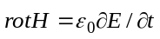 one can find:
.
For the circle with the radius r≤0.5R_{aperture} (perpendicular to the cavity z-axes), one can find eds=e_{z}(r,θ,z)rdrdθ ≅ e_{z}(0,0,z)rdrdθ and hdl=h_{θ}rdθ therefore
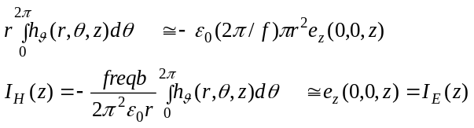
The electric field amplitude will be multiplied by CFE*te00 in the MWSread.exe code. Similarly, magnetic field is multiplied by CFH*te00. Both functions I_{H}(z) and I_{E}(z) are evaluated for RF cavities and z, I_{H}(z) and I_{E}(z) are extracted in the file check_field.dat. The code MWSread.exe compares functions I_{H}(z) and I_{E}(z) and will ask to define necessary sign of electric or magnetic field using the parameters CFE and CFH if initial CFE and CFH are wrong. It can be necessary to change the sign either CFE or CFH.
Example of output information on the PC screen and in the output.dat file:
CFE=1, CFH=-1
Warning: CFE and CFH are inappropriate.
Please insert new CFE and CFH and press enter
-1 -1 or
1 1 are possible answers.
It is very useful to plot and compare functions I_{H}(z) and I_{E}(z).

Note: for the RF cavity with negligible magnetic field copy e_field.dat to h_field.dat and use CFE=1,CFH=0. Ignore the warning about CFE and CFH and insert 1 and 0 for CFE, CFH one more time.

Running MWSread.exe with different set of parameters d_device and z_device one can divide 3D-field table into several zones. This feature is useful for representation of the fringing fields. Another reason could be to insert long devices as separate zones.
Ncells ≥1 (optional for MWSread.exe)→ virtual number of “cells”, have been used in transform.exe.
Abeta (optional) → virtual beta, has been used in transform.exe.
Three parameters freqb, Ncells and abeta have been used in the old code for calculation purpose only.

d_device =0.5* abeta *c_light* ncells/freqb.

In MWSread.exe parameters Ncells and abeta are also available but parameter d_device is more convenient for defining the extension of the field distribution along the z-axis.

Variables NCAV, atp, ztp, targ, drft, tt0 are optional and included in Input.dat file only for compatibility with previous version transform.exe.
r_fourier (=0.5 by default) the relative radius for Fourier analysis of the fields at r=r_fourier*aperture
Parameters iread (=0, default value), iprint (=0, default value),Vf and Bf are used to analyze the properties of the field distribution obtained by the external 3D-codes for the devices defined in sclinac.dat.

iread =0 the files eh_MWS.#01 or eh_EMS.#01 are created.
iread =n old files eh_MWS.#n or eh_EMS.#n are read and analyzed.
Vf amplitude of the electric field.
Bf amplitude of the magnetic field.
iprint=1 ASCII files with electric and magnetic fields on
the uniform-mesh spatial grid of the TRACk code are extracted.

4.2 Output Data

The code MWSread.exe produces binary eh_MWS.#01 file for the RF devices or eh_EMS.#01 file for the static devices. The following line must be inserted into the sclinac.dat file to represent a device with realistic 3D field distributions:
n elem … d_elem … te00 ... rap … for RF devices
n elem … d_elem … Bf ... rap … for magnetostatic devices
n elem … d_elem … Vf ... rap … for electrostatic devices
n elem … d_elem … Bf,Vf ... rap … for static devices

where
n -is the number of file containing the field tables (consistent with the extension of the file eh_MWS.#xx).
elem –is the name of the element( cav,eq3d, enzl …)
d_elem length of the device
te00,Bf,Vf amplitudes of the field.
The binary file eh_MWS.#01 produced by the code MWSread.exe eh_MWS.#01 must be renamed to
eh_MWS.#0n if 0<n<9
eh_MWS.#n if 10<n<99
Examples: 5 cav .. eh_MWS.#01 -> eh_MWS.#05
13 cav .. eh_MWS.#01 -> eh_MWS.#13
96 eq3d .. eh_EMS.#01 -> eh_EMS.#96
1 eq3d .. eh_EMS.#01 -> eh_EMS.#01
The code MWSread.exe produces check_field.dat for the set of mesh-points z_{i}_{0≤z_{i}≤d_device}
if symmetry=’rf’ , then z_{i,} I_{H}(z_{i}), I_{E}(z_{i});
if symmetry =’axial’ , then z_{i,} V(z_{i}) ,where V is the normalized voltage along Z- axis for axially symmetric electrostatic fields;
if symmetry =’axial’ , then z_{i,} B_{z}(z_{i}), B_{hard}(z_{i}), where B_{z}(z_{i}) is the normalized
z-component of the magnetic field B_{z}(z_{i}), for axially symmetric magnetostatic fields.

Typical set of parameters in input.dat for RF cavity:
& freqb = 100d6,
cfe=1,cfh=-1,te00=0.9,
d_device=50. ,aperture=1. ,
file_MWS_e=’e.txt’ , file_MWS_h=’h.txt’ ,
key_1_e=1, key_2_e=1, key_3_e=0
& end
Typical set of parameters for solenoid:
& symmetry=’axial’
d_device=50. ,aperture=1.
file_MWS_h=’solenoid.txt’
key_1_e=1, key_2_e=1, key_3_e=1
& end
Typical set of parameters for electrostatic quad:
& symmetry=’quad’
te00=1
d_device=20. ,aperture=3.
file_MWS_e=’equad.txt’ ,
key_1_e=0, key_2_e=0, key_3_e=0
& end
Typical set of parameters for Einzel lens:
& symmetry=’axial’
te00=1
d_device=10. ,aperture=0.5
file_MWS_e=’e.txt’
key_1_e=0, key_2_e=0, key_3_e=1
& end

5. TRACK Input Files

The simulation is performed in right-handed Cartesian coordinate system.
Y
Z
Z is the direction of the beam propagation.
X

To run this code the following files must be copied to a designated directory:

TRACKv37.exe = simulation code
fi_in.dat = has the input “synchronous” phases of all SRF cavities
Track.dat = contains general input parameters of the beam and linac
sclinac.dat = file containing geometry of the Linac (focusing, accelerating structure and other elements)
graph.cfg = input file to support on-line Windows graphs.
cavity.#01 = for the first type of cavity (not needed if iflag_cav=1), in recent simulations using TRACKv35.exe we do not use this file.
eh_MWS.#01 = for the first type of cavity. If sclinac.dat contains more types of cavities all files with appropriate extensions should exist.
solenoid.#01 = if isol=1 (file of realistic field distribution in the solenoid)
deck.#01 = transition to/from HV deck, axial symmetric lens.
RFQ.#01 = RFQ data.
MHBrz.#01 = field distribution in rf buncher (2-gap resonator, can operate at 2 frequencies simultaneously)
stripper.#01 = stripper data.

The number in the file extension corresponds to the successive number of similar elements along the linac.

5.1 Track.dat

The input data is defined using the FORTARN statement ‘namelist’.

namelist /TRAN/ Win,atp,freqb,sfas,serf,npat
& ,nqtot,part,qq,epsnx,alphx,betx,epsny,alphy,bety,DEESRF
& ,epsnz,alphz,betz,aper,x00,xp00,y00,yp00,ph00,dww00,phi0
& ,disp,dcav,phmax,dwwmax,db_b,Qavr,df_4D,Qdesign, Adesign
& ,current,amass,dWWacc
& ,n_tp,n_tt,ncells,np_set

The input file consists of the following data (this is an example of simulation of the whole RIA driver linac from 0.19 MeV/u to 400 MeV/u):

&TRAN
table_dir=' c:\BASELINE_2005\FIELDS\ '
work_dir = ' '
Win =0.19d06, atp =238.D0,
nqtot=2, qq=28.,29., npat=500000,500000
Qavr=28.5, Adesign=238, Qdesign=28.5
Amass=238,238
Current=0,0
freqb =57.5D06, part = 0.95
epsnz =25.D0, alphz = 0.6D0, betz =4,
epsnx = 0.06, alphx =1., betx =60.,
epsny = 0.06, alphy =1., bety=60.,
phmax=90., dwwmax=20., dwwacc=0.1
x00=0.,0., xp00=0.,0., y00=0.,0., yp00=0.,0., ph00=-0.,0., dww00=0.
&end

Line
table_dir=' c:\BASELINE_2005\FIELDS\ '
is given as an example. This line shows the directory where all files are located with the tables of device fields. All files with the extension .#xx are located in this directory. There is no need to copy these files into the directory where the input files with the extension .dat and TRACKv35.exe are located.
This line
work_dir = ' '
will serve similar function as table_dir for the output files. Will be modified in future.

WIN [eV/u]= input beam energy.
atp = mass number.
nqtot= number of different ion species.
qq(1:nqtot)[Q/e]- charge state of each species.
npat(1:nqtot) - number of macro-particles with given q/A. If beam current is not equal to zero, final adjustment of the number of particles takes place in the code: each multi-particle will carry the same charge for the space charge calculation routines.
np_set - number of particles in each charge state for the accelerator reference setting. This setting is required if the flag iflag_corr=1 and the steering correction is activated. The steering correction of the beam centroid in transverse phase space is required to avoid emittance growth of multi-q beams and minimize the coherent oscillations in the transverse phase space. To search for optimum fields in the correctors several complete runs of the linac must be done. To run for this optimization procedure the setting of the linac must be defined.
Qavr - average charge state, it is used for 2-charge state injecton Qavr~0.5*(qq(1)+qq(2)). This parameter is effective upstream of the RFQ, in the LEBT.
Adesign – mass number of the design particle for the accelerator or transport system.
Qdesign – charge state of the design particle for the accelerator or transport system.
Amass(1:nqtot)- ion mass number, useful for simulation of various masses exiting the ion source.
Freqb( Hz),- fundamental frequency of the incoming beam. All rf resonators frequencies are set with respect to freqb using a harmonic number. This number can be an integer or a non-integer. For dc beams one can use the frequency of the first rf device located downstream of the ion source.
current(1:nqtot)-[mA] electrical current of each heavy ion beam component.
part <=1 for calculation of emittances of beam, containing >'part' particles with respect to the total number of survived particles.

df_4D – phase width (+/-) of the initial 4-dimensional distribution (dc beam) if the flag iflag2D=1 is used.
epsnx,alphx,betx¦ [cm*mrad] , [unitless] [cm/rad]→ initial transverse
epsny,alphy,bety¦ parameters of beam, emittance is total and normalized.

epsnz,alphz,betz [deg*%] ,[unitless] , [deg/%]→ initial longitudinal parameters of beam, degrees at frequency freqb. epsnx, epsny are the full normalized emittances in pi*cm*mrad. epsnz is the longitudinal emittance in dW/W(%) and phase (degree of freqb) of current frequency freqb (this emittance is not invariant). Currently in TRACKv35 we generate 4D or 6D water bag distributions. In this case 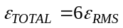 for the 4D Waterbag and 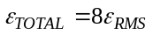 for the 6D Waterbag.

phmax - is calculated using subroutine PHASSET

dwwmax - [%],amplitude of energy spread of the initial distribution for the acceptance calculation.
Dwwacc – [%], ΔW/W for the acceptance calculations, if particle energy is lower than dwwacc then this particle will be treated as an unaccelerated particle.
x00 (1:nqtot)[cm] - initial displacement of center of the beam
xp00 (1:nqtot)[mrad] - at entrance of accelerator for each
y00 (1:nqtot)[cm] - charge state
yp00 (1:nqtot)[mrad]- *----*
ph00 (1:nqtot)[deg]- *----*
Dww00(1:nqtot)[%]- *----*

db_b - delta_beta/beta for dc beam exiting ion source.

DEESRF – the relative range (like 0.2, for example, which corresponds to ±20% field deviation from the design field) of SC cavity field with respect to the average design value. This feature can be activated to study beam evolution along the linac with different level of fields in the SC resonators. The field level in the resonators is generated using uniform random distribution within ±DEESRF.

The track.dat file has a section with integer values and flags:

namelist /INDEX/ isol,lstep,iaccep,iaxial,NRZ,igraph,isrf
&,iflag_lev,IINT,iflag_env,iflag_cav,iflag_ell,nstep_cav
&,iflag_bc,iflag_dis,iflag_qq,iflag2D,iflag_fenv
&,iflag_mhb,iflag_upd,iflag_rms,iflag_tac,iflag_halo,iflag_corr
&,iwrite_dis,iread_dis,iRIARFQ,nrz_min
This is the example of the integer parameter list in the track.dat file:

&INDEX
NRZ=1, igraph=1, iaccep=0, isol=1, iflag_dis=0,iflag2D=0,iflag_qq=1,
iflag_rms=1, iint=100, nstep_cav=50
iflag_env=1, iflag_cav=1, iflag_ell=0, iflag_fenv=0
iflag_upd=0, iflag_halo=0, iflag_lev=1, isrf=100
iwrite_dis=1, iRIARFQ=0,iflag_corr=0
&END

The parameters given below are shown with default values.

NRZ=1 - number of seeds for error and misalignment simulations, for single simulations NRZ=1. If NRZ not equal 1 use igraph=0 just to save CPU time. The graphs are not completely supported for NRZ≠1.
igraph=1 – show graphs on PC screen, =0 no graphic output
iaccep=0 – if 1 the longitudinal acceptance is calculated. See details in Appendix 3.
isol=0 - 1-realistic fields, 0-rectangular model. If isol=1 the code TRACKv35.exe will search for ASCII data file solenoid.#01 with the distribution of axial symmetric magnetic field along z. If solenoid is defined with 3d-field distribution and element ‘sol3d’ then the parameter isol is ignored.
ISRF=0 - the seed of the random number generator ISRF must be in the range (0, 2147483646). If ISRF is zero, a value is computed using the system clock; and, hence, the result of the program using the IMSL random number generators will be different at different times.
IINT=50 - number of steps for Runge-Kutta integrator which is applied for drift spaces and solenoids.
iflag2D=1 starts with DC beam and calculates only 2D electric fields due to
space charge, in z direction space charge field is equal to 0.
iflag_qq=1 will show phase space plots for indicated ion species or charge state of given ion species.
iflag_env=1 number of graphical outputs along one element (if ≠1 it is not supported in all elements)
iflag_fenv=1 extracts rms phase [deg] on the PC screen(shown in green color). Check vertical scale to see the curve.
iflag_cav=1 RK integration in the accelerating cavities, 0 – use iterative method (as in the LANA code). Do not use 0 – it is obsolete.
iflag_ell=1 Draw ellipses on the PC screen,if =0 do not draw ellipses.
nstep_cav=50 number of steps for RK integrator in the rf cavity.
iflag_dis=1 6D waterbag distribution,if =0 is a 4D waterbag distribution
iflag_upd=0 - this is an internal flag, not to be used.
iflag_rms=1 Show rms envelopes on the PC screen, =0 do not show rms envelopes
iflag_tac=0, Do not calculate transverse acceptance, if =1 calculate transverse acceptance. See details in Appendix 3.
iflag_halo=0 if =1, generates and simulates halo particles after the stripper #2. This feature is not ready to be used.
iflag_mhb=0 MHB is calculated on the base of 3d table
iflag_bc=0 phase setting is not adjusted for average bunch center before the each cavity. It is important that for the acceptance calculations iflag_bc must be 0.
iflag_lev=0 → do not calculate N/N0(relative beam intensity) as a function of emittance(f(є)). If this parameter =1, then N/N0 as f(є) is reduced to the rms emittance for xx’,yy’ and the{ϕ - ∆W/W}-planes will be extracted in the file level.dat. Use this flag with element ‘prmtr’ to extract ‘emittance distribution’ in given location along the structure.
iwrite_dis=1 - writes unformatted data file read_dis.dat of the particle distribution at the end of simulation (at the end of last element in sclinac.dat file) for future use as an initial distribution.
iread_dis=1 - reads file read_dis.dat of the particle distribution and starts simulation with this distribution ignoring generation of the initial distribution. Use this flag to read custom formed initial distribution (see Appendix 6).
iflag_corr=1 - Calls beam centroid steering subroutine to find corrector strength (see Appendix 7). iflag_corr =-1 is required to start simulations for many seeds. In addition see Appendix 1 to set up the simulations of errors and misalignments.
IRIARFQ=0 - simulates single or multiple charge state beam within 360° of the RFQ frequency (inside one bucket). This option is not valid for simulation of two charge-state beam with space charge as for RIA RFQ. If IRIARFQ=1, then simulation takes place within 720° and 2 neighboring buckets can be populated with different charge states (or the same charge state). Use IRIARFQ=1, to simulate RIA driver linac RFQ in two-charge state mode with MHB and velocity equalizer.
The following values are set by default in the TRACKv35 code:
isol=0
iaccep=0
i_step=0 index for the array of central trajectory in the bending magnet,
it is used for the space charge calculations
isrf=0
part=0.
db_b=0.
Qdesign=28.5
Adesign=238.
nstep=100 This parameter depends on space charge calculations
and it is better to define the integration step for each device in the structure file sclinac.dat.

nstep_cav=50 !Number of integration steps in resonators.

5.2 Sclinac.dat
The file sclinac.dat defines the following elements of the accelerating-focusing channel or transport line. Each element in the TRACK code has own ID:
c i_device=0 ! no device assigned
c i_device=1 !*DRIFT *!
c i_device=2 !*SOLENOID*,*HARD-EDGE SOLENOID*!!
c i_device=3 !*Bending Magnet*!
c i_device=4 !*QUAD **HARD-EDGE QUAD*!
c i_device=5 !*BUNCHER*!
c i_device=6 !*CAVITY *!
c i_device=7 !*CORR*!
c i_device=8 !*MULTIPOLE*!
c i_device=9 !*RFQ*!
c i_device=10 !*MHB*!
c i_device=11 !*HV DECK*!
c i_device=12 !*SLIT*!
c i_device=13 !*FHIDE*!
c i_device=14 !*MONITOR*!
c i_device=15 !*EQUAD3D*! electrostatic quadrupole with 3D mesh from EM Studio
c i_device=16 !*EINZEL*! electrostatic lens with 3D mesh from EM Studio
c i_device=17 !*EQUAD*! electrostatic quadrupole
c i_device=18 !*SOL3D *! solenoid with 3D mesh from EM Studio
c i_device=19 !*cdump*! This marker defines correction section boundaries
c i_device=21 !*extrc*! A device with 3D electrostaic field
c i_device=22 !*UDS*! User Defined structure (multi-gap resonator like DTL )
c i_device=23 !*shrt*!
c i_device=24 !*strip*! STRIPPER
c i_device=25 !*EH3D*! static field (combined electric and magnetic field)

5.3 Fi_in.dat
The file fi_in.dat for the TRACKv35.exe must be generated manually and it contains the phase angle with respect to the maximum energy gain in a given resonator.It should be negative for stable longitudinal motion. For the bunch rotator the phase is –90 deg (or close to this number,and can be adjusted using simulated results, for example, to keep average beam energy unchanged). For a chain of similar accelerating resonators the phase angle is practically equal to the synchronous phase. As soon as one runs TRACKv35.exe, the code produces file linac.dat which combines sclinac.dat and fi_in.dat files. Using the data in file linac.dat, one can check the final phases assigned to each resonator.

5.4 Solenoid.#01: Data file for 1D solenoid field profile

This file has been used together with element sol and the flag isol=1 before the development of the element sol3d. The number in the file extension corresponds to the successive number of solenoids along the linac. If in track.dat the parameter isol=1, then TRACKv35.exe will search for ASCII data file solenoid.#01 with the distribution of axial symmetric magnetic field along z. Below is the typical field distribution of a solenoid with bucking coils. The first line is the number of mesh-points. The total length of the solenoid L_{S} is given in sclinac.dat file. The distribution is applied to this length L_{S.} This distribution should be smooth enough in order to avoid irregularities in higher order derivatives otherwise it can result in non-physical field distribution and emittance growth. The solenoid field map is calculated using 4th order derivatives.
37
-0.014143283
-0.025661771
-0.040576367
-0.054855518
-0.056903368
-0.027229919
0.053280013
0.191001852
0.369154663
0.547779134
0.692967978
0.798030467
0.870633884
0.920061736
0.953459121
0.975653094
0.98971838
0.99750644
1.000000009
0.99750644
0.98971838
0.975653094
0.953459121
0.920061736
0.870633884
0.798030467
0.692967978
0.547779134
0.369154663
0.191001852
0.053280013
-0.027229919
-0.056903368
-0.054855518
-0.040576367
-0.025661771
-0.014143283

5.5 Stripper.#01: Data file for stripper parameters

In addition to the stripper description in the sclinac.dat file there is a file stripper.#01 (the number in the file extension corresponds to the successive number of similar elements along the linac). Below is the typical stripper file. First line: number of charge states after the stripper. Second line charge states, the first charge state will be used as a reference charge state for the phase setting in the resonators. The third line: percentage of particles at corresponding charge states. The total percentage is 100.
The fourth line is equal to the second line (this line will be used in future).
The last line is the kinetic energy per nucleon after the stripper [keV/u].

5
72. 70. 71. 73. 74.
0.3 0.15 0.2 0.2 0.15
72. 70. 71. 73. 74.
10000.

5.6 RFQ.#01: Data file for RFQ parameters.

This is an ASCII file with the RFQ parameters on the base of a 2-term potential expansion. These parameters must be produced by RFQ optimization codes such as DESRFQ or some other code. It is important that the accelerating and focusing parameters are determined with the actual shape of vane modulations. The total number of RFQ accelerating cells nRFQ is given in the element “RFQ”. The format for reading is:
read (1,*)(bRFQ(i),tRFQ(i),xRFQ(i),aRFQ(i),dRFQ(i),indRFQ(i),i=1,nRFQ)

There are 6 columns, the definitions corresponding to those in the original Kapchinsky-Teplyakov paper.
1: beta at the exit of the cell, this column is used just for reference, does not effect on beam parameters.
2: Parameter teta as is defined by Kapchinsky and teta=π*A/4, where A is the accelerating efficiency defined by the LANL group.
3: Kappa;
4: Aperture radius [cm];
5: length of the accelerating cell [cm];
6: index, equal to 0 if the cell is of regular length βλ/2 otherwise =1.

5.7 Graph.cfg: Data file for graphics output.

The lines in this file are self-explanatory. In case of any doubts, just run TRACKv35.exe to identify the parameters of the graphics. Do not change the integer arrays. The graphics are not perfect: if particles are outside the graph boundary, they will be shown with “wrong” coordinates. In case of the RFQ, the particles are “filtered” by energy before sending for graphics.

&WINS
title = ' Superconducting Linac '
ix(1) = 114, iy(1) = 32, jx(1) = 322, jy(1) = 240, lx(1) = 4, ly(1) = 8,
xmin(1)= -1. , xmax(1)= 1. , ymin(1)= -0.01, ymax(1)= 0.01,

ix(2) = 394, iy(2) = 32, jx(2) = 602, jy(2) = 240, lx(2) = 4, ly(2) = 8,
xmin(2)= -1. , xmax(2)= 1. , ymin(2)= -0.01, ymax(2)= 0.01,

ix(3) = 674, iy(3) = 32, jx(3) = 882, jy(3) = 240, lx(3) = 4, ly(3) = 8,
xmin(3)= -30., xmax(3)=30., ymin(3)= -0.01, ymax(3)= 0.01,

ix(4) = 75, jx(4) = 950, iy(4) = 399, jy(4) = 599, lx(4) = 1, ly(4) = 5,
xmin(4) = 0., xmax(4) = 30000., ymin(4) = 0., ymax(4) =1.5
&end

5.8 Maximum size of arrays in the code.

Maximum possible numbers for the arrays in the TRACKv35 are given in FORTRAN
Data file in the code. Depending on the code application and hardware parameters, the code can be compiled for different mesh size, number of macroparticles and number of ion species.
& NXmax=25 , NYmax=25 , NZmax=201 ! grid for dist. of field in rect reg.
&, KSTEPR= 8,JSTEPA= 16 ,LSTEPZ= 48 !max number of grids for field distribution of axial-symmetric electromagnetic field of resonators.
&, PI= 3.141592653589793d0 ! [rad]
&, PIOVHR= PI/180d0 ! [rad/ø]
&, HROVPI= 180d0/PI ! [rad/ø]
&, CC= 2.99792458d10 ! [cm/sec]
&, C_light= 2.99792458d8 ! [m/sec]
&, EPS0= 1/(4.d0*PI*1.d-9*CC**2) ! [F/cm]
&, EE= 4.803242d-10 ! [CGSe]
&, EV= 1.60217733d-12 ! [erg/eV]
&, AMU= 931.49432d6 ! amu [eV]
&, W0= 1.0073*amu ! proton rest mass [eV]
&, emass= 510.079 ! electron rest mass [KeV]
&, ch_to_m=3.2184034535d-3 ! [C*sec/kg] = [1/T]
&, mu0=4d0*pi*1d-7 ! [T/(A/m)]
&, twopi=2d0*pi ! [rad]
&, tovpi=2d0/pi ! [rad]
&, degrad=pi/180d0 ! [rad/deg]
&, ngridx=32, ngridy=32, ngridz=64, nm3=16, nm5=33 !For Space Charge field mesh.
&, MNtot = 100000 ! maximum number of particles of each type.
&, Melem = 2000 ! maximum number of elements (drifts, magnets...)
&, MQtot = 20 ! total number of charges (masses)
&, CRO=4d0*pi**2/3.13d10) ! [1/milliamper], for space charge calculation

& NXmax=25 , NYmax=25 , NZmax=201 ! grid for dist. of field in rect reg.
! Attention: For simulation of long DTLs use NZmax=801 for compiling files
! This requires appropriate generation of field files by transform.exe
&, maxNseed=200 ! max number of seeds
&, maxNCorr = 150, maxNMon = 100 ! max number of correctors and monitors
&, maxNSection = 30 ! max number of correction sections.
&, Nbuf=200000 ! max number of buffer size for graphics, can be suspended for non-graph option
&, PI= 3.141592653589793d0 ! [rad]
&, PIOVHR= PI/180d0 ! [rad/deg]
&, HROVPI= 180d0/PI ! [rad/deg]
&, CC= 2.99792458d10 ! [cm/sec]
&, C_light= 2.99792458d8 ! [m/sec]
&, EPS0= 1/(4.d0*PI*1.d-9*CC**2) ! [F/cm]
&, EE= 4.803242d-10 ! [CGSe]
&, EV= 1.60217733d-12 ! [erg/eV]
&, AMU= 931.49432d6 ! amu [eV]
&, W0= 1.0073*amu ! proton rest mass [eV]
&, emass= 510.079 ! electron rest mass [KeV]
&, ch_to_m=3.2184034535d-3 ! [C*sec/kg*(m/cm)] = [1/(T*cm)]
&, mu0=4d0*pi*1d-7 ! [T/(A/m)]
&, twopi=2d0*pi ! [rad]
&, tovpi=2d0/pi ! [rad]
&, degrad=pi/180d0 ! [rad/deg]
&, ngridx=32, ngridy=32, ngridz=64 !For space charge field grid
&, nm3=16, nm5=33 !nm=max(nx,ny,nz/2) nm3=nm/2,nm5=nm+1,For SC grid
&, MNtot = 250000 ! maximum number of particles
&, Melem = 2000 ! maximum number of elements (drifts, magnets...)
&, m_cell=15 ! total number of cells in the cavity
&, maxn_tp=99 ! number of different cavity types
&, MQtot = 5 ! total number of charges (masses)
&, nm_halo = 10000 ) ! max number of halo particle generator,

Attention: For simulation of long DTLs with large number of accelerating cells (more than 10) use NZmax=801 for compiling TRACKv35.exe. This requires appropriate generation of field files by MWSread.exe. The same mesh number along the z-axis must be used in the code MWSread.exe during the compiling. Depending on PC memory the code TRACKv35.exe can be compiled with required dimensions of the arrays.

6. Beam line elements supported by TRACK

6.1 RF devices

*Accelerating Cavity*

n cav d_elem harm TE00 any nstep(optional)
n type of cavity: each type of cavity must have field files with
the name eh_EMS.#**.
d_elem [cm] total length of cavity
harm harmonic number of cavity with respect to the fundamental
beam frequency freqb defined in the TRACK.dat file
TE00 field level of cavity. This parameter is equivalent to the
parameter TE00 in the input.dat file for MWSread.exe. If used in the sclinac.dat file it can define the field level in a particular resonator.
any no longer in use in TRACKv35. In previous versions it meant shift of the cavity in vertical direction. Use shift device for this purpose.
nstep (optional)number of steps for integration of the cavity. If it is voided, then nstep = nstep_cav given from TRACK.dat.

Misalignment errors of cavity displacement in transverse directions and static and dynamic errors of the RF phase and amplitude are defined by the device ‘align’.

Example:
5 cav 43.79542 3. 1.0 0.0 here nstep=nstep_cav
5 cav 43.79542 3. 1.0 0.0 500 here nstep=500

*Multi-Cell RFQ*

ncells rfq Vf d_elem R0RFQ RFQ_ph0 harm nstep n ncoef
ncells number of βλ/2-length cells in the RFQ
Vf [kV] Inter-vane Voltage
d_elem [cm] total length of the RFQ
R0RFQ [cm] average radius
RFQ_ph0 [deg] Phase of the RFQ field with respect to the incoming pre-bunched beam.
harm harmonic number of the RFQ cavity with respect to the
freqb defined in the track.dat file.
nstep number of steps for integration per cell (d_{cell} =0.5βλ), were
λ=c/(harm*freqb)is current RF wave length and βc – is velocity
of the reference particle
n (=1 by default,optional) number of the extension of the file
with name rfq.#n
ncoef (ncoef=2 by default, optional)number of field coefficient in Fourier-Bessel expansion of the filed in RFQ cell.
Examples:
1) Two coefficients field distribution. Input file is rfq.#1
138 rfq 68.47 394.3084938 0.6 90. 2. 50

1) Eight coefficients field distribution. Input file is rfq.#5
138 rfq 68.47 394.3084938 0.6 90. 2. 50 5 8

1) Five coefficients field distribution. Input file is rfq.#1
138 rfq 68.47 394.3084938 0.6 90. 2. 50 1 5
More details of the potential expansion in the RFQ are given in Appendix 4.

Modifications, October 4, 2005
RFQ can consist of entrance and exit regions as 3D tables obtained from EM studio. In order to have possibility to optimize vane shapes in the end regions iterative procedure of EM calculations and TRACK simulation may be necessary. To do this there is an option to write a scratch file inside the RFQ. An example follows.

1 prmtr iflag_t=1
-68 scrch 260
263 rfq 90.4 303.442 .34 -90. 1.0 100 3
This line makes scratch file scrch.#68 after cell #260. The RFQ input file is rfq.#03.

Reading of the scratch file.
1 prmtr iflag_t=1
68 scrch 260
263 rfq 90.4 303.442 .34 -90. 1.0 100 3

*two-Harmonic Buncher*

n mhb Ef1 Ef2 d_elem rap MHB_ph0 any any MHBh1 MHBh2 nstep
n number of the extension of the file with name eh_EMS.#** 3D table
field MHB or file with name eh_2d.#** for 2D table field MHB
Ef1 [V] amplitude of the voltage of the first harmonic
Ef2 [V] amplitude of the voltage of the second harmonic
d_elem [cm] total length of the MHB
rap [cm] aperture radius
MHB_ph0[deg] initial phase set of the MHB
any not in use
any not in use
MHBh1 first harmonic number of MHB with respect to the fundamental
beam frequency freqb given in the TRACK.dat file
MHBh2 second harmonic number of MHB with respect to the fundamental
beam frequency freqb given in the TRACK.dat file
nstep (optional)number of steps for integration for the MHB.
If this parameter is voided, nstep = iint which is defined in the TRACK.dat.

Example:
1 mhb 2500. 0. 4.65728 2.0 14.5 257 16
Comment. The MHB can be defined as a sequence of resonators (element ‘cav’). However, the element ‘MHB’ allows one to apply 2 harmonics of rf field with different amplitudes simultaneously.
Note:
This element is considered as an rf cavity with only electric field.

*4-Harmonic IDEAL Buncher*

Element name: ‘fhide’
c ntype = el.n ! Type of the MHB to read the field distribution
c EMHB1 = el.p1 ! Amplitude of the ideal "Saw tooth" voltage
c FFAS = el.p2 ! Phase of the ideal "Saw tooth" voltage (degree)

Example:
1 fhide -0.015 40.

*BUNCHER*
This device is equivalent to the device *CAVITY* with fi_in=-90°.

n bunch d_elem harm TE00 nstep
n type of cavity: each type of cavity must have field files with
the name eh_EMS.#**.
d_elem [cm] total length of cavity
harm harmonic number of cavity with respect to the fundamental
beam frequency freqb given in the TRACK.dat file
TE00 field level of the cavity.
nstep number of the integration step for the device

Example:
2 bunch 43.79542 3. 1.0 100
field distribution is defined in eh_EMS.#02

6.2 Magnetostatic devices

*HARD-EDGE or 1D TABLE FIELD SOLENOID*
This element can be used to define either a hard-edge solenoid (isol=0) or a 1D table field solenoid (isol=1). 1D table format is described in chapter 5.4.
We recommend using the element sol3D as a “soft edge” solenoid.

n sol Bf* d_elem heff** rap rap*** nstep
n n=0 isol=0,1 hard-edge solenoid
n>0 isol=0 hard-edge solenoid
n>0 isol=1 n extension number of the file solenoid.#n
Bf [G] field level in the solenoid
d_elem [cm] total length of solenoid
heff [cm] effective length of solenoid, d_elem≥heff.
rap [cm] aperture radius
rap*** [cm] placeholder
nstep**** (optional) number of integration steps for the 1D table
field solenoid. If it is voided, nstep = iint given from
TRACK.dat.
Note:
* Use normalization B_{z}(0,0,d_elem/2)=1 for solenoid field table.
Bf is the field value in center of the solenoid.
** heff has no meanning for 1D table field solenoid and is a placeholder.
**** nstep is placeholder for the hard-edge solenoid

Examples:
1) isol=1. Field is given in solenoid.#01. In this example nstep = iint.
The effective length is placeholder and can be used as a reference.
1 sol 110000. 30. 20. 3. 3.

2) isol=1. Field is given in solenoid.#45. In this example nstep = 500.
The effective length is placeholder and can be input for reference.
45 sol 110000. 30. 20. 3. 3. 500

3) isol=0. All lines below represent the same hard-edge solenoid.
heff must be defined as an input parameter. rap*** and nstep are
used as the placeholders and can be skiped.

1 sol 110000. 30. 20. 3.
1 sol 110000. 30. 20. 3. 3.
1 sol 110000. 30. 20. 3. 3. 200
0 sol 110000. 30. 20. 3.

* 2D or 3D Table Field Solenoid *
The solenoid field is calculated by some external electromagnetic code.
2D and 3D table format is described in chapter 5.???

n sol3D Bf d_elem rap nstep

n>0 extension number of the file eh_EMS.#n
d_elem [cm] total length of the solenoid (the field extension along z)
Bf [Gs] peak magnetic field at the center of the solenoid
rap [cm] aperture radius
nstep number of integration steps for the device.
Note:
The pre-processor code TRANSFORM.exe normalizes solenoid field table to provide Bz(0,0,d_elem/2)=1.
Bf is the field in the center of the solenoid.

Examples:
1) Field is given in eh_EMS.#01
1 sol3d 110000. 30. 3. 100

2) Field is given in eh_EMS.#67
67 sol3d 110000. 30. 3. 50

* dipole MAGNET, ROuNded pole face*

Internal or user defined set of Enge coefficients c0÷c5 can be used for
the fringe field calculation. User can define Enge coefficient using the
commands 1 enge bmag c0 ..c5 and 2 enge bmag c0 ..c5 . The number 1 (2) in the first position defines coefficients for the entrance (exit) edge ???.

n bmag d_elem rbend theta airgap width bet1 bet2 r1_inv r2_inv nstep
n=0 the fringe field is calculated analytically, Eq. (A5-1,A5-2)
n>1 extension number of the file eh_EMS.#n containing
the entrance fringe field 2D table. A file eh_EMS.#n+1 must
contians 2D table for the exit fringe field, see Fig. A5-4B
2D table format is described in chapter 5.???
d_elem [cm] the total length of the magnet, this length includes entrance
and exit fringe fields L=2d+ρ₀θ (d≅3g)
rbend [cm] ρ₀ is the bending radius
theta [deg] θ is the bending angle (θ>0 bend to the right, θ<0 bend to the left)
airgap [cm] g is the gap width for field calculations
width [cm] w is the horizontal aperture of dipole
bet1 [deg] β₁ is the entrance edge angle
bet2 [deg] β₂ is the exit edge angle
r1_inv [1/cm] 1/R₁ is the curvature of entrance pole face
r2_inv [1/cm] 1/R₂ is the curvature of exit pole face
nstep number of integration steps for the device.
Note:
It is recommended to read Appendix A5 for more information.
Addititional dipole parameters are (=0.9 by default) and (=3 by default). The first parameter is defined a vertical vacuum chamber dimension,
see Fig. A5-3, the parameter defines the fringe fields extensions 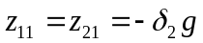 inside the dipole, see Fig. A5-4. TRACK terminates task for
the intersecting entrance and exit fringe fields. User can change this parameters.
The command line 1 prmtr delta1=r assigns r to .
The command line 1 prmtr delta2=r assigns r to .
The command line 1 prmtr dev_field= calculates dipole
parameters p, Bf, k1, xcr1, xcr2, z11, z12, x11, x12, z21, z21, x21, x22 and extracts them into the file log.dat. 1D table containing a field falloff By(0,0,z), see Fig. A5-5A is also extracted in the file log.dat
The command 2 prmtr dev_field= extracts 2D tables contaning the entrance and exit fringe field B_{y}(x,0,z), see Fig. A5-4, into the file dev_field.dat .

Examples:
1) Enge coefficients are internal c0=-0.003183,c1=2.32, c2÷c5=0.
0 bmag 108.432 40. 90. 7.6 10. 31. 31. 0.01 -0.01 200

2) Enge coefficients are user defined.
1 enge bmag 0.1756 2.4415 -0.0555 0.4293 -0.4706 0.1088
2 enge bmag 0.1756 2.4415 -0.0555 0.4293 -0.4706 0.1088
1 prmtr delta1=0.8
1 prmtr delta2=2.5
1 prmtr dev_field=
0 bmag 108.432 40. 90. 7.6 10. 31. 31. 0.01 -0.01 200

*dipole MAGNET, any pole face*
This element supports any shape of the poles (not only rounded one) and magnetic field with arbitrary field gradient. N is the field index. This elment is more generalized bending magnet and supports all 5 types of diples defined in the code RAYTRACE [A5-4].

n dipo d_elem rbend theta airgap width bet1 bet2 Ν Β Γ Δ mtype nstep
n extension number in the files eh_EMS.#n
for 2D table fringe field of the dipole
d_elem [cm] L-total length of the dipole, this length includes the entrance
and exit fringe fields ,L=2d+ρ₀θ (d≅3g)
rbend [cm] ρ₀-bending radius
theta [deg] θ-bending angle (θ>0 right bend , θ<0 left bend)
airgap [cm] g-gap width for field calculations
width [cm] w-horizontal aperture of dipole
bet1 [deg] β₁ -entrance edge angle
bet2 [deg] β₂ exit edge angle
Ν
Β Ν, Β, Γ,and Δ are cofficient of the Taylor expansion of the
Γ magnetic field in a “uniform” field region,see Eq. (A5-4)
Δ
mtype type of the dipole magnet
mtype=1,2 homogenous field dipole
mtype=3 dipole with field gradient.
nstep number of integration steps for the device
Note:
The dipole parameters are defined in Appendix 5. The parameters xcr1, xcr2 are output parameters. The parameters xmax, zmin, zmax are included in eh_2d.#n. The code “TRANSPORT” uses parameter k1, “GIOS” uses the function E(z), and “RAYTRACE” uses 2D tables with B_{x}(x,0,z) for fringe field description. Subroutine dipo calculates k1, E(z), and 2D tables with B_{x}(x,0,z). RAYTRACE can calculate 2D fringe field tables for different types of dipole magnets. These tables can be used for the element dipo after some modification.

Examples:
1) 34 dipo 40.0 143.2 35. 3. 10. 5. -15. -15. 2 200
2) 34 dipo 40.0 143.2 35. 3. 10. 5. -15. -15. 3 200 1st line
0.5 0. 0. 0. 2nd line
2D tables for fringe fields are in the file eh_2d.#34

n =0.5, b=0, Γ=0, Δ=0

*Magnetic MULTIPOLE with fringe fields*
Internal or user defined set of Enge coefficients c0÷c5 can be used for
the fringe field calculation. User can define Enge coefficient using the
command lines 1 enge mult c0 ..c5 and 2 enge mult c0 ..c5. The number 1 (2) in the first position defines coefficients for the entrance (exit) edge.

n mult d_elem Heff* Bq** Bh** Bo** rap i_quad nstep
n
d_elem[cm] total length of the multipole
Heff [cm] effective length of the multipole
Bq [G] quadrupole field component at r=Ra
Bh [G] hexapole field component at r=Ra
Bo [G] octupole component at r=Ra
Ra [cm} aperture radius
i_quad 0 - full lens, 1 - first half of lens, 2 -second half of lens
Note: when the lement is devided to two halves, the total length of the element is equal to the length of two halves. However, the effective length is the same independently either it is full multipole or the half of the multipole.
nstep number of integration steps for the device.
Note.
* The effective length heff and Enge coefficients are the same for all
multipole components. A device m6 for more precise description of
the edge fields of the magnetic multipole is being developed.
** Bq, Bh, and Bo are some values of the field defined as G= Bq/Ra, H= Bh/Ra²,and O= Bh/Ra³ where G, H, and O are coefficiens of multipole field
expansion, see Appendix XXX (being developed).
Bq >0 provides focusing in the horizontal plane.

Examples:
1) Full lens. Enge coefficients are internal.
1 mult 115. 50. 4834. -350.0 0. 5. 0 200
2) The lens is divided into two halves. Enge parameters of each half are
internal.
1 mult 57.5 50. 4834. - 350.0 0. 5. 1 100
1 mult 57.5 50. 4834. - 350.0 0. 5. 2 100

3) Enge coefficients are user defined. In this example we use the Enge
coefficients which are equal to the internal coefficients.
1 enge mult -0.00004, 4.518219, 0, 0, 0
2 enge mult -0.00004, 4.518219, 0, 0, 0
******
******
1 mult 115. 50. 4834. -350.0 0. 5. 0 200
All these examples provide the same beam transformation.

*Magnetic Quadrupole with fringe fields*

*HARD EDGE Magnetic Quadrupole*
Internal or user defined set of Enge coefficients c0÷c5 can be used for
the fringe field calculation. User can define Enge coefficient using the
commands 1 enge quad c0 ..c5 and 2 enge quad c0 ..c5
The quadrupole with d_elem=Heff or nstep=0 is treated as a hard edge quadrupole.

n quad Bq * d_elem Heff rap any** nstep***
n
Bq [G] quadrupole component at r=Ra
d_elem[cm] total length of the quadrupole
Heff [cm] effective length of the quadrupole
Ra [cm] aperture radius
any placeholder, arbitrary number
nstep number of integration steps for the device

Note.
* Bq is an artificial number and defines G= Bq/Ra, where G is a coefficient
of the quadrupole field expansion, see Appendix XXX (being developed).
Bq >0 provides focusing in a horizontal plane
** Sorry
*** nstep is placeholder for the hard-edge quad

Example:
1) The quad with the fringe fields. Enge coefficients are internal.
1 quad -1126.0 40. 25. 3. 0 200
2) The quad with the fringe fields. Enge coefficients are user defined.
In this example we use the Enge coefficients which are equal to
the internal coefficients.
1 enge quad -0.00004, 4.518219, 0, 0, 0
2 enge quad -0.00004, 4.518219, 0, 0, 0
******
******
1 quad -1126.0 40. 25. 3. 0 200

3) The hard edge quad (nstep=0).
1 quad -1126.0 40. 25. 3. 0 0

4) The hard edge quad (d_elem=Heff).
1 drift 8.5 3. 3.
1 quad -1126.0 25. 25. 3. 0 200
1 drift 8.5 3. 3.
The beam transformation is the same for examples 3) and 4).
The “soft-edge” quad in the example 1) or 2) is treated as “hard-edge”
quad in the example 3) by applying nstep=0. It’s a recommended way of
switching between “soft-edge” and “hard-edge” quads.

*3D-field-map magnetostatic Quadrupole*
The quad field is calculated by some external electromagnetic code.
3D table format is described in chapter 5.?.

n mq3d d_elem Bq * rap nstep
n>0 extension number of the files eh_EMS.#n
Bq [G] quadrupole component at r=Ra
d_elem [cm] total length of the quad
Ra [cm] aperture radius
nstep number of the integration steps for the device

Note.
* Bq is an artificial number and defines G= Bq/Ra, where G is a coefficient
of the quadrupole field expansion, see Appendix ??.
Positive field Bq>0 implies focusing in a horizontal plane.
The field table eh_EMS.#n is normalized by TRANSFORN.exe so that G=1 in
the quad center. TRANSFORN.exe evaluates the quad effective length Heff
and Enge coefficients for the field table eh_EMS.#n
(see chapter 4 for further explanation).

Example:
1) field is given in eh_EMS.#04
4 mq3d 6000.0 13.61 2. 40
2) field is given in eh_EMS.#67
67 mq3d 6000.0 13.61 2. 140

6.3 Electrostatic devices

*3D-field-map ELECTROSTATIC Quadrupole*

n eq3d d_elem Vf rap nstep
n extension number in the files eh_EMS.#n
d_elem [cm] total length of the quad
Vf [V] inter-electrode voltage*
Ra [cm] aperture radius
nstep number of integration steps for the device

* The field table eh_EMS.#n is normalized by MWSread.exe so that the
inter electrode voltage is equal to 1 (see chapter 4 for explanation).
Vf is the inter electrode voltage of the quad.

Note.
1) Vf>0 provide focusing in a horizontal plane.
2) Field gradient in the center of the 3D electrostatic quad is
G=k*Vf/Ra**2, k≠1. MWSread.exe evaluates k and the quad effective
length Heff and extracts this two parameters in the file output.dat.
For linear calculations the device eq3d can be replaced by the equad with rhe aperture radius Ra, effective length Heff,and inter electrode voltage Vf*=k*Vf.

Examples:
4 eq3d 6000.0 13.61 2. 40 , field is given in eh_EMS.#04
67 eq3d -1000.0 13.61 2. 140 , field is given in eh_EMS.#67

*3D-field-map three-electrode EINZEL lens*

n einz Vf d_elem rap nstep
n extension number in the files eh_EMS.#n
d_elem [cm] total length of the quad
Vf [V] voltage of the central electrode*, field level
Ra [cm] aperture radius
nstep number of integration steps for the device

*The field table eh_EMS.#n is normalazed by MWSread.exe so that the voltage of the outer electrodes is equal to 0 and the voltage of the central electrode is equal to 1, see chapter 4 of this manual for the explanations. Vf is the central electrode voltage of the einzel lens.
Example:
9 einz 6000.0 13.61 2. 40 , field is given in eh_EMS.#09
97 einz -1000.0 13.61 2. 140 , field is given in eh_EMS.#97

*ELECTROSTATIC Quadrupole with fringe fields*

n quad Vf d_elem Heff rap nstep
n n=0 internal set of Enge coefficients c0÷c5 is used
n=1 the Enge coefficients c0÷c5 are defined by the latest
element 1 enge equad c0 ..c5 placed upstream the line describing equad in the sclinac.dat file.
Vf [V] inter-electrode voltage
d_elem[cm] actual length of the quadrupole
Heff [cm] effective length of the quadrupole
Ra [cm] aperture radius
nstep number of integration steps for the device**

Note.
1) vf >0 provides focusing in a horizontal plane
2) Field gradient in the center of the quad is G=Vf/Ra**2
3) Hard edge electrostatic quadrupole is not applicapable in TRACK.

Example:
1) Enge coefficients are internal.
0 equad 5126.0 40. 25. 3. 0 200
2) Enge coefficients must be defined. In this example we use the
Enge coefficients which are equal to internal ones.
1 enge equad -0.00004, 4.518219, 0, 0, 0
******
******
1 equad -1126.0 40. 25. 3. 0 200

Beam transformation is the same in the examples 1) and 2).

*HV platform entrance&exit*

Element name: ‘deck’
ntype = el.n ! Type of the lens, determines the file with input field distribution.
Vdeck = el.p1 ! Voltage with respect to the ground [kV]
Positive voltage accelerates positively charged ions
d_elem = el.p2 !total length of the electric field distribution at the edge of the HV deck [cm]
rap = el.p3 ! aperture of the beam pipe [cm]
mesh_Z = el.n1 ! number of meshpoints along z
mesh_R = el.n2 ! number of meshpoints along r

Note.
1) This element is being reconstructed. Use the device ‘extrc’ instead of the ‘deck’.

Example:
2 deck -35. 20. 1.5 201 16
1 extrc 2000. (voltage,V) 78.(length,cm) 2. (aperture, cm) 100 (number of integration steps)

6.4 Drift space and other elements of the beamline

*DRIFT*

n drift d_elem rapx rapy nstep
n -any integer number
d_elem [cm]-length of the drift space
Rx [cm] -horizontal half aperture (X direction)
Ry [cm] -vertical half aperture (Y direction)
nstep -(optional, ≥2)number of steps for integration along the -drift space. If this parameter is omitted,
nstep =max{2, d_elem/(0.25βλ)}, where λ=c/(harm*freqb) is the current RF wave length and βc – is the velocity of the reference particle.
Note.
1) Ry>0 :the aperture of the drift is rectangular{-|Rx|x<|Rx|,-Ry<y<Ry}.
2) Ry<0 :the aperture of the drift is elliptical (x/Rx)²+ (y/Ry)² <1
3) The drift space with the length close to zero can be used as a slit in sclinac.dat input.

Example:
1) 1 drift 9.0 3. 3. nstep is defined internally, the
aperture is rectangular
2) 1 drift 9.0 3. 3. 45 nstep=45, the aperture is rectangular
3) 0 drift 9.0 3. -3. 245 nstep=245, the aperture is elliptical

*SLIT*

n slit rapx rapy
n = 1 defines element ‘slit’
n = 0 defines element ‘pseudo slit’
n =-1 no action
Rx [cm] half aperture in x direction
Ry [cm] half aperture in y direction

1)Ry>0 :the aperture of the slit is rectangular{-|Rx|x<|Rx|,-Ry<y<Ry}.
2)Ry<0 :the aperture of the slit is elliptical: (x/Rx)²+ (y/Ry)² <1
3)The slit element has a zero length along z-coordinate.
Note:
Particle is marked as a ‘lost’ particle if it is outside the slit aperture. The ‘lost’ particle is not traced further. The coordinates of the ‘lost’ particle on the slit will be saved. All particles lost in ‘pseudo slit’ and upstream of the ‘pseudo slit’ will be removed from the array of particle coordinates. The latter is redefined and will consist of less or equal number of particles than upstream of the element ‘pseudo slit’.

*STRIPPER*

n strip xWtarg dWtarg dxtarg dds
n number of the stripper film or foil and extension number of the
file stripper.#0n
xWtarg energy loss (keV/u)
dWtarg RMS energy straggling in keV/u, rms value calculated by the external
code,in TRACK we assume the distribution is Gaussian.
dxtarg RMS scattering in X' and Y', in radians.
ddS fluctuation of the target thickness (relative unit), peak-to-peak
amplitude. The number of charge states and the percentage of particle distribution in different charge states, as well as average beam energy after the stripper must be given in file stripper.#0n.

Example:
1 strip 10. 4.1 0.0002 0.05
*) Currently this element is suitable only for uranium at energies ~10-15 MeV/u at the first stripper and at ~85-90 MeV/u at the second stripper. The stripper subroutines in TRACK are based on SRIM simulations. The passage through the stripper was initially simulated using the SRIM code and the ion beam distribution has been parameterized. Detailed description of the procedure will follow. Generalized particle distribution after the passage of the stripper is being developed by B. Mustapha.

*Shift-rotate*

Element name: 'shrt'
ntype = el.n = 0 no meaning
fiz [deg] = el.p1 angle of rotation (positive for the counterclockwise rotation)
delx [cm] = el.p2 displacement in X-direction
dely [cm] = el.p3 displacement in Y-direction

Example:
1 shrt 45. 0.1 0.1

*UDS*

n uds d_elem Vf rap dz_elem nstep z1 z2 z3 z4 z5

User defined structure. This element can be used to define a gap inside the multi-gap resonator.

n extension number of the file eh_EMS.#**. The field file defines 3D distribution of the electric field in the accelerating gap (no magnetic field is assumed). This field can be generated by an external electrostatic code.
d_elem[cm] total length of the user defined device
Vf[V] gap voltage
rap [cm] radius of aperture
dz_elem[cm] shortening of the second drift tube length to fit the reference particle phase in the following rf gap if such a gap exists.
nstep number of the integration steps for the device
z1 z2 z3 z4 z5 (optional) z-coordinates for extracting the reference particle’s (r.p.) phase along the element. Example: if one needs to know phase of the r.p. one of z-coordinates should be equal to d_elem/2. The phases of the r.p. will be extracted into the file matrix.dat.

*PRMTR*
This element can be used to define a drift tube resonator containing many accelerating gaps. In addition, prmtr can be used to define or re-define any integer flag from the list given as input parameters in the file track.dat.

0 prmtr iflag_chain=phasa_in [deg]
n uds
n drift
n uds
n drift
…….

0 prmtr iflag_chain=0

Examples:
If iflag_log=1, it will extract major information about the element following the line ”prmtr” into the file log.dat.
If isol=0,1 it will introduce solenoid with out fringe fileds (isol=0) and with fring fields (requires solenoid.dat file).
If current=0 it will introduce zero current and replaces the ’current’ definition in the track.dat file.

*SCRATCH*

Element name: 'scrch'

Example:
-1 scrch
1 scrch
-1 : the code writes all necessary information to temporary file scratch.#01.
+1 : the code reads all data and starts simulation from the intermediate location along z where file scratch.#01 has been created.

*STOP*

n stop
n any
stop stops simulation at this given location along the z.

Example:
0 stop

*SWITCH*

n SWTCH coeff
n -number of correction sections
coeff -This element is used to change the field level in focusing elements during the correction procedures. swtch acts on focusing devices (solenoids and quadrupoules) located immediately after swtch

Example:
2 swtch coeff
1 sol B0 d Heff rap rap

*UPDATE*
When 0 updat structure line appears in scilinac.dat the beam matrix for all charge states is calculated and then the transfer matrices of each device between 0 updat and 1 updat are calculated, both for reference particle with charge state Qdesign and mass Adesign and for each ion species with Q(iq), A(iq), where iq=1,nqtot. For charge state Qdesign and mass Adesign a cumulative matrix of all devices from 0 updat to exit of this device is calculated. Beam matrix after each element is calculated as matrix production and from ray trace calculations.
Matrix of devices and cumulative matrix from 0 updat to exit of this device and two kinds of beam matrices are extracted into the file matrix.dat.
It is possible to have any number of non-intersecting 0 updat … 1 updat blocs in the sclinac.dat. The matrix calculations do not include beam space charge yet(it is being developed).

*FILTeR*
This element is used to filter unaccelerated particles after the RFQ by setting dw_w=0.04. (relative energy deviation from the reference particle energy). This mode is used for matching purposes. If dw_w=1.0 all particles are kept and the un-accelerated particles will be lost either on the aperture walls or on the slits.

Element name ‘FILTR’

n filtr dw_w QdesignNew Index
n =1 element is activated, if n=-1, element is de-activated
dw_w energy cut-off boundary
QdesignNew – Charge of the reference particle after the filter, should be equal to the charge state of one of the charge states upstream of the element ‘filtr’
index If index=0, then no effect on bunch structure; if index=1, two different charge states are combined into one bucket artificially (space charge effect is ignored, current =0).

Example:
0 filtr 0.05 28 0.

6.5 Misalignments, errors and beam steering correction

*ALIGN*

n align name Δ_{xy} Δ_{z} φ_{z} ΔΦ_{j} ΔF_{j} ΔΦs ΔFs
n = nt_cav - the SRF cavity type (name=cav)
= 1 for all other devices
=-1 no action
name the device name in sclinac.dat
Δ_{xy} [cm] (=0 by default) the amplitude of the element displacement in x
and y direction w.r.t. the entrance and exit coordinate systems
of the device **.
Δ_{z} [cm] (=0 by default)the amplitude of the element displacement in z
direction w.r.t. the entrance and exit coordinate systems of the
element
φ_{z} [mrad] (=0 by default)the amplitude of the element rotation about
z-axe of the entrance and exit coordinate system of the
element.
ΔΦ_{j} [deg] (=0 by default)the rms fast error of the phase**.
ΔF_{j} [%] (=0 by default) the rms fast error of the field amplitude***.
ΔΦs [deg] (=0 by default) the amplitude of the element static phase error
ΔFs [%] (=0 by default) the amplitude of the element static field
error

Note:
1) The previous version of the code, TRACKv34, defined the misalignements of the solenoids and SRF cavities in the input file track.dat. TRACKv35 define the misalignements all of the devices by the command align in the input file sclinac.dat

2) The line in the sclinac.dat file 1 align name.. defines the position of misalignments, phase and field errors for all devices, except cavities, with the given name located downstream of this line. The line nt_cav align cav ..
defines the errors only for cavities of the type nt_cav i.e. only for devices nt_cav cav .. located downstream of this command.

3) The errors and misalignments of the device are described by 10 randomly generated numbers R₁÷R₁₀. Particularly, R₁÷R₆ defines the spatial misalignments of the device, see Appendix A1 for the explanations.
x_{in} =Δ_{xy}*R₁ is the device displacement along x axis of the entrance
coordinate system.
y_{in} =Δ_{xy}*R₂ is the device displacement along y axis of the entrance
coordinate system.
z_{in} =Δ_{xy}*R₃ is the device displacement along z axis of the entrance
coordinate system.
φ_{xin} =φ_{xy}*R₄ is the device rotation about x axis of the entrance
coordinate system.
φ_{yin} =φ_{xy}*R₅ is the device rotation about y axis of the entrance
coordinate system.
φ_{zin} =φ_{z}*R₆ is the device rotation about z axis of the entrance
coordinate system.
Phase and amplitude fast errors are described by Gaussian
distribution with standard deviation σ=1.0 and truncated at the 3σ-
level. R₇,R₈, |R_{7,8}|≤ 3. The fast errors are known as jitter or
dynamic errors.
ΔΦ_{j}*R₇ is the fast phase error of the device
ΔF_{j}*R₈ is the fast field error of the device
R₉ and R₁₀ are uniformly distributed in interval [-1,1] and defined to be the
static errors of the phase and amplitude of the rf field.
ΔΦ_{s}*R₉ is the static phase error of the device.
ΔF_{s}*R₁₀ is the static field error of the device.

4) The line 1 prmtr mslgn_dstr=N followed by a device evaluates
N seeds for spatial misalignment of this device. The device
displacements and rotation w.r.t. entrance coordinate system are
extracted into the file r_in.dat. The file r_in.dat contains the title:
name Xin[cm] Yin[cm] Zin[cm] RXin[mrad] RYin[mrad] RZin[mrad]
and N line with the device coordinate w.r.t. entrance coordinate
system.
The device displacement and rotation w.r.t. exit coordinate system
is extracted in a file r_out.dat. The file r_out.dat has the
heading:
name Xout[cm] Yout[cm] Zout[cm] RXout[mrad] RYout[mrad] RZout[mrad]
and N line with the device coordinate w.r.t. exit coordinate
system.
If the line 1 prmtr mslgn_dstr=N appears in the sclinac.dat several
times,only the last line will be executed.

5) In each accelerator seed 10 numbers R₁÷R₁₀ are generated for each element defined in the file sclinac.dat. These data is extracted into the file VRAND_nnn.dat, where nnn is the number of seed.

Examples:
1) 1 align mult 0.03 0. 0. 0. 0.
The misalignment is assigned or re-assigned to all multipoles
(n mult..) located downstream of this line.
2) 23 align cav 0.03 0. 0. 0.1 0.1 1. 1.
The misalignment is assigned or re-assigned to all cavities of the
type 23 (23 cav ..) located downstream of this line.
The field in the cavity of type 23 is defined by the file eh_MWS.#23.

*ARtificial Steering corrector*

n zero pos ang

n = 1 the "zero" corrector is activated

=-1 no action (the "zero" corrector is not activated.)

pos[cm] error of beam center position after correction in the horizontal

and verical planes

ang[mrad] error of beam centroid angle after correction in the horizontal and verical planes

Note:
This element assigns zero to the center of gravity (with some
residual errors of positioning) of the beam in xx’ and yy’ planes.
The new beam center positions Xc and Yc, and the beam center angles X’c
and Y’c will be uniformly distributed in intervals
-pos≤ Xc ≤pos , -pos≤ Yc ≤pos , -ang≤ X’c ≤ang , -ang≤ Y’c ≤ang .

Example:
1 zero 0.01 0.1

*Thin-dipole Steering corrector*
n CORR L FH FV rapC nstep FHkick FVkick
n =1 corrector is activated
n =-1 no action (corrector is not activated )
L[cm] (=0 by default), “thin”corrector has zero length
FH[mrad] -maximum horizontal corrector strength for transverce
correction procedure ( FHkick>0)
-actual corrector strength if FHkick=0. In this case it acts as an externally defined corrector with the kick FH (manual corrector).

FV[mrad] -maximum vertical corrector strength for transverce
correction procedure ( FHkick>0)
-actual corrector strength if FHkick=0. In this case it acts as an externally defined corrector with the kick FV (manual corrector).

RapC[cm] -(optional)aperture of the corrector, it is not applied to “thin” corrector
nstep -(optional) number of integration steps, it is not applied to “thin” corrector
FHkick[mrad] -vertical corrector strength for transfer function calculation
FVkick[mrad] -horizontal corrector strength for transfer function calculation

Note:
This element assigns thin-dipole corrections to the center of gravity of the beam in xx’ and yy’ planes. Strengths are determined by running the correction module of the code or are defined manually.
Details are given in Appendix 2.

Examples:
1)0 corr 0. 2. 3. - manual corrector
2)0 corr 0. 2. 3. 0. 0. 1. 1. – “calculated” correction strengths
3)0 corr 0. 2. 3. 0. 0. 0. 0. - manual corrector
4)0 corr 0. 2. 3. 0. 0. 0. 1. – manual horizontal corrector and the
“calculated” correction strength in
vertical plane

*Dipole corrector*

n CORR L FH FB rapC nstep FHkick FVkick

n>1 -number of the extension of the file with name eh_2d.#n
for 2D table with B_{y}(x,0,z) and B_{z}(0,y,z) of the corrector
L[cm] -length of the corrector
FH=BYmax[G] -maximum vertical field in the center of the corrector for
transverce correction procedure (FHkick>0)
-actual corrector strength (FHkick=0). In this case the corrector is
“manual”.
Vertical field bends beam in the horizontal plane.

FV=BXmax[G] -maximum horizontal field in the center of the corrector for
transverse correction procedure ( FVkick>0).
-actual corrector strength (FVkick=0). In this case the corrector is “manual”.
Horizontal field bends beam in the vertical plane

RapC [cm] - the corrector aperture
nstep -number of integration steps
FHkick[G] -vertical field in the center of the corrector for transfer
function calculation
FVkick[G] -horizontal field in center of the corrector for transfer
function calculation

Note:
This realistic dipole corrector subroutine uses 2D-field distribution in XZ and YZ planes.

*Dipole corrector combined with solenoid*

n1 sol3D Bf d_elem rap nstep
& n CORR L FH FV rapC nstep FHkick FVkick
n>1 -extension number in the files eh_2d.#n
for 2D table with B_{y}(x,0,z) and B_{z}(0,y,z) with field of
the corrector
L[cm] -length of the corrector*

FH=BYmax[G] -vertical field, bends beam in the horizontal plane
-maximum vertical field in the center of the corrector for
transverce correction procedure ( FHkick>0)
-actual corrector strength (FHkick=0). The corrector is
“hmanual”.
FV=BXmax[G] horizontal field, bends beam in the vertical plane
-maximum horizontal field in the center of the corrector for
transverce correction procedure ( FVkick>0)
-actual corrector strength (FVkick=0). The corrector is
“manual”.
RapC [cm] - the corrector aperture*
nstep -number of integration steps*
FHkick[G] -vertical field in center of the corrector for transfer
function calculation
FVkick[G] -horizontal field in center of the corrector for transfer
function calculation
* The length, aperture and number of integration steps of the combined corrector are defined in the line for the upstream solenoid.

Note:
1) This modification of the corrector subroutine is used for combined solenoid and dipole fields.
2) The center of the corrector coincides with the center of the solenoid
which is defined in preceding line, see Fig???.

*BEAM POSITION MONITOR*

n MON L dx dy Wx Wy

n -any integer, no meaning in this version of the TRACK
L [cm] (=0, by default, optional)
dx[cm] -accuracy of the BPMX
dy[cm] -accuracy of the BPMY
Wx[cm] - weight in the correction equation for the BPMX
Wy[cm] - weight in the correction equation for the BPMX

Note:
1) This line defines two Beam Position Monitors (BPM) simultaneously:
BPMX measures the x-coordinate of the beam center and BPMY measures
the y-coordinate of the beam center.
2)L≠0 defines a virtual monitor to measure the beam center angle. Accuracy of the angle measurement is dϕ_{x} and dϕ_{y,} which are

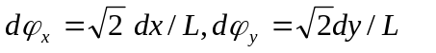

*CORRECTION SECTION MARKER*
n CDUMP
n >0 number of the correction sections.
Note:
In TRACKv35 cdump is used like brackets.
The correction section number n is defined by two or three n cdump elements. The code uses correctors and monitors between 1st n cdump and 2nd n cdump when the correction section is marked by two n cdump elements. TRACK uses correctors between 1st n cdump and 2nd n cdump and the monitors between 1st n cdump and 3rd n cdump when the correction section is marked by three elements cdump. See Fig.??

Example:

Δ₁(₁*<-- 1st section----><--2nd section--><--3rd sect.---><-- 4st sect.--><--------------- 5th section-------->
***********(₁ Δ**=* Δ₁ ) ********(₂Δ ** = ₁) ** =* Δ*=₂) ********
<------ -----1st correction section--------------->
<------- 2nd correction section---->

< --------1st section ----------><--- -----------------------2^{snd} section--------------------------->
(₁*********Δ*** Δ ₁) (₂******* Δ ** = *₁) ** =* Δ*=********₂)
< ----------------1st correction section -------------------------->
<----------------------- 2nd correction section------------------>
(this figure needs some modifications)

Beam passes through the first section. The strengths of the correctors between (₁ ₁) are defined in the first correction section using the BPM inside the brackets (₁ ₁) ₁).

7. Launching the code TRACK

Collect all necessary files in one directory. Click TRACKv37.EXE, hit the letter ‘g’ and press ENTER. For a file manager & editor, we use a very convenient software “Windows Commander” v.4.52 purchased from Christian Ghisler (Switzerland).
TRACKv37.EXE simulates beam dynamics with the graphical windows. On running the code several output files are produced.

8. TRACK Output data

Beam parameters after each element of sclinac.dat are extracted into file out.dat. The first line in the file out.dat is the title of various beam parameters. The second line contains beam parameters w.r.t. Cartesian coordinate system (CCS) 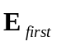 which is the entrance CCS of the accelerator. The subsequent lines contain beam parameters w.r.t. the device exit coordinate system CCS 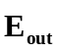. Definitions of different CCS along the beam path are shown in Fig. 1 below.

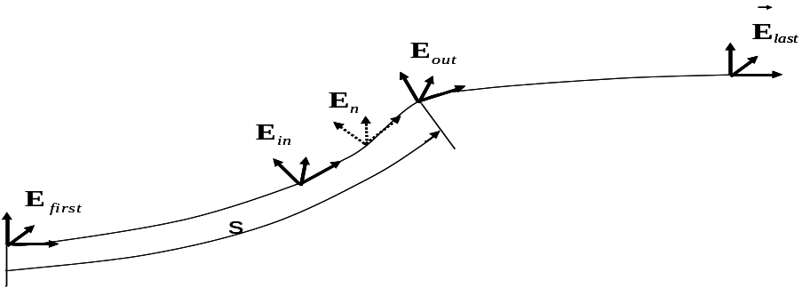

Figure 1. Trajectroy of the reference particle.

For each device TRACK defines entrance CCS 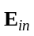, exit CCS 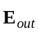 and nstep+1
intermediate CCS 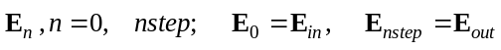. Three numbers (x,y,s), where s is a distance along the reference particle path from accelerator entrance to origin of any CCS 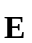, x and y are given w.r.t. this CCS , generate a curvilinear beam optical coordinate of the particle.

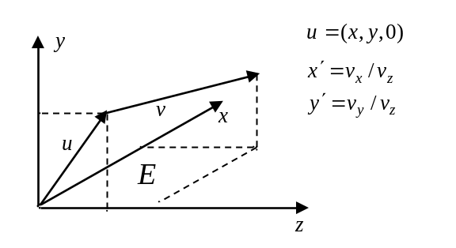
Figure 2. Cartesian coordinate system, is the velocity of the reference particle.

The column names in the file out.dat are:
n_el - sequence number of the element in sclinac.dat
name - name of the element( cav, align .. )
dist[m] – distance along the accelerator beam optic axis from the beginning of the entrance to the exit of the given element
Energy[MeV/u] – average kinetic energy of the beam
x_rms[cm] ₋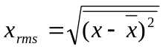, x rms envelope of beam
y_rms[cm] _{-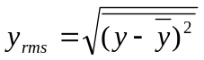,} y rms envelope of beam
Xmax[cm] -x_{max} envelope of beam (100% of particles)
Ymax[cm] -y_{max} envelope of beam (100% of particles)
phi_rms[deg] ₋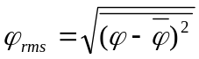 rms phase envelope of beam
phi_max[deg] -φ_{max} phase envelope of beam (100% of particles)
DW/W[rel.u.] -(dW/W)_{max} energy envelope of beam (100% of particles)
4*exn_rms[cm*mrad]- 4ε_{x},where 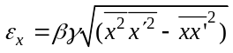 is normalized rms emittance in the(xx’) phase plane
ex##.#[cm*mrad] ε_{x}(##.#%)normalized emittance in (xx’) phase plane containing
##.#[%] of the beam particles. ##.# is defined by variable
part in the file track.dat. ##.#=100*part, for example if part=0.995, then ##.#=99.5)

exn_max[cm*mrad] ε_{x}(100%) normalized emittance in (xx’) phase plane
containing 100% of particles.
4*eyn_rms[cm*mrad]- 4ε_{x},where 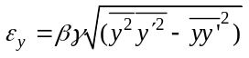 is normalized rms emittance
in the (yy’) phase plane
ey##.#[cm*mrad] -ε_{y}(##.#%) normalized emittance in (yy’) phase plane
containing ##.#[%] of the beam particles. ##.# is defined by
variable part in the file track.dat.

eyn_max[cm*mrad] -ε_{y}(100%) normalized emittance in (yy’) phase plane
containing 100% of the beam particles.
4*ezn_rms[keV/u*ns] -4ε_{z},where 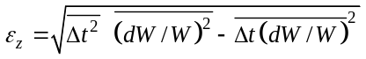 is normalized rms
emittance in longitudinal (Δt=t-t_{RP}, ΔW/W=(W-W_{RP})/ W_{RP} )
phase plane. t_{RP} and W_{RP} is time of flight and kinetic
energy of the reference particle.

ezn##.#[ keV/u*ns] -ε_{z}(##.#%) normalized emittance in longitudinal (Δt=t-t_{RP},
ΔW/W=(W-W_{RP})/ W_{RP} ) containing ##.#[%] of the beam
particles. ##.# is defined by variable part in the file
track.dat.

ezn_max[cm*mrad] -ε_{y}(100%) normalized emittance in longitudinal
(Δt=t-t_{RP},ΔW/W=(W-W_{RP})/ W_{RP} ) containing of the beam particles.
XPc[cm] - spatial beam center position in (xx’) phase plane
BXc[mrad] 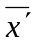 - angular beam center position in (xx’) phase plane
YPc[cm] - spatial beam center position in (yy’) phase plane
BYc[mrad] 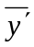 - angular beam center position in (yy’) phase plane
btgm βγ, β=v/c is velocity of the reference particle,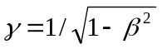
zcn[deg] 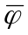 phase beam center position in (φ dw/w) phase plane w.r.t reference particle
a_x α_{X} -Twiss-parameter of the beam in (xx’) phase plane
b_x[cm/mrad] β_{X} -Twiss-parameter of the beam in (xx’) phase plane
a_y α_{y} -Twiss-parameter of the beam in (yy’) phase plane
b_y[cm/mrad] β_{y} -Twiss-parameter of the beam in (yy’) phase plane
a_z α_{z} -Twiss-parameter of the beam in (φ dw/w) phase plane
b_z[deg*(%ofD_W/W)] β_{z} -Twiss-parameter of the beam in (φ dw/w) phase plane
#of_lost_part number of the lost particles
total#of_part total number of the survived particles

File coord.dat contains coordinates of particles transmitted to the line 0 stop in the sclinac.dat file. The particle coordinates are calculated w.r.t. the CCS  which is the exit CCS of the accelerator. The first line of this file is column names:
Nseed iq dt[nsec] dW[Mev/u] x[cm] x'[mrad] y[cm] y'[mrad].
Nseed is the seed number. For ideal machine without errors Nseed=0.

iq is the charge state number of ion. The charge and mass of the ion is equal
Q_{iq}=qq(iq)and A_{iq}=amass(iq). The arrays qq and amass are
defined in the file track.dat.
dt dt=t-t_{RP} ,where t is the particle time-of-flight and t_{RP} is the
reference particle time-of-flight.

dW dW=W-W_{RP} ,where W is the energy of the particle, and W_{RP} is
the energy of the reference particle.
x is the x-coordinate of the particle w.r.t. CS
x’ x’=v_{x}/v_{z}
y is the y-coordinate of the particle w.r.t. CS
y’ y’= v_{y}/v_{z}

The file lost .dat containes coordinates of the particles which are lost
in the accelerator or transport line. The coordinates and velocities of the particles lost in a given device are extracted in the first CCS of the accelerator and in the entrance CCS of the device.

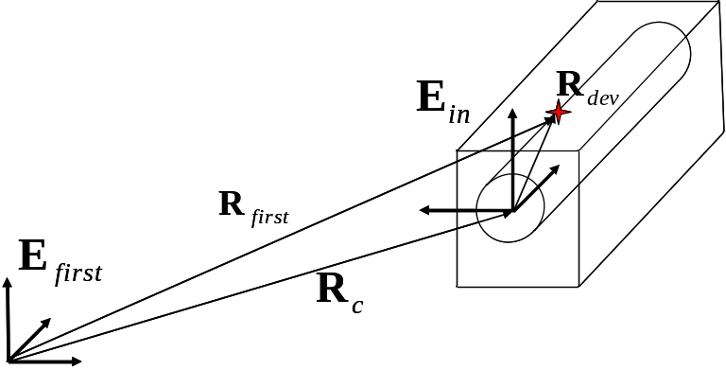

The unit vectors of the device CCS are defined by the transformation matrix O and the unit vectors of the device CCS as
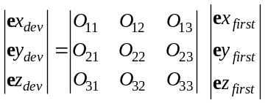 .
The transformation rule from the device CCS to the CCS
for the particle coordinate and velocity is
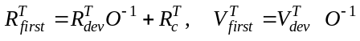,

where T means transpose.

The column names of the file lost.dat are:
n_el -sequence number of element in the file sclinac.dat
name -name of the device( cav, align .. )

Q[|e|] –the charge of the ion
A –the mass number of the ion
Xfirst[cm] -x-coordinate of the particle w.r.t. the CCS
Yfirst[cm] -y-coordinate of the particle w.r.t. the CCS
Zfirst[cm] -z-coordinate of the particle w.r.t. the CCS
VXfirst Vx/c-x-component of the particle velocity w.r.t. the CCS
VYfirst Vy/c-y-component of the particle velocity w.r.t. the CCS
VZfirst Vz/c- z-component of the particle velocity w.r.t. the CCS
Xdev[cm] - x-coordinate of the particle w.r.t. the device CCS
Ydev[cm] - y-coordinate of the particle w.r.t. the device CCS
Ydev[cm] - z-coordinate of the particle w.r.t. the device CCS
VXdev Vx/c- x-component of the particle velocity w.r.t. the CCS
VYdev Vy/c- y-component of the particle velocity w.r.t. the CCS
VZdev Vz/c- z-component of the particle velocity w.r.t. the CCS
Xc[cm] x-coordinate of the origin the CCS w.r.t. the CCS
Yc[cm] y-coordinate of the origin the CCS w.r.t. the CCS
Zc[cm] z-coordinate of the origin the CCS w.r.t. the CCS

O(1,1) O₁₁ transformation matrix element
O(1,2) O₁₂ transformation matrix element
O(1,3) O₁₃ transformation matrix element
O(2,1) O₂₁ transformation matrix element
O(2,2) O₂₂ transformation matrix element
O(2,3) O₂₃ transformation matrix element
O(3,1) O₃₁ transformation matrix element
O(3,2) O₃₂ transformation matrix element
O(3,3) O₃₃ transformation matrix element

A flag iflag_lost provides two features.

9. Acknowledgements

We appreciate very much the continuous help from B. Mustapha who supports the UNIX version of TRACK. Many our colleagues contributed to the code development. Particularly, the following subroutines were developed with the help of our associates: a)the early version of the code transform.exe - A.A. Kolomiets;
b) the 3D Poisson solver - V.A. Moiseev (INR, Moscow-Troitsk),
c) the parametrization of the stripper on the base of SRIM code - B. Mustapha (ANL-PHY);
d) the original version of automatic steering correction in transverse phase space - E. Lessner (ANL-PHY).
The authors thank M. Sengupta for careful reading of the Manual.

10. References

- P. N. Ostroumov and K. W. Shepard, Correction of Beam Steering Effects in Low-Velocity Superconducting Quarter- Wave Cavities, Phys. Rev. ST. Accel. Beams 11, 030101 (2001).
- V.A. Moiseev and P. N. Ostroumov. High Intensity Beam Dynamics in the Ion Linear Accelerators. Proc. of the 1998 European Part. Accel. Conf., EPAC98, Stockholm, p.1216. http://accelconf.web.cern.ch/AccelConf/e98/PAPERS/THP10F.PDF
- P.N. Ostroumov†, V. N. Aseev, B. Mustapha. Beam Loss Studies in High-Intensity Heavy-Ion Linacs. Phys. Rev. ST. Accel. Beams, Volume 7, 090101 (2004).

Appendix 1. Simulation of element misalignments and field errors

There are three groups of errors:
- Misalignment error is a displacement of the device as a rigid body.
- Field error is the field amplitude of the device.
- Error of the rf field phase.
A rigid body requires six independent coordinates to specify its displacement. Usually a Cartesian set of coordinates (CSC) is fixed in the rigid body and the body motion is defined by three shifts x, y, z of the CSC origin and three angles ϕx, ϕy, ϕz which specify the rotation axes about the initial axes. In TRACK there are two equivalent sets of the coordinates for each device: the entrance CSC and the exit CSC, Figure 1a.

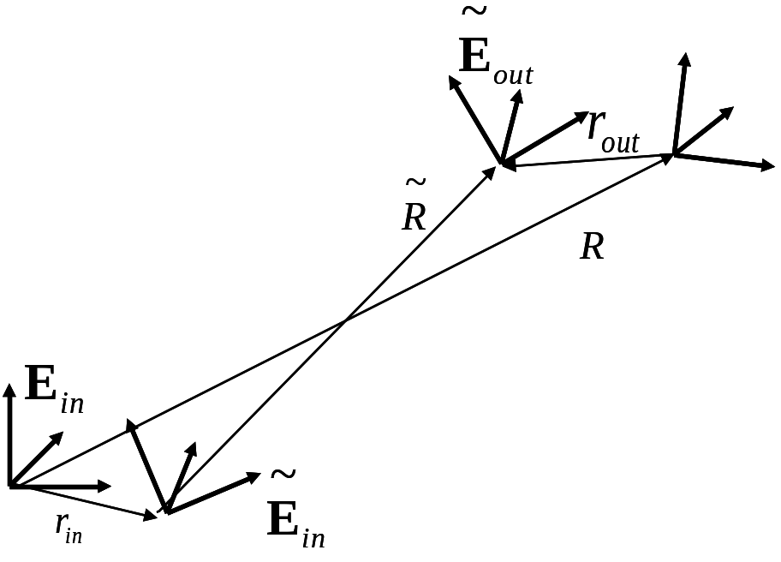

Figure 1a

A special set of the device coordinates is for providing equality of the device entrance and exit CSC’s. This set contains the device shifts x_{in}, y_{in} and z_{in} and a rotation angle ϕz_{in} about the z-direction of the entrance CSC ,and the device shifts x_{out}, y_{out} and z_{out} w.r.t. exit SC,and rotation angle ϕz_{in} about the z-direction of the exit SC. The actual position of the device is uncertain within the given tolerances (Δ_{x}, Δ_{y}, Δ_{z}, ϕz). In TRACK we use the uniform distribution of misalignments and randomly generate x_{in}, y_{in}, … within the given tolerance amplitudes (Δ_{x}, Δ_{y}, Δ_{z}, ϕz).
A complete position of the misaligned device is determined by its displacements x_{in}, y_{in}, z_{in} and the rotation angles ϕx_{in}, ϕy_{in}, ϕz_{in} w.r.t. the entrance CSC. Tolerances ϕx and ϕy can be estimated as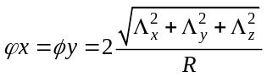, where R is the distance between the origins of the entrance and exit CSC. They are the upper boundaries for ϕx, ϕy (a device with rectilinear optic axis has ϕx=2Δ_{y}/R, ϕy=2Δ_{x}/R). The set of values {x_{in}, y_{in}, z_{in} ϕx_{in}, ϕy_{in}, ϕz_{in} } unambiguously determine the device displacements x_{out}, y_{out}, z_{out} and rotation angles ϕx_{out}, ϕy_{out}, ϕz_{out} w.r.t. the exit CSC as is seen from the equations (A2-2)
One can obtain x_{in}, y_{in}, z_{in}, ϕx_{in}, ϕy_{in}, ϕz_{in} uniformly distributed within their tolerances, calculate x_{out}, y_{out}, z_{out}, ϕz_{out} and check conditions

-Δ_{x}<x_{out}<Δ_{x}, -Δ_{y} <y_{out}<Δ_{y}, -Δ_{z} <z_{out}<Δ_{z}, -ϕz<ϕz_{out}<ϕz. (A1-1)

This procedure is continued until (A1-1) will be satisfied.
In this way a distribution function of each pair of the coordinates (x_{in},x_{out}), (y_{in},y_{out}), (z_{in},z_{out}), and (ϕz_{in},ϕz_{out}) are the same and the equality of the entrance and exit CSC are provided.

Below we present mathematical formalism to support our conclusions. Let and be vectors:

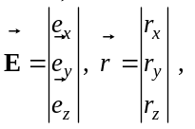
where 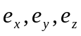 are basic unit vectors of an arbitrary Cartesian System of Coordinate (CSC) w.r.t. “master” or accelerator hall coordinate system. Any vector defined in CSC is a scalar product 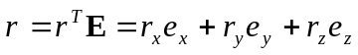 where “T” means transpose. The entrance CSC 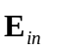, exit CSC,and vector 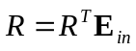-a origin of the exit CSC w.r.t. entrance CSC are defined for any device as is presented in Fig1. The 3×3 matrix O and R^{T} are defined by the device setup. O is the 3×3 unit matrix and R^{t}=(0,0,d_elem) is valid for the devices with rectilinear central trajectory. For the dipole magnets one can obtain the following matrix O and vector R:
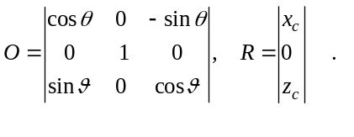

The entrance CSC 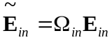 of the misaligned device is defined to be 3×3 rotation matrix Ω_{in} and a shift vector r_{in} as is seen in Fig 1a. The rotation
matrix 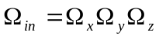, where

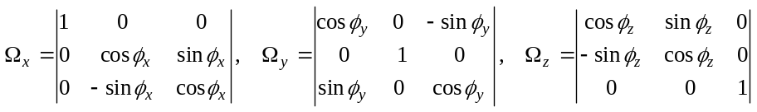

For small angles the rotation matrix is
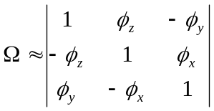.

Because the device is a rigid body, the matrix O and vector R^{T} have the same numerical values for the unmoved and misaligned device: 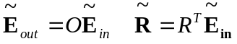.
We can define a rotation matrix Ω_{out} and a shift vector r_{out} for exit CSC:

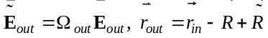.

From the following equalities

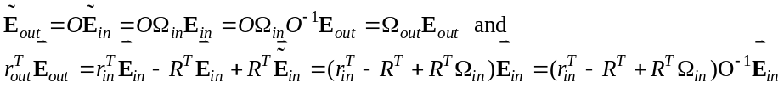

One can obtain
(A2-2)

Particle motion through the device starts in the plane z=0 of the entrance CSC.

The particle position 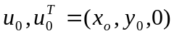 and velocity 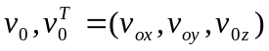 (see Fig.2a) are transformed from the entrance CSC to CSC 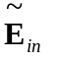 as
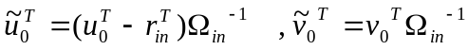

Using the equation of motion in field free space
the particle is transformed to the plane 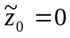 of the entrance CSC .

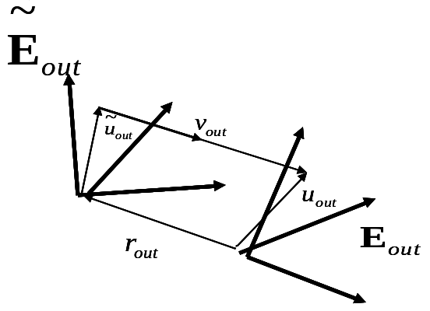
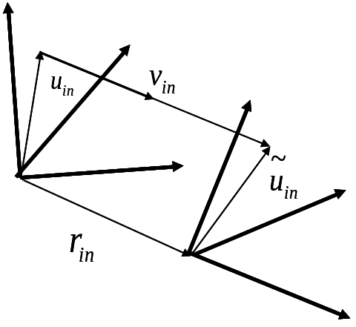

Figure 1b Figure 1c

Then the particle is tracked through the device using the Lorenz equations and arrives at the plane 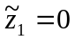 of the exit CSC 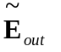. Let us denote as 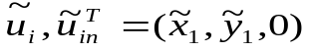 the particle coordinate and velocity 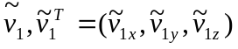 on this plane, Fig.2b. The transformation rule from of the exit CSC to the exit CSC 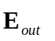 for the particle coordinate and velocity is

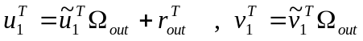.

Ultimately, particle is transported to the plane z₁=0 of the exit CSC

according to the equations

Misalignment errors are introduced in the file sclinac.dat by using the element align. All devices of the type n downstream of the line align experience position misalignments, phase and field errors within the tolerances defined in the line align.
The errors and misalignments of the device are described by 10 randomly generated numbers R₁÷R₁₀. Particularly, R₁÷R₆ define spatial misalignments of the device, see below for more details.
x_{in} =Δ_{xy}*R₁ is the device displacement along x axis in the entrance coordinate system;
y_{in} =Δ_{xy}*R₂ is the device displacement along y axis in the entrance coordinate system;
z_{in} =Δ_{xy}*R₃ is the device displacement along z axis in the entrance coordinate system;
φ_{xin} =φ_{xy}*R₄ is the device rotation about x axis in the entrance coordinate system;
φ_{yin} =φ_{xy}*R₅ is the device rotation about y axis in the entrance coordinate system;
φ_{zin} =φ_{z}*R₆ is the device rotation about z axis in the entrance coordinate system;
Phase and amplitude fast errors are described by the Gaussian distribution with standard deviation σ=1.0 and truncated at the 3σ-level. R₇,R₈, |R_{7,8}|≤ 3. The fast errors are known as jitter or dynamic errors:
ΔΦ_{j}*R₇ is the fast phase error of the device;
ΔF_{j}*R₈ is the fast field error of the device
R₉ and R₁₀ are uniformly distributed in interval [-1,1] and defined static errors of the phase and amplitude of the rf field.
ΔΦ_{s}*R₉ is the static phase error of the device.
ΔF_{s}*R₁₀ is the static field error of the device.
In each accelerator seed 10 random numbers R₁÷R₁₀ are generated for each element defined in the file sclinac.dat. These data is stored in the file VRAND_nnn.dat, where nnn is the total number of accelerator seeds.

To start simulation of many seeds with errors the following steps should be applied:
- In the track.dat file. Assign NRZ the number of required seeds, there are no misalignments for the first seed. Set iflag_corr=-1. Add the following lines;
&correct
partCorr=1
&end
- Add lines with the element align in the sclinac.dat file.

A1.1 Main Cycle for generation of different accelerator seeds
Before simulation with errors, TRACK performs calculation for ideal machine
without errors to define phase setting of the accelerator devices and design
energy of the reference particle for each device. After the first run of the whole machine without errors TRACK generates several samples of the accelerator with error. Each seed (or sample of the accelerator with error) have a number.
This number is included in the correction procedure output files names. Usually, they are useful for comparison of the PC and multiprocessor calculations.
Two parameters define the number of the seeds:
nrz (=1 by default) number of seeds in given run of the TRACK
nrz_min (=1 by default) number of the first seed in a given run of the TRACK
The seeds have the numbers nrz_min÷nrz_min+nrz-1 in a given run.
Note:
Some seeds can have an error set that can result in unusual particle motion and extra losses. It can take place due to the resonance motion in the given set of fields or unsatisfactory work of the beam center correction procedure. The flag iglag_vrand can be used for the error set extraction and detailed investigation of such accelerator seed.

Examples:
1) nrz_min=4, nrz=2, iflag_vrand=0. The randomly generated errors are calculated for seeds ##4÷5 in a given run.

2) nrz_min=4, nrz=2, iflag_vrand=1. The randomly generated errors are calculated for seeds ##4÷5 in a given run. As a result of the run the files vrand_004.dat and vrand_005.dat will be created.

3) nrz_min=4, nrz=2, iflag_vrand=-1. Files vrand_004.dat and vrand_005.dat
must be generated in some previous run and must exist in the directory to run the code successfully. The seeds #4÷5 are calculated with previously generated errors.

Appendix 2. Optimization of the corrector fileds

The accelerator (or beam line) can be divided into several “correction sections”, for correction of the spatial and angular beam center displacement from the accelerator axis due to misalignements of the elements.
Let us introduce the vectors
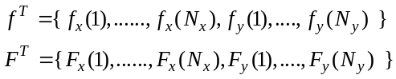,
where f_{x}(i)and f_{y}(i) are actual and F_{x}(i)and F_{y}(i) are maximum strength of the corrector number i. N_{x} and N_{y} are the number of the x-correctors and y-correctors in a given section as is seen in Fig. A2-1. This section is delimited by two first brackets as is shown in Fig. A2-1. The beam steering algorithm can be implemented in “correction sections”, whereby N correctors and M monitors are related by the following two sets of equations:
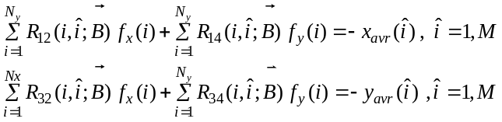, (1)
where 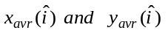 are beam center displacement at the ^{th} monitor.

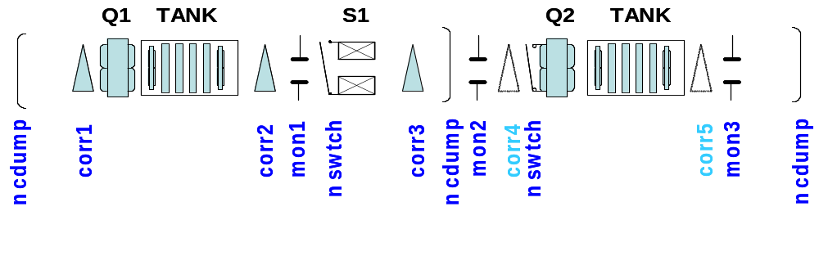

Figure A2-1.

Indexes i denote correctors, and ‘covered’ indexes denote monitors. Here 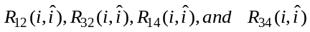 are transfer functions from the corrector i to the monitor .  denotes the vector containing device parameters in the given section.
The test particle with coordinates at the entrance of each correction section is used to evaluate the transfer function. 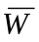 is an average beam energy. Beam center, 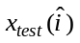, 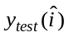, at the monitor number is calculated for special sets of the correctors’ strengths
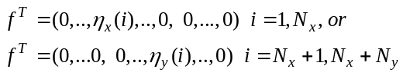 (2)
The transfer functions are defined as

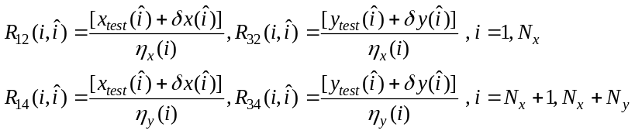 (3)

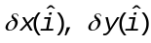 are beam position mesurament errors.
We can repeat calculations (or measurements with the real beam) with other set parameters 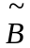 (for example, turn off the quad Q2 in Fig A2-1) and obtain the additional correction equations
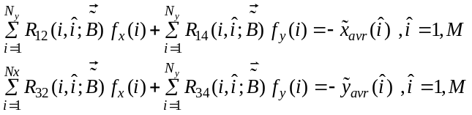 (4)
We can rewrite equations (3) in matrix form 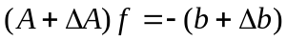, where transfer matrix 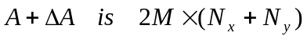 rectangular matrix and equals to
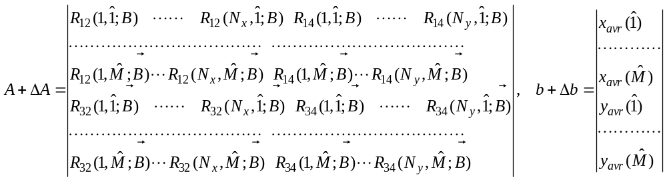 (5)

In equation (5) transfer matrix and right hand vector are divided into two parts. A and b are calculated without beam position measurement errors (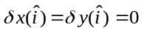). ΔA and Δb are random numbers because of the devices’ field errors and finite accuracy of the monitors. To find the correctors’ strengths we minimize over the vector f the function

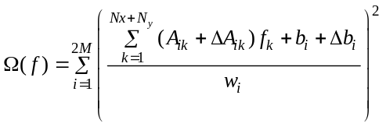 with restrictions 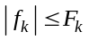, (6)
where w_{i} is the ‘weight’ of the ^{th} monitor. Usually w_{i} is equal to the standard

deviation of the measurament errors of the monitor. The residual beam desplacement on the ^{th} monitors after correction is nonzero and equals to
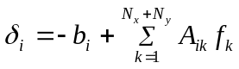
We estimate the quality of the given correction procedure by solving (6)
Nr times with monitor errors 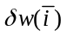 uniformly distributed in the interval 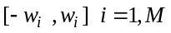. The correlation matrix for the correctors’ strength is

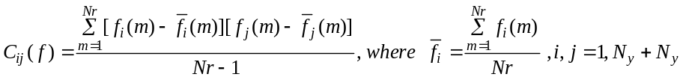

and for residual beam positions on monitors is
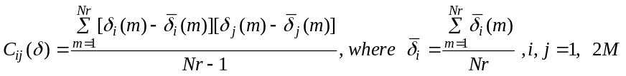.

Abnormal value 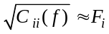 where F_{i} is the maximum strength of the i^{th} corrector or 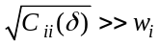 gives warning of possible difficulties of the given correction procedure.
Useful information about the solution of the matrix A can be obtained from the covariance matrix of the set of solutions f_{n} for randomly defined matrix A_{n}=A+ΔA_{n} and right-hand side b+b_{n} for N samples of the correction equations.
The code TRACK provides four possibilities depending on parameter MonErr for calculations of the covariance matrix C. For each seed, the devices are misaligned and their phases and field amplitudes are deviated from the nominal values. The set of particles npatC(iq),iq=1,nqtot, where npatC(iq)≤npat(iq), is transported through the correction section to calculate the vector b and the beam with zero transverse and longitudinal emittances is transported through the section Neq times. Each time only one corrector is on (remember, that the device corr define simultaneously two correctors), the first deflects the beam in the horizontal plane and the second - in the vertical plane. The correctors’ strength F_{i} for the correction matrix calculation is equal to ThetaH or Bymax.

- MonErr=1 (by default). In each seed erros and misalignemnets are generated for each device and BPMs measure beam position in each monitor. Matrix A_{n} and b_{n} are defined in each seed with the errors of the devices position and field errors, in this case Δb=0.
- MonErr=0 beam experiences errors only due to the device misalignments and field errors, in this case Δb=0 (no measurement errors)
- MonErr >1 The matrix A and b are calcualted including randomly generated monitor errors with uniform distribution in the interval 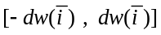 i=1,Nmon. The minimization problem (6) is solved M=MonErr times for different sets of the monitor errors.
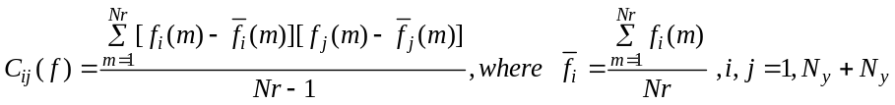

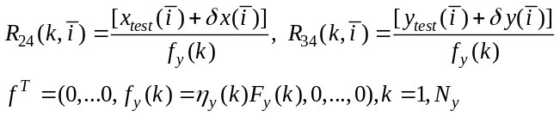

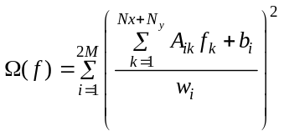
Efficiency of the correction procedure is determined by the condition number of the transfer matrix A. The large condition number indicates that small changes in A and b can lead to large changes in the solution f.

Appendix 3. Acceptance calculation

The code allows one to generate both transverse and longitudinal acceptance of the accelerating-focusing system. The acceptance picture at the beginning of the accelerator or transport system can be obtained as an area in the phase space occupied by survived particles which are tracked to the end of the system defined in the file sclinac.dat. To simulate acceptance two flags either iaccep=1 for the longitudinal acceptance or iflag_tac=1 for the transverse acceptance are used (see the description of the file input.dat). As a result two files accep.dat and negative.dat are generated. The coordinates of the survived particles are stored in accep.dat. Coordinates of the lost particles are stored in negative.dat. Options iaccep=1 and iflag_tac=1 don’t work together.
For the acceptance calculations NRZ in the input.dat file must be equal to 1. The output data can be processed using EXCEL or ORIGIN to produce the acceptance picture. Acceptance calculation in one transverse phase space usually should be done with negligible emittance in another transverse plane.

Appendix 4. Potential expansion in a multi-cell RFQ

A Radio Frequency Quadrupole accelerator can be separated into three functional sections:
1) A regular bunching or accelerating section.
2) A transition cell between the radial matcher and regular cell.
3) Entrance and exit radial matchers.
For the beam dynamics simulation in the TRACK code we assume electrostatic approximation of the fields. The RFQ fields can be inserted into the code by using numerical 3D tables and/or by using the coefficients of Fourier-Bessel expansion of the electrostatic potential in each cell. The design of the vane profile must be known and an external code must be used to generate 3D fields in the RFQ sections and cells. Usually we use the code DESRFQ [1] which is available through contact to Dr. A.A. Kolomiets (ITEP, Moscow). Also the PARMTEQ code of LANL can be used to generate TRACK input files.
The transverse cross-section of the vanes has a shape shown in Fig. A4-1. We assume that the regular RFQ cells are sinusoidally shaped:

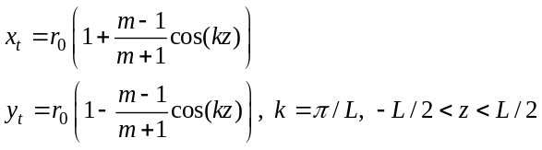, (1)
where a and ma are the minimum and maximum distance of the vane tips wrt the z-axes, x_{t} and y_{t} are the coordinates of the horizontal and vertical vanes,
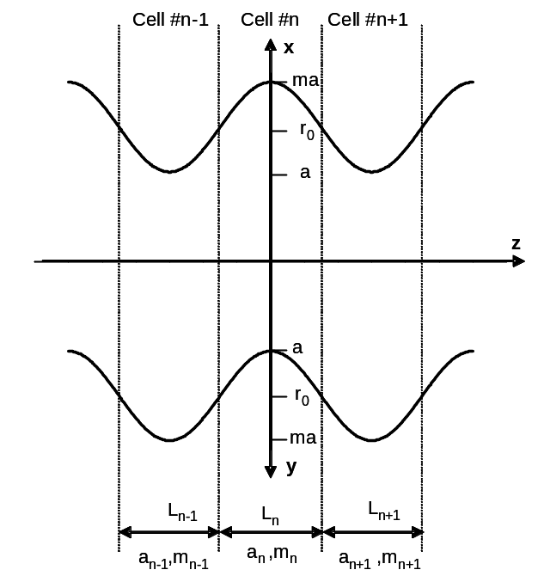

Fig. A4-2. Longitudinal profile of the RFQ vanes.

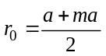 is the average radius of the vanes and L is the cell length as shown in Fig. A4-2.
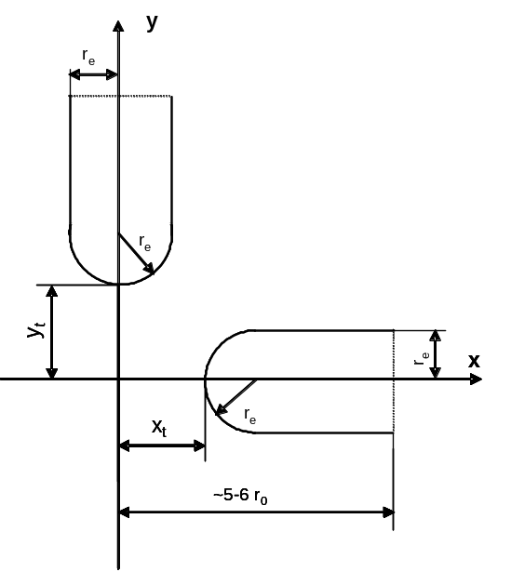
Fig. A4-1. Transverse cross-
section of the RFQ vanes.

A4.1 Regular accelerating cells

In the TRACK code we assume that the cell begins at the point where the vane tips have exact quadrupole symmetry as is shown in Fig. A4-2. As usual, we assume that the parameters a,m,L are varied slowly along the RFQ and the potential in a regular cell can be found applying a mirror symmetry wrt the xy-plane at the beginning and the end of cell. Let’s assume z=0 at the center of the cell then the potential function satisfies symmetry conditions which can be written in cylindrical coordinates as:
` 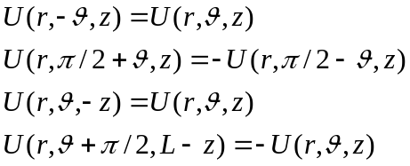 (2)
The potential is:
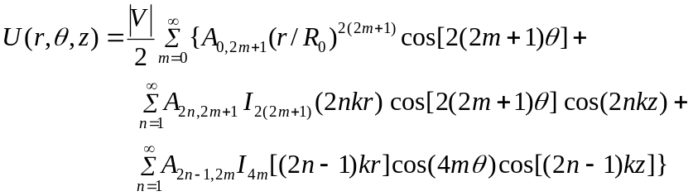 (3)

The potential expansion in a regular RFQ cell with an accuracy of the order r⁷ contains eight terms:

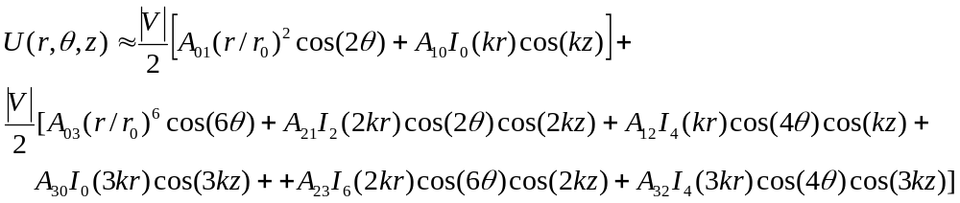(4)

In the TRACK code, the line in the input file RFQ.#nn for regular RFQ cell may contain thirteen parameters

, (5)

where β=v/c is the reference particle velocity at the exit of the cell, T=πA₁₀/4, κ=a²A₀₁,index=0. First six parameters in this line define two-term potential approximation (A₀₁≠0, A₁₀≠0). The first column is used only for the graphic outputs and does not effect on particle tracking.
Six parameters A_{mn} and the file name eh_EMS.#nn are optional. By default all 6 coefficients A_{mn} are equal to zero. These coefficients must be defined by an external code for the given design of the RFQ if one likes to track particles in 8-term potential. If the file name eh_EMS.#nn is appeared in the line, the field in the cell must be given as a 3D table field in the file eh_EMS.#nn. In this case TRACK reads file eh_EMS.#nn and uses this field to interpolate for trajectory integration.

The command line in the sclinac.dat file
1 prmtr ncoef=k₀₁ k₁₀ k₂₁ k₁₂ k₃₀ k₀₃ k₂₃ k₃₂
is used to turn off the effect of each term in series (4). By default all coefficients k_{mn} are equal to 1. Defining k_{mn}=0 one can make A_{mn} =0 for all regular cells even if these coefficients are not equal to zero in the line (5) in the sclinac.dat file.
A period of modulation with the length 2L consist of two cells. For certainty, we assume the vane tip in horizontal plane in the center of n-th cell is at the maximum and the vane tip in the vertical plane is at the minimum wrt the z-axis. In the (n+1)-cell the location of H- and V-vane tips wrt the z-axis is opposite. For each cell, the potential expansion is performed assuming that the center of z-coordinate is located in the center of cell and H-vane tip reaches its minimum distance wrt the z-axis. Usually RFQ begins with the radial matcher which does not have any modulation. The first RFQ cell with modulation has maximum distance of the vane tip from the z-axis in horizontal plane at the center of the cell. In order to reverse this condition, one should define vane=-1 in the line
n rfq …..

A4.2 Transition cell

Transition cell is the cell between two sections of the RFQ with non-adiabatic change of modulation. For example, a cell between the uniform section of the RFQ without any modulation and the section with modulation is the transition cell. In the transition cell the potential function satisfies symmetry conditions:

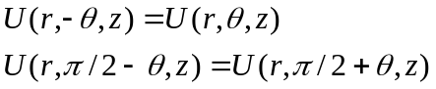 (6)

The potential can be expanded into series

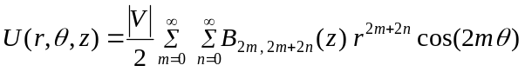 (7)

with recursive relation between the series coefficients:

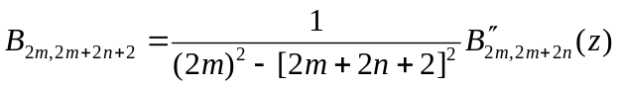 (8)

The field distribution in the transition cell is essentially three dimensional. To define transition cell fields in TRACK, we use 3D field tables obtained from EM Studio. Also, an analytical field expansion in the transient cell is available in TRACK with an accuracy of order r³

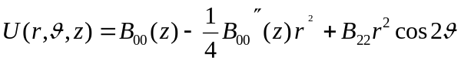 (9)

Vane tip profiles and potential expansion in the transition cell between modulated and unmodulated vanes has been discussed by K. Crandall [2]. K. Crandall divides transition cell into two sections as is shown in Fig. A4-3. In the first section where -L/2<z<0, the vane tip modulation is similar as in a regular accelerating cell. At z>0 the vane modulation is given by the expression:
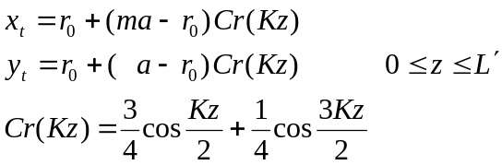 , (10)

where 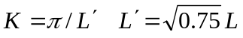. In ref. [2] it is proposed to provide continuity of the functions x_{t}(z) and y_{t}(z) and its first and second derivatives in the points of conjugation at z=0 and z=L’ as is shown in Fig. A4-3. If the vane modulation is given by (10), a good approximation to the expansion coefficients in the expression (9) is:

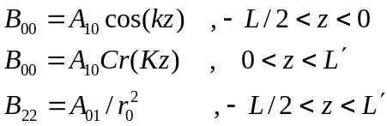 (11)

where A_{01,} A₁₀ are the expansion coefficients of the series (4) for the regular cell with the parameters a,m,L,r_{e}. Fig. A4-4 shows the longitudinal electric field obtained from numerical calculations with EM Studio and analytical expansion (9).
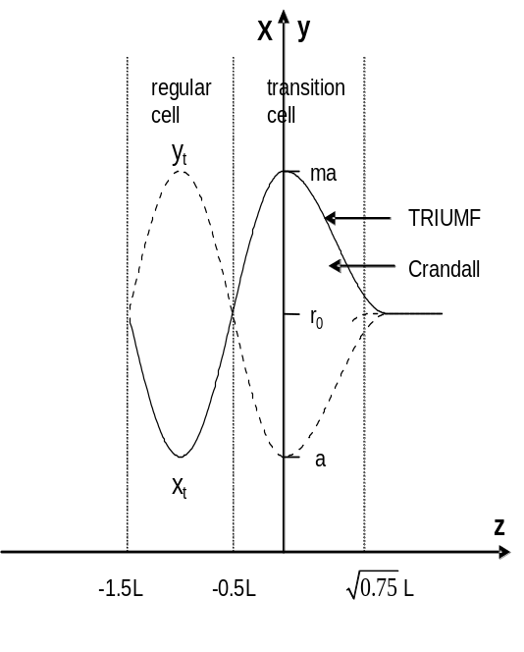
Fig. A4-3. Transition cell.
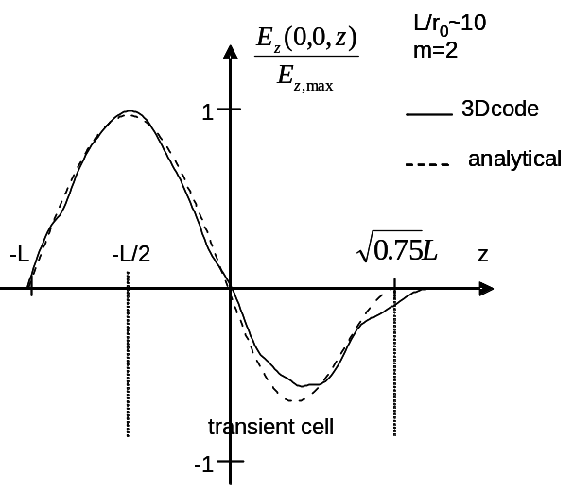

Fig. A4-4. Electric field distribution in
the transition cell. The results were
obtained by EM studio and analytically.

In the RFQ for ISAC at TRIUMF a sinusoidal modulation of the vanes for z>0 has been applied [3]:

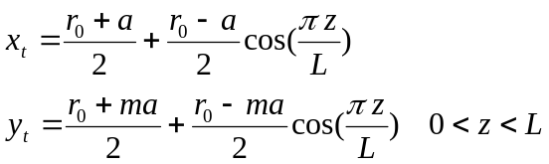.

The line in the input file RFQ.#nn for transient RFQ cell may contain seven parameters

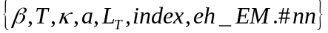, (12)

where index=2 is for the entrance transition cell and index=-2 is for the exit transition cell and 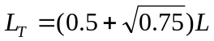. Parameter eh__EM.#nn appears if 3D-table of the electric field obtained from EM studio code will be used.

A4.3 Entrance and exit radial matchers

In radial matcher section (RMS) the potential function has symmetry planes x=0, y=0, x=y and satisfies the symmetry conditions:

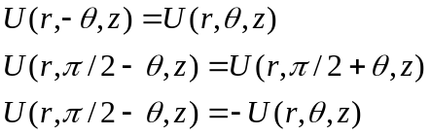 (13)

The potential can be expanded into the series

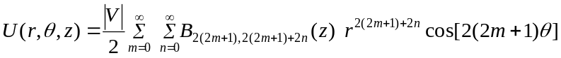 (14)

with recursive relation

. (15)

With the accuracy of r⁷ as in a regular cell, the potential expansion in the RMS is

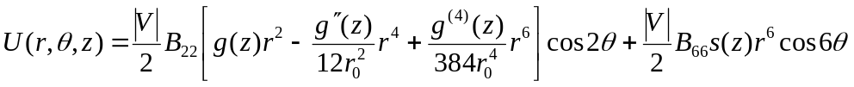 (16)
Where B₂₂ =A₀₁/r₀² and B₆₆ =A₀₃/r₀⁶, A₀₁ and A₀₃ is the expansion coefficients of the series (???) for the cell without modulation. Let’s assume z=0 at the beginning of the RMS. The functional form of a falloff function g(z) is
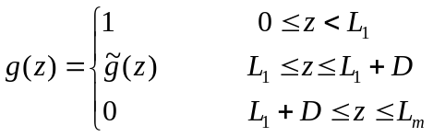 (17)
Where L_{m} is the RMS length. As a 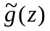 one can use
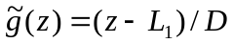, linear function (18)
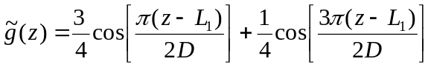, Crandall function [2] (19)
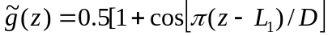, sinusoidal ramp [3] (20)

For the falloff function one can define two parameters: effective length of the field falloff and effective length of the transition region:
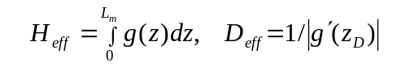, (21)
where z_{D} is defined as a solution of the equation 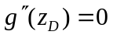.
Let’s define the vane tip profile in the RMS as
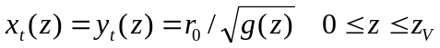, (22)
where z_{v} is the endpoint of the vanes. If the condition 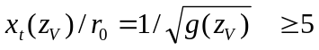 is satisfied, the falloff function behavior does not depend from the location of the point z_{V}.
Fig. A4-5 and A4-6 show different falloff functions and vane profiles calculated by the expression (22) at the same values of parameters H_{eff} and D_{eff} for x_{t}(z_{v})=8. The vane profiles to produce the falloff functions (19) and (20) have smoother field transition compared with the low (1). Once there is no significant difference between falloff functions (19) and (20), in the TRACK code we use the sinusoidal ramp (20) for the analytical representation of the field in the entrance and exit RMS.
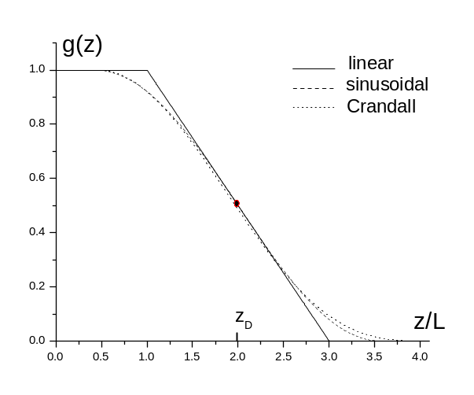

Fig. A4-5. Falloff fucntions.
The RMS described by the expression (22) and (20) has been simulated by EM Studio which shown that the Fourier expansion of the numerically calculated potential reproduces the analytical as is shown in Fig. A4-7.
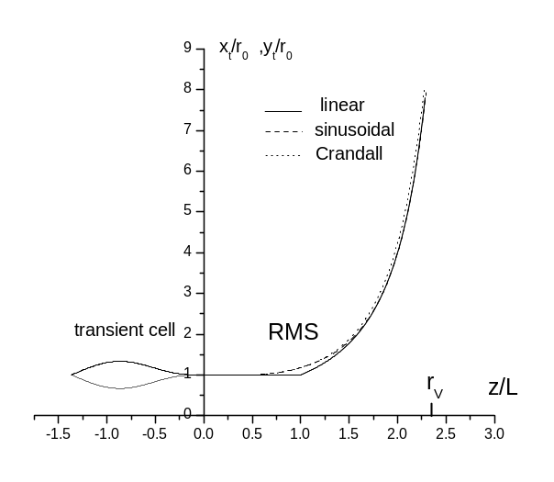
Fig. A4-6. Vane profiles corresponding
to falloff functions given in Fig.5.

The line in the input file RFQ.#nn for RMS may contain 11 parameters

, (23)
where H_{eff} ,D_{eff} - effective length and the effective transient length of the quadrupole field component, L₁=H_{eff}-πD_{eff}/4, D=πD_{eff}/2, see equation (9)
A₀₁, A₀₃ are the expansion coefficients of the series (2) for the unmodulated cell, k_{H} (=1 by default, optional)–correction coefficient for the effective length, of the duodecapole field component, k_{V} (=1 by default, optional)–correction coefficient for the effective transient length of the duodecapole component, index=1 for the entrance transient cell and index=-1 for the exit. Parameter eh__EM.#nn is optional. Appearance of the parameter em_EM.#nn in cells description string means that TRACK uses the 3D-table field approximation for this transition cell.

The code MWS_read.exe with input.dat file as defined below
&fasa
device='RFQM'
r_fourier=.6
Vf=1
file_MWS_e='cellM.dat',
file_MWS_h='empty',
key_1_e=1, key_2_e=1, key_3_e=0,
aperture=2*r0
d_device=L_{M}
z_device=
&end

produces a line (23) for given input 3D-table cellM.dat.

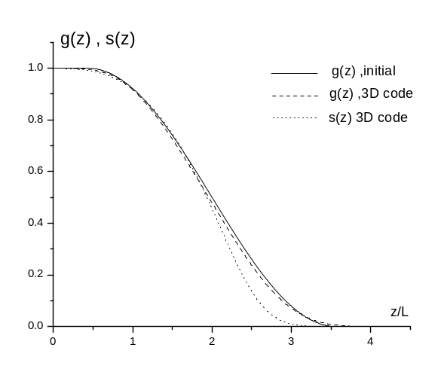
Fig. A4-7. Analytical and computer simulated falloff functions.

References
A4-1. A.A. Kolomiets, T.E. Tretjakova and S.G. Yaramishev. DESRFQ – a code for Generation of Radio Frequency Qudarupole. ITEP report, 2001.
A4-2. K. R. Crandall Effects of Vane-Tip geometry on the Electric Fields in Radio-Frequency Quadrupole Linacs. Technical report LA-9595, LANL, April 1983.
A4-3. L. Root. TRIUMF report. 1996.

Appendix 5. Particle simulation in dipole magnets

Four coordinate systems (CS) are used for the dipole: an entrance CS (X_{in},Z_{in}), an exit CS (X_{out},Z_{out}), an entrance fringe field CS (X₁,Z₁ ) and an exit fringe field CS (X₂,Z₂ ). Axis Z₁ is normal to the entrance effective field boundary. Axis Z₂ is normal to the exit effective field boundary. The positive Y direction is out of the page, see Fig. A5-1. TRACK sign convention for parameters is identical to the sign convention in the TRANSPORT code. θ>0 means rotation of the beam direction clockwise about positive Y axis. Positive β₁, β₂ imply transverse focusing i. e. focusing in YZ plane. Positive R₁, R₂ (convex curvature) represent negative sextupole components. On Fig. A5-1 θ>0 , β₁>0 , β₂<0, R₁>0 , R₂>0 .
The central trajectory is defined using the “hard edge” approximation as a straight line, a circular arc and another straight line. There is no particle moving along this trajectory in realistic field. As a central trajectory we use the trajectory which coincides with the circular arc inside the dipole, see Fig. A5-2. We also suggest that the beam enters the dipole along Z_{in} –axis and exit along Z_{out} –axis. To provide these conditions, the dipole is artificially moved Δx=-xcr1 and Δz =-xcr2/sin(θ) w.r.t. the entrance coordinate system (X_{in}, Z_{in}). XCR1 and XCR2 are parallel shifts of the realistic central trajectory w.r.t. the hard edge central trajectory at entry and exit fringe fields respectively [A5-1, A5-2]. The code TRACK evaluates XCR1 and XCR2 and shifts the dipole automatically.
TRACK dipole aperture is a curvilinear tube with the rectangular cross section. The shape of the tube is defined in Fig. A5-3. The vacuum tube has finite thickness and it is taken into account by the parameter δ₁ (δ₁=0.9 by default).

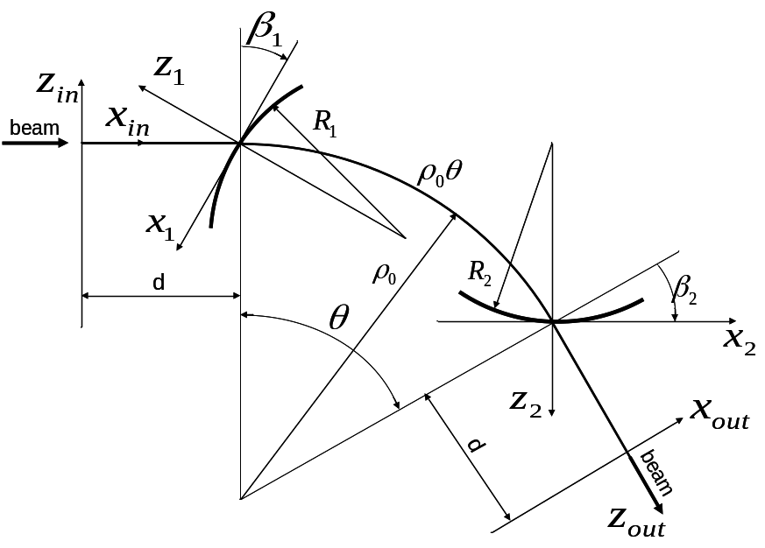

Fig. A5-1: Definition of dipole parameters in the TRACK code.

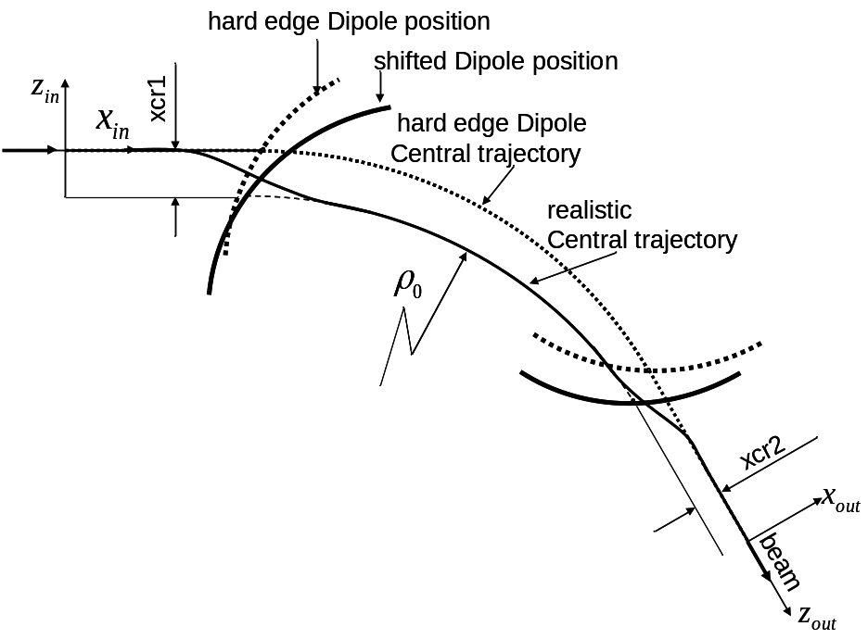
Fig. A5-2: The reference particle (central) trajectory.

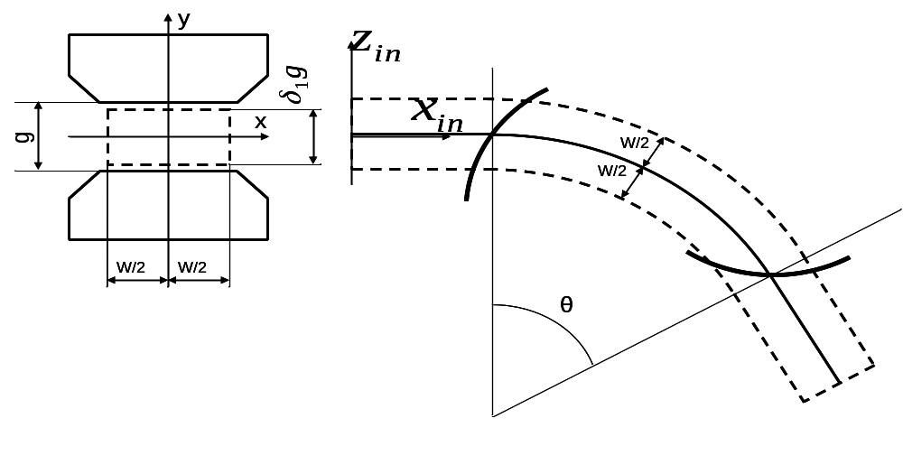
Fig. A5-3. The dipole aperture.

The element bmag is a dipole magnet with the homogenous magnetic field in the central region of the magnet and rounded pole tip edges. Due to rounded pole shape (see Fig A5-1), only the field components B_{y}(0,y,z) and B_{z}(0,y,z) are needed for the field calculations in the fringe field regions. We use the Enge type function E(z) for magnetic field falloff at the dipole edges {A5-5, A5—6], see Fig. A5-4.

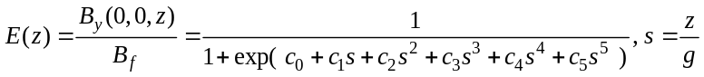 (A5-1)

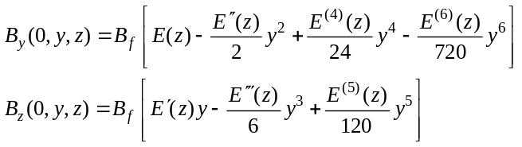 (A5-2)

The entrance fringe field covers an interval from z11=-δ₂g to 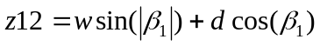 and the exit fringe field covers an interval
from z21=-δ₂g to 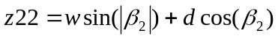.
2D field tables are also available for the bmag fringe fields evaluation. These tables have to be defined on a rectangular grid {0≤y≤g/2, z11≤z≤z12} for
enrance fringe field and on a rectangular grid {0≤y≤g/2, z21≤z≤z22} for the
exit fringe field,see Fig. A5-5B
The codes “TRANSPORT” [A5-1] and “TRACE-3D” [A5-2] use the parameter
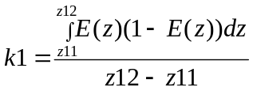 (A5-3)
the code “GIOS” [A5-3] uses the function E(z),and the code “RAYTRACE” [A5-4] uses 2D tables with B_{y}(x,0,z) for fringe field description.
The momentum p of the reference particle, magnetic field Bf in the uniform region, and k1, xcr1, xcr2, x11, z11, x12, z12, x21, z21, x22 and z22 are the output parameters of the TRACK code.

********************************************************************************This section is the description of the element “dipo”. Currently it is under development.

The “dipo” is a dipole with the homogenous field or field with a field gradient inside the magnet (the uniform field region in the element “bmag”). The field expansion in the median plane is given by:

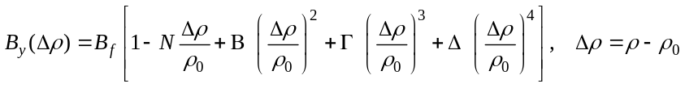, (A5-4)

where ρ is the distance between the point and the curvature center of the layout circular arc (see fig. A5-1). 2D tables are used for the definition of the magnetic field in the fringe field regions. These tables are defined in the Cortesian coordinates, see Fig. A5-4,{-xmax≤x≤xmax, zmin≤z≤zmax}, where xmax = max(x11,x12,x21,x22), for the entrance and exit fringe fields. The y-component of the magnetic field B_{y}(x,0,z) is given on the median plane.

********************************************************************************
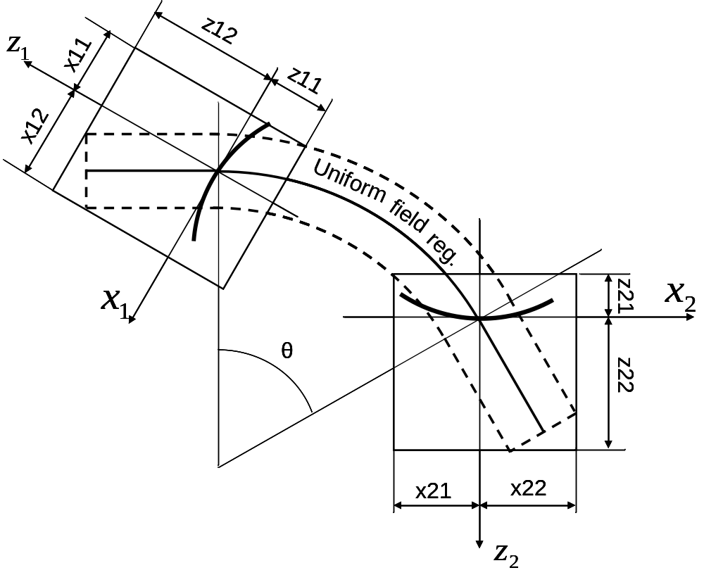
Fig. A5-4. Fringe fields extension in the median plane.

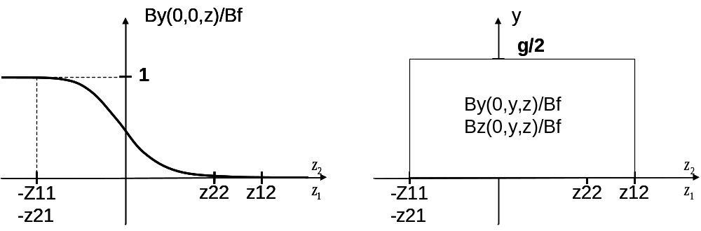

a) b)

Fig. A5-5. Fringe fields extension in the {y,z} plane.
References
[A5-1] K.L. Brown, The ion optical program TRANSPORT. Technical Report 91, SLAC, 1979.
[A5-2] K.R. Crandall, TRACE 3-D Documentation, Report LA-11054-MS, Los Alamos, 1987.
[A5-3] H. Wollnik, J. Brezina and M. Berz, Nucl. Instr. and Meth. A 258 (1987) 408.
[A5-4] S. Kowalsky and H.A. Enge, RAYTRACE, MIT Report, Cambridge, Massachusetts, July 1, 1987.
[A5-5] H.A. Enge, Rev. of Sci. Instr, 34, 385 (1964)
[A5-6] H.A. Enge, Rev. of Sci. Instr, 35, 278 (1964)

A5.1 Structure line for the element “rounded DIPOLE”

amu= 931.49432d3[keV/u]
W is the kinetic energy per nucleon
Q is the ion charge
A is the ion mass
γ=1+W/amu, 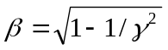 p[GeV/c]=10⁻⁶⋅amu⋅βγ/(Q/A) 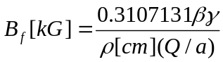

0 bmag L ρ θ g w β₁ β₂ 1/ R₁ 1/R₂ nstep

The input file for the same element in the code TRANSPORT
' DIPOLE '
0
15. 1. 'mm' 0.1 ;
15. 5. 'mm' 0.1 ;
15. 6. 'P/10' 0.1 ;
1. 0. 0. 0. 0. 0. 0. p ;
17. '2ND ' ;
16. 5. w/2 ;
16. 5. g/2 ;
16. 7. k1 ;
16. 8. 0. ;
16. 12. 1/R₁ ;
16. 12. 1/R₂ ;

20. 180. ; (if θ<0)
3. d=0.5(L- ρ|θ| ) ;
2. β₁ ;
4. ρ|θ|, Bf 0.0 'BMAG' ;
2. β₂;
3. d=0.5(L- ρ|θ| ) ;
20. -180. ; (if θ<0)
SENTININEL

Appendix 6. Creation of user defined initial distribution.

Frequently it is useful to start the simulation with the existing particle distribution, not from the initial distribution generated inside the code. A particular example is the simulation of the SC linac with the initial distribution obtained from TRACK or another code by simulation of the elements located upstream of the SC linac. For beam loss simulation on the SC linac it is preferable to start with the distribution formed in the RFQ. For this and similar cases we have developed a possibility to write a file with the information of total charge states nqtot, average energy Wtmp [keV/u], number of particles of each charge state npat(ird), charge states qq(ird) and 6 coordinates of each particle. The maximum size of the particle coordinates is usually 0:500000, however, it can be larger for specific cases. The particle phase csi(i,iq) is in radians at the fundamental frequency of the accelerator or front end that was used for generation of the distribution.
Example: In the front end of the RIA driver linac there is MHB operating at 28.75 MHz therefore the simulation starts with fundamental frequency 28.75 MHz. The particle distribution is written into the file after the RFQ which operates at 57.5 MHz. Before writing into the file the array is reduced to 28.75 MHz by dividing the array elements by harmonic number which is 2 in this case.

The following text is the excerpt from the FORTRAN program which shows format of the file.

if (iwrite_dis.eq.1) then
open(1, file='read_dis.dat', status='unknown'
& ,access='SEQUENTIAL',form='UNFORMATTED')
write(1) Wtmp,nqtot
write(1) (npat(ird),ird=1,nqtot)
write(1) (qq (ird),ird=1,nqtot)
do iq = 1,nqtot
do i = 0,npat(iq)
write(1) x(i,iq) , xx(i,iq) , y(i,iq) , yy (i,iq),
& csi(i,iq)/harm0, bb (i,iq) , spin(i,iq)
enddo
enddo
close(1)
endif

Units:
x(i,iq)[cm], xx(i,iq)[rad], y(i,iq)[cm], yy(i,iq) [rad], csi(i,iq) [rad],
bb(i,iq) [relative velocity] , spin(i,iq) [1.d0 if particle is within the acceptance of the following system, otherwise =-1d0]

To write a file with the particle distribution at the end of simulation the flag iwrite_dis=1.
Reading of the particle distribution will be done with the initial flag iread_dis=1.
By default these flags are equal to 0.
The following steps are necessary to provide correct simulation with the initial distribution which is read from the file read_dis.dat:
  - Make track.dat file assuming that the simulation starts with the internally generated distribution.
  - Be sure that files track.dat and sclinac.dat are compatible to start the simulation with fundamental frequency that was used for the phases in the file read_dis.dat.
  - In the “INDEX” section of the track.dat file set iread_dis=1.
  - Be sure that file read_dis.dat exists in the directory where all files related to the TRACKv35.exe code are located.
  - Check flag isol. For hard edge solenoids isol=0. Check parameter current=0 for zero space charge calculations. Set iflag_dis=1 for bunched beam structure, not for dc beam.

Appendix 7. A short manual for longitudinal corrections using TRACK
A correction section should be bracketed between two 'cdump' commands with the same index number 'n'. The index number 'n' refers to the number of the correction section; the first is 1, the second is 2, ...
An example of a correction section is given below
n cdump
..
..
.. here is the regular lattice
..
..
..
phcor i1 i2 r1 r2
n cdump
The command 'phcor' is the actual correction command, it should be bewteen two 'cdump' commands of the same index. The arguments of the command 'phcor' are:
i1: energy correction flag:
i1=0 No correction;
i1=1 correction using the reference charge state average energy;
i1=2 correction using the multiple charge state beam average energy.
i2: phase correction flag:
i2=0 No correction;
i2=1 correction using the reference charge state average phase;
i2=2 correction using the multiple charge state beam average phase.
r1: energy correction residual error in %
r2: phase correction residual error in deg

1 This work is supported by the U. S. Department of Energy, Office of Nuclear Physics, under contract No. DE-AC02-06CH11357.
The version of TRACKv37 for multiprocessor platform operating on LINUX has been also developed.
In this write-up the term “device” and “beam-line element” are equivalent.
LINUX version of the TRACKv37 exists and the Manual is being written.

