# **­­­­­Data Trends for Guana Water Quality Sampling Project**

## Background

Monthly water sample collections began in the Guana system in July 2017 with five sites: Micklers, Lake Middle, Lake South, River North and Guana River. This totaled to three stations in the Guana Lake and two in the Guana River. All water samples were sent to ALS Environmental Labs in Jacksonville, FL for nutrient analyses.

Starting in July 2018, at the conclusion of the one-year pilot study, an additional five sampling stations were added after input and additional funding from Florida Department of Environmental Protection’s (FDEP) Division of Environmental Assessment and Restoration (DEAR) and Florida Fish and Wildlife Conservation Commission (FWC). The original five stations, plus these new five stations, were then sampled for another full year (see map).

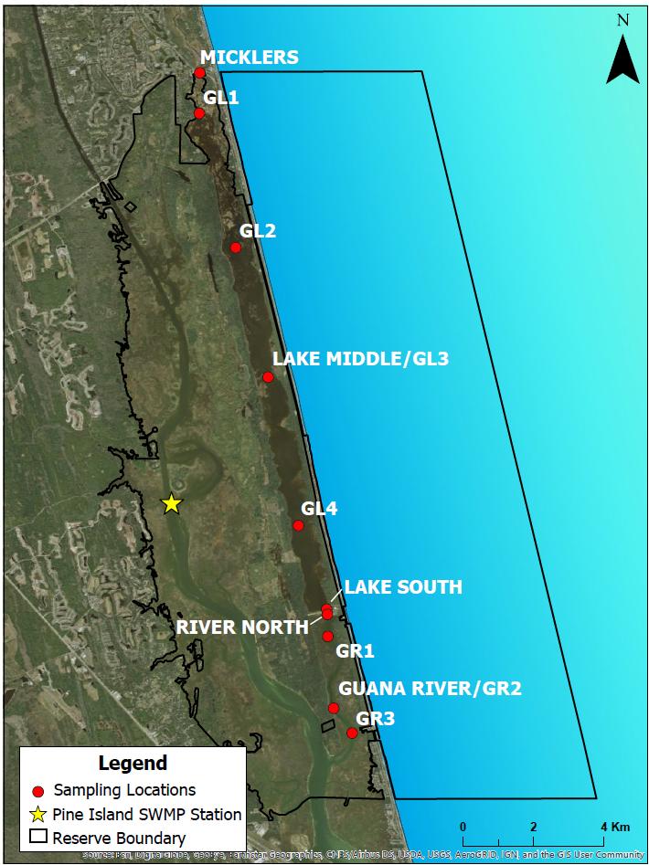

All of the data included in the calculations and figures below has been provisionally reviewed but has not gone through a quality assurance and quality check (QAQC) process with GTMNERR staff. The attached figures are also not finalized products as an official two-year project report is still in progress at this time. For any further questions, please reach out to the project’s principal investigator, Dr. Nikki Dix ([Nikki.Dix@floridadep.gov](mailto:Nikki.Dix@floridadep.gov)).

## Parameters available in dataset:

|  |  |
| --- | --- |
| Parameter | Abbrev |
| Total Alkalinity | Alkalinity |
| Wind Direction | WIND_D |
| Chlorophyll a, Uncorrected (Trichromatic) | CHLa_UnC |
| Total Nitrogen | TN |
| Total Suspended Solids | TSS |
| Fluoride | Fluoride |
| Organic Carbon | W-TOC |
| Air temperature | ATEMP |
| Wind Speed | WIND_S |
| Water temperature | WTEM |
| Ammonia as Nitrogen, Dissolved | NH4_N |
| Chlorophyll a, Corrected (Monochromatic) | CHLa_C |
| Chlorophyll b (Trichromatic) | CHLb_Tri_N |
| Chlorophyll c (Trichromatic) | CHLc_Tri_N |
| Nitrate+Nitrite | NO23F |
| Turbidity | Turbidity |
| Secchi Disk | SECCHI |
| Water Depth | WDEPTH |
| Specific Conductance | SpCond |
| pH | pH |
| Dissolved oxygen | DO |
| Dissolved oxygen, percent saturation | DO_p |
| Salinity | SALT |
| Coliform, Fecal | FECCOL |
| Enterococcus | ENTERO |
| Kjeldahl Nitrogen, Dissolved | DTKN |
| Total Phosphorus | TP |
| Kjeldahl Nitrogen | TKN |
| OD664b/OD665a | OD664b/OD665a |
| Pheophytin a | PHEA |
| human-specific HF183 Bacteroides genetic marker | HF183 |
| Fluridone | Fluridone |
| Linuron | Linuron |
| Methylchlorophenoxypropionic acid | MCPP |
| Naproxen | Naproxen |
| 2,4-Dichlorophenoxyacetic acid | 2, 4-D |
| Triclopyr | Triclopyr |
| TDS | W-TDS |
| Chloride | W-CL-IC |
| Sulfate | W-SO4-IC |
| Sucralose | Sucra |
| Acetaminophen | Aceta |
| Bentazon | Bentazon |
| Carbamazepine | Carbamazepine |
| Diuron | Diuron |
| Fenuron | Fenuron |
| Hydrocodone | Hydrocodone |
| Ibuprofen | Ibuprofen |
| Imazapyr | Imazapyr |
| Imidacloprid | Imidacloprid |
| Primidone | Primidone |
| Pyraclostrobin | Pyraclostrobin |
| Color (true) | W-COLOR |
| coastal bird specific Catellicoccus marimammalium Gull2 genetic marker | GULL2 |
| bird specific Helicobacter GFD genetic marker | GFD |
| Bromide | W-BR-IC |
| Ruminant specific Bacteroidetes BacR genetic marker | BacR |
| canine-specific DG3 Bacteroides genetic marker | DG3 |

## Figures

The following are figures of the open water stations (not near a water control structure) in Guana Lake that would most likely be included in an assessment by FDEP. The chlorophyll *a* data presented in the figures and used in calculations of the annual geometric mean has had the pheophytin correction.

### Chlorophyll

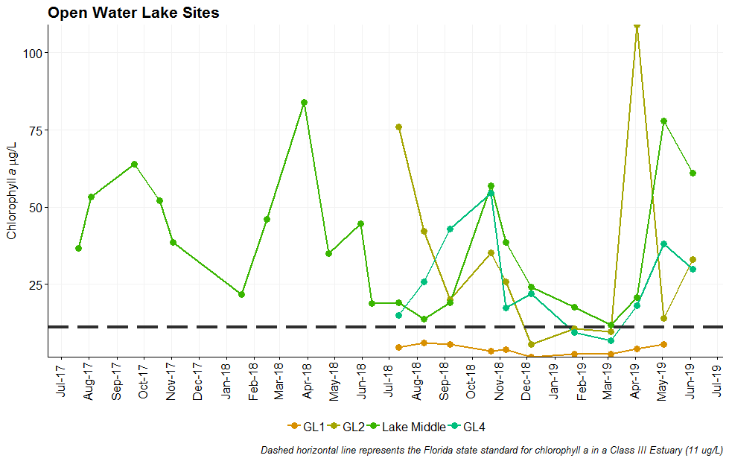

### Total Nitrogen (mg/L)

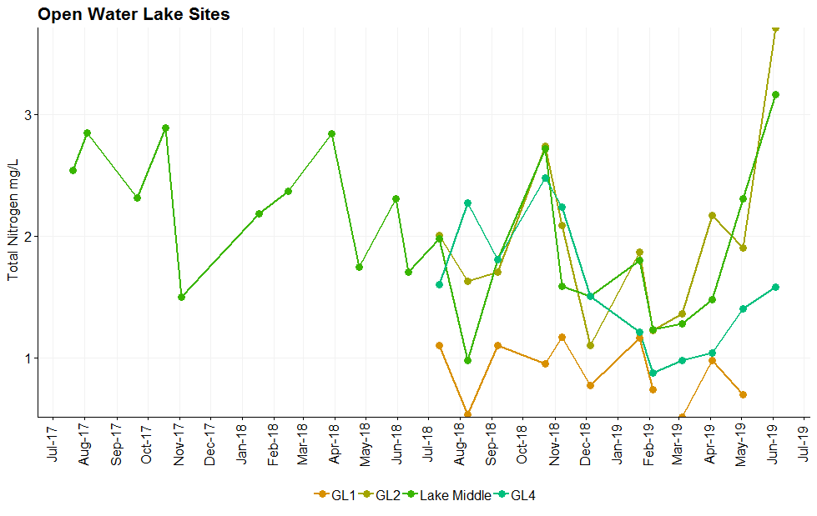

### Total Phosphorus (mg/L)

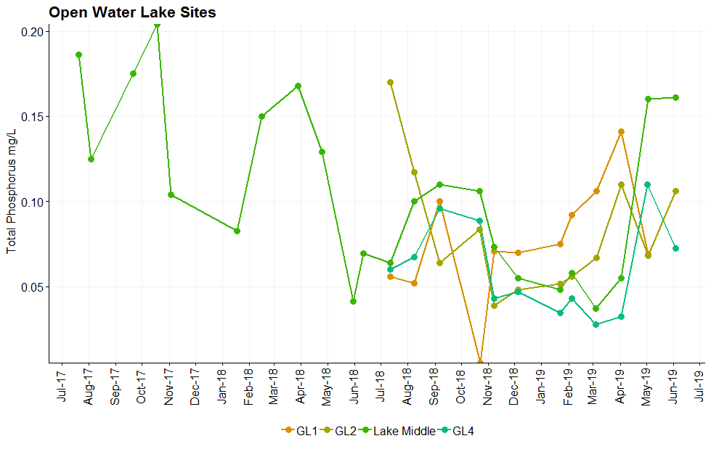

### Enterococcus

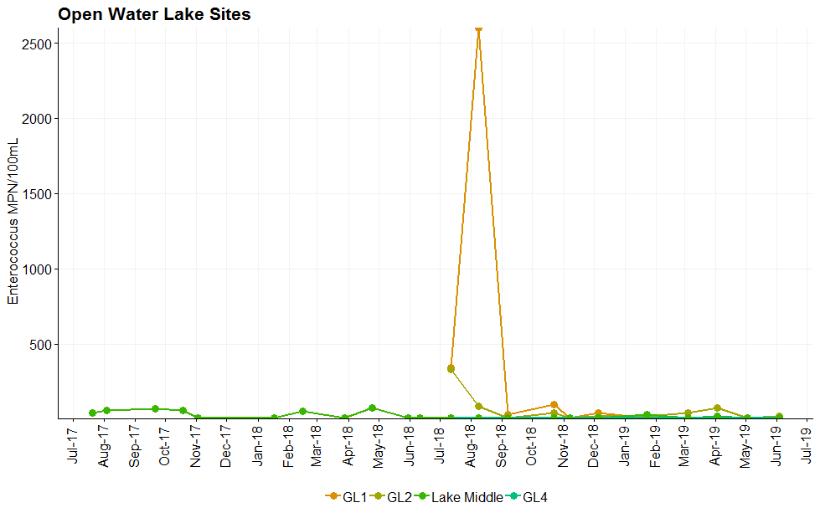

When the extreme data point is removed, most of the values are below 100 MPN/100mL. 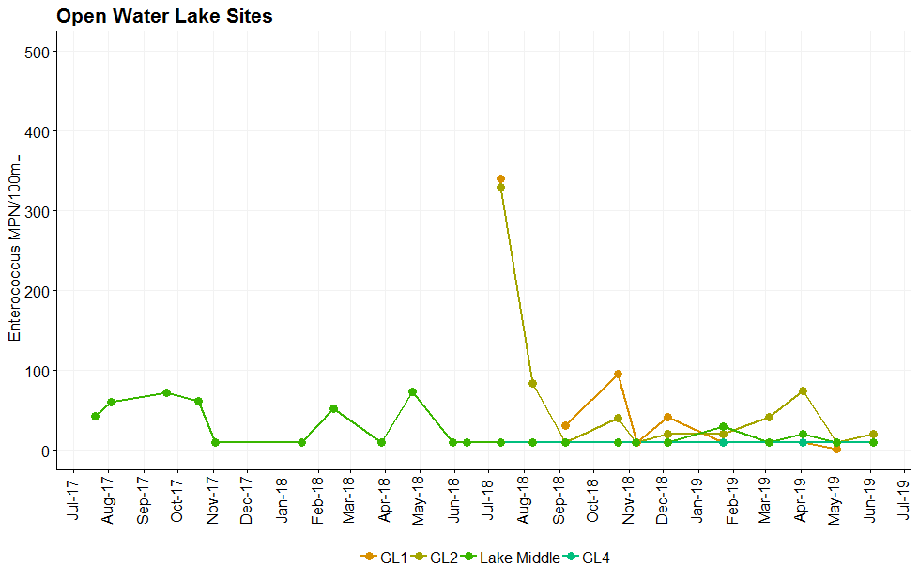

### Salinity

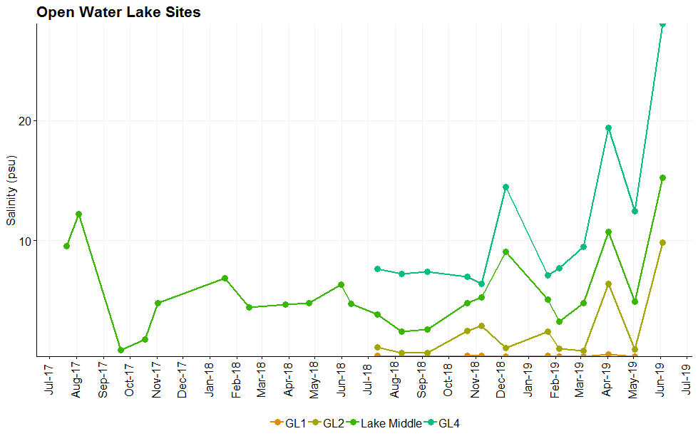

## Annual Geometric Means

Below are the calculated geometric means of each year of sampling. “Year 1” (July 2017-June 2018), only includes data collected at the Lake Middle site. For more direct comparison in “Year 2” (July 2018 – June 2019), all open water lake sites and Lake Middle data are presented.

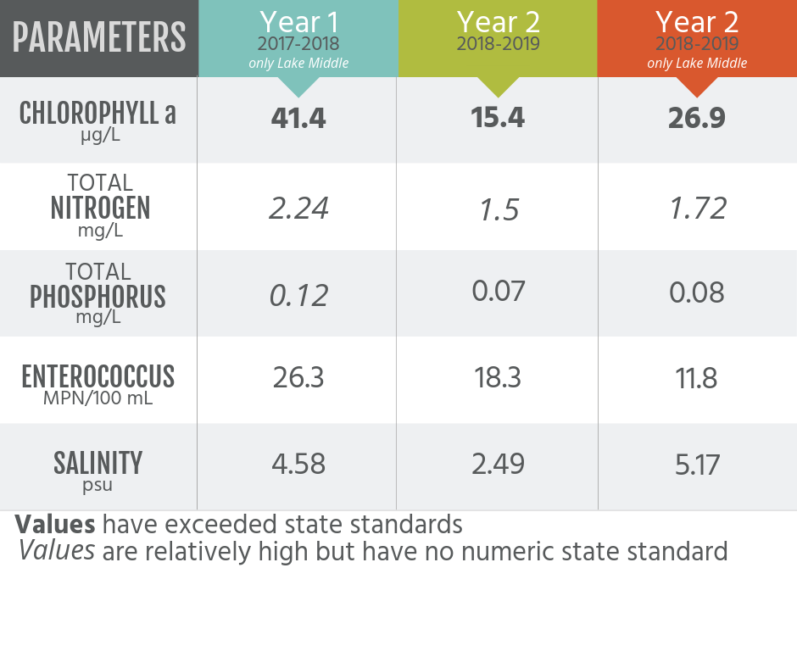

## Waterbody Criteria

