**Haul-out behavior and detectability of bearded, ribbon, and spotted seals in the Bering and Chukchi Seas**

Joshua M. London, Paul B. Conn, Erin L. Richmond, Jay M. Ver Hoef, Stacie Hardy, Irina S. Trukhanova, Michael C. Cameron, and Peter L. Boveng

Marine Mammal Laboratory, Alaska Fisheries Science Center, NOAA-NMFS, 7600 Sand Point Way NE, Seattle, WA 98115 USA

*first author TBD (insert email here)

**Appendix C. Additional plots of covariate effects on seal haul-out probabilities.**

Fig C1. Predicted effect of atmospheric pressure on ribbon seal (*Histriophoca fasciata*) haul-out probability, as estimated with a generalized linear mixed pseudo-model. Predictions were made by averaging predictions over all values of other covariates (i.e., keeping other environmental covariates constant and varying atmospheric pressure values).

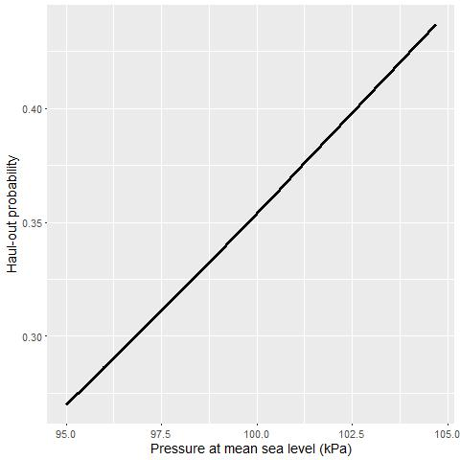

Fig C1. Predicted effect of precipitation on spotted seal (*Phoca largha*) haul-out probability, as estimated with a generalized linear mixed pseudo-model. Predictions were made by averaging predictions over all values of other covariates (i.e., keeping other environmental covariates constant and varying precipitation values).

