Haul-out behavior and aerial survey detectability of seals in the Bering and Chukchi Sea

Josh M. London1,✉, Paul B. Conn1, Stacie K. Hardy1, Erin L. Richmond1, Jay M. Ver Hoef1, Irina S. Tukhanova1, Michael F. Cameron1, and Peter L. Boveng1

1 Marine Mammal Laboratory, Alaska Fisheries Science Center, NOAA Fisheries, Seattle, Washington, USA

✉ Correspondence: [Josh M. London <[josh.london@noaa.gov](mailto:josh.london@noaa.gov)>](mailto:josh.london@noaa.gov)

## Abstract

Ice-associated seals rely on sea ice for a variety of activities, including breeding, molting, pupping, and rest. In the Arctic, many of these activities occur in spring and early summer (April-June) as sea ice begins to melt and retreat northward. Rapid acceleration of climate change in Arctic ecosystems is thus of concern, as the quantity and quality of suitable habitat is forecast to decrease. In this paper, we use data collected from satellite-linked telemetry tags deployed between 2005 and 2017 to investigate the seasonal timing and environmental factors affecting sea ice use by seals (specifically, bearded, ribbon, and spotted seals) in the Bering, and Chukchi seas. In addition to providing baseline data on phenology, these data also allow us to refine availability estimates needed to accurately estimate abundance from aerial survey counts of seals basking on ice (i.e., to correct for the proportion of animals that are in the water while surveys are conducted). Using generalized linear mixed pseudo-models to properly account for temporal autocorrelation, we fit models with a variety of covariates (e.g., day-of-year, solar hour, age-sex class, wind speed, barometric pressure, temperature, precipitation) to examine their ability to explain variation in hourly haul-out records. We found evidence for strong diurnal and seasonal patterns in haul-out behavior, as well as strong weather effects (particularly wind and temperature). In general, seals were more likely to bask on ice in the middle of the day and when wind speed was low and temperatures were higher. Haul-out propensity increased through March and April, peaking in May and early June before declining again. The timing and frequency of haul-out events also varied substantially based on species and age-sex class. For ribbon and spotted seals, models with year effects were highly supported, indicating that the timing and magnitude of haul-out behavior varied among years. This analysis suggested a large degree of plasticity in the timing of annual haul-out peaks, suggesting that they may have ability to adapt breeding, molting, and pupping to environmental conditions. Our analysis also emphasizes the importance of accounting for factors affecting haul-out behavior when interpreting the number of seals counted in aerial surveys.

keywords: availability; generalized linear mixed pseudo-model; haul-out behavior; phenology; Phocidae; sea ice

# Introduction

The global climate crisis is causing considerable reductions in seasonal Arctic sea ice extent, volume, and seasonal presence (Kwok 2018; Meier et al. 2014; Wang et al. 2017). These changes have ripple effects on Arctic ecosystems, taxa, and the human communities who live in the region. These disruptions are a particular cause of concern for ice-associated seals (ringed, bearded, spotted, and ribbon seals) which depend on spring and early summer sea ice (March-June) for diverse functions such as pupping, molting, breeding, and resting (Boveng et al. 2009, 2013; Cameron et al. [2010; Kelly et al. [2010). Limited data and large knowledge gaps prevent our ability to make definitive predictions about the ultimate effects of changes in sea ice on the abundance and distribution of these seals. Knowledge about biological constraints on the phenology of reproductive and molting behavior is generally lacking, so it is difficult to predict the readiness with which ice-associated seal species will be able to adapt to future changes (e.g., by adjusting pupping or molting schedules to earlier dates or different locales). Additionally, trends in abundance of these species are largely unknown, so it is difficult to say what effect, if any, declines in sea ice habitat have had, or will have, on seal densities.

Ultimately, knowledge of trends in phenology and abundance (or life history surrogates such as survival and recruitment) will be necessary to make credible quantitative predictions about the effects of the climate crisis on the abundance and distribution of Arctic seal populations. Before we can construct a trend, however, we first need credible data points. Several studies have contributed estimates of the distribution and abundance of ice-associated seal species in the Arctic using aerial surveys (e.g., (Bengtson et al. 2005), (Conn et al. 2014), and (Ver Hoef et al. 2014)). Such studies are conducted over very large areas and estimation of absolute abundance requires making inference about numerous nuisance processes affecting the observation of seals on ice. This includes availability (only seals basking on ice are available to be counted), detection probability (observers or automated detection systems may miss some seals on ice), species misclassification, and possible disturbance of seals by aircraft (Conn et al. 2014; Ver Hoef et al. 2014).

Quantitative studies regarding the phenology of sea ice use by seals and walruses have been conducted, but large knowledge gaps remain. Several authors have used logistic regression-style analyses to estimate the probability of sea ice use from data garnered from bio-loggers. In these models, haul-out probabilities are expressed as a function of predictive covariates, such as time-of-day, day-of-year, sex, age class, and environmental conditions (e.g., (Reder et al. 2003), (Bengtson and Cameron 2004), (Bengtson et al. 2005), (Udevitz et al. 2009), and (Ver Hoef et al. 2014)). However, sample sizes have often been low and insufficient to permit strong inference about life history and/or seasonal variation in haul-out probabilities. For instance, Bengtson and Cameron’s (2004) study included 5 adult and 2 juvenile crabeater seals, while Bengtson et al.’s (2005) study was based on 6 telemetered ringed seals (*Phoca hispida*) in the Chukchi Sea. These studies are often further limited by logistical constraints on tagging fieldwork and the attachment duration or operational life of satellite tags. For ringed seals, tagging can often only occur after seals emerge from snow dens in the spring . The use of satellite tags adhered to the back or head provide some benefits over flipper mounted tags (e.g. increased satellite transmittal rates), but these are lost during the annual molt, limiting the effective length of haul-out timelines.

This is a multiline comment ... blah blah blah ... blah blah blah ... blah blah blah ... blah blah blah ... blah blah blah ... blah blah blah ... blah blah blah ... blah blah blah

# Methods

## Data collection

Haul-out behavior data from 201 bio-loggers deployed on bearded, spotted, and ribbon seals was subset to include only records from the months of March, April, May, and June between 2005 and 2018. Bio-loggers were of the ‘SPLASH’ or ‘SPOT’ family of tags developed by Wildlife Computers (Redmond, Washington, USA) and either adhered to the hair on the seal or attached to the rear flipper inter-digital webbing. In cases where both tag types were deployed, percent dry observations from the flipper tag were preferred. Table 1 provides a summary of these deployments and data received from them.

Table 1: Summary of bio-logger deployments across seal species and age classification during the months of March, April, May, and June. Total seal hours represents the sum of available data across all seals.

| species | sex | YOUNG OF YEAR | SUBADULT | ADULT |
| --- | --- | --- | --- | --- |
| Bearded seal | F | 5 (5904 seal hours) | 4 (4296 seal hours) | 3 (3408 seal hours) |
| Bearded seal | M | 7 (6383 seal hours) | 12 (10584 seal hours) | 4 (3068 seal hours) |
| Ribbon seal | F | 17 (5438 seal hours) | 21 (13296 seal hours) | 50 (34480 seal hours) |
| Ribbon seal | M | 12 (5404 seal hours) | 21 (11102 seal hours) | 36 (26697 seal hours) |
| Spotted seal | F | 14 (14497 seal hours) | 11 (6694 seal hours) | 25 (18854 seal hours) |
| Spotted seal | M | 13 (9197 seal hours) | 11 (8264 seal hours) | 14 (14710 seal hours) |

Tags that fall off due to molt or mortality and remain on ice or land can still send data to satellites and we did not want to include data from these tags in our analyses. As such, start and end times of each deployment were made by experts who examined several simultaneous data streams (e.g., tag locations and dive behavior) to determine when tags

Haul-out behavior data was recorded and transmitted via the Argos satellite network as hourly percent-dry timelines. For each hour of a day, the wet/dry sensor was polled by the tag firmware every few seconds and a percent of the hour in a dry state was calculated. Each data transmission message consisted of a complete 24-hour record.

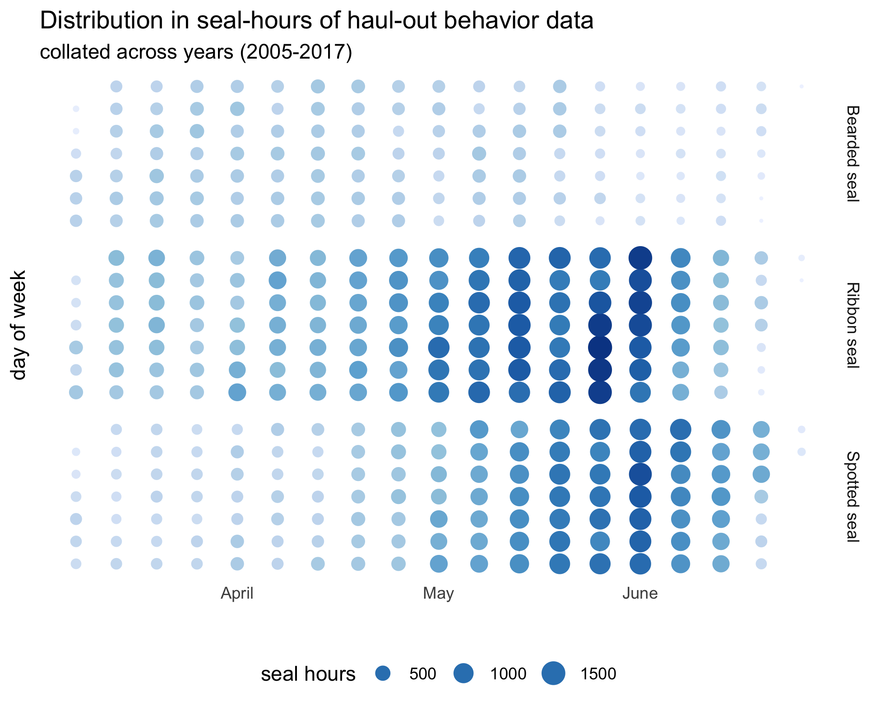

Figure 1: Distribution of of haul-out behavior data during the season of interest for each species. Data were collated across all years between 2005 and 2017.

# Acknowledgements

The findings and conclusions in the paper are those of the author(s) and do not necessarily represent the views of the National Marine Fisheries Service, NOAA. Any use of trade, product, or firm names does not imply an endorsement by the U.S. Government. Funding for this study was provided by the U.S. National Oceanic and Atmospheric Administration. MMPA permit #?

# References

Bengtson, John L, and Michael F Cameron. 2004. “Seasonal Haulout Patterns of Crabeater Seals (Lobodon Carcinophaga).” *Polar Biology* 27 (6): 344–49.

Bengtson, John L, Lisa M Hiruki-Raring, Michael A Simpkins, and Peter L Boveng. 2005. “Ringed and Bearded Seal Densities in the Eastern Chukchi Sea, 1999.” *Polar Biology* 28 (11): 833–45.

Boveng, Peter Laurens, John L. Bengtson, Troy William Buckley, Michael Foley Cameron, Shawn Patrick Dahle, Brendan Patrick Kelly, Bernard A. Megrey, James E. Overland, and Neal J. Williamson. 2009. “Status Review of the Spotted Seal (Phoca Largha).” Edited by Alaska Fisheries Science Center (U.S.), NOAA technical memorandum NMFS-AFSC ; 200,.

Boveng, Peter Laurens, John L. Bengtson, Michael Foley Cameron, Shawn Patrick Dahle, E. A. (Elizabeth A.) Logerwell, Josh M. London, James E. Overland, et al. 2013. “Status Review of the Ribbon Seal (Histriophoca Fasciata).” Edited by Alaska Fisheries Science Center (U.S.), NOAA technical memorandum NMFS-AFSC ; 255,.

Cameron, Michael Foley, John L. Bengtson, Peter Laurens Boveng, J. K. (John Kevin) Jansen, Brendan Patrick Kelly, Shawn Patrick Dahle, E. A. (Elizabeth A.) Logerwell, et al. [2010. “Status Review of the Bearded Seal (Erignathus Barbatus).” Edited by Alaska Fisheries Science Center (U.S.), NOAA technical memorandum NMFS-AFSC ; 211, [2010.

Cavalieri, Donald. 1996. “Sea Ice Concentrations from Nimbus-7 SMMR and DMSP SSM/I-SSMIS Passive Microwave Data, Version 1.” <https://doi.org/10.5067/8gq8lzqvl0vl>.

Conn, Paul B., Jay M. Ver Hoef, Brett T. McClintock, Erin E. Moreland, Josh M. London, Michael F. Cameron, Shawn P. Dahle, and Peter L. Boveng. 2014. “Estimating Multispecies Abundance Using Automated Detection Systems: Ice-Associated Seals in the Bering Sea.” Edited by Charles Francis. *Methods in Ecology and Evolution* 5 (12): 1280–93. <https://doi.org/10.1111/2041-210X.12127>.

Fedoseev, Gennadiı̆ Aleksandrovich. 2000. *Population Biology of Ice-Associated Forms of Seals and Their Role in the Northern Pacific Ecosystems*. Center for Russian Environmental Policy.

Kelly, Brendan Patrick, John L. Bengtson, Peter Laurens Boveng, Michael Foley Cameron, Shawn Patrick Dahle, J. K. (John Kevin) Jansen, E. A. (Elizabeth A.) Logerwell, et al. [2010. “Status Review of the Ringed Seal (Phoca Hispida).” Edited by Alaska Fisheries Science Center (U.S.), NOAA technical memorandum NMFS-AFSC ; 212, [2010.

Kwok, R. 2018. “Arctic Sea Ice Thickness, Volume, and Multiyear Ice Coverage: Losses and Coupled Variability (1958).” *Environmental Research Letters* 13 (10): 105005. <https://doi.org/10.1088/1748-9326/aae3ec>.

London, Josh M., Jay M. Ver Hoef, Steven J. Jeffries, Monique M. Lance, and Peter L. Boveng. 2012. “Haul-Out Behavior of Harbor Seals (Phoca Vitulina) in Hood Canal, Washington.” *PLoS One; San Francisco* 7 (6): e38180. https://doi.org/<http://dx.doi.org/10.1371/journal.pone.0038180>.

Meier, Walter N., Greta K. Hovelsrud, Bob E. H. van Oort, Jeffrey R. Key, Kit M. Kovacs, Christine Michel, Christian Haas, et al. 2014. “Arctic Sea Ice in Transformation: A Review of Recent Observed Changes and Impacts on Biology and Human Activity.” *Reviews of Geophysics* 52 (3): 185–217.

Mesinger, Fedor, Geoff DiMego, Eugenia Kalnay, Kenneth Mitchell, Perry C. Shafran, Wesley Ebisuzaki, Dušan Jović, et al. 2006. “North American Regional Reanalysis.” *Bulletin of the American Meteorological Society* 87 (3): 343–60. <https://doi.org/10.1175/BAMS-87-3-343>.

Perpiñán, Oscar. 2012. “solaR: Solar Radiation and Photovoltaic Systems with R.” *Journal of Statistical Software* 50 (9): 1–32.

R Core Team. 2019. *R: A Language and Environment for Statistical Computing*. Vienna, Austria: R Foundation for Statistical Computing.

Reder, S., C. Lydersen, W. Arnold, and K. M. Kovacs. 2003. “Haulout Behaviour of High Arctic Harbour Seals (Phoca Vitulina Vitulina) in Svalbard, Norway.” *Polar Biology* 27 (1): 6–16. <https://doi.org/10.1007/s00300-003-0557-1>.

Trukhanova, Irina S., Paul B. Conn, and Peter L. Boveng. 2018. “Taxonomy-Based Hierarchical Analysis of Natural Mortality: Polar and Subpolar Phocid Seals.” *Ecology and Evolution* 8 (21): 10530–41. <https://doi.org/10.1002/ece3.4522>.

Udevitz, Mark S., Chadwick V. Jay, Anthony S. Fischbach, and Joel L. Garlich-Miller. 2009. “Modeling Haul-Out Behavior of Walruses in Bering Sea Ice.” *Canadian Journal of Zoology* 87 (12): 1111–28. <https://doi.org/10.1139/Z09-098>.

Ver Hoef, Jay M., Michael F. Cameron, Peter L. Boveng, Josh M. London, and Erin E. Moreland. 2014. “A Spatial Hierarchical Model for Abundance of Three Ice-Associated Seal Species in the Eastern Bering Sea.” *Statistical Methodology*, Modern Statistical Methods in Ecology, 17 (March): 46–66. <https://doi.org/10.1016/j.stamet.2013.03.001>.

Ver Hoef, Jay M., Josh M. London, and Peter L. Boveng. 2010. “Fast Computing of Some Generalized Linear Mixed Pseudo-Models with Temporal Autocorrelation.” *Computational Statistics* 25 (1): 39–55. <https://doi.org/10.1007/s00180-009-0160-1>.

Wang, Muyin, Qiong Yang, James Overland, and Phyllis Stabeno. 2017. “Sea-Ice Cover Timing in the Pacific Arctic: The Present and Projections to Mid-Century by Selected Cmip5 Models.” *Deep Sea Research Part II: Topical Studies in Oceanography*, December. <https://doi.org/10.1016/j.dsr2.2017.11.017>.