# Chapter 2. Impacts of Two Extended Foraging Events by Mammal-Eating Killer Whales on the Population of Harbor Seals in Hood Canal, Washington.

## Introduction

The theory that transient-type, mammal-eating killer whales may be responsible for declines of pinniped populations in the Eastern North Pacific has garnered significant debate (Springer et al. 2003; Williams et al. 2004). This hypothesis stems from the conclusion that predation by a few killer whales is responsible for a dramatic decline in abundance of sea otters in the Aleutian Islands (Estes et al. 1998). Springer et al. (2003) expanded the top-down effect of killer whale predation to other pinniped species in the North Pacific. Their theories rely heavily on assumptions regarding daily metabolic requirements of wild killer whales and their functional response to prey populations. These assumptions and analyses were outlined in Williams et al. (2004). Unfortunately, opportunities to verify these assumptions with empirical data from wild populations are limited. Mammal-eating killer whales are characterized by discreet behavior and spend much of their time in remote locations not frequented by researchers. Therefore, knowledge of killer whale intake rates is limited to small datasets of mostly opportunistic data or extrapolations from captive killer whales or other large terrestrial carnivores.

One might imagine an ideal situation whereby daily requirements of killer whales could be estimated from a wild population. Under this scenario, a group of whales would be confined to a specific geographic area over a certain period of time. These whales would then be provided with a known amount of prey. As long as no additional prey were added to the area or removed by any means other than killer whale predation, differences in prey abundance would provide an estimate for daily energetic requirements and insights into the potential impact killer whales might have on isolated pinniped populations throughout the Eastern North Pacific. Additionally, observations of killer whales while in the area would provide an independent assessment of prey consumption.

Two recent extended foraging events by killer whales in Hood Canal, Washington are a close representation of this ideal situation and have provided an unprecedented opportunity to empirically measure the impact of mammal-eating killer whales on a pinniped population. Hood Canal is an isolated 100km fjord on the west side of Puget Sound and supported an estimated population of 1068 harbor seals in 2002. Between 2 January and 3 March, 2003, eleven mammal eating killer whales foraged exclusively within Hood Canal. A second group of six mammal-eating whales were in Hood Canal for 172 days in 2005.

Three separate killer whale ecotypes are present in the marine waters of the Pacific Northwest. Fish-eating, resident-type orcas are believed to feed exclusively on fish and predominantly on salmon. Fish-eating killer whales have a strong matrilineal social structure and have been extensively studied throughout Washington and British Columbia for the past 30 years. Mammal-eating, transient-type killer whales are known to feed exclusively on other marine mammals (seals, sea lions, small cetaceans and some large whales). Mammal-eating orcas are less frequently observed, although an extensive photo-identification catalog does exist and many individuals have been photographed at least once. Offshore killer whales are a third distinct ecotype and are most commonly found away from coastal waters. Little is known about this ecotype, though preliminary studies indicate they may be feeding on high trophic level fish species.

Killer whales have not had a significant presence in Hood Canal within the past thirty years, although both mammal-eating and fish-eating killer whales have been previously observed in Hood Canal. For both types, occurrences have been extremely rare and for less than one or two days. A few acoustic recordings of killer whales from U.S. Navy operations in Hood Canal have been confirmed and identified from their unique acoustic dialect as fish-eating orcas.

Harbor seals are reported to be one of the preferred prey items for mammal-eating killer whales, and harbor seals are the only consistently abundant resident marine mammal species known to occur in Hood Canal. Regular aerial and ground counts of harbor seals in Hood Canal have been conducted since the late 1970s and the population, as a part of the larger population of seals within the semi-enclosed marine waters of Washington, is believed to have stabilized at near carrying capacity in the mid-1990s (Jeffries et al. 2003). Tagging and telemetry studies conducted in Hood Canal and other areas of Washington indicate no significant movement of seals between areas and, therefore, any comparison of pre and post harbor seal relative abundance is likely not significantly compromised by emigration or immigration.

The unique nature of these two killer whale incursions to Hood Canal has provided an opportunity for empirical investigation into predation behavior of mammal-eating killer whales and their impacts on localized pinniped populations. In order to maximize this potential, a multi-faceted investigation was employed. The approach can be divided into three key areas. First, behavioral observations, mostly from the 2005 event, have provided opportunities to directly estimate killer whale consumption and document foraging behaviors of mammal-eating killer whales. Second, a quantitative analysis of harbor seal aerial survey counts over time provides a mechanism to evaluate expected population responses given the presence of killer whales. Third, bio-energetic modeling allows a more theoretical examination of the trophic impact of killer whales. Each facet provides an independent evaluation of the impact of killer whale predation on the population of harbor seals in Hood Canal. By comparing these estimates we not only gain insight into the trophic ecology of killer whales, but also the benefits and limitations of each approach.

## Methods

### Behavioral Observations

All behavioral observations were conducted under the authority of Scientific Research Permit No. 782-1719, issued by the National Marine Fisheries Service under the authority of the Marine Mammal Protection Act and the Endangered Species Act. Opportunities to observe killer whales in Hood Canal during 2003 were limited to a few days. Most of the 2003 field effort focused on documenting group structure through photo identification and understanding the spatial use of Hood Canal. All whales were photographed from the left and right side and individual identification was determined from identification catalogs.

Hood Canal is populated with a number of shore-side residences and, because of its narrow, fjord-like geography, provides ample opportunity for residents of Hood Canal to observe killer whales. Observations by a few residents and a dedicated volunteer provided the best information on movement and behavior of the whales in 2003.

In 2005, a coordinated effort between three research groups, in addition to observations of local residents and volunteers, provided a better dataset for examining killer whale foraging behavior and their spatial use patterns. As in 2003, all whales were photographed from their left and right side and identified through comparisons with photographic catalogs. Nineteen boat-based observations were conducted to document predations and movements of the killer whales within Hood Canal. Each observation was done opportunistically given weather and researcher availability. All observations were conducted from 19-21 foot outboard powered vessels and all available resources were used to locate the whales as soon as possible. Mobile phone coverage within Hood Canal allowed local residents to quickly communicate sightings to researchers and recent postings to internet distribution lists often provided critical information on sightings. When recent sightings were not available, a search transect of Hood Canal was conducted from the research boat until the whales were located.

Once whales were located, an initial GPS location was recorded and a trackline record was initiated. Whales were counted and visually identified to confirm all individuals were present. In general, the focus of the observation boat after first contact was to follow and record confirmed predation events without altering whale behavior. Under these circumstances, the general protocol was for the research boat to remain approximately 100m behind the whales. Fast acceleration and ‘leap frog’ actions were typically avoided and all attempts were made to minimize any effects the research boat might have on the behavior of the whales. For some of the observation periods, other objectives, such as collection of biopsy samples or prey remains, required temporary departures from this protocol.

A strict protocol was employed for identification and confirmation of predation events. Whales were closely observed for any changes in their behavior that might indicate potential interactions with harbor seals or other prey. All predations were confirmed by the presence of prey remains in the water column, an oil-slick on the surface of the water or an observation of prey remains within the mouth of a whale. Additional behavioral clues, such as observed interactions with live seals on the surface, and the presence of diving gulls provided further evidence of predation activity but were not used as sole confirmation of a predation event. The GPS location of all predation events was recorded, and each predation event was considered complete when the whales returned to their nominal travel behavior.

In order to extrapolate observed predations to an estimate of killer whale consumption, observations would ideally be of equal length and scheduled randomly across time. However, the opportunistic constraints of our effort negated the ability to plan observations in advance. Additionally, time to first location for any given planned observation trip was not predictable. Therefore, all attempts were made to approximate a random and unbiased sample of time. When possible, the length of the observation period was pre-determined on commencement. This was done to avoid any bias that might occur if whale behavior was used as a determining factor. For instance, it would not be advisable to consistently end observations after a predation event or to continue an observation until a predation event occurred. Both situations would bias the final estimates towards a higher consumption rate.

For each observation, a predation rate (kills/hour) was calculated from the number of confirmed predations and the length of the observation. An average predation rate was extrapolated across the duration of killer whale presence in Hood Canal under two scenarios. Scenario 1 assumes predations only occurred during daylight hours. All observations were conducted during daylight hours only. Information on the behavior of mammal-eating killer whales at night is limited and the only available study suggests indications of lower activity levels at night (Baird et al. *in review*). For the daylight-only scenario, the average predation rate was only extrapolated across hours between sunrise and sunset. Scenario 2 was evaluated under the assumption that predation rates observed during the day are representative of killer whale behavior across day and night. Under this scenario, the average predation rate was extended across all hours of the day.

### Generalized Linear Model

Aerial counts done between 1996 and 2004 were assembled and incorporated into a generalized linear model (GLM) to evaluate the impact of killer whale consumption in 2003 on the harbor seal population of Hood Canal. Further details on the aerial survey protocol can be found in Jeffries et al. (2003). When available, all counts were done from photographs taken during the aerial survey. When photographs were not taken, counts recorded by the aerial observer were used.

Harbor seal haul out patterns are known to be influenced by tidal height, tidal stage, time of day and day of year. Historical observations in Hood Canal suggest harbor seals are more likely to haul out at high tide stages in mid-afternoon and during the pupping (August-October) and molting (September-November) seasons. All aerial surveys in Hood Canal between 1996 and 2004 were flown between August and November and within +/- 2 hours of high tide. Because surveys are limited to times when seals are expected to haul out in the highest proportions, the inclusion of tidal factors (stage and height) were not included in the final GLM analysis.

Four hypotheses on how the Hood Canal seal population has responded to killer whale predation can be expressed as different GLMs. The first hypothesis suggests ‘no effects,’ and that aerial counts are correlated with only ‘day of year’ and ‘haul-out site.’ This hypothesis also suggests the population is stable over time period from 1996 to 2002. The second hypothesis predicts a ‘year effect’: the population of seals in Hood Canal is changing on an annual basis. The third hypothesis is the ‘treatment’ and represents a stable population between 1996 and 2000 that then changed in 2003 due to killer whale predation. The final hypothesis is similar to the ‘treatment’ effect but allows for growth in the population between 2003 and 2004. To evaluate whether there was a reduction in seal abundance in 2003, the four model variants were compared using AIC model selection.

At the time of writing, the aerial surveys of Hood Canal for 2005 have been completed but counts from photographs have not been finalized. Once final counts are available, a similar GLM analysis will be conducted.

### Bio-Energetic Monte Carlo Simulation

A bio-energetic model of killer whale consumption was developed to estimate the predicted number of seals consumed by killer whales during the extended stays in Hood Canal. Parameters for metabolic requirements for killer whales were selected from published literature and information on the caloric value of seals was derived from seals captured in Hood Canal, caloric analysis of seals from Washington state and values from published literature.

Caloric content of harbor seals was determined from two whole body carcasses collected in the Grays Harbor and south Puget Sound regions of Washington. Both animals were considered in healthy body condition at the time of death and were provided by the Washington Department of Fish and Wildlife.

Carcasses were ground whole in the food preparation area at United Farms in Graham, Washington. Homogenate was passed through the grinder twice to insure complete homogenization. Four approximate four ounce aliquots were taken from each homogenate and stored at -20 C. The grinder was washed and cleaned between each of the carcasses to minimize any cross contamination.

Calorimetric content was determined with a Parr 1425 semi-micro bomb calorimeter (Parr Instrument Company, Moline, Illinois). Two 10g sub samples from each specimen were dried to constant mass at 50 C. Constant mass was reached when the percent change in mass was less than 0.2% in a 24-hour period. Sub-samples were further homogenized with mortar and pestle and an approximate 0.10g pellet was used in the bomb calorimeter. Caloric content was determined and converted to wet weight values based on sample moisture loss during drying.

The equation for determining total caloric requirements of the mammal-eating killer whales in Hood Canal:

(Whale kcal/kg/day) x [(Adult Male Mass x Nm whales) + (Adult Female - Subadult Mass x Nf whales) + (Juvenile Mass x Nj whales)] x (t Days)

Where Nm = number of Adult Males, Nf = number of Adult Females and Subadults, Nj = number of Juveniles, and t = the number of days present in Hood Canal

The caloric value of harbor seals in Hood Canal can be determined from

*(Seal kcal/kg) x Seal Mass x Whale Assimilation Value*

Whale requirements divided by the caloric value of harbor seals results in a predicted number of harbor seals consumed. This value, however, does not accurately reflect uncertainty around any of the parameters. Therefore, a Monte Carlo simulation was used to include uncertainty in the final estimate.

**Table 2.1** Parameter values and distributions used in the Monte Carlo simulation of Killer Whale consumption of Harbor Seals in Hood Canal, Washington.

|  |  |  |  |
| --- | --- | --- | --- |
| Parameter | Source | Range | Distribution |
| Whale Requirements | Williams et al. (2004) | 55 kcal/kg/day | Fixed |
| Adult Male Mass |  | 4200-7000 kg | Uniform |
| Adult Female-Subadult Mass |  | 2100-3500 kg | Uniform |
| Juvenile Mass |  | 1365-2275 kg | Uniform |
| Harbor Seal Caloric Content | Perez | 2500-3800 kcal/kg | Uniform |
| Harbor Seal Mass | WDFW unpub. data | 50kg | Normal with s.d. = 7 |
| Assimilation Value | Williams et al. (2004) | 0.85 | Fixed |
| Number of Days |  | 59 | Fixed |
|  |  |  |  |

A range of values was used for each parameter in the model (Table 2.1). A value of 55 kcal/kg/day is the median value reported (51-59) by Williams et al. (2004) for metabolic requirement of mammal eating killer whales. Ranges for killer whale mass were determined from reported values and consultation with other killer whale biologists. The harbor seal caloric content range includes values determined from the analysis of seals from Washington as well as reported values by Perez (1990) for ringed seals. The harbor seal mass value is a weighted average of non-pup, non-pregnant harbor seals captured in Hood Canal between 1998 and 2002 (n=175). Non-pup, non-pregnant weights are used to best represent the available prey between January and June. The assimilation value of 0.85 is similar to values reported by Williams et al. (2004).

The bio-energetic model was calculated 15,000 times with new parameter values chosen from the listed ranges each time. A distribution of simulation outcomes and the median outcome along with 2.5 and 97.5 percentiles were calculated.

## Results

### Behavioral Observations

The killer whales present in 2003 and 2005 represent different individuals that are of no known relation. In 2003, the group consisted of 11 individuals (T14, T74, T73, T73a, T73b, T73c, T77, T77a, T77b, T123, and T123a) of which 2 were adult males (T14 and T74), 7 were sub-adults or females and 2 were juveniles (T73c and T77b). In 2005, six whales were present (T71, T71a, T71b, T124a, T124a1, T124a2) and the group was composed of two adult females (T71 and T124a) and their two offspring. With the exception of whale T14 (2003), these whales have limited to no sighting history in Washington state. The longest and most consistent sighting record of individuals from both groups comes from areas of northern Southeast Alaska (pers. comm. Jan Straley, University of Alaska Southeast, Sitka, AK).

Opportunities for detailed observations of the group in 2003 were limited to a few boat-based observations and sighting reports from residents of Hood Canal. All eleven whales were observed to use the entire expanse of Hood Canal and were most often observed as either one large group or two smaller groups of 5-6 whales. No confirmed predations were observed during boat-based research observations, however, several residents did report sightings of harbor seal predations and a few of those observations were confirmed with photographic documentation.

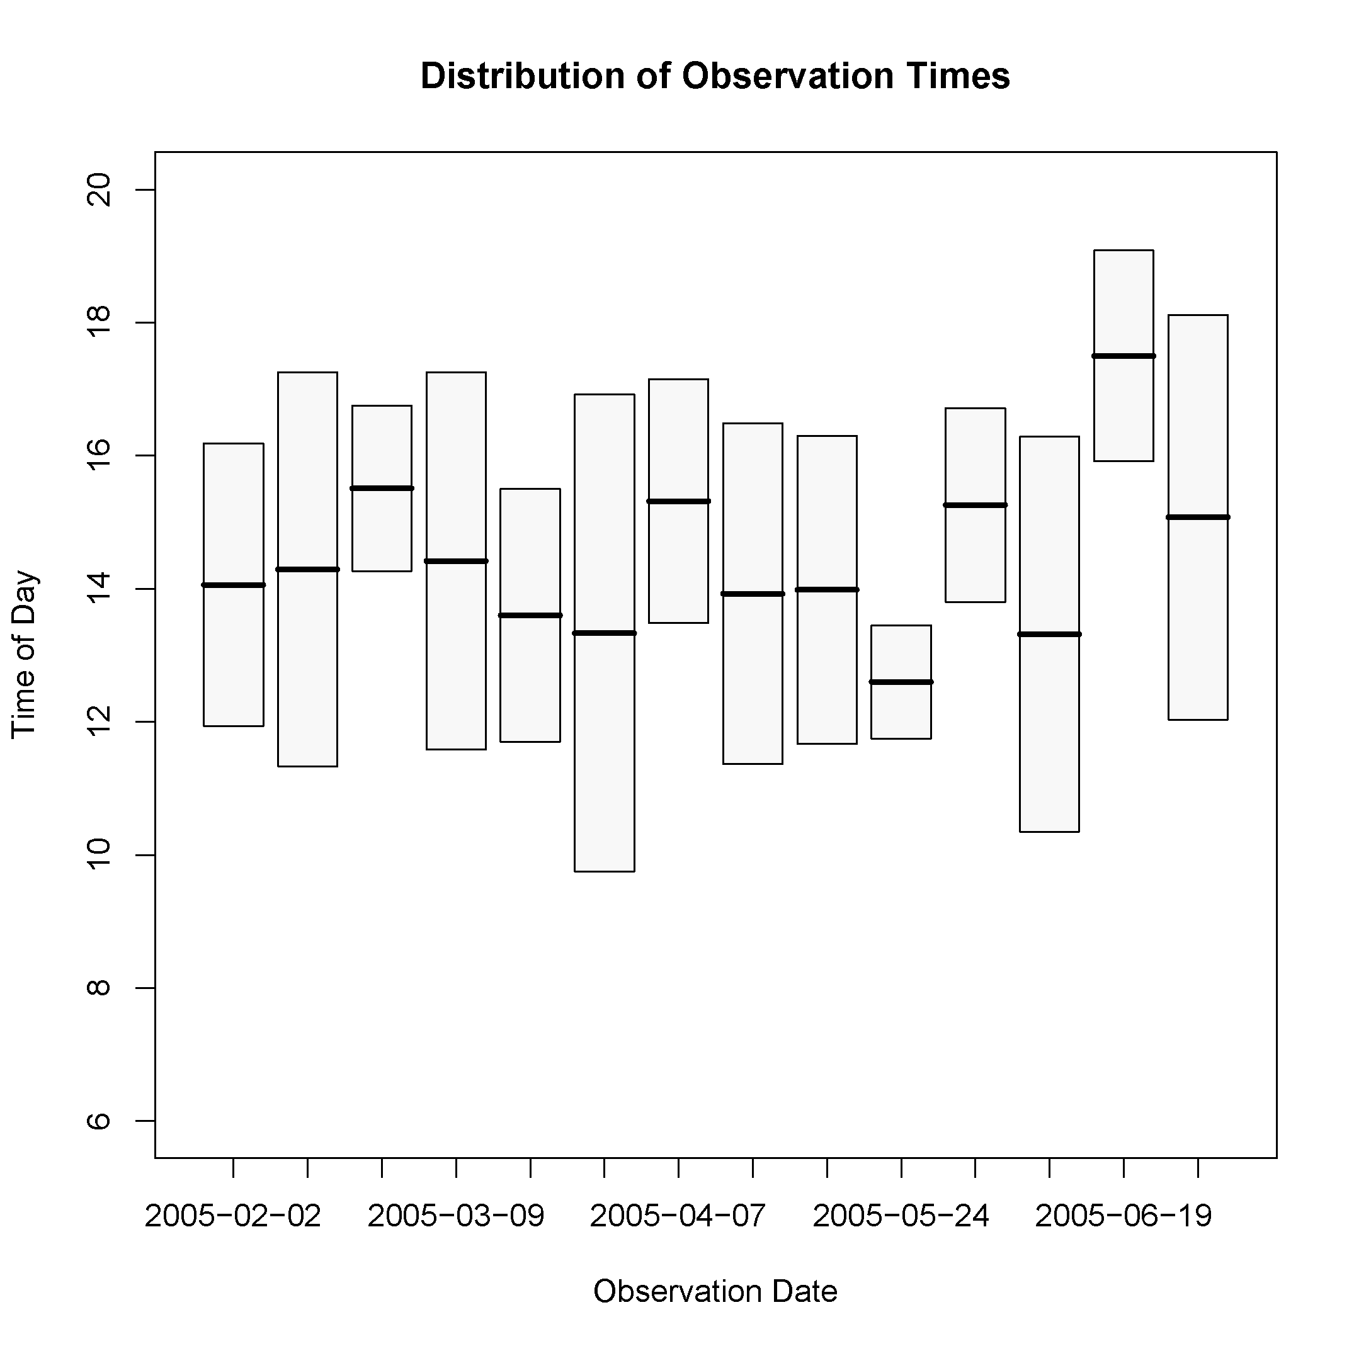

**Figure 2.1** Box plot of observation times during 2005. The box extents represent the time when observers were following the whales and the dark lines represent the mid-point of the observation.

Vessel based observation effort in 2005 was significantly greater than in 2003. Fourteen observation periods were conducted between February 2, 2005 and July 1, 2005.. The average observation period lasted 4.64 hours with a minimum of 1.7 hours and maximum of 7.17 hours (Figure 2.1).

GPS track-lines and predation locations (Figure 2.2) clearly demonstrate how these whales used the entire expanse of Hood Canal. Additional locations reported by residents to Orca Network (not shown) present a similar spatial use pattern.

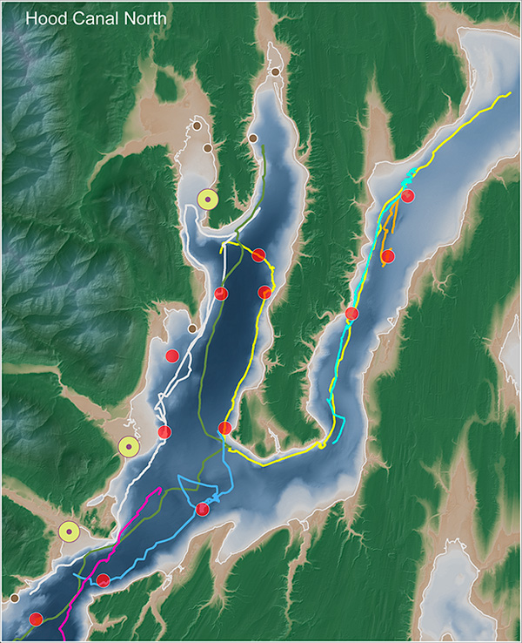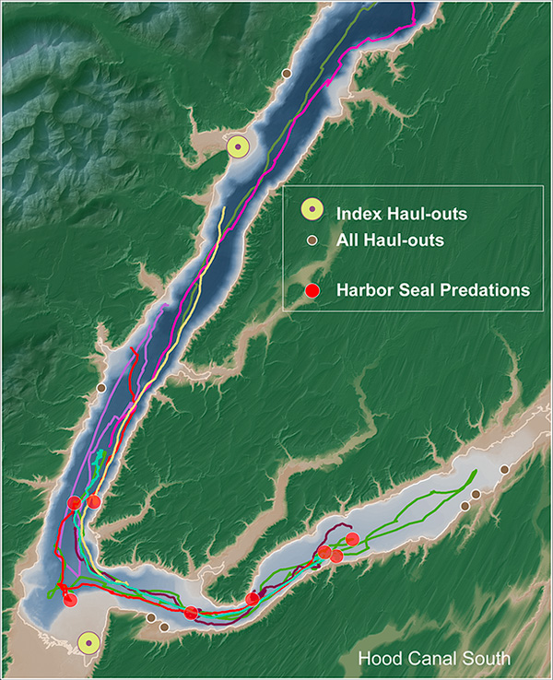

**Figure 2.2** Map of North and South Hood Canal showing tracklines from each of the boat based observations and locations of all confirmed harbor seal predations in 2005.

A total of 18 confirmed harbor seal predations were observed during the observation periods. One unsuccessful predation attempt on a California sea lion was also observed, but all other predation events were confirmed as harbor seals. It was not possible to determine the level of individual consumption; therefore a group predation rate was calculated. When adjusted for observation effort, the median consumption rate is 0.329 harbor seals per hour with boot-strapped 97.5 and 2.5 percentiles of 0.465 and 0.215 harbor seals per hour, respectively. The diurnal estimate for total consumption is 758 harbor seals consumed with a boot-strapped confidence interval of 495-1072. The estimate of consumption across all hours is 1358 with boot-strapped confidence interval of 887-1921.

Behaviors observed in Hood Canal appear to be typical of other mammal-eating killer whales. Predation events occurred over deep water, away from any shoreline, and within a few meters of the shoreline in relatively shallow water. The range of behaviors observed was also variable between events. On those occasions when a predation event was relatively short, an oil slick and small remains in the water column were often the only indication of harbor seal presence. However, extended predation events were often characterized by the presence of a seal at the surface. These longer predation events often involved a number of tail slap and ramming attacks on the seal.

### Generalized Linear Model

Counts from aerial surveys at five index haul-outs in Hood Canal do not exhibit obvious signs of significant population reduction after either of the killer whale incursions (Figure 2.3). The average count across years from 1996 to 2000 was 684. Huber et al. (2001) have proposed a correction factor for seals in the water of 1.56 for the inland waters of Washington. Thus, the pre-killer whale estimate of seals in Hood Canal is 1068.

**Figure 2.3** Box and whisker plot of aerial survey counts in Hood Canal summed across five index haul-outs for surveys flown between August and November from 1996 to 2004.

AIC values were determined for each GLM representing the four hypotheses (Table 2.2). The ‘Treatment + Growth’ model was favored with the lowest AIC value of 1070.064. However, the AIC values for the other models resulted in delta values of as little as 1.196 (‘Year Model’) and as much as 3.233 (‘Treatment Model’).

**Table 2.2** AIC values from four GLMs evaluating hypotheses of harbor seal population response to killer whale predation in Hood Canal, Washington

|  |  |
| --- | --- |
| Model | AIC |
| No Effect | 1072.736 |
| Year Effect | 1071.260 |
| Treatment Only | 1073.297 |
| Treatment + Growth | 1070.064 |

The treatment and growth coefficients calculated from the GLM under the favored ‘Treatment + Growth’ model suggest a treatment reduction of 24% (95% CI: +3.5% to -45.1%) after 2003 and a growth of 49% (95% CI: 0% to 123%) in 2004. Note, for treatment effect and growth, the 95% confidence intervals include 0%.

### Bio-energetic Monte Carlo Simulation

Moisture content values were approximately 42 to 51 percent in the two harbor seal carcasses processed (Table 2.3). The yearling harbor seal carcass was recovered from southern Puget Sound and had a mass of 19 kg. The sub-adult animal had a mass of 49 kg and was recovered from Gray’s Harbor, Washington.

The values of 2798 kcal/kg for the 49kg sub-adult and 3590 kcal/kg for the 19kg yearling are lower values than reported for ringed seals (Perez 1990) and other pinnipeds (Williams et al. 2004).

Table 2.3 Calorimetric values determined from whole body harbor seal carcasses recovered in Washington State.

|  |  |  |  |
| --- | --- | --- | --- |
| Age Class | Mass (kg) | % Moisture | kcal/kg |
| SubAdult | 49 kg | 42.6 | 2798 |
| Yearling | 19 kg | 50.8 | 3590 |

The bio-energetic Monte Carlo simulation for the 2003 event resulted in a median outcome of 997 seals consumed (5th and 95th percentiles: 708, 1435). For the 2005 event, the median outcome determined from the model was 960 (2.5 and 97.5 percentiles: 685, 1383). The distributions of outcomes for both events are strikingly similar (Figure 2.4). The bio-energetic model prediction compares with estimates of 758 and 1358 seals consumed for the diurnal only and all hour assumptions respectively. The estimate from the bio-energetic model falls almost near the midpoint of these two empirical estimates and the all-hour consumption estimate of 1358 is within the 95% confidence range. The daylight only estimate falls just outside the 2.5 percentile.

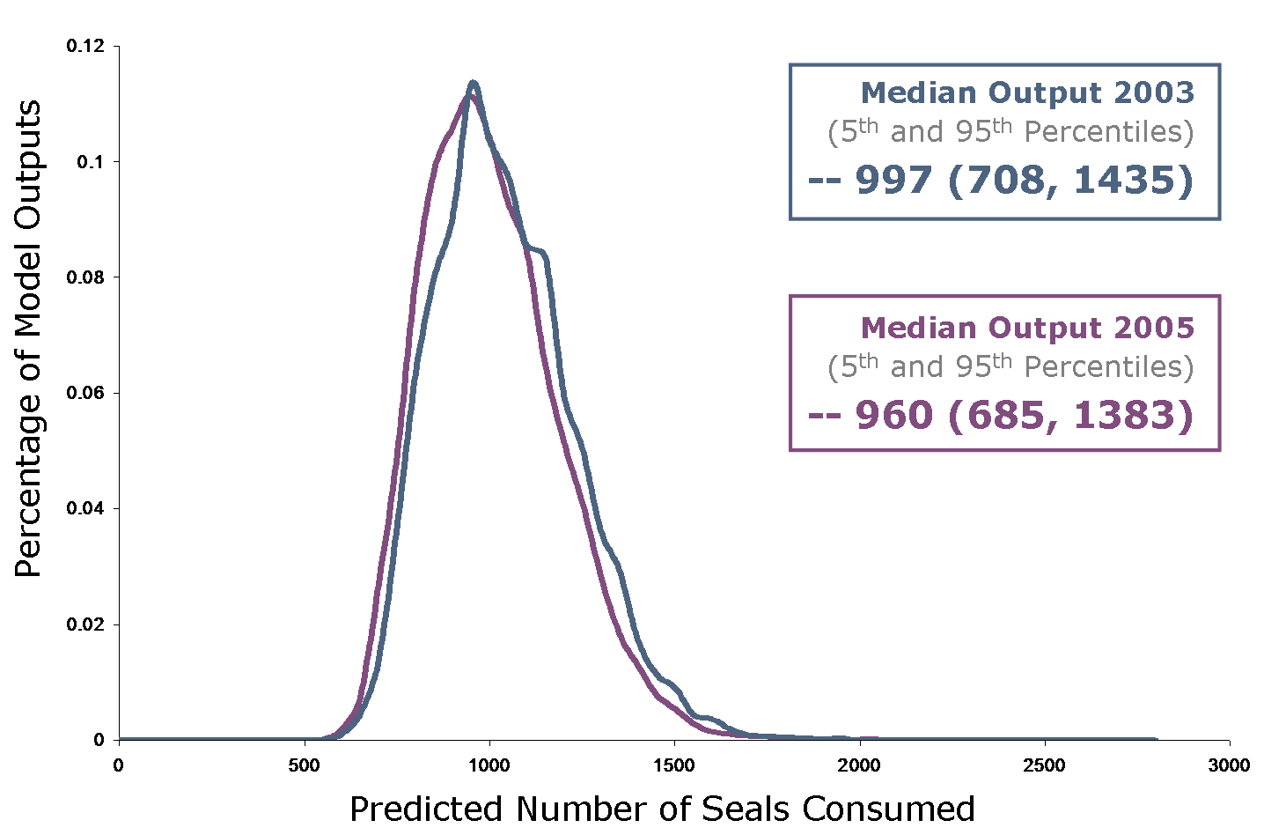

**Figure 2.4** Frequency distribution of model outputs from the bio-energetic Monte Carlo simulation for the 2003 and 2005 killer whale incursions.

## Discussion

### Behavioral Observations

The two extended foraging events by killer whales in Hood Canal differ in many respects from the expected behavior of mammal-eating killer whales. Transient type killer whales are thought to travel in small groups and spend only a few days in one particular area. With stays of 59 and 172 days, the Hood Canal events represent some of the longest reported stays by mammal-eating killer whales in one area. However, the observed behaviors while in Hood Canal were not atypical of those seen in other mammal-eating killer whales. In both 2003 and 2005, the killer whales appear to have used the full expanse of Hood Canal as part of their regular movement and foraging patterns. Neither group exhibited any abnormal behaviors that might be characteristic of a group trapped or lost.

Predation locations were not necessarily associated with harbor seal haul-outs. Harbor seal haul-out locations in Hood Canal are characterized by large, shallow-water, tidal expanses. The physical characteristics of these haul-outs would provide refuge from killer whale predation. Predation locations may better reflect harbor seal foraging locations. The seals would be more vulnerable during foraging activities and some of the predation locations do overlap with confirmed foraging locations from harbor seal movement studies in Hood Canal (WDFW unpublished data).

The estimate of total harbor seal predation during the 2005 event relies on two key assumptions. First, that every predation event occurring during an observation was recorded accurately. Most of the predation activity occurs under water and out of sight of the observer. This limitation is most obvious during shorter predation events when one might only get a fleeting glimpse at the prey animal. During longer events, it was more common to see a harbor seal at the surface and the final consumption was more easily confirmed. To alleviate uncertainty in our predation estimates, we employed a strict protocol for identification of predations. Given other reports of harbor seal predations being very subtle and hard to detect, estimates presented here are probably conservative.

The second assumption critical to the calculation of total harbor seal predation is that the predation rate observed during our observations is representative of the un-sampled period. With the limited observation time and opportunistic nature of the study plan, the robustness of our estimate is lower than would normally be desirable. However, we made a concerted effort to minimize any activity that would contribute any significant bias to the final outcome. It would be reasonable to expect the predation rate of the killer whale group in 2005 to change over the nearly six month presence in Hood Canal due to changes in prey availability or improved knowledge of the area. With only 18 observations, we are unable to examine this possibility. Fortunately, our observation effort is spread relatively even across this period and our estimate of average predation rate would not be overly influenced by any temporal changes.

All predation observations conducted were diurnal and little is known about nocturnal behaviors of mammal-eating killer whales. Baird et al. (in review) present limited data from time-depth recorders that suggest mammal-eating killer whales have a lower activity level at night compared to daylight hours. Given the uncertainty about circadian changes in foraging rates, we have chosen to present two estimates of total harbor seal consumption. One estimate is extrapolated across just the diurnal period, while the other is across all hours. Activity levels of killer whales are likely influenced by more than just light-level. Actual predation rate likely falls within the bounds of these two estimates.

### Bio-Energetic Model

Despite differences in the 2003 and 2005 events (number of days, number of whales, individuals present, age and sex distribution), projected consumption of harbor seals in each year based on the bio-energetic model is strikingly similar. A likely explanation for the model consistency is the importance of prey density and corresponding functional response of the killer whales. As the population of seals in Hood Canal drops due to killer whale predation, so does prey density and prey availability. At some threshold, the cost of finding and catching one more harbor seal in Hood Canal is no longer energetically beneficial and the whales leave. In Hood Canal, this threshold level appears to be a removal of just under 1000 seals and seems to have remained the same across these two events. The longer presence in Hood Canal for the 2005 group is a result of their smaller group size and the absence of large adult males, reducing their combined daily foraging requirements.

Parameters included in the bio-energetic model are reasonable given the current state of knowledge with respect to the ecology and biology of mammal-eating killer whales. By incorporating parameter uncertainty into the model we can better represent our understanding of killer whale bio-energetics and the range of population impacts that could be expected. Validation is a key aspect of any modeling exercise, and observations conducted during the 2005 incursion have provided an opportunity to compare the model predictions with empirical field data. Overall, the bio-energetic model is not inconsistent with empirical estimates determined from field observations. The bio-energetic model and range of parameters used appear to be appropriate predictors of killer whale consumption of harbor seals in Hood Canal.

### GLM Analysis of Harbor Seal Counts

The difference between the predicted impact of killer whales on the harbor seal population in Hood Canal and the observed population change is unexpectedly large. The reason for the disparity is unknown at this time. While many of the parameter values and ranges used in the bio-energetic model are not based on empirical data, we feel these values are reasonable based on all current knowledge of killer whale and large mammal bio-energetics. The aerial surveys do exhibit a large amount of variability within and between years. It is not known how much of the variability is due to natural variation and how much is related to sampling variability. A significant factor in this variation may be the influence of human disturbance on haul-out patterns of seals in Hood Canal.

The fact such a rare behavior has happened twice in the same location within two years suggests there may be something especially attractive about Hood Canal. The harbor seal population in Hood Canal is relatively naïve to killer whale predation. Hood Canal is a long and narrow fjord with deep water areas that may provide a situational advantage to the predator. Warmer temperatures and relative quietness of the environment in Hood Canal may also be of importance to killer whales. Any attempt to explain why whales have chosen Hood Canal for these extended stays is mostly speculative at this point. It does, however, seem clear from the bio-energetic models that prey density plays a critical role in determining the timing of departure from Hood Canal.