Guidelines for Routine User Maintenance of Gas Chromatographs

John-Michael Marquardt

Sr. Customer Support Engineer

**PerkinElmer** | *Discovery and Analytical Sciences*

April 02, 2020

Contents

Purpose 4

A. Gas Management 4

A.1. Traps and Filters 4

A.2. Regulators 4

A.3. Tubing and fittings 4

B. Headspace Autosampler Maintenance 5

B.1. The Sampling Needle (Jet Needle) 5

B.1.a. Types of HS Needles 5

B.1.b. Removing and Replacing the Needle (Headspace Only) 6

B.1.c. Cleaning the Jet Needle 7

B.2. Replacing the Needle O-ring’s and Needle Seal Assemblies 8

B.2.a. Replacing the Upper Needle Seal Assembly 8

B.2.b. Replacing the Lower Seal Assembly 10

B.2.c. Replacing the Sample Needle O-rings 12

B.3. Leak Testing the Sample Injection System 13

C. Clarus 500 GC Liquid Autosampler Maintenance (Building 50) 14

C.1. Per-use or Daily Maintenance 14

C.2. Routine Periodic Maintenance (every 500 injections) 14

C.3. Replacing a Syringe 15

C.3.a. Removing a Syringe 16

C.3.b. Cleaning a Syringe 16

C.3.c. Installing a Syringe 17

C.4. Replacing the Vial-Locator Mechanism 18

D. Capillary Split/Splitless (CAP) Injection Ports (injectors) 19

D.1. Replacing Septa 20

D.2. Replacing CAP Injector Liners 21

D.3. Removing a Broken Liner from the Injector Body 23

D.4. Replacing Charcoal traps on CAP Injectors 23

E. Flame Ionization Detector (FID) Maintenance 24

E.1. Replacing a FID Jet 24

E.2. Replacing the O-ring in the FID Collector 26

F. Tools 27

G. Consumable Parts and Frequency List 28

# Purpose

The purpose of this document is to provide the end-users in the Laboratories in buildings 46, 47 and 50 at DSM Dyneema, LLC (5750 Martin Luther King Jr. Highway, Greenville, North Carolina 27834) with a general guideline for maintaining their Clarus 500/580 gas chromatographs and Turbomatrix Headspace Autosamplers in-house, following the routine maintenance steps laid out in the instrument customer hardware and user guides. This document also contains recommendations for tools and consumables to have on hand as well as any industry standard best practices that are not expressly documented within the official manuals for the above instrument models. This document can be used stand-alone or as a guide for developing an in-house protocol by the customer. The images contained in this document as well as part numbers and some procedural steps and usage specifications come directly from the hardware and user guides, and exclude configurations and accessories that are not currently installed at the above site.

# A. Gas Management

## A.1. Traps and Filters

Gas traps and filters should be installed in-line between your ultra-high purity (UHP 5.0 grade or 99.999% purity) compressed gas cylinders and your instrument. A minimum purity of UHP Hydrogen, UHP Helium and Zero grade air should be used on GC systems. Traps should have high capacity and efficiency levels for oxygen, hydrocarbons and water such that the gas output of these traps is 99.9999% pure for chemical analysis. It is recommended for UHP 5.0 grade Helium (carrier flow) and UHP 5.0 grade Hydrogen to have traps for Oxygen, moisture and hydrocarbons. Zero grade Air requires traps for moisture and hydrocarbons only.

These traps need to be replaced by whichever occurs first of the following conditions:

1. The trap is saturated as indicated by performance or a physical indicator in the trap such as color changing particles.
2. The trap is clogged, leaking or otherwise malfunctioning or defective
3. You have had 12 tank changes since installing the trap or trap cartridge
4. The expiration date has passed or the maximum lifetime as indicated by the trap manufacturer has been exceeded.

Generally, traps should be replaced every year and purged with gas for 15 minutes at low flow before reconnecting the outlet of the gas cylinder to the GC. Part numbers for traps, cartridges, fittings etc. can be found in the attached consumables catalog.

## A.2. Regulators

Gas tank regulators have an average wear life on their gaskets of no more than (NMT) 5 years. Regulators should be replaced or rebuilt, and leak tested every 5 years with the appropriate style, purity and pressure ratings for the gas used. Leak test the regulator on every tank change and every time a new regulator is installed.

## A.3. Tubing and fittings

Copper tubing oxidizes and leaks over time and becomes brittle at the joints or in spots that experience changes in humidity or temperature (such as behind a GC oven). It is recommended that you use an electronic leak detector or a mixture of 50/50 isopropanol and water to check all fittings from the gas source to the back of the instrument on a monthly basis or if anything has disrupted the position of the tubing or connected instruments.

# B. Headspace Autosampler Maintenance

Before starting any maintenance:

1. Switch off all the instruments in the system.
2. Disconnect the instruments from the electrical supply.
3. Allow hot parts of the instrument to cool down.
4. Flame on GC Flame Ionization Detector must be off.
5. GC oven, injector and detector in the HS analytical column channel should be cool to the touch.

|  |  |
| --- | --- |
| **Item/Operation** | **Frequency** |
| Clean the Needle | Every 500 injections |
| Replace the Needle | When worn, corroded, clogged, uncleanable, or causing performance issues. |
| Replace needle O-ring seals | Every 1500 injections maximum. O-rings are rated for up to 1500 injections, usage may necessitate more frequent replacement. |
| Replace Needle Seal Assembly (black plastic disc that holds the needle O-rings) | Every 2500 injections or when visibly worn or scratched. |
| Perform Autosampler Leak Tests | After every user maintenance (above) or when a leak is suspected to be causing performance issues (e.g. loss of sample, excessive carrier gas consumption). |

## B.1. The Sampling Needle (Jet Needle)

Every 1500 injections the three O-ring seals on the needle need to be replaced. Usage and application may necessitate more frequent replacement. It is only necessary to replace the sampling needle when it is damaged, or when you wish to change to another needle type. You may also want to replace the needle if you are changing applications. A platinum/iridium (Pt/Ir) needle is available for highly corrosive applications and Siltek® inert coated needle is available for reactive samples. For most applications, the Standard Stainless-Steel needle (shipped with the instrument) is optimal.

### B.1.a. Types of HS Needles

Depending on the sample type, the jet needle installed on your system is commonly one of two different materials:

1. Standard stainless-steel needle (P/N B4000011). This needle has three grooves at the top of the needle to differentiate between the stainless-steel needle and the Pt/Ir needle.
2. Platinum/Iridium Needle for free volatile organic acids, bases and other corrosive compounds. The Pt/Ir needle has 4 grooves at the top of the needle (P/N B0510364).

### B.1.b. Removing and Replacing the Needle (Headspace Only)

To change or replace the needle (see the following figure):

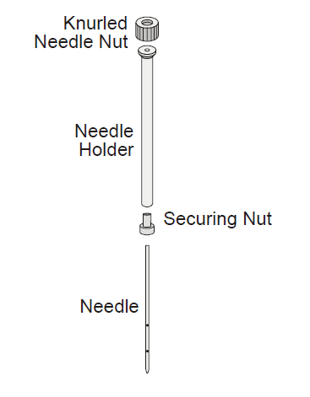

1. Turn off all heated zones by setting the temperature to 0. Allow approximately 30 minutes for the needle assembly and transfer line to cool down.
2. Once the system has cooled, switch off the instrument.
3. Turn off the gas supplies to the instrument. Ensure that the flame is out if using an FID and that your oven/injectors and detectors are at room temperature.
4. Disconnect the instruments from the electrical supply.
5. Pull gently on the magnetic door release to open the door.
6. Loosen and remove the knurled needle nut.
7. Lift the needle holder out of the rack.
8. Loosen the securing nut and pull the needle out.
9. Place the new needle in the needle holder nut. The top of the needle will butt up against the bottom of the needle holder.
10. Tighten the needle holder nut. The nut must be finger-tight.
11. Clean the needle with a lint free cloth or tissue. If necessary, dampen the cloth slightly with methanol.
12. Carefully slide the needle holder with the cleaned or new needle back into the rack as far as the stop. CAUTION: Do not touch the lower half of the needle with your fingers.
13. Rotate the needle so that the holes line up with the transfer line.
14. Securely hand-tighten the knurled nut.
15. Close the front panels and reconnect the instrument to the electrical supply.
16. Turn on the gases.
17. Power up the instrument.
18. Perform the leak test.

### B.1.c. Cleaning the Jet Needle

Abraded sealing material from the vial septa may stick to the needle and can cause the needle to seal incorrectly during pressurization and withdrawal. A needle coated with sealing material may also lead to unnecessary wear on the O-rings contained in the needle seal assemblies.

The recommended interval for cleaning the needle, will depend on the needle temperature and the type of septum being used. The minimum interval should be every 500 injections. Avoid unnecessarily high needle temperatures. Usually 10 °C above the thermostatting temperature is enough.

To clean your jet needle:

1. Remove the needle as outlined in Removing and Replacing the Needle (Headspace Only) above.
2. Clean the needle with a lint free cloth or tissue. If necessary, dampen the cloth slightly with methanol.
3. When you are wiping the needle, ensure that you do not force any material into the holes located on the side of the needle.
4. Blow filtered carrier gas through the needle.
5. Inspect the needle for dirt, debris, corrosion after cleaning. If there is any buildup of residue on the needle, or the holes on the side of the needle are discolored or clogged, replace the needle.
6. Install the cleaned or replaced needle in the headspace as described in B.1.b.
7. Perform the leak test.

## B.2. Replacing the Needle O-ring’s and Needle Seal Assemblies

### B.2.a. Replacing the Upper Needle Seal Assembly

Check the needle seal assemblies (Part Number B0500833) every 1500 injections. Replace the O-rings and check the holders for damage. The seal assemblies (holders and O-rings) need to be replaced if they are scored or scratched on the top or bottom surfaces. The graphite-coated, Viton® O-rings (B0198110) should be replaced every 1500 injections (maximum). The needle seal holders (B0500833) should be replaced every 2500 injections.

The special tools required to remove and replace the seals and O-rings are supplied in the shipping kit provided with the instrument.

To change the upper needle seal assembly:

1. Turn off all heated zones by setting the temperature to 0C. Allow approximately 30 minutes for the needle assembly and transfer line to cool down.
2. Once the system has cooled, switch off the instrument.
3. Disconnect the instrument from the electrical supply.
4. Turn off the gas supplies to the instrument. Ensure that the flame is out and that your oven/injectors and detectors are at room temperature.
5. Pull gently on the magnetic door release to open the door.

1. Remove the needle holder and the needle as outlined in *B.1.b. Removing and Replacing the Needle (Headspace Only)*
2. Blow filtered carrier gas through the needle.
3. Screw the O-ring assembly tool (P/N B0131410) into the threaded hole (M3) of the upper needle seal

assembly.

1. Loosen the adapter sleeve with the adapter sleeve tool (P/N M0415330). You will gain access to the adapter sleeve through a window in the needle unit drive assembly. Use the tool to turn the adapter sleeve counterclockwise (left to right, facing instrument). This lifts the adapter sleeve up and allows you to remove the seal assembly.
2. Using the seal removal tool, gently pull out the needle seal assembly. If the seal assembly cannot be removed, then loosen adapter sleeve further.
3. Replace the O-ring. *Refer to B.2.c. Replacing the O-rings*. In the upper needle seal assembly, there is only one O-ring located on the bottom of the seal assembly.

NOTE: Do not touch the new O-rings with your fingers. Use forceps or tweezers to remove the O-ring from its bag and place it on the seal assembly. If you touch the O-ring for any reason, throw it out and use a clean one.

1. Ensure that the correct needle seal assembly orientation is maintained. The side with the O-ring is placed down. The assembly must be correctly seated before securing it with the adapter sleeve.
2. Tighten the adapter sleeve. As you tighten the adapter sleeve the needle unit drive assembly will move the rack down. You will need to turn the rack counterclockwise to move it out of the way.

NOTE: Do not over-tighten the adapter sleeve as it will damage the seal assembly and cause it to leak.

1. Unscrew the seal removal tool from the threaded hole (M3) of the seal assembly.
2. Carefully slide the needle holder back into the rack as far as the stop.
3. Securely hand-tighten the knurled nut.

### B.2.b. Replacing the Lower Seal Assembly

The seal assemblies need to be replaced if they are scored or scratched on the top or bottom surfaces. The graphite-coated, Viton O-rings (B0198110) should be changed every 1500 injections. The below steps refer to the parts labeled in the following figure:

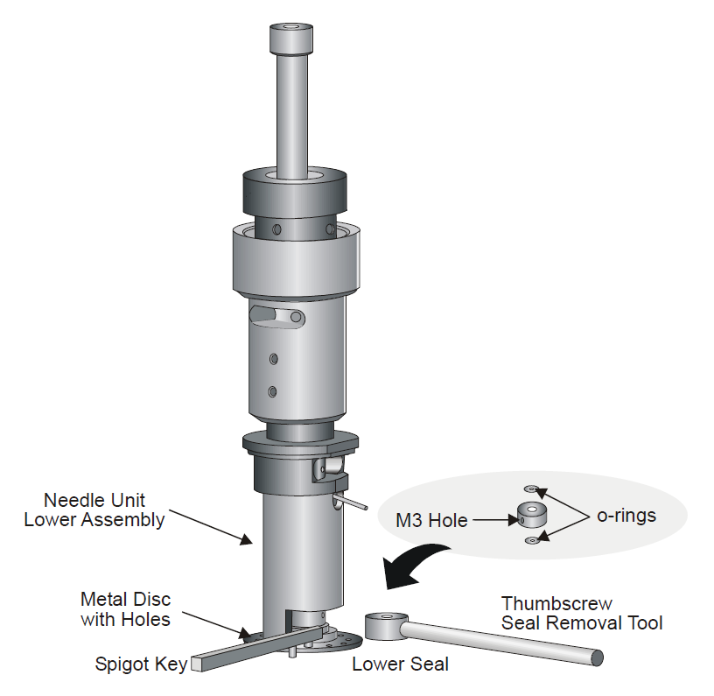

To change the lower seal assembly:

1. Turn off all heated zones by setting the temperature to 0C. Allow approximately 30 minutes for the needle

assembly and transfer line to cool down.

1. Once the system has cooled, switch off the instrument.
2. Disconnect the instrument from the electrical supply.
3. Pull gently on the magnetic door release of the front panel to open the door.
4. Remove the needle holder and the needle as outlined in *B.1.b. Removing and Replacing the Needle (Headspace Only)*.
5. Screw the seal removal tool into the threaded hole (M3) of the lower needle seal assembly. You will need to hold the removal tool as it will rotate once you begin to loosen the metal disc.
6. Place the spigot key into one of the holes in the metal disc.
7. Turn the metal disk clockwise (right to left when facing the instrument) to undo it as far as necessary to allow the lower seal assembly to be released.
8. Using the seal removal tool, gently pull out the needle seal assembly. Take note of the orientation of the seal assembly. You must retain this orientation.
9. Check the seal assembly and replace the O-rings as outlined in *B.2.c. Replacing the O-rings*. There are two O-rings in the lower needle seal assembly.

NOTE: Do not touch the new O-rings with your fingers. Use forceps or tweezers to remove the O-ring from its bag and place it on the seal assembly. If you touch the O-ring for any reason, throw it out and use a clean one.

1. Replace the seal assembly. Ensure the seal assembly is replaced in the same orientation as when it was removed. i.e. the same side must be facing up. Retain the seal removal tool in the seal assembly.
2. Ensure that the needle seal assembly is correctly seated before securing it with the metal disc. Tighten the metal disk by hand enough to hold the seal assembly in place. Use the spigot key to turn the metal disk counterclockwise.
3. Close the front panels and reconnect the instrument to the electrical supply.
4. Power up the instrument and turn on gases.
5. Perform a leak test to ensure the instrument is leak tight.

### B.2.c. Replacing the Sample Needle O-rings

Normally it is not necessary to replace the whole needle seal assembly. In most cases it is only the O-rings that need to be changed. A special O-ring tool (B0147449) is supplied for removing and inserting the O-rings.

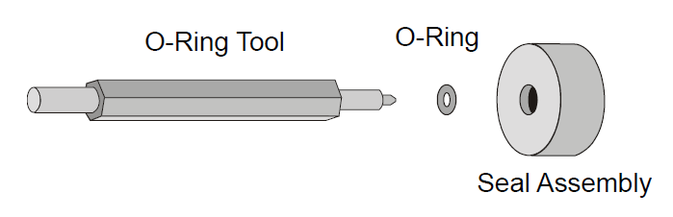

To replace the O-ring:

1. Remove the needle seal assembly. See *B.2.a. Replacing the Upper Needle Seal Assembly* or *B.2.b. Replacing the Lower Seal Assembly*.
2. Insert the narrow end of the O-ring tool into the O-ring.
3. Carefully press the tool to the side and remove the O-ring.
4. Take care not to damage the O-ring seat of the seal assembly.

NOTE: Do not touch the new O-rings with your fingers. Use forceps or tweezers to remove the O-ring from its bag and place it on the seal assembly. If you touch the O-ring for any reason, throw it out and use a clean one.

1. Place a replacement O-ring (P/N B0198110) into the seal assembly. The upper seal assembly contains one O-ring on the lower surface. The lower seal assembly contains two O-rings (one on each side).
2. With the broader flat end of the O-ring tool press the O-ring into the seat. Take care not to damage the O-ring or the seat.
3. Replace the needle seal assembly. See *B.2.a. Replacing the Upper Needle Seal Assembly* or *B.2.b. Replacing the Lower Seal Assembly*.

## B.3. Leak Testing the Sample Injection System

If a leak is occurring and you cannot isolate the source, it is suggested that you separate the HS from the GC and leak test each instrument separately. Once each instrument is leak tight you can then connect them and test them together.

The automated leak test will leak test the sampling system. You must plug the end of the fused silica transfer line.

To leak test the sample injection system:

NOTE: If you use a split/splitless injector, the split and purge outlet must be closed for the leak test. If you intend to leak test only the HS remove the fused silica line from the injector and plug the fused silica line with a septum.

1. Turn off all heated zones by setting the temperature to 0C. Allow approximately 30 minutes for the needle assembly and transfer line to cool down. Ensure that the flame is out and that your oven/injectors and detectors are at room temperature.
2. Once the system has cooled, switch off the instrument.
3. Disconnect the instrument from the electrical supply.
4. Undo and remove the chromatographic column at the detector inlet.
5. Use a blanking plug to seal the detector column fittings. Seal capillary columns with a new, clean septum.
6. Switch the HS on. Open the Temperature tab and reduce the set points to ambient or lower.

NOTE: It may be necessary to touch some of the fittings if the leak test fails so set the temperature of the needle and transfer line to ambient or lower. If you enter a value of 0 the heaters are shut off.

1. Set the carrier pressure to 45 psi (roughly 310 kPa).
2. When the instrument is in the Standby mode, open the Tools menu and select Maintenance. Then select Leak Test.
3. The HS sampling system is now a closed, pressurized system. The pressure, displayed on the PPC tab, must not drop by more than 1 psi over a period of 40 seconds.
4. If a leak is detected, check all the connections with an Electronic Leak Detector.
5. Reduce the carrier pressure to the normal method pressure.
6. Unplug the fused silica line and ensure that there is no septum material blocking the fused silica line.

If you are leak testing the HS sampling system you should check the following connections first:

• O-rings in the upper and lower needle sealing elements.

• Transfer line connection to the needle unit.

If you are testing the whole chromatographic system, leakage may be occurring at the GC connections.

NOTE: Ensure the HS sampling system is leak tight before connecting the transfer line to the GC.

# C. Clarus 500 GC Liquid Autosampler Maintenance (Building 50)

Autosampler maintenance consists of replacing a syringe and replacing a vial locator mechanism.

## C.1. Per-use or Daily Maintenance

The syringe plungers should be cleaned regularly upon each sample injection, with an appropriate number of solvent rinses for the sample matrix injected.

## C.2. Routine Periodic Maintenance (every 500 injections)

After approximately 500 injections, since insoluble compounds can build up and cause friction, the syringe should be inspected and cleaned per the below procedure. Additionally, syringes that are not used for several hours could "freeze," i.e., the syringe plunger will not move (this can also be caused by some solvents or sample matrices) which would require the below maintenance steps.

## C.3. Replacing a Syringe

1. From the System Status screen on the GC select the Run icon.



1. On the Run Type page select the Autosampler radio button and the Task tab. The following page will appear:



1. Select the Park button and the autosampler tower moves to the park position (facing the front of the Clarus 500/580/580 GC).
2. Open the tower door on the autosampler tower cover.

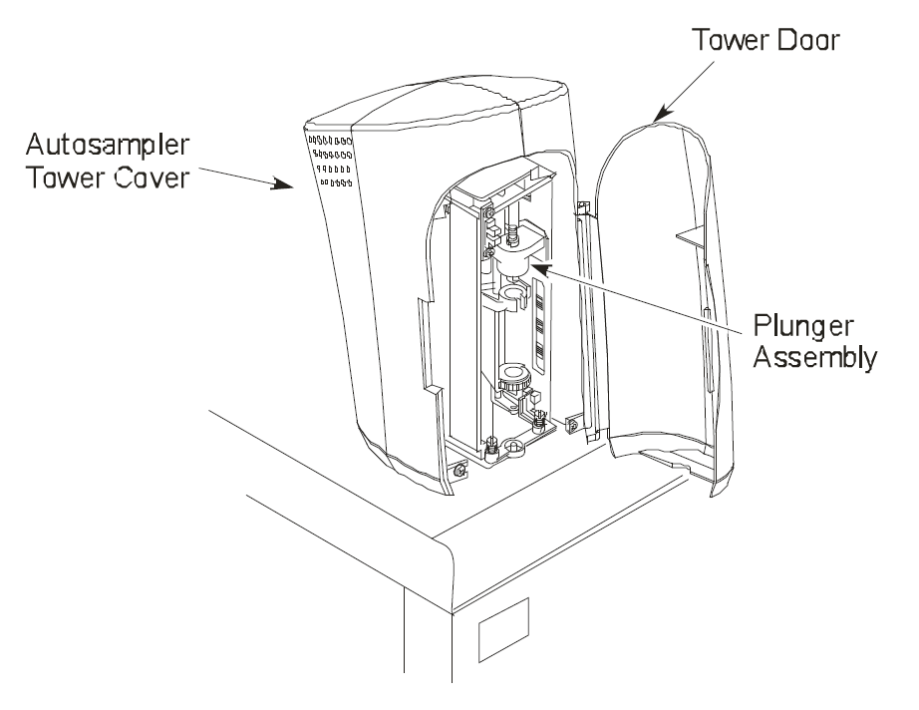

### C.3.a. Removing a Syringe

1. Locate the plunger assembly shown in the previous illustration. Then, refer to the following figure, as you lift the plunger cap handle and rotate it until it rests on the collar. Then release the plunger cap handle.

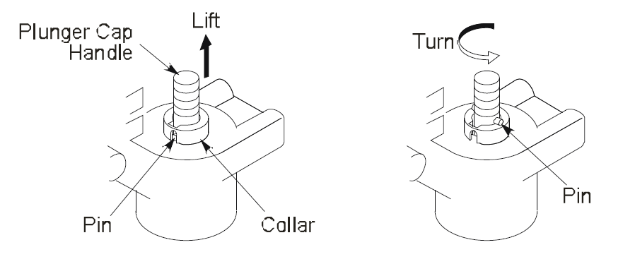

1. Hold the syringe by the barrel or syringe nut (see the following figure) and turn the carriage thumbscrew clockwise until the syringe is free.

1. Gently pull the top of the syringe forward until it just clears the carriage

assembly.

1. Gently lift the syringe out of the carriage assembly.

### C.3.b. Cleaning a Syringe

NOTE: It is typically advised to replace the syringe instead of performing the below maintenance steps, as removing and replacing the plunger can sometimes scratch the inner surface of the syringe barrel and create active sites or decrease the accuracy and precision of the syringe.

To clean the syringe plunger:

1. Remove the plunger from the syringe barrel. If there are any signs of rust or plunger wear, replace the syringe.
2. Wipe the plunger with a tissue soaked in an appropriate solvent.
3. Replace the plunger.
4. Pull and expel the same solvent through the barrel several times.

### C.3.c. Installing a Syringe

1. Guide the needle through the hole in the carriage thumbscrew, and then thread the needle through the needle guide. Use your fingers as a guide.
2. Rest the top of the plunger on the plunger cap slide, which is a shelf located on the underside of the plunger assembly.
3. While holding the syringe nut, engage the carriage thumbscrew on the threaded part of the syringe by turning the carriage thumbscrew counterclockwise.
4. Continue turning the thumbscrew counterclockwise. This slowly lowers the needle. Carefully guide the needle through the needle guide into the vial locator.
5. Tighten the carriage thumbscrew.

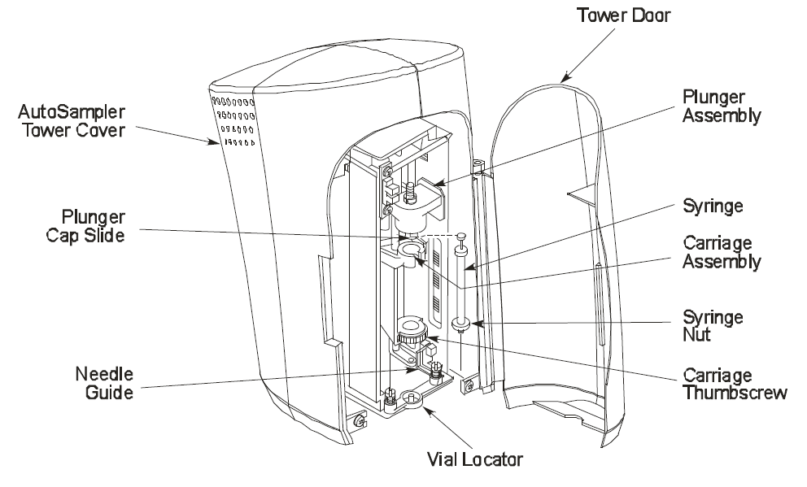

## C.4. Replacing the Vial-Locator Mechanism

The vial-locator mechanism will wear out with extended use and require replacement. If the autosampler begins missing vials, or if the hole for the syringe needle begins to plug, it is an indication that you should replace the vial locator mechanism.

To replace a vial-locator mechanism:

1. Remove the two shoulder screws that secure the locator to the autosampler tower frame. Remove the two springs, then remove the vial locator. Discard the vial locator.
2. Mount the new vial locator (Part Number N6101182) on the autosampler tower frame.
3. Install the two shoulder screws through the two springs and into the vial locator. This secures the vial locator to the autosampler tower frame.

When securing the vial-locator molding, be sure that the flag is centered (not touching either side) in the sensor. If it touches a side, adjust the flag by loosening and then tightening the screws.

DO NOT ADJUST THE SENSOR!

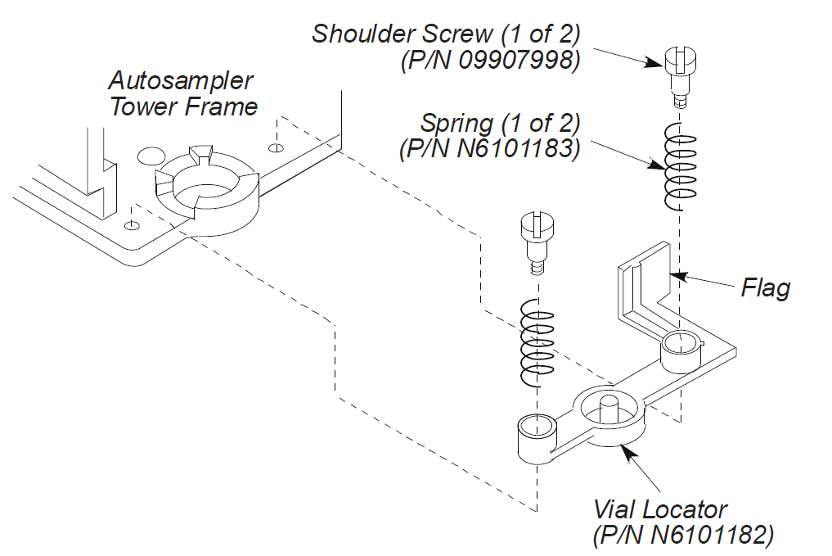

# D. Capillary Split/Splitless (CAP) Injection Ports (injectors)

The injection ports tend to require the most frequent maintenance as they are the point of entry for your sample into the system. Injector maintenance consists of:

1. Replacing septa (every 200 injections).
2. Replacing CAP injector liners
3. Removing a broken liner from the injector body
4. Replacing the charcoal trap on the split/splitless CAP injector.

****CAUTION: The injection ports (injectors) on the GC are heated zones, as that is where sample volatilization occurs. Cool the injectors to below 100°C before performing maintenance to avoid burns and damage to the injector.

## D.1. Replacing Septa

Septa should be replaced on a regular basis. How often depends on the type of septa used, the temperature of the injection port, and the number of injections made. The septum that shipped with your instrument is a Thermogreen LB-2 Septa (Part Number N6621028, package of 50). This septum can handle about **200** injections at moderate temperatures and is one of the more robust types of septum as far as thermal stability and wear. Your septa may need to be replaced more frequently, but typically every 200 injections is the general guideline.

*NOTE: To minimize the possibility of contamination, avoid unnecessary handling of septa.*

To change a septum:

1. Turn off the injector heater and allow the injector to cool.
2. Remove the septum cap.
3. Pry the old septum from the septum cap with a screwdriver.
4. Insert a new septum in the septum cap.
5. Replace the septum cap.

## D.2. Replacing CAP Injector Liners

To remove the liners, you need a CAP liner-removal tool (Part Number 02506534) as shown below.

To remove a capillary injector liner:

1. Turn off the injector heater.

Note: Allow the injector to cool until it is slightly warm to the touch. Cooling the injector to a temperature that is too low (<80 °C) will make it difficult to remove the injector liner.

1. Remove the septum cap.
2. Remove the injector cover.

1. Loosen the threaded collar using the spanner (Part Number N6101359) provided, then remove the threaded collar.

1. Replace the septum cap on the injector.
2. Pull the septum cap upwards to remove the septum purge assembly. The carrier gas inlet line is coiled. This allows you to pull the septum purge assembly over to the side and gain access to the injector liner.

NOTE: The inlet line used in PPC capillary injectors (CAP) is coiled but the septum purge assembly does not terminate in a snubber as shown. Instead it is connected to a PPC module. The coil of the inlet line is long enough so that you can pull the septum purge assembly out of the opening in the top cover and gain access to the injector liner.

1. Insert the CAP liner-removal tool (Part Number 02506534) over the end of the CAP liner and lift the liner out of the injector.

** CAUTION: The liner must be cool (no hotter than 100 °C) or the liner-removal tool will melt! The end of the liner-removal tool may flare out with use. If this happens, cut off about ¼” of the worn end of the tube.

NOTE: If the quartz liner breaks inside the CAP injector, it can be removed by first removing the column, then removing with a 9/16-inch wrench the 1/4-inch injector fitting that is inside the oven. The liner should fall out of the injector with the fitting. If the liner is stuck, you can push it out from the top or bottom of the injector.

NOTE: Each capillary liner has an O-ring installed on the frosted portion of the CAP liner. If the O-ring has adhered to the injector, you may not be able to easily remove the liner (step 7 above). If this is the case, use a small screwdriver to dislodge the O-ring before removing the liner and O-ring.

1. Install a new liner O-ring near the ground portion of the liner.

NOTE: If your results produce background contamination when a new O-ring is first installed, condition the injector at the maximum temperature of the O-ring. Depending on the type of column used, you may first want to remove the column before baking it out at a high temperature.

1. Insert the liner in the injector body.
2. Place the septum purge assembly over the liner.
3. Press the septum purge assembly down to correctly position the liner in the injector.
4. Make sure that you secure the septum purge assembly tightly to the injector base with the 1/4-inch spanner.

## D.3. Removing a Broken Liner from the Injector Body

If the quartz liner breaks inside the CAP injector, it can be removed by first removing the column, then removing with a 9/16-inch wrench the 1/4-inch injector fitting that is inside the oven. The liner should fall out of the injector with the fitting. If the liner is stuck, you can push it out from the top or bottom of the injector. At this time, you should clean the injector fitting inside the oven with a swab and appropriate solvent and inspect the ferrule. If the ferrule is worn, replace it too.

## D.4. Replacing Charcoal traps on CAP Injectors

The charcoal trap will eventually become saturated. When this occurs, ghost peaks and changes in split ratio will be observed.

1. Turn off the GC. Allow the injectors/detectors to become cool to the touch.
2. Loosen the two hold-down screws on the top cover of the GC (see following figure) and raise the top cover until the cover locks in the raised position.
3. Remove the septum cap, then remove the top cover from the injector.
4. Loosen the threaded collar using the 1/4-inch spanner (Part Number N6101359), and then remove the threaded collar.
5. Replace the septum cap on the injector.
6. Pull the septum cap upwards to remove the septum purge assembly.
7. Using a 1/8-inch wrench, loosen the fittings that are connected to the charcoal trap and remove the charcoal trap (see the following figure).
8. Install a new PPC version charcoal trap (Part Number N6100331).

# E. Flame Ionization Detector (FID) Maintenance

FID maintenance consists of replacing the FID jet, cleaning the FID jet, replacing an O-ring in the collector, and cleaning the FID collector and cap.

## E.1. Replacing a FID Jet

NOTE: The FID jet rarely becomes plugged. However, if plugging occurs, it is usually sample dependent. It is recommended that you replace a plugged jet rather than clean it.

To replace the FID jet:

** WARNING! Before you begin, extinguish the flame via the keyboard by setting the

hydrogen flow to 0 mL/min.

1. Turn off the Clarus 500/580 GC power.

WARNING! The FID is hot and can cause serious burns! To prevent injury, allow the detector to become cool to the touch.

2. Open the detector cover (see Figure 9-26).

3. Remove the polarizing cable from the pin on the polarizing filter assembly.

1. Loosen the knurled ring, then lift the FID collector off of the FID base and put it out of the way.
2. Insert the nozzle removal tool (Part Number N6103188) into the FID base and lift the nozzle out of the FID base. Do not unscrew it.

1. Insert a 1/4-inch nutdriver into the FID base to engage the 1/4-inch nut on the FID jet assembly.
2. Loosen the FID jet assembly (turn the 1/4-inch nut counterclockwise) and pull it out of the FID. You should be able to pull out the FID jet assembly with the nutdriver. If not, then pull out the FID jet assembly with a pair of forceps or needle nose pliers.

1. Insert a new FID jet assembly (P/N N6100361) and secure it in place with the 1/4-inch nut driver.

NOTE: Inspect the metal ring within the FID nozzle since it may become bent or deformed after repeated removal.

1. Insert the nozzle assembly into the FID base until you feel it bottom.
2. Insert the FID collector back on the FID base and tighten the knurled ring.
3. Reconnect the polarizing wire to the polarizing pin on the FID collector.
4. Turn on the FID heater and allow it to return to the temperature setting.
5. Re-ignite the flame.

## E.2. Replacing the O-ring in the FID Collector

Since the O-ring in the FID collector is in contact with the heated surface of the FID base, you will notice over time that it has become brittle or broken and must be replaced.

 CAUTION: The FID is hot and can cause serious burns! To prevent injury, extinguish the FID flame, turn off the FID heater, and allow the detector to become cool to the touch.

To replace the O-ring in the FID collector:

1. Remove the polarizing voltage wire from the polarizing pin (as shown in the Replacing a Jet steps above).

2. Loosen the knurled ring, then lift the FID collector off the FID base.

3. Remove the old O-ring (see the following figure) from the FID collector and insert a new O-ring (P/N 09902143).

4. Insert the FID collector back on the FID base and tighten the knurled ring.

5. Connect the polarizing wire to the polarizing pin on the FID collector.

6. Turn on the FID heater and allow it to return to the temperature setting.

7. Re-ignite the flame.



# F. Tools

The tools to have on hand:

|  |  |  |
| --- | --- | --- |
| **Tool** | **Use** | **Part Number** |
| ¼” Crescent wrench | Column fittings at injector end | These can be purchased individually from a hardware store or come as part of the basic GC toolkit part number N9301327 |
| 7/16” Crescent wrench | Brass swagelock fittings on gas plumbing, and column fittings on FID |
| ½” Crescent wrench | Injector fitting |
| 9/16” Crescent wrench | Injector fitting |
| Flat Screwdriver | Opening top lid of GC |
| Electronic Gas Leak Detector | Check for helium and hydrogen leaks | N9306089 |
| Electronic Gas Flowmeter | Verify your flowrates | N9307086 |
| FID flow measuring adaptor tube (autolite fid) | To measure gas flow rates from the detector output (with the flame off) | N6103119 |
| Polarizing filter Nozzle assembly extraction tool | Replacing the FID Jet | N6103188 |
| Modified 1/4-inch nutdriver narrow OD | Replacing the FID Jet | N6101297 |
| Ceramic wafer scribe (pack of 10) | Cutting capillary columns | N9301376 |
| CAP liner-removal tool | Replacing Injector liners | 02506534 |
| PSS liner-removal tool | Replacing Injector liners | 02506247 |
| ¼” Spanner | Replacing Injector liners | N61001359 |
| O-ring assembling tool | Replacing Headspace Needle O-rings | B0131410 |
| Top Seal Changing Tool | Replacing Headspace Needle O-rings | M0415330 |
| Spigot Key Lower Seal Tool | Replacing Headspace Needle O-rings | B0500843 |
| O-ring Extraction/Insertion Tool | Replacing Headspace Needle O-rings | B0147449 |

# G. Consumable Parts and Frequency List

Table of part numbers with frequencies

|  |  |  |
| --- | --- | --- |
| **Part Description** | **Part Number** | **Frequency** |
| **Gas Management** | | |
| Traps  (for UHP Helium and UHP Hydrogen) | Moisture, Hydrocarbons, Oxygen (see catalog) | Every 12 months or 12 tanks |
| Traps  (for zero grade air) | Moisture and Hydrocarbons (see catalog) | Every 12 months or 12 tanks |
| **Syringes** | | |
| 5 μL Syringe, Metal Plunger PTFE-tipped Seal 0.63 mm OD Needle BLUE Barrel (Pkg. 10 syringes) Standard syringe for autosampler. | N6103241 (pack of 10) | Every 500 injections or once a month based on your usage |
| **Injectors** | | |
| Septa, thermogreen (package of 50)—or whatever septa you choose | N6621028  (for the thermogreen pack of 50) | Every 200 injections on liquid (syringe) injections, every 12 months or when worn on Headspace injections. |
| Injector Liners |  | Every 200-600 injections |
| Liner O-ring (CAP) Silicone  (Max temp 250C) | N6101374 (pack of 10) | Every liner replacement or removal |
| Liner O-ring (CAP) Graphite  (Max temp 450C) | N6101378 (pack of 5) | Every liner replacement or removal |
| Charcoal Trap PPC Pneumatics  CAP and PSS injectors  (Clarus 500 and 580) | N6100331 | When saturated or every 24 months |
| Capillary Column nut-Injector | 09903392 (pack of 5) | When worn or plugged |
| Capillary Column ferrule-injector  (for columns with id of 530µm) | 09920107 (pack of 10) | When leaking or worn, or when installing a column |
| Capillary Column ferrule-injector  (for columns with id of 180µm—320 µm) | 09920105 (pack of 10) | When leaking or worn, or when installing a column |
| 1/16 in. Short Graphite/Vespel Ferrule (Pkg. 10)  For column ID 530 µm | 09200687 (pack of 10) | When leaking or worn, or when installing a column |
| **FID Detector-Clarus 500, Clarus 580 GC’s** | | |
| FID Jet | N6100361 | When clogged or every 12 months |
| FID Nozzle Assembly | N6100430 | When -0.97 mV or every 24 months |
| FID Collector O-ring | 09902143 | When brittle |
| FID Collector assembly autoignite | N6100357 | Have one on-hand |
| Capillary Column nut-FID  (also used on both ends of Packed columns) |  | When worn or plugged |
| 1/8 in. Graphite/Vespel Ferrule (Pkg. 10)  For column ID 180 – 530 µm | 09903394 | When leaking or worn, or when installing a column |
| **Turbomatrix Headspace Autosampler** | | |
| Needle O-rings | B0198110 (pack of 10) | Every 1500 injections |
| Needle Seal assembly (O-ring holder) | B0500833 | Every 2500 injections or when visibly worn or scratched. |
| Needle | B4000011 | When worn, corroded, plugged or uncleanable. |