Joshua Mercier

CIS355 01 WI19

Prog02

|  |
| --- |
| **Customer** |
| + id : String  + name : String  + email : String  + mobile : String  - noerrors : boolean  - nameError : String  - emailError : String  - mobileError : String  - title : String  - tableName : String |
| create_record()  read_record()  update_record()  delete_record()  insert_db_record()  - select_db_record(id : String)  update_db_record(id : String)  delete_db_record(id : String)  - generate_html_top(fun : String, id : String)  - generate_html_bottom(fun : String)  - generate_form_group(label : String, labelError : String, val : String, modifier : String)  - fieldsAllValid()  list_records() |

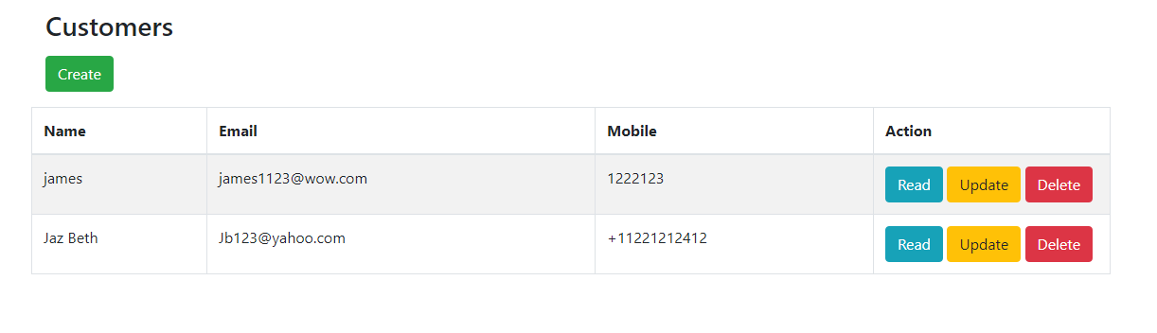**START (Customers.php)**

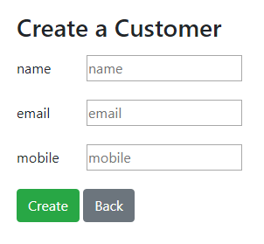Press Create to launch create_record()

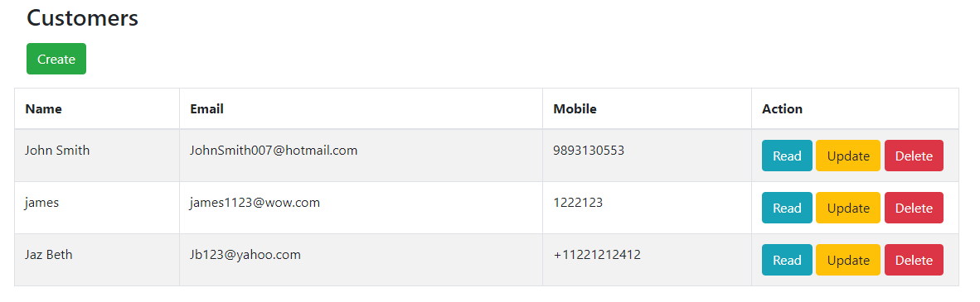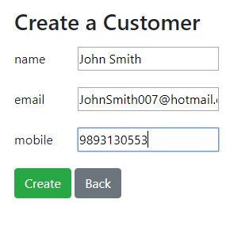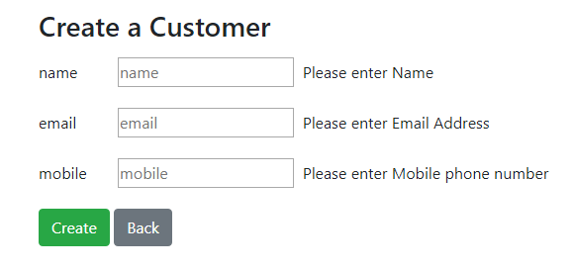 Hitting cr eate without valid fields inputted triggers fieldsAllValid()

With valid data, insert_db_record() will run.

Hitting Read will launch read_record($id), which launches select_db_record($id)

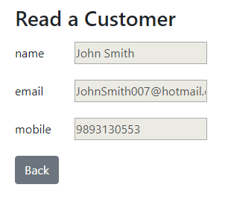

Hitting Back returns to Customers.php

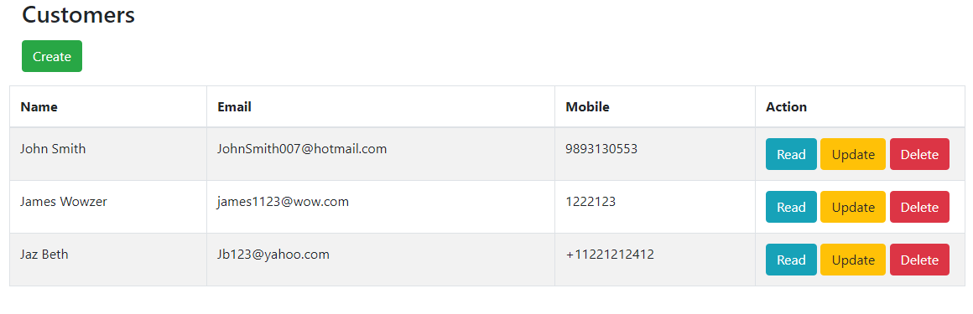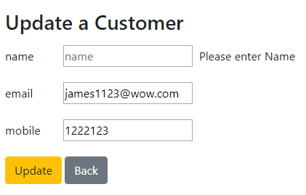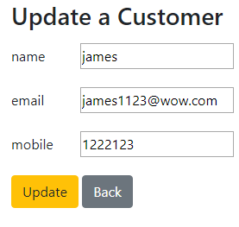Hitting Update launches update_record($id), omitting data like before triggers field sAllValid()

Properly Updating triggers update_db_record($id)

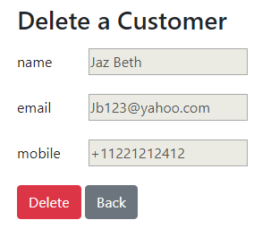Hitting Delete launches delete_record($id), Pressing Delete on the delete form triggers delete_db_record($id).

