Joshua Mercier

CIS355 01 WI19

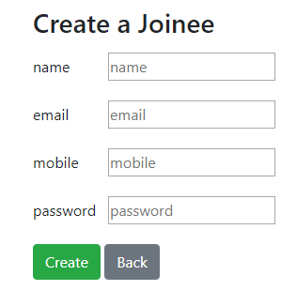Prog03

|  |  |
| --- | --- |
| **Customer** | **Joinee** |
| + id : String  + name : String  + email : String  + mobile : String  - noerrors : boolean  - nameError : String  - emailError : String  - mobileError : String  - title : String  - tableName : String | + id : String  + name : String  + email : String  + mobile : String  - noerrors : boolean  - nameError : String  - emailError : String  - mobileError : String  - title : String  - tableName : String |
| create_record()  read_record()  update_record()  delete_record()  insert_db_record()  - select_db_record(id : String)  update_db_record(id : String)  delete_db_record(id : String)  - generate_html_top(fun : String, id : String)  - generate_html_bottom(fun : String)  - generate_form_group(label : String, labelError : String, val : String, modifier : String)  - fieldsAllValid()  list_records() | create_record()  insert_db_record()  - generate_html_top(fun : String, id : String)  - generate_html_bottom(fun : String)  - generate_form_group(label : String,  - fieldsAllValid() |

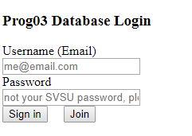**START (login.php)**

If valid user/pass inputted, takes to customers.php

If join clicked, takes to join.php which launches join.class.php which allows user to join the database. Clicking back returns user to login.php.

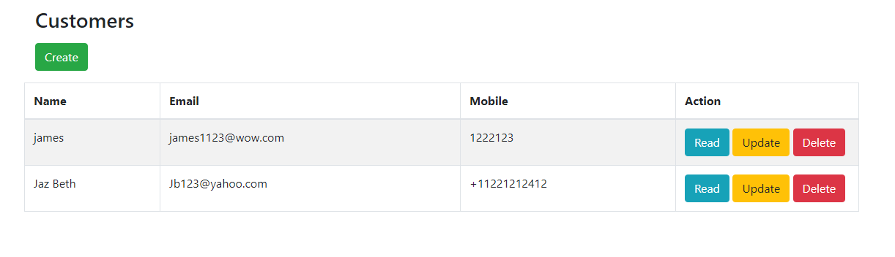

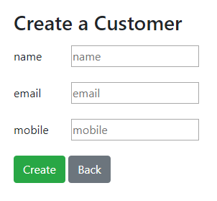Press Create to launch create_record()

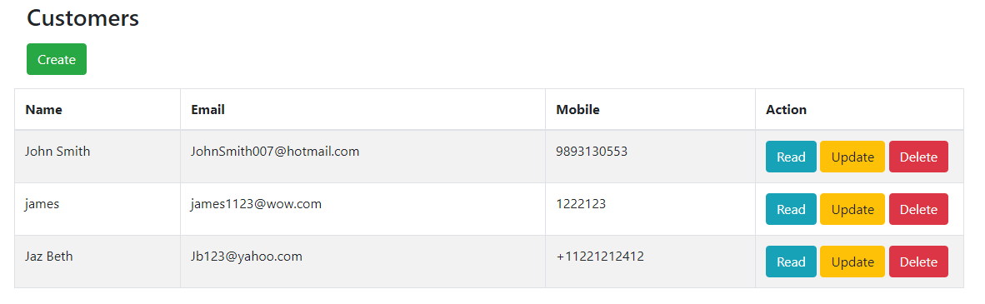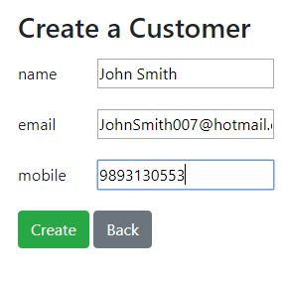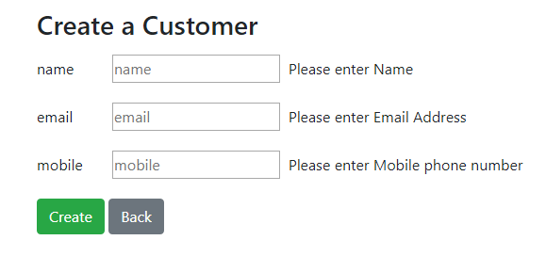 Hitting cr eate without valid fields inputted triggers fieldsAllValid()

With valid data, insert_db_record() will run.

Hitting Read will launch read_record($id), which launches select_db_record($id)

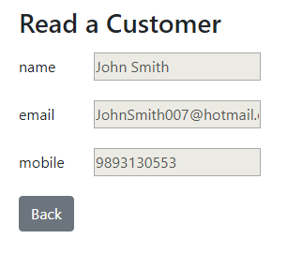

Hitting Back returns to Customers.php

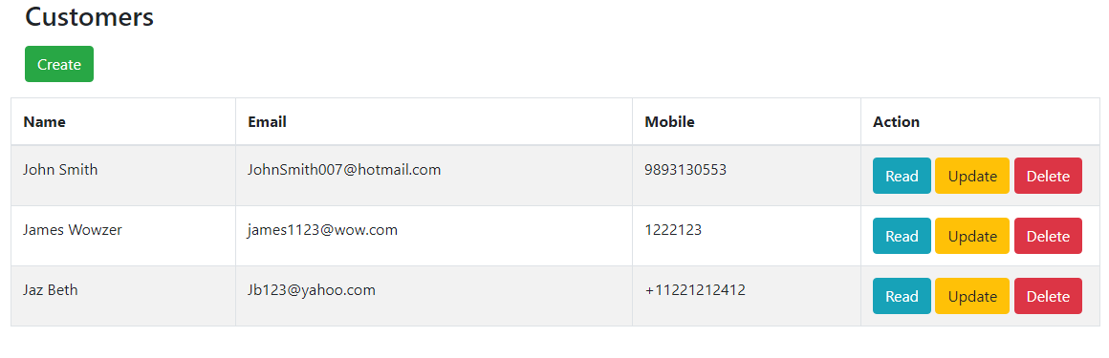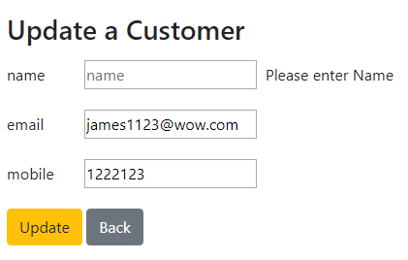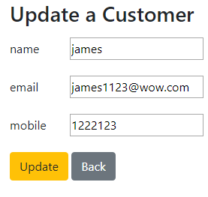Hitting Update launches update_record($id), omitting data like before triggers field sAllValid()

Properly Updating triggers update_db_record($id)

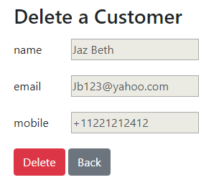Hitting Delete launches delete_record($id), Pressing Delete on the delete form triggers delete_db_record($id).

