**UNIVERSIDAD DE LAS FUERZAS ARMADAS – ESPE**

**CAREER**

**SOFTWARE ENGINEERING**

**SUBJECT**

**FUNDAMENTALS OF ENGINEERING**

**Team 03 Gamers**

**Topic: Mobility in the Quito’s Subway**

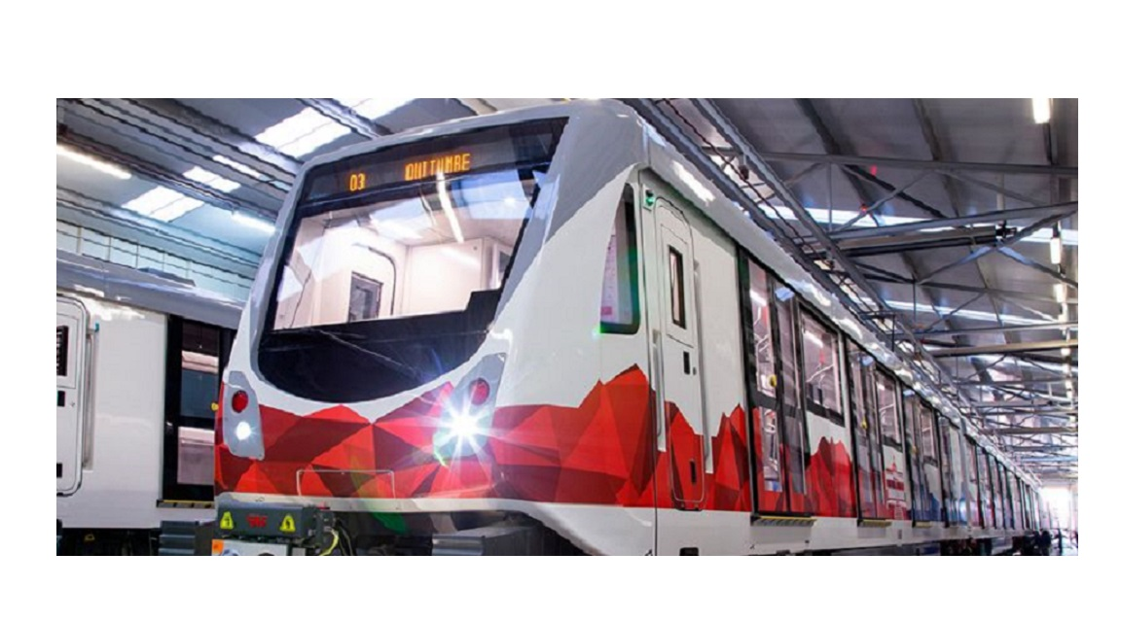

**Integrant**

**MASAPANTA GUILCATOMA JEFFERSON SANTIAGO**

**MIDEROS CRUZ SAMIR ESTEBAN**

**MOLINA GUAICO GUSTAVO STIVEN**

**MORALES SOSA JEIMY MARLEY**

**ORRICO EMME CAMILO ANDRES**

**Topic: Mobility in the Quito’s Subway**

**Problem**

The excess of passengers in public transport doesn’t allow a good social coexistence. Some reasons are that they are exposed to different dangers, another reason is that the units are terribly unclean. A passenger control system is needed in order to counts how many passengers join and how many leave, so that there is a passenger limit and security within the transport be more efficient, in addition, an administrative control is needed so that some aspects of the platform can be manipulated, such as the price of the ticket, the schedules and the registration of the personnel designated to certain areas.

To understand what the program or application is going to do, it’s necessary to have a notion of the problem that arises, the capacity of each wagon and the waiting time at each stop.

**Overview**

Nowadays, the public transportation in the Metropolitan District of Quito has evidenced several social problems that have generated discomfort in users such as; abuse, harassment, theft, crime, discomfort, in addition to the state of health emergency precautions must be taken to avoid crowds and the spread of the virus. In public transportation, the travel experience is not positive and therefore a system should be implemented to help avoid these types of discomfort that occur daily in public transportation, since the purpose of this program / software is to eradicate these problems, and this be able to provide good service as they are used by most people.

**The program would be based on:**

* **Ticket purchase:** through identification, and user control, if it reaches the capacity limit, this would be responsible for placing it to the next car or in the case that all this is its maximum capacity sends it to the next subway that is close to arrive.
* **Control of schedules** which are available for each shift of the day and so people can be informed of the arrival of each unit.
* **Maintenance control** listed of the technical personnel in charge of the unit and personnel of distribution and registration of each meter.

The program would need a database that collects Ecuador's identity cards and a system for "guest" for foreigners.

The digital ticket will include the chosen time, the estimated time of departure and arrival, the wagon and the user's data. The ticket will contain a QR code for security, so the ticket can be downloaded digitally or printed.

For authorized personnel, a User Interface would be made, by this means it will be modified, information will be consulted, etc. The goal is the interaction between the system and the authorized user.

**Background**

The capacity/limit that each Metro can transport is 1230 people and for each train wagon is 205 people, each train has 132 seats and 22 seats per wagon, for that reason 1098 people won’t have a seat.

To calculate the schedule we need to know the average speed of the train that is 44 km/h, 22 km connect Quitumbe and the Labrador that are at 34 minutes, and the interval of each stop is approximately 3 to 4 minutes.

**A database:** A database is a structured repository of data in a systematic way where the data is stored, consulted and retrieved. We could use a management system like MySQL.

**Guest system:** A guest system is an account that allows you to join a platform in an anonymous way when the guest doesn't have an account.

**Digital ticket:** This system was devised in order to allow anyone to enter a virtual office, this could also be a digital currency that gives us access to: a ticket to an event, a ticket to a public service, since This aims to facilitate the purchase of said ticket, and thus not waste time in long lines.

In this case, it would be an entrance to a means of transport, which would function by recharging a certain amount of money to be able to buy a place in the train car; the ticket is validated when the user correctly enters the requested data.

**A QR code:** It is a square two-dimensional barcode that can store the encoded data. Most of the time the data is from a link to a URL.

**User interface:** It is a concept that encompasses information architecture that allows us to interact effectively with a program. Basically, you transmit or indicate what you want to do and it responds.

After the previous analysis, we were able to generate the following requirements:

**Requirements:**

1. The system will start with a login where the user must enter the ID or passport number.
2. The system will have the option to register or create an account with personal data.
3. The system will use a multimodal card, which is recharged through the mobile application.
4. The system will allow passengers to resort to an emergency button. In risky situations, the user must press the button and it will automatically call 911.
5. The system will have access to the control record and the list of employees, for the knowledge of the users, this section cannot be modified.
6. The system will share the schedule of each unit, as well as the time of departure and arrival at the different Quito metro stations.