**Tutorial 03-B to do in class – Remember to upload the repo link to Teams**

**DIP**

**Antes de iniciar:**

* Terminar los talleres no calificables anteriores
* Este taller muestra el ejemplo de una inversión de dependencias y de una inyección de dependencias.
* ¿Puede identificar donde está la inversión, y donde la inyección?
* Al final vemos un ejemplo de cómo sería sin inversión de dependencias.

1. **An interface**

**Interface**

* Go to *app/* create a folder *Interfaces*
* Go to *app/Interfaces/* create a file *ImageStorage.php* with the next content:

|  |
| --- |
| **Add Entire Code** |

<?php

namespace App\Interfaces;

use Illuminate\Http\Request;

interface ImageStorage {

public function store(Request $request): void;

}

1. **A util library**

**Image local storage**

* Go to *app/* create a folder *Util*
* Go to *app/Util/* create a file *ImageLocalStorage.php* with the next content:

|  |
| --- |
| **Add Entire Code** |

<?php

namespace App\Util;

use App\Interfaces\ImageStorage;

use Illuminate\Http\Request;

use Illuminate\Support\Facades\Storage;

class ImageLocalStorage implements ImageStorage

{

public function store(Request $request): void

{

if ($request->hasFile('profile_image')) {

Storage::disk('public')->put(

'test.png',

file_get_contents($request->file('profile_image')->getRealPath())

);

}

}

}

1. **A service provider**

**Provider**

* Go to *app/Providers/* create a file called *ImageServiceProvider.php* with the next content:

|  |
| --- |
| **Add Entire Code** |

<?php

namespace App\Providers;

use Illuminate\Support\ServiceProvider;

use App\Interfaces\ImageStorage;

use App\Util\ImageLocalStorage;

class ImageServiceProvider extends ServiceProvider

{

public function register(): void

{

$this->app->bind(ImageStorage::class, function (){

return new ImageLocalStorage();

});

}

}

**Registering the new provider**

* In *config/app.php*, make the following changes in **bold**.

|  |
| --- |
| **Modify Bold Code** |

<?php

use Illuminate\Support\Facades\Facade;

return [

...

'providers' => [

...

/*

* Package Service Providers...

*/

/*

* Application Service Providers...

*/

App\Providers\AppServiceProvider::class,

App\Providers\AuthServiceProvider::class,

// App\Providers\BroadcastServiceProvider::class,

App\Providers\EventServiceProvider::class,

App\Providers\RouteServiceProvider::class,

**App\Providers\ImageServiceProvider::class,**

],

...

1. **Rest of the code**

**Controller**

* Go to *app/http/Controllers/* create a file *ImageController.php* with the next content:

|  |
| --- |
| **Add Entire Code** |

<?php

namespace App\Http\Controllers;

<?php

namespace App\Http\Controllers;

use App\Interfaces\ImageStorage;

use Illuminate\Http\RedirectResponse;

use Illuminate\Http\Request;

use Illuminate\View\View;

class ImageController extends Controller

{

public function index(): View

{

return view('image.index');

}

public function save(Request $request): RedirectResponse

{

$storeInterface = app(ImageStorage::class);

$storeInterface->store($request);

return back();

}

}

**Routes**

* Go to *routes/web.php* and add these new routes by adding the next lines at the end of the file (check **bold**).

|  |
| --- |
| **Modify Bold Code** |

…

**Route::get('/image', 'App\Http\Controllers\ImageController@index')->name("image.index");**

**Route::post('/image/save', 'App\Http\Controllers\ImageController@save')->name("image.save");**

**View**

* Go to *resources/views/* create a folder *image*.
* Go to *resources/views/image/* create a file *index.blade.php* with the next content:

|  |
| --- |
| **Add Entire Code** |

@extends('layouts.app')

@section("title", "Image Storage - DI")

@section('content')

<div class="container">

<div class="row justify-content-center">

<div class="col-md-8">

<div class="card">

<div class="card-header">Upload image</div>

<div class="card-body">

<form action="{{ route('image.save') }}" method="post" enctype="multipart/form-data">

@csrf

<div class="form-group">

<label>Image:</label>

<input type="file" name="profile_image" />

</div>

<button type="submit" class="btn btn-primary">Submit</button>

</form>

<img src="{{ URL::asset('storage/test.png') }}" />

</div>

</div>

</div>

</div>

</div>

@endsection

**Artisan**

* Run the next command in Terminal

|  |
| --- |
| **Execute in Terminal** |

php artisan storage:link



**Execution**

* Go to <http://127.0.0.1:8000/image/>

**Upload image**

* Upload a new image

**SAME APPLICATION WITHOUT DEPENDENCY INVERSION**

**Controller**

* Go to *app/http/Controllers/* create a file *ImageNotDIController.php* with the next content:

|  |
| --- |
| **Add Entire Code** |

<?php

namespace App\Http\Controllers;

<?php

namespace App\Http\Controllers;

use App\Util\ImageLocalStorage;

use Illuminate\Http\RedirectResponse;

use Illuminate\Http\Request;

use Illuminate\View\View;

class ImageNotDIController extends Controller

{

public function index(): View

{

return view('imagenotdi.index');

}

public function save(Request $request): RedirectResponse

{

$storeImageLocal = new ImageLocalStorage();

$storeImageLocal->store($request);

return back();

}

}

**Routes**

* Go to *routes/web.php* and add these new routes by adding the next lines at the end of the file (check **bold**).

|  |
| --- |
| **Modify Bold Code** |

…

**Route::get('/image-not-di', 'App\Http\Controllers\ImageNotDIController@index')->name("imagenotdi.index");**

**Route::post('/image-not-di/save', 'App\Http\Controllers\ImageNotDIController@save')->name("imagenotdi.save");**

**View**

* Go to *resources/views/* create a folder *imagenotdi*.
* Go to *resources/views/imagenotdi/* create a file *index.blade.php* with the next content:

|  |
| --- |
| **Add Entire Code** |

@extends('layouts.app')

@section("title", "Image Storage - DI")

@section('content')

<div class="container">

<div class="row justify-content-center">

<div class="col-md-8">

<div class="card">

<div class="card-header">Upload image</div>

<div class="card-body">

<form action="{{ route('imagenotdi.save') }}" method="post" enctype="multipart/form-data">

@csrf

<div class="form-group">

<label>Image:</label>

<input type="file" name="profile_image" />

</div>

<button type="submit" class="btn btn-primary">Submit</button>

</form>

<img src="{{ URL::asset('storage/test.png') }}" />

</div>

</div>

</div>

</div>

</div>

@endsection

**Execution**

* Go to <http://127.0.0.1:8000/image-not-di>

**Preguntas**

* ¿Puedes entender las diferencias entre las dos propuestas?
* ¿Ventajas/desventajas de cada una?
* Qué tal si tratas de comparar estas propuestas con lo siguiente (ver siguiente página):

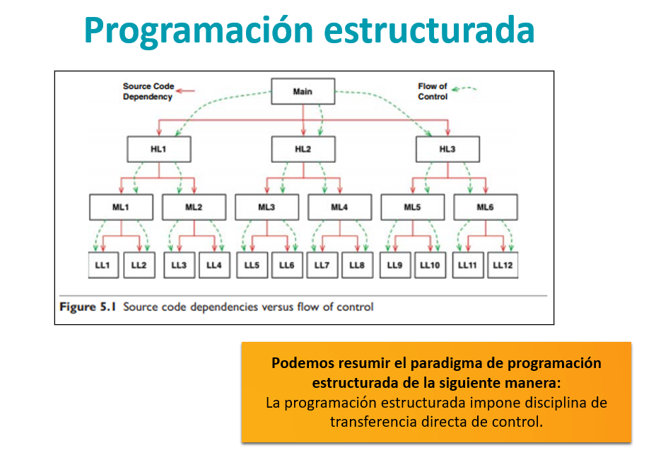

**¿Será que con el ejemplo ya te queda clara esa carreta? ¿Sí? ¿No? La próxima clase conversaremos sobre esto**