**Appendix**

1. Results of catastrophic forgetting by coupling two multi-layer perceptrons:

|  |  |
| --- | --- |
| report-pp-1.jpg  ***Figure A.1 –*** Original set of images learned by NET1 | report-pp-2.jpg  ***Figure A.2 –*** Pseudo-patterns generated by NET1 after it has been bombarded with noise |
| report-pp-3.jpg  ***Figure A.3 –*** Pseudo-patterns learned by NET2 and originally generated by NET1 | report-pp-4.jpg  ***Figure A.4 –*** Pseudo-patterns originally generated by NET2, learned by NET1 along with external input |
| report-pp-5.jpg  ***Figure A.5 –*** Output of NET1 after learning pseudo-patterns from NET2 and external input |  |

1. Results of catastrophic forgetting by using:

|  |  |
| --- | --- |
| pseudo-original-2.jpg  ***Figure B.1 –*** Original set of learned images | pseudo-vectorsinput-2.jpg  ***Figure B.2 –*** Learned pseudo-patterns along with learned image (i.e. diagonal) |
| pseudo-remember-2.jpg  ***Figure B.3 –*** Attempt to remember after new image (i.e. diagonal) has been learned |  |

1. Online Learning for Image Learning Module

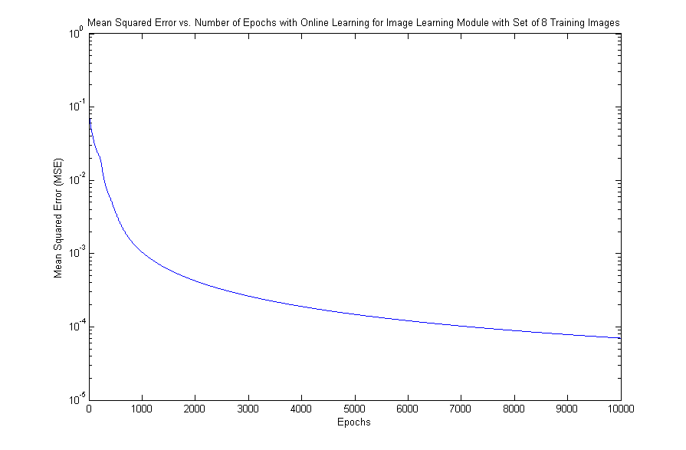

***Figure C.1 –*** Mean squared error vs. number of epochs for image learning module with online learning

1. Batch Learning for Image Learning Module

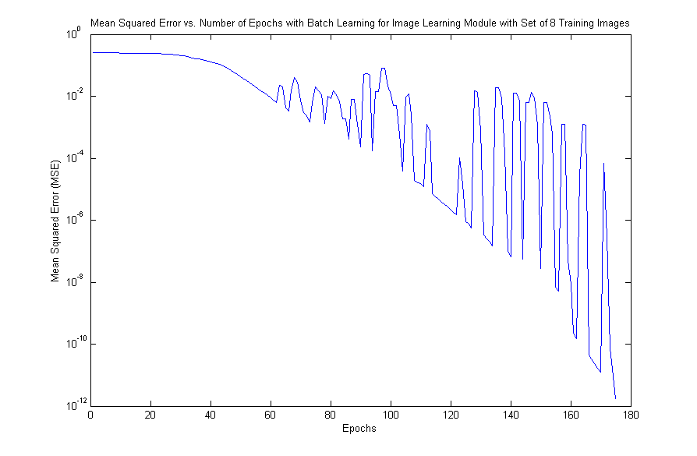

***Figure D.1 –*** Mean squared error vs. number of epochs for image learning module with batch learning

1. Sample Input/Output for Relations Learning Module

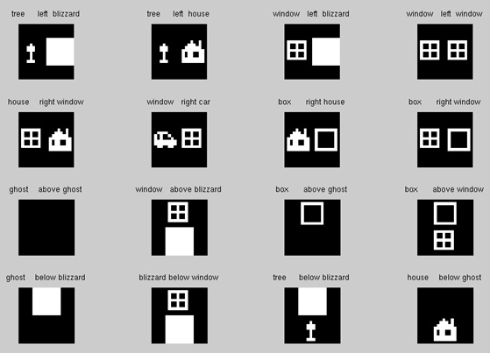

***Figure E.1 –*** Sample input/output associations for relations learning module

1. Test Input/Output for Relations Learning Module

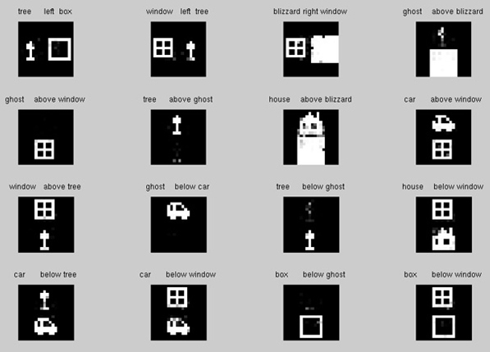

***Figure F.1 –*** Test input/output associations for relations learning module

1. Results of iRprop+ with new weight function

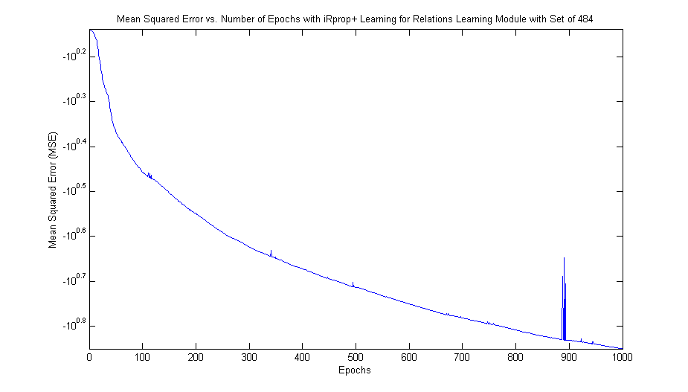

***Figure G.1 –*** Results of iRprop+ with new weight function

1. Implementation Details

We implemented everything in Matlab. Juan used the neural network toolbox to implement the Elman network he used when trying to implement the reverberating network.

Matlab website: <http://www.mathworks.com/>

Matlab neural network toolbox: <http://www.mathworks.com/products/neuralnet/>

References

1. Ans, B., Rousset, S. Avoiding Catastrophic Forgetting by Coupling Two Reverberating Neural Networks. Laboratoire de Psychologie Experimentale (CNRS EP 617), Universite Pierre-Mendes-France, BP 47, 38040 Grenoble cedex 9, France. November 3, 1997. DOI= <http://adsabs.harvard.edu/abs/1997CRASG.320..989>
2. Ans, B., Rousset, S., French, R. M., and Musca, S. Self-Refreshing Memory in Artificial Neural Networks: Learning Temporal Sequences without Catastrophic Forgetting. Connectionist Science, Vol. 16, No. 2, June 2004, pp. 71-79. DOI= <http://www.citeulike.org/user/chchatham/article/461062>
3. Elman, J. L. Finding Structure in Time. University of California, San Diego. Cognitive Science, 14, pp. 179-211, 1990. DOI= <http://homepages.inf.ed.ac.uk/keller/teaching/connectionism/CogSci90-Elman.pdf>
4. Riedmiller, Martin. Rprop - Description and Implementation Details. 1994. DOI= <http://citeseer.ist.psu.edu/rd/2171473%2C711503%2C1%2C0.25%2CDownload/http://citeseer.ist.psu.edu/cache/papers/cs2/20/http:zSzzSzamy.informatik.uos.dezSzriedmillerzSzpublicationszSzrprop.details.pdf/riedmiller94rprop.pdf>
5. Igel, C. Husken, M. Empirical Evaluation of the Improved Rprop Learning Algorithms. Institut fur Neuroir Formatik, Ruhr-Universitdt. Bochum, 44780, Germany. Neurocomputing, 2003, pp. 105-123. DOI= <http://www.google.com/url?sa=t&source=web&ct=res&cd=2&url=http%3A%2F%2Fwww.neuroinformatik.ruhr-uni-bochum.de%2FPEOPLE%2Figel%2FEEotIRLA.ps.gz&ei=p3ItSvDqN5S6tgO92NjrCg&usg=AFQjCNFeyyx8F18iD5xCB8jl7WQjnDXeSA&sig2=XmPojoDbXV02WPKY7DO5IQ>