# **FanOnTour**

# Created on September 05 2014

# **Table of Contents**

1.0. Header

2.0. Footer

# **1.0. Header**

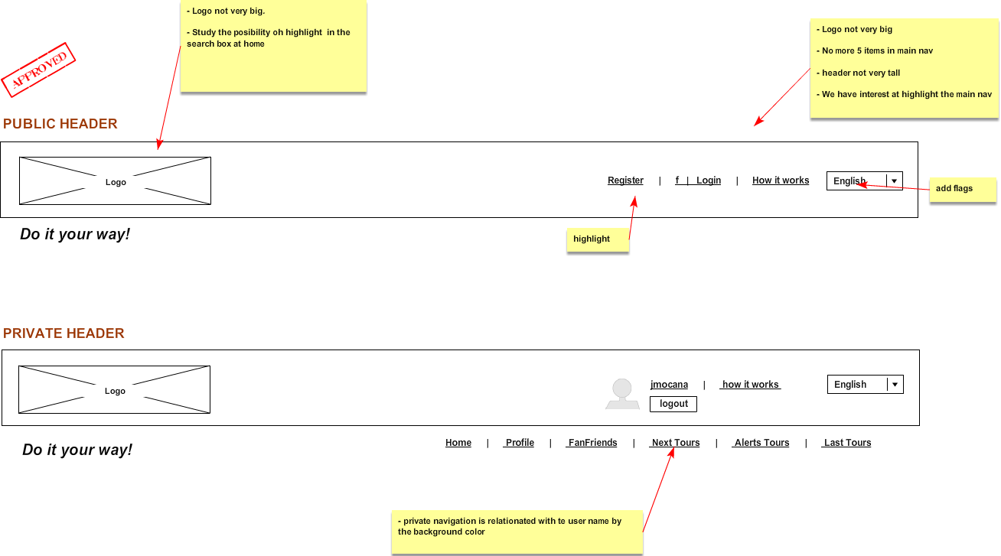

# **2.0. Footer**

