File: allows saving selected search results as tab-delimited text and loading existing search results files. Also allows saving and loading queries.  Scripting: allows creating GET scripts, executing GETs from VSS (assumes VSS command line program SS.EXE is on the path), and viewing GET logs  VSS Filters: is a number of VSS search path to search in (see example) multiple paths may be included. Note: everything before the last slash is the folder (aka VSS project) spec, everything after the last slash is treated as a file spec. Multiple search paths can be placed on separate lines (with the enter key) or delimited by semicolons.  VSS Label: is a pattern for the label being searched for (this may be a date to search for everthing with the given date). Alternatively you can search for the last items labeled for Test, Prep, or Prod, or the last checkin.  Query: allows you to start and cancel searches  Additive: Indicates the search results should not be cleared prior to each load or query.  Filter Boxes: allow filtering of results based on wildcard expressions (use ! to exclude a pattern, use | to "or" patterns)  Search Results List: allows sorting and selection of items for saving or scripting and also allows you to view the file, find in VSS, view all versions. copy path, and copy label, copy key. | 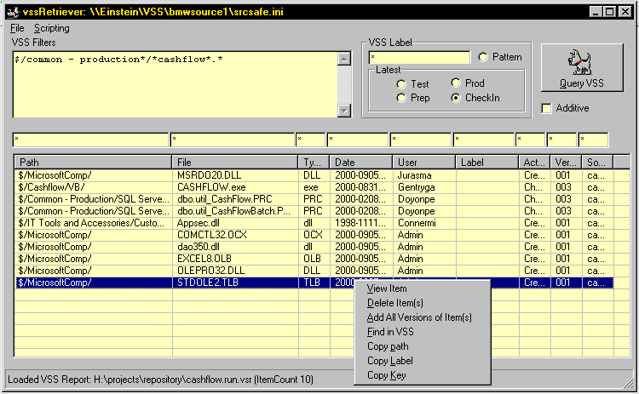

A version of the tool is in \\einstein\apps\VSSRetriever\VssRetriever.EXE . Requires VB6 runtime and VSS5, both of which are on the current IT image.

Please contact Mark Juras if you have questions or Comments.

