FACE TO BMI

In this project we are using python CNN (convolution neural networks) algorithm to predict BMI by analysing facial features. CNN will take image as input and then extract facial features from image and based on facial features BMI will be predicted. To implement this project we have designed following modules.

1. Generate & Load BMI & Face Detection Models: Using this module we will load facial detection CV2 library and BMI detection CNN model. Facial detection library help us to detect human face from uploaded image and then facial features will input to CNN model to predict BMI
2. Upload Image: using this module we will upload image to application
3. Run Face & BMI Detection Algorithm: This model extract face from given input image and then facial features will be analyse to predict BMI. Based on predicted BMI insurance policy will be quoted to users.

SCREEN SHOTS

To run project double click on ‘run.bat’ file to get below screen

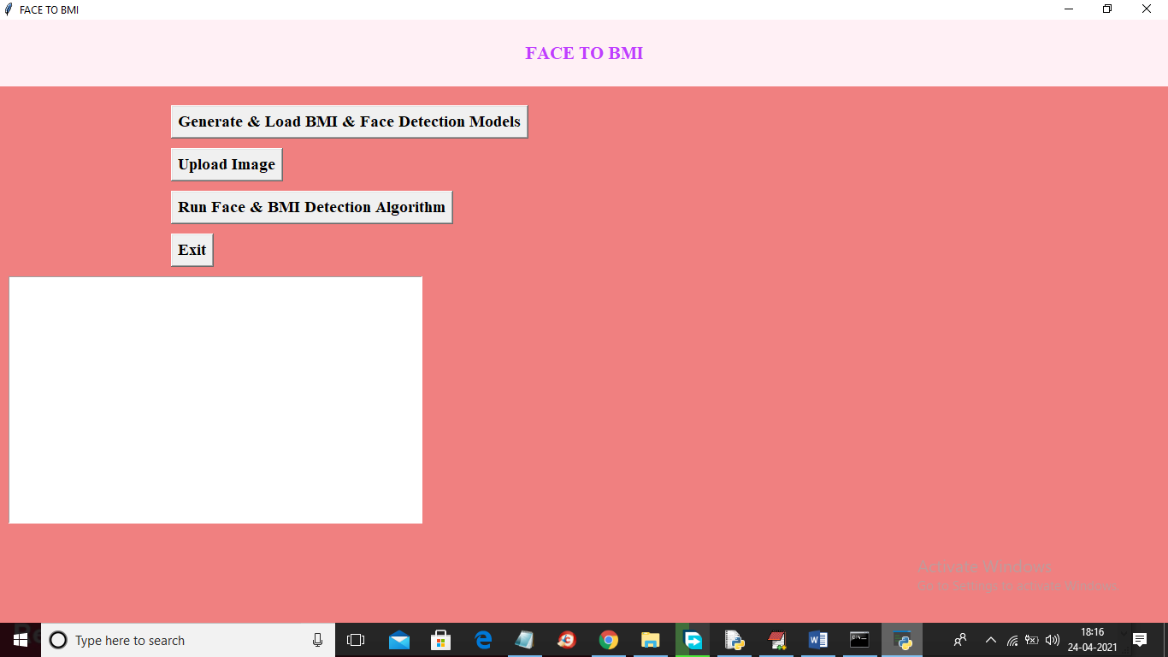

In above screen click on ‘Generate & Load BMI & Face Detection Models’ button to load face detection library and CNN model to detect BMI.

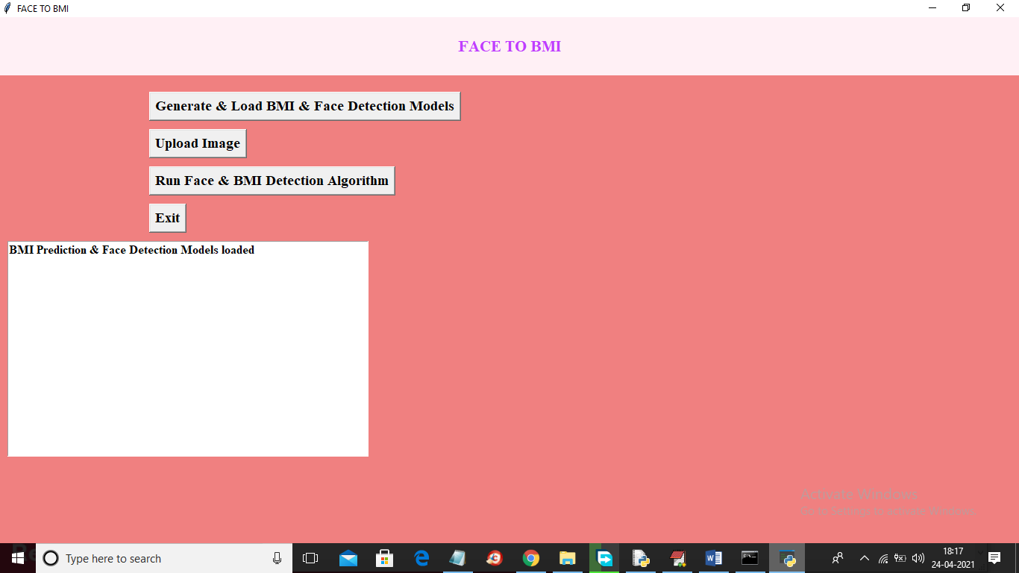

In above screen both libraries are loaded and now click on ‘Upload Image’ button to upload image



In above screen selecting and uploading ‘4.png’ file and then click on ‘Open’ button to load image and will get below screen

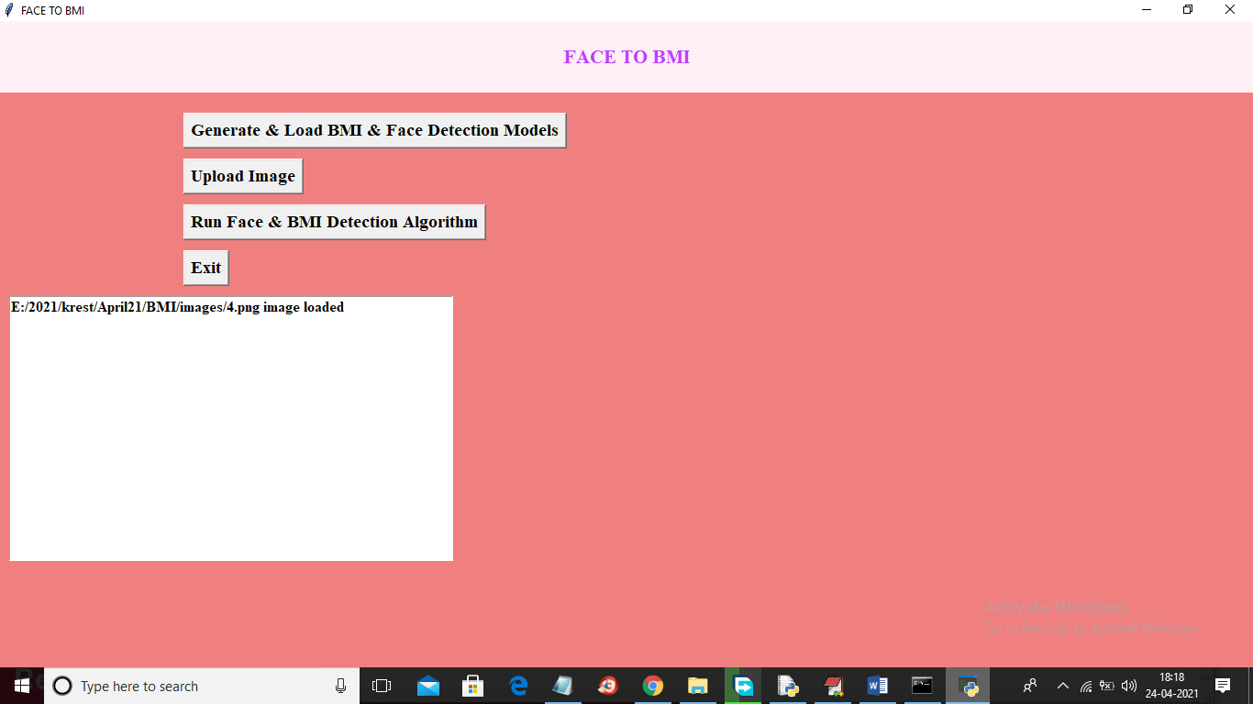

In above screen image is loaded and now click on ‘Run face & BMI Detection Algorithm’ button to get below result

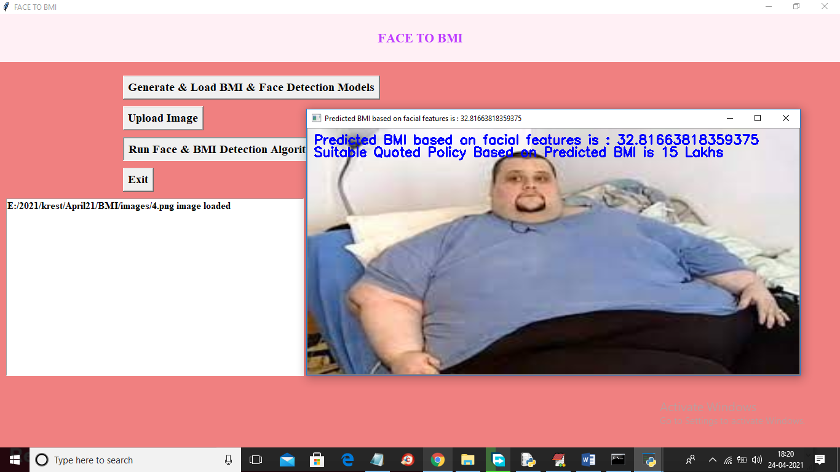

In above screen for given image detected BMI is 32.81 and suggested insurance policy is for 15 lakhs and now try other image



In above screen selecting and uploading 2.png file and then click on ‘Open’ button and then click on ‘Run Face & BMI Detection Algorithm’ button to get below screen

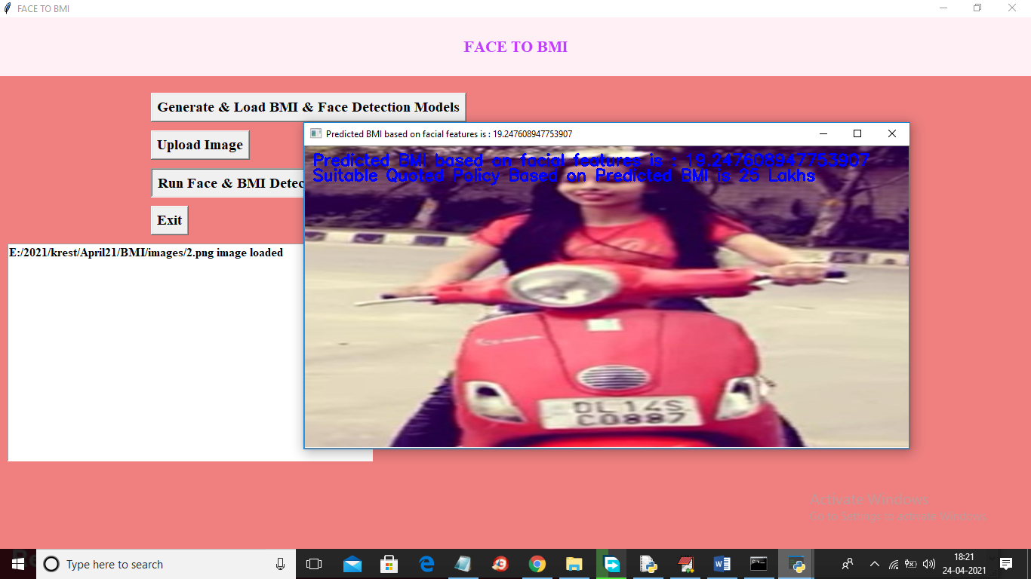

In above screen for uploaded image predicted BMI from face is 19.24 and suggested policy amount is 25 lakhs and similarly you can upload other images and test



