Summary of modeling difficulties: 5/15/18

**Behavioral task**

Monkeys have been trained to respond to either a visual or auditory cue by making a saccade to their estimate of that cue’s location. Cues are either unisensory (just visual or just auditory), or are combined with varying degrees of spatial separation. When the targets are widely separated monkeys make two saccades (one to each target), but when they are in the same place monkeys must make only a single saccade. Ideally this provides both a readout of explicit causal inference (number of targets = number of saccades) as well as implicit CI (influence between modalities when only one target is reported).

**Brief description of model**

I am building a model of multisensory causal inference based on the work of Konrad Kording and others (<https://doi.org/10.1371/journal.pone.0000943>). Briefly, given some visual and auditory estimates with respective means and variances, plus some prior bias, there is an optimal way to determine whether these originated from the same cause. Assuming only 1 or 2 causes:

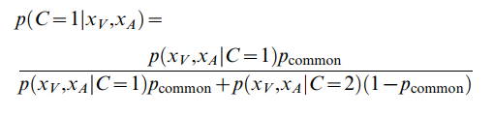

We can solve this analytically to get the posterior, and then use that to decide how to combine the location estimate distributions which come from assumed optimal integration. For common cause:

${\hat{μ}}_{AV}= \frac{\frac{x_{V}}{σ_{V}^{2}}+\frac{x_{A}}{σ_{A}^{2}}+\frac{μ_{p}}{σ_{p}^{2}}}{\frac{1}{σ_{V}^{2}}+\frac{1}{σ_{A}^{2}}+\frac{1}{σ_{p}^{2}}} , {\hat{σ}}_{AV}=\sqrt{ \frac{1}{\frac{1}{σ_{V}^{2}}+\frac{1}{σ_{A}^{2}}+\frac{1}{σ_{p}^{2}}}}$

And for two separate causes:

${\hat{μ}}_{V}= \frac{\frac{x_{V}}{σ_{V}^{2}}+\frac{μ_{p}}{σ_{p}^{2}}}{\frac{1}{σ_{V}^{2}}+\frac{1}{σ_{p}^{2}}}$, ${\hat{σ}}_{V}=\sqrt{ \frac{1}{\frac{1}{σ_{V}^{2}}+\frac{1}{σ_{p}^{2}}}} ,$ ${\hat{μ}}_{A}= \frac{\frac{x_{A}}{σ_{A}^{2}}+\frac{μ_{p}}{σ_{p}^{2}}}{\frac{1}{σ_{A}^{2}}+\frac{1}{σ_{p}^{2}}}$, ${\hat{σ}}_{A}=\sqrt{ \frac{1}{\frac{1}{σ_{A}^{2}}+\frac{1}{σ_{p}^{2}}}}$

I determine the “combined” distribution that can be compared to the data by summing the common and separate cause distributions together, weighted by the posterior on common cause. So if post_common = 1, it’s a single normal distribution given by the first set of equations (${\hat{μ}}_{AV},{\hat{σ}}_{AV}$). I fit the model by calculating the negative log likelihood of the observed real saccade endpoints, summed across all conditions, and using fminsearch to find the optimal parameter values.

Currently, I’m fitting this model with 5 free parameters: $σ_{V}, σ_{Ac},σ_{Af}, σ_{p}, p_{common}$. The variance for auditory responses is split into two components (c, close and f, far) because there is a lot more variance in the eccentric targets than the central targets, which I’ll get into below. The values xA and xV are assumed to be the actual target locations in space, and μp is assumed to be zero (though I’ve also tried fitting it to account for some kind of left/right bias)

**Modeling results and issues**

Overall the model does an OK job, but is clearly not capturing the behavior. After correcting for number of parameters, it doesn’t actually do any better than a control/comparison model which assumes no integration at all.

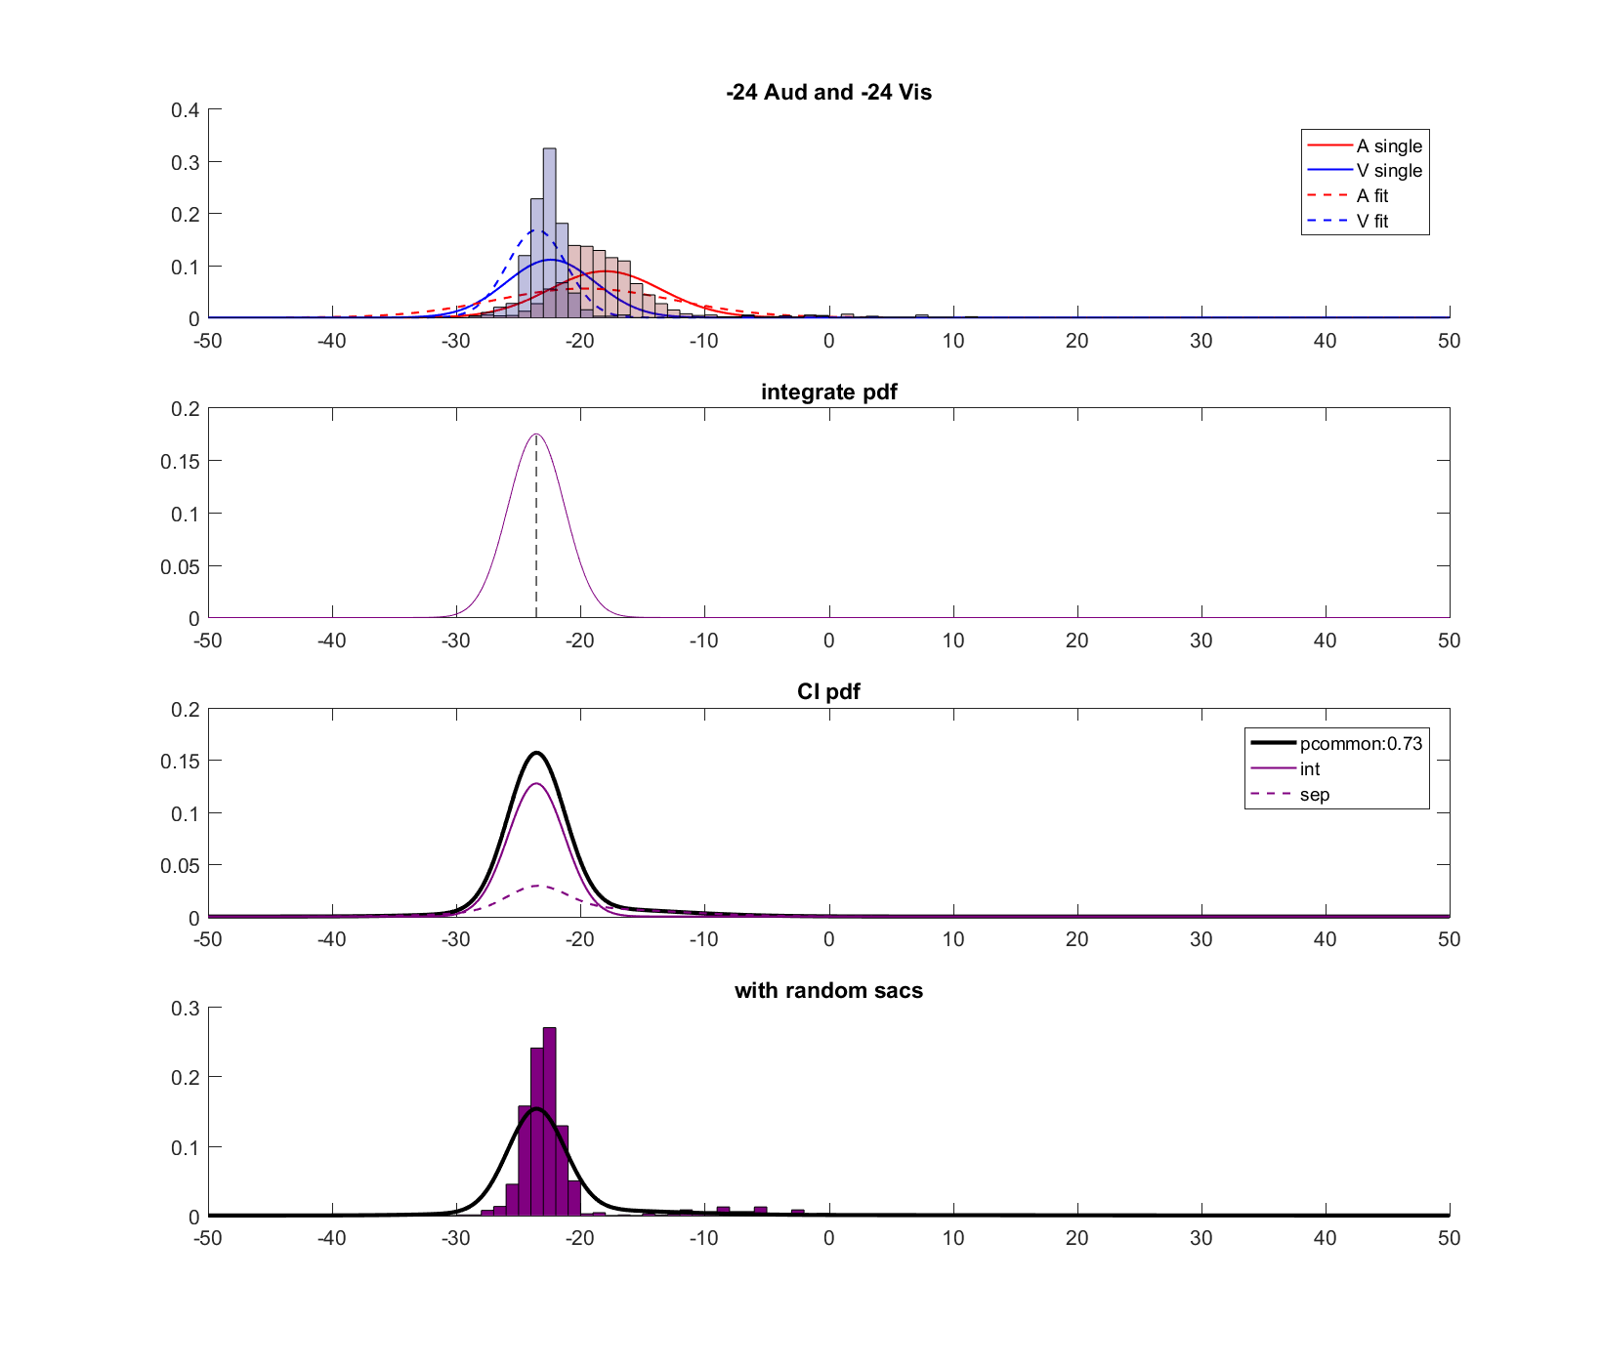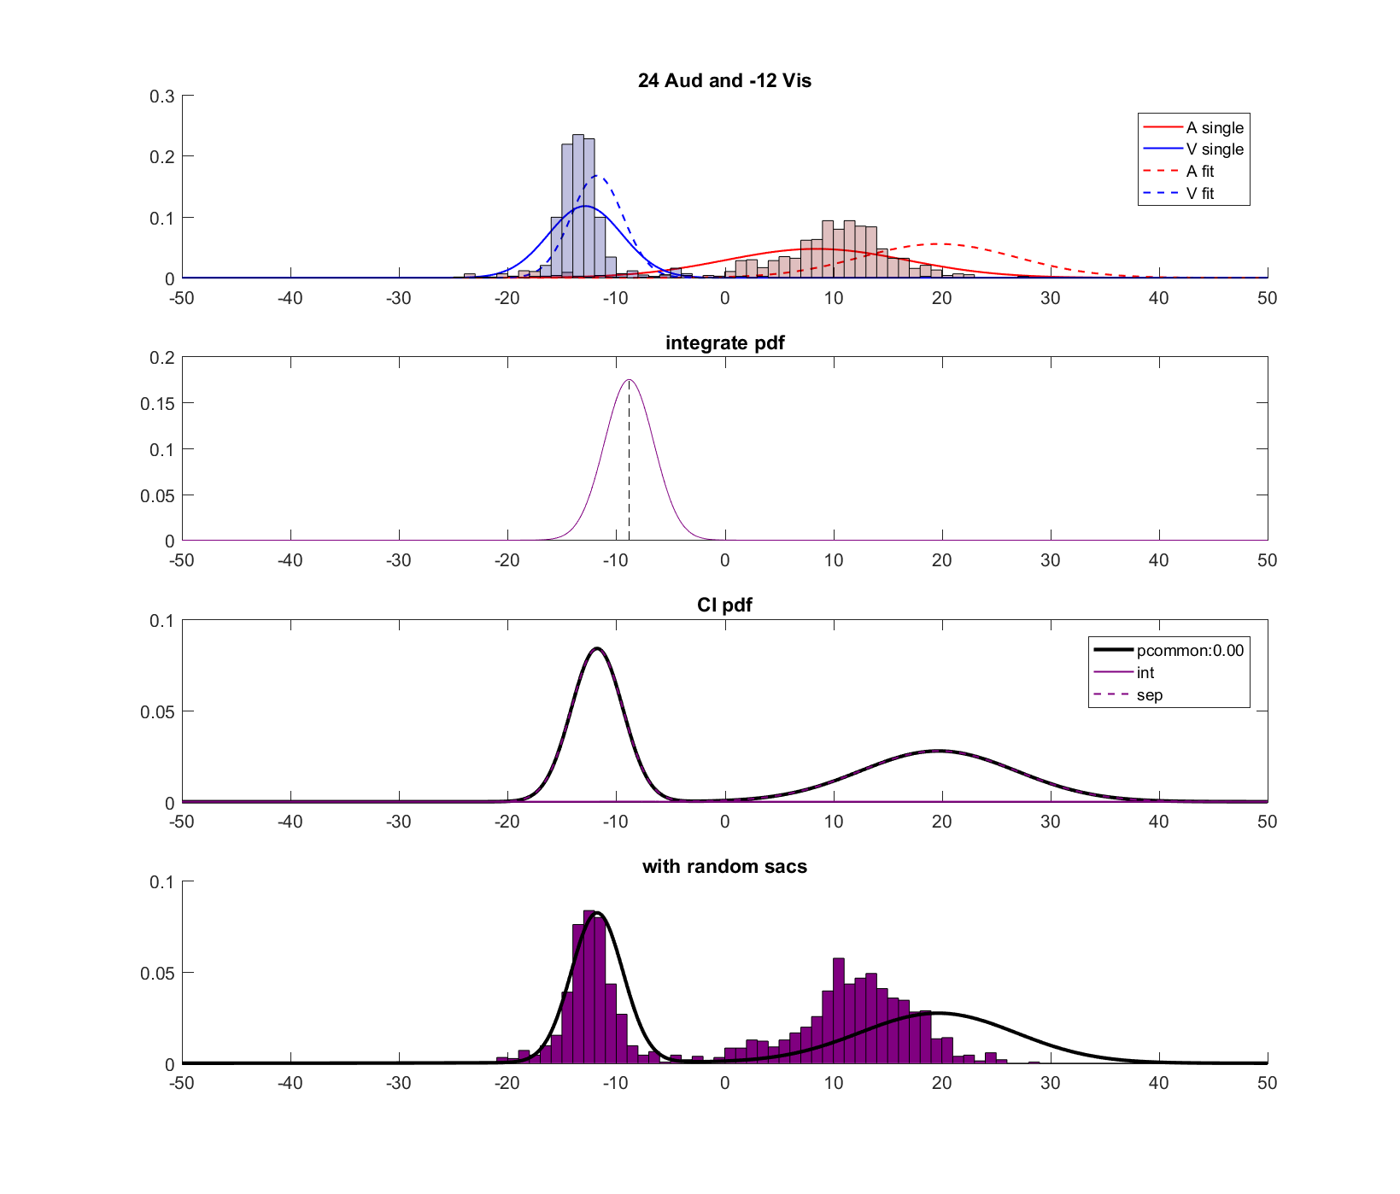 **-24 A with -24 V (integrate) +24 A with -12 V (separate)**

**Figure 1:** *model fits vs actual saccade endpoints for two example conditions.* Saccade endpoints (purple histogram) compared to fit distributions (black line) for two example conditions, one with both targets in the same position (left) and one with targets separated by 36 degrees (right). Both are normalized.

I really think the main problem is that the model has assumptions that are violated by the actual data, but that I’m not sure how to correct for. These assumptions are (1) the auditory and visual estimate means will match the actual spatial location, (2) responses will be distributed normally around these means, with the same variance for each location, and (3) the prior is normal and centered at location = 0.

Point (1) is an especially big problem for auditory stimuli, as you can see in the right half of figure 1 where the auditory distribution is clearly not centered on the actual location (+24 degrees). If you look at the auditory distributions for each condition compared to the visual targets you can see this very clearly. The auditory distributions are not centered on the target locations (black lines), but there isn’t an obvious bias that can be accounted for with a single normal prior. It seems like there are at least two components: one that biases saccades towards some point in between the targets on either side (as though the monkey knows the target will be somewhere in this range, and not in the middle), and another that biases the monkey towards leftward saccades. Something like the schematic in figure 3.

A side effect of this inaccuracy is that the

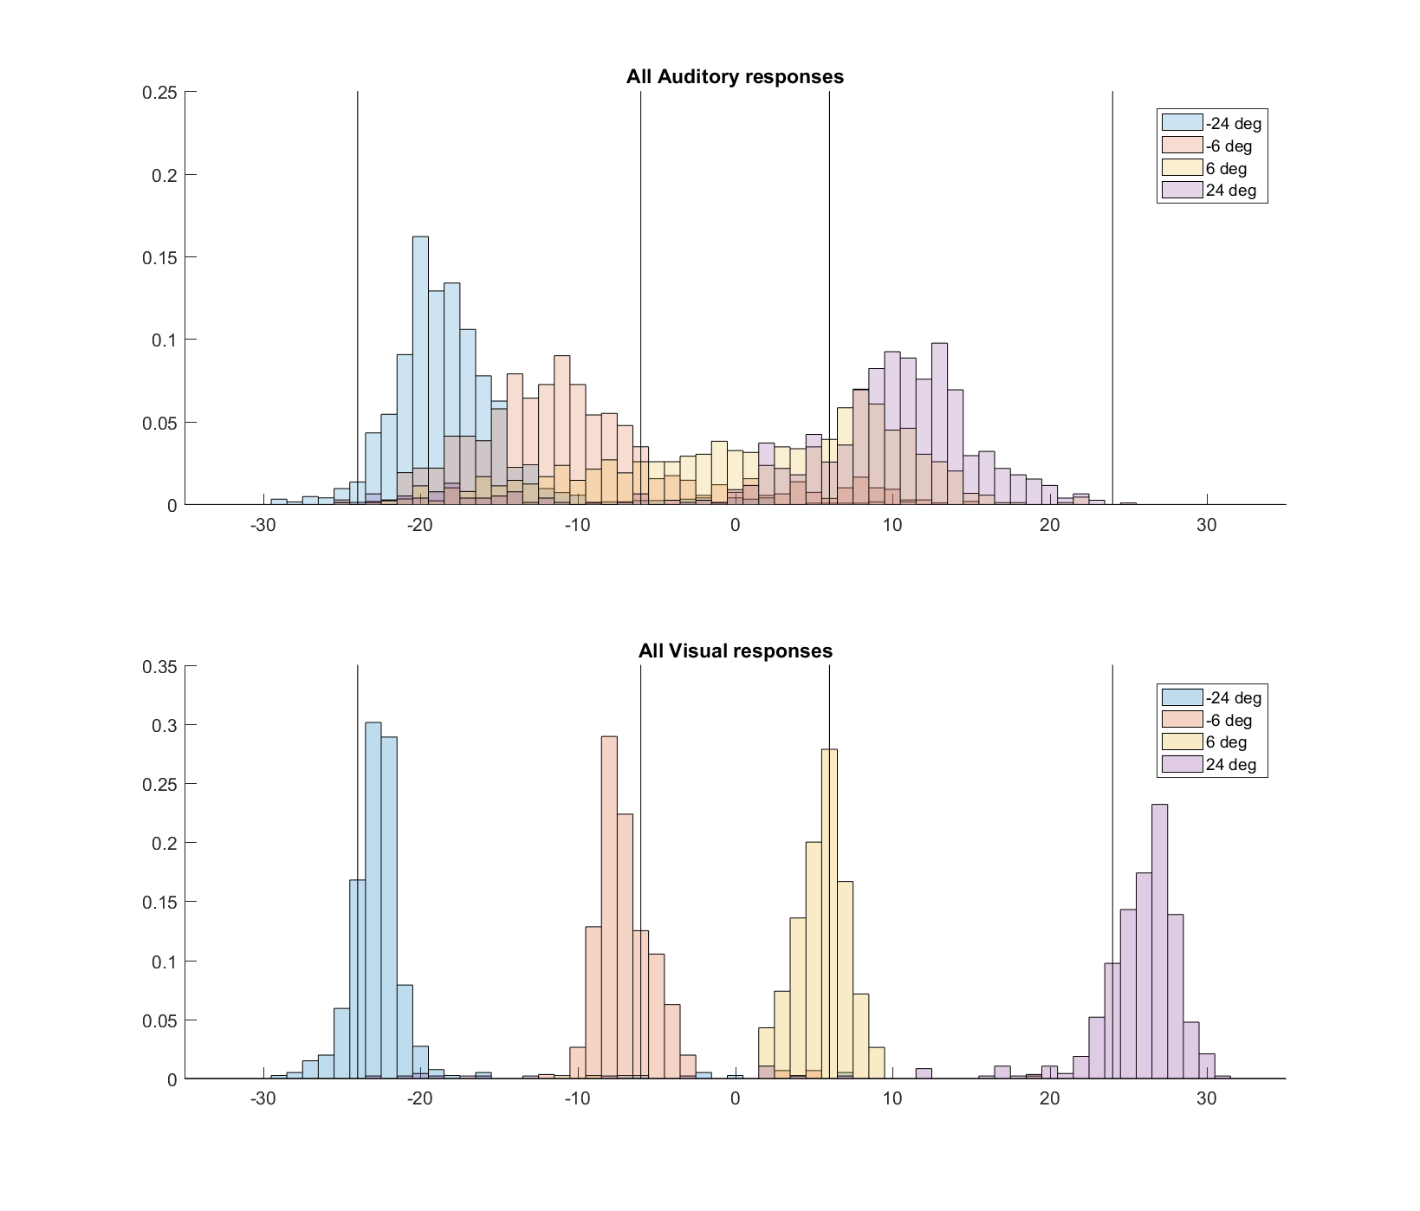

**Figure 2:** *Auditory guided vs visually guided saccade endpoints.* Auditory guided saccades (top) are much less accurate (mean should match with black line) and less precise than visually guided saccades (bottom).

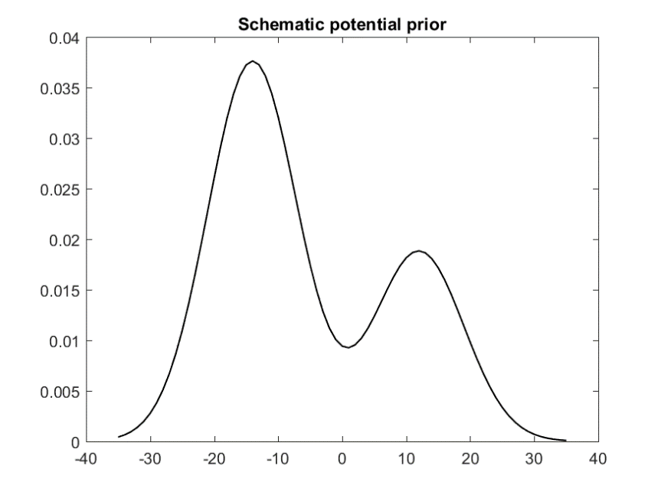

**Figure 3:** *Schematic of potential prior.* Monkey is biased towards either left or right saccades, rather than central. Bias towards left side is stronger.

**Questions**