MeOS Screens V1.0

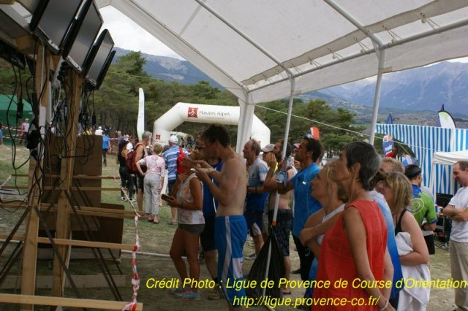

# Introduction to *MeOS Screens*

*MeOS Screens* is a set of web pages initially developed by the Metraware Company for the French 2014 orienteering championship. It is published under the open source Apache license. It is aimed at displaying in real time on one or many computer screens results of orienteering events managed by the open source *MeOS* software.

This solution can also be used with other orienteering events management software if they can transmit data according to Mop protocol as defined by *MeOS*.

Every screen includes:

* A title with both left and right images and eventually a sub-title
* A display zone that could be divided in two panels

In the display zone, one can display:

* Text
* Image
* Results
* Start list
* HTML pages

Any screen used for display must be connected to a device holding a web browser that can get a dedicated page from a web server. The display is updated at regular user defined intervals.

The screen content is updated from the Event management software database thanks to *MeOS* “online results” service.

The way the data are displayed on its side is defined by parameters that can be modified directly using a simple browser.

*MeOS Screens* allowsmanaging individual course as well as relays, vene if for now they are limited to teams made of three members maximum.

*MeOS Screens* source files can be downloaded freely from GitHub at:

<https://github.com/jmonclard/MopScreens>

# Installation

## Hardware

Even if the system can work with only one PC, it is highly probable that at least two computers will be used in addition to the ones that hold browsers used for the screens. They then need to be connected using either a wired or wireless network.

The communication with small computers connected to the screens (for instance Android MK808B devices) can advantageously be made with WiFi. The WiFi router can then be used as a DHCP server delivering IP address to PCs on the network. Nevertheless it is customary to fix the web pages server IP address in order to access more easily to the pages from the devices connected to the screens.

Alternatively, fixing all IP address is an excellent solution too.

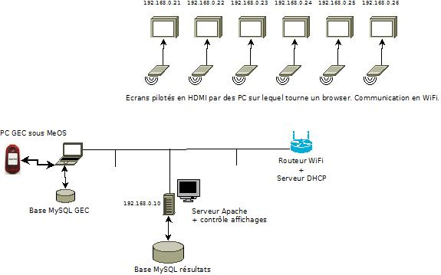

It may be useful to check that the network is working correctly, for instance opening a command window on the PC on which *MeOS* is installed and sending a *ping* command to the page server.

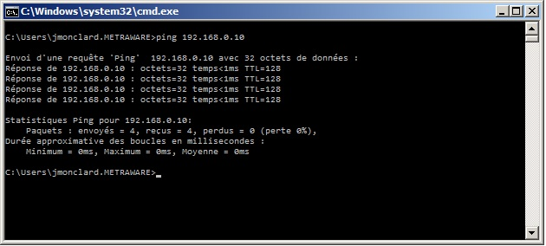

## Installing MeOs

*MeOS* software can be freely downloaded from <http://www.melin.nu/meos/en/download.php>

Installation procedure is described in the documentation available on the same website.

The usage of screens to display results beeing mainly in relation with large events, the most probable configuration is « Large event ». In this configuration the use of a MySQL database for MeOS and a client/server scheme allows the simultaneous access of many computers to the database for race management and animation.

## HTTP server installation

To work properly, the screen display software requires an http server to broadcast html pages to screens’ PC browsers. One can for instance use an Apache server.

A simple solution under Windows® is to use WAMP: <http://www.wampserver.com/>

Please see the installation documentation on the same website for details.

A Linux machine may also advantageously be used as a server. In this case the easiest way is to use the LAMP suite.

## MySQL data base installation

If WAMP or LAMP has been installed, you already have a MySQL database ready to be used on the server computer. Otherwise you have to install MySQL from: <http://www.mysql.fr/>

## MeOS Screens installation

The required files can be freely downloaded from: <https://github.com/jmonclard/MopScreens>

In the www directory created by the Apache installation, create a sub-directory in order to copy MeOS Screens files here.

For instance if one creates a “cfco” folder, the tree like structure should look like:

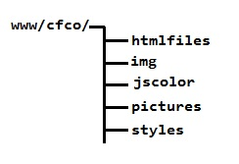

Copy all the *.php* files in the base directory (in the example here /cfco)

Sub-directory ***htmlfiles*** is to contain the html files created by the user to be displayed on screens.

The ***img*** sub-directory contains the icons used by *MeOS Screens*. It is required to copy in this folder all the provided icon files.

The ***jscolor*** folder contains the code used to display a dialog box for the user to pick a color. The provided files must be copied here.

The ***pictures*** directory is to contain images that have to be displayed on screens such as the event logo, sponsors banners, maps etc.

Finally, the ***styles*** folder contains the *.css* files defining the style of the generated pages.

## Launching of MeOS

Start *MeOS* normally, in simple mode or as an event server according to the configuration chosen. Select or create a competition. Then add, if not already done, everything that is necessary for the competition management such as competitors, controls, courses, etc.

## Launching Apache/MySQL

If the Appache server is not up and running on the server, you must start it manually clicking on WampServer icon then activating both Apache and MySQL clicking on the icon that appeared at the far right bottom corner of the screen. This icon that was originally red turns yellow when one of the services is running, then white when they are both operational.

It is possible to check for a working server launching a web browser on the server then entering as a web address: <http://localhost>

Then it is possible to run a browser on the computer on which *MeOS* has been installed and ask for a page on the screen server, entering for instance: <http://192.168.0.10/>

The same page should then been displayed both on the server and the *MeOS* computer.

## Activating MeOS sevice

In *MeOS* select the « Services » tab then click on «Online results »

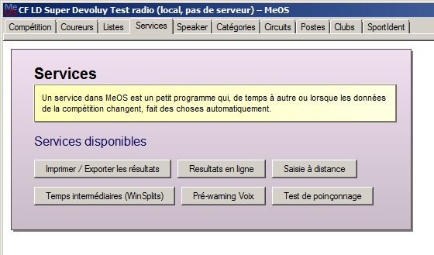

In the dialog box that appears you can leave the interval value to its default value of 10 seconds or modify it at your wish. It is the time separating two updates of the database used for screen display from *MeOS* database.

Keep the export format to its default value (MeOS Online Protocol XML).

**Uncheck** « Compress large files ».

**Check** «Send to the web »and enter the address of the *update.php* on the server. Continuing with the same example it would be: <http://192.168.0.10/cfco/update.php>

Enter the competition ID number and the password that has been defined in the *config.php* file.

**Beware! Two competitions can’t have the same ID number. If an ID is reused, the existing competition having the same ID will be replaced by the new one.**

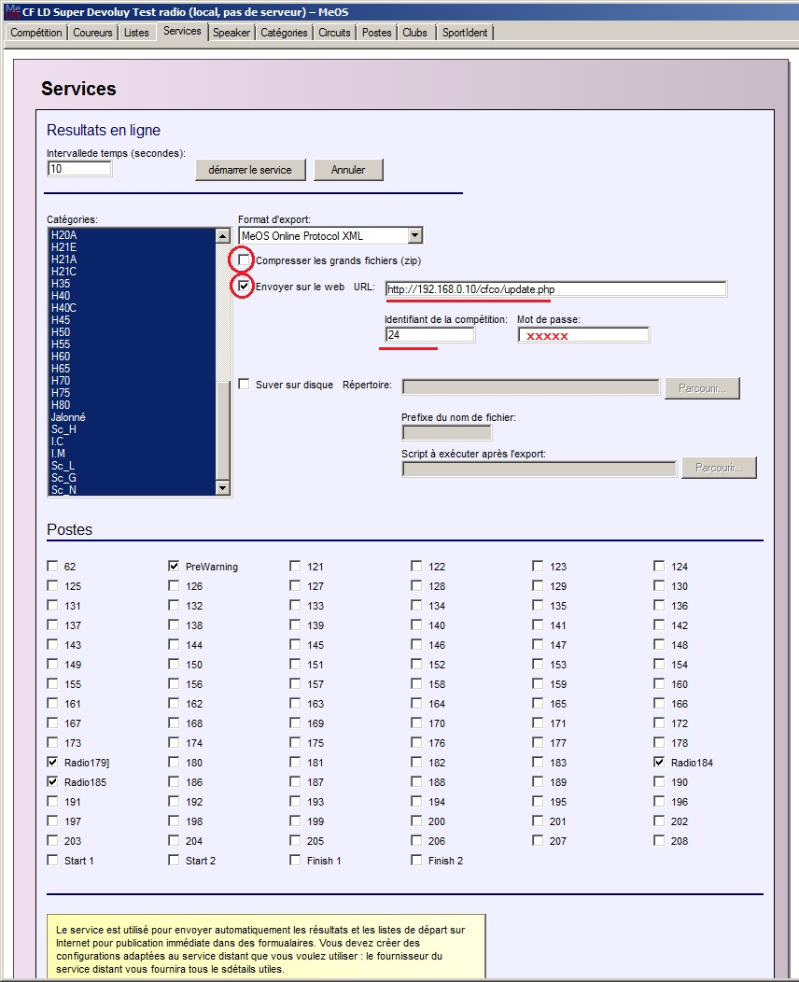

Keep selected the useful classes. The radio controls that have been previously named are automatically selected, but others radio controls can still be added checking the corresponding checkbox.

Finally click on “Start service”.

# Configurations

Screen management is done through the configuration pages. A configuration memorizes all the parameters used to define the content of screens. Thus it is possible to change the aspect of all screens at once as well as preparing screens layout before activating them.

To do that, user must enter in its browser the path to the *screenconfig.php* page located on the server, typing in for instance:

<http://192.168.0.10/cfco/screenconfig.php>

The displayed page holds the list of the existing configurations. It is then possible to create, edit, activate or delete a configuration. The active one is identified by the “green circular arrow” icon.

The bottom of the page lists all the available competitions. They are competitions for which data have been sent previously or are presently sent by *MeOS* to the screens server.

The *Id* column corresponds to the number that has been used in the “online result” field of the “services” tab of *MeOS*. Two competitions can’t have the same number. If one number is reused, the existing competition having the same Id is overwritten by the new one.

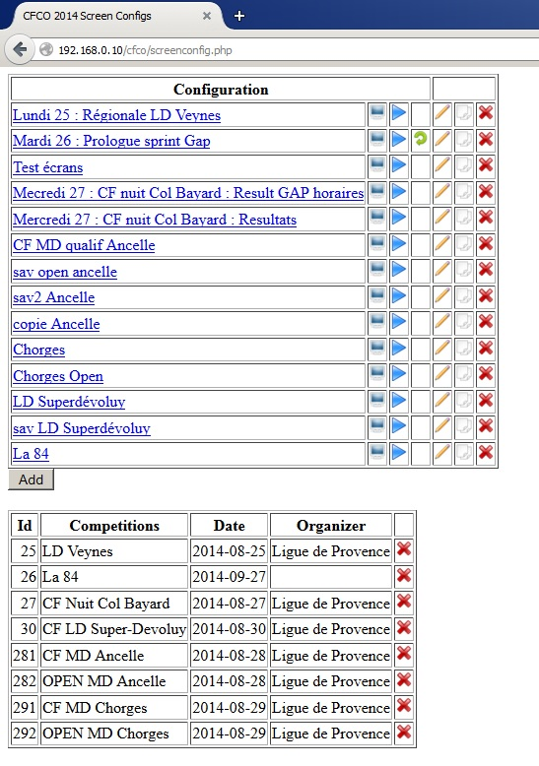

## Adding a configuration

Adding a configuration can be done in two different ways:

1. Creating a new configuration with the “Add” button. It will be created with default values.
2. Duplicating an existing configuration using the “clone” icon  located in the last but one column of the configuration row to be cloned. In this case the new configuration is identical to the duplicated configuration.

In both cases, the user is prompted for the name of the configuration to be created.

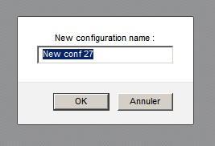

## Renaming a configuration

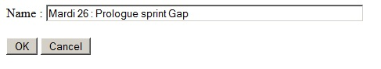

It is possible to rename a configuration clicking on the “pencil” icon.

## Activating a configuration

The activation of a configuration is obtained by clicking on the “blue arrow”  icon of the row corresponding to the configuration of interest.

Once the configuration is active, a green circular arrow icon  appears on the line. The previously activated configuration is automatically deactivated.

## Deleting a configuration

It is possible to delete a configuration clicking on the red cross icon of the row of the configuration to be deleted.

## Editing of a configuration

The edition of a configuration, i.e. defining what should be displayed on every screen, is obtained by clicking on the “screen” icon . A page showing a table with the entire screens to setup is then displayed.

By default the number of screens the program can deals with is 12. It is possible to change this number by altering the constant located at the beginning of the *screen.php* file.

# Setting up the screens

This page presents two distinct zones:

* In the upper part, a table shows the main parameters of all the screens
* In the lower part tables give statistics about the competitions to be displayed.

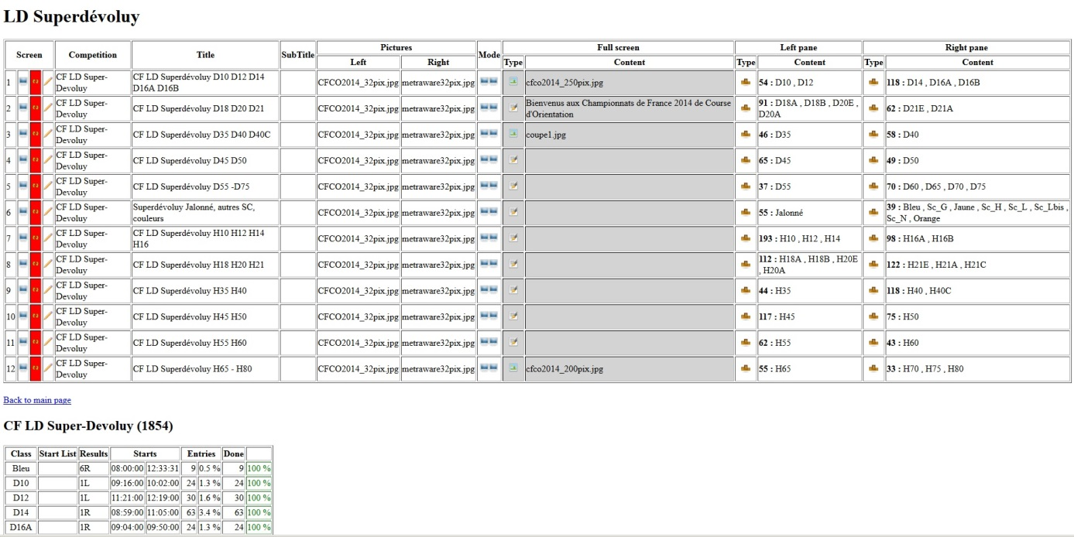

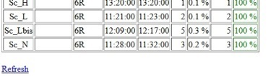

## Main screens parameters

For any screen it is possible to see at a glance:

* The competition used
* The screen title
* The sub-title
* Images on the left and right hand side of the title
* The display mode:
  + Full screen 
  + Two parts 
* In full screen mode:
  + Type of display:
    - Image 
    - Text 
    - HTML page 
  + The content, which can be:
    - For an image : the name of the image file
    - For a text : the text to be displayed
    - For an HTML page : the HTML file name
* When the screen is divided in two parts:
  + The display content type of the left hand side:
    - An image 
    - A text 
    - An html page 
    - A start list 
    - Results 
  + The content of the left hand side which can be according to the type:
    - For an image : the name of the image file
    - For a text : the text to be displayed
    - For an html page : the html file name
    - For a start list : the classes to be displayed
    - For results : the classes to be displayed
  + The display content type for the right hand side (similar to the left side)
  + The content of the right hand side (similar to the left side)

Moreover icons can be clicked in the first column and sometime in the “type” columns.

Clicking on the screen icon  a new page is open in the browser to display the content of the corresponding screen, allowing the user to immediately see the result.

The icon is used to indicate that the screen display system is working properly. The background of this zone turns red  if the page corresponding to the screen has not been accessed on the server for a few tens of seconds denoting an abnormal situation. In normal situation the icon background should be white for the screen used.

The pencil iconallows editing the screen parameters (see below details).

Finally, when the content of the screen is either “start list” or “results” it is possible to directly choose the classes to be displayed clicking on or icons (see chapter « selecting classes » below). This same operation can also be done from the parameters edition page (see hereafter).

# Editing a screen

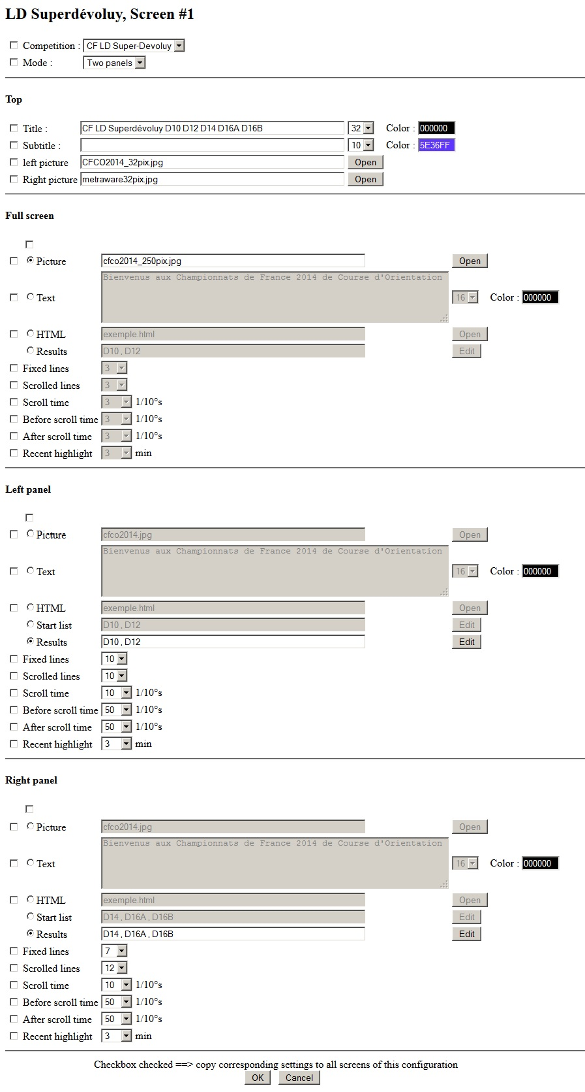

## Checkboxes

In the screen configuration page every parameter is preceded by a checkbox. If this checkbox is checked, the parameter, as defined, will be applied to all other screens when the OK button will be pressed. This allows the user to define at once a default value on all screens or ensure consistency from screen to screen using the same parameter value (scroll speed for instance).

Modifications are only taken into account after the OK button has been pressed.

## Competition and mode

Any screen can be affected to any past or present competition. The competition choice is done using the drop list.

Two display modes are available: full screen or two panels. The choice is done using the corresponding drop list.

For relays, the full screen mode must be chosen. It is also worth to note that in relay at least one radio control must be selected in MeOS.

## Title

A title and a sub-title can be defined along with their font size and color.

Title and sub-title are displayed centered on top of the screen, whatever the mode is (full screen or two panels).

Pictures can be displayed from either side of the title. The supported image file format depends on the browser used for displaying the page on the screens.

## Full screen

Parameters of the “full screen” section applied when the full screen mode is selected.

It is the possible to define the type of the content of the screen using radio buttons. If this choice has to be applied to all other screens, one will check the checkbox located above the radio buttons column. This choice can be either:

* A picture
* A Text
* The content of an HTML file
* One or many classes’ results

For images, the supported file format depends on the browser used. The image is resized to fit the screen size while preserving its aspect ratio.

For text, it is possible to choose the font size and the color.

For an HTML file, it is advisable to first verify that the html file content is acceptable and there is no syntax error in it. The main usage of this option is to allow displaying more evolved texts, for instance including tables, or texts using a mixture of fonts or mixing texts and pictures.

For results display, the choice of the classes to be displayed can be done clicking on the “Edit” button. Please see the “Selecting classes” section below.

For results it is possible to define the number of fixed rows and the number of scrolling rows.

When the page is displayed, scrolling starts after a time defined by the « Before scroll time » parameter and tab swapping to the next class occurs when « After scroll time » elapsed at the end of scrolling.

Scroll speed is defined by the « Scroll time » parameter.

Finally, when a row is updated, either because a new radio time is available or because the runner just arrived, the row text color is changed during a duration defined by the « Recent highlight » parameter.

Durations are defined in tenth of second for scrolling and in minutes for highlighting.

## Left panel

In two panels mode, parameters of the left panel are defined in the « Left panel » section. There are very similar to the one previously described for the full screen case, except that it is also possible to display start lists. In this case, classes to be displayed can be chosen using the Edit button as it could be done for the result classes.

## Right panel

In two panels mode, parameters of the right panel are defined in the « Right panel » section. Parameters are exactly identical to the one described above for the left panel.

# Selecting classes

The selection of the classes to be displayed, either for results or start lists, can be done moving in the “taken” column the desired classes.

The right column (« Available ») holds all the classes that can be chosen. The left column (« Taken ») the classes already selected. It is possible to move a class from one column to the other using either the « > » and « < » buttons.

It is possible to move many classes at once selecting many classes by holding the Ctrl or Shift keys pressed while the name of the class is clicked.

Note that selected classes, being for results or start lists, will be displayed in a separated tab in the same panel.

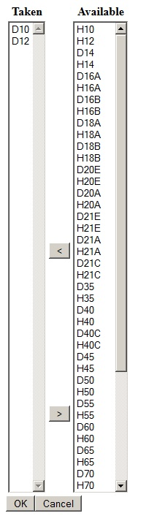

# Displaying content

### On screens

The display on the screens is obtained entering the url of the desired page in the web browser of the PC connected to the screen. The url is of the form *pages.php ?p=*nn where *nn* is the page number.

For instance, if cfco is MopScreens’ directory on the sever, you can enter: <http://192.168.0.10/cfco/pages.php?p=1> to obtain the first page.

Likewise <http://192.168.0.10/cfco/pages.php?p=8> allows displaying page number 8.

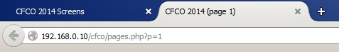

### On the PC used to configure screens

It is possible to visualize the generated screens on the PC used for configuration using the “screen” icon  located at the beginning of the row of the screen configuration page. In this case a new page is opened in the browser. The content of this page is strictly identical to the one displayed on the screen.

