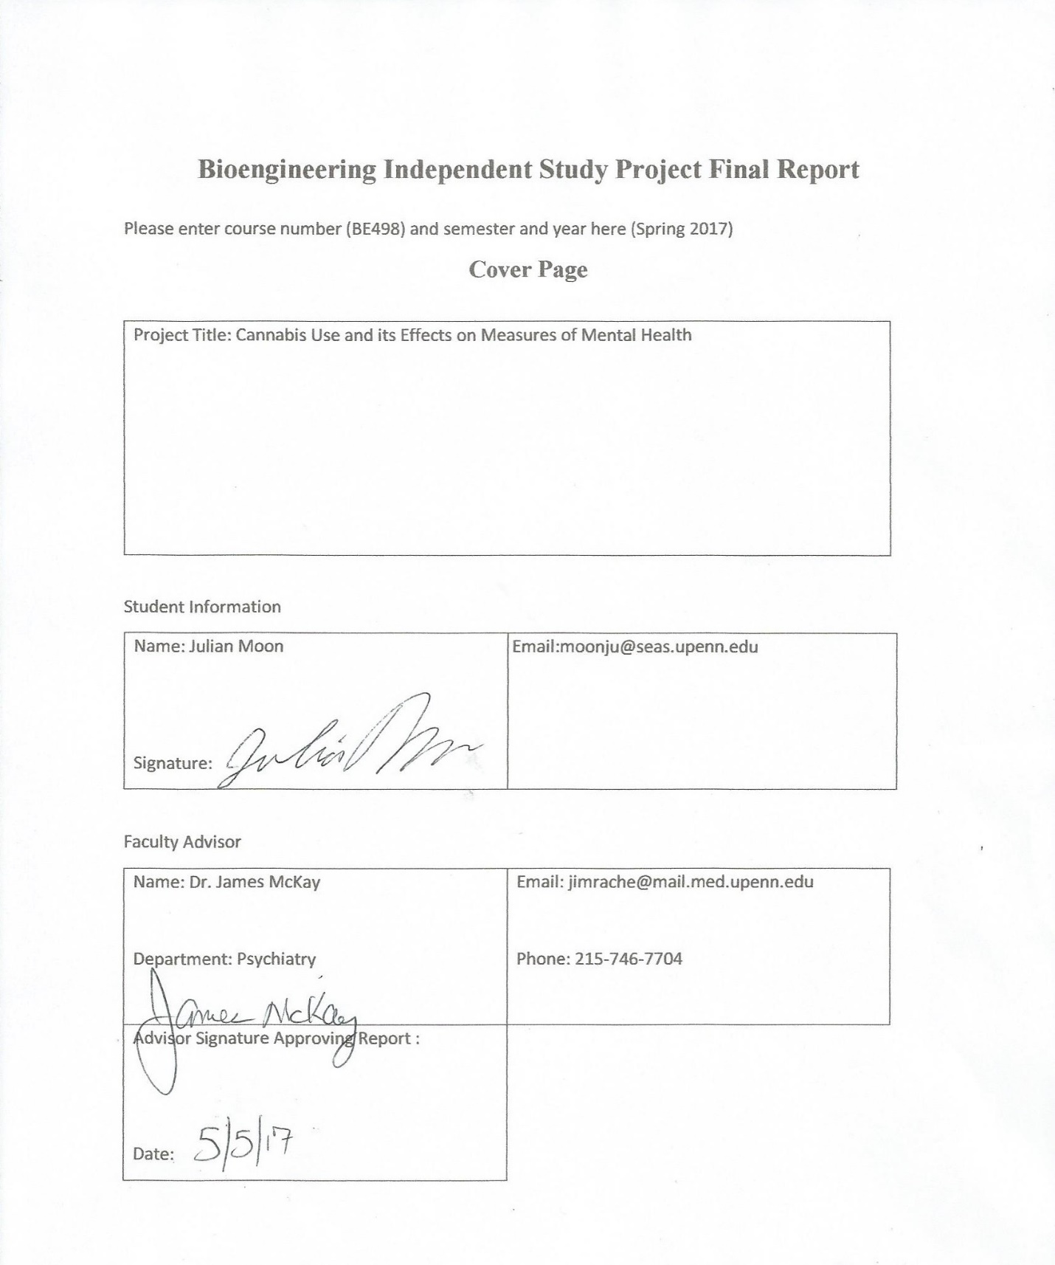

Contents

1. Abstract 3

2. Introduction 4

3. Methods 5

Figure 3.1 7

Table 3.1 7

Figure 3.2 9

Figure 3.3 10

Table 3.2 11

4. Results 12

Table 4.1 12

Figure 4.1 12

5. Discussion 13

Results 13

Limitations 15

6. Directions and Considerations for Future Work 17

7. Conclusions 18

8. Acknowledgements 19

9. Referencesh 19

10. Index A 20

CUDIT (Cannabis Use Disorder Identification Test) 20

CEQ (Cannabis Expectancy Questionnaire) 21

IDAS (Inventory of Depression and Anxiety Symptoms) 22

**Cannabis Use and its Effects on Measures of Mental Health  
Julian Moon  
Independent study project, BE498 Spring 2017  
Advisor: Dr. James McKay  
Department of Psychiatry**

Abstract

Marijuana is one of the most widely used illicit substance worldwide. Its potential medicinal use has garnered much attention in the scientific community, and studies of both its negative and positive aspects have been steadily increasing in the past few years. Using a sample population of veterans in Santa Cruz, California, this study observes the effects of cannabis use with regard to three measures of mental health that address dependency, depression, anxiety and post-traumatic stress disorder. Using Welch’s t-test, Mann-Whitney U test, and randomization, the null hypothesis, which states that there is no difference in mean between two groups categorized by frequency and amount of cannabis use, was tested. The results showed statistical significance only with the measure that evaluates depression and anxiety, favoring the alternative hypothesis that asserted an improved mental state with greater use. These results however, must be interpreted with caution, as a multitude of limitation, both within the data and the testing methods, exist. A more carefully controlled study, as well as more powerful testing methods, would be required to obtain even more accurate and meaningful results.

Introduction

Marijuana is one of the most widely used illicit substance worldwide. Relative to other abused substances, people perceive marijuana use to be without severe health consequences or addiction potential. However, with the emergence of more potent strains through advanced cultivating techniques, there has also been a rise in people seeking help for dependency on the substance on their own volition.

Δ-9-tetrahydrocannabinol (THC), as one of the main cannabinoids found in cannabis, is a psychoactive component of the plant that mimics the effects of endocannabinoids, which include regulation in hunger, memory, decision-making, emotions etc. It binds to the CB1 and CB2 receptors, which after sufficient continuous stimulation, go through the process of down regulation to become less active (Hirvonen et al.*).*  This indicates the development of tolerance, the need for additional stimulation to achieve the same effects. Tolerance to the various effects of cannabis develop at different rates, but as is the case with virtually every psychoactive drug, if given at a dose and a dose schedule producing sustained tissue levels, a definite tolerance, and possible dependency develops (Benowitz et al.*)*.

CB1 receptor transmission strongly regulates expression of cognitive and emotional behaviors (Silveira et al.*)* which suggests that a downregulation of the receptors from frequent and prolonged use could lead to changes in behavior and lifestyle. The use of cannabis as a treatment for mental health issues, such as depression and post-traumatic stress disorder, has been receiving increasing amounts of attention as legalization in some parts of the world began. Cannabidiol (CBD), another cannabinoid found in significant quantities in cannabis, has been shown to attenuate or block acute dose-related amnestic, psychotic, and anxiogenic effects of THC (Lawn et al.*)*. It has even been used for treatment in addiction for other substances, and is the principal component of cannabis that shows medicinal potential. However, with limited research and resources, more study is needed to make definitive conclusions on the nature of cannabis with regard to dependency and different aspects of mental health.

Methods

The data used comes from a cross-sectional survey with 90 participants who were US military veterans and members of the Santa Cruz Veteran’s Alliance (SCVA) in Santa Cruz, California. Participants were attendants of the SCVA’s weekly medicinal cannabis co-op meeting that allowed members with medicinal cannabis prescriptions to get access to free cannabis products. They were asked to complete a self-report battery of questionnaires assessing demographics, cannabis use history, and problematic use of cannabis. Additional questionnaires, which were not relevant to the aims of the current study, were also included as part of a larger, ongoing, longitudinal study.

To establish the independent variable, the responses to four questions were taken into account: Duration of cannabis use in years, duration of cannabis use in months, frequency of use, and amount of use. To assess frequency of use, participants were asked to report how often they use cannabis using a 9-point Likert scale ranging from 1, ‘less than 1 time per month’ to 9 ‘more than 4 times per day’. To assess quantity of use, participants were asked to report how much cannabis they use per week using a 7-point Likert scale ranging from 1 ‘1 gram’ to 7 ‘greater than 12 grams’. To unify these scores into one independent variable, the scores were summed up with the score for duration of cannabis use in months divided by twelve to account for its lesser weight. To categorize the independent variable, the median of the score was used to divide the sample into two groups: light smoker and heavy smoker.

The dependent variables consist of three questionnaires: CUDIT (Cannabis Use Disorder Identification Test), IDAS (Inventory of Depression and Anxiety Symptoms), and CEQ (Cannabis expectancy Questionnaire). Each had eight, sixty-four, and six questions respectively (The detailed questionnaires and scoring information is available in the Appendix A). To convert the scores of the responses into a numerical variable, the sum of the scores for each individual was taken with each question holding equal weight. The total sum scores for each measure were then divided into the corresponding categories of the independent variable in order to perform hypothesis testing. CUDIT explored dependency and CEQ asked questions on the subjects thoughts on cannabis as a treatment for PTSD. IDAS, as the name implies, consisted of questions that addressed symptoms of depression and anxiety. Note that while for CUDIT and IDAS, a higher score reflects worse mental health, whereas for CEQ, a higher score reflects positively on the use of cannabis. In order to predetermine the appropriate steps for further statistical analysis, the scatterplots between the independent variable and dependent variables were observed.

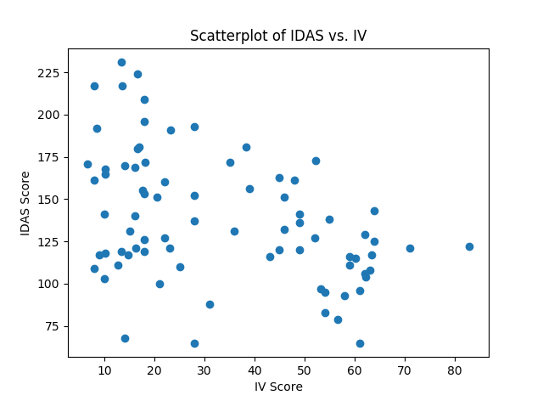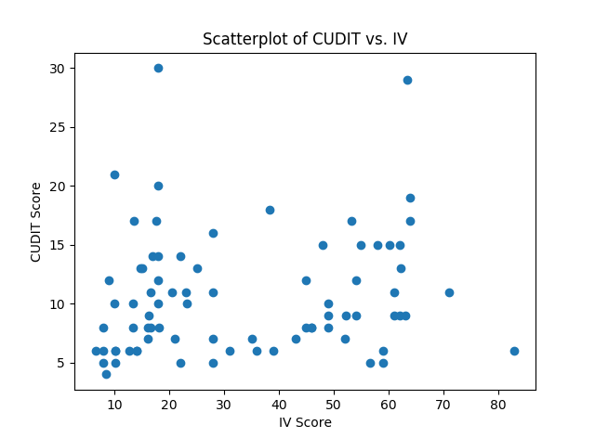

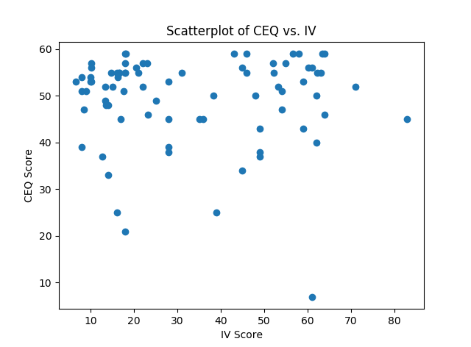

Figure 3.1. Scatterplot for the sum scores of independent variable and dependent variables. CUDIT displays a slight positive correlation, IDAS displays a slight negative correlation, and CEQ displays close to no correlation. The specific values for the correlation coefficient is found in Table 2.1.

|  |  |  |  |
| --- | --- | --- | --- |
| Correlation Coefficient | CUDIT | IDAS | CEQ |
| IV | $$0.1374$$ | $$-0.4201$$ | $$-0.02352$$ |

Table 3.1. Pearson’s correlation coefficient calculated between independent variable and the three dependent variables. As expected, CUDIT is slightly positive, IDAS is negative and CEQ is close to zero.

In order to categorize the independent variable, the median value was used to split the sample into two groups: light and heavy smokers. Likewise, the corresponding CUDIT, IDAS and CEQ sums were categorized into two separate groups for the purpose of hypothesis testing. Using the Pearson’s correlation coefficient in Table 1 as a basis, the following hypothesis were generated. The null hypothesis is identical for all measures, but the alternative hypothesis is split into two. $H_{A1}$ for CUDIT, and $H_{A2}$ for IDAS and CEQ.

$H_{0}:$ The difference in mean of the sum scores between the heavy and light smokers is zero. That is, $μ_{H}-μ_{L}=0$ $H_{A1}:$ 
 The difference in mean of the sum scores between heavy and light smokers is greater than zero. That is, $μ_{H}-μ_{L}>0$ $H_{A2}:$ 
 The difference in mean of the sum scores between heavy and light smokers is less than zero. That is, $μ_{H}-μ_{L}<0$

To determine appropriate testing methods, I first generated the histograms for all the dependent variables.

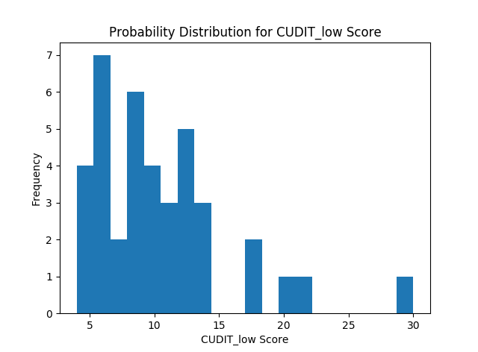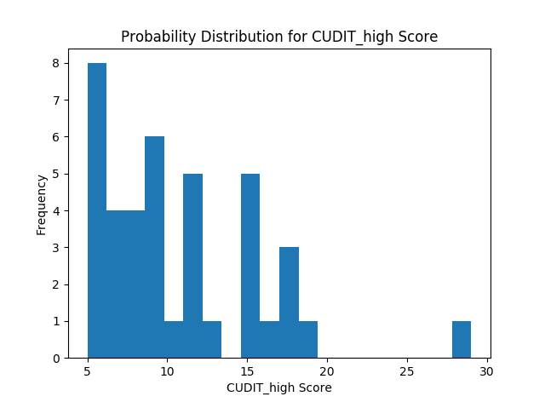

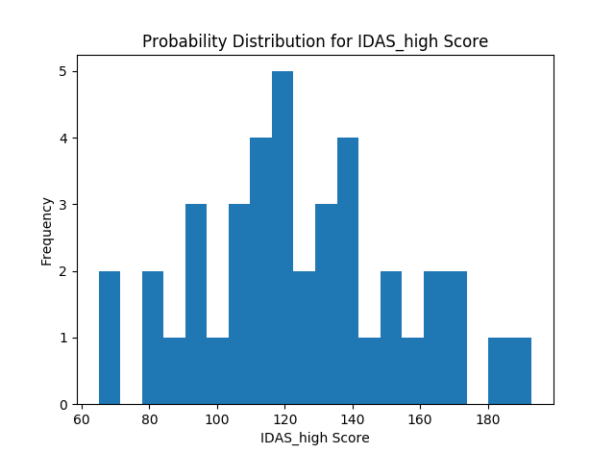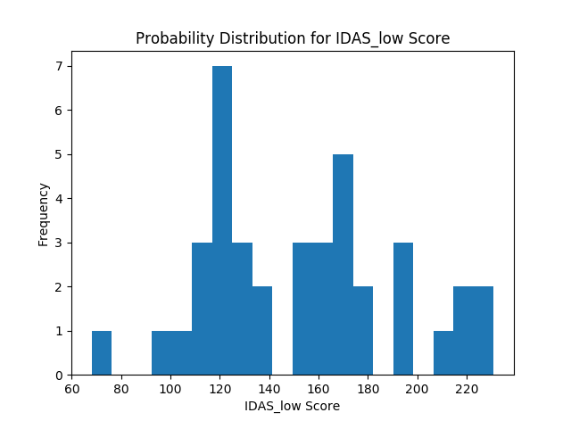

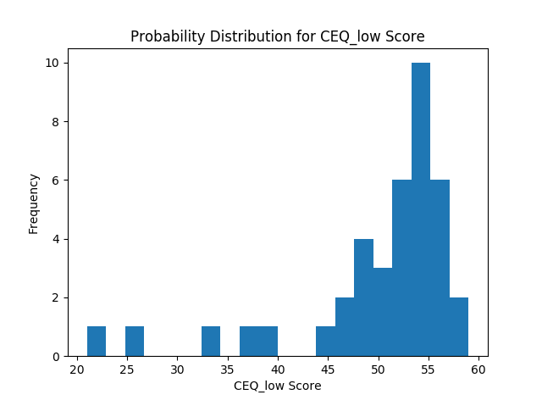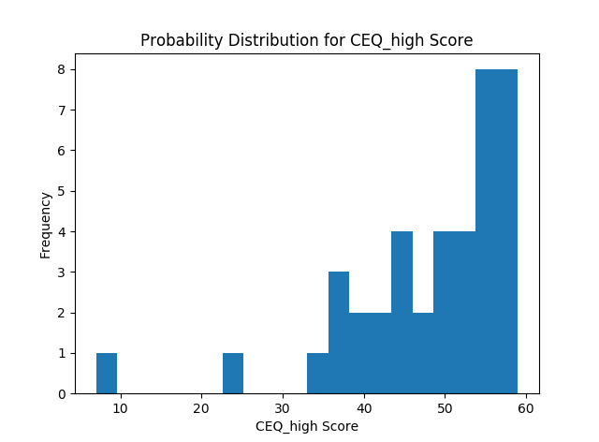

Figure 3.2. Histograms for CUDIT, IDAS and CEQ. CUDIT displays strong positive skew, IDAS displays a roughly normal shape and CEQ displays strong negative skew.

Because of the strong positive skew for CUDIT and strong negative skew for CEQ, appropriate transformations were considered to facilitate statistical testing. The natural logarithm transformation was used for CUDIT and all values in CEQ was raised to the fifth power. The histograms below show the transformed histograms for CUDIT and CEQ.

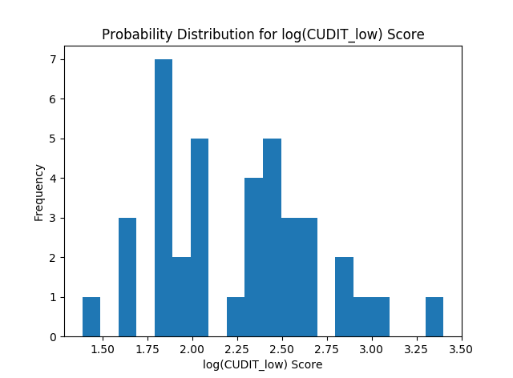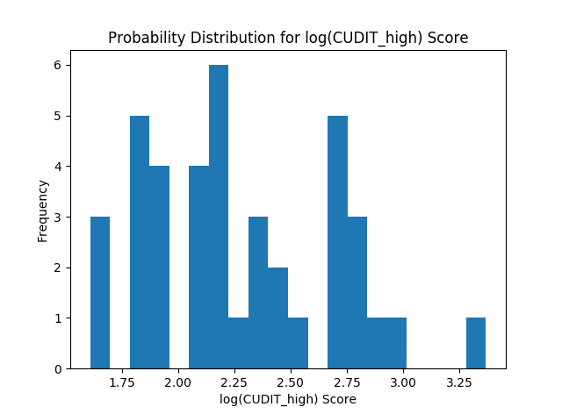

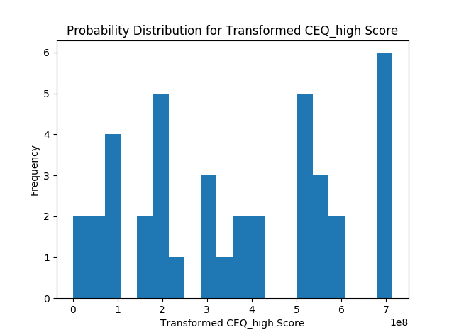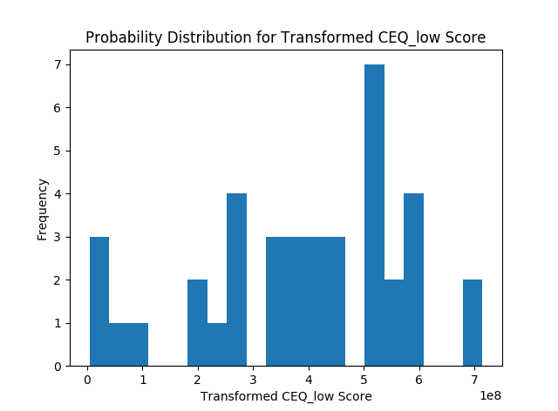

Figure 3.3. The log and power transformed data for CUDIT and CEQ scores are shown. Although the transformation has pushed the distribution toward a more normal shape, all four still have highly problematic shapes to use for a t-test.

To get an even better sense of the data, the means and variances for every dependent variable were also calculated and shown in the table below.

|  |  |  |
| --- | --- | --- |
|  | Mean | Variance |
| CUDIT_low | 10.4359 | 27.1690 |
| CUDIT_high | 10.7500 | 24.3875 |
| log(CUDIT_low) | 2.2394 | 0.2028 |
| log(CUDIT_high) | 2.2821 | 0.1791 |
| CEQ_low | 50.2564 | 71.7291 |
| CEQ_high | 48.4750 | 109.5494 |
| Transformed CEQ_low | 3.8912 e+8 | 3.3996 e+16 |
| Transformed CEQ_high | 3.6210 e+8 | 5.2151 e+16 |
| IDAS_low | 152.0769 | 1510.9941 |
| IDAS_high | 124.4500 | 904.2975 |

Table 3.2. The mean and variances for each of the dependent variable used for analysis.

As shown above, the transformed data still is not quite normal. Therefore, nonparametric testing seemed more appropriate for the situation. However, Welch’s t-test was also used for reference for p-values. As for the nonparametric methods, the Mann-Whitney U test and randomization were used. For randomization, I shuffled the independent variable such that each individual received a random corresponding dependent variable. Then the dependent variables were categorized into the aforementioned two groups, and then the test statistic, namely, the difference between means between the two groups, was calculated. Through ten-thousand iterations, a null distribution for the test statistic was established for the three dependent variables.

Results

The p-values for each of the hypothesis were calculated using Welch’s t-test, Mann-Whitney U test, and randomization testing. The values are shown below in Table 3.

|  |  |  |  |
| --- | --- | --- | --- |
|  | CUDIT | IDAS | CEQ |
| t-test | 0.3347 | 0.0004263 | 0.2845 |
| Mann-Whitney U | 0.3200 | 0.0014581 | 0.2943 |
| Randomization | 0.4025 | 0.0004 | 0.2078 |

Table 4.1. The p-values for each dependent variable is shown. Every test, with different assumptions and computations, produce varying results, but the p-values differences between the different approaches are within 0.10 from each other.

Since the randomization method generates a null distribution of its own, the distribution, along with the test statistic calculated from the original sample, is shown in the figure below.

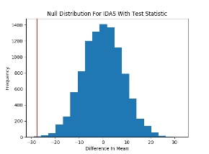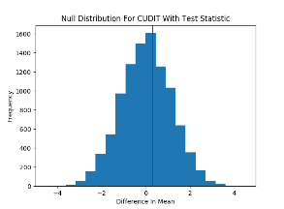

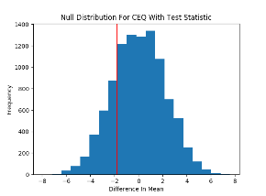

Figure 4.1. The null distributions generated from randomization and the test statistic from the original sample (shown as a red vertical line) for CUDIT, IDAS and CEQ. The locations of the test statistics corroborate the p-values shown in table 2.

Discussion

Results

The scatterplots from Figure 2.1 provided initial direction and predictions for the results of the hypothesis testing. The t-test, one of the more well-known parametric methods, was first employed only to visualize the shift in location and obtain an estimate of the p-value. The power of this test is severely limited due to its strict assumptions and nature of the data. As we can see in Figure 2.3, even the transformed data for CUDIT and CEQ do not satisfy the condition of normality, which means that the sampling distribution for the difference in mean cannot possibly be normally distributed as well. Even with a sufficiently large sample size, the irregularly distributed values make it difficult for the Welch’s t-test to estimate standard error very well. Therefore, we do not put much significance to the p-value obtained by the t-test.

The Mann-Whitney U-test, a rank based test for data that is not normally distributed, is a more appropriate choice for this study considering the distribution of the data. Despite the variances across dependent variables being different, all three have roughly similar distribution shape, and location, which are key assumptions for the Mann-Whitney U-test. The power of this test is still limited however, from the fact that we do not have truly random samples. As we can see from Table 3.1, the p-value using this test yielded similar results for CUDIT and CEQ, while the p-value for IDAS increased by more than three-fold. The increase for IDAS may be explained by the fact that the Mann-Whitney U-test employs ranks, rather than actual values, which would decrease the significance of the stronger negative correlation found in IDAS, resulting in the test-statistic being not as significant as the t-test. However, with a p-value of 0.001458, the test still concludes the result as significant with regards to our alpha value of 0.05.

Finally, to correct for the distribution of data even better, randomization testing was used. As described in the method section, this test creates the null distribution for the test statistics using ten-thousand random permutations of the independent variable. This allows us to compare the test statistic to a null distribution that is derived directly from the data itself, which allows us to avoid strict assumptions used in parametric methods. At 0.4075 and 0.2104, the p-values for CUDIT and CEQ remain not significant at the given alpha level, while IDAS, with a p-value of 0.0007 is still significant.

The null hypothesis for all three dependent variables was that the difference in mean between heavy-smoking and light-smoking group is zero, while our alternative hypotheses were that the difference in mean was greater than zero for CUDIT, and lower than zero for IDAS and CEQ. However, all nine p-values derived from the three statistical tests conclude that we cannot reject the null for CUDIT and CEQ, while we can reject the null for IDAS.

As mentioned earlier, CUDIT is a measure that is associated with problematic use of cannabis. With continuously increasing widespread misuse of cannabis products throughout the country, the alternative hypothesis was naturally formulated to lean towards the heavy-smoking group. However, as aforementioned, the results are not statistically significant, and with a p-value of 0.4075, the probability of a type II error is relatively low.

IDAS, as its name implies, measures symptoms of anxiety and depression, and a p-value of 0.0007 illustrates a marked difference between the two groups. This suggests that on average, the heavier smoking group had lower levels of symptoms related to anxiety and depression. However, a confounding factor that must be taken into account is that the sample consisted entirely of veterans, who often have had to go to through trauma and experience mental issues caused by war-related incidents. Despite the statistical significance, it may be the case that the heavier use of cannabis simply masked the symptoms, but not necessarily solved the cause. Nevertheless, this finding has deep implications in the potential use of cannabis to treat veterans, as many suffer from extended post-traumatic experiences.

The CEQ provides more insight into post-traumatic experiences as it directly deals with the issue. Unlike IDAS, the p-value is much greater at 0.2104, and is not significant. The hypothesis predicted that heavier smokers will view cannabis as a treatment for PTSD more unfavorably. This was based heavily on the increase of problematic cannabis use, but as is the case with IDAS, the demographic characteristics may present a confounding factor. In addition, this allows us to interpret the broad results of IDAS better, since this suggests that heavier cannabis use does not necessarily reflect poorly on this specific aspect of mental health.

Limitations

The use of a cross-sectional study, rather than a longitudinal study, presented numerous limitations considering the nature of the research. Since the goal of the study is to observe the relationship between amount and frequency of cannabis use and its subsequent effects on perception of cannabis, depression/anxiety, and trauma, using a cross-sectional study only provides a one-dimensional view of the effect. In addition, the diversity in demographic information of the sample further limits the power of the study. Even though the sample shares the same characteristic of being veterans, each have widely different personal traits, and as such, must respond to cannabis use in varying manners. In contrast to a cross-sectional study, a longitudinal study would have limited this confounding factor, since we could study the change in response for each individual multiple times over a given time-course and compare results within an individual before comparing results across individuals. This approach would allow us to isolate the effects of the independent variable on the dependent variables more accurately.

The nature of the data also presents profound limitations for the study. The survey not only had more than seven hundred variables, but the questionnaires were often overlapping and repetitive. In addition, the incompleteness of the responses presented limits to the quality of variables. The initial aim of the research was to observe %THC and %CBD in the cannabis used by the individuals and how it correlates to various behavioral aspects. However, both variables were riddled with large outliers, but a larger problem was the disproportionate absence of any response. To makes matters even more difficult, even the self-reported values of %THC/CBD, are not laboratory tested results, but merely personal estimates, which would lead to lower quality of data and decreased significance for the study itself. As such, the independent variable was instead chosen to explore the general frequency and amount of cannabis use.

Another aspect of the data that presented limitations was the use of the Likert scale, which does not directly measure a quantity, but encompasses an arbitrary range of numbers predetermined by the measure itself. In order to perform statistical testing, I took the sum of various measures and used those to compare the numerical values. This however, presents two major issues. First is that it the nature of the Likert scale limits precision, making it difficult to accurately interpret how the numerical values of the independent and dependent variable translate to values or measures in real life. This issue however, is somewhat unavoidable when we consider the fact that the dependent variables are more qualitative than quantitative. A tool to convert qualitative data into numerical data was necessary, and the Likert scale, while not the best, bridged the gap. The second problem about simply taking the sum is that it gives uniform weight to each of the questions for every measure. However, because each dependent variable, although designed to measure a certain type of behavior or attitude, has a broad array of questions, it is difficult to determine the best way to allocate weights. As such, taking the sum score seemed to be the most appropriate way for statistical analysis.

Directions and Considerations for Future Work

As is the case with many illicit substances, cannabis research has faced severed limitations in both quality and quantity of data due to lacking resources and funding. However, with the rise of the legalization controversy, both positive and negative aspects of cannabis use have been receiving more and more attention. Studies such as this one relies too much on general information that employs arbitrary processes solely for statistical analysis. Increasing funding and research would lead to more detailed scientific information on the substance itself. For example, with legalization, people will have more access to information on their cannabis such as percent THC and percent CBD. These specific numbers alone, in tandem with the measures used in this study, would result in a much more precise study that can accurately analyze the nature of cannabis and its effects on mental health. Overall, much work is still needed in our understanding of addiction and mental health, as well as the chemical nature of phytocannabinoids and the biological mechanism involved in processing cannabis. Without these advancements, general studies can only continue to produce lower quality, and sometimes, conflicting, results, inhibiting us from gaining any significant knowledge in the field.

Conclusions

The difference between the means for CUDIT and CEQ were not significant with respect to the null hypothesis at the alpha level of 0.05. However, the difference in mean for IDAS was significant with respect to the null hypothesis that asserted no difference. Taking the hypotheses into consideration, this suggests that subjects in the two groups did not have any statistically significant differences in terms of their views on dependency and PTSD treatment. In contrast, the heavier smoking group had a significantly lower mean in IDAS score, supporting the potential medicinal benefits of cannabis in terms of mental health. A recurring trend in cannabis research is the emergence of conflicting results across different studies, and even within this study itself, one may find conflicting results within the interpretation of the effects on cannabis. The inherent limitations of using numerical analysis for psychiatric study will still remain, but with more resources, studies with stricter controls and methods will be available, leading to tests with increased power and accuracy. Until then, studies such as this one must first pave the way for future research by contributing to literature using whatever resources available at the time.

Acknowledgements

Thank you to Dr. McKay, for providing insight and guidance in psychiatric research, as well as for providing professional and personal support for the project throughout. I would also like to thank Dr. Bonn-Miller, and Mallory Loflin, for providing me with the data and as well as thorough guidance on how to integrate it into my research.

References

J Hirvonen, RS Goodwin et al. Reversible and regionally selective downregulation of brain cannabinoid ${CB}_{1}$ receptors in chronic daily cannabis smokers. Mol Psychiatry. 2012 June ; 17(6): 642-649

Jones, Benowitz et al. Clinical Relevance of Cannabis Tolerance and Dependence. J Clin Pharmacol. 1981; 21:143S-152S.

Lawn, Freeman et al. Acute and chronic effects of cannabinoids on effort-related decision-making and reward learning: an evaluation of the cannabis ‘amotivational’ hypothesis. Psychopharmacology (2016) 233:3537-3552.

Silveira, Arnold et al. Seeing Through the smoke: Human and animal studies of cannabis use and endocannabinoid signaling in corticolimbic networks. NBR-2593.

Index A

CUDIT (Cannabis Use Disorder Identification Test)

Have you used any cannabis over the past six months? **YES/NO**

If YES, please answer the following questions about your cannabis use. Circle the response that is most correct for you in relation to your cannabis use over the past six months:

**1. How often do you use cannabis?**

|  |  |  |  |  |
| --- | --- | --- | --- | --- |
| Never | Monthly or less | 2-4 times a month | 2-3 times a week | 4 or more times a week |
| 0 | 1 | 2 | 3 | 4 |

**2. How many hours were you “stoned” on a typical day when you had been using cannabis?**

|  |  |  |  |  |
| --- | --- | --- | --- | --- |
| Less than 1 | 1 or 2 | 3 or 4 | 5 or 6 | 7 or more |
| 0 | 1 | 2 | 3 | 4 |

**3. How often during the past 6 months did you find that you were not able to stop using cannabis once you had started?**

|  |  |  |  |  |
| --- | --- | --- | --- | --- |
| Never | Less than monthly | Monthly | Weekly | Daily or almost daily |
| 0 | 1 | 2 | 3 | 4 |

**4. How often during the past 6 months did you fail to do what was normally expected from you because of using cannabis?**

|  |  |  |  |  |
| --- | --- | --- | --- | --- |
| Never | Less than monthly | Monthly | Weekly | Daily or almost daily |
| 0 | 1 | 2 | 3 | 4 |

**5. How often in the past 6 months have you devoted a great deal or your time to getting, using, or recovering from cannabis?**

|  |  |  |  |  |
| --- | --- | --- | --- | --- |
| Never | Less than monthly | Monthly | Weekly | Daily or almost daily |
| 0 | 1 | 2 | 3 | 4 |

**6. How often in the past 6 months have you had a problem with your memory or concentration after using cannabis?**

|  |  |  |  |  |
| --- | --- | --- | --- | --- |
| Never | Less than monthly | Monthly | Weekly | Daily or almost daily |
| 0 | 1 | 2 | 3 | 4 |

**7. How often do you use cannabis in situations that could be physically hazardous, such as driving, operating machinery, or caring for children?**

|  |  |  |  |  |
| --- | --- | --- | --- | --- |
| Never | Less than monthly | Monthly | Weekly | Daily or almost daily |
| 0 | 1 | 2 | 3 | 4 |

**8. Have you ever thought about cutting down, or stopping, your use of cannabis?**

|  |  |  |
| --- | --- | --- |
| Never | Yes, but not in the past 6 months | Yes, during the past 6 months |
| 0 | 2 | 4 |

CEQ (Cannabis Expectancy Questionnaire)

We would like you to indicate below how much you believe, *right now*, that marijuana would help to reduce your PTSD/trauma symptoms. Belief usually has two aspects to it: (1) what one *thinks* would happen and (2) what one *feels* would happen. Sometimes these are similar; sometimes they are different. Please answer the questions below. In the first set, answer in terms of what you *think*. In the second set answer in terms of what you really and truly *feel*.

Set I

1. At this point, how logical does marijuana seem as a treatment?

|  |  |  |  |  |  |  |  |  |
| --- | --- | --- | --- | --- | --- | --- | --- | --- |
| 1 | 2 | 3 | 4 | 5 | 6 | 7 | 8 | 9 |
| not at all logical | | | somewhat logical | | | very logical | | |

1. At this point, how successfully do you think marijuana would be in reducing your trauma symptoms?

|  |  |  |  |  |  |  |  |  |
| --- | --- | --- | --- | --- | --- | --- | --- | --- |
| 1 | 2 | 3 | 4 | 5 | 6 | 7 | 8 | 9 |
| not at all useful | | | somewhat useful | | | very useful | | |

1. How confident would you be in recommending marijuana to a friend who experiences similar problems?

|  |  |  |  |  |  |  |  |  |
| --- | --- | --- | --- | --- | --- | --- | --- | --- |
| 1 | 2 | 3 | 4 | 5 | 6 | 7 | 8 | 9 |
| not at all confident | | | somewhat confident | | | very confident | | |

1. After using marijuana, how much improvement in your trauma symptoms do you think would occur?

|  |  |  |  |  |  |  |  |  |  |  |
| --- | --- | --- | --- | --- | --- | --- | --- | --- | --- | --- |
| 0% | 10% | 20% | 30% | 40% | 50% | 60% | 70% | 80% | 90% | 100% |

Set II

For this set, close your eyes for a few moments, and try to identify what you really *feel* about marijuana and its likely success. Then answer the following questions.

1. At this point, how much do you really *feel* that marijuana would help you to reduce your trauma symptoms?

|  |  |  |  |  |  |  |  |  |
| --- | --- | --- | --- | --- | --- | --- | --- | --- |
| 1 | 2 | 3 | 4 | 5 | 6 | 7 | 8 | 9 |
| not at all | | | somewhat | | | very much | | |

1. After using marijuana, how much improvement in your trauma symptoms do you really *feel* would occur?

|  |  |  |  |  |  |  |  |  |  |  |
| --- | --- | --- | --- | --- | --- | --- | --- | --- | --- | --- |
| 0% | 10% | 20% | 30% | 40% | 50% | 60% | 70% | 80% | 90% | 100% |

IDAS (Inventory of Depression and Anxiety Symptoms)



38. _____I felt a pain in my chest

39. _____I was worried about embarrassing

myself socially

40. _____I felt dizzy or light headed

41. _____I cut or burned myself on purpose

42. _____I had little interest in my usual

hobbies or activities

43. _____I thought that the world would be

better off without me

44. _____I felt much worse in the morning

than later in the day

45. _____I felt drowsy, sleepy

46. _____I woke up early and could not get

back to sleep

47. _____I had trouble concentrating

48. _____I had trouble making up my mind

49. _____I talked more slowly than usual

50. _____I had trouble waking up in the

morning

51. _____I found myself worrying all the time

52. _____I woke up frequently during the night

53. _____It took a lot of effort for me to get going

54. _____I woke up much earlier than usual

55. _____I was trembling or shaking

56. _____I became anxious in a crowded public

setting

57. _____I felt faint

58. _____I found it difficult to make eye

contact with people

59. _____My heart was racing or pounding

60. _____I got upset thinking about something

bad that happened

61. _____I found it difficult to talk with

people I did not know well

62. _____I had a very dry mouth

63. _____I was short of breath

64. _____I felt like I was choking