Dear Deans Horn and Olesik,

I am writing to express my enthusiastic support for the BuckAI Observatory project proposed by Joachim Moortgat in the white paper dated May 1, 2025. This initiative, housed within the College of Arts and Sciences at The Ohio State University, aims to position OSU as a national leader in artificial intelligence (AI) research and education, with a primary emphasis on Earth Observation.

The BuckAI Observatory is designed to complement existing AI centers at OSU, such as TDAI, ICICLE, AI-EDGE, CQISE, CDME, Imageomics, and ACCAD. By focusing on applied AI, particularly in Earth Observation, the Observatory will foster interdisciplinary collaboration among researchers from various fields, including Computer Science and Engineering, remote sensing, microbiome science, and the Arts. This collaboration will be symbiotic, benefiting both AI method experts and remote-sensing scientists through the exchange of state-of-the-art algorithms and rich, multi-modal satellite data.

Additionally, the BuckAI Observatory will leverage Ohio State's world-class research in remote sensing and geodesy. The university's expertise in these areas will be instrumental in advancing the Observatory's mission. By integrating cutting-edge AI techniques with OSU's renowned capabilities in remote sensing and geodesy, the Observatory will enhance the accuracy and applicability of Earth Observation data. This integration will not only improve the quality of research but also provide valuable insights into environmental monitoring, disaster response, and resource management.

My own research will significantly benefit from the BuckAI Observatory by enabling cutting-edge AI methods in polar remote sensing, modeling, and data analysis. The resources and collaborative environment provided by the Observatory will enhance our ability to analyze and interpret complex data sets, leading to more accurate and impactful scientific outcomes.

Furthermore, the BuckAI Observatory will bring together existing activities in AI and Earth Observation across various units within OSU, including the School of Earth Sciences, Geography, Astronomy, EEOB (Evolution, Ecology, and Organismal Biology), and other units, as well as those outside of the College of Arts and Sciences. This comprehensive approach will foster a robust interdisciplinary research environment, driving innovation and collaboration across the university.

The Observatory will also closely work with research conducted at the Byrd Polar and Climate Research Center, leveraging their expertise in polar and climate science to enhance AI applications in these critical areas. This collaboration will further strengthen OSU's leadership in environmental research and AI.

The strategic seed funding from ASC is expected to catalyze research programs of over ten affiliated faculty and enable over $10M in external funding proposals within five years. Beyond research, the Observatory will enrich student training, modernize curriculum development, and foster industry partnerships, positioning OSU as a national leader in applied AI for Earth and environmental science.

In conclusion, the BuckAI Observatory represents a significant opportunity for OSU to advance its leadership in AI research and education. I wholeheartedly support this project and believe it will bring substantial benefits to the university, its students, and the broader scientific community.

Sincerely,

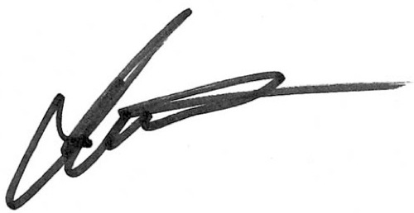

Ian M. Howat
Director, Byrd Polar & Climate Research Center
ENGIE-Axium Professor, School of Earth Sciences
The Ohio State University

