May 5, 2025

Re: Letter of Support for an ASC Center of Excellence in Applied AI

Dear Prof. Moortgat,
I very much support the creation of the BuckAI Observatory in OSU’s Arts and Sciences College. This ASC Center of Excellence, with its focus on applied artificial intelligence in the earth sciences, will significantly enhance collaborations, positioning OSU as a national leader in AI-driven Earth observation.
I have been fortunate to publish and win grants for my research using satellite measurements of surface waters. During my four-decade career, hydrology has been transformed from a somewhat data poor science to one with terabytes of measurements. This is a result of NASA and many of the world’s space agencies launching satellites for measuring various parts of the hydrologic cycle, e.g., rainfall, surface waters, soil moisture, and ground water. Understanding the global water cycle requires global measurements. Yet, our ability to integrate these measurements, particularly with models, remains challenging in part because of the massive amounts of data. The BuckAI Observatory will provide us with new abilities to analyze our data with the goal of integrating this knowledge into various government and commercial entities. For example, flooding is the most expensive natural hazard with insurance companies and particularly reinsurance companies being keenly interested in accurate forecasts of potential losses. The BuckAI Observatory, as described in the white paper, will significantly improve our opportunity to collaborate with such groups.
Beyond research, I endorse the proposed goal of better educating our students for a marketplace in which AI will play an increasingly critical role. I expect that students in the School of Earth Sciences will be keenly interested in such classes (such as ES5757 “AI in Geosciences”).
Should ASC support the founding of the BuckAI Observatory, please reach out to me about how I can be involved and/or for any further information that would be helpful.

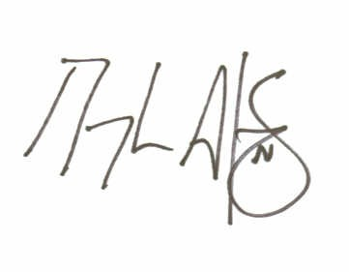
Sincerely,

Douglas Alsdorf, Ph.D.
Professor in the School of Earth Sciences

