School of Earth Sciences
125 South Oval Mall
275 Mendenhall Laboratory
Columbus, OH 43210
614-247-4835

May 5, 2025

Re: Letter of Support for an ASC Center of Excellence in Applied AI

Dear Joachim,

I enthusiastically support the creation of the BuckAI Observatory—an applied-AI Center of Excellence in the College of Arts and Sciences. The Observatory will lower technical barriers, catalyze interdisciplinary collaborations, and position OSU as a national leader in AI-driven Earth observation.

Research in my lab involve remote sensing of hydrological processes, with an emphasis on remote sensing of snow and river discharge. The data storage and AI capabilities described by Prof Moortgat would enable new prospects for collaboration, including grand ideas that I’ve entertained to make Ohio State a center for bringing the many river remote sensing observations together to estimate both inundation and river bathymetry. Moortgat and I have collaborated on this in past years, as part of a NASA project, and these resources would be something we could leverage in seeking funding for such a project. I expect that a seed investment by ASC in shared storage and computational resources, matched with initial technical support (a data engineer and student assistance with manually generating training data), as well as the other initiatives outlined in your white paper (such as championing interdisciplinary teams and annual workshops) will increase my success in pursuing extramural funding from NASA. I am also interested in learning more about the opportunities to broaden my funding sources beyond federal funding agencies through partnerships with industry and private foundations as well through the commercialization of intellectual property developed by my team.

Beyond research, I endorse the proposed goal of better educating our students for a marketplace in which AI will play an increasingly critical role. I expect that students in my department will be interested in such classes (such as ES5757 “AI in Geosciences”) and plan to either share domain-specific case studies and/or contribute to new AI-related courses in my own unit.

Should ASC support the founding of the BuckAI Observatory, please reach out to me about how I can be involved and/or for any further information that would be helpful.

Sincerely,
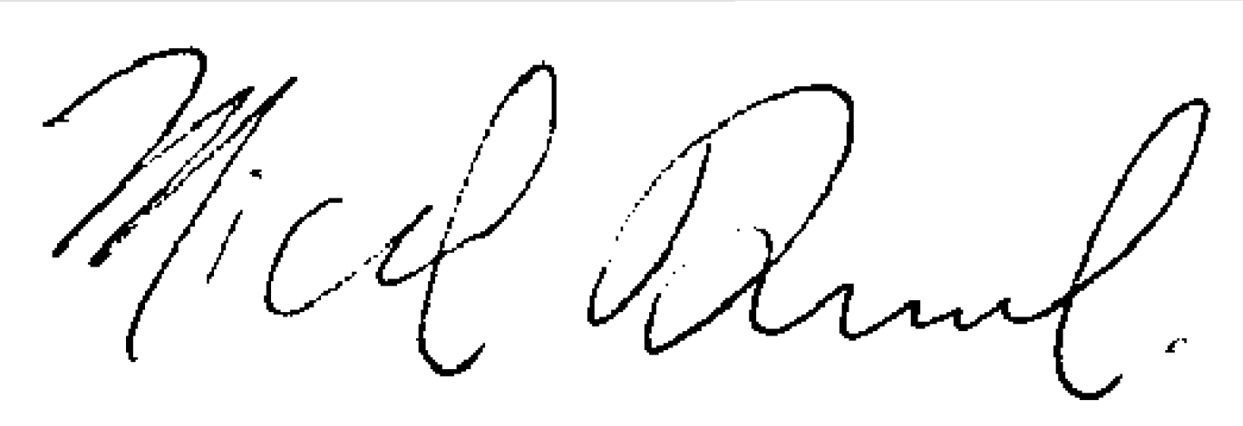

Michael Durand
Professor and Associate Director for Graduate Studies
School of Earth Sciences
(m) 614-302-8920 (e) durand.8@osu.edu

