Medical

The Medical applet displays a sample display that could be used in a hospital room.

There are many controls and displays that are used. This demo is busy – lots of things to show.

The main philosophy of this applet is that the data comes from the serial connection and, therefore, does not do a lot of calculations or logic on its own.

The display is comprised of several areas.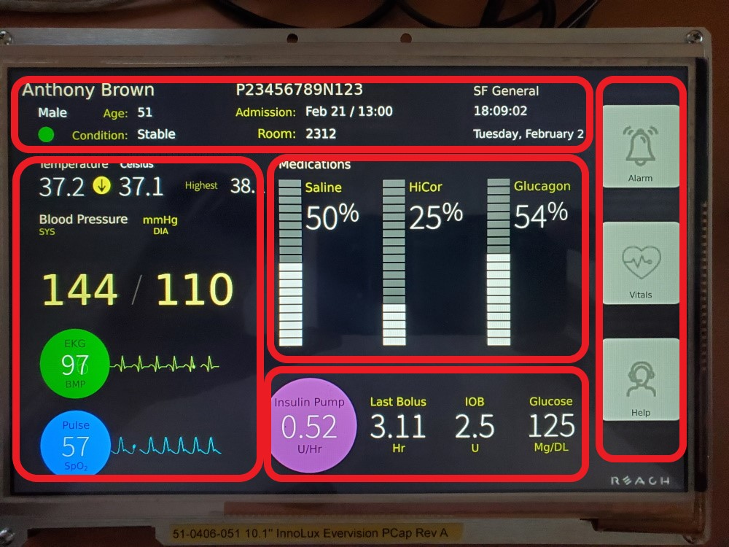

The boxes in red are showing functional areas including patient information, paitient vital signs, medication controls, control data, and, on the far right, user buttons.

The medication sliders are actuated by swiping and the output value is sent to the serial port upon release.

The user button states are also sent to the serial port.

The other information is controlled by sending values to the serial port. Sample text files show how to set these controls. These files are located in the medical/Scripts folder.