**GPIO App**

The sample application demonstrates the use of general purpose input / output (GPIO) pins on the Reach Tech G3 module.

This app exercises the GPIO pins on the G3 that are on J22. See here for the pinouts [GPIO J22 pinout](https://reach-technology-g3-manuals.readthedocs-hosted.com/en/latest/hw/BNG/interfacing.html#j22).

**Console and UART communications with the G3**

Ensure that the Debug interface is connected to the G3 as well as the Console. Inside the G3 VM, connect com0 and com1 using terminals for each connection. See G3 related documentation for details on setting up these connections.

**Setup the G3**

To prepare the demo - connect GPIO0 to GPIO1. On the Reach supplied cable these are the yellow and green wires.

The GPIO app will set GPIO0 as an input and GPIO1-4 as outputs.

**Run the GPIO application**

The GPIO project can be found in the ReachTech Git site in this set of projects - [Sample apps](https://github.com/jmore-reachtech/reach-g3-qt5-sample-apps).

Load the GPIO app into Qt Creator.

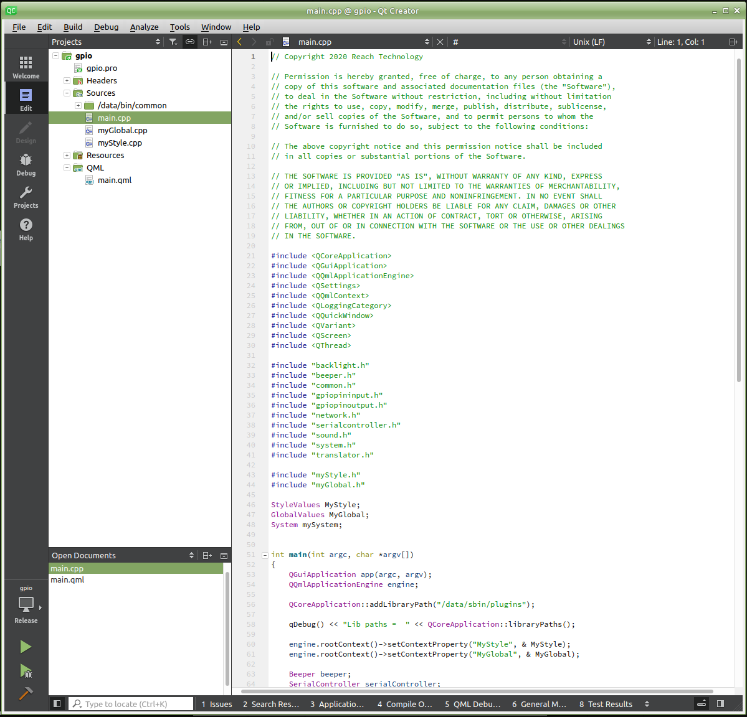

A Screenshot of the initial screen is shown below.

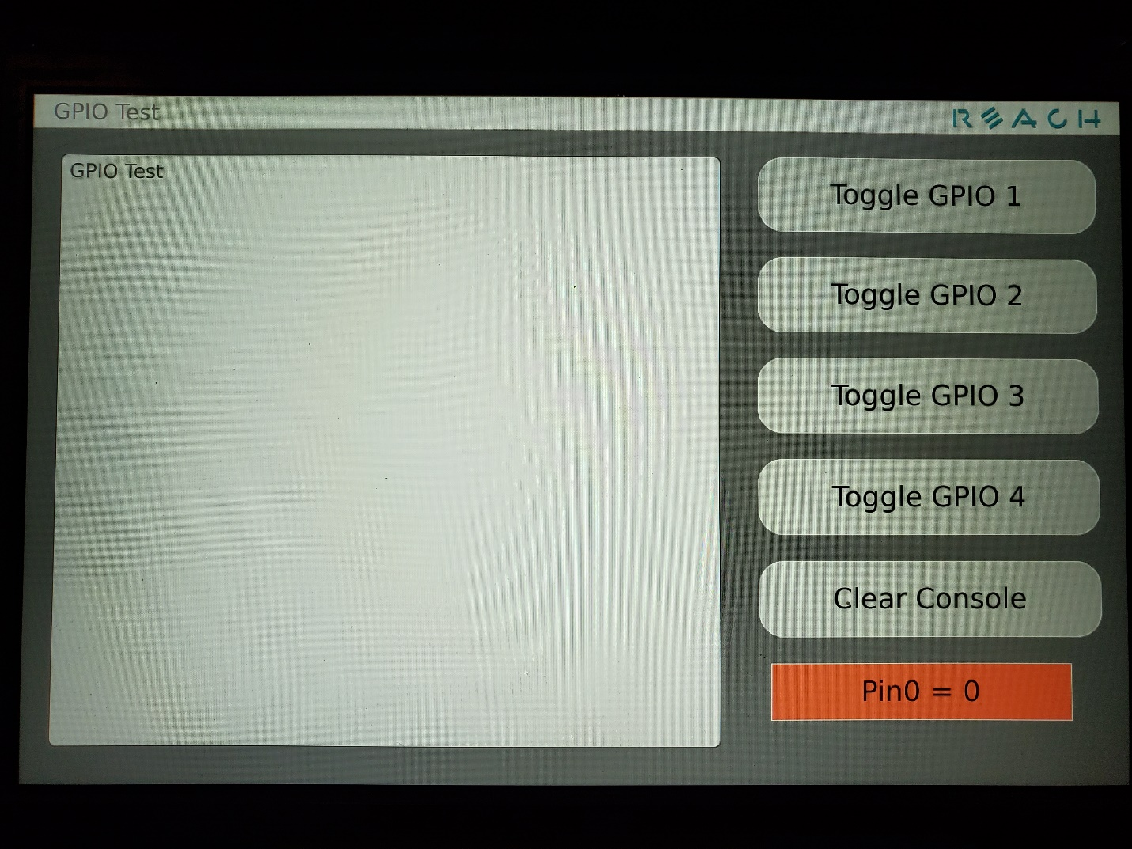

The left box with “GPIO Test” in it is the console. This will display commands as they are pressed.

On the right side of the display are buttons to toggle the 4 GPIO pins, a button to clear the console, and a box to show the value of the input line, GPIO0.

**Running the demo**

The easiest test is to press the Toggle GPIO1 button. This will result in -

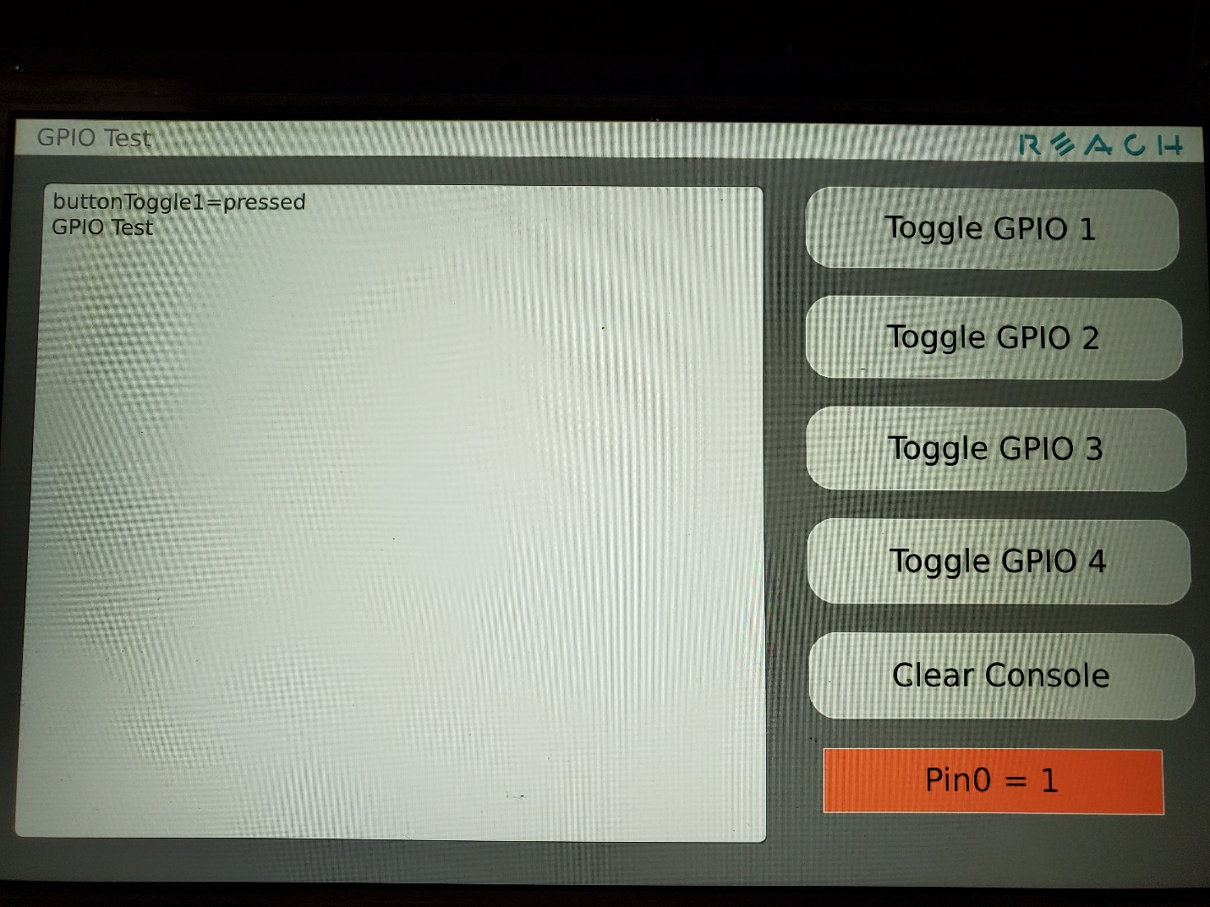

As can be seen, the button press is noted in the console and the resulting change to GPIO0 is shown in the orange box on the bottom right of the display.

In the Console output you will see the actions that have occurred including the changing values of GPIO0 – noted as gpioPin0Value.

To set the value of the GPIO outputs enter the following into the console –

setGpioPin1=0

This will set GPIO1 to 1 and will set the value of GPIO0.

With this application, GPIO0 will always send its value when it changes.