**LuxSensor App**

This sample application demonstrates the use of I2C bus on the Reach Tech G3 module using a light sensor with the MAX44009 digital ambient light sensor.

The board can be found here - <https://www.amazon.com/dp/B07HFRS8XX?psc=1&ref=ppx_yo2_dt_b_product_details>

**Console and UART communications with the G3**

Ensure that the Debug interface is connected to the G3 as well as the Console. Inside the G3 VM, connect com0 and com1 using terminals for each connection. See G3 related documentation for details on setting up these connections.

**Setup the G3**

Using the flying lead cable part #23-01490-10 included in the G3 dev kit, connect power, gnd, and the I2C bus pins as follows:

Vcc – white

Gnd – brown

SCL – black

SDA – orange

Connection of the sensor board

**Run the LuxSensor application**

The CanBus project can be found in the ReachTech Git site in this set of projects - [Sample apps](https://github.com/jmore-reachtech/reach-g3-qt5-sample-apps).

Load the LuxSensor app into Qt Creator.

**Running the demo**

With the sensor board connected and the software running on the G3, the display will show the lux value as seen below. The software will automatically read the sensor every second and display the *changed* value on the G3 console box as well as send the value over serial.

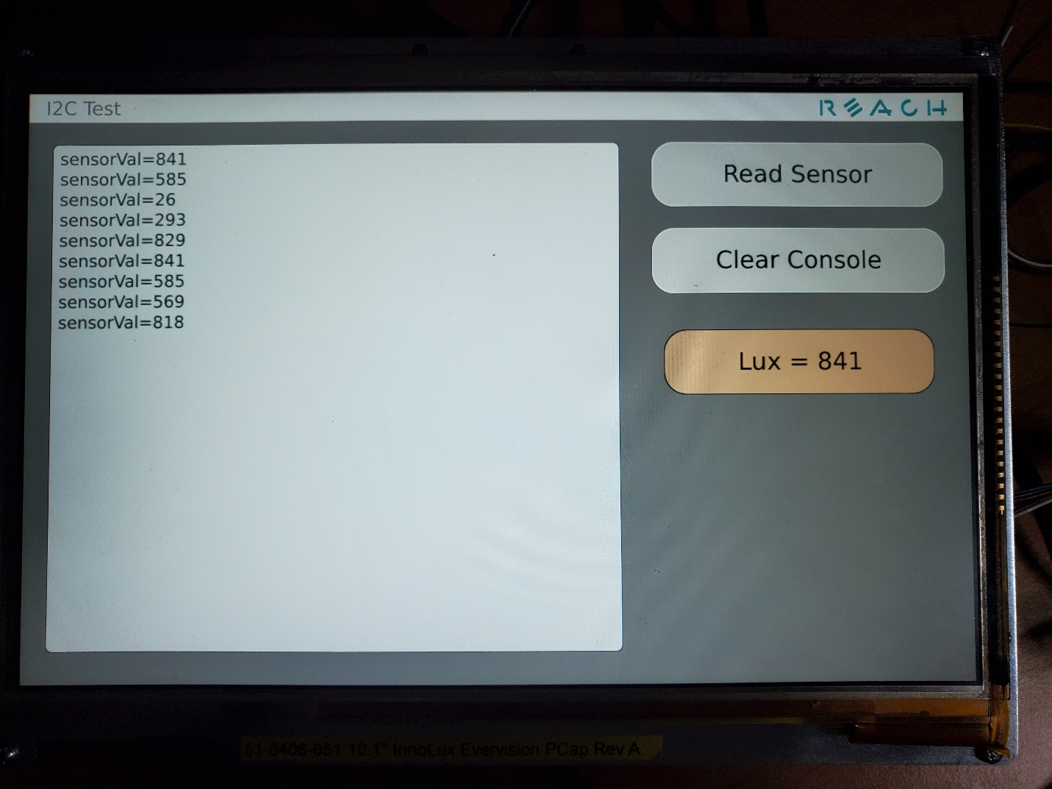

G3 console view

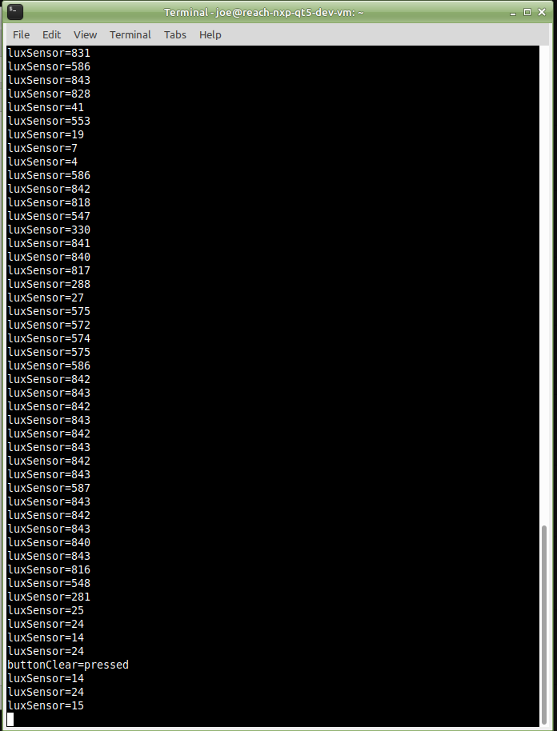

Serial output of values