# 1. Asignación de roles

ID: REQ004

Se debe tener un apartado donde se le asignen los roles a los usuarios:

1. Aprendiz
2. Usuario SENA
3. Instructor
4. Coordinador

# 2. Datos obligatorios

ID: REQ002

Los datos que son fundamentales para el registro, identificación reconocimiento y comunicación son:

1. documento.
2. nombre
3. apellido
4. email

# 3. Emails únicos

ID: REQ003

Los correo de las personas registradas deben ser únicos por cada usuario.

# 4. Registro de usuarios

ID: REQ001

El sistema muestra un formulario que permita el registro de los usuarios:

Se recopila los datos:

1. documento.
2. nombre
3. apellido
4. email

# 5. Roles

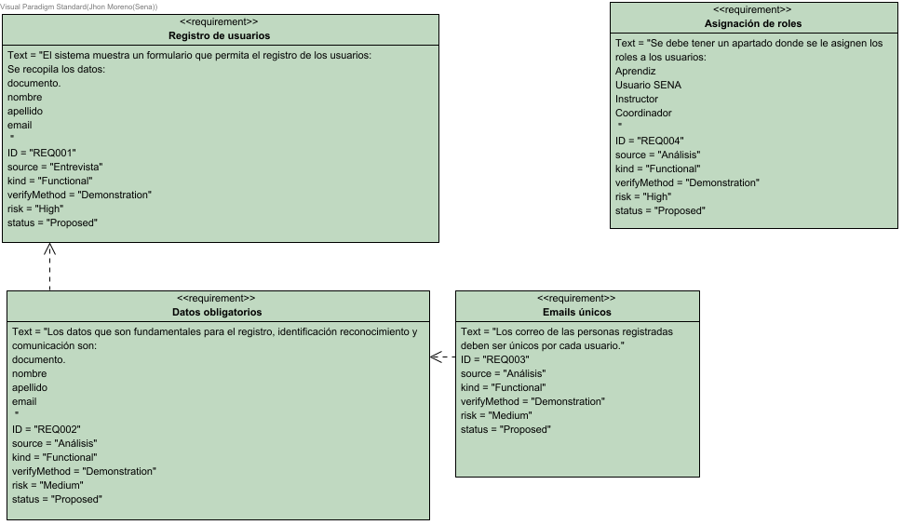

# 6. Personas

## 6.1. Properties

|  |  |
| --- | --- |
| Discriminator | N/A |
| Class model | Person |
| Schema | N/A |

## 6.2. Column Summary

| Name | Description |
| --- | --- |
| apellido |  |
| documento |  |
| email |  |
| nombre |  |
| Rolesid |  |

## 6.3. Column Details

### 6.3.1. apellido

|  |  |
| --- | --- |
| Type | varchar |
| Length | 45 |
| Scale | 0 |

### 6.3.2. documento

|  |  |
| --- | --- |
| Type | int |
| Length | 10 |
| Scale | 0 |
| Primary Key | true |

### 6.3.3. email

|  |  |
| --- | --- |
| Type | varchar |
| Length | 150 |
| Scale | 0 |
| Unique | true |

### 6.3.4. nombre

|  |  |
| --- | --- |
| Type | varchar |
| Length | 45 |
| Scale | 0 |

### 6.3.5. Rolesid

|  |  |
| --- | --- |
| Type | int |
| Length | 10 |
| Scale | 0 |

## 6.4. Column Mappings

| Column Name | Attribute Name |
| --- | --- |
| apellido | apellido |
| documento | documento |
| email | email |
| nombre | nombre |
| Rolesid | rolesid |

## 6.5. Relationships

| Relationship | From | To |
| --- | --- | --- |
| unnamed | Personas | RolesPorPersonas |

# 7. Roles

## 7.1. Properties

|  |  |
| --- | --- |
| Discriminator | N/A |
| Class model | Rol |
| Schema | N/A |

## 7.2. Column Summary

| Name | Description |
| --- | --- |
| id |  |
| rol |  |

## 7.3. Column Details

### 7.3.1. id

|  |  |
| --- | --- |
| Type | int |
| Length | 10 |
| Scale | 0 |
| Primary Key | true |

### 7.3.2. rol

|  |  |
| --- | --- |
| Type | varchar |
| Length | 50 |
| Scale | 0 |
| Unique | true |

## 7.4. Column Mappings

| Column Name | Attribute Name |
| --- | --- |
| id | id |
| rol | rol |

## 7.5. Relationships

| Relationship | From | To |
| --- | --- | --- |
| unnamed | Roles | RolesPorPersonas |

# 8. RolesPorPersonas

## 8.1. Properties

|  |  |
| --- | --- |
| Discriminator | N/A |
| Class model | N/A |
| Schema | N/A |

## 8.2. Column Summary

| Name | Description |
| --- | --- |
| Personasdocumento |  |
| Rolesid |  |

## 8.3. Column Details

### 8.3.1. Personasdocumento

|  |  |
| --- | --- |
| Type | int |
| Length | 10 |
| Scale | 0 |
| Primary Key | true |
| Foreign Key | true |

### 8.3.2. Rolesid

|  |  |
| --- | --- |
| Type | int |
| Length | 10 |
| Scale | 0 |
| Primary Key | true |
| Foreign Key | true |

## 8.4. Relationships

| Relationship | From | To |
| --- | --- | --- |
| unnamed | Roles | RolesPorPersonas |
| unnamed | Personas | RolesPorPersonas |

# 9. Entity Relationship Diagram1

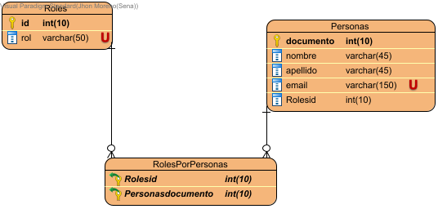

# 10. CRUD

## 10.1. Stereotypes

<<Interface>>

## 10.2. Properties

|  |  |
| --- | --- |
| Visibility | public |
| Abstract | false |
| Leaf | false |
| Root | false |
| Active | false |

## 10.3. Operations Summary

| Name | Description |
| --- | --- |
| actualizar |  |
| consultar |  |
| eliminar |  |
| registrar |  |

## 10.4. Operations

### 10.4.1. actualizar

|  |  |
| --- | --- |
| Visibility | public |
| Return Type | void |

### 10.4.2. consultar

|  |  |
| --- | --- |
| Visibility | public |
| Return Type | void |

### 10.4.3. eliminar

|  |  |
| --- | --- |
| Visibility | public |
| Return Type | void |

### 10.4.4. registrar

|  |  |
| --- | --- |
| Visibility | public |
| Return Type | void |

## 10.5. Relationships

| Relationship | From | To |
| --- | --- | --- |
| unnamed | CRUD | RolControl |
| unnamed | CRUD | PersonaControl |

# 11. Person

## 11.1. Stereotypes

<<ORM Persistable>>

## 11.2. Properties

|  |  |
| --- | --- |
| Visibility | public |
| Mapped Table | Personas |
| Abstract | false |
| Leaf | false |
| Root | false |
| Active | false |

## 11.3. Attributes Summary

| Name | Description |
| --- | --- |
| apellido |  |
| documento |  |
| email |  |
| nombre |  |
| rolesid |  |

## 11.4. Attributes

### 11.4.1. apellido

|  |  |
| --- | --- |
| Visibility | private |
| Type | String |

### 11.4.2. documento

|  |  |
| --- | --- |
| Visibility | private |
| Type | int |

### 11.4.3. email

|  |  |
| --- | --- |
| Visibility | private |
| Type | String |

### 11.4.4. nombre

|  |  |
| --- | --- |
| Visibility | private |
| Type | String |

### 11.4.5. rolesid

|  |  |
| --- | --- |
| Visibility | private |
| Type | int |

## 11.5. Relationships

| Relationship | From | To |
| --- | --- | --- |
| unnamed | Person | PersonaControl |
| unnamed | Rol | Person |

# 12. PersonaControl

## 12.1. Stereotypes

<<control>>

## 12.2. Properties

|  |  |
| --- | --- |
| Visibility | public |
| Abstract | false |
| Leaf | false |
| Root | false |
| Active | false |

## 12.3. Relationships

| Relationship | From | To |
| --- | --- | --- |
| unnamed | Person | PersonaControl |
| unnamed | CRUD | PersonaControl |
| unnamed | PersonaVista | PersonaControl |

# 13. PersonaVista

## 13.1. Stereotypes

<<boundary>>

## 13.2. Properties

|  |  |
| --- | --- |
| Visibility | public |
| Abstract | false |
| Leaf | false |
| Root | false |
| Active | false |

## 13.3. Relationships

| Relationship | From | To |
| --- | --- | --- |
| unnamed | PersonaVista | PersonaControl |

# 14. Rol

## 14.1. Stereotypes

<<ORM Persistable>>

## 14.2. Properties

|  |  |
| --- | --- |
| Visibility | public |
| Mapped Table | Roles |
| Abstract | false |
| Leaf | false |
| Root | false |
| Active | false |

## 14.3. Attributes Summary

| Name | Description |
| --- | --- |
| id |  |
| rol |  |

## 14.4. Attributes

### 14.4.1. id

|  |  |
| --- | --- |
| Visibility | private |
| Type | int |

### 14.4.2. rol

|  |  |
| --- | --- |
| Visibility | private |
| Type | String |

## 14.5. Relationships

| Relationship | From | To |
| --- | --- | --- |
| unnamed | Rol | RolControl |
| unnamed | Rol | Person |

# 15. RolControl

## 15.1. Stereotypes

<<control>>

## 15.2. Properties

|  |  |
| --- | --- |
| Visibility | public |
| Abstract | false |
| Leaf | false |
| Root | false |
| Active | false |

## 15.3. Attributes Summary

| Name | Description |
| --- | --- |
| vista |  |

## 15.4. Operations Summary

| Name | Description |
| --- | --- |
| capturaTexto |  |
| RolControl |  |

## 15.5. Attributes

### 15.5.1. vista

|  |  |
| --- | --- |
| Visibility | private |
| Type | RolVista |

## 15.6. Operations

### 15.6.1. capturaTexto

|  |  |
| --- | --- |
| Visibility | public |
| Return Type | void |

### 15.6.2. RolControl

|  |  |
| --- | --- |
| Visibility | public |

## 15.7. Relationships

| Relationship | From | To |
| --- | --- | --- |
| unnamed | Rol | RolControl |
| unnamed | CRUD | RolControl |
| unnamed | RolVista | RolControl |

# 16. RolVista

## 16.1. Stereotypes

<<boundary>>

## 16.2. Properties

|  |  |
| --- | --- |
| Visibility | public |
| Abstract | false |
| Leaf | false |
| Root | false |
| Active | false |

## 16.3. Relationships

| Relationship | From | To |
| --- | --- | --- |
| unnamed | RolVista | RolControl |

# 17. Entity Relationship Diagram1 - Class Diagram

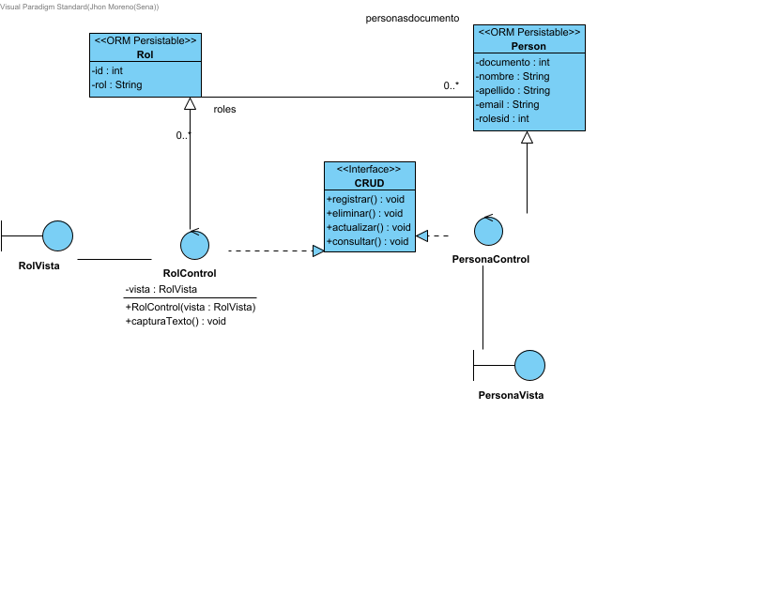

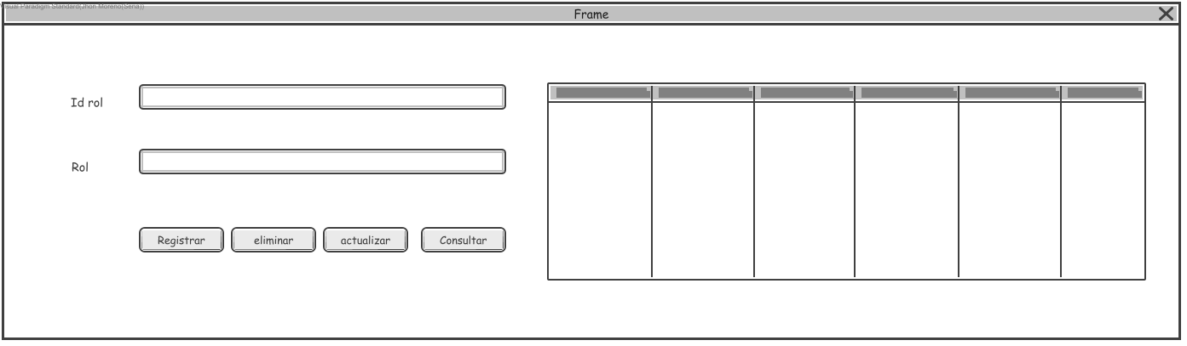

# 18. Desktop Wireframe1 - Initial

# 19. registrar

