easyCyte Flow Cytometer

## Preparation

1. Pipette your samples in an appropriate scheme on a well plate

## Acquisition

1. Start the guavaSoft software on the attached PC
2. Select InCyte
3. In the top left, under the Acquire menu, click Edit Worklist 
4. Populate the plate map with your sample information by clicking one or more wells and checking off Acquire this sample and entering the Sample ID. Enter the number of Events to Acquire
5. On the right, click Run Worklist
6. Click Adjust Settings
7. Place your plate in the ejected tray
8. Follow the on-screen instructions for the eppendorf tube contents

* 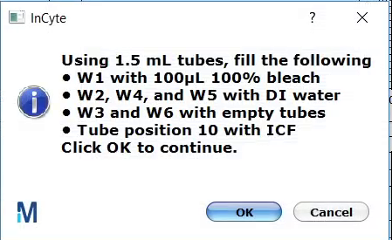
* then click OK

1. Another Adjust Settings panel will appear. Click a well to acquire and click OK. Adjust settings as necessary
2. Click Next Step to proceed to the next well next_sample  
   and Resume Worklist

## Analysis

1. Click Analyse
2. Select one of the samples
3. Set the event gate by clicking on the New Region button on the plot and selecting the gate shape

* 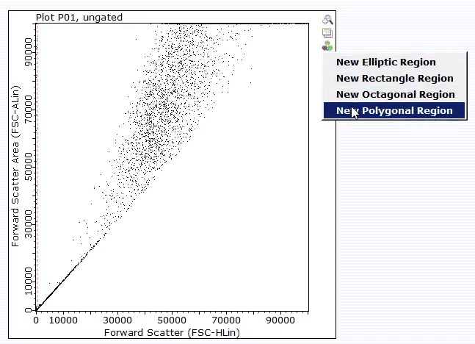

1. Apply the gate to plot 2 by clicking this button over there button and select either dimension
2. Click New Region on plot 2 and draw a gate around the group of interest
3. Apply the gate to plot 3 to gate the histogram

For more information see the full instruction manuals at

<https://www.luminexcorp.com/?wpdmdl=41831>

and

<https://www.luminexcorp.com/?wpdmdl=41833>