Countess II FL Automated Cell Counter

1. Turn on the Countess using the power switch in the back right of the instrument
2. Pipette 10 µL of cell suspension to either or both sides of a disposable countess slide via the opening

* 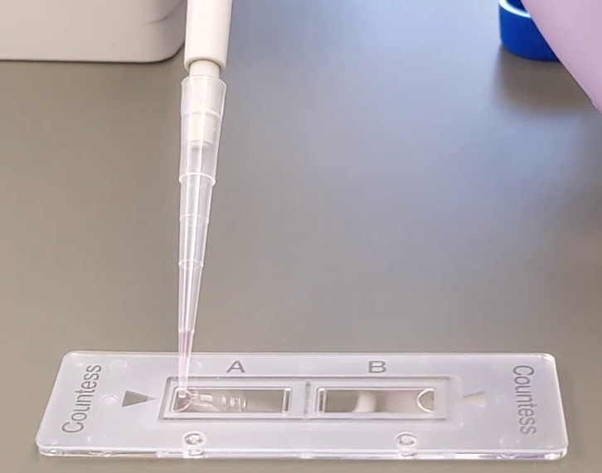

1. Insert the slide into the slide port on the Countess until it clicks into place
2. *Optional*: The instrument will auto-focus. You can manually adjust the focus by pressing the Focus button and adjusting the slider.
3. Select the light source and capture channels using the menu on the right. Options are Brightfield (BF), Texas Red (TxRed), and GFP (green fluorescent protein).
4. Press Capture to get the total concentration of cells, percentage of live cells, and percentage of dead cells. Live cells will be circled in green and dead cells in red.

* 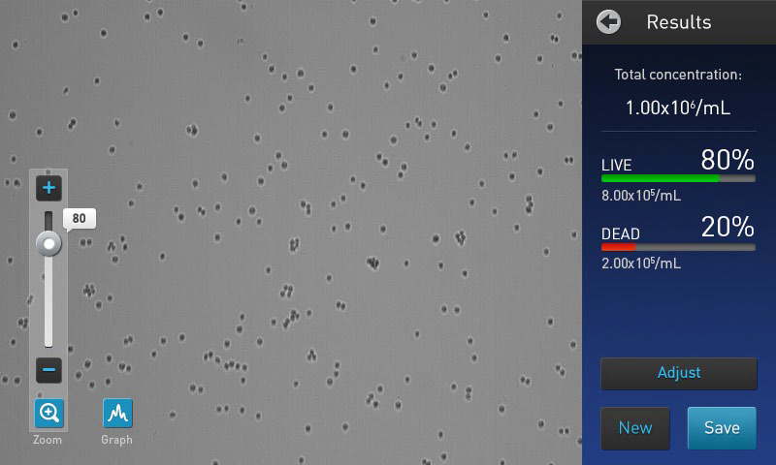

1. *Optional*: Plot the cell size distribution with the Graph button.

* 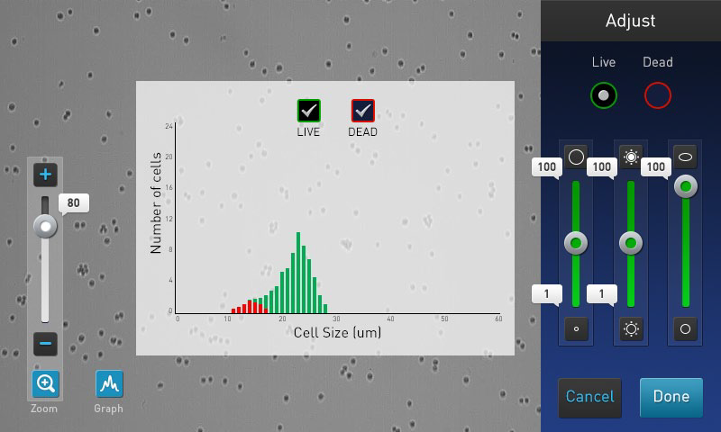

1. *Optional*: Save the results to a USB drive by clicking Save.
2. Eject the slide by pushing inwards until it clicks and the spring ejects it
3. *Optional*: Press New to start another assay with the reverse side or another slide.

For more information see the full instruction manual at <https://www.thermofisher.com/content/dam/LifeTech/global/life-sciences/cellanalysis/Files/0914/MAN0010644_Countess%20II.pdf>