Computer Vision Reflection and Football Foul Detection
Jamal Moussa

1. Personal Views on Computer Vision and Its Applications

1.1 Computer Vision Personal Views
My personal view is that computer vision is moving from being a collection of image-processing tricks into a broader intelligence layer for safety, accessibility, automation, and human decision support. The classical fundamentals are still important because they teach us how images are represented and how motion and appearance can be measured. I don’t think those fundamentals by themselves do a good job with many modern applications. Histogram techniques, color models, color segmentation, edge detection, Hough transforms, texture analysis, 2D motion, tracking, image stitching, local features, camera calibration, pose estimation, and stereo vision are all useful building blocks, but they are usually not enough for high-level understanding in open-world environments.

1.2 Limits of Classical Methods in Modern Applications
For example, self-driving cars cannot rely only on edge detection or simple optical flow. They need robust semantic understanding of roads, pedestrians, signs, cyclists, weather, lighting changes, occlusion, and unexpected behavior. Sports analytics also requires more than detecting lines or tracking blobs. A useful sports system must understand tactics, player intent, contact, timing, referee rules, and multi-camera evidence. Healthcare is another important example. MRI, CT, X-ray and ultrasound images often contain subtle patterns that are difficult to define by hand. Classical image processing can enhance contrast or segment structures, but modern diagnostic support often needs learned representations that can capture complex anatomical variation and disease patterns.

1.3 Why Classical Foundations Still Matter
At the same time, I do not see modern neural networks as a replacement for all classical computer vision. I see the future as an intersection between neural methods and traditional CV ideas. Neural networks are powerful because they can learn features that are hard to hand-design, but they can also become expensive and brittle. The strongest systems use a neural model for recognition and a geometric or visual module for explanation, verification, or control. My foul-detection project followed that idea. The deep VARS-style model handles foul recognition, while the computer vision pipeline localizes and visualizes the likely contact region.

1.4 Safety and Accessibility
One of the biggest goals I think computer vision should pursue is enabling safety and accessibility. Vision systems can help people drive more safely, detect health issues earlier, improve accessibility tools for people with disabilities. I believe a model that only works on a huge GPU server is useful for research, but it may not be accessible in small clinics, schools, local sports programs, or embedded devices.

1.5 Small-Scale Models and Hardware Constraints
Because of that, I also think there is a major opportunity in advancing small-scale vision models. Hardware is a real issue in vision. Video neural networks are expensive because they process many frames, often at high resolution, and sometimes from multiple cameras. This creates a gap between what is possible in a lab and what is practical on local machines. I want to see more work on efficient transformers, compact convolutional models and hybrid systems that use neural networks only where they add the most value. If computer vision is going to improve safety and accessibility, it cannot depend only on the largest models running in expensive environments.

2. What I Learned in This Course

2.1 Image Foundations
This course gave me a much better understanding of the foundations of computer vision. I learned that an image is not only a picture but also a structured numerical signal. Histogram techniques showed me how pixel intensity distributions can describe contrast and support operations such as histogram equalization. Color models and color segmentation showed that choosing the right representation, such as RGB, HSV, or other color spaces, can make a problem easier or harder. Edge detection showed how gradients reveal boundaries, while the Hough transform demonstrated how local edge evidence can be organized into global shapes such as lines or circles.

2.2 Motion, Tracking, and Video Understanding
2D motion analysis and object tracking were important for my project because video sports analytics depends on understanding movement over time. Optical flow, background subtraction, and tracking provide useful cues about where interactions happen and when contact may occur.

2.3 Multi-View Geometry and Camera Reasoning
The course topics on image stitching, local visual features, calibration, pose estimation, and stereo vision also changed how I think about multi-view systems. Image stitching and local features taught me why keypoints and descriptors matter when two images show the same scene from different viewpoints. I changed my thinking about how a camera is projecting a 3D world onto a 2D plane. Stereo vision showed how depth can be estimated when two views are available, and it also showed why correspondence is difficult in real scenes with occlusion and changing viewpoints.

2.4 Recognition and Rendering
I also learned about object detection and recognition, and image-based rendering. These topics ask the system to identify meaningful objects and reconstruct or synthesize views. What stood out to me is that computer vision is always evolving for example, large-scale vision remains unsolved. This is why I think the intersection of neural networks and classical CV can continue to advance the field.

2.5 Topics I Want to Study More
The main thing I want to study more is modern neural vision, especially for sports and healthcare. In sports, I am interested in action recognition, multi-object tracking, multi-camera fusion, and referee-assistance systems. In healthcare, I want to learn more about segmentation, weak supervision, uncertainty, interpretability, and safe deployment of medical imaging models.

2.6 Vision, Reinforcement Learning, and Simulation
I am also curious about integrating reinforcement learning with vision. Simulated environments, including games such as chess and video games, allow agents to learn from visual input and feedback. Even though chess itself is not visually complex in the same way as soccer video, the idea of combining perception, planning, and decision-making is important. In more complex simulated games, reinforcement learning with vision could help train agents to understand environments before transferring ideas to real-world tasks.

3. Project Description: Problem Statement and Proposed Solution

3.1 Problem Context
The problem begins with how hard football contact is to see. The key moment may last only a few frames, and it can be blocked by another player, blurred by camera motion, or made too small by a wide broadcast angle. A tackle, elbow, push, high leg, or holding action can look very different depending on the view. Referees usually need replay angles because the live camera may show the overall play but not the exact body contact. That makes automated foul review a difficult vision problem: the system has to understand the action while also helping a person inspect the evidence.

3.2 Problem Statement
The core problem is not only whether a clip can be labeled correctly. The harder issue is whether the result can be inspected. A classifier might output 'Offence, severity 3.0, tackling,' but that prediction alone does not show the contact point, the players involved, or the body region that caused the decision. For a sports review tool, that missing visual evidence matters. My problem statement is: how can a foul-detection pipeline move from a class label to a visible review output that points to the likely contact moment?

3.3 Project Goal as a Proposed Solution
My goal was to build that visible review output around the existing VARS-style baseline. The recognizer makes the high-level foul prediction first. After that, my pipeline focuses on the human-facing evidence: choosing useful views, looking near the foul window, estimating player pose, placing a red box near likely contact, and saving videos or still images that can be reviewed. In my design, the box is not a separate referee. It is a visual explanation that makes the model output easier to understand.

3.4 Dataset and Multi-View Setup
I used SoccerNet-MVFoul because it matches the review setting I wanted to study. Each action can include the original broadcast clip plus replay or close-up clips. The wide view helps explain the buildup, spacing, and direction of play, while the replay view is usually better for checking body contact. I kept both types of views in the outputs so the project could show context and contact evidence instead of depending on only one camera angle.

3.5 Body-Part Recognition Objective
I also used body-part evidence as part of the explanation. Instead of only reporting whether the action was a foul, the pipeline tries to describe the contact area in a more concrete way. It estimates a fine region such as arm, head, torso, hip, leg, or foot from pose keypoints, then converts that estimate into the broader upper-body or lower-body category used for evaluation. This gives the red contact box more meaning because the output can connect the visual cue to a possible body region.
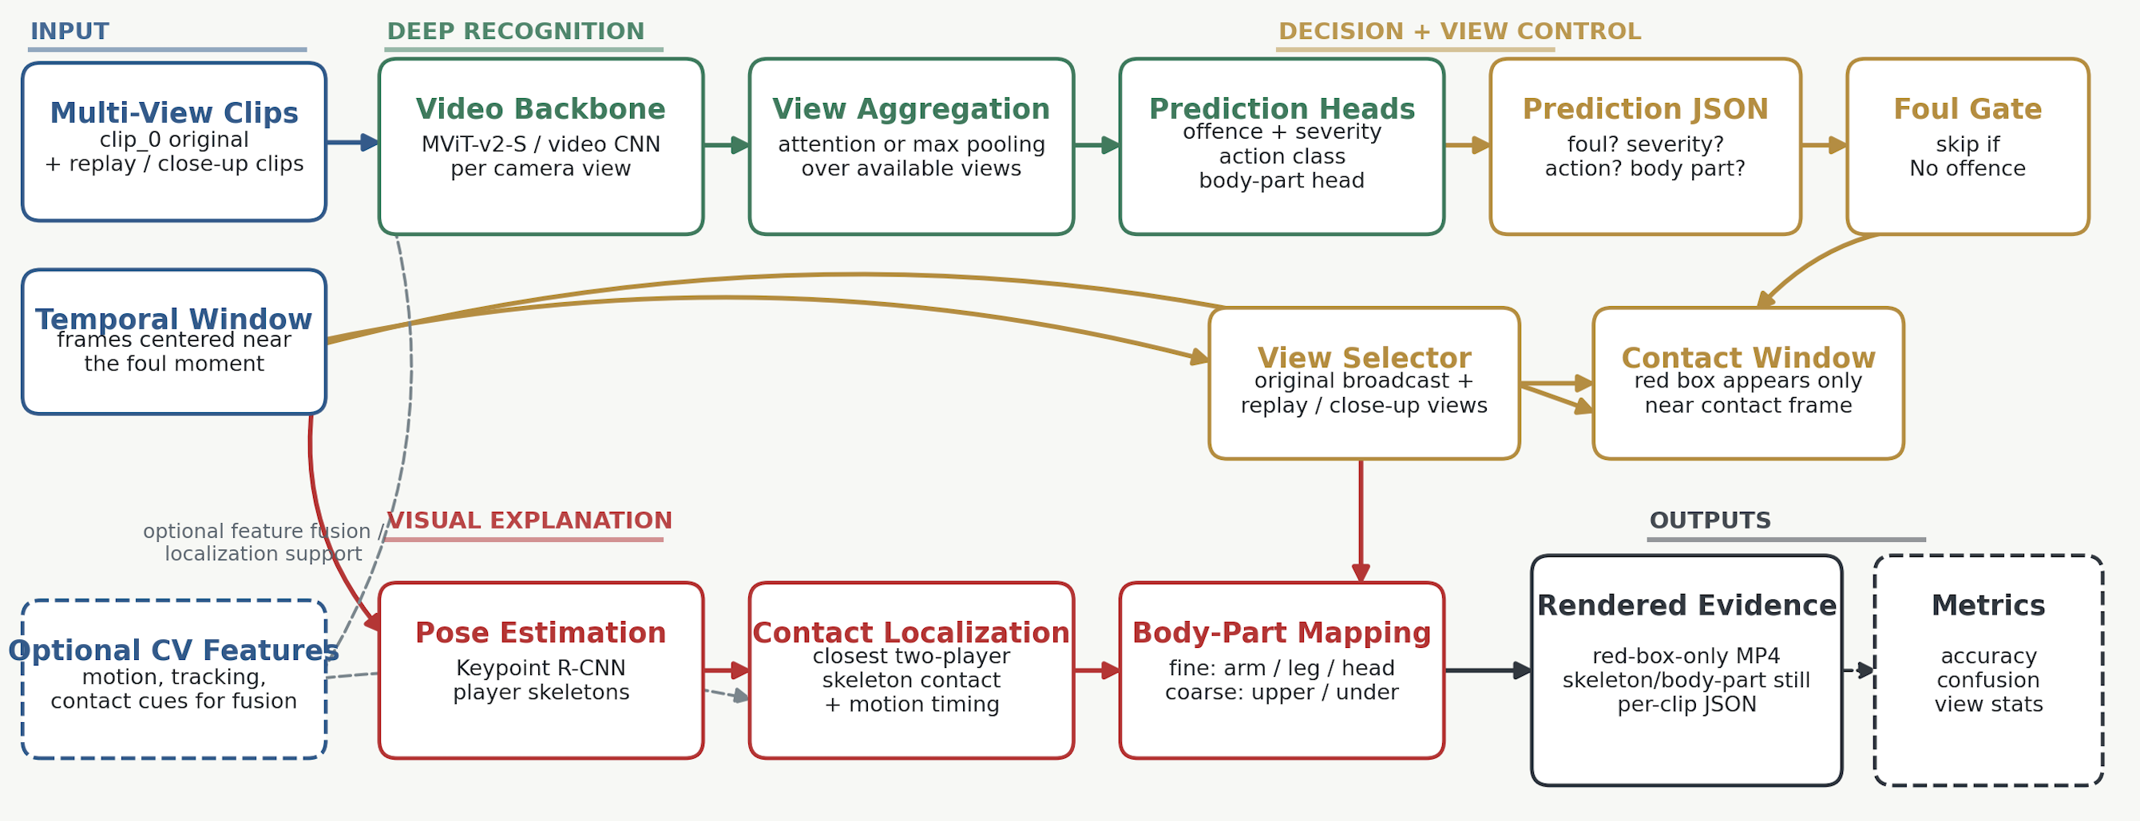
Figure 1. VARS-style multi-view recognition pipeline.
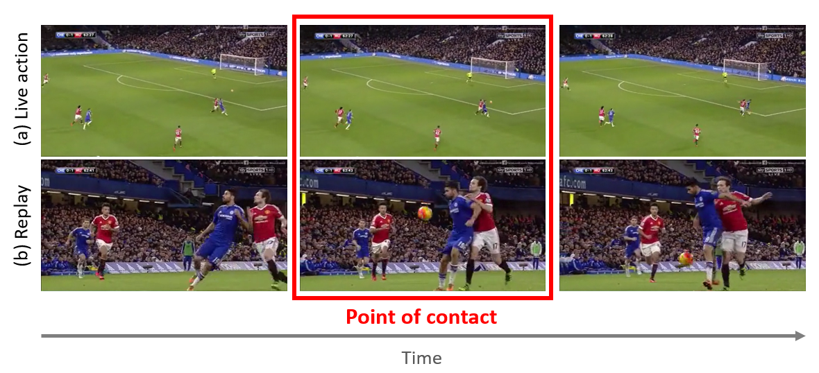
Figure 2. SoccerNet-MVFoul multi-view example from the project documentation.

4. Design and Implementation

4.1 System Overview
My design is intentionally deep-first. The model prediction comes first because foul recognition is too complex for simple motion blobs or edges alone. After the prediction, the visual layer takes over and tries to show what happened on screen. This keeps the roles clear: the neural video model handles recognition, and the CV/pose code handles explanation, tracking cues, contact boxes, and presentation outputs.

4.2 Deep Recognition Baseline
For recognition, I used the VARS baseline setup with an MViT-v2-S video backbone. Each available view is encoded, the view features are combined, and the task heads produce the offence/severity and action predictions. I kept this part as the recognizer because it is better suited to understanding football actions than hand-built CV rules. The generated prediction JSON then controls the visualization stage: clips predicted as fouls are passed to the contact-box pipeline, while non-offence clips can be ignored.

4.3 Contact Localization Pipeline
The videos are decoded and sampled over a window around the likely foul moment. Motion cues can be extracted using optical flow and frame differences, while moving regions can be tracked over time. In earlier versions of the project, I experimented with motion blobs and centroid tracking. These methods helped identify moving areas and possible interactions, but they were not accurate enough for placing a red box directly on player bodies.

4.4 Pose-Based Contact Explanation
The contact-box logic became more body-aware after the earlier motion-region version failed to place evidence directly on players. In the pose version, the system estimates skeleton keypoints for visible players inside the selected window. It compares nearby player keypoints, chooses the closest two-player contact candidate, and draws the red box around that estimated area. This is still approximate, especially in occluded tackles, but it is much closer to the body-contact idea than drawing lines between moving blobs.

4.5 Replay-Aware View Selection
The system can render replay or close-up views, original broadcast views, or both. The outputs include the wide broadcast view and selected replay views. The original view is useful because it shows the entire play and the players' movement before contact. The replay or close-up view is usually better for the red contact box because the players occupy more pixels.

4.6 Output Rendering
The final stage turns the analysis into review artifacts. The skeleton/body-part video shows the pose reasoning, and the red-box-only video gives a cleaner contact visualization. One important change was making the box appear only near the contact window instead of leaving it on the screen for the entire clip. That made the videos easier to present because the viewer sees the buildup, the contact cue, and the continuation without constant visual clutter.

4.7 Structured JSON Outputs
For each rendered clip, I saved a machine-readable record so the results could be summarized later. Those records include identifiers for the action and split, the clip/view information, the model prediction, the contact-frame estimate, the red-box coordinates, pose/player counts, body-part output, and the paths to the rendered images or videos.

5. Individual Contributions

5.1 Baseline Integration and System Design
My individual contribution was the design and implementation of the visual foul-contact pipeline around the baseline VARS project. The public baseline already provides a deep multi-view foul recognition direction, but I built and tuned the contact-box rendering pipeline.

5.2 Visual Tracking and Red-Box Overlays
At first, the system used moving regions and lines but the red lines were not always on player bodies and did not look like a clear foul explanation. I then changed the visualization to contact boxes and eventually to pose-based contact boxes because the goal was to show contact on the players themselves.

5.3 Replay-Aware Results
I also added the windowed red-box video output, where the box is shown near the detected contact frame. This made the videos smoother, less cluttered, and more appropriate for presentation.

5.4 Body-Part Explanation Layer
I connected the contact point to pose keypoints and mapped the result to fine body parts and coarse Upper/Under body categories. I also created output summaries from the generated results.

6. Results and Analysis

6.1 Result Folders and Evaluation Sets
The final outputs used three main result folders. The first was a small Test demonstration with 5 actions and 13 rendered clips. It included original broadcast views, replay close-ups, and one other replay view. The second was an output with 5 actions and 12 rendered clips with no labels so it could not be evaluated with body-part accuracy, but it is useful for seeing how our model performed.

6.2 Body-Part Accuracy
The full Test output showed a clear difference between the pose/CV body-part prediction and the deep body-part head. Pose/CV achieved 46.8% coarse body-part accuracy on 158 labelled samples. The deep body-part head achieved 71.5% on the same labelled samples. In the small windowed Test demonstration, pose/CV achieved 60.0% on 5 labelled samples and the deep head achieved 80.0%. These numbers suggest that pose-based contact localization is useful for visualization, but deep learned features are stronger for the actual body-part classification task.
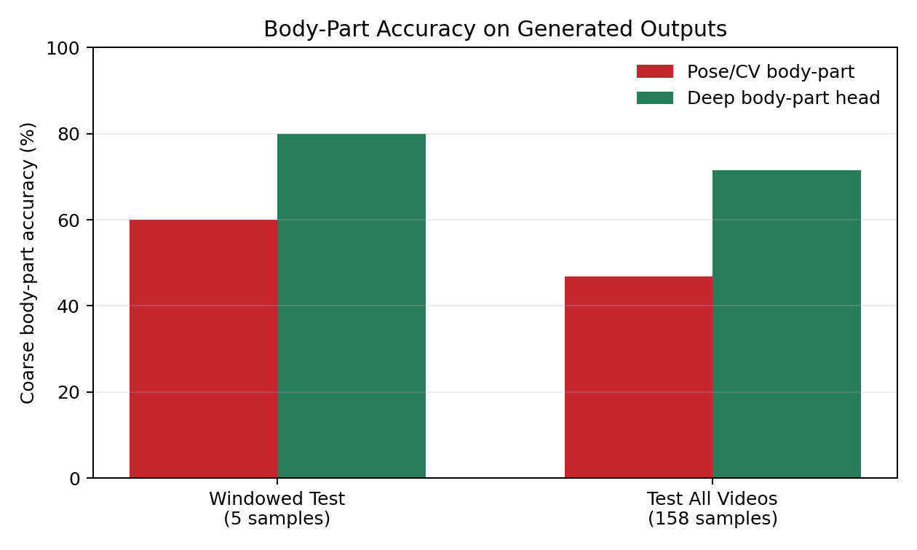

6.3 Confusion Matrix Analysis
In the full Test run, the pose/CV method often predicted Upper body when the truth was Under body. Specifically, many Under-body examples were mapped to visible arms, heads, or torso areas. This makes sense because the pose method chooses the nearest visible keypoints at the estimated contact point. In a wide view or an occluded tackle, the actual leg contact may be hidden, while an upper-body keypoint is visible and closer to the red-box center. The deep body-part head handled Under-body labels better, but it still confused some Upper-body examples as Under body.
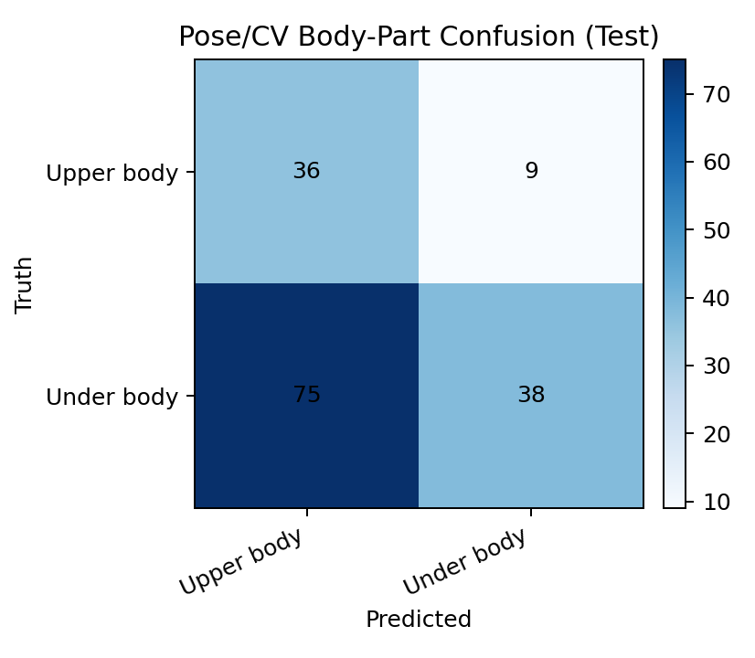

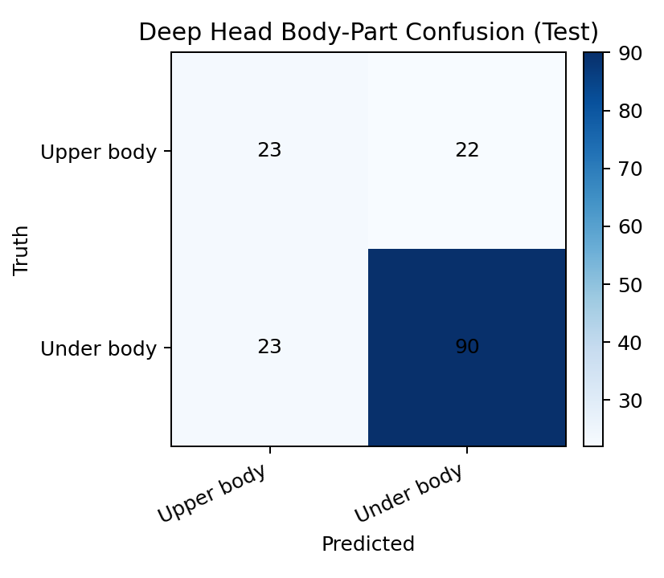

6.4 Qualitative Result Sequences
The qualitative result sequences show the value of the windowed red box. In the red-box-only videos, the viewer sees the players approach, the red box appear at the likely contact moment. The body-part stills with skeleton overlays is how the vision determines where the contact happens.
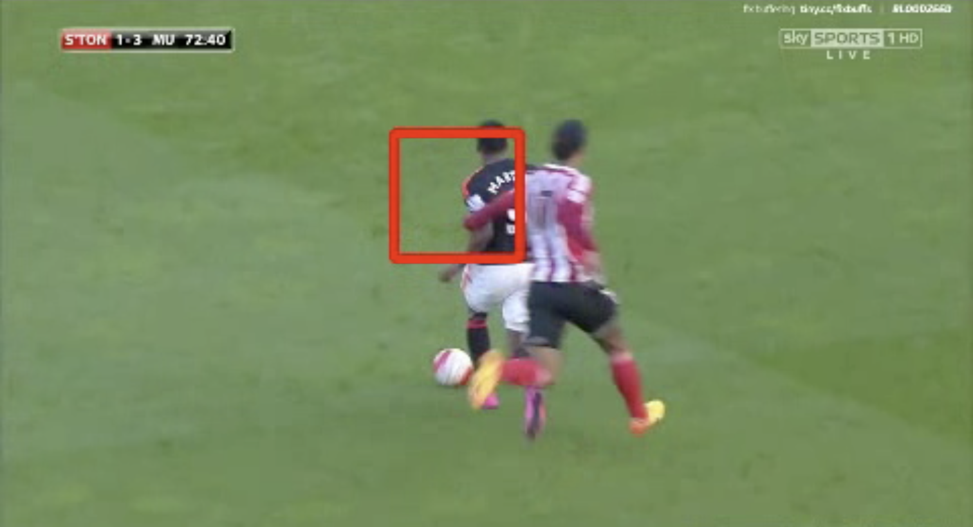
Figure 3. Windowed replay red-box sequence: the red box appears around the detected contact moment.
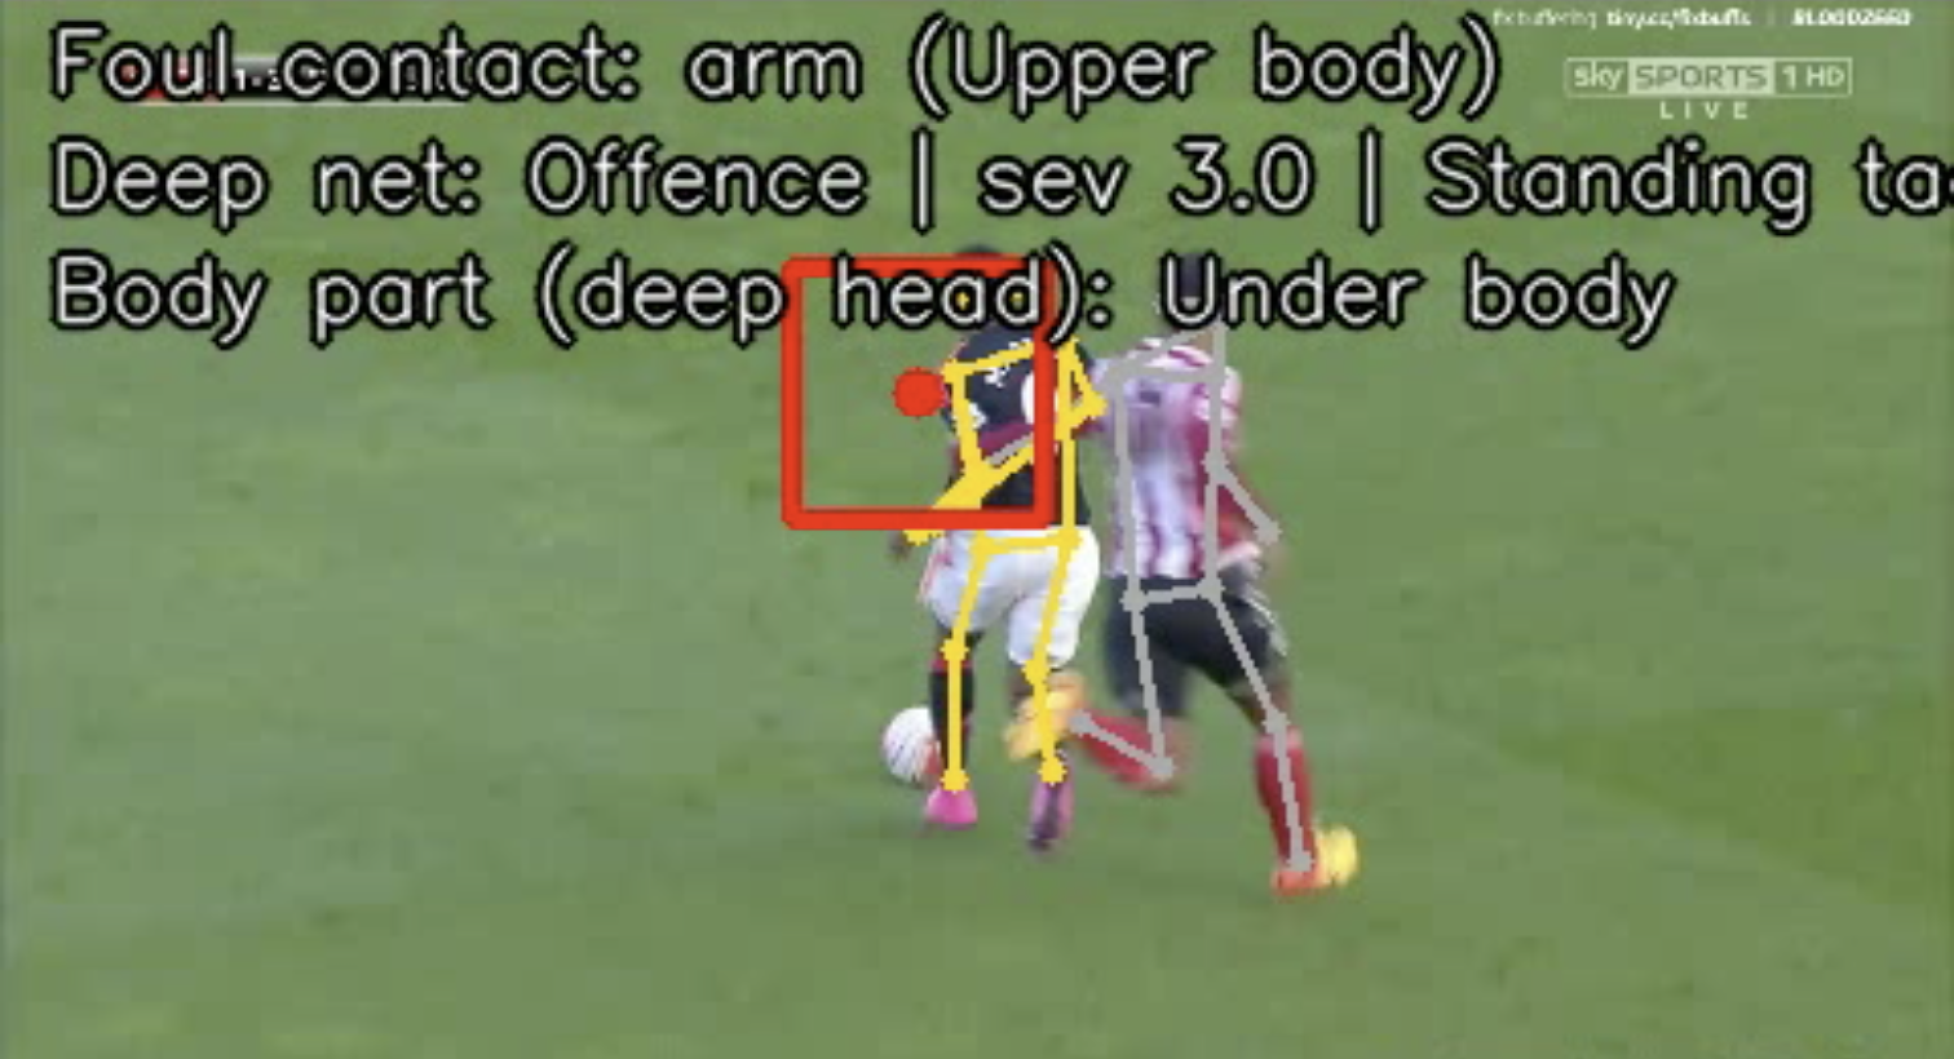

7. Limitations

7.1 Wide and Bird's-Eye View Limitations
The biggest limitation is the bird’s-eye versus the wide broadcast view. The wide view is useful for foul recognition because it shows speed and direction, but it is weak for contact localization. Players occupy few pixels and the true point of contact may be hidden by another player or by the camera angle.
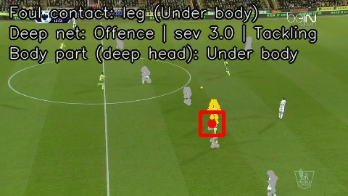

7.2 Post-Hoc Nature of Contact Boxes
Another limitation is that the red box should not be treated as ground truth. It is produced after the foul prediction and depends on what the pose/contact logic can see. If the real foul is hidden, outside the crop, caused by subtle force, or not a clean body-to-body collision, the box may highlight the wrong region even when the classifier's foul decision is reasonable.
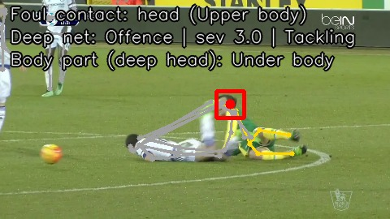

7.3 Pose Estimation Stability
A third limitation is pose stability. Football clips move quickly, and players often overlap, fall, or leave the frame. The current pipeline estimates pose frame by frame instead of maintaining one consistent tracked skeleton over time. This can create jitter, identity switches, and contact boxes that move less smoothly than they should.

7.4 Hardware Constraints
We attempted to run train a VARS model using a TAdaFormer-L/14 architecture but ran into compute constraints.

8. Remarks and Future Work

8.1 Direct Contact Localization
The most important future improvement is to learn contact localization more directly. The system should learn from contact annotations or weak supervision.

8.2 Better Multi-View Fusion
The second improvement is stronger view reasoning. Right now, the outputs can include original and replay clips, but the contact estimate is still mostly made per clip. A better version would score each view by player size, visibility, pose confidence, and replay usefulness, then combine the best evidence before choosing the contact frame.

8.3 Temporal Smoothing and Pose Tracking
The third improvement is temporal smoothing and pose tracking. The system should track players and skeletons over time. This would reduce jitter and make the contact box move more naturally.

8.4 Course-Level Future Learning
From a course perspective, I think we should spend more time on neural network techniques in computer vision. Classical fundamentals are important and should not be removed, but modern CV is now heavily driven by deep learning.

References
Held, J., Cioppa, A., Giancola, S., Hamdi, A., Ghanem, B., & Van Droogenbroeck, M. (2023). VARS: Video Assistant Referee System for Automated Soccer Decision Making From Multiple Views. CVSports.
SoccerNet-MVFoul project repository and dataset documentation used through the local project files and generated outputs.

