A Template File for Microsoft Word for AutoCarto 2008 Conference Papers

Keith C. Clarke

ABSTRACT: The purpose of this template is to make all of the AutoCarto 2008 conference papers fit a common format. This is done by following the instructions included in this template. With good luck, we will have a great conference, extraordinary papers, and make a major impact on the fields of Cartography and Geographic Information Science. Note that in the tabs above, the formatting for this section is entitled “Abstract.” The header is Abstract+Bold.

KEYWORDS: Quote five or so key words that would be useful in a web search for your paper. In this case: template, AutoCarto 2008 conference, proceedings

Introduction

This is the content of the introduction. Note that the template assigned here is BodyText+First Line 0”, which means that this is the standard format for a regular paragraph. It is indented for each new paragraph, after a major header. Note that HeadingTwo is not the same as heading two. Select the one used in this template.
This is the second paragraph. I have deliberately left no blank line to separate it from the previous paragraph. Please keep to this format throughout the document. The label is body paras for everything other than the first paragraph. Note that the template contains several choices. Use the one that matches this template exactly.
As far as references go, please avoid using footnotes if at all possible. For references, use the (Author, Date) style. For example, Smith (1990) stated that “cartography can be fun.” That cartography is indeed fun, is clearly evident from the literature (Smith, 1990; Smith and Jones, 1991; Smith et al., 1992). To quote Smith, “cartography is great fun”, (Smith, 1997, p. 187). Use the “et al.” form for more that two authors.

Dealing with Figures and Tables
Special attention should be devoted to making sure that figures and tables fit within the bounds of this page (i.e. 6 inches width, centered). Each figure should stand alone, with a caption and a reference in the text (Figure 1).

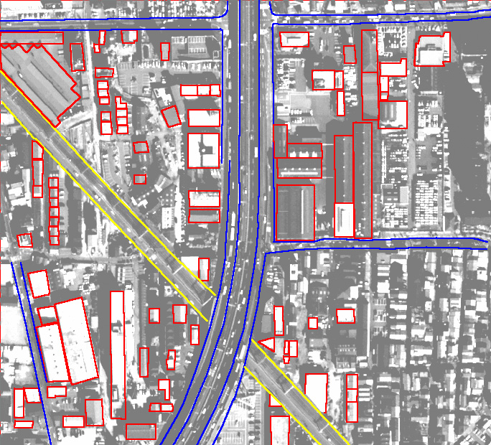

Figure 1: A gratuitous graphic. Source: http://www.hgiis.com/images/pic_app_cartography.jpg.

This line is centered and uses the Figure Caption Char label in the window at the upper left.
When you need to insert an equation, just go ahead and use the Word equation editor. The equation can be formatted with the Equation Line One, Equation Line Two template. For example:

E = m c²
There is no need to number equations, unless it is important to refer to them. Tables can be treated the same as figures, and embedded into the Word file. They should be referred to in the text, and have their own number sequence, independent of figures. They also need captions. Be sure to try and avoid figures and tables rolling over or getting split between pages. You can usually move them around until they appear on their own page. If not, you can force a new page using the Insert Tab and Break menu choice. Use the standard table tools in word, or import the table from Excel or equivalent (Table 1).

Table 1: A meaningless table, added to show the basics of formatting.

Distance from Point A (mm) | Distance from Point B (mm) | Value assigned | Purpose
1.2 | 1.3 | 1000 kP | Instruction
3.1 | 2.1 | 1020 kP | Distraction

Results

Many papers follow an IMRAD format, that is Introduction, Methods, Results, Analysis and Discussion (Davis, 2005). Of course there are many different paper formats. Follow the one that communicates your findings best. Use passive voice for preference, avoid grey literature, and use the third person.

Conclusions
If we all follow this easy to use template, hours of valuable conference time will be saved in preparing the conference proceeding. There is no word or page limit on your paper, but papers should be in the order of 12 pages long, single spaced, and including references and figures, etc.

REFERENCES

Davis, M. (2005) Scientific Papers and Presentations, 2ed. Oxford: Elsevier Academic Press.

Smith, A. (1999) Maps: A Laugh a Minute. Hungarian Journal of Cartographic Logic, 11, 6, pp. 145-180.

Smith, A. and Jones, B. (1991) More Cartographic Hilarity. Cartography and Geographic Information Science. 22, 1, pp. 123-145.

Smith, A. Jones, B. and Smythers, C. (1992) Two Years of Cartographic Humor. http://www.funnymaps.com Last visited 5/19/2008.

Keith C. Clarke, Professor, Department of Geography, University of California, Santa Barbara. Santa Barbara, CA 93106-4060. E-mail:<kclarke@geog.ucsb.edu>.

