Non-Photorealistic Rendering of Stylized Block Diagrams
James E. Mower
University at Albany

Department of Geography and Planning
AS 218, University at Albany
Albany, New York 12222 USA
jmower@albany.edu
voice: 518-442-4779
fax: 518-442-4742

ABSTRACT: This paper will introduce object-space procedures for extracting silhouettes, slope lines, and drainage features from DEMs to direct the non-photorealistic rendering of landforms as stylized block diagrams. The ultimate goal of this work is to produce fully-automated tools that can imitate the style of illustrations characterized by traditional pen and ink techniques. Through the implementation of a Java 3D API prototype, this project establishes a testing platform for the application of stylistic elements to linework representing surface form lines. This project will begin to explore the aesthetic effects of silhouette lines, creases, and hachures on the rendering of terrain features. It also introduces the use of adaptively resampled TINs as a basis for perspective rendering applications.
Introduction
Block diagrams are large-scale illustrations of surface features and their underlying geologic structures drawn from a particular point of view following the rules of artistic perspective. Armin Lobeck, whose Block Diagrams has remained one of the most influential guides to their manual construction, argues that these illustrations gain much of their effectiveness from their visual simplicity (Lobeck 1958, p. 1). This paper will explore the application of his aesthetic to the automatic construction of block diagrams from digital elevation models (DEMs) under the rubric of non-photorealistic rendering. Following a review of earlier work on automated systems, I will introduce a new testing platform for stylistic experimentation, provide the relevant algorithms underlying its implementation, and discuss the contributions of particular graphic elements to good expression of landscape form.
Previous Related Work
Over the past decade, the rapid development cycle of fast, relatively inexpensive graphics processing chips along with concomitant developments in 3D application programming interfaces (APIs) has fostered a period of intense growth in perspective rendering applications in cartography, GIS, and in other, non-geographic disciplines. Much of this work has been related to realistic renderings of landscapes, whether for gaming, site planning, or other uses that require a relatively ‘complete’ description of a scene. Another rendering paradigm, non-photorealistic rendering (NPR), provides a close analogy to the construction of traditional landscape line drawings by fostering the communication of specific, often scientific information through a language composed of symbols with well-understood meanings (Kennelly and Kimerling 2006). This definition is consistent with the goals of cartographic forms that use the rules and constraints of generalization to establish a message for an image and to focus a viewer’s attention upon it.
Starting with an image space approach, Saito and Takahashi (1990) lay out many of the ground rules for NPR using 2D digital images as their base data. Their successful demonstration of techniques for generating simplified line drawings from photographed 3D objects established a vocabulary for further NPR research on the extraction of edges (rendered as silhouette lines) and components of surface curvature, represented by hachures. Isenberg, et al. (2003) provide a comprehensive classification of NPR modeling techniques for both image and object space approaches along with definitions of terminology. Kennelly and Kimerling (2006) provide an excellent overview of those approaches that are specific to renderings of landforms, placing them in the context of the manual methods defined and described by Raisz, Imhof, Lobeck, and other 20th century cartographers and illustrators.
Most current NPR research in landform representation has focused on object space approaches, deriving perspective line-drawn images entirely from 3D spatial data represented in a DEM. Lesage and Visvalingam (2002) use this approach to implement p-stroke sketching, which is itself closely related to the inclined contour method of Tanaka (1932). Buchin, et al. (2004) model surface slope to apply scanned, hand-drawn slope and loose lines from a look-up table, dependent on surface slope and lighting conditions.
This paper will focus on the development of a robust technique for representing silhouettes and hachures from adaptively resampled DEMs in the form of variable resolution triangulated irregular networks (VTINs). By resampling a DEM with greater tolerance for surface error away from a selected viewpoint, areas of triangles remain relatively constant (given constant surface variability) with distance from the viewpoint under perspective rendering. It is thus possible to extract and render features from a resampled DEM without need for line simplification in a post-rendering operation. This paper will also introduce the extraction of drainage features from DEMs to aid in the rendering of creases—view-independent features that contribute visual cues for surface interpretation.
Modeling Surfaces with Linework
NPR terrain renderings must account for both view-dependent and view-invariant features. A silhouette, representing the profile of a ridge or hill against the sky or another background feature, is unique to a given observer. A crease, on the other hand, represents a feature like a prominent hydrologic ridge, a spur, a drainage channel, or some other surface discontinuity that holds important visual cues regardless of its orientation to the viewer. A crease is frequently accompanied by slope lines which show surface curvature away from their discontinuity. This project will implement silhouettes, creases, and slope lines to render surfaces in the style of block diagrams.
Throughout this project, all facets are represented as 3D triangles within a VTIN. Each VTIN triangle is defined by its vertices and edges, where each edge record includes the IDs of its bordering triangles. The network of triangles is traversable both by triangle and edge IDs.
Silhouettes
A silhouette segment is a rendered edge separating a visible and invisible facet, where visibility is determined by the angle made between the viewer’s line of sight and the facet’s surface normal (Figure 1). In this sense, visibility has nothing to do with the presence or absence of obscuring surfaces between the viewer and the facet in question. A silhouette can be thought of as a ‘visibility ridge’ from the viewer’s point of view. Silhouette segments are computed locally as specified by Algorithm Build Silhouettes:
Algorithm Build Silhouettes
To build silhouette lines:
- For each facet,
  - Determine the angle between the viewer’s line of sight and the surface normal
  - If the angle is between 0 and 90 degrees, mark the facet as visible. Otherwise, mark it invisible
- For each edge,
  - If one of the bordering facets is visible and the other is invisible,
    - Render the edge as a silhouette segment
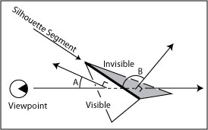
Figure 1. An edge between 2 surface facets is a silhouette segment if one facet is visible (with a normal less than 90 degrees from the line of sight (angle A)) and the other is invisible (normal greater than 90 degrees away from the line of sight (angle B)).
Since hidden line removal is not an integral part of this algorithm, silhouette segments are rendered along with their referent surfaces, themselves rendered with emissive lighting in the background color of the rendered frame. Emissive lighting provides no differentiation in surface shading with respect to light source direction and surface normals. When rendered in the background color, surfaces disappear, yet supply appropriate masking for silhouette segments (Figure 2).
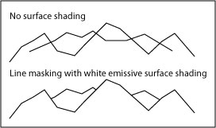
Figure 2. In the upper image, silhouettes are rendered without their associated surfaces and intersect inappropriately. In the lower image, surfaces are rendered with emissive shading in the background color, masking background linework.
Surface Creases
In the NPR literature, a crease is a line representing an edge that carries important visual information independent of the viewer’s line of sight (Isenberg, et al. 2003, p. 28). Drainage features such as channels and ridges represent creases in block diagrams and can be extracted from DEMs in several ways. One approach examines the angle made by normals of adjacent triangles and renders their shared edge as a crease if the angle falls within a given range, either as a convex or concave feature with respect to the projected plane of the ellipsoid (Figure 3).
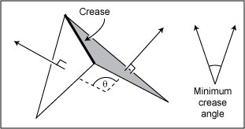
Figure 3. The angle θ between the 2 adjacent facets is greater than the minimum crease angle. The edge between the 2 facets will be rendered as a crease.
This analysis does not provide particularly good results for topographic surfaces, however. In 10-meter horizontal resolution elevation models (such as those used by this project), ridge and channel features rarely exhibit sudden slope breaks along connected triangle edges. In Figure 4, an actual surface (represented by the underlying block diagram, presents a visually interesting feature but the feature is “spread out” among a region of triangles with relatively small slope transitions along adjacent edges. The crease detection method illustrated in Figure 3 would likely fail here.
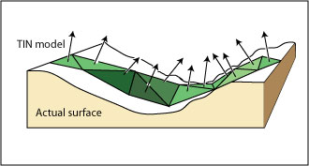
Figure 4. A surface that presents a problem to the crease detection method presented in Figure 3.
I found that a drainage accumulation analysis provided a visual solution much closer to that of hand-drawn illustrations. Algorithm Build Creases summarizes this approach:
Algorithm Build Creases
To build creases:
- Initialize the drainID for each facet to RIDGE
- For each facet,
  - Find the centroid of the neighboring facet with the steepest downhill slope from the current facet. Note its ID as the current facet’s drainID. If a facet has no downhill neighbor, call it a pit
  - Initialize all facets with 1 unit of input water and 0 units of accumulated water
- While any but pit facets contain greater than 0 units of input water,
  - For each facet,
    - Decrement its total input water value and increment both the drainID facet’s input water value and its accumulated water value by the total input water value
- For each facet,
  - Render a line between the current facet’s centroid and that of the drainID if the drainID facet’s accumulated water value is greater than a preset threshold value
Build Creases provides a localized method for constructing drainage lines, requiring only that each facet know the ID of its downhill neighbor. Steps 1 through 2 create a drainage direction map, indicating the drain for each triangular facet. Following step 2, those triangles with no uphill source are on a ridge. Pits are triangles that have no exterior drainage.
Most drainage direction models built from data originally extracted from grid cell DEMs (like that of the current project) will find numerous internal pits. False internal pits are by-products of grid sampling patterns, occurring when an elevation sampled along a stream channel is lower than its 8 surrounding neighbors on the bank above (O’Callaghan and Mark 1984, Mower 1994). Since the channel itself is not explicitly extracted, channel samples are frequently separated from one another and thus have no continuous drainage path. Unlike a realistic hydrologic drainage model, the crease algorithm does not, for now, ‘flood’ false pits to assume a regular drainage pattern. This feature will be added in the next version.
Steps 3 through 4 run a drainage accumulation model through the drainage direction map. At each step of the algorithm, an uphill neighbor transfers its water supply to its downhill neighbor (indicated by drainID) which tracks the total amount of water passing through itself over the life of the procedure. Step 4 ends when all the remaining water is in the pit facets.
Step 4.1 inspects the drainage accumulation of each downhill neighbor of a facet. If the accumulated value is above a preset threshold, a line segment is rendered between the 2 triangle centroids. Depending on the value of the threshold, the procedure will draw more or less of the drainage network detail. For the moment, at current threshold values, ignoring false pits does not negatively impact the line drawing. However, given that drainage networks are promising crease generators, future enhancements may require an additional flooding procedure to avoid potential artifacts.
Slope Lines
On a planimetric map, hachures are linear symbols drawn perpendicular to contours and represent paths of steepest slope across a surface patch. On a block diagram, slope lines perform a different function, emphasizing surface curvature over slope. This project has explored several strategies for using linework to show surface trends: 1) by employing simple hachures as lines of steepest slope, 2) by limiting hachure rendering to regions adjacent to stream channels (to suggest surface curvature), and 3) by sampling elevations along surface profiles away from creases to render 3D curves. The first 2 strategies have been implemented; the third is currently under development and discussed below in the section on Future Work.
The first technique, rendering hachures as lines of steepest slope, adds reasonable slope information to a block diagram rendering but does not imitate typical manual practice (Lobeck 1958, p.33). It is discussed here because it forms the basis of the second, more successful strategy. The following algorithm, Build Hachures, outlines a procedure for constructing straight line segments along the line of steepest descent through a facet (Figure 5):
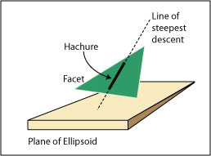
Figure 5. A hachure is computed as a segment of the line of steepest descent through the facet.
Algorithm Build Hachures
To build hachures:
- For each facet,
  - Find the coordinates of the facet centroid
  - Find the equation of the plane of the facet
  - If the facet slope exceeds the preset minimum value,
    - Find the equation of the line of steepest descent through the facet centroid
    - Render the segment of the line within the facet up to a preselected margin bordering the edge of the facet
The algorithm creates hachures of uniform width. Although it could be modified to scale the width of the rendered line to the slope of the facet, this is largely unnecessary. As vertical resolution decreases away from the viewpoint, the screen space areas of rendered triangles remain relatively uniform given constant surface variability. Therefore, the separation of rendered hachures remains a good visual indicator of surface slope regardless of the 3D distance of the surface patch from the viewpoint.
Nonetheless, hachured renderings are somewhat atypical for block diagrams. Most utilize curved lines parsimoniously to emphasize surface trends near creases. To make the implementation of slope lines more like that of a tradition block diagram, the second strategy, represented by algorithm Build Slope Lines, extends Build Hachures with a recursive technique that limits line rendering to triangles falling within a specified topological distance from a crease:
Algorithm Build Slope Lines
To build slope lines:
- Establish a maximum rendering distance (in integer facets) from a crease
- For each facet containing a crease segment,
  - Apply procedure Find Slope Region to each of the facet’s neighbors with the maximum rendering distance criterion
Recursive Procedure Find Slope Region
- Decrement the rendering distance criterion
- If the rendering distance criterion is not less than 0,
  - Note that this facet has been visited
  - For each of the facet’s neighbors,
    - Find the coordinates of the neighboring facet’s centroid
    - Find the equation of the plane of the neighboring facet
    - If the neighboring facet has not been visited, if it is not on a crease, and its slope exceeds the preset minimum value,
      - Find the equation of the line of steepest descent through the facet centroid
      - Render the segment of the line within the facet up to a preselected margin bordering the edge of the facet
      - Apply procedure Find Slope Region to its neighboring facets
This algorithm ensures that slope lines will only be drawn within a predetermined distance from a crease. By using topological distances rather than ground or pixel distances, the algorithm leaves generalization issues to the adaptively resampled surface model.
The Implementation
The block diagram implementation has been written in Java and the Java 3D API. Although earlier work on this and related rendering projects used C# and the Direct3D API, I found that Direct3D (the Microsoft 3D rendering library) provides insufficient control for line widths, critical to the successful implementation of this project. Since OpenGL provides such control, and since the Java 3D API makes OpenGL calls on a client computer by default, this environment provides a natural platform for experimentation and collaboration across the Internet.
The implementation supports the rendering of a scene in layers. After loading the VTIN, the user typically renders the scene with the emissive background color. For debugging purposes, the surface can be rendered with flat shading in any non-emissive color, enabling the type of image shown in Figure 6. Once the surface has been rendered, slope lines, silhouettes, or creases can be rendered with a button push. The user may toggle a rendered layer once it has been created and can zoom, pan, or tilt the surface with the mouse. Since the creation of silhouette lines is view dependent, the user would normally render a new set of silhouette lines after a significant shift in viewing position.
Adaptive Resampling and TIN creation
The project data originally came from 10-meter horizontal resolution grid cell DEMs in native USGS 1:24000 format produced by the New York State Department of Environmental Conservation and distributed by the Cornell University Geospatial Information Repository (CUGIR). For ease of use, the data was transformed into 10 km by 10km grids from which a dense TIN (DTIN) was created (Mower, in press). The DTIN is formed by a recursive resampling of the region files such that every retained sample is recorded along with an error term that measures its orthogonal distance from its parent plane. A variable TIN (VTIN) is created by scanning the DTIN and selecting those samples whose error term is greater than a tolerance whose value increases linearly with distance from a specified viewpoint. The VTIN provides a relatively constant number of samples per pixel for perspective rendering applications.
Results
Figures 6 through 10 show renderings of Mount Rainier, as viewed from a point due east of the summit, starting with a rendered surface with flat shading for reference (Figure 6). All of the images were taken as screen shots from the current implementation, keeping the viewpoint, view angles, field of view, and other rendering parameters constant. Silhouettes, slope lines, and creases are purposely left unrendered within 3 km of the viewpoint world coordinates. Each of the screen shots were captured at actual rendered size and were framed with a border for this paper.
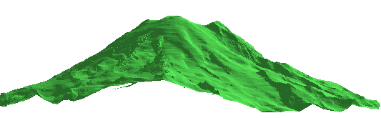
Figure 6. Flat shaded rendering. The images in this sequence share a common viewpoint, view angles, and other rendering parameters.
Figure 7 renders the scene in silhouette lines. The image captures the profile of the larger mountain and the lower foreground peak particularly well.
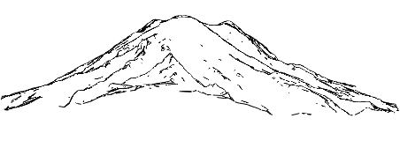
Figure 7. Silhouette rendering. Lines represent borders between edges facing toward and away from the viewer. This and the remaining figures render the surface with white emissive color to enable hidden line removal
Figure 8 renders the drainage accumulation data as a set of crease lines. Although the image provides strong depth cues and models the east face of Mt. Rainier appropriately, it provides a somewhat different view of the landform than do most traditional pen and ink sketches. In those produced by Imhof (2007) and others, where the erosive patterns of exposed rock or cracking in glacial ice may be the most important information in the image, creases typically follow different patterns than shown below.
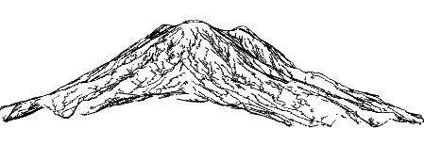
Figure 8. Crease rendering as drainage lines with white emissive surface rendering. False pits have not been removed from the drainage direction map.
Figure 9 renders the scene with Build Slope Lines. Rendering was limited to only those facets whose slopes are within 3 triangles of a rendered crease (not shown here). Since the VTIN maintains a relatively constant rendered triangle size throughout the scene, slope lines do not coalesce in the background. The current implementation limits the rendering of slope lines to straight line segments.
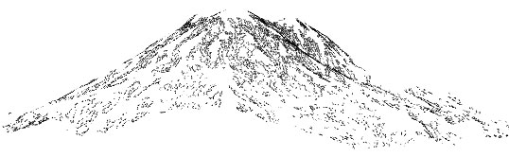
Figure 9. Slope line rendering.
Figure 10 shows a screen shot of the composite image. The remaining portion of this paper will outline several research paths that will move toward a more faithful pen and ink style representation, resulting in an improved visual experience.
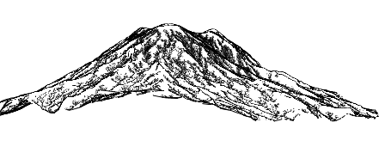
Figure 10. The composite image.

Future Work
The next phase of this project will investigate 3 major themes: 1) changing the representation of slope lines and creases from simple, straight line segments to complex curves, 2) exploring other techniques for crease generation, and 3) implementing several features to support ‘on the fly’ calculations.
Build Slope Lines produces renderings that are still somewhat deficient. I expected that triangles near creases would have lines of steepest descent more or less perpendicular to their referent creases. Instead, lines more than a single triangular facet away from a crease have a tendency to follow surface trends that are parallel to, rather than normal to the drainage creases. Figure 11 illustrates the problem in a close-up view of slope line and crease renderings. In A, most slope lines run parallel to their referent creases. In B, I have drawn slope lines by hand to demonstrate a more reasonable approach.
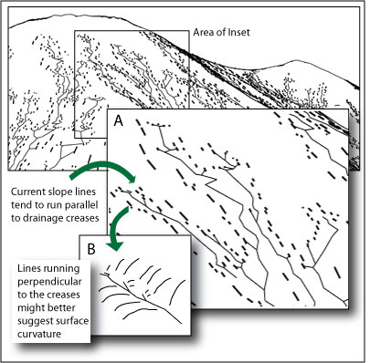
Figure 11. A problem and a solution for slope line rendering.
To implement this new approach, I am developing a third slope line strategy to interpolate and render elevations along profiles extending some maximum topological distance away from crease vertices (Figure 12). Elevations will be interpolated from the equations of the planes of the triangles over which the profile (implemented as a ray) passes, sampling each triangle at most once. The interpolated points would then be rendered as a 3D curve. To ensure that the rendered lines do not intersect one another, each facet will be limited to one representation. Silhouette lines will be given first priority, then crease lines, and finally slope lines on a first-come, first-served basis.
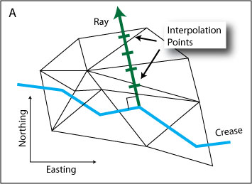
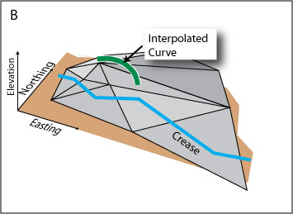
Figure 12. Interpolating elevations for slope lines along rays. In A, a ray is constructed normal to the crease with an interpolation point for each intersected triangle. In B, the interpolated points have been connected and rendered as a 3D curve.
Creases and silhouettes will also be represented as curves in subsequent projects. Buchin, et al. (2004) describe a procedure for creating curves as an application of a vector field visualization but their approach requires a complex iterative procedure for line intersection detection. Creases can be drawn more simply as curves within the current project’s drainage framework by using the points extracted from the accumulation model as Bezier control points. Bezier curves are particularly attractive forms for this application because such curves are guaranteed to remain entirely within the convex hull described by their control points (Foley and Van Dam, p. 521). Thus, drainage lines for separate basins should not intersect one another. Points along drainage basin ridges (extracted, but unused in the current implementation) could also be rendered as Bezier segments, especially for surfaces modeling exposed rock faces.
Imhof (2007, pp. 235-260), provides numerous examples of rock face drawing in which both hydrologic channels and ridges are rendered by a variety of techniques, some involving connected, branching linework and others in which the linework is largely disconnected. The next implementation of this project will experiment with the rendering of hydrologic ridges and also with disconnected ridge and drainage network curves.
To support development and debugging, the current prototype allows the user to recalculate slope lines, creases, and silhouettes at any time through a button push. In a finished application, silhouette construction would need to be recomputed on the fly given a change in the viewpoint. If its position shifts beyond an established threshold, the implementation would also need to calculate a new VTIN and underlying surface rendering. Furthermore, since the shift in position would change the resolution of the surface upon which the slope lines and creases are built, they should be recalculated as well. The next project will begin to implement automatic resampling and rendering on changes in the user’s viewpoint. It will also clean up the drainage model by adding a procedure for false internal pit elimination.
Conclusions
Much of the beauty of pen and ink renderings of landscapes is expressed through an economy of strokes. It is hoped that this project and others like it will focus attention on the work of Lobeck, Imhof, and other masters of line drawing techniques and help to develop adequate methods for their imitation in digital form.
References

Buchin, K., Sousa, M.C., Dollner, J., Samavati, F., Walther, M. (2004) Illustrating Terrains Using Direction of Slope and Lighting. 4th ICA Mountain Cartography Workshop in Vall de Núria, Catalunya, Spain, September 30-October 2 2004, http://www.mountaincartography.org/ publications/papers/papers_nuria_04/buchin.pdf.

Foley, J.D. and Van Dam, A. (1984) Fundamentals of Interactive Computer Graphics. Reading, MA: Addison-Wesley Publishing Co.

Imhof, E. (2007) Cartographic Relief Presentation. Redlands, CA: ESRI Press.

Isenberg, T., Freudenberg, B., Halper, N., Schlechtweg, S., Strothotte, T. (2003) A Developer’s Guide to Silhouette Algorithms for Polygonal Models. IEEE Computer Graphics and Applications, 23, 4, pp. 28-37.

Kennelly, P.J. and Kimerling, A.J. (2006) Non-Photorealistic Rendering and Terrain Representation. Cartographic Perspectives 54, pp. 35-54.

Lesage, P.L. and Visvalingam, M. (2002) Towards Sketch-Based Exploration of Terrain. Computers and Graphics, 26, pp. 309-328.

Lobeck, A.K. (1958) Block Diagrams and Other Graphic Methods Used in Geology and Geography, Amherst, MA: Emerson Trussell Book Company.

Mower, J. E. (1994) Data-Parallel Procedures for Drainage Basin Analysis. Computers and Geosciences, 20, 9, pp. 1365-1378.

Mower, J.E. (in press) Creating and Delivering Augmented Scenes. International Journal of Geographic Information Systems.

O’Callaghan, J.F. and Mark, D.M. (1984) The Extraction of Drainage Networks from Digital Elevation Data. Computer Vision, Graphics, and Image Processing, 28, 3, pp. 323-344.

Saito, T. and Takahashi, T. (1990) Comprehensible Rendering of 3-D Shapes. Computer Graphics, 24, 4, pp. 197-206.

Tanaka, K. (1932) The Orthographic Relief Method of Representing Hill Features on a Topographic Map. Geographical Journal, 79, 3, pp. 213-219.

