TITLE OF THE PAPER: CENTERED, UPPERCASE, 14 POINT TIMES NEW ROMAN, ON SECOND LINE FROM THE TOP MARGIN, PREFERABLY NOT MORE THAN 3 LINES LONG

**Author A and Author B[1]\***

Department of Nuclear Engineering

Name of University

Address

a@name.univ.edu, b@name.univ.edu

ABSTRACT

Use 8.5 x 11 paper size, with 1" margins on all sides. A required 200-250 word abstract starts on this line. Leave two blank lines before “ABSTRACT” and one after. Use 10 point Times New Roman here and single (10 point) spacing. The abstract is a very brief summary highlighting main accomplishments, what is new, and how it relates to the state-of-the-art.

*Key Words*: List of no more than five key words

# INTRODUCTION: Use Heading 1 style

Use 8.5 x 11 paper size, with 1" margins on all sides. Use Heading 1, 2, 3 styles to get the appropriate paragraph spacing. Section titles using style “Heading 1”, are 12 point font, must be all uppercase and centered, and must be numbered in Arabic numerals as shown above. Introduce the topic of your work in this section.

Indent the first line of a paragraph. Use a 12 pt Times New Roman font for report text unless additional guidance is provided. There are four types of reference styles: journal paper [1], proceeding paper [2], book [3], and website [4]. References to websites are discouraged, but acceptable if absolutely necessary. It is the author’s responsibility to check links in the pdf file.

Since the paper will be included as a .pdf file for the proceedings, the author will get the best results from Word or WordPerfect by using the Acrobat Distiller or Acrobat PDFWriter as the default printer. When creating the PDF version, check the “Embed All Fonts” option. Note that it is the author’s responsibility to review the final PDF version of the paper to ensure proper translation into PDF. Final PDF file size should be no more than 4 MB. Recommended paper length is 10-12 pages.

## Second or Subsequent Major Heading (Heading 2)

A logical division of your paper into sections makes it much easier to understand. The style for subsection titles and all text in this template is “Heading 2,” “Heading 3,” etc. All text in this template is “Body Text 3.” If you use the styles provided ***widow/orphan*** lines will be avoided.

## Subsection Title: First Character of Each Non-trivial Word is Uppercase

Secondary titles should start flush left, and are numbered as illustrated above.

Equations should be centered and sequentially numbered to the flush right of the formula.



The continuation of a paragraph after an equation is not indented (you may use Body Text 2 style). All paragraphs, as well as section or subsection headings, are separated from the following text by 6 pts.

### Sub-subsection level and lower: only first character uppercase

Figures and tables should appear as closely as possible to where they are first cited, e.g.   
Fig. 1, in the text. Figures are numbered in Arabic numerals, with the caption centered below the figure, in **boldface**. Color graphics are acceptable since the proceedings will be published to CD.

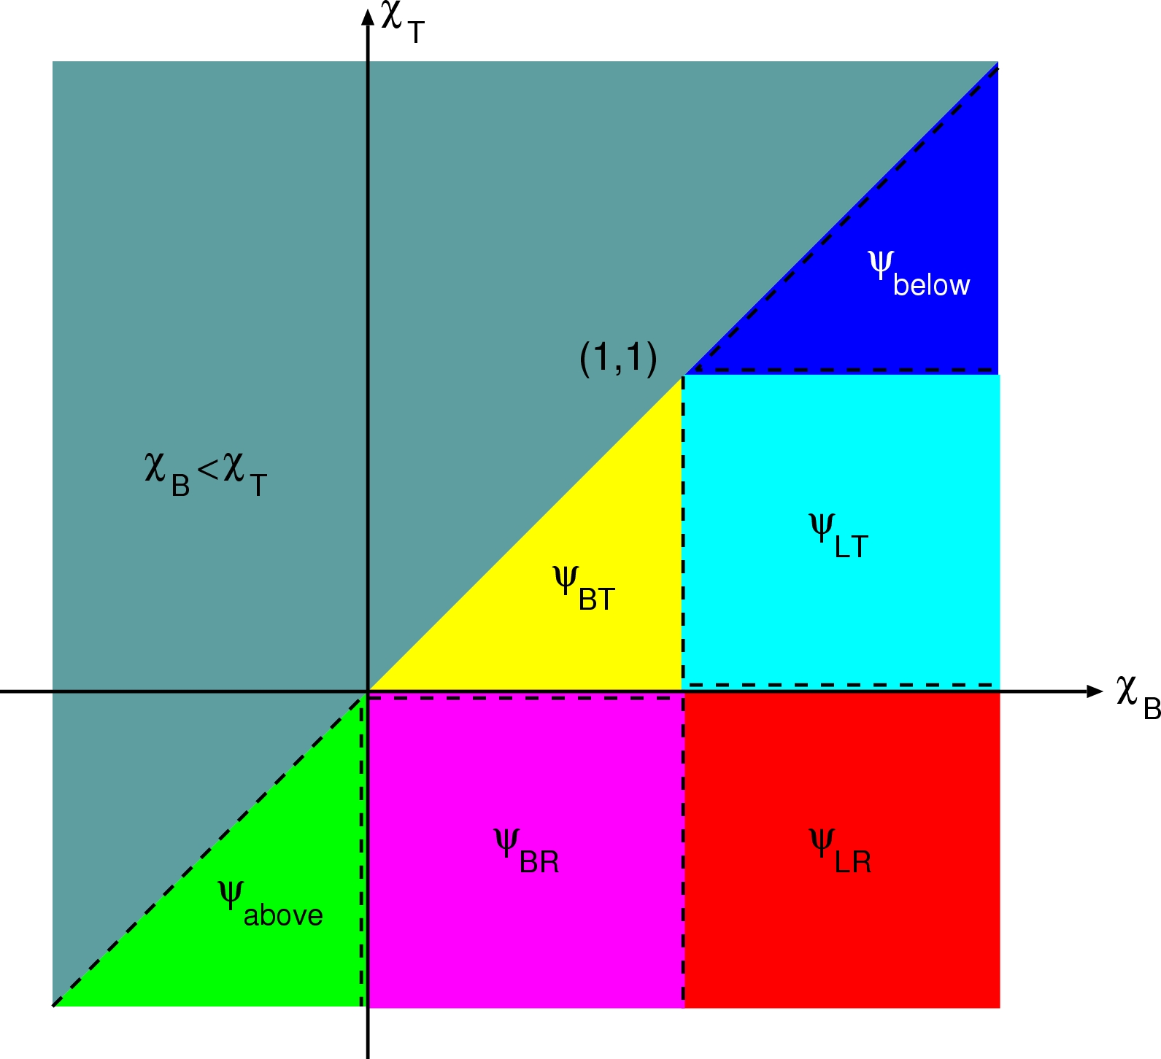

Figure 1. Sample figure. Color is permitted, but must be readable if printed in grayscale.

When importing figures or any graphical image please verify two things:

1. Any number, text or symbol is no smaller than 10-point after reduction to the actual window in your paper;
2. That it can be translated into PDF.

Tables, like Table I, are numbered in Roman numerals, with the caption centered above the table, in **boldface**. Double-space before and after the table.

|  |  |  |  |  |
| --- | --- | --- | --- | --- |
| **Table I. Sample table: accuracy of nodal and characteristic methods** | | | | |
| **Mesh** | **8 x 8** | **16 x 16** | **32 x 32** | **64 x 64** |
| **Nodal** | 1.000 10-1 | 2.500 10-2 | 6.250 10-3 | 1.563 10-3 |
| **Characteristic** | 1.000 10-1 | 2.500 10-2 | 6.250 10-3 | 1.563 10-3 |

# CONCLUSIONS

Present your summary and conclusions here.

# ACKNOWLEDGMENTS

This template was adapted from the template for PHYSOR 2002 posted on the Internet. Acknowledge the help of colleagues, and sources of funding, if you wish.

# REFERENCES

1. B. Author(s), “Title,” *Journal Name in Italic*, **Volume in Bold**, pp.34-89 (19xx).
2. C. D. Author(s), “Article Title,” *Proceeding of Meeting in Italic*, Location, Dates of Meeting, Vol. n, pp.134-156 (19xx).
3. E. F. Author, *Book Title in Italic*, Publisher, City & Country (19xx).
4. “Spallation Neutron Source: The next-generation neutron-scattering facility for the United States,” <http://www.sns.gov/documentation/sns_brochure.pdf> (2002).

APPENDIX A

If necessary, include Appendices numbered in upper case alphabetical order.

In order to ensure a uniform, professional look to the proceedings, please ***do not modify*** the format of this template without checking with the organizers first.

1.