Documentation: Auto-reporting
Introduction
The Auto-Reporting Tool Kit (ARTK) is a postprocessing platform which aims to be a simple, flexible, and common tool for various teams. The ARTK accomplishes its purpose by using JMP as its main scripting language, which provides a scalable framework with native features such as: database-fetching functions, statistical analysis tools and graphical components.
ARTK’s main features are a SQL-assisted fetching module, a data filtering module, and a report generator. Each of these modules is meant to work at a high abstraction layer with the least amount of user-dependent field-fillings, which means that in order to reduce at the most the user-made errors, most of these field-options will be constrained to values retrieved from the database. Along this document, different use cases will be explained for each of these modules.
Cloud
Validation/Functional Lab
JMP Platform (Engineer Equipment)
Reusable settings
SQL-assisted fetching
Data filtering
Report generator
Figure 1 – The ARTK main purpose is to perform multiple postprocessing-reports in a time-effective manner. The data can be fetched from a centralized Cloud-service, while the ARTK might be used from decentralized equipment with the proper ODBC.
How to get started?
- JMP 14 license, access, and installation. Refer to: http://goto/IntelJMP
- Database access
  - Go to: http://iem2.intel.com/GroupManagement/RequestGroupAccess.aspx and request Read/Write : amr\cloudcds_rw.
- Gitlab access and installation. Refer to: https://wiki.ith.intel.com/display/SCMTools/Getting+Started+on+GitLab
- Gitlab repo access: https://gitlab.devtools.intel.com/eio/data-analysis

- ARTK installation and first steps.
  - cd C:\
  - git clone ssh://git@gitlab.devtools.intel.com:29418/eio/data-analysis.git
  - Go to C:\data-analysis\Autoreporting\documentation\
  - Run the ODBC .bat file for the specific database you are using.
    - Ex: cloudcds_ts_dsn.bat
  - Run C:\data-analysis\Autoreporting\main.jsl using JMP
ARTK-GUI
The Auto-Reporting Tool Kit (ARTK) recommended use is through its Graphical-User-Interface (GUI), which is presented in the following figure.
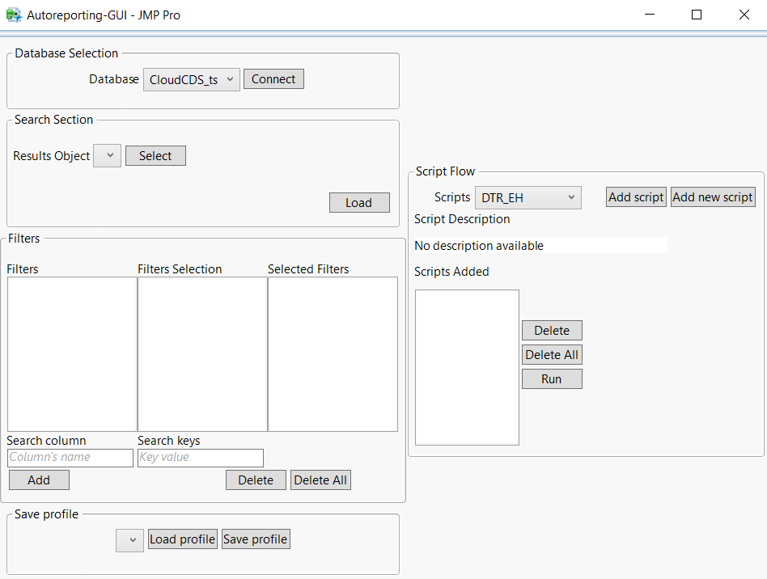
Report-generator
Data-filtering
Pre-filter & Data Retrieve

Figure 2 – The ARTK-GUI has three main-modules: Database & Result Object selection (both being part of the SQL-assisted fetching module), Filters (Data-filtering module) and Script Flow (Report generator module).
Modules
- Data Retrieve – This module allows the user to stablish a connection with a database. For this to happen the user’s equipment must already have a registered ODBC (consult How to get started? for further doubts regarding this).
- Select a Data Base. The GUI will automatically detect ODBC that are enable in the current equipment and match the following DSNs: cloudcds, cloudcds_ts, cloudcds_dev.
- Click the Connect button. The Search section will be updated for you to choose the exact content you are looking for.
- Select a Results Object.
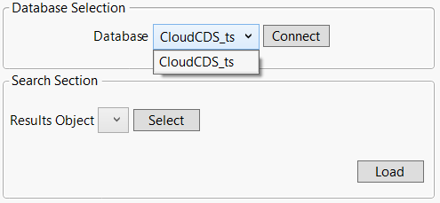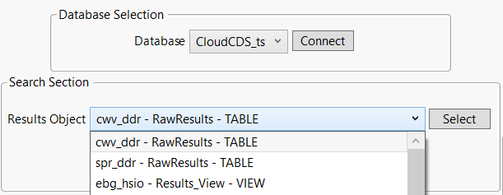
a)
b)
c)
Figure 3 – Section ‘Database selection’ automatically detects valid DSNs.
- Select and Apply a date interval.
- Select an additional filter to narrow down the retrieved data.
- Check that the query data is correct.
- Load data table.
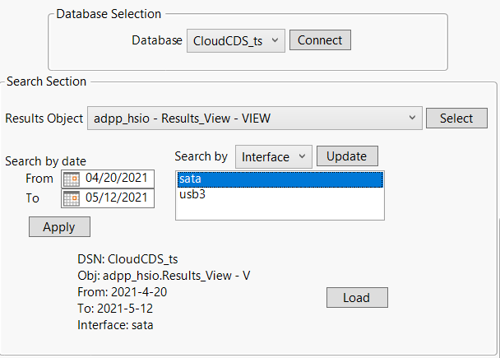
d)
e)
f)
g)
Figure 4 - Prefilter section.
- Data filtering – This section is meant for creating specific subsets of the retrieved data table by selecting column-oriented filters.
- Select a Column from which it values can be filtered.
- Select one or multiple key-values to be filtered.
- Click Add button. Selected filters have a cumulative behavior, key-values available for selection are constrained by previously selected filters.
- Delete filters by selecting them from the list-box and clicking Delete or Delete All
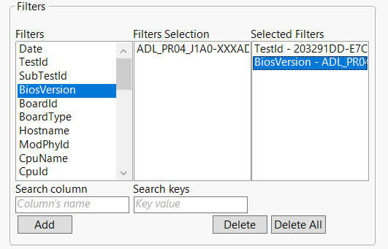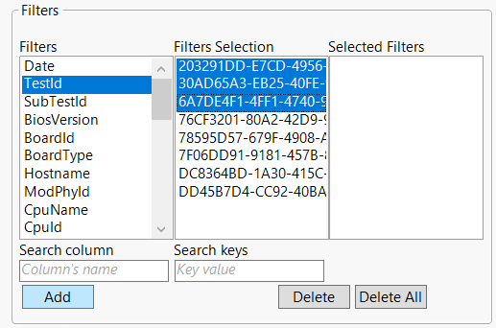
a)
b)
c)
d)
Figure 5 – Column-oriented filters section.
- Report generation – This section uses an orchestrator to automate post-processing tasks by performing sequences of scripts.
- Select and add the sequence of scripts to execute.
- Check de description. It can include a graphical representation of how charts are generated.
- Select and Delete a script from the list if necessary.
- Run the script orchestrator. Notice that some of the scripts may use content from previous scripts to work (like save_as_image or save_as_pptx scripts).
- Add* any custom script through the interface if needed (Following section).
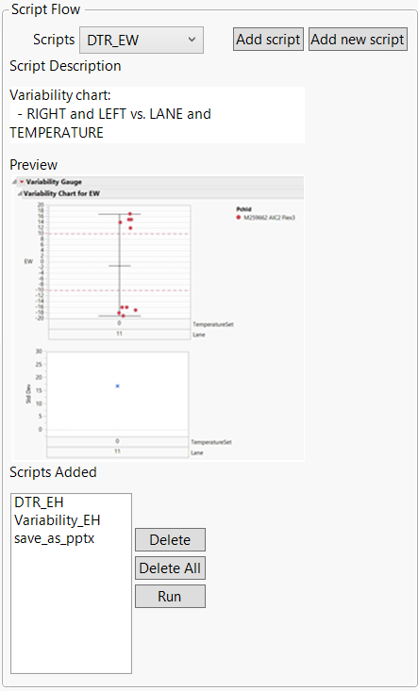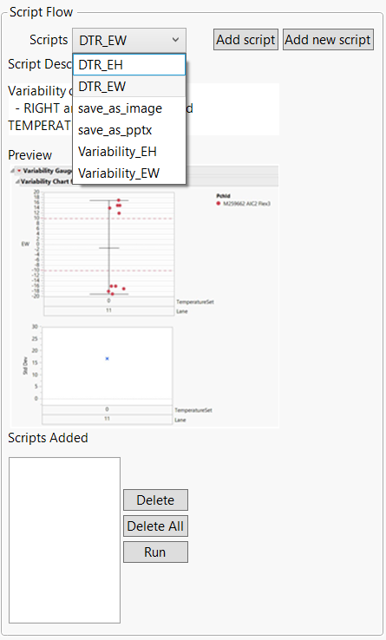
a)
b)
c)
d)
e)
Figure 6 – Script orchestrator section.
- Write a name to identify the new script (this name must be unique).
- Write a description (optional).
- Scripts must follow the next guidelines:
  - Access to the filtered data table thought the variable ‘dt’.
  - Access to the list of previously generated reports pointers through the variable ‘pntr’.
  - Append current report to the list of pointers (‘pntr’) by adding ‘Return( <pntr_report> );’ at the end of the script.
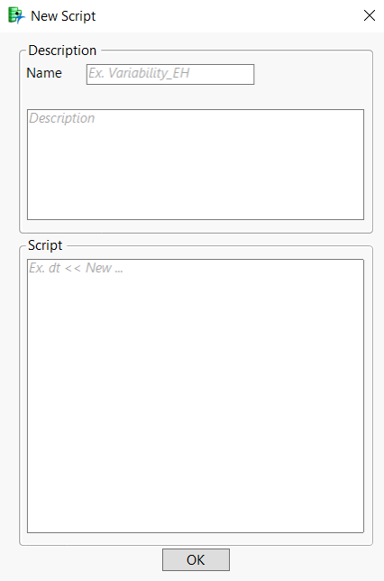
Figure 7 – New script form
Script syntax examples:
// Example: Access to dt object
// Save dt in selectable path
path = PickDirectory( "Save data table" ); // Opens Windows explorer
dt << SaveAs( path || "table.csv" ); // Save data table in selected path as .csv format
Return( 0 ); // Default return value if omitted

// Example: Generate report from data table
// Histogram graph

report = dt << Distribution( // Create histogram
Continuous Distribution( // Save pointer to the report in variable 'report'.
Column( :<Column_name> )
)
);
Return( report ); // Adds current pointer to the pointers list

// Example: Manage reports pointer list ( 'pntr' )
// Iterate through all reports in 'pntr'

path = PickDirectory( "Save as" ); // Open windows explore.
order = pntr << GetKeys; // Get indexes of report list ( 'pntr' ).
/* For each 'report' in 'pntr' */
For( i = 1, i <= NItems( order ), i++,
report = pntr[ order[ i ] ];

/* Modifiable section ( start ) */
report << SaveCapture(
path || order[ i ] || ".jpg", "JPG" // Save report as .jpg image in path
);
/* Modifiable section ( end ) */

);

Return( 0 ); // Exit with default value.

Config file:
The following .json file can be modified to extend the usage of the program: C:\data-analysis\Autoreporting\config\config.json
{  "navigation_mode": 1,  …  "results_search": [  "result"  ],  …  "prefilter_key_column": [  "%product%",  "%interface%"  ],  "author": "Name (author)",  "title": "Results (title)",  "description": "Description"  } | // Display more buttons [ 1-ON, 0-OFF ]  // Results objects:  // SQL-Objects that contain “result” word.  // Pre-filters:  // Column names that contain “product” word.  // … “interface” word.  // Autofill pptx with certain data:  // NAME  // TITLE for the pptx  // Template DESCRIPTION

