Senior Software Engineering Project

Veterans Museum

Ben Ward

John Michael Raimondi

# Project Summary

The main task of our project was to help our client, Mr. Bob Borden, have an easier time managing his database of Alabama veterans. We decided to move Bob away from Microsoft Access and build him two standalone applications that he can use to manage this database. Both applications, one for visitors to look at data and one for Mr. Borden to manage data, were written in C# with Windows Presentation Foundation (WPF). We also decided to merge his 6 database files and migrate to MariaDB.

# Table of Contents

**Project Summary** **1**

**Table of Contents** **2**

**Problem and Objectives** **3**

**Design Documentation** **4**

Database Design 4

Application Design 5

Viewer Application 5

Administrator Application 6

**References** **10**

# Problem and Objectives

The main objective this project aimed to complete was to alleviate as many of our client’s issues with using Microsoft Access to manage his database as possible. Our client had trouble saving and loading his database and would sometimes create new files on accident. Our solution for this issue was to remove any unnecessary interaction with the backend data through building our applications that will handle loading and saving the database automatically. Both applications connect to this database when launched and the option to choose where to save within the administrator application was removed when saving updated or new records. Configuration files were also made to allow for the use of a separate, centralized server where both applications can connect via network. A cleaner user interface was designed for ease of use, both for users in the viewer side and for our client in the administrator side. The original Access database files were all merged into one and migrated into mariaDB. This was done by opening each database file into Microsoft Access and exporting to a temporary mysql database. These 6 exported databases were then merged into another temporary table where each column was looked at to find discrepancies in naming conventions within the records. Next, each column in all 6 exported database files were updated to match each other and the data was merged again into another temporary table. Finally the data was moved into their permanent tables and exported for use in the final mariaDB implementation.

# Design Documentation

## Database Design

The following diagram shows the layout for the final implementation of the database.

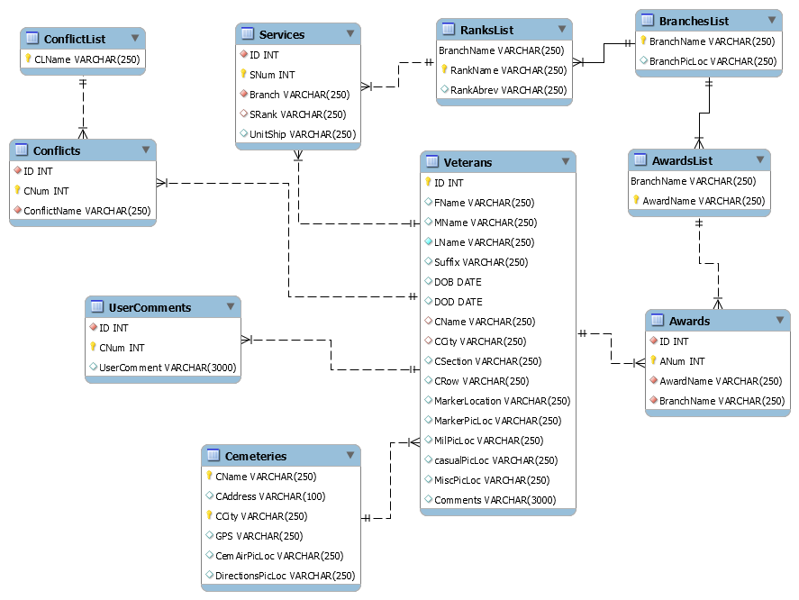

## Application Design

### Viewer Application

The following figures show the final layout of the Viewer application where users can search and view veteran records.

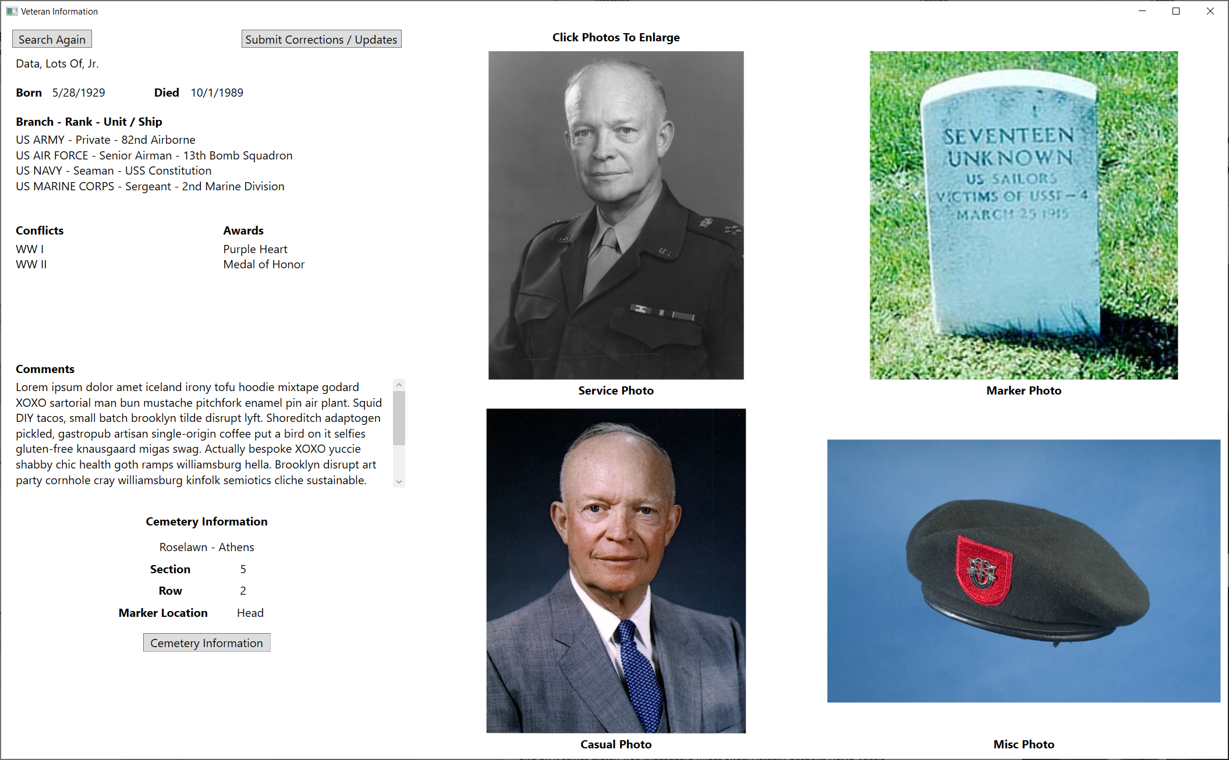



### 

### Administrator Application

The following figures show the final layout of the administrator application where the client may edit anything he wishes.

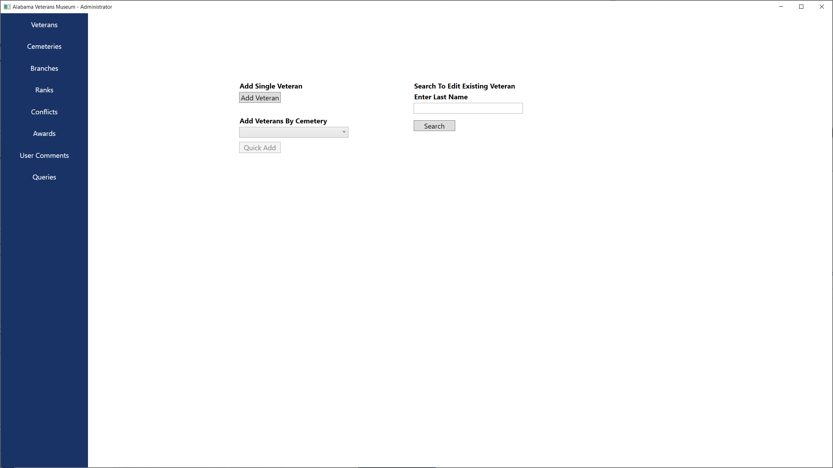

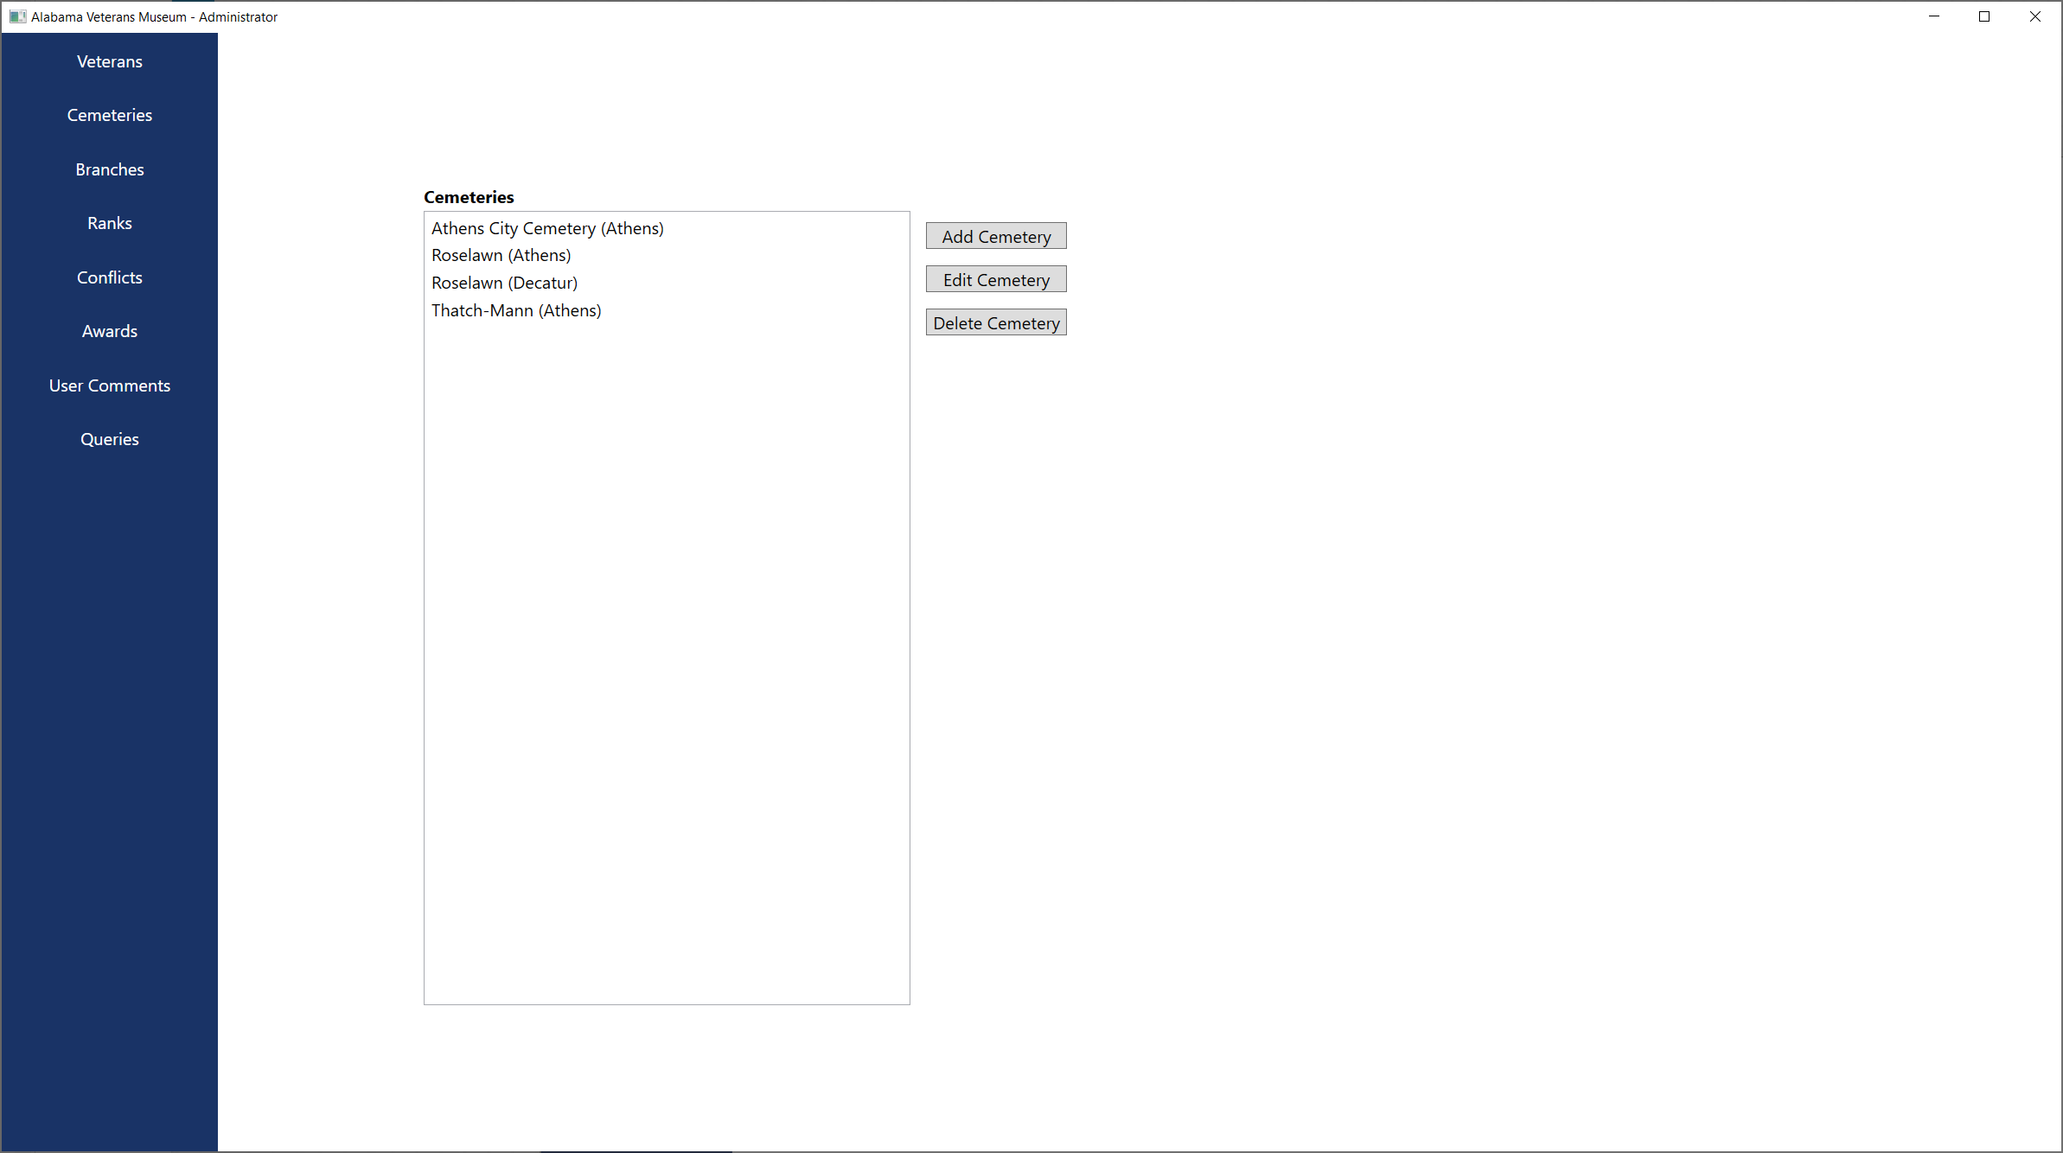

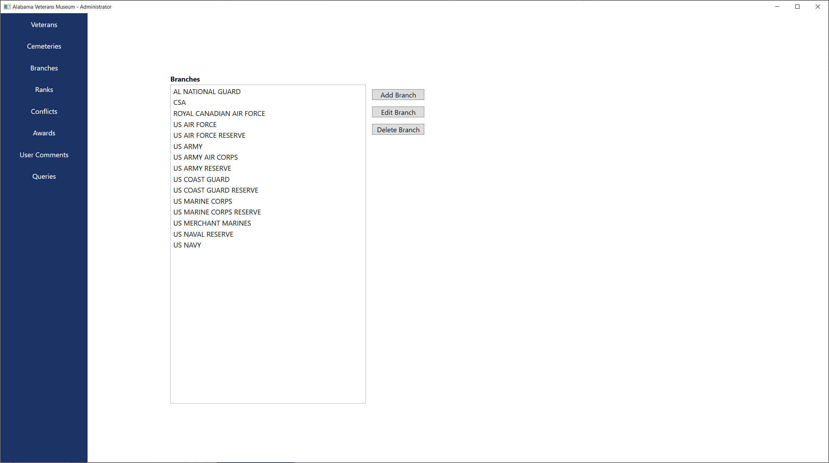

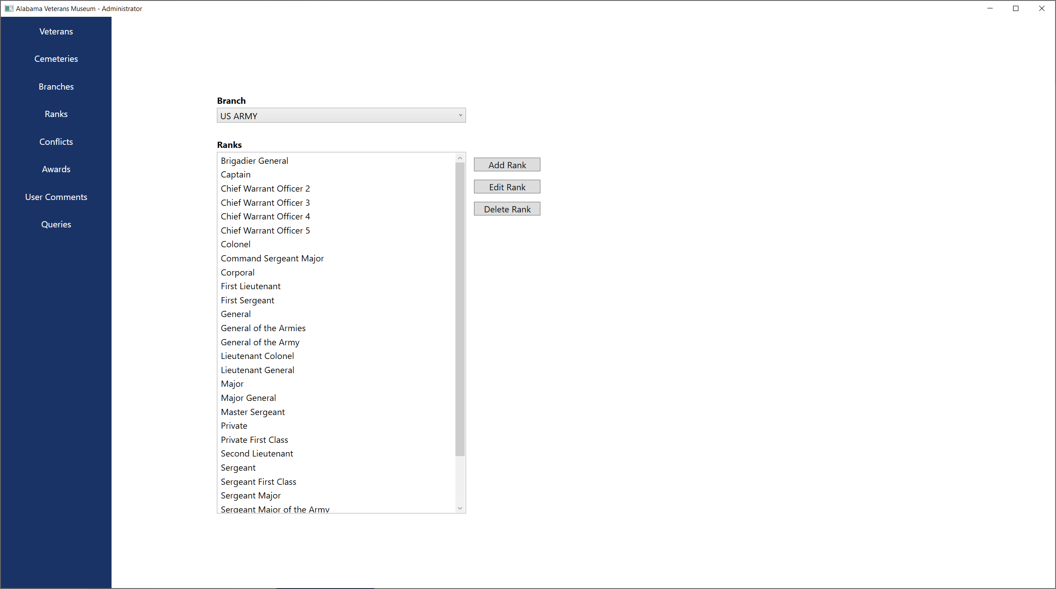

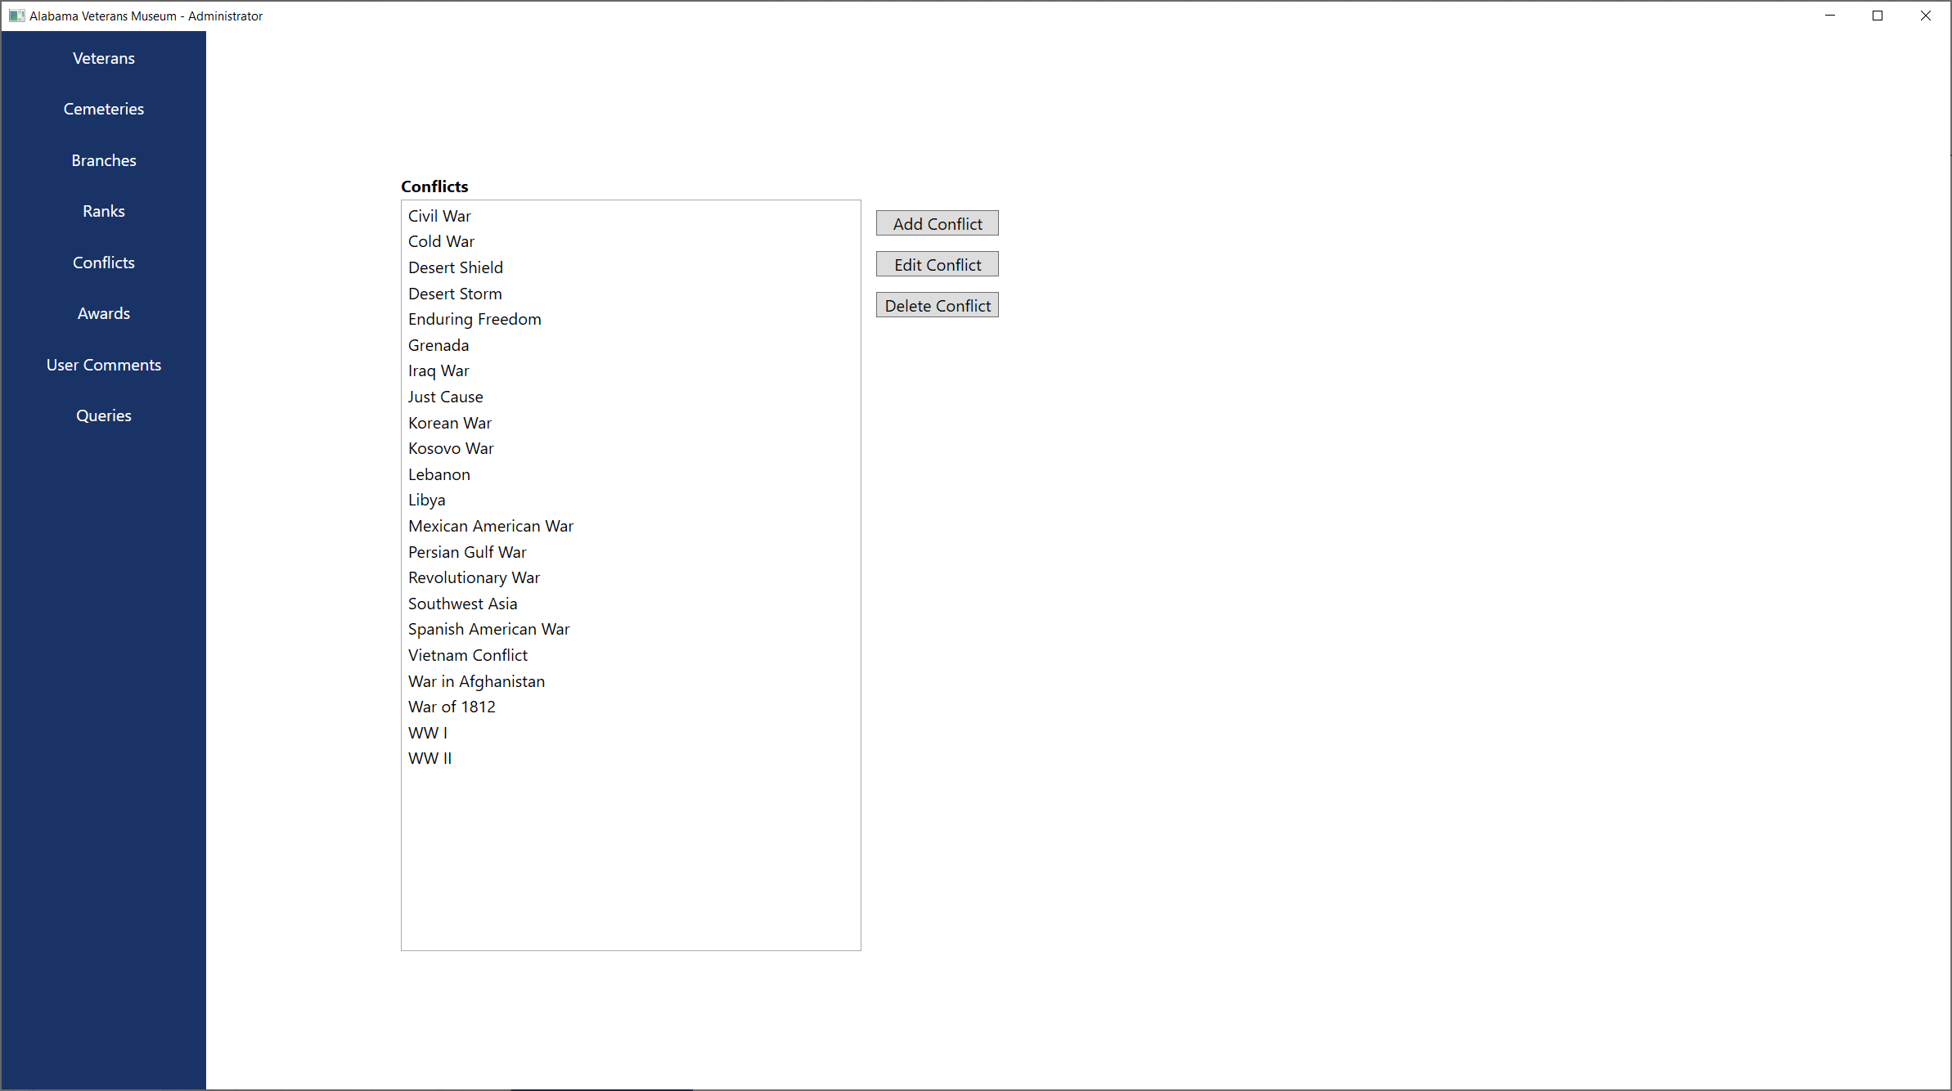

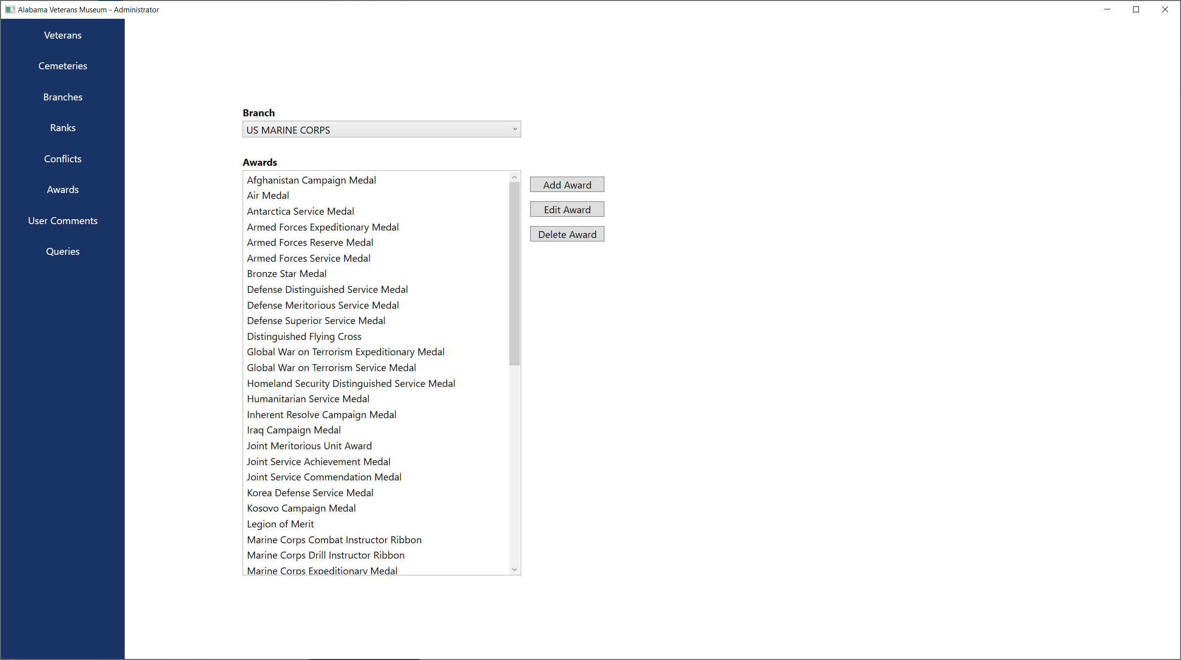

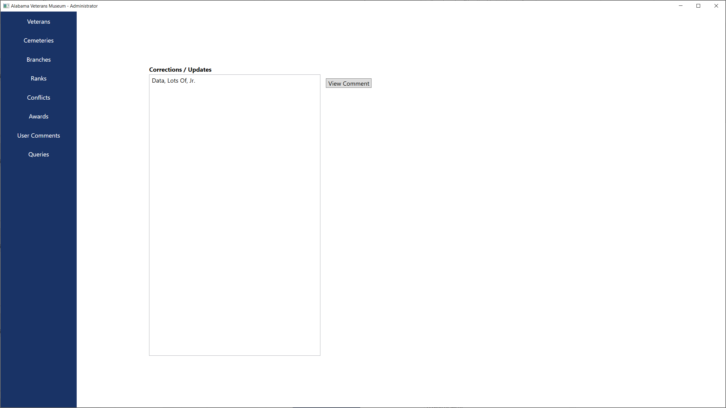

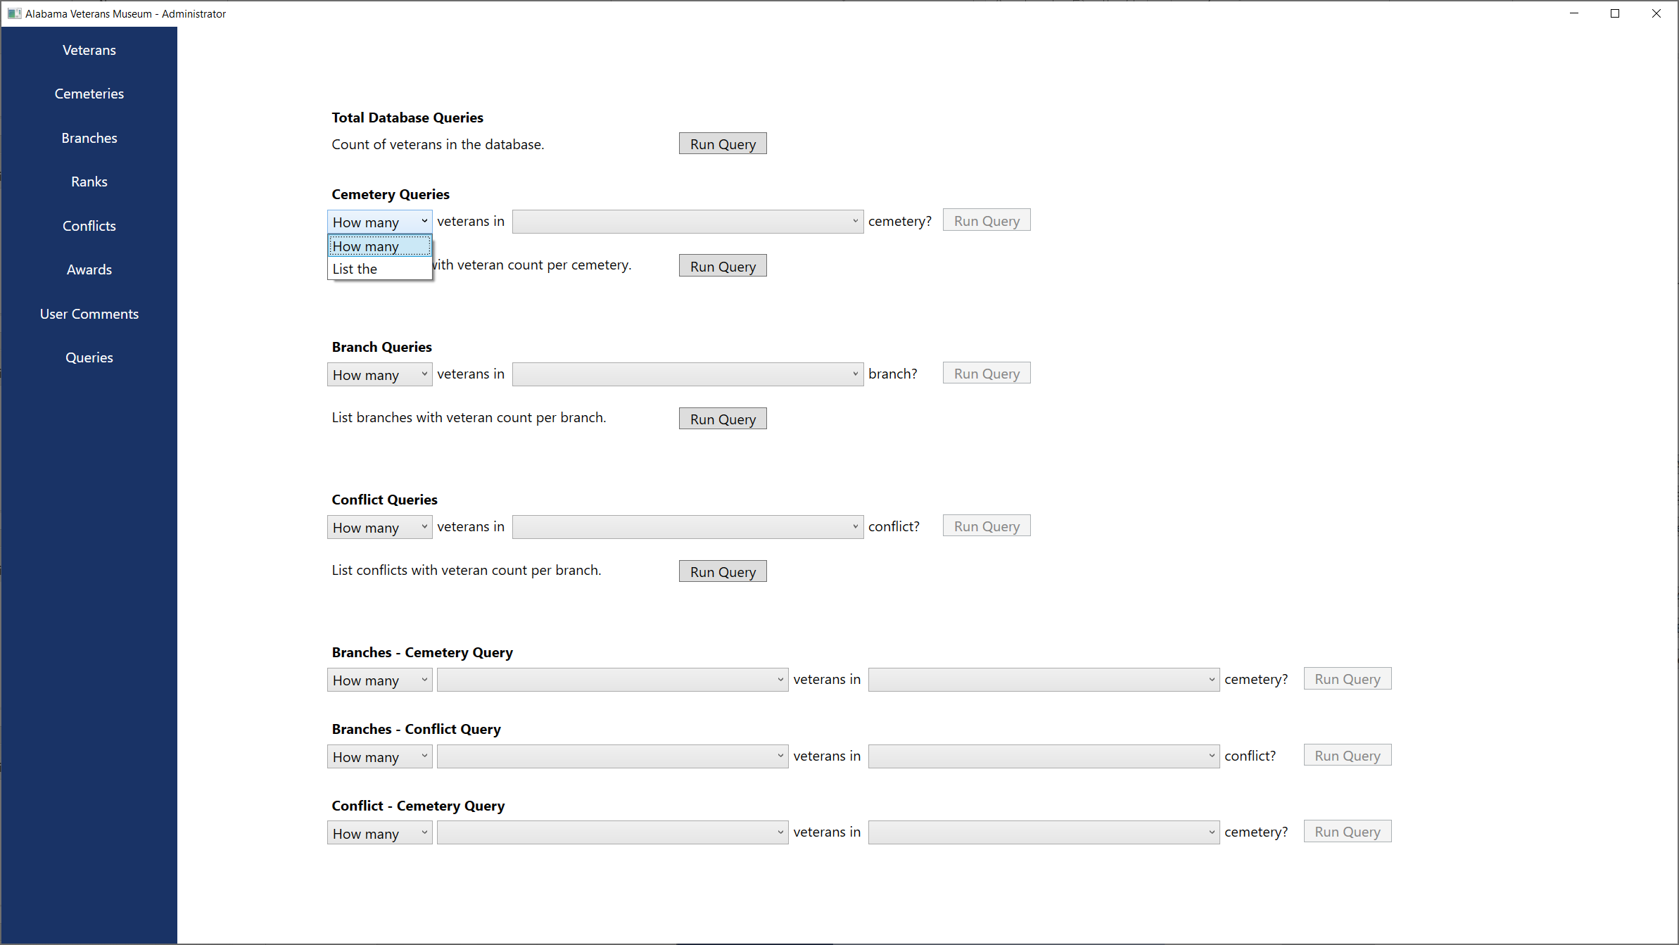

# References

MariaDB - <https://mariadb.org/>

Mysql dev - <https://dev.mysql.com/>