Rscript.R

jessicaraygoza

2024-10-11

# R script   
 x <- 1:50  
plot(x)

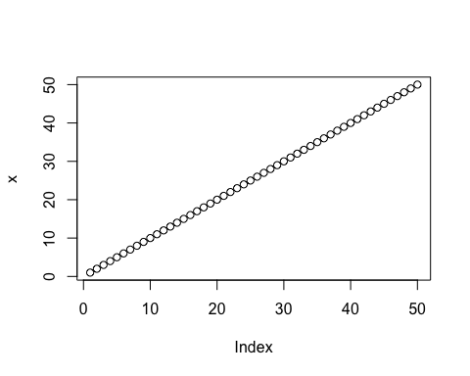

plot(x, sin(x), type = "l", col = "blue")

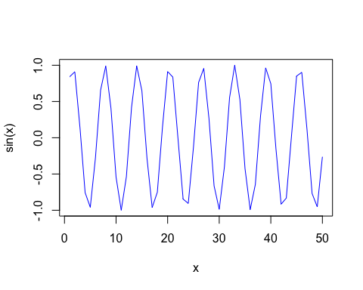

plot(x = x, y=sin(x), col = "red", typ ="l", lwd = "3")

