Editorial Board

Editor-in-Chief
Dr. Karthick B
Assistant Professor
Department of Computer Applications
Government Arts and Science College, Gudalur
The Nilgiris – 643212, Tamil Nadu, India
karthik@jmrh.in
View Profile →

Managing Editor
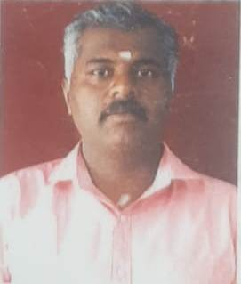
Dr. Sivasankaran M S
Assistant Professor
Department of Commerce with Computer Applications
Government Arts and Science College, Gudalur
The Nilgiris – 643212, Tamil Nadu, India
sivasankaranms@jmrh.inView Profile →

Editorial Board Members
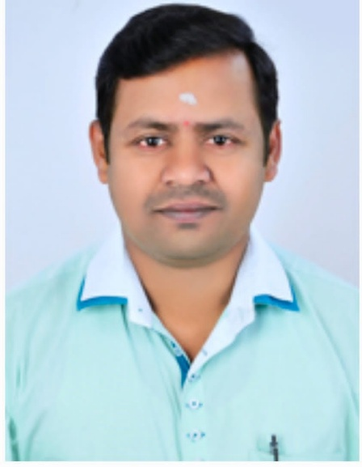
Dr. Jaganathan
Head & Assistant Professor
Department of Commerce with Information Technology
Government Arts and Science College, Gudalur
jaganathan@jmrh.in
View Profile

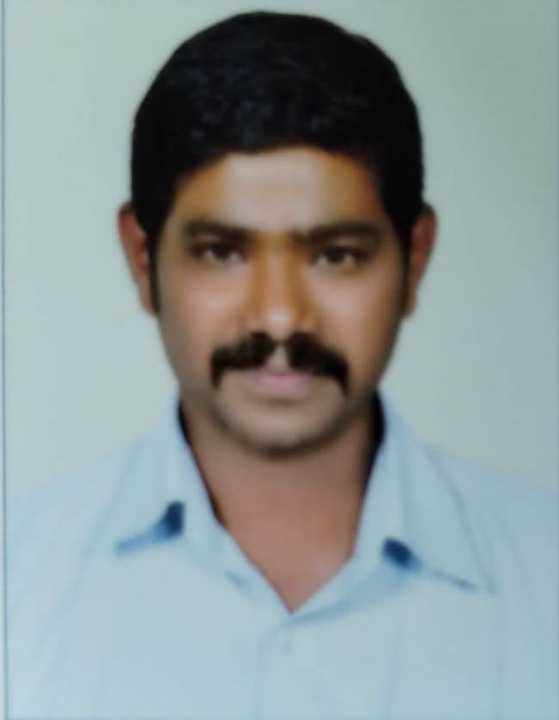
Dr. Porko
Assistant Professor
Department of English
Government Arts and Science College, Gudalur
porko@jmrh.in
View Profile

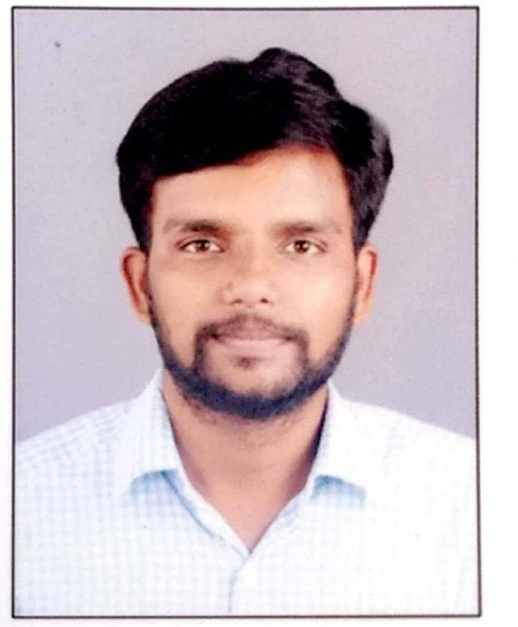
Dr. T. Sathish
Assistant Professor
Department of Mathematics
Government Arts and Science College, Gudalur
sathisjt@jmrh.in
View Profile

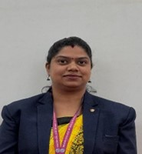
Dr. Dency Mary
Assistant Professor
Department of BBA (IB)
Nilgiri College of Arts and Science (Autonomous), Thaloor
The Nilgiris – 643240, Tamil Nadu, India
dencymary@nilgiricollege.ac.in
View Profile:

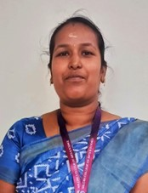
Dr. K Thamarai Selvi
Research Coordinator & Assistant Professor
Department of Commerce
Nilgiri College of Arts and Science (Autonomous)
Konnachal Post, Thaloor, The Nilgiris, Tamil Nadu - 643239
thamaraiselvi@nilgiricollege.ac.in
View Profile: https://nilgiricollege.ac.in/faculty/thamarai

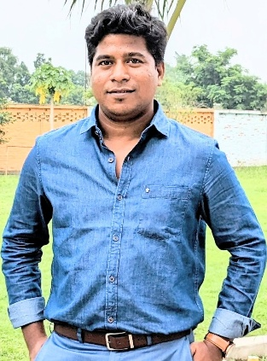
Dr. Sandip Kumar Mukherjee
Associate Professor
Department of Business Administration,
Eminent College of Management and Technology, Barasat, Kolkata 700126
sandip@ecmt.in
https://sites.google.com/ecmt.in/skm

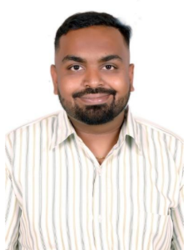
Abhishek BP
Assistant Professor in Language Pathology
AIISH
Centre of Speech Language Sciences, AIISH, Mysuru, karnataka, India 570006
abhishekbp@aiishmysore.in
https://aiishmysore.in/ka/faculty-members-staff/abhishek-b-p

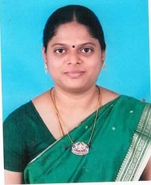

Dr.R.UMAMAGESWARI
ASSOCIATE PROFESSOR
DEPARTMENT OF ELECTRICAL &ELECTRONICS ENGINEERING, ANNAI MIRA COLLEGE OF ENGINEERING & TECHNOLOGY, RANIPET, TAMILNADU,632517
umaamcet2023@gmail.com
https://amcet.in/academics/courses-offered/electrical-and-electronics-engineering/faculty-team/

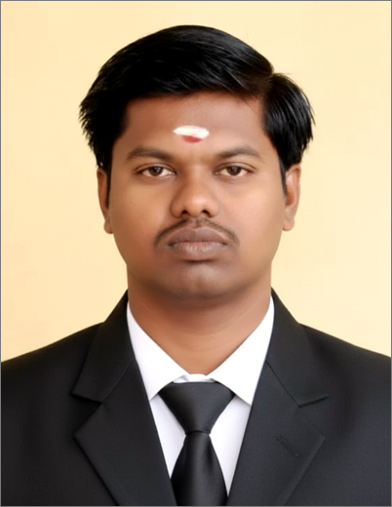

Dr.R.D.Sivakumar
Assistant Professor (Senior Grade)
Mepco Schlenk Engineering College, Sivakasi
Dr.R.D.Sivakumar, Assistant Professor (Sr. Grade), PG Department of Computer Applications, Mepco Schlenk Engineering College, Sivakasi - 626 005. Virudhunagar District, Tamil Nadu, india.
sivakumar@mepcoeng.ac.in
https://www.mepcoeng.ac.in/sivakumarrd

