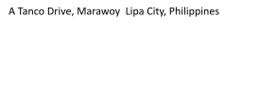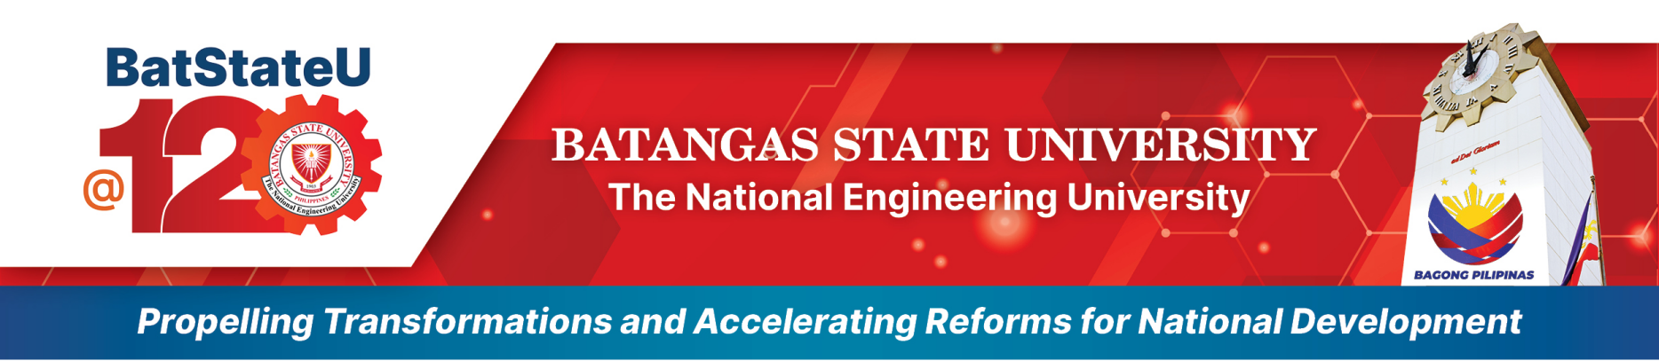

College of Informatics and Computing Sciences

MEMORANDUM OF AGREEMENT (MOA)

Date: November 27, 2023

ToWhomItMayConcern,

This Memorandum of Agreement (MOA) serves as an acknowledgment that Jennifer C. Ritual has selected ORVS as its partner for Online Ordering and Viewing System.

We, ORVS, hereby accept the responsibility and privilege of serving as your partner for the aforementioned project. We are committed to providing our expertise and resources to ensure the successful development and implementation of the Online Library Book Reservation System to meet your needs and expectations.

This MOA signifies our joint commitment to this partnership and the project's objectives. We will work together closely to define the project's details.

We look forward to a productive and collaborative partnership. If you have any questions or require further clarification, please do not hesitate to contact us at [21-32259@g.batstate-u.edu.ph.](mailto:21-32259@g.batstate-u.edu.ph.)

Sincerely,

Jun Mark C. Ritual

*Lead Developer of ORVS*

Miko Jasper M. Salangsang

Co-Developer of ORVS

Cedrick Jhon Fiestada

Co-Developer of ORVS

Accepted by:

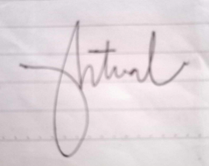

Mrs. Jennifer C. Ritual

*Sisterakas Restaurant Owner*

November 27, 2023