**Domain Class Diagrams and Database Design for Team 3**

**Team Members Participating:**

|  |
| --- |
| **Carlos Mo** |
| **Igor Naperkovskiy** |
| **Joao Rodrigues** |
| **Minna Lin** |

Table of Contents

Class Diagram 1 “Product, Category, Supplier, Invoice and Purchase Order” 3

Class Diagram 2 “Profile” 4

Database Design Part 1 5

Database Design Part 2 6

# Class Diagram 1 “Product, Category, Supplier, Invoice and Purchase Order”

**Description of what this diagram covers**: *data and relationships between the main classes in the system.*

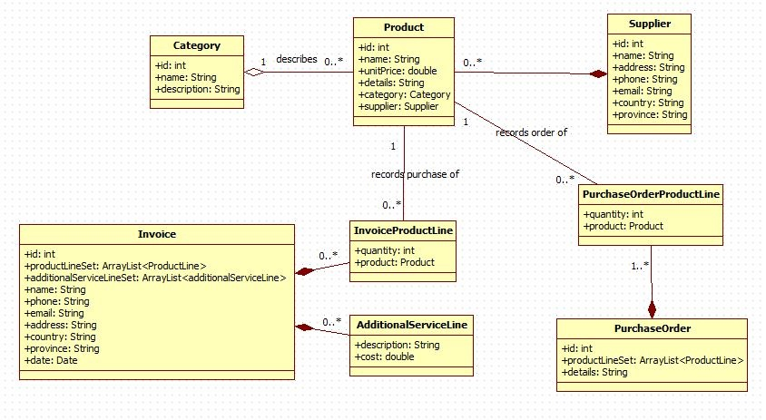

# Class Diagram 2 “Profile”

**Description of what this diagram covers:** *user account details*

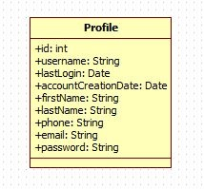

# Database Design Part 1

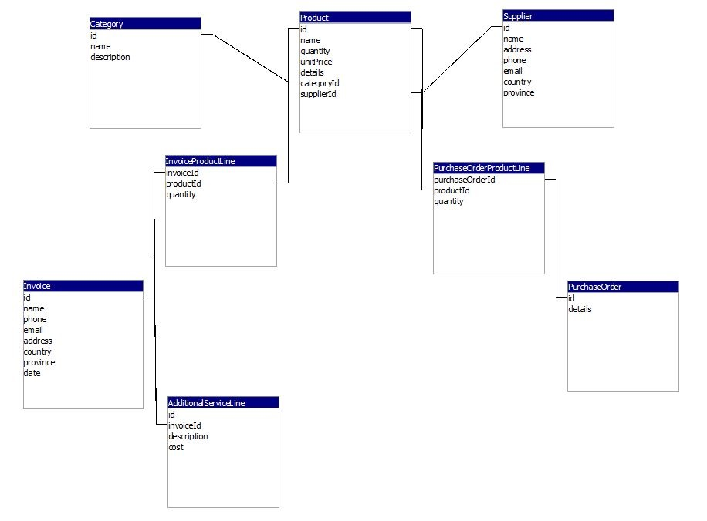

# Database Design Part 2

