|  |
| --- |
| New Town Cabinetry |
| Requirements Document |
| Team 3  Submitted:July 31, 2015 |

|  |
| --- |
| Created By: |
| Minna Lin |
| Carlos Mo |
| Joao Rodrigues |
| Igor Naperkovskiy |

Contents

1 Project Proposal 11

1.1 Team Skill/Experience Inventory: 11

1.2 Client or Mentor: 11

1.3 Brief description of required system: 11

1.4 Description of any Technological Constraints: 11

1.5 Key System Components: 11

1.6 Context Diagram(s): 13

2 The Business Problem 16

2.1 The Business 16

2.2 Problem Statement 17

3 Stakeholders 17

4 Business Rules 17

6 Use Case Specifications 23

6.1 Use Case Name: Manage Product 23

6.1.1 Author: Igor Naperkovskiy, Joao Rodrigues, Carlos Mo, Minna Lin 23

6.1.2 Actor(s) 23

6.1.3 Use Case Preconditions 23

6.1.4 Use Case Successful Post Conditions 23

6.1.5 Main Flow: 23

6.1.6 Alternate Flows 23

6.2 Use Case Name: Add Product 24

6.2.1 Author: Igor Naperkovskiy, Joao Rodrigues, Carlos Mo, Minna Lin 24

6.2.2 Actor(s) 24

6.2.3 Use Case Preconditions 24

6.2.4 Use Case Successful Post Conditions 24

6.2.5 Applicable Business Rules 24

6.2.6 Main Flow: 24

6.2.7 Alternate Flows 24

6.3 Use Case Name View Product 25

6.3.1 Author: Igor Naperkovskiy, Joao Rodrigues, Carlos Mo, Minna Lin 25

6.3.2 Actor(s) : 25

6.3.3 Use Case Preconditions 25

6.3.4 Use Case Successful Post Conditions 25

6.3.5 Applicable Business Rules 25

6.3.6 Main Flow: 25

6.4 Use Case Name: Edit Product 25

6.4.1 Author: Igor Naperkovskiy, Joao Rodrigues, Carlos Mo, Minna Lin 25

6.4.2 Actor(s) 25

6.4.3 Use Case Preconditions 25

6.4.4 Use Case Successful Post Conditions 25

6.4.5 Applicable Business Rules 25

6.4.6 Main Flow: 26

6.4.7 Alternate Flows 26

6.5 Use Case Name: Delete Product 26

6.5.1 Author: Igor Naperkovskiy, Joao Rodrigues, Carlos Mo, Minna Lin 26

6.5.2 Actor(s) 26

6.5.3 Use Case Preconditions 26

6.5.4 Use Case Successful Post Conditions 26

6.5.5 Applicable Business Rules 26

6.5.6 Main Flow: 27

6.5.7 Alternate Flows 27

6.6 Use Case Name: Search Product 27

6.6.1 Author: Igor Naperkovskiy, Joao Rodrigues, Carlos Mo, Minna Lin 27

6.6.2 Actor(s) 27

6.6.3 Use Case Preconditions 27

6.6.4 Use Case Successful Post Conditions 27

6.6.5 Applicable Business Rules 27

6.6.6 Main Flow: 27

6.6.7 Alternate Flows 28

6.7 Use Case Name: Add Category 28

6.7.1 Author: Igor Naperkovskiy, Joao Rodrigues, Carlos Mo, Minna Lin 28

6.7.2 Actor(s) 28

6.7.3 Use Case Preconditions 28

6.7.4 Use Case Successful Post Conditions 28

6.7.5 Applicable Business Rules 28

6.7.6 Main Flow: 28

6.7.7 Alternate Flows 28

6.8 Use Case Name View Category 29

6.8.1 Author: Igor Naperkovskiy, Joao Rodrigues, Carlos Mo, Minna Lin 29

6.8.2 Actor(s) : 29

6.8.3 Use Case Preconditions 29

6.8.4 Use Case Successful Post Conditions 29

6.8.5 Applicable Business Rules 29

6.8.6 Main Flow: 29

6.9 Use Case Name: Edit Category 29

6.9.1 Author: Igor Naperkovskiy, Joao Rodrigues, Carlos Mo, Minna Lin 29

6.9.2 Actor(s) 29

6.9.3 Use Case Preconditions 29

6.9.4 Use Case Successful Post Conditions 29

6.9.5 Applicable Business Rules 29

6.9.6 Main Flow: 29

6.9.7 Alternate Flows 30

6.10 Use Case Name: Delete Category 30

6.10.1 Author: Igor Naperkovskiy, Joao Rodrigues, Carlos Mo, Minna Lin 30

6.10.2 Actor(s) 30

6.10.3 Use Case Preconditions 30

6.10.4 Use Case Successful Post Conditions 30

6.10.5 Applicable Business Rules 30

6.10.6 Main Flow: 30

6.10.7 Alternate Flows 31

6.11 Use Case Name: Search Category 31

6.11.1 Author: Igor Naperkovskiy, Joao Rodrigues, Carlos Mo, Minna Lin 31

6.11.2 Actor(s) 31

6.11.3 Use Case Preconditions 31

6.11.4 Use Case Successful Post Conditions 31

6.11.5 Applicable Business Rules 31

6.11.6 Main Flow: 31

6.11.7 Alternate Flows 31

6.12 Use Case Name: Manage Category 32

6.12.1 Author: Igor Naperkovskiy, Joao Rodrigues, Carlos Mo, Minna Lin 32

6.12.2 Actor(s) 32

6.12.3 Use Case Preconditions 32

6.12.4 Use Case Successful Post Conditions 32

6.12.5 Main Flow: 32

6.12.6 Alternate Flows 32

6.13 Use Case Name: View Profile 32

6.13.1 Author: Igor Naperkovskiy, Joao Rodrigues, Carlos Mo, Minna Lin 32

6.13.2 Actor(s) 32

6.13.3 Use Case Preconditions 32

6.13.4 Use Case Successful Post Conditions 32

6.13.5 Applicable Business Rules 32

6.13.6 Main Flow: 33

6.14 Use Case Name: Edit Profile 33

6.14.1 Author: Igor Naperkovskiy, Joao Rodrigues, Carlos Mo, Minna Lin 33

6.14.2 Actor(s) 33

6.14.3 Use Case Preconditions 33

6.14.4 Use Case Successful Post Conditions 33

6.14.5 Applicable Business Rules 33

6.14.6 Alternate Flows 33

6.15 Use Case Name: Change Password 34

6.15.1 Author: Igor Naperkovskiy, Joao Rodrigues, Carlos Mo, Minna Lin 34

6.15.2 Actor(s) 34

6.15.3 Use Case Preconditions 34

6.15.4 Use Case Successful Post Conditions 34

6.15.5 Applicable Business Rules 34

6.15.6 Alternate Flows 34

6.16 Use Case Name: Manage Account 34

6.16.1 Author: Igor Naperkovskiy, Joao Rodrigues, Carlos Mo, Minna Lin 34

6.16.2 Actor(s) 34

6.16.3 Use Case Preconditions 35

6.16.4 Use Case Successful Post Conditions 35

6.16.5 Main Flow: 35

6.16.6 Alternate Flows 35

6.17 Use Case Name: Log In 35

6.17.1 Author: Igor Naperkovskiy, Joao Rodrigues, Carlos Mo, Minna Lin 35

6.17.2 Actor(s) 35

6.17.3 Use Case Preconditions 35

6.17.4 Use Case Successful Post Conditions 35

6.17.5 Applicable Business Rules 35

6.17.6 Alternate Flows 36

6.18 Use Case Name: Log Out 36

6.18.1 Author: Igor Naperkovskiy, Joao Rodrigues, Carlos Mo, Minna Lin 36

6.18.2 Actor(s) 36

6.18.3 Use Case Preconditions 36

6.18.4 Use Case Successful Post Conditions 36

6.18.5 Applicable Business Rules 36

6.18.6 Alternate Flows 36

6.19 Use Case Name: Forgot Password 36

6.19.1 Author: Igor Naperkovskiy, Joao Rodrigues, Carlos Mo, Minna Lin 36

6.19.2 Actor(s) 36

6.19.3 Use Case Preconditions 36

6.19.4 Use Case Successful Post Conditions 36

6.19.5 Applicable Business Rules 37

6.19.6 Alternate Flows 37

6.20 Use Case Name Create Invoice 37

6.20.1 Author: Igor Naperkovskiy, Joao Rodrigues, Carlos Mo, Minna Lin 37

6.20.2 Actor(s) 37

6.20.3 Use Case Preconditions 37

6.20.4 Use Case Successful Post Conditions 37

6.20.5 Applicable Business Rules 37

6.20.6 Main Flow: 37

6.20.7 Alternate Flows 38

6.21 Use Case Name View Invoice 38

6.21.1 Author: Igor Naperkovskiy, Joao Rodrigues, Carlos Mo, Minna Lin 38

6.21.2 Actor(s) : 38

6.21.3 Use Case Preconditions 38

6.21.4 Use Case Successful Post Conditions 38

6.21.5 Applicable Business Rules 38

6.21.6 Main Flow: 38

6.21.7 Alternate Flows 38

6.22 Use Case Name Edit Invoice 39

6.22.1 Author: Igor Naperkovskiy, Joao Rodrigues, Carlos Mo, Minna Lin 39

6.22.2 Actor(s) 39

6.22.3 Use Case Preconditions 39

6.22.4 Use Case Successful Post Conditions 39

6.22.5 Applicable Business Rules 39

6.22.6 Main Flow: 39

6.22.7 Alternate Flows 39

6.23 Use Case Name: Manage Invoice 40

6.23.1 Author: Igor Naperkovskiy, Joao Rodrigues, Carlos Mo, Minna Lin 40

6.23.2 Actor(s) 40

6.23.3 Use Case Preconditions 40

6.23.4 Use Case Successful Post Conditions 40

6.23.5 Main Flow: 40

6.23.6 Alternate Flows 40

6.24 Use Case Name: Manage Purchase Order 40

6.24.1 Author: Igor Naperkovskiy, Joao Rodrigues, Carlos Mo, Minna Lin 40

6.24.2 Actor(s) 40

6.24.3 Use Case Preconditions 40

6.24.4 Use Case Successful Post Conditions 40

6.24.5 Main Flow: 41

6.24.6 Alternate Flows 41

6.25 Use Case Name View Purchase Order 41

6.25.1 Author: Igor Naperkovskiy, Joao Rodrigues, Carlos Mo, Minna Lin 41

6.25.2 Actor(s) : 41

6.25.3 Use Case Preconditions 41

6.25.4 Use Case Successful Post Conditions 41

6.25.5 Applicable Business Rules 41

6.25.5.1 Main Flow: 41

6.26 Use Case Name Create Purchase Order 41

6.26.1 Author: Igor Naperkovskiy, Joao Rodrigues, Carlos Mo, Minna Lin 41

6.26.2 Actor(s) 41

6.26.3 Use Case Preconditions 42

6.26.4 Use Case Successful Post Conditions 42

6.26.5 Applicable Business Rules 42

6.26.6 Main Flow: 42

6.26.7 Alternate Flows 42

6.27 Use Case Name Edit Purchase Order 42

6.27.1 Author: Igor Naperkovskiy, Joao Rodrigues, Carlos Mo, Minna Lin 42

6.27.2 Actor(s) 42

6.27.3 Use Case Preconditions 42

6.27.4 Use Case Successful Post Conditions 42

6.27.5 Applicable Business Rules 43

6.27.6 Main Flow: 43

6.27.7 Alternate Flows 43

6.28 Use Case Name: Delete Purchase Order 43

6.28.1 Author: Igor Naperkovskiy, Joao Rodrigues, Carlos Mo, Minna Lin 43

6.28.2 Actor(s) 43

6.28.3 Use Case Preconditions 43

6.28.4 Use Case Successful Post Conditions 43

6.28.5 Applicable Business Rules 43

6.28.6 Main Flow: 44

6.28.7 Alternate Flows 44

6.29 Use Case Name Generate Report 44

6.29.1 Author: Igor Naperkovskiy, Joao Rodrigues, Carlos Mo, Minna Lin 44

6.29.2 Actor(s) 44

6.29.3 Use Case Preconditions 44

6.29.4 Use Case Successful Post Conditions 44

6.29.5 Applicable Business Rules 44

6.29.6 Main Flow: 44

6.29.7 Alternate Flows 44

6.30 Use Case Name Download Report 45

6.30.1 Author: Igor Naperkovskiy, Joao Rodrigues, Carlos Mo, Minna Lin 45

6.30.2 Actor(s) 45

6.30.3 Use Case Preconditions 45

6.30.4 Use Case Successful Post Conditions 45

6.30.5 Applicable Business Rules 45

6.30.6 Main Flow: 45

6.30.7 Alternate Flows 45

6.31 Use Case Name: Manage Report 45

6.31.1 Author: Igor Naperkovskiy, Joao Rodrigues, Carlos Mo, Minna Lin 45

6.31.2 Actor(s) 45

6.31.3 Use Case Preconditions 45

6.31.4 Use Case Successful Post Conditions 46

6.31.5 Main Flow: 46

6.31.6 Alternate Flows 46

6.32 Use Case Name View Supplier 46

6.32.1 Author: Igor Naperkovskiy, Joao Rodrigues, Carlos Mo, Minna Lin 46

6.32.2 Actor(s) : 46

6.32.3 Use Case Preconditions 46

6.32.4 Use Case Successful Post Conditions 46

6.32.5 Applicable Business Rules 46

6.32.5.1 Main Flow: 46

6.33 Use Case Name: Add Supplier 46

6.33.1 Author: Igor Naperkovskiy, Joao Rodrigues, Carlos Mo, Minna Lin 47

6.33.2 Actor(s) 47

6.33.3 Use Case Preconditions 47

6.33.4 Use Case Successful Post Conditions 47

6.33.5 Applicable Business Rules 47

6.33.6 Main Flow: 47

6.33.7 Alternate Flows 47

6.34 Use Case Name: Edit Supplier 47

6.34.1 Author: Igor Naperkovskiy, Joao Rodrigues, Carlos Mo, Minna Lin 47

6.34.2 Actor(s) 47

6.34.3 Use Case Preconditions 48

6.34.4 Use Case Successful Post Conditions 48

6.34.5 Applicable Business Rules 48

6.34.6 Main Flow: 48

6.34.7 Alternate Flows 48

6.35 Use Case Name: Delete Supplier 48

6.35.1 Author: Igor Naperkovskiy, Joao Rodrigues, Carlos Mo, Minna Lin 48

6.35.2 Actor(s) 48

6.35.3 Use Case Preconditions 48

6.35.4 Use Case Successful Post Conditions 48

6.35.5 Applicable Business Rules 48

6.35.6 Main Flow: 49

6.35.7 Alternate Flows 49

6.36 Use Case Name: Search Supplier 49

6.36.1 Author: Igor Naperkovskiy, Joao Rodrigues, Carlos Mo, Minna Lin 49

6.36.2 Actor(s) 49

6.36.3 Use Case Preconditions 49

6.36.4 Use Case Successful Post Conditions 49

6.36.5 Applicable Business Rules 49

6.36.6 Main Flow: 49

6.36.7 Alternate Flows 50

6.37 Use Case Name: Manage Supplier 50

6.37.1 Author: Igor Naperkovskiy, Joao Rodrigues, Carlos Mo, Minna Lin 50

6.37.2 Actor(s) 50

6.37.3 Use Case Preconditions 50

6.37.4 Use Case Successful Post Conditions 50

6.37.5 Main Flow: 50

6.37.6 Alternate Flows 50

7 Non-Functional requirements 51

# Project Proposal

## Team Skill/Experience Inventory:

*Technical skills/experience: computer languages, platforms, environments: e.g. Java, Web Services, .NET etc.*

|  |  |
| --- | --- |
| Student | Skills |
| Carlos Mo | ASP.NET, HTML, PHP, CSS, C++, Java, SQL, Oracle, Windows XP/7/8/Server2008, UNIX/Linux, Bash |
| Igor Naperkovskiy | ASP.NET, HTML, CSS, PHP, JavaScript, C, C++, Java, SQL, Oracle, Windows XP/7/8/Server2008, UNIX/Linux, Bash |
| Joao Rodrigues | ASP.NET, HTML, PHP, CSS, C++, Java, SQL, Visual Studio 2013, Oracle, Windows XP/7/8/Server2008, UNIX/Linux, Bash |
| Minna Lin | ASP.NET, HTML, CSS, PHP, C++, Java, SQL, Oracle, Windows XP/7/8/Server2008, UNIX/Linux, Bash |

## Client or Mentor:

|  |  |
| --- | --- |
| Client or Mentor’s Organization | New Town Cabinetry (NTC) |
| Client or Mentor’s name and contact (i.e. email address) | Harley Lin  [harleylin@yahoo.com](mailto:harleylin@yahoo.com) |
| Client or Mentor’s position (e.g. owner, professor, etc.) | Owner |

## Brief description of required system:

The proposed system will allow the NTC manager to generate purchase orders, customer invoices, and monthly financial reports. There will also be a search function for suppliers and products. Generated documents will be stored online so that the client may access them from mobile devices.

## Description of any Technological Constraints:

Must be web-based and compatible with mobile browsers.

## Key System Components:

**Supplier Management Module**

This component will allow NTC to view and edit suppliers. Functions include:

* View suppliers
* Add supplier
* Edit supplier
* Delete supplier
* Search suppliers

**Product Management Module**

This component will allow NTC to view and edit products. Functions include:

* View products
* Add products
* Delete product
* Edit product
* Search products

**Category Management Module**

This component will allow NTC to view and add product categories. Functions include:

* View category
* Add category
* Edit category
* Delete category
* Search category

**Purchase Order Management Module**

This component will allow NTC to view and generate purchase orders. Functions include:

* View purchase orders
* Create purchase order
* Edit purchase order
* Delete purchase order

**Invoice Management Module**

This component will allow NTC to view and generate customer invoices. Functions include:

* View invoices
* Edit invoice
* Modify invoice
* Delete invoice

**Report Management Module**

This component will generate monthly financial reports based on purchase orders and invoices. Functions include:

* Generate report
* Download report

**Account Management Module**

This component will allow for the manager to create, view, modify and delete, log in and out.

Function include:

- View profile

- Edit Profile

- Change Password

- Forgot Password

- Log in

- Log out

## Context Diagram(s):

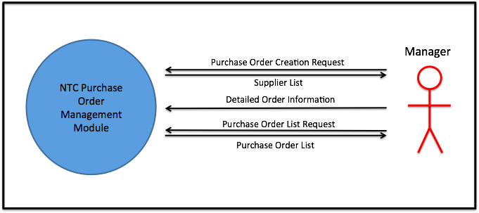

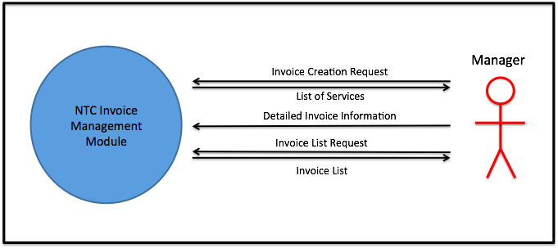

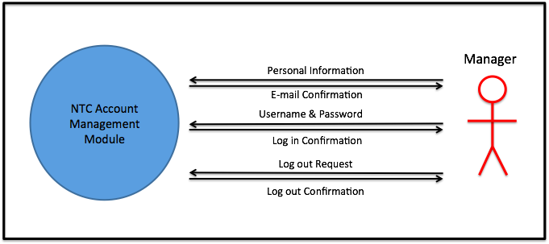

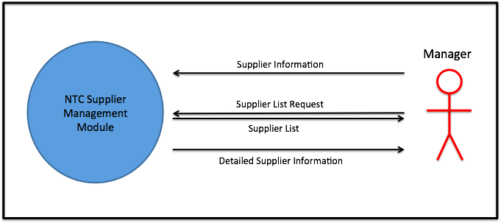

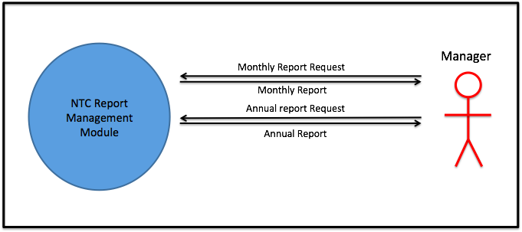

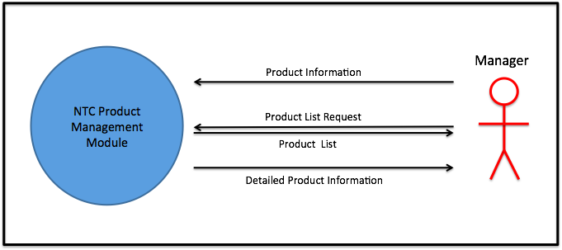

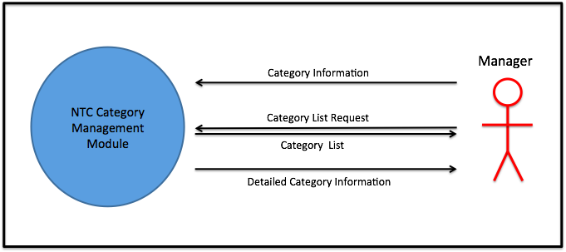

# The Business Problem

## The Business

New Town Cabinetry is a privately owned store located in Newmarket, Ontario. It sells kitchen and bathroom renovation items such as cabinets, counter tops, and sinks. Services include designing and installation.

## Problem Statement

Issue:

As of now New Town Cabinetry’s way of organizing product information is via spreadsheets. This system is causing the company to take too long looking for information, which ultimately affects not only the owner and employees but also the customers.

Vision:

The vision for the company is an online invoice management system. The system will support the owner to view products and their information, suppliers, and order information with a login system that will only allow the owner to view these details. The system will support the company’s management team to manage orders, look up information, and ultimately save time with a search option integrated into the program.

# Stakeholders

|  |  |  |  |  |
| --- | --- | --- | --- | --- |
| **Stakeholder** | **Role** | **Power (L/M/H)** | **Interest  (L/M/H)** | **Opposition (L/M/H/none)** |
| NTC Owner, Harley Lin | Sponsor & Authority, end user | H | H | none |
| Developers | Technical Expert | M | H | none |
| Customers | Customer | L | L | none |
| Suppliers | Supplier | L | L | none |
|  |  |  |  |  |
|  |  |  |  |  |
|  |  |  |  |  |

# Business Rules

|  |  |
| --- | --- |
|  | Description |
|  | Manager must be logged in to access the system. |
|  | Products registered must have suppliers. |
|  | Invoice will only be created for a customer |
|  |  |
|  |  |
|  |  |

1. **System Use Case Diagram (s)**

**NTC Supplier Management Module**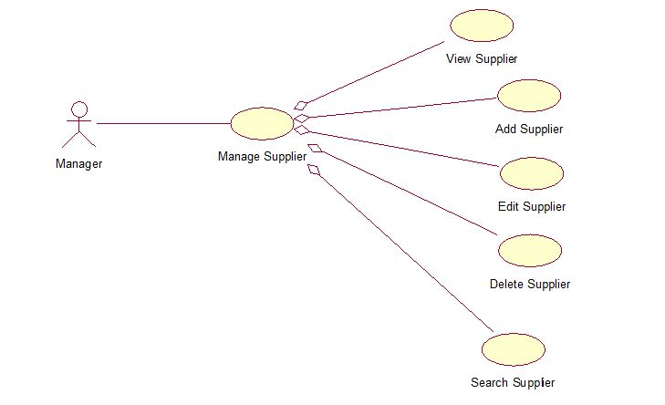

**NTC Product Management Module**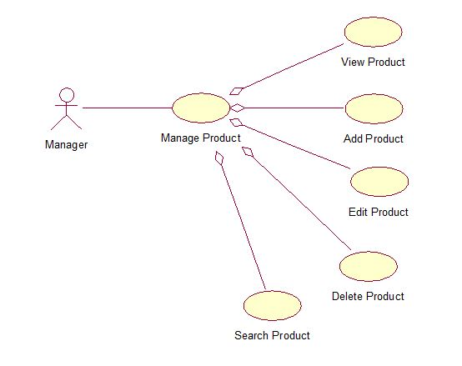

**NTC Category Management Module**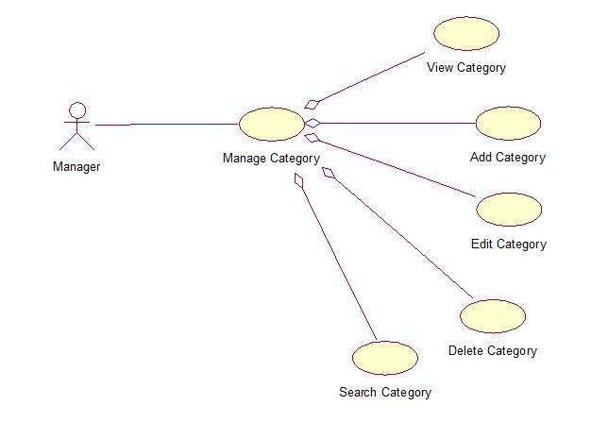

**NTC Report Management Module**

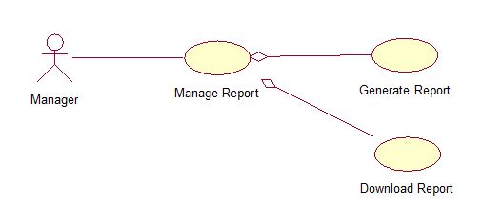

**NTC Account Management Module**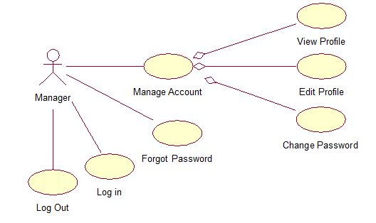

**NTC Invoice Management Module**

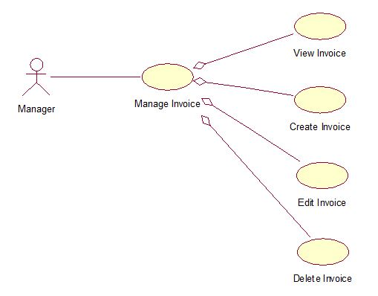

**NTC Purchase Order Management Module**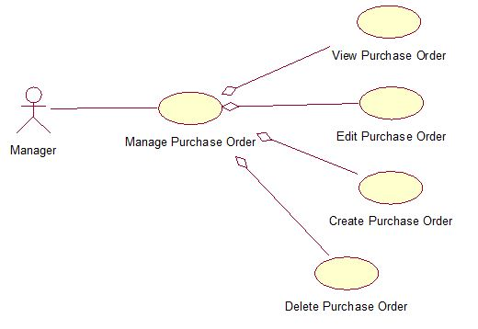

# Use Case Specifications

## Use Case Name: Manage Product

Manager uses this system to view, add, edit, delete and search products

### Author: Igor Naperkovskiy, Joao Rodrigues, Carlos Mo, Minna Lin

### Actor(s)

* Manager

### Use Case Preconditions

* User has to be logged in to the system.

### Use Case Successful Post Conditions

* User manages product

### Main Flow:

|  |  |  |
| --- | --- | --- |
|  | Actor(s): Manager | System |
| 1 |  | System shows a manage product view |
| 2 | The actor selects an option and the appropriate use case is initiated:  View: View product  Add: Add product  Edit: Edit product  Delete: Delete product  Search: Search product |  |

### Alternate Flows

|  |  |  |
| --- | --- | --- |
|  | Alternate Flow | Description |
| A2 | Actor selects to log out | User logs out of system |

## 

## Use Case Name: Add Product

Manager uses this system to add new products

### Author: Igor Naperkovskiy, Joao Rodrigues, Carlos Mo, Minna Lin

### Actor(s)

* Manager

### Use Case Preconditions

* User has to be logged in to the system.

### Use Case Successful Post Conditions

* Product is added to the database

### Applicable Business Rules

* Product has to have a supplier

### Main Flow:

|  |  |  |
| --- | --- | --- |
|  | Actor(s): Manager | System |
| 1 | Select product category from list | Displays list of suppliers in that category |
| 2 | Select supplier from the list | System shows detailed supplier information (Name, ID, Address, Phone Number, E-mail) and existing products for that supplier |
| 3 | Select add new product | Displays the form for adding a new product |
| 4 | Enter product information | Validate product information |
| 5 |  | Redisplay product information |
| 6 |  | Request confirmation |
| 7 | Confirm | Update database. Display manage products page and acknowledgement message |

### Alternate Flows

|  |  |  |
| --- | --- | --- |
|  | Alternate Flow | Description |
| A1 | No suppliers for product category | Actor will invoke the Add Supplier use case |
| A4 | Invalid product information | System will provide the specific error message and will not allow to submit the form until it is clear of error messages |
| A4 | Duplicate product ID’s | System will go back to the form, repopulate the fields and give the error massage that the product already exists |
| A5 | Actor does not confirm | System displays the form and repopulates the fields |
| A5 | Actor selects to exit | System displays the main page and does not save the form |

## 

## Use Case Name View Product

Manager uses this system to view supplier list

### Author: Igor Naperkovskiy, Joao Rodrigues, Carlos Mo, Minna Lin

### Actor(s) :

* Manager

### Use Case Preconditions

* User has to be logged in to the system.
* User must be in the Manager Supplier and Products page
* There must be products populated on the products list

### Use Case Successful Post Conditions

* Products list is viewable

### Applicable Business Rules

* Product must be in the system

### Main Flow:

|  |  |  |
| --- | --- | --- |
|  | Actor(s): Manager | System |
| 1 | Manager selects a product | System displays product info |

## Use Case Name: Edit Product

Manager uses this system to update existing supplier products

### Author: Igor Naperkovskiy, Joao Rodrigues, Carlos Mo, Minna Lin

### Actor(s)

* Manager

### Use Case Preconditions

* User has to be logged in to the system.

### Use Case Successful Post Conditions

* Product is updated

### Applicable Business Rules

* Product has to have a supplier
* Product has to exist in the database

### Main Flow:

|  |  |  |
| --- | --- | --- |
|  | Actor(s): Manager | System |
| 1 |  | Displays list of all supplier products, suppliers and product categories from database |
| 2 | Selects a supplier | Display products that belong to that supplier |
| 3 | Select product category | Displays all the products in that category |
| 4 | Select product | Display edit form with fields populated with info about that product |
| 5 | Edit’s required information | Validate product information |
|  |  | Redisplay product information |
| 6 |  | Request confirmation |
| 7 | Confirm | Update database. Display manage products page and acknowledgement message |

### Alternate Flows

|  |  |  |
| --- | --- | --- |
|  | Alternate Flow | Description |
| A5 | Invalid product information | System will provide the specific error message and will not allow to submit the form until it is clear of error messages |
| A5 | Duplicate product information | System will display the warning message that fields have not been edited |
| A7 | Actor does not confirm | System displays the form and repopulates the fields |
| A8 | Actor selects to exit | System displays the main page and does not save the form |

## Use Case Name: Delete Product

Manager uses this system to delete a supplier

### Author: Igor Naperkovskiy, Joao Rodrigues, Carlos Mo, Minna Lin

### Actor(s)

* Manager

### Use Case Preconditions

* User has to be logged in to the system.

### Use Case Successful Post Conditions

* Product is deleted from database

### Applicable Business Rules

* Product must be in the database
* Product must be associated to a supplier

### Main Flow:

|  |  |  |
| --- | --- | --- |
|  | Actor(s): Manager | System |
| 2 | Select product from the list | System shows detailed product information |
| 3 | Select ‘Delete’ | Request confirmation |
| 4 | Confirm | Update database. Display manage suppliers and products page and acknowledgement message |

### Alternate Flows

|  |  |  |
| --- | --- | --- |
|  | Alternate Flow | Description |
| A3 | Actor selects to exit | System displays the suppliers and products page |
| A4 | Actor does not confirm | System displays the delete supplier page |

## 

## Use Case Name: Search Product

Manager uses this in order to search

### Author: Igor Naperkovskiy, Joao Rodrigues, Carlos Mo, Minna Lin

### Actor(s)

* Manager

### Use Case Preconditions

* User has to be logged in to the system.
* User must be on a page that contains an active search bar

### Use Case Successful Post Conditions

* Search parameter is displayed

### Applicable Business Rules

* Product must be in the database
* Product must be associated to a supplier
* Search parameters must not contain illegal characters

### Main Flow:

|  |  |  |
| --- | --- | --- |
|  | Actor(s): Manager | System |
| 2 | Type search parameters |  |
|  | Selects ‘Product’ from drop down menu |  |
| 3 | Selects ‘Go’ | System searches for specified parameters within the database filtering results by product only |
| 4 |  | System displays result |

### Alternate Flows

|  |  |  |
| --- | --- | --- |
|  | Alternate Flow | Description |
| A3 | Search cannot find any results | System notifies user that parameters could not be found |
| A3 | Search contains illegal characters | System notifies user and does not search parameters |
| A3 | Actor does not confirm search | System does not search parameters |

## 

## Use Case Name: Add Category

Manager uses this system to add new categories

### Author: Igor Naperkovskiy, Joao Rodrigues, Carlos Mo, Minna Lin

### Actor(s)

* Manager

### Use Case Preconditions

* User has to be logged in to the system.

### Use Case Successful Post Conditions

* Category is added to the database

### Applicable Business Rules

* Category must be utilized in company

### Main Flow:

|  |  |  |
| --- | --- | --- |
|  | Actor(s): Manager | System |
| 1 | Select add new category | Displays the form for adding a new category |
| 2 | Enter category information | Validate category information |
| 3 |  | Redisplay category information |
| 4 |  | Request confirmation |
| 5 | Confirm | Update database. Display manage categories page and acknowledgement message |

### Alternate Flows

|  |  |  |
| --- | --- | --- |
|  | Alternate Flow | Description |
| A2 | Invalid product information | System will provide the specific error message and will not allow to submit the form until it is clear of error messages |
| A5 | Actor does not confirm | System displays the form and repopulates the fields |
| A5 | Actor selects to exit | System displays the main page and does not save the form |

## 

## Use Case Name View Category

Manager uses this system to view category list

### Author: Igor Naperkovskiy, Joao Rodrigues, Carlos Mo, Minna Lin

### Actor(s) :

* Manager

### Use Case Preconditions

* User has to be logged in to the system.
* User must be in the Manager Supplier and Products page
* There must be categories populated in the categories list

### Use Case Successful Post Conditions

* Category details is viewable.

### Applicable Business Rules

* Category must be in the system

### Main Flow:

|  |  |  |
| --- | --- | --- |
|  | Actor(s): Manager | System |
| 1 | Manager selects a category | System displays category details. |

## Use Case Name: Edit Category

Manager uses this system to update existing category

### Author: Igor Naperkovskiy, Joao Rodrigues, Carlos Mo, Minna Lin

### Actor(s)

* Manager

### Use Case Preconditions

* User has to be logged in to the system.

### Use Case Successful Post Conditions

* Category is updated

### Applicable Business Rules

* Category has to exist in the database

### Main Flow:

|  |  |  |
| --- | --- | --- |
|  | Actor(s): Manager | System |
| 1 |  | Displays list of all supplier products, suppliers and product categories from database |
| 2 | Select category | Display edit form with fields populated with info about that category |
| 3 | Edit’s required information | Validate category information |
| 4 |  | Redisplay category information |
| 5 |  | Request confirmation |
| 6 | Confirm | Update database. Display manage products page and acknowledgement message |

### Alternate Flows

|  |  |  |
| --- | --- | --- |
|  | Alternate Flow | Description |
| A5 | Invalid category information | System will provide the specific error message and will not allow to submit the form until it is clear of error messages |
| A5 | Duplicate category information | System will display the warning message that fields have not been edited |
| A7 | Actor does not confirm | System displays the form and repopulates the fields |
| A8 | Actor selects to exit | System displays the main page and does not save the form |

## 

## Case Name: Delete Category

Manager uses this system to delete a category

### Author: Igor Naperkovskiy, Joao Rodrigues, Carlos Mo, Minna Lin

### Actor(s)

* Manager

### Use Case Preconditions

* User has to be logged in to the system.

### Use Case Successful Post Conditions

* Category is deleted from database

### Applicable Business Rules

* Category must be in the database

### Main Flow:

|  |  |  |
| --- | --- | --- |
|  | Actor(s): Manager | System |
| 2 | Select category from the list | System shows detailed category information and products associated with it |
| 3 | Select ‘Delete’ | Request confirmation |
| 4 | Confirm | Update database. Display manage suppliers and products page and acknowledgement message |

### Alternate Flows

|  |  |  |
| --- | --- | --- |
|  | Alternate Flow | Description |
| A3 | Actor selects to exit | System displays the suppliers and products page |
| A4 | Actor does not confirm | System displays the delete supplier page |

## 

## Use Case Name: Search Category

Manager uses this in order to search

### Author: Igor Naperkovskiy, Joao Rodrigues, Carlos Mo, Minna Lin

### Actor(s)

* Manager

### Use Case Preconditions

* User has to be logged in to the system.
* User must be on a page that contains an active search bar

### Use Case Successful Post Conditions

* Search parameter is displayed

### Applicable Business Rules

* Category must be in the database
* Search parameters must not contain illegal characters

### Main Flow:

|  |  |  |
| --- | --- | --- |
|  | Actor(s): Manager | System |
| 2 | Type search parameters |  |
|  | Selects ‘Category’ from drop down menu |  |
| 3 | Selects ‘Go’ | System searches for specified parameters within the database filtering results by product only |
| 4 |  | System displays result |

### Alternate Flows

|  |  |  |
| --- | --- | --- |
|  | Alternate Flow | Description |
| A3 | Search cannot find any results | System notifies user that parameters could not be found |
| A3 | Search contains illegal characters | System notifies user and does not search parameters |
| A3 | Actor does not confirm search | System does not search parameters |

## 

## Use Case Name: Manage Category

Manager uses this to manage categories

### Author: Igor Naperkovskiy, Joao Rodrigues, Carlos Mo, Minna Lin

### Actor(s)

* Manager

### Use Case Preconditions

* User has to be logged in to the system.

### Use Case Successful Post Conditions

* User manages categories

### Main Flow:

|  |  |  |
| --- | --- | --- |
|  | Actor(s): Manager | System |
| 1 |  | System displays a view for Manage Category |
| 2 | Manager selects an option and the appropriate use case is initiated:  View Category  Edit Category  Delete Category  Add Category  Search Category |  |

### Alternate Flows

|  |  |  |
| --- | --- | --- |
|  | Alternate Flow | Description |
| A1 | Log out | User logs out of the system |

## 

## Use Case Name: View Profile

Manager uses this in order to view his own profile within the system

### Author: Igor Naperkovskiy, Joao Rodrigues, Carlos Mo, Minna Lin

### Actor(s)

* Manager

### Use Case Preconditions

* User has to be logged in to the system.

### Use Case Successful Post Conditions

* Profile information is displayed

### Applicable Business Rules

* Account must only be accessible by the manager

### Main Flow:

|  |  |  |
| --- | --- | --- |
|  | Actor(s): Manager | System |
| 1 | Manager selects ‘View Profile’ | System displays a view of the user’s profile information |

## Use Case Name: Edit Profile

Manager uses this in order to modify his own profile information

### Author: Igor Naperkovskiy, Joao Rodrigues, Carlos Mo, Minna Lin

### Actor(s)

* Manager

### Use Case Preconditions

* User has to be logged in to the system.

### Use Case Successful Post Conditions

* Password is changed

### Applicable Business Rules

* Account must only be accessible by the manager

|  |  |  |
| --- | --- | --- |
|  | Actor(s): Manager | System |
| 1 | Manager selects ‘Edit Profile’ | System displays an edit profile form |
| 2 | Manager edits profile information | Validate profile information |
| 3 |  | Redisplay profile information |
| 4 |  | Request confirmation |
| 5 | Confirm | Update database. Display profile information view |

### Alternate Flows

|  |  |  |
| --- | --- | --- |
|  | Alternate Flow | Description |
| A2 | Invalid profile information | System will provide the specific error message and will not allow to submit the form until it is clear of error messages |
| A5 | Actor does not confirm | System displays the form and repopulates the fields |
| A6 | Actor selects to exit | System displays the supplier and categories page and does not save the form |

## Use Case Name: Change Password

Manager uses this in order to change account password

### Author: Igor Naperkovskiy, Joao Rodrigues, Carlos Mo, Minna Lin

### Actor(s)

* Manager

### Use Case Preconditions

* User has to be logged in to the system.

### Use Case Successful Post Conditions

* Information is modified

### Applicable Business Rules

* Account must only be accessible by the manager

|  |  |  |
| --- | --- | --- |
|  | Actor(s): Manager | System |
| 1 | Manager selects ‘Change Password’ | System displays a view of the user’s profile information |
| 2 | Manager enters old password | Validate profile information |
| 3 | Manager enters new password | Redisplay profile information |
| 4 | Manager re-enters new password | Request confirmation |
| 5 | Manager presses confirm | Validate entered passwords |
| 6 |  | Display new password confirmation message |
| 7 |  | Request confirmation |
| 8 | Confirm | Display success message |
| 9 |  | Email user about password change |

### Alternate Flows

|  |  |  |
| --- | --- | --- |
|  | Alternate Flow | Description |
| A2 | Invalid old password | System will notify user and won’t change to new password |
| A4 | Invalid re-entry of new password | System displays error message and won’t change password |
| A5 | Invalid characters used | System notifies user about invalid characters |
| A6 | Actor selects to exit | System displays the View Profile |

## Use Case Name: Manage Account

Manager uses this to manage his/her account

### Author: Igor Naperkovskiy, Joao Rodrigues, Carlos Mo, Minna Lin

### Actor(s)

* Manager

### Use Case Preconditions

* User has to be logged in to the system.

### Use Case Successful Post Conditions

* User manages account

### Main Flow:

|  |  |  |
| --- | --- | --- |
|  | Actor(s): Manager | System |
| 1 |  | System displays a view for Manage Account |
| 2 | Manager selects an option and the appropriate use case is initiated:  View Profile  Edit Profile  Change Password |  |

### Alternate Flows

|  |  |  |
| --- | --- | --- |
|  | Alternate Flow | Description |
| A1 | Log out | User logs out of the system |

## 

## Use Case Name: Log In

Manager uses this in order to log into system

### Author: Igor Naperkovskiy, Joao Rodrigues, Carlos Mo, Minna Lin

### Actor(s)

* Manager

### Use Case Preconditions

* User has to be part of the system.

### Use Case Successful Post Conditions

* Information is modified

### Applicable Business Rules

* Account must only be accessible by the manager

|  |  |  |
| --- | --- | --- |
|  | Actor(s): Manager | System |
| 1 |  | System displays a log in view |
| 2 | Manager enters user name |  |
| 3 | Manager enters password |  |
| 4 | Manager presses confirm | Validate entered credentials |
| 5 |  | Log into system |

### Alternate Flows

|  |  |  |
| --- | --- | --- |
|  | Alternate Flow | Description |
| A2 | Invalid user name/password | System will notify user and won’t log in |

## Use Case Name: Log Out

Manager uses this in order to log out of account

### Author: Igor Naperkovskiy, Joao Rodrigues, Carlos Mo, Minna Lin

### Actor(s)

* Manager

### Use Case Preconditions

* User has to be logged in to the system.

### Use Case Successful Post Conditions

* User logs out of system

### Applicable Business Rules

* Account must only be accessible by the manager

|  |  |  |
| --- | --- | --- |
|  | Actor(s): Manager | System |
| 1 | Manager selects ‘Log out’ | System requests confirmation |
| 2 | Confirm | System logs user out |

### Alternate Flows

|  |  |  |
| --- | --- | --- |
|  | Alternate Flow | Description |
| A1 | Actor does not select log out | Account will remain active |
| A2 | Actor does not confirm log out request | Account will remain active |

## Use Case Name: Forgot Password

Manager uses this if password is forgotten

### Author: Igor Naperkovskiy, Joao Rodrigues, Carlos Mo, Minna Lin

### Actor(s)

* Manager

### Use Case Preconditions

* User has to be part of the system
* User isn’t logged in

### Use Case Successful Post Conditions

* User receives email with temporary password

### Applicable Business Rules

* Account must only be accessible by the manager

|  |  |  |
| --- | --- | --- |
|  | Actor(s): Manager | System |
| 1 | User selects ‘Forgot Password’ | System displays the forgot password view |
| 2 | Manager enters email |  |
| 3 | Confirm | Validate email information |
| 4 |  | System sends email to user |
| 5 |  | System returns to log in view |

### 

### Alternate Flows

|  |  |  |
| --- | --- | --- |
|  | Alternate Flow | Description |
| A2 | Invalid email | System will not email user |
| A3 | Actor selects to exit | System returns to log in view |

## Use Case Name Create Invoice

Manager uses this system to create invoices for customers

### Author: Igor Naperkovskiy, Joao Rodrigues, Carlos Mo, Minna Lin

### Actor(s)

* Manager

### Use Case Preconditions

* User has to be logged in to the system.

### Use Case Successful Post Conditions

* Invoice is created

### Applicable Business Rules

* Invoice will only be created for a customer

### Main Flow:

|  |  |  |
| --- | --- | --- |
|  | Actor(s): Manager | System |
| 1 |  | Displays the form for a new invoice. |
| 2 | Manager enters customer information (Name, Address, Phone# E-mail) and date |  |
| 3 | Add Products | Summary updates subtotal, tax and total |
| 4 | Add additional services details and price | Summary updates subtotal, tax and total |
| 5 | Confirm | Validate invoice information |
| 6 |  | Redisplay invoice information |
| 7 |  | Request confirmation |
| 8 |  | Update database. Display Invoices page and acknowledgement message |

### Alternate Flows

|  |  |  |
| --- | --- | --- |
|  | Alternate Flow | Description |
| A5 | Actor does not confirm | System displays the form and repopulates the fields |
| A6 | Actor selects to exit | System displays the purchase orders page and does not save the form |

## Use Case Name View Invoice

Manager uses this system to view invoices

### Author: Igor Naperkovskiy, Joao Rodrigues, Carlos Mo, Minna Lin

### Actor(s) :

* Manager

### Use Case Preconditions

* User has to be logged in to the system.

### Use Case Successful Post Conditions

* Invoice is viewable in .PDF format

### Applicable Business Rules

* Invoice must have a customer

### Main Flow:

|  |  |  |
| --- | --- | --- |
|  | Actor(s): Manager | System |
| 1 | Manager selects ‘View’ | Displays the PDF file for chosen invoice |

### Alternate Flows

|  |  |  |
| --- | --- | --- |
|  | Alternate Flow | Description |
| A5 | Actor does not confirm | System displays the form and repopulates the fields |
| A6 | Actor selects to exit | System displays the purchase orders page and does not save the form |

## Use Case Name Edit Invoice

Manager uses this system to modify existing invoices for customers

### Author: Igor Naperkovskiy, Joao Rodrigues, Carlos Mo, Minna Lin

### Actor(s)

* Manager

### Use Case Preconditions

* User has to be logged in to the system.
* Invoice has to exist

### Use Case Successful Post Conditions

* Invoice is edited

### Applicable Business Rules

* Invoice will only be created for a customer

### Main Flow:

|  |  |  |
| --- | --- | --- |
|  | Actor(s): Manager | System |
| 1 |  | System displays a list of already created invoices and customers |
| 2 | Manager selects a customer | System will display a list of invoices that belong to the customer sorted by Date |
| 3 | Manager selects the invoice | System displays an edit form with fields populated |
| 4 | Manager edits the fields and submits | System validates the information |
| 5 |  | Redisplays invoice information |
| 6 |  | Requests confirmation |
| 7 | Manager confirms | Update database. Displays manage invoice page and acknowledgement message |

### Alternate Flows

|  |  |  |
| --- | --- | --- |
|  | Alternate Flow | Description |
| A4 | Invalid invoice information | System signals error(s) to the manager and prompts re-entry |
| A4 | Duplicate invoice information | System will display the warning message that fields have not been edited |
| A7 | Manager does not confirm | System returns to the confirmation page and repopulates the fields |
| A8 | Manager selects exit | System returns to the main page |

## Use Case Name: Manage Invoice

Manager uses this to manage invoice

### Author: Igor Naperkovskiy, Joao Rodrigues, Carlos Mo, Minna Lin

### Actor(s)

* Manager

### Use Case Preconditions

* User has to be logged in to the system.

### Use Case Successful Post Conditions

* User manages invoices

### Main Flow:

|  |  |  |
| --- | --- | --- |
|  | Actor(s): Manager | System |
| 1 |  | System displays a view for Manage Invoice |
| 2 | Manager selects an option and the appropriate use case is initiated:  View Invoice  Create Invoice  Edit Invoice  Delete Invoice |  |

### Alternate Flows

|  |  |  |
| --- | --- | --- |
|  | Alternate Flow | Description |
| A1 | Log out | User logs out of the system |

## 

## Use Case Name: Manage Purchase Order

Manager uses this system to view, create and edit a purchase order

### Author: Igor Naperkovskiy, Joao Rodrigues, Carlos Mo, Minna Lin

### Actor(s)

* Manager

### Use Case Preconditions

* User has to be logged in to the system.

### Use Case Successful Post Conditions

* User manages purchase order

### Main Flow:

|  |  |  |
| --- | --- | --- |
|  | Actor(s): Manager | System |
| 1 |  | System shows a manage product view |
| 2 | The actor selects an option and the appropriate use case is initiated:  View: View purchase order  Create: Add product  Edit: Edit product |  |

### Alternate Flows

|  |  |  |
| --- | --- | --- |
|  | Alternate Flow | Description |
| A2 | Actor selects to log out | User logs out of system |

## 

## Use Case Name View Purchase Order

Manager uses this system to view purchase orders.

### Author: Igor Naperkovskiy, Joao Rodrigues, Carlos Mo, Minna Lin

### Actor(s) :

* Manager

### Use Case Preconditions

* User has to be logged in to the system.
* User must be in the purchase orders page
* There must be purchase orders populated in the purchase orders list

### Use Case Successful Post Conditions

* Purchase order details is viewable.

### Applicable Business Rules

* Purchase order must be in the system.

### Main Flow:

|  |  |  |
| --- | --- | --- |
|  | Actor(s): Manager | System |
| 1 | Manager selects a purchase order | System displays purchase order details. |

## Use Case Name Create Purchase Order

Manager uses this system to create a purchase order.

### Author: Igor Naperkovskiy, Joao Rodrigues, Carlos Mo, Minna Lin

### Actor(s)

* Manager

### Use Case Preconditions

* User has to be logged in to the system.

### Use Case Successful Post Conditions

* Purchase order is created.

### Applicable Business Rules

* Each purchase order may only contain products from one supplier.

### Main Flow:

|  |  |  |
| --- | --- | --- |
|  | Actor(s): Manager | System |
| 1 |  | Displays the form for a new purchase order. |
| 2 | Manager enters purchase order information (supplier, products, quantities) | Validate purchase order information. |
| 3 |  | Redisplay purchase order information |
| 4 |  | Request confirmation |
| 5 | Confirm | Update database. Display purchase orders page and acknowledgement message |

### Alternate Flows

|  |  |  |
| --- | --- | --- |
|  | Alternate Flow | Description |
| A2 | Invalid purchase order quantities | System will provide the specific error message and will not allow to submit the form until it is clear of error messages |
| A5 | Actor does not confirm | System displays the form and repopulates the fields |
| A6 | Actor selects to exit | System displays the purchase orders page and does not save the form |

## 

## Use Case Name Edit Purchase Order

Manager uses this system to edit a purchase order.

### Author: Igor Naperkovskiy, Joao Rodrigues, Carlos Mo, Minna Lin

### Actor(s)

* Manager

### Use Case Preconditions

* User has to be logged in to the system.

### Use Case Successful Post Conditions

* Purchase order is updated.

### Applicable Business Rules

* Purchase order

### Main Flow:

|  |  |  |
| --- | --- | --- |
|  | Actor(s): Manager | System |
| 1 |  | Displays the form for a purchase order with populated fields. |
| 2 | Manager edits purchase order information (supplier, products, quantities) | Validate purchase order information. |
| 3 |  | Redisplay purchase order information |
| 4 |  | Request confirmation |
| 5 | Confirm | Updates database and display purchase orders page with acknowledgement message |

### Alternate Flows

|  |  |  |
| --- | --- | --- |
|  | Alternate Flow | Description |
| A2 | Invalid purchase order quantities | System will provide the specific error message and will not allow to submit the form until it is clear of error messages |
| A5 | Actor does not confirm | System displays the form and repopulates the fields |
| A6 | Actor selects to exit | System displays the purchase orders page and does not save the form |

## Use Case Name: Delete Purchase Order

Manager uses this system to delete a purchase order

### Author: Igor Naperkovskiy, Joao Rodrigues, Carlos Mo, Minna Lin

### Actor(s)

* Manager

### Use Case Preconditions

* User has to be logged in to the system.

### Use Case Successful Post Conditions

* Purchase order is deleted from database

### Applicable Business Rules

* Purchase order must be in the database

### Main Flow:

|  |  |  |
| --- | --- | --- |
|  | Actor(s): Manager | System |
| 2 | Select purchase order from the list | System shows detailed purchase order information with suppliers, products and quantities associated with it. |
| 3 | Select ‘Delete’ | Request confirmation |
| 4 | Confirm | Update database. Display manage suppliers and products page and acknowledgement message |

### Alternate Flows

|  |  |  |
| --- | --- | --- |
|  | Alternate Flow | Description |
| A4 | Actor does not confirm | System displays the delete purchase order page. |
| A5 | Actor selects to exit | System displays the purchase orders page |

## 

## Use Case Name Generate Report

Manager uses this system to generate reports

### Author: Igor Naperkovskiy, Joao Rodrigues, Carlos Mo, Minna Lin

### Actor(s)

* Manager

### Use Case Preconditions

* User has to be logged in to the system.

### Use Case Successful Post Conditions

* New monthly/yearly report would be generated

### Applicable Business Rules

* Can only generate report for the month/year he has been in business for

### Main Flow:

|  |  |  |
| --- | --- | --- |
|  | Actor(s): Manager | System |
| 1 |  | System displays two date input fields (start and end date) |
| 2 | Manager inputs the dates | System generates a report based on the selected dates |
| 3 |  | System displays a report in PDF format |

### Alternate Flows

|  |  |  |
| --- | --- | --- |
|  | Alternate Flow | Description |
| A2 | Invalid date entry (start date cannot be before the end date) | System signals error(s) to the manager and prompts re-entry |
| A2 | Non-existent dates (inputted dates are not within the business dates of operation) | System signals error(s) to the manager and prompts re-entry |
| A4 | Manager selects exit | System returns to the main page |

## Use Case Name Download Report

Manager uses this system to download a report

### Author: Igor Naperkovskiy, Joao Rodrigues, Carlos Mo, Minna Lin

### Actor(s)

* Manager

### Use Case Preconditions

* User has to be logged in to the system.

### Use Case Successful Post Conditions

* Report would be downloaded

### Applicable Business Rules

* Report parameters must already exist in the database

### Main Flow:

|  |  |  |
| --- | --- | --- |
|  | Actor(s): Manager | System |
| 2 | Manager selects a report | System displays view and download buttons |
| 3 | Manager selects download | Report info is pulled from database, PDF view fills the blanks and is downloaded to the computer |

### Alternate Flows

|  |  |  |
| --- | --- | --- |
|  | Alternate Flow | Description |
| A4 | Manager selects exit | System returns to the main page |

## 

## Use Case Name: Manage Report

Manager uses this to manage reports

### Author: Igor Naperkovskiy, Joao Rodrigues, Carlos Mo, Minna Lin

### Actor(s)

* Manager

### Use Case Preconditions

* User has to be logged in to the system.

### Use Case Successful Post Conditions

* User manages report

### Main Flow:

|  |  |  |
| --- | --- | --- |
|  | Actor(s): Manager | System |
| 1 |  | System displays a view for Manage Report |
| 2 | Manager selects an option and the appropriate use case is initiated:  Download Report  Generate Report |  |

### Alternate Flows

|  |  |  |
| --- | --- | --- |
|  | Alternate Flow | Description |
| A1 | Log out | User logs out of the system |

## Use Case Name View Supplier

Manager uses this system to view supplier list

### Author: Igor Naperkovskiy, Joao Rodrigues, Carlos Mo, Minna Lin

### Actor(s) :

* Manager

### Use Case Preconditions

* User has to be logged in to the system.
* User must be in the Manager Supplier and Products page
* There must be suppliers populated on suppliers page

### Use Case Successful Post Conditions

* Supplier list is viewable

### Applicable Business Rules

* Supplier must be in the system

### Main Flow:

|  |  |  |
| --- | --- | --- |
|  | Actor(s): Manager | System |
| 1 | Manager selects a supplier | System displays supplier info |

## Use Case Name: Add Supplier

Manager uses this system to add new suppliers

### Author: Igor Naperkovskiy, Joao Rodrigues, Carlos Mo, Minna Lin

### Actor(s)

* Manager

### Use Case Preconditions

* User has to be logged in to the system.
* User must be in the Manager Supplier and Products page

### Use Case Successful Post Conditions

* Supplier is added to the database

### Applicable Business Rules

* Supplier must be affiliated with company

### Main Flow:

|  |  |  |
| --- | --- | --- |
|  | Actor(s): Manager | System |
| 1 |  | Displays add supplier form |
| 2 | Enter supplier information | Validate Supplier Information |
| 3 |  | Redisplay supplier information |
| 4 |  | Request confirmation |
| 5 | Confirm | Update database. Display supplier and products page and acknowledgement message |

### Alternate Flows

|  |  |  |
| --- | --- | --- |
|  | Alternate Flow | Description |
| A2 | Invalid supplier information | System will provide the specific error message and will not allow to submit the form until it is clear of error messages |
| A2 | Duplicate supplier ID’s | System will go back to the form, repopulate the fields and give the error massage that the supplier already exists |
| A5 | Actor does not confirm | System displays the form and repopulates the fields |
| A6 | Actor selects to exit | System displays the supplier and products and does not save the form |

## Use Case Name: Edit Supplier

Manager uses this system to edit supplier information

### Author: Igor Naperkovskiy, Joao Rodrigues, Carlos Mo, Minna Lin

### Actor(s)

* Manager

### Use Case Preconditions

* User has to be logged in to the system.

### Use Case Successful Post Conditions

* Supplier is updated

### Applicable Business Rules

* Supplier has to exist in the database

### Main Flow:

|  |  |  |
| --- | --- | --- |
|  | Actor(s): Manager | System |
| 1 | Selects a supplier | System displays edit supplier form with populated fields |
| 2 | Edit supplier information | Validate supplier information |
| 3 |  | Redisplay supplier information |
| 4 |  | Request confirmation |
| 5 | Confirm | Update database. Display supplier and products page and acknowledgement message |

### Alternate Flows

|  |  |  |
| --- | --- | --- |
|  | Alternate Flow | Description |
| A3 | Invalid supplier information | System will provide the specific error message and will not allow to submit the form until it is clear of error messages |
| A5 | Actor does not confirm | System displays the form and repopulates the fields |
| A6 | Actor selects to exit | System displays the supplier and products page and does not save the form |

## Use Case Name: Delete Supplier

Manager uses this system to delete a supplier

### Author: Igor Naperkovskiy, Joao Rodrigues, Carlos Mo, Minna Lin

### Actor(s)

* Manager

### Use Case Preconditions

* User has to be logged in to the system.

### Use Case Successful Post Conditions

* Supplier is deleted from database

### Applicable Business Rules

* Supplier must be in the database

### Main Flow:

|  |  |  |
| --- | --- | --- |
|  | Actor(s): Manager | System |
| 2 | Select supplier from the list | System shows detailed supplier information (Name, ID, Address, Phone Number, E-mail) and existing products for that supplier |
| 3 | Select ‘Delete’ | Displays message warning user that products associated with supplier will also be deleted |
|  |  | Request confirmation |
| 4 | Confirm | Update database. Display manage suppliers and products page and acknowledgement message |

### Alternate Flows

|  |  |  |
| --- | --- | --- |
|  | Alternate Flow | Description |
| A3 | Actor selects to exit | System displays the suppliers and products page |
| A4 | Actor does not confirm | System displays the delete supplier page |

## 

## Use Case Name: Search Supplier

Manager uses this in order to search

### Author: Igor Naperkovskiy, Joao Rodrigues, Carlos Mo, Minna Lin

### Actor(s)

* Manager

### Use Case Preconditions

* User has to be logged in to the system.
* User must be on a page that contains an active search bar

### Use Case Successful Post Conditions

* Search parameter is displayed

### Applicable Business Rules

* Supplier must be in the database
* Search parameters must not contain illegal characters

### Main Flow:

|  |  |  |
| --- | --- | --- |
|  | Actor(s): Manager | System |
| 2 | Type search parameters |  |
|  | Selects ‘Supplier’ from drop down menu |  |
| 3 | Selects ‘Go’ | System searches for specified parameters within the database filtering results by suppliers only |
| 4 |  | System displays result |

### Alternate Flows

|  |  |  |
| --- | --- | --- |
|  | Alternate Flow | Description |
| A3 | Search cannot find any results | System notifies user that parameters could not be found |
| A3 | Search contains illegal characters | System notifies user and does not search parameters |
| A3 | Actor does not confirm search | System does not search parameters |

## 

## Use Case Name: Manage Supplier

Manager uses this to manage suppliers

### Author: Igor Naperkovskiy, Joao Rodrigues, Carlos Mo, Minna Lin

### Actor(s)

* Manager

### Use Case Preconditions

* User has to be logged in to the system.

### Use Case Successful Post Conditions

* User manages supplier

### Main Flow:

|  |  |  |
| --- | --- | --- |
|  | Actor(s): Manager | System |
| 1 |  | System displays a view for Manage Supplier |
| 2 | Manager selects an option and the appropriate use case is initiated:  View Supplier  Edit Supplier  Delete Supplier  Add Supplier  Search Supplier |  |

### Alternate Flows

|  |  |  |
| --- | --- | --- |
|  | Alternate Flow | Description |
| A1 | Log out | User logs out of the system |

## 

# Non-Functional requirements

In the table below you are asked to specify the type of non-functional requirement you have identified and then describe what the requirement is and how you plan to satisfy it.

|  |  |  |
| --- | --- | --- |
|  | **Requirement Type** | **Description and Implementation Plan** |
| **1.** | Look and feel | Looks and acts like a regular website with the permission for manager to manage his business online |
| **2.** | Usability and Humanity | Usable by manager to manage his business online |
| **3.** | Performance | Has to be available 24/7 |
| **4.** | Operational | Operates on all popular browsers |
| **5.** | Security | **Access:** Only manager can access the certain areas of the website  **Privacy:** All customer and supplier information must be protected; customer and client information is not released to others  **Integrity:** All product information is accurate.  **Audit:** All sales information logged and stored; payment methods validated before acceptance. |
| **6.** | Legal | Must adhere to all Canadian tax and business legislation |