|  |
| --- |
| New Town Cabinetry |
| Requirements Document |
| Team 3  Submitted: August 12, 2015 |

|  |
| --- |
| Created By: |
| Minna Lin |
| Carlos Mo |
| Joao Rodrigues |
| Igor Naperkovskiy |

**Contents**

1 Project Proposal

1.1 Team Skill/Experience Inventory:

1.2 Client or Mentor:

1.3 Brief description of required system:

1.4 Description of any Technological Constraints:

1.5 Key System Components:

1.6 Context Diagram(s):

2 The Business Problem

2.1 The Business

2.2 Problem Statement

3 Stakeholders

4 Business Rules

5 System Use Case Diagram (s)

6 Use Case Specifications

6.1 Use Case Name

6.1.1 Author: Name

6.1.2 Actor(s)

6.1.3 Use Case Preconditions

6.1.4 Use Case Successful Post Conditions

6.1.5 Applicable Business Rules

6.1.6 Main Flow:

6.1.7 Alternate Flows

6.2 Use Case Name

7 Non-Functional requirements

# Project Proposal

## Team Skill/Experience Inventory:

*Technical skills/experience: computer languages, platforms, environments: e.g. Java, Web Services, .NET etc.*

|  |  |
| --- | --- |
| Student | Skills |
| Carlos Mo | ASP.NET, HTML, PHP, CSS, C++, Java, SQL, Oracle, Windows XP/7/8/Server2008, UNIX/Linux, Bash |
| Igor Naperkovskiy | ASP.NET, HTML, CSS, PHP, JavaScript,  Ruby on Rails, C, C++, Java, SQL, Oracle, Windows XP/7/8/Server2008, UNIX/Linux, Bash |
| Joao Rodrigues | ASP.NET, HTML, PHP, CSS, C++, Java, SQL, Visual Studio 2013, Oracle, Windows XP/7/8/Server2008, UNIX/Linux, Bash |
| Minna Lin | ASP.NET, HTML, CSS, PHP, C++, Java, SQL, Oracle, Windows XP/7/8/Server2008, UNIX/Linux, Bash |

## Client or Mentor:

|  |  |
| --- | --- |
| Client or Mentor’s Organization | New Town Cabinetry (NTC) |
| Client or Mentor’s name and contact (i.e. email address) | Harley Lin  [harleylin@yahoo.com](mailto:harleylin@yahoo.com) |
| Client or Mentor’s position (e.g. owner, professor, etc.) | Owner |

## Brief description of required system:

The proposed system will allow the NTC manager to generate purchase orders, customer invoices, and monthly financial reports. There will also be a search function for suppliers and products. Generated documents will be stored online so that the client may access them from mobile devices.

## Description of any Technological Constraints:

Must be web-based and compatible with mobile browsers.

## Key System Components:

**Supplier Management Module**

This component will allow NTC to view and modify suppliers and their products. Functions include:

* View suppliers
* Add supplier
* Modify supplier
* Delete supplier
* View products of supplier
* Add product to supplier
* Delete product
* Update product information
* Search suppliers
* Search products

**Purchase Order Management Module**

This component will allow NTC to view purchase orders and generate new ones. Functions include:

* View past purchase orders
* Create purchase order
* Modify purchase order
* Delete purchase order

**Invoice Management Module**

This component will allow NTC to view and generate customer invoices. Functions include:

* View invoices
* Create invoice
* Modify invoice
* Delete invoice

**Report Management Module**

This component will generate monthly financial reports based on purchase orders and invoices. Functions include:

* View reports
* Generate report for month
* Delete report

**Account Management Module**

This component will allow for the manager to create, view, modify and delete, log in and out.

Function include:

- View account

- Modify account information

- Delete account

- Create account

- Log in

- Log out

## Context Diagram(s):

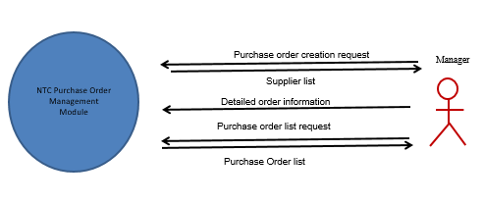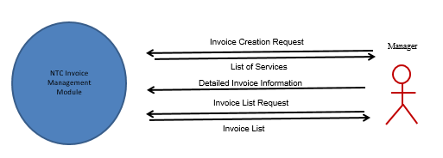 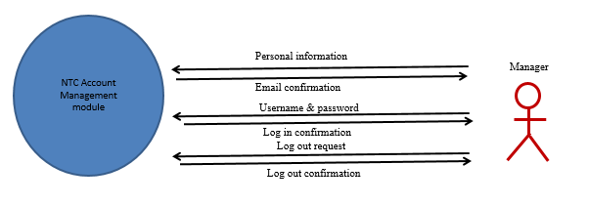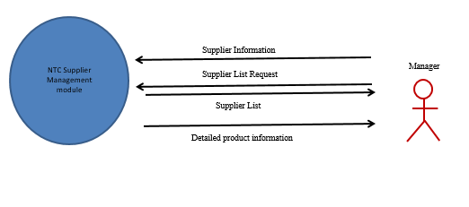

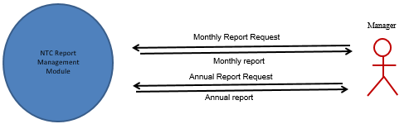

# The Business Problem

## The Business

New Town Cabinetry is a privately owned store located in Newmarket, Ontario. It sells kitchen and bathroom renovation items such as cabinets, counter tops, and sinks. Services include designing and installation.

## Problem Statement

Issue:

As of now New Town Cabinetry’s way of organizing product information is via spreadsheets. This system is causing the company to take too long looking for information, which ultimately affects not only the owner and employees but also the customers.

Vision:

The vision for the company is an online invoice management system. The system will support the owner to view products and their information, suppliers, and order information with a login system that will only allow the owner to view these details. The system will support the company’s management team to manage orders, look up information, and ultimately save time with a search option integrated into the program.

# Stakeholders

|  |  |  |  |  |
| --- | --- | --- | --- | --- |
| **Stakeholder** | **Role** | **Power (L/M/H)** | **Interest  (L/M/H)** | **Opposition (L/M/H/none)** |
| NTC Owner, Harley Lin | Sponsor & Authority, end user | H | H | none |
| Developers | Technical Expert | M | H | none |
| Customers | Customer | L | L | none |
| Suppliers | Supplier | L | L | none |
|  |  |  |  |  |
|  |  |  |  |  |

# Business Rules

|  |  |
| --- | --- |
|  | Description |
|  | Manager must be logged in to access the system. |
|  | Products registered must have suppliers. |
|  | Invoice will only be created for a customer |
|  |  |
|  |  |
|  |  |

1. **System Use Case Diagram (s)**

**NTC Supplier Management Module**

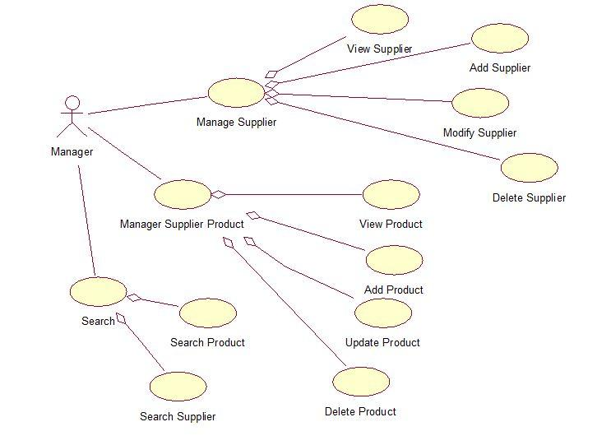

**NTC Report Management Module**

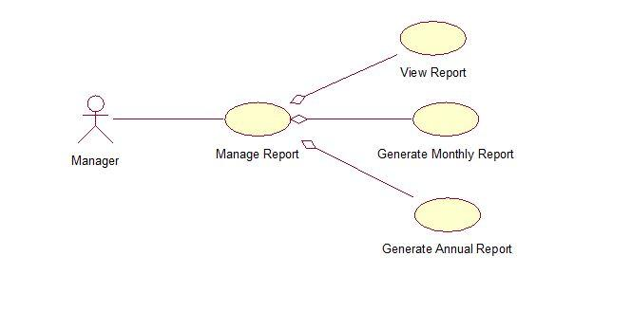

**NTC Account Management Module**

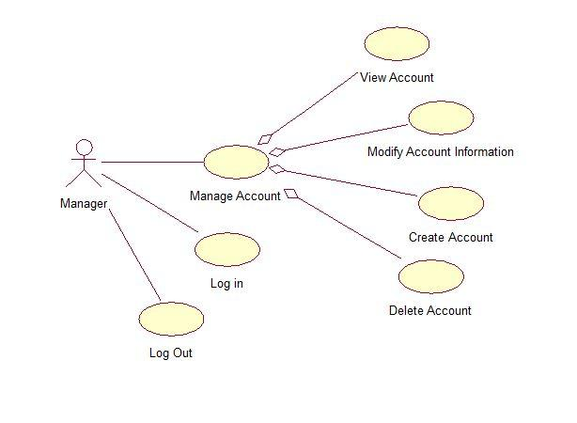

**NTC Invoice Management Module**

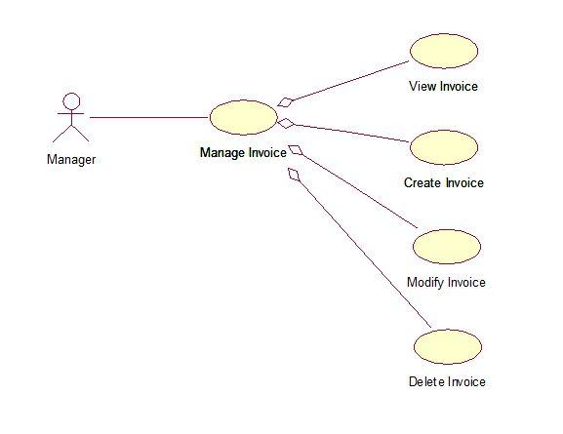

**NTC Purchase Order Management Module**

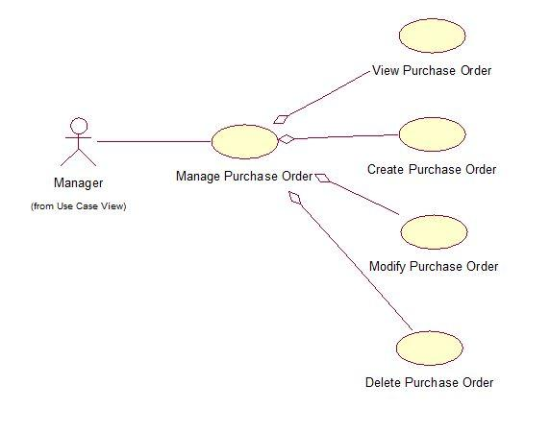

# Use Case Specifications

## Use Case Name: Add Supplier Product

Manager uses this system to add new products

### Author: Igor Naperkovskiy, Joao Rodrigues, Carlos Mo, Minna Lin

### Actor(s)

* Manager

### Use Case Preconditions

* User has to be logged in to the system.

### Use Case Successful Post Conditions

* Product is added to the database

### Applicable Business Rules

* Product has to have a supplier

### Main Flow:

Additional Precondition (if any; if not then just N/A):

|  |  |  |
| --- | --- | --- |
|  | Actor(s): Name of actor(s) | System |
| 1 | Select product category from list | Displays list of suppliers in that category |
| 2 | Select supplier from the list | System shows detailed supplier information (Name, ID, Address, Phone Number, E-mail) and existing products for that supplier |
| 3 | Select add new product | Displays the form for adding a new product |
| 4 | Enter product information | Validate product information |
| 5 |  | Redisplay product information |
| 6 |  | Request confirmation |
| 7 | Confirm | Display manage products page and acknowledgement message |

### Alternate Flows

|  |  |  |
| --- | --- | --- |
|  | Alternate Flow | Description |
| A1 | No suppliers for product category | Actor will invoke the Add Supplier use case |
| A4 | Invalid product information | System will provide the specific error message and will not allow to submit the form until it is clear of error messages |
| A4 | Duplicate product ID’s | System will go back to the form, repopulate the fields and give the error massage that the product already exists |
| A5 | Actor does not confirm | System displays the form and repopulates the fields |
| A5 | Actor selects to exit | System displays the main page and does not save the form |

## 

## Use Case Name: Create Invoice

Manager uses this system to create invoices for customers

### Author: Igor Naperkovskiy, Joao Rodrigues, Carlos Mo, Minna Lin

### Actor(s)

* Manager

### Use Case Preconditions

* User has to be logged in to the system.

### Use Case Successful Post Conditions

* Invoice is created

### Applicable Business Rules

* Invoice will only be created for a customer

### Main Flow:

1. Manager enters customer information(Name, Address, Phone #, E-mail) and invoice date
2. System creates a new record in a database
3. System displays a table of all products in a database and a filter menu
4. System populates the filter menu with a list of product categories
5. Manager selects a product category
6. System populates the filter menu with a list of suppliers and filters the table of products according to the selected product category
7. Manager selects a supplier
8. System filters the table of products according to the selected supplier
9. Manager selects products to be included in the invoice and clicks add
10. System saves selected products to the invoice record and updates subtotal
11. System displays a list of services
12. Manager selects services to be added to the invoice
13. System saves selected services to the invoice record and updates subtotal
14. System displays the form for additional fees
15. Manager inputs additional fees and it’s descriptions
16. System displays selected additional fees, services and products, then requests confirmation
17. Manager confirms
18. System saves entered fees to the invoice record, updates subtotal and calculates total with tax
19. System displays the final view of the invoice

### Alternate Flows

1a. Invalid customer information or invoice details

System signals error(s) to the manager and prompts re-entry

17a. Manager does not confirm

1. System returns to the confirmation page and repopulates the fields

20 Manager selects exit

1. System returns to the main page

## Use Case Name: View Invoice

Manager uses this system to view invoices

### Author: Igor Naperkovskiy, Joao Rodrigues, Carlos Mo, Minna Lin

### Actor(s) :

* Manager

### Use Case Preconditions

* User has to be logged in to the system.

### Use Case Successful Post Conditions

* Invoice is viewable in .PDF format

### Applicable Business Rules

* Invoice must have a customer

### Main Flow:

1. System displays advanced search box with a table of all invoices
2. Manager selects the number of fields that he wants to search by
3. Manager enters search field(s) specifying the search details on dropdown bar(s) containing database column names
4. System validates search parameters
5. System filters table of invoices according to search parameters
6. Manager selects invoice from list
7. System displays selected invoice in .PDF format

### Alternate Flows

2a. Manager reduces number of search fields

1. System removes specified number of search fields

3a. Manager requests for search reset

1. System clears all search fields and continues as in step 2

5a. No results found

1. Systems displays message and prompts manager to refine search parameters

8a. Manager selects exit

1. System returns to the main page

## Use Case Name: Update Supplier Product

Manager uses this system to update existing supplier products

### Author: Igor Naperkovskiy, Joao Rodrigues, Carlos Mo, Minna Lin

### Actor(s)

* Manager

### Use Case Preconditions

* User has to be logged in to the system.

### Use Case Successful Post Conditions

* Product is updated

### Applicable Business Rules

* Product has to have a supplier
* Product has to exist in the database

### Main Flow:

Additional Precondition (if any; if not then just N/A):

|  |  |  |
| --- | --- | --- |
|  | Actor(s): Name of actor(s) | System |
| 1 |  | Displays list of all supplier products, suppliers and product categories from database |
| 2 | Selects a supplier | Display products that belong to that supplier |
| 3 | Select product category | Displays all the products in that category |
| 4 | Select product | Display edit form with fields populated with info about that product |
| 5 | Edit’s required information | Validate product information |
|  |  | Redisplay product information |
| 6 |  | Request confirmation |
| 7 | Confirm | Display manage products page and acknowledgement message |

### Alternate Flows

|  |  |  |
| --- | --- | --- |
|  | Alternate Flow | Description |
| A5 | Invalid product information | System will provide the specific error message and will not allow to submit the form until it is clear of error messages |
| A5 | Duplicate product information | System will display the warning message that fields have not been edited |
| A7 | Actor does not confirm | System displays the form and repopulates the fields |
| A8 | Actor selects to exit | System displays the main page and does not save the form |

## Use Case Name: Modify Existing Invoice

Manager uses this system to modify existing invoices for customers

### Author: Igor Naperkovskiy, Joao Rodrigues, Carlos Mo, Minna Lin

### Actor(s)

* Manager

### Use Case Preconditions

* User has to be logged in to the system.
* Invoice has to exist

### Use Case Successful Post Conditions

* Invoice is edited

### Applicable Business Rules

* Invoice will only be created for a customer

### Main Flow:

|  |  |  |
| --- | --- | --- |
|  | Actor(s): Manager | System |
| 1 |  | System displays a list of already created invoices and customers |
| 2 | Manager selects a customer | System will display a list of invoices that belongs to the customer sorted by Date |
| 3 | Manager selects the invoice | System displays an edit form with fields populated |
| 4 | Manager edits the fields and submits | System validates the information |
| 5 |  | Redisplays invoice information |
| 6 |  | Requests confirmation |
| 7 | Manager confirms | Displays manage invoice page and acknowledgement message |

### Alternate Flows

|  |  |  |
| --- | --- | --- |
|  | Alternate Flow | Description |
| A4 | Invalid invoice information | System signals error(s) to the manager and prompts re-entry |
| A4 | Duplicate invoice information | System will display the warning message that fields have not been edited |
| A7 | Manager does not confirm | System returns to the confirmation page and repopulates the fields |
| A8 | Manager selects exit | System returns to the main page |

## Use Case Name: Create New Purchase Order

Manager uses this system to create invoices for customers

### Author: Igor Naperkovskiy, Joao Rodrigues, Carlos Mo, Minna Lin

### Actor(s)

* Manager

### Use Case Preconditions

* User has to be logged in to the system.

### Use Case Successful Post Conditions

* Invoice is created

### Applicable Business Rules

* Invoice will only be created for a customer

### Main Flow:

|  |  |  |
| --- | --- | --- |
|  | Actor(s): Manager | System |
| 1 |  | System displays a list of all suppliers |
| 2 | Manager selects a supplier from the list | System displays a list of products for the selected supplier |
| 3 | Manager selects the product(s) along with their respective quantities to be included in the purchase order | System displays an additional details form |
| 4 | Manager fills out the additional details form | System calculates the totals (subtotal and tax), displays the purchase order, and requests confirmation |
| 5 | Manager confirms | System creates a new purchase order record in the database |
| 6 |  | System displays a final view of the purchase order in PDF format |

### Alternate Flows

|  |  |  |
| --- | --- | --- |
|  | Alternate Flow | Description |
| A2 | Manager does not select supplier | System signals error(s) to the manager and prompts re-entry |
| A3 | Manager does not select product(s) | System signals error(s) to the manager and prompts re-entry |
| A5 | Manager does not confirm | System returns to the confirmation page and repopulates the fields |
| A7 | Manager selects exit | System returns to the main page |

## Use Case Name: Generate Report for the Month/Year

Manager uses this system to generate monthly/yearly report

### Author: Igor Naperkovskiy, Joao Rodrigues, Carlos Mo, Minna Lin

### Actor(s)

* Manager

### Use Case Preconditions

* User has to be logged in to the system.

### Use Case Successful Post Conditions

* New monthly/yearly report would be generated

### Applicable Business Rules

* Can only generate report for the month/year he has been in business for

### Main Flow:

|  |  |  |
| --- | --- | --- |
|  | Actor(s): Manager | System |
| 1 |  | System displays two date input fields (start and end date) |
| 2 | Manager inputs the dates | System generates a report based on the selected dates |
| 3 |  | System displays a report in PDF format |

### Alternate Flows

|  |  |  |
| --- | --- | --- |
|  | Alternate Flow | Description |
| A2 | Invalid date entry (start date cannot be before the end date) | System signals error(s) to the manager and prompts re-entry |
| A2 | Non-existent dates (inputted dates are not within the business dates of operation) | System signals error(s) to the manager and prompts re-entry |
| A4 | Manager selects exit | System returns to the main page |

# Non-Functional requirements

In the table below you are asked to specify the type of non-functional requirement you have identified and then describe what the requirement is and how you plan to satisfy it.

|  |  |  |
| --- | --- | --- |
|  | **Requirement Type** | **Description and Implementation Plan** |
| **1.** | Look and feel | Looks and acts like a regular website with the permission for manager to manage his business online |
| **2.** | Usability and Humanity | Usable by manager to manage his business online |
| **3.** | Performance | Has to be available 24/7 |
| **4.** | Operational | Operates on all popular browsers |
| **5.** | Security | **Access:** Only manager can access the certain areas of the website  **Privacy:** All customer and supplier information must be protected; customer and client information is not released to others  **Integrity:** All product information is accurate.  **Audit:** All sales information logged and stored; payment methods validated before acceptance. |
| **6.** | Legal | Must adhere to all Canadian tax and business legislation |