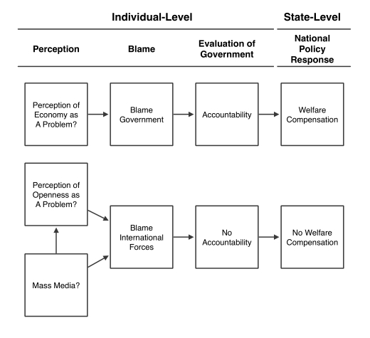

Figure 1: Summary of the Hypothesized Effects of Perception and Mass Media in Domestic Responses to Economic Liberalization

13

Respondents are asked to identify their main source of information from among the following: friends, family, opinion leaders, and mass media. Respondents are also asked to identify the top two problems facing France, and whether individuals, social institutions, the government, or international forces beyond government control are to blame for the problem.7 Finally, respondents are asked about their satisfaction with President Mitterrand, how well they think the government is handling the problem identified by the respondent as a top problem, and their intention to turnout for the March 1993 elections. There are several reasons why French survey data from the early 1990s represents a uniquely useful laboratory for testing the individual-level hypotheses. First, while other surveys gauge perceptions of responsibility on many issues, and many other surveys gauge media exposure, this is the only survey known to the author which effectively gauges both perceptions of responsbility for issues of economic openness and media exposure. Second, although the survey data is limited to France and therefore limits our ability to generalize to other countries, France is a hard case for testing the hypotheses, and so evidence for the hypotheses would suggest such a process is likely to occur in other countries as well. First, the survey takes place around the time of the Maastricht Treaty, a time when the problems of economic openness are highly policy-related. If media diffuses blame away from governments and onto international forces in France in the early 1990s, mass media is even more likely to do the same in situations where problems of economic openness are less related to high-visibility policy decisions. Additionally, France has relatively high rates of political engagement, and a statist, egalitarian political culture in which elite opinion claims more control over globalization than in countries such as Italy or the United Kingdom (Hay and Rosamond 2011, 159). Thus, evidence that mass media leads French citizens near the time of the Maastricht Treaty to blame international forces rather

7Respondents were asked to identify national problems in an open-ended fashion; their answers were then coded by the interviewer and into the general problem types listed here. To create the binary vari- able which measures whether the respondent sees some aspect of international economic openness as a top problem, I coded respondents as 1 if they identified one of the following issues as one of the “second most important problems”: “Intl economic competition,” “EC-92, economic integration,” “Foreign trade,” “Rati- fication of Maastricht,” and “Maastricht Treaty.” All other respondents were coded as 0 for the variable Openness Problem.

14

than their government suggests that such a relationship is even more likely in countries where globalization is more widely seen as ineluctable. Although ideally the hypotheses could be tested in multiple countries at once, this particular survey offers an ideal opportunity to test the hypotheses under conditions relatively favorable to generalization.

To test the direct and indirect effects of mass media on blame (Hypothesis 1), I estimate two logistic regression models. The first estimates the probability a respondent will blame international forces as a function of mass media exposure and a vector of control variables including controls for the nature of the problem. The equation is

Blamei = α + β1ProblemAreai + β2OpennessProblemi + β3Mediai + β4Controlsi + ei (1)

where Blame is a binary variable taking a value of 1 for respondents who blame international forces and 0 for respondents who blame the government for whichever national problem they have identified.8 ProblemArea is a categorical variable with four levels indicating whether the problem deals with social, economic, political, or foreign issues;9 Openness Problem is a binary variable I constructed to take a value of 1 for respondents who identified a problem specifically related to economic openness and 0 otherwise. If the mass media have an independent effect on diffusing blame away from government policymakers and toward international forces, then we would expect β3 to be positive and significant.

Then, to assess the indirect effect of mass media on blame as its channeled through perceptions of economic openness, I estimate a logistic regression modeling the probability

8Because of space constraints and for ease of interpretation in light of the hypotheses under consideration, I consider here only the difference between blaming the government and blaming international forces, omitting respondents who placed the blame on “society” or “people like you and me.” However, the results obtained here are robust to alternative specifications in which the dependent variable takes a value of 1 for respondents who blame international forces and 0 for respondents who select any of the other possible targets of blame. See Supplementary Information for full results.

9In the first wave of the survey, so many respondents identified unemployment as the top problem facing France that a question was added to measure what respondents identified as the “second most important problem facing France today.” All the analyses here, including the variables measuring blame attributions and evaluations of government handling, refer to this second most important problem.

15