on public opinion and voting in open economies, the perception of economic openness as a problem also increases the probability a respondent will blame international forces for that problem.13 Indeed, of all the variables considered here, the perception of economic openness as one of the nation’s top problems is the strongest determinant of whether a respondent will blame international forces for that problem (a logit estimate of 1.1 and standard error of .14). In this case, for a typical individual who identifies a top problem other than one of openness the probability of blaming international forces is .41 but for the same individual who identifies a top problem related to openness, that probability increases to .68 (a mean increase of .26 and standard deviation .03). To check the robustness of this finding, I also estimate several models using different operationalizations of the dependent variable.14 These additional models are consistent with the evidence presented in this section.

Model 2 considers the indirect effect of mass media on blame attributions through their effect on perceptions of openness as a problem. Reliance on mass media has a positive marginal effect on the perception of openness as a problem (a logit estimate of .33 and standard error of .17; p=.06). For a typical individual who does not rely primarily on mass media, the probability of perceiving an issue of openness to be a top problem is .08; relying on mass media increases this probability by a mean of .03 (standard deviation = .01) to .11. Thus, the indirect effect of mass media on blaming international forces, through its slight marginal effect on the perception of openness as a problem, is merely .01 (.26\*.03). The small size of this effect and its statistical significance near the conventional cutoff of 95%

party male at the mean age and with mean levels of political interest, who identifies the second top problem as “Economic” and not related to economic openness.

13It could be the case that individuals with cosmopolitan outlooks are more interested in mass media because of their greater interest in global issues, in which case mass media exposure could be endogenous to knowledge of issues surrounding economic globalization. Although the survey data used in this paper provide no measure of overall interest in international affairs, the analyses below control for the best predictors of cosmpolitanism: education, class, and general interest in politics. Because these are the best predictors of cosmpolitanism, it is unlikely that a partial, independent effect of mass media exposure would be spurious due to this particular risk of endogeneity.

14Whereas Model 1 considers for simplicity the binary opposition between blaming the government (de- pendent variable equal to 0) and blaming international forces (dependent variable equal to 1), I estimated additional models where the binary dependent variable opposes each of these targets of blame to anyone who blames any other target. See Supplementary Information.

19

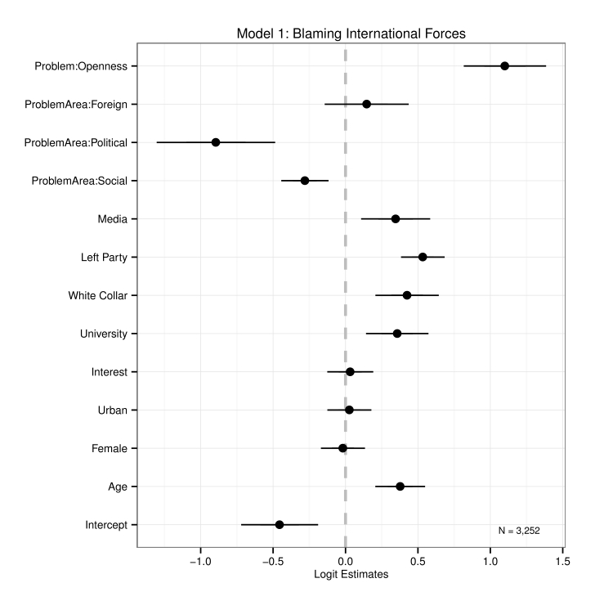

Figure 2: Determinants of Blaming International Forces

20

confidence suggest only weak evidence that mass media exerts much indirect effect on blame attributions by increasing awareness of openness as a problem.

The coefficient plot for Model 3, testing Hypothesis 2, reveals statistical evidence for the expectation that blaming international forces, in turn, has a positive effect on evaluations of the government ( logit estimate = .38, standard error = .03).15 Simulating quantities

of interest suggests that blaming international forces for a top problem increases a typical individual’s evaluation of government handling by .38 (standard devation = .03), from 1.6 to 2.0 on the four-point scale of the dependent variable. These results also hold when the dependent variable refers to satisfaction with the President rather than government handling of a top problem. They are also robust to an expanded operationalization of the blame variable considering the government, international forces, and other possible targets.16

Thus the results provide evidence consistent with each essential step of the causal chain at the individual level, though the estimated indirect effect of mass media on diffusing blame (through increasing perceptions of openness as a problem) is very weak. Nonetheless, the evidence suggests that mass media directly diffuse blame away from governments toward international forces (increasing the probability of blaming international forces by about 8%) even controlling for the general issue area in which the respondent locates a top problem and whether it is related to openness.

15There is reason to suppose that blame attributions could be endogenous to evaluations of how the government is handling a problem, in the sense that perceptions of poor or satisfactory government handling could increase or decrease the government’s perceived culpability. First, however, it should be recalled that survey question I am using to measure blame attributions refers specifically to the cause of the problem. Thus, strictly speaking, evaluations of how the government handles the problem should not affect who or what individuals identify as the cause or source of the problem. Second, it is much harder to believe that evaluations of government handling could drive individuals’ blame of international forces or blame of the two alternative targets from which respondents were able to choose (individuals “like you and I” or social institutions) simply because it is hard to imagine how government handling of the problem could make any of these other targets more or less culpable. Thus, I estimate an additional model which has separate binary independent variables for blaming government, international forces, or “other” as the baseline (see Supplementary Information). The coefficient for blaming government is larger than that for blaming international forces but both remain signed as expected and significant. This alternative specification mitigates the possibility that blaming international forces merey reflects respondents who are less likely to blame the government. Finally, if it can be assumed that endogeneity between evaluations of handling and blame would be most likely among partisans, then the control for partisanship and the two separate controls for support of President Mitterrand likely absorb much of this endogeneity.

16See Supplementary Information.

21