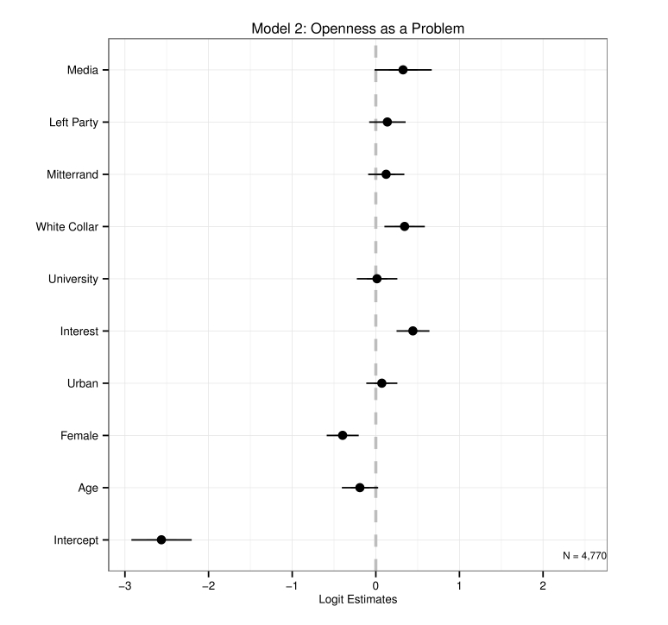

Figure 3: Determinants of Perceiving Openness as a Top Problem

22

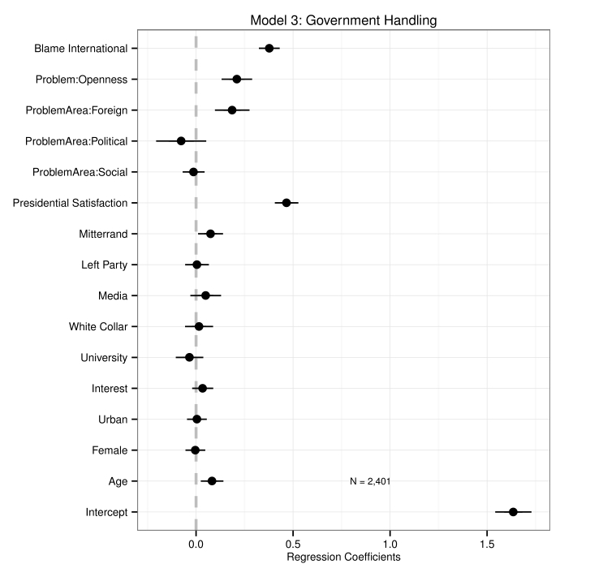

Figure 4: Determinants of Government Evaluations

23

Table 1 displays results from three regression models which provide initial support for the state-level expectations regarding the effect of mass media on the globalization-welfare relationship. Models 4 and 5 consider variable levels only, while Model 6 is an error-correction model using first-differences (year-to-year changes) in the dependent variable and lagged levels of the dependent variable on the right-hand side of the equation, alongside levels and first-differences of the key independent variables.17 Although a level dependent variable

with a lagged level on the right-hand side is formally equivalent to a differenced dependent variable, the error-correction specification is useful here because it allows us to separate

short-run and long-run effects.18 The differenced independent variables reflect immediate,

short-run effects and the level independent variables reflect the long-run effect after the short- run effects decay. All three models include fixed effects for country and year to account for unobserved differences in countries or unobserved temporal shocks in any particular year.19 To control for the clustering of errors within countries and the possibility of downwardly biased standard errors, I also calculate panel-corrected standard errors following Beck and Katz (1995). Panel-corrected standard errors did not appreciably change the statistical significance of any estimates reported in this paper.20

In each of the three model specifications, the variable Tradeit−1 ∗ MDIit−1 is negative

and statistically significant, suggesting that media density decreases the association between

17For Model 6, inclusion of a second lag of level of spending (t − 2) makes the covaration matrix non- invertible and therefore precludes a unique estimation of the model. However, omitting it leads us to reject the null hypothesis of no serial correlation in the error term according to the Breusch-Godfrey test for panel

models (p=0.026). I therefore use Spendingit−3on the right-hand side of the equation, which leads us to fail

to reject the null hypothesis of no serial correlation (p=.13).

18The error-correction specification is useful here for another reason. Although government spending and media density are not quite co-integrated, they are nearly cointegrated. In such situations, error-correction specifications are ideal for insuring against the possibility of spurious correlations driven by that shared integration.

19This was done using the “within” transformation and “two-way” effect option in the plm package for R (Croissant and Millo 2013).

20It is common to display the panel-corrected standard errors rather than the untransformed errors, but it is not obvious that treating them as a default has improved our use of cross-sectional, time-series data. On this point, see Wilson and Butler (2007), with whom I take the view that panel-corrected standard errors are only one of many checks against difficulties common in cross-sectional, time-series data. Fixed effects, lagged dependent variables, and dynamic specifications are some of the other techniques stressed by those authors. Here, I employ all of these latter techniques, and in some cases all together.

24