**Mass Media and the Domestic Politics of Globalization**

Although the relationship between economic globalization and the modern welfare state has been one of the most studied issues in political economy over the past three decades

(e.g., Gourevitch 1978; Garrett 1995; Rodrik 1998; Adserà and Boix 2002; Oatley 2011, 316), recent research on public opinion and political behavior in open economies raises questions about the assumptions of this tradition (Hellwig 2007, 155). A fundamental assumption in globalization-welfare research, which dates back to Karl Polanyi’s *The Great Transformation*, is that policymakers who wish to liberalize economic markets are held accountable by those groups who would suffer the adjustment costs (Polanyi [1944] 2001, 79, 385). Scholars have shown that to sustain political coalitions in favor of opening national economies, national policymakers have to compensate protectionist domestic groups with side payments in the form of social welfare programs (Katzenstein 1985; Rodrik 1998; Adserà and Boix 2002, 1028-29).

However, research in comparative political behavior shows that as domestic economies become increasingly integrated, citizens perceive that governments have less “room to maneu- ver” and accordingly shift their blame away from domestic policymakers to the unaccountable pressures of the global economy (Alcañiz and Hellwig 2010; Hellwig 2012). Citizens in coun- tries highly exposed to the global economy are less likely to punish incumbents for a poorly performing economy (Hellwig and Samuels 2007) and more likely to base their vote on non- economic issues (Hellwig 2008). If domestic groups do not punish politicians for economic losses made possible by the political decisions to maintain open national economies, then

1

an essential causal link in current accounts of the globalization-welfare nexus may not hold under certain conditions. Furthermore, this current of research has yet to take seriously that economic globalization does not inherently constrain policymakers’ “room to maneuver” but rather has been socially constructed as such by elites and typically through the mass media (Hay and Rosamond 2011; Hay and Smith 2005; Hay 2002).

At the same time, previous research has shown that mass media have direct effects on perceptions relevant to how citizens are likely to understand the politics of globalization. Specifically, mass media have direct effects on perceptions of responsibility (Iyengar 1987; Iyengar 1991), the politicization of economic hardship (Mutz 1992; Mutz 1994), and civic engagement more broadly (Putnam 1995; Norris 2000). In the specific context of the dis- tributive domestic politics of globalization, the preponderance of previous research strongly converges on a set of counter-intuitive arguments: By amplifying the dominant construction of globalization as an external imperative constraining policymakers and in this way shifting citizen blame attributions away from governments and toward international forces, the mass media should reduce the ability of domestic groups to hold national policymakers account- able for the effects of economic openness. In turn, as the global economy and mass media penetrate states, national policymakers should face less pressure to compensate protection- ist domestic groups for economic hardships linked to the global economy. As states become increasingly penetrated by both the global economy and mass media, at the state-level we should observe a weakened relationship between economic openness and welfare spending.

These expectations are tested with survey data and state-level economic data ideally suited to assess the implications of these arguments at both levels of analysis. A Legido- scope survey from France in 1992-1993 provides a uniquely valuable opportunity to test the argument that mass media has independent effects on individuals’ perceptions, blame at- tributions, and behavior around issues of economic openness. The findings show that mass media exposure is positively associated with individuals’ perceptions of economic openness as a problem and then, controlling for whether economic openness is perceived as a prob-

2

lem, the attribution of blame to international forces. The state-level implications of the theory are tested on pooled cross-sectional, time-series data from most countries in the world between 1960 and 2010. Using penetration rates of information-communication technology (ICT) as a proxy for the prevalence of mass media within states—in particular, the number of newspapers, televisions, and radios per person—several analyses across multiple model specifications suggest that the spread of ICT and the mass media they carry is associated with a weakening of the positive relationship between economic openness and social welfare spending. The dampening effect of mass media holds after controlling for several rival expla- nations and when included in the replication of previous, influential studies. Consistent with the survey analysis, the state-level associations are interpreted as evidence for the argument that policymakers are more likely to neglect domestic groups harmed by political decisions to liberalize markets the more prevalent is mass media within their states. Specifically, this is because mass media tends to shift the perceptual and behavioral response of protectionist individuals away from blaming and acting against the government on the politics of openness.

These findings alter the prevailing wisdom in at least two ways. First, they provide new evidence for the claim that economic openness makes citizens less likely to blame, and less likely to punish, incumbent governments for poor economic performance, but they also reveal that mass media exposure may be an alternative and independent causal path to the same effect, controlling for perceptions of economic openness. Second, this is one of the first systematic investigations of mass media as a political institution that conditions the domestic politics of the global economy. As such, it directly responds to calls for more truly political accounts of the domestic effects of globalization (Kayser 2007, 341) and for a more rigorous examination of the micro-foundations of work in this tradition (Hays, Ehrlich, and Peinhardt 2005; Walter 2010).

The article proceeds as follows. In the first section, previous literature is reviewed to reveal a gap between comparative and international political economists on the one hand

3

and scholars of public opinion and political behavior on the other, and to suggest how mass media research speaks directly to this gap. A second section develops specific hypotheses regarding how mass media is likely to affect individual perceptions, blame attributions, and electoral accountability around the politics of economic openness. A third section discusses the data and modeling strategy, the penultimate section discusses the core findings, and a final section concludes.

1 Mass Media Between Globalization and Domestic Politics

One of the most robust findings in international and comparative political economy is the positive state-level correlation between international trade and size of the public sector (Cameron 1978; Rodrik 1998; Garrett 1995; Adserà and Boix 2002). Most political scientists theorize this regularity as "embedded liberalism,” exemplified in the postwar proliferation of Keynesian social pacts that promoted open national markets with state-sponsored social protections (Ruggie 1982). Although social scientists widely agree that the expansion of in- ternational trade is welfare-improving in the long run, they also agree that the construction or expansion of markets often induces political backlash from domestic groups in the short run. This backlash requires policymakers in favor of increasing openness to compensate such groups through side payments, typically in the form of redistributive social spending, lest the necessary political support for increasing openness breaks down.

Despite the leverage it provides to models of the relationship between globalization and

4

welfare-state effort, there is surprisingly little evidence for the assumption that domestic groups harmed by economic liberalization exert sufficient political pressure on national pol- icymakers that policymakers provide welfare compensation to appease them. Hays, Ehrlich, and Peinhardt (2005) find evidence that government spending helps sustain support for free trade, and Walter (2010) finds consistent evidence in Swiss survey data for multiple points in the individual-level causal chain of the compensation thesis. Margalit (2011) finds that job losses due to offshoring had a stronger negative effect on incumbent vote share than job losses not related to offshoring. Additionally, Margalit also finds that spending from the Trade Adjustment Assistance program significantly reduced the size of the effect. Still, it remains unclear whether and how other institutions moderate the public perceptions and electoral consequences of liberalization and if different dimensions of liberalization have the same domestic effects as offshoring in particular. For instance, Guisinger (2009) finds that trade policy may not be sufficiently salient, even to the most affected groups, to justify voter-driven models of trade policy. Baker (2003; 2005; 2009) argues that, especially in the developing world, public support for trade openness remains high because it is associated with relatively high-quality goods at relatively low prices, despite sometimes dramatic negative macro-economic consequences. Such findings highlight pathways through which certain negative effects of trade liberalization can have different effects on individuals, depending on how they are perceived. Baker’s finding of high support for free trade even in national contexts of dramatic negative macro-economic consequences, only adds scholarly interest to the puzzle of precisely how and why individuals come to find consumption effects more salient than other effects of trade liberalization.

Other research also suggests causal pathways through which citizens harmed by the adjustment costs of liberalization would not hold policymakers accountable for the political

5

decision of liberalization. First, research mostly from advanced democratic countries finds that as the sources of economic growth shift, citizens accordingly adjust their expectations of government policymaking and their attributions of blame for national problems.1 Using

time-series data from France between 1985 and 2002, Hellwig shows that as exposure to trade and capital flows increase, citizens becomes less confident in the ability of national policymakers to solve national problems and the public demand for economic policy solutions decreases (Hellwig 2007). Voters also adjust their judgment of governments in predictable ways as other components of the institutional context change. For instance, when the Bank of England gained political independence, British voters were less likely to base their evaluation of the government on monetary policy and more likely to base it on fiscal policy (Sattler, Brandt, and Freeman 2010).

Secondly, perceptions and blame attributions affect political outcomes by altering what policymakers can be credibly held accountable for. Analyzing all 560 democratic elections between 1975 and 2002, Hellwig and Samuels (2007) show that as trade and capital flows increase as a share of gross domestic product, domestic economic growth rates have a smaller effect on incumbent vote share. Cross-sectional analyses of French and British survey data from 1997 and 2001, respectively, show similar effects of globalization on the determinants of vote choice, decreasing the effect of voter’s economic performance evaluations and party positions on economic issues (Hellwig 2008). Perceptual shifts in the ability of governments to affect economic policy also affect voter turnout. Analysis from the United States has found that individuals who suffer economic adversity but do not blame the government are less likely to vote than comparable individuals who do blame the government (Arce- neaux 2003). In terms of policymaking, elite messaging in the mass media (Hellwig and

6

Coffey 2011) and interviews with party elites in Europe (Hellwig 2012, 206) confirm that politicians consciously stress globalization constraints on their own behavior. Additionally, changes in the institutional setting are found to have predictable moderating effects on the responsivness of policy to public opinion. For instance, Sattler, Brandt, and Freeman (2010) show that before central bank independence, British fiscal and monetary policies were re- sponsive to aggregate voting intentions and government approval ratings but, after central bank indepedence, monetary policy was no longer responsive. Interestingly, however, Sattler, Brandt, and Freeman (2008) find mutual responsiveness between public opinion and policy outputs, despite a lack of responsiveness in policy outcomes such as inflation and economic growth. That this responsiveness is observed outside real economic outcomes is accredited to the difficulty of identifying the effects of policies in open economies.

Given that public perceptions of the institutional context have been shown to affect po- litical consequences of the economy, it is puzzling that scholarship on the domestic politics of economic globalization has largely neglected a serious inquiry into political communication and the mass media in particular. Scholars of American politics have shown that national policymakers actively engage in strategies of “blame avoidance” through the mass media (Weaver 1986; Jacobson and Kernell 1983), diffusing blame horizontally toward other equals or vertically upward in the chain of authority (McGraw 1990, 1991).2 Variation in blame attributions, in turn, has predictable effects on how individuals judge both policies and policymakers (McGraw, Best, and Timpone 1995). Other work has shown that under cer- tain conditions mass media can diffuse blame through issue framing (Iyengar 1987; Iyengar 1991), depoliticize personal experience in favor of sociotropic perceptions (Mutz 1992), and exacerbate inequalities in political participation (Norris 2000).

2Hood (2002, 20) suggests that by lowering the potential costs of communicating malign policy effects to harmed groups, mass media may increase the incentives for politicians to avoid blame.

7

In light of these currents, it is a surprising omission in previous research on the domestic politics of globalization that testimony by party elites in research interviews (Hellwig 2012, 206-07) and via the mass media (Hellwig and Coffey 2011, 420-21) is more often cited as evidence of room-to-maneuver constraints than questioned as possible strategic communication or media bias. Especially because evidence for opinion-policy responsiveness in open economies can be observed apart from and despite the objective economic effects of policy (Sattler, Freeman, and Brandt, 2008), a necessary next step in studying the domestic politics of globalization is to theorize more specifically how political communication—in particular, the mass media—may directly and indirectly affect the relationship between objective patterns of economic openness and domestic political outcomes.

2 Theory and Hypotheses

A central premise of this article is that issues of economic openness have been socially constructed by elite opinion-leaders as an external and objective process, typically known as “globalization,” which shapes policymakers’ room-to-maneuver (Hay 2002; Hay and Smith 2005; Hay and Rosamond 2011). The novel and central theoretical claim of this article is that the mass media diffuse responsibility for policies of economic liberalization over and above whatever diffusion of responsibility is created by the objective realities of economic openness. The warrant for this claim is straightforward: the mass media amplify and extend the reach of elite-sponsored social constructions beyond the reach they would have in the absence of mass media. This section develops the reasoning which moves from this premise to the central claim and then deduces a series of hypotheses regarding how mass media should be expected to affect individuals’ perceptions of economic openness, blame attributions for national problems, and ultimately the decisions of national policymakers.

8

Previous research already reviewed demonstrates that the dominant social construction of economic globalization—the one consistently endorsed in interviews with elites and in mass media messaging (Hellwig 2012, 206-07; Hellwig and Coffey 2011, 420-421)—is that of an external, objective pressure on policymaking (Hay 2002; Hay and Smith 2005; Hay and Rosamond 2011).3

Given this general elite consensus, standard theories of media coverage lead to the expectation that the media will tend to amplify this particular social construction. The “indexing” theory of news coverage suggests that the distribution of news coverage on a particular political issue will tend to follow the distribution of elite opinion on that issue (Bennett 1990; Zaller and Chiu 1996; Bennett, Lawrence, and Livingston 2006). The indexing theory of news coverage would suggest that mass media is more likely to represent economic globalization as an external constraint on policymaker autonomy rather than alternative critical narratives attributing responsibility to governments for negative consequences of globalization. Adding to the indexing theory the general responsibility-diffusing tendencies inherent to mass media discussed above, such as its episodic nature and the prevalence of elite blame avoidance, the overall expectation is that mass media should amplify the dominant construction of economic globalization as an external pressure which imposes itself on domestic policymakers, rather than an outcome of policymaking for which policymakers might be held responsible.

This basic indexing theory leads to two different versions of a first hypothesis, one imply- ing a direct effect and the other implying an indirect effect. Mass media may have an indirect effect on how individuals attribute blame for national problems, by informing individuals of objective problems pertaining to economic openness (merely transmitting information about objectively constraining realities pertaining to economic openness). The stronger version of this argument is that mass media may have a direct effect on how individuals attribute blame for national problems, uniquely diffusing responsibility in their perception of national

9

problems above and beyond its effect of making individuals more aware of the problems of economic openness.4

Hypothesis 1: Individuals more exposed to mass media are more likely to blame interna- tional forces for national problems than individuals less exposed to mass media. This effect is expected directly (by diffusing political responsibility in general, controlling for perceptions of openness as a problem) and indirectly (by increasing awareness of openness as politically problematic).

A second hypothesis captures implications of previous research suggesting that perceptions of a policymaker’s “room to maneuver” affect how individuals evaluate government performance. If the effect of economic perceptions on vote choice weakens because increasing economic openness shifts blame attributions toward the global economy and away from governments, then blame attributions should be associated with evaluations of government economic performance. Thus, I hypothesize that individuals who blame international forces for national economic problems should be more favorable toward incumbent governments than those who blame the government.

Hypothesis 2: Individuals who blame international forces for national problems evalu-

4It stands to reason that various individual-level factors might condition this general expectation. Po- litical partisanship, political interest and/or knowledge, economic anxiety, and various other factors might deserve to be included not only as control variables (as they are here, data permitting) but as interaction terms capturing the heterogeneity of effects. While a great number of additional complicating factors are plausible, no general argument linking media to the globalization-welfare nexus has yet been established in the literature. Therefore I only seek to theorize and test one set of general causal links, in order that future research may then investigate various plausible forms of causal complexity within the general arguments and evidence presented here.

10

ate incumbent governments more favorably than individuals who blame the government for national problems.

To assess how mass media enters into models of the globalization-welfare nexus, consider Adserà and Boix (2002, 231-236) as a baseline. The model explicates the conditions under which national policymakers must provide welfare compensation to protectionist interests in order to secure political support for opening the domestic economy. Adserà and Boix consider an economy of three groups of identical individuals with distinct trade interests. Groups C, P, and O are groups that can be thought of as classified by factor endowment, sector, or firm. C is a group that prefers a closed economy, with utility decreasing in a linear fashion as the economy opens. O is a group that prefers an open economy, with utility increasing in a linear fashion as the economy opens. P is a group the preferences of which are contingent on the state of the international business cycle but, other things equal, the expected return of a closed economy is greater than that of an open economy. Groups C, P , and O choose one of two parties at a national election. A protectionist party, Σ, receives the votes of C and a pro-trade party, Ω, receives the votes of O. Neither C nor O represent a majority of voters, so P is the median and swing vote. Both parties, Σ and Ω , credibly commit to a level of openness, λ, and a publicly-funded compensation package, α, for P in cases of international recession.

In this model, to open the domestic economy under competitive elections, a pro-trade political party must offer domestic spending to compensate P for the increased risks of international openness (Adserà and Boix 2002, 236). P voters vote for the pro-trade party, Ω, if the expected value of an open economy plus the compensation package promised by Ω is greater than the the expected value of a closed economy plus the compensation package offered by Σ. Because P’s gains from trade are always lower than the expected gains from a closed economy ex ante, the pro-trade party Ω always offers a compensation package sufficient to draw P voters (Adserà and Boix 2002, 236). Because this model assumes full and equal participation of voters, as Adserà and Boix point out in a

11

footnote, if turnout varies across domestic groups then the incentives driving the provision of compensation should change. Intuitively, the incentives for pro-trade party Ω to offer a compensation package decrease as the voter turnout of either C or P decreases; Ω is required to provide compensation to P only to the degree that C and P would vote against Ω because of its position on trade policy. If mass media increases the perception that economic liberalization is a process occurring external to domestic policymakers and is therefore domestically blameless, the effect would be to reduce the electoral salience of liberalization for those otherwise opposed to it. This is functionally equivalent to reducing the voter turnout of C and P around trade policy. Therefore the provision of compensatory public spending in response to economic openness should be moderated by levels of mass media. The final hypothesis encapsulates this implication.

Hypothesis 3: At the state level, the interaction of economic globalization and mass media penetration will be associated with lower levels of domestic welfare spending than predicted by the level of economic globalization alone.

3 Data and Method

Given the individual-level and state-level implications of the theory, data is gathered from both levels of analysis.5 The individual-level data come from a Legidoscope survey of public opinion in France between 1992 and 1993 (Chrique 1997). The survey asks respondents several questions tapping blame attribution, media exposure, and political mobilization.6

5Full summary statistics for both datasets can be found in Supplementary Information. 6See Supplementary Information for the text of the survey questions.

12

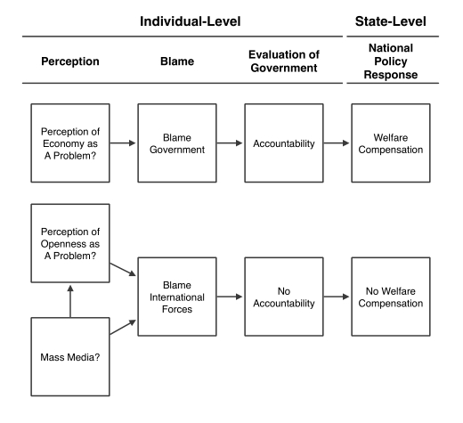

Figure 1: Summary of the Hypothesized Effects of Perception and Mass Media in Domestic Responses to Economic Liberalization

13

Respondents are asked to identify their main source of information from among the following: friends, family, opinion leaders, and mass media. Respondents are also asked to identify the top two problems facing France, and whether individuals, social institutions, the government, or international forces beyond government control are to blame for the problem.7 Finally, respondents are asked about their satisfaction with President Mitterrand, how well they think the government is handling the problem identified by the respondent as a top problem, and their intention to turnout for the March 1993 elections.

French survey data from the early 1990s represents a uniquely useful laboratory for testing the individual-level hypotheses. First, while other surveys gauge perceptions of responsibility on many issues, and many other surveys gauge media exposure, this is the only survey known to the author which effectively gauges both perceptions of responsibility for issues of economic openness and media exposure. Second, France in this time period is a hard case for testing the hypotheses, and so evidence for the hypotheses would suggest such a process is likely to occur in other countries as well. The survey takes place around the time of the Maastricht Treaty, when the problems of economic openness are highly policy-related. Additionally, France has relatively high rates of political engagement, and a statist, egalitarian political culture in which elite opinion claims more control over globalization than in countries such as Italy or the United Kingdom (Hay and Rosamond 2011, 159). Thus, evidence from this least-likely case should generalize to many other national situations in which the hypothesized relationships are more likely to hold.

7Respondents were asked to identify national problems in an open-ended fashion; their answers were then coded by the interviewer and into the general problem types listed here. To create the binary vari- able which measures whether the respondent sees some aspect of international economic openness as a top problem, I coded respondents as 1 if they identified one of the following issues as one of the “second most important problems”: “Intl economic competition,” “EC-92, economic integration,” “Foreign trade,” “Rati- fication of Maastricht,” and “Maastricht Treaty.” All other respondents were coded as 0 for the variable Openness Problem.

14

To test the direct and indirect effects of mass media on blame (Hypothesis 1), I estimate two logistic regression models. The first estimates the probability a respondent will blame international forces as a function of mass media exposure and a vector of control variables including controls for the nature of the problem. The equation is

Blamei = α + β1ProblemAreai + β2OpennessProblemi + β3Mediai + β4Controlsi + ei (1)

where Blame is a binary variable taking a value of 1 for respondents who blame international forces and 0 for respondents who blame the government for whichever national problem they have identified.8 ProblemArea is a categorical variable with four levels indicating whether the problem deals with social, economic, political, or foreign issues;9 Openness Problem is a binary variable I constructed to take a value of 1 for respondents who identified a problem specifically related to economic openness and 0 otherwise. If the mass media have an independent effect on diffusing blame away from government policymakers and toward international forces, then we would expect β3 to be positive and significant.

Then, to assess the indirect effect of mass media on blame as its channeled through perceptions of economic openness, I estimate a logistic regression modeling the probability

8Because of space constraints and for ease of interpretation in light of the hypotheses under consideration, I consider here only the difference between blaming the government and blaming international forces, omitting respondents who placed the blame on “society” or “people like you and me.” However, the results obtained here are robust to alternative specifications in which the dependent variable takes a value of 1 for respondents who blame international forces and 0 for respondents who select any of the other possible targets of blame. See Supplementary Information for full results.

9In the first wave of the survey, so many respondents identified unemployment as the top problem facing France that a question was added to measure what respondents identified as the “second most important problem facing France today.” All the analyses here, including the variables measuring blame attributions and evaluations of government handling, refer to this second most important problem.

15

of perceiving openness as a top problem as a function of mass media exposure and a vector of control variables:

Openness Problemi = α + β1ProblemAreai + β2Mediai + β3Controlsi + ei (2)

where the main variables of interest are the same as in Equation 1 except that here the dependent variable is the binary variable capturing whether openness is perceived as a top problem. If mass media affect blame attributions indirectly by making individuals more aware of international economic forces, which in turn would shift their blame toward international forces, then β2 should be positive and significant.

To test Hypothesis 2 regarding the effect of blame attributions on evaluations of the gov- ernment, I estimate a linear regression modeling how individuals evaluate the government’s handling of the problem they identified as one of the most important facing the country. I model evaluations of government handling as a function of respondents’ blame attributions and a vector of control variables. The equation is

GovHandlingi = α+β1ProblemAreai +β2OpennessProblemi +β3Blamei +β4Controlsi +ei

(3) where GovHandlingi measures, on a scale from 1 to 4, how the i th respondent evaluates the government’s handling of the top problem they identified. The theory predicts that for a particular problem such as the domestic costs of economic openness, blaming international forces rather than the government will make individuals less likely to hold governments ac- countable for that problem. If this is the case, then individuals who think a problem is caused by forces outside of the government’s purview should be less critical of the govern- ment’s handling of that problem. In this case, then, the theoretical expectation is that β3 will be positive and significant, reflecting that blaming international forces for a problem

16

leads individuals to view the government’s handling of that problem more favorably than if they blamed the government for the problem.

To test Hypothesis 3, state-level economic data are gathered from the World Bank’s World Development Indicators (World Bank 2012), unless otherwise noted. Media penetra- tion rates come from the World Development Indicators and Arthur Banks’ Cross-National Time-Series Data Archive (Banks and Wilson 2005; World Bank 2012).10 The variable

Democracy is the conventional measure using the 20-point scale from Polity IV (Marshall, Jaggers, and Gurr 2011), reflecting a country’s score for democratic institutions minus its score for autocratic institutions. Most models have around 130 countries with an average of roughly 8 observations per country. To test Hypothesis 3, I fit several variants of the pooled cross-sectional, time-series regression equation:

Spendingit = α+β1Tradeit−1+β2MDIit−1+β3Tradeit−1*MDIit−1+β4Controlsit−1+eit (4)

where the dependent variable, Spendingit, is a measure of final government consumption ex- penditure for country i in year t. Final government consumption expenditure is a standard measure of social welfare spending. Trade indicates imports plus exports as a percentage of GDP. MDI indicates an additive index of media density measuring television, newspa- per, and radios per capita (Warren 2014). Because the theory deals with the conditioning effects of mass media on domestic exposure to the global economy, I am most interested in

the multiplicative interaction of trade and mass media (Tradeit−1 * MDIit−1) rather than

the independent marginal effects. If mass media exposure has the individual-level effects hypothesized above, then an increasing density of mass media technologies within a state should weaken the positive relationship historically observed between levels of trade openness and levels of domestic spending. In other words, the coefficient β3 should be negative and

10Summary statistics can be found in Supplementary Information.

17

significant, reflecting that the predicted effect of trade on spending given high levels of mass media is less than the predicted effect that trade has on spending given low levels of mass media. In the first models testing Hypothesis 3, a battery of controls are included to account for non-trade and non-media determinants of government consumption expenditure. I then check the robustness of my models against a series of rival hypotheses in a set of subsequent models.

4 Findings and Discussion

Before analysis, all numerical independent variables were de-meaned and divided by two standard deviations so that coefficients reflect the expected effect of a two standard deviation increase in the variable and are therefore roughly comparable to the coefficients for any categorical independent variables. The coefficient plots in Figures 2 and 3 show mixed statistical support for Hypothesis 1 regarding the expectation that mass media diffuse blame for national problems away from governments and toward international forces (directly and indirectly).11 Respondents who rely on the mass media as their most important source of information are significantly more likely to blame international forces for what they identify as one of the nation’s top problems (a logit estimate of .35 and standard error of .12), even controlling for perceptions of economic openness as a problem and the more general issue area in which a respondent locates that problem. To get a better sense of the effect size, consider probabilities. Based on 1000 simulations, the probability of blaming international forces for a typical individual who does not rely primarily on the mass media for information is .33. Relying primarily on mass media increases this probability to .41 (a mean change of .08 with a standard deviation of .03).12 Also as we would expect from previous research

11Numerical model results are included in Supplementary Information. All models were estimated with the Zelig package in R (Imai, King, and Lau 2009).

12“Typical” refers to mean values on the numerical independent variables and the reference levels for categorical variables, i.e., in this case, a non-urban, non-university-educated, non-white-collar, non-left-

18

on public opinion and voting in open economies, the perception of economic openness as a problem also increases the probability a respondent will blame international forces for that problem.13 Indeed, of all the variables considered here, the perception of economic openness as one of the nation’s top problems is the strongest determinant of whether a respondent will blame international forces for that problem (a logit estimate of 1.1 and standard error of .14). In this case, for a typical individual who identifies a top problem other than one of openness the probability of blaming international forces is .41 but for the same individual who identifies a top problem related to openness, that probability increases to .68 (a mean increase of .26 and standard deviation .03). I also estimated additional models where the binary dependent variable opposes each of these targets of blame to anyone who blames any other target. The results are consistent with those presented here.14

Model 2 considers the indirect effect of mass media on blame attributions through their effect on perceptions of openness as a problem. Reliance on mass media has a positive marginal effect on the perception of openness as a problem (a logit estimate of .33 and standard error of .17; p=.06). For a typical individual who does not rely primarily on mass media, the probability of perceiving an issue of openness to be a top problem is .08; relying on mass media increases this probability by a mean of .03 (standard deviation = .01) to .11. Thus, the indirect effect of mass media on blaming international forces, through its slight marginal effect on the perception of openness as a problem, is merely .01 (.26*.03). The small size of this effect and its statistical significance near the conventional cutoff of 95%

party male at the mean age and with mean levels of political interest, who identifies the second top problem as “Economic” and not related to economic openness.

13It could be the case that individuals with cosmopolitan outlooks are more interested in mass media because of their greater interest in global issues, in which case mass media exposure could be endogenous to knowledge of issues surrounding economic globalization. Although the survey data used in this paper provide no measure of overall interest in international affairs, the analyses below control for the best predictors of cosmpolitanism: education, class, and general interest in politics. Because these are the best predictors of cosmpolitanism, it seems unlikely that observing an independent effect of mass media exposure would be spurious due to this particular risk of endogeneity.

14See Supplementary Information.

19

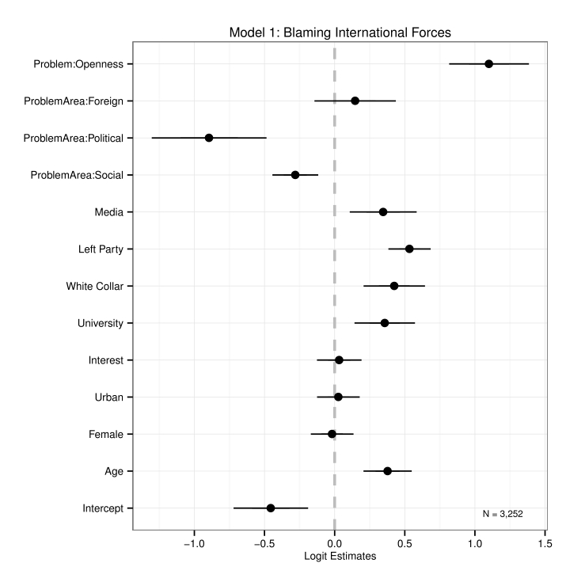

Figure 2: Determinants of Blaming International Forces

20

confidence suggest only weak evidence that mass media exerts much indirect effect on blame attributions by increasing awareness of openness as a problem.

The coefficient plot for Model 3, testing Hypothesis 2, reveals statistical evidence for the expectation that blaming international forces, in turn, has a positive effect on evaluations of the government (logit estimate = .38, standard error = .03).15 Simulating quantities

of interest suggests that blaming international forces for a top problem increases a typical individual’s evaluation of government handling by .38 (standard devation = .03), from 1.6 to 2.0 on the four-point scale of the dependent variable. These results also hold when the dependent variable refers to satisfaction with the President rather than government handling of a top problem. They are also robust to an expanded operationalization of the blame variable considering the government, international forces, and other possible targets.16

Thus the results provide evidence consistent with each essential step of the causal chain at the individual level, though the estimated indirect effect of mass media on diffusing blame (through increasing perceptions of openness as a problem) is very weak. Nonetheless, the evidence suggests that mass media directly diffuse blame away from governments toward international forces (increasing the probability of blaming international forces by about 8%) even controlling for the general issue area in which the respondent locates a top problem and whether it is related to openness.

15There is reason to suppose that blame attributions could be endogenous to evaluations of how the government is handling a problem, in the sense that perceptions of poor or satisfactory government handling could increase or decrease the government’s perceived culpability. First, however, it should be recalled that survey question I am using to measure blame attributions refers specifically to the cause of the problem. Thus, strictly speaking, evaluations of how the government handles the problem should not affect who or what individuals identify as the cause or source of the problem. Second, it is much harder to believe that evaluations of government handling could drive individuals’ blame of international forces or blame of the two alternative targets from which respondents were able to choose (individuals “like you and I” or social institutions) simply because it is hard to imagine how government handling of the problem could make any of these other targets more or less culpable. Thus, I estimate an additional model which has separate binary independent variables for blaming government, international forces, or “other” as the baseline (see Supplementary Information). The coefficient for blaming government is larger than that for blaming international forces but both remain signed as expected and significant. This alternative specification mitigates the possibility that blaming international forces merely reflects respondents who are less likely to blame the government.

16See Supplementary Information.

21

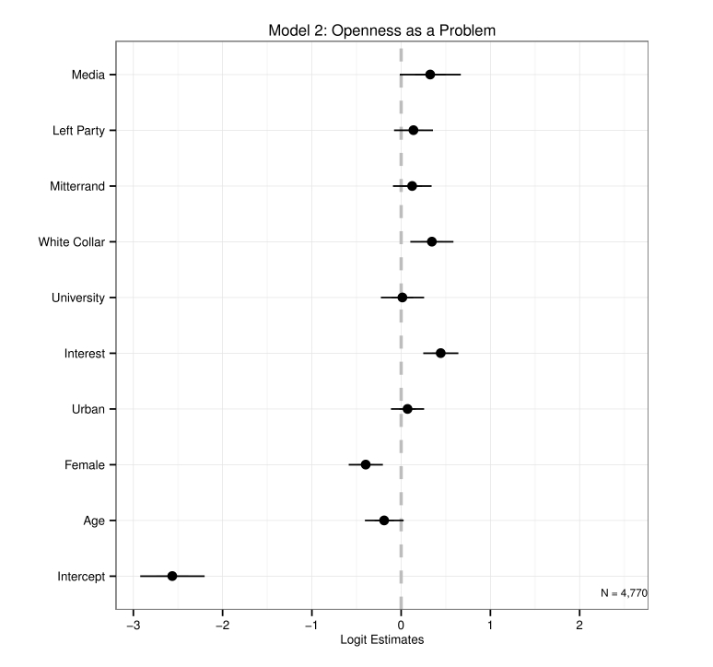

Figure 3: Determinants of Perceiving Openness as a Top Problem

22

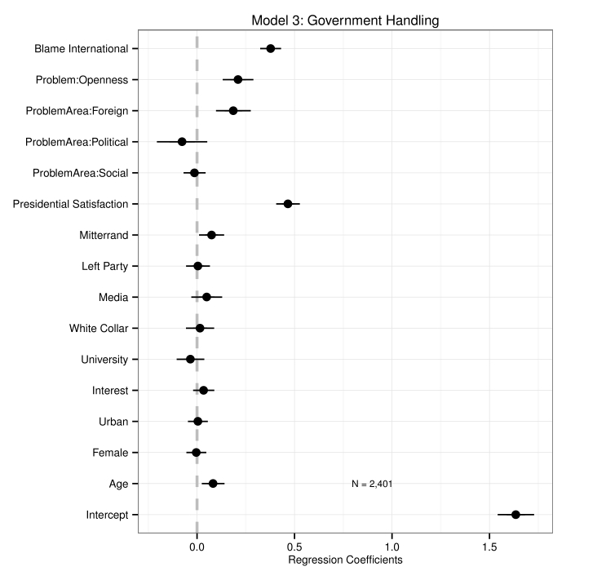

Figure 4: Determinants of Government Evaluations

23

Table 1 displays results from three regression models which provide initial support for the state-level expectations regarding the effect of mass media on the globalization-welfare relationship. Models 4 and 5 consider variable levels only, while Model 6 is an error-correction model using first-differences (year-to-year changes) in the dependent variable and lagged levels of the dependent variable on the right-hand side of the equation, alongside levels and first-differences of the key independent variables.17 The error-correction specification is useful here because it allows us to separate short-run and long-run effects.18 The differenced independent variables reflect immediate, short-run effects and the level independent variables reflect the long-run effect after the short- run effects decay. All three models include fixed effects for country and year to account for unobserved differences in countries or unobserved temporal shocks in any particular year.19 To control for the clustering of errors within countries and the possibility of downwardly biased standard errors, I also calculate panel-corrected standard errors following Beck and Katz (1995). Panel-corrected standard errors did not appreciably change the statistical significance of any estimates reported in this paper.20

In each of the three model specifications, the variable Tradeit−1 * MDIit−1 is negative

and statistically significant, suggesting that media density decreases the association between

17For Model 6, inclusion of a second lag of level of spending (t − 2) makes the covaration matrix non- invertible and therefore precludes a unique estimation of the model. However, omitting it leads us to reject the null hypothesis of no serial correlation in the error term according to the Breusch-Godfrey test for panel models (p=0.026). I therefore use Spendingit−3on the right-hand side of the equation, which leads us to fail

to reject the null hypothesis of no serial correlation (p=.13).

18The error-correction specification is useful here for another reason. Although government spending and media density are not quite co-integrated, they are nearly cointegrated. In such situations, error-correction specifications are ideal for insuring against the possibility of spurious correlations driven by that shared integration.

19This was done using the “within” transformation and “two-way” effect option in the plm package for R (Croissant and Millo 2013).

24

levels of trade and subsequent levels of government consumption expenditure. The coefficient

of -.97 for Tradeit−1 *MDIit−1 in Model 4 suggests that, on average, a two standard deviation

increase in media density (109.3 points) in the long-run decreases the estimated effect that a two standard deviation increase in trade openness (85.2% of GDP) would have on government spending by .97% of GDP. Model 6 estimates that this negative conditioning effect of media density is as little as .61% of GDP. Moving from the minimum density of media (0) to the maximum in the sample (313.3) is associated, on average, with a decrease of as much as

2.78%, and as little as 1.8%, in the expected effect of an 85% increase in trade openness on government spending as a share of GDP. Although the estimated effect appears relatively slight, it should be kept in mind that the mean level of government consumption expenditure in the sample is only 15.7% of GDP. Thus, for a country that begins with no mass media and becomes as fully penetrated as the most penetrated (the United States in 1986), the roughly 1-3% of GDP by which we would expect the country to reduce its compensatory public spending in the long-run for an 85% increase in trade openness is a substantial portion of what a typical country spends.

Models 5 and 6 also test the conditioning effect of media density against the conditioning effects of democracy on the trade-welfare relationship, which previous research has found to increase the redistributive responsiveness of domestic welfare spending to international trade (Adserà and Boix 2002). The results here suggest that media density has a robust conditioning effect on the relationship between trade and spending, while the interaction found by Adserà and Boix no longer appears statistically distinguishable from zero.

To check for the possibility that the above models are spuriously driven by some dif- ferent but unobserved process distinct from the effects of mass media, I gather additional data to test my state-level argument against a series of rival explanations. Specifically, it is argued that left parties and union density are aspects of the domestic institutional environ- ment which lead to more redistributive responses to economic liberalization (Garrett 1995, 674); that electoral systems defined by proportional representation are more redistributive

25

than majoritarian systems (Iversen and Soskice 2006); and that the degree of unitarism or government centralization affects welfare spending (Crepaz 1998, 72). Finally, of particular interest in the literature relating economic globalization to the politics of welfare is the argu- ment of Iversen (2001) that deindustrialization rather than globalization has driven the expansion of welfare spending since the 1960s.

In Table 2, I re-estimate the error-correction model (as in Model 6 of Table 1) controlling for each of the rival explanations above.21 The interaction of trade levels and media density levels is robust to the inclusion of each potentially confounding variable, suggesting that the conditioning effect of media density on the trade-spending relationship is not a spurious cor- relation due to an omitted variable. In an additional model not displayed for lack of space, I

included the terms Tradeit−1*GDPPerCapitait−1 and ∆Tradeit−1*∆GDPPerCapitait−1 on

the right-hand side of the equation in the fashion of the models in Table 2; neither coefficient

is statistically significant and the main independent variable of interest, Tradeit−1 *MDIit−1,

remains signed as expected and statistically significant (β=-1.56, standard error=.000, panel- corrected standard error=.005).

Several additional robustness checks were conducted. With panel data, Nickell bias can lead to rejecting a true null hypothesis when the number of units is large relative to the time period (Gaibulloev, Sandler, and Sul, 2014). Given that the present panel contains a relatively large number of countries with a sampling period of more than 30 years (the period beyond which Nickell bias becomes ignorable), I re-estimate the models in Table 2 on only those countries with complete data for the 38 years between 1961 and 1999. Table 12 in Sup- plementary Information shows the results, substantially the same as the those reported here.

I also checked sensitivity to lag specification for Tradeit−1 * MDIit−1 estimating the models in Table 1 using Tradeit * MDIit as the independent variable instead. The coefficients and

standard errors are not substantially changed (see Table 13 in Supplementary Information). Therefore the state-level models provide additional, robust evidence that mass media shape

20See Supporting Information for more information on variable descriptions and sources.

26

|  |
| --- |
| Table 1: Determinants of Government Consumption Expenditure |
| Model 1 Model 2 Model 3 |
| Tradeit−1 0.14 0.15 0.32 |
| (0.21) (0.21) (0.23) |
| ∆Tradeit−1 −0.88­­*  (0.41) |
| MDIit−1 −0.16 −0.11 0.70** |
| (0.40) (0.40) (0.33) |
| ∆MDIit−1 1.01  (1.76) |
| Democracyit−1 0.03 −0.03 −0.11  (0.15) (0.16) (0.16) |
| GDPPerCapitait−1 0.62*** 0.61*** |
| (0.19) (0.19) |
| Dependencyit−1 −0.22 −0.24  (0.23) (0.23) |
| LandAreait−1 13.92 20.36 |
| (191.65) (191.68) |
| ∆Democracyit−1 0.04  (0.30) |
| ∆GDPPerCapitait−1 0.64  (0.73) |
| ∆Dependencyit−1 2.59  (1.86) |
| Spendingit−1 0.72*** 0.72*** −0.19***  (0.02) (0.02) (0.02) |
| Spendingit−2 0.11*** 0.11*** |
| (0.02) (0.02) |
| Spendingit−3 0.03  (0.02) |
| ∆Spendingit−1 −0.09***  (0.02) |
| Tradeit−1 * MDIit−1 −0.97*** −0.88*** −0.71** |
| (0.32) (0.33) (0.33) |
| ∆Tradeit−1 * ∆MDIit−1 −0.29  (16.85) |
| Tradeit−1 * Democracyit−1 −0.43 −0.45 |
| (0.30) (0.31) |
| ∆Tradeit−1 * ∆Democracyit−1 −3.53*  (2.01) |
| N 3911 3911 3785 |
| R-squared 0.67 0.67 0.11 |
| Adj. R-squared 0.64 0.64 0.10 |
| ***p < .01; **p < .05; *p < .1 |

27

|  |
| --- |
| Table 2: Rival Explanations: Electoral System, Centralization, Left Party Seats, Union |
| Density, and De-Industrialization |
| (7) (8) (9) (10) (11) |
| ∆Tradet−1 -0.668 -0.429 -2.431** -1.362 -1.376*** |
| (0.458) (0.467) (1.055) (0.879) (0.482) |
| MDIt−1 0.045 -0.014 -0.278 -0.589** 0.177 |
| (0.416) (0.416) (0.262) (0.242) (0.609) |
| ∆MDIt−1 0.814 0.743 2.258*** 2.839*** -0.866 |
| (1.743) (1.741) (0.775) (0.821) (2.256) |
| GDPPerCapitat−1 0.472** 0.509*** 0.556*** 0.427*** 0.776*** |
| (0.187) (0.187) (0.137) (0.117) (0.273) |
| Spendingt−1 -0.233*** -0.234*** -0.071*** -0.075*** -0.253*** |
| (0.014) (0.014) (0.018) (0.015) (0.013) |
| Tradet−1 X MDIt−1 -0.662* -0.641** -0.891** -1.184*** -2.048*** |
| (0.342) (0.324) (0.354) (0.314) (0.549) |
| ∆Tradet−1 X ∆MDIt−1 5.072 4.268 -39.462 -41.014 40.023  (18.142) (18.194) (25.394) (25.531) (25.338) |
| PRt−1 0.476  (0.359) |
| Tradet−1 X PRt−1 0.296  (0.334) |
| ∆Tradet−1 X ∆PRt−1 -11.343***  (3.858) |
| Unitarismt−1 -0.695  (0.681) |
| Tradet−1 X Unitarismt−1 0.651  (0.536) |
| ∆Tradet−1 X ∆Unitarismt−1 -12.632*  (6.579) |
| UnionDensityt−1 -0.086  (0.167) |
| Tradet−1 X UnionDensityt−1 -0.8**  (0.393) |
| ∆Tradet−1 X ∆UnionDensityt−1 -14.819  (21.369) |
| LeftSeatst−1 0.208*  (0.125) |
| Tradet−1 X LeftSeatst−1 0.441  (0.343) |
| ∆Tradet−1 X ∆LeftSeatst−1 -2.568  (4.755) |
| Industryt−1 0.007  (0.25) |
| ∆Industryt−1 -0.361  (0.469) |
| Tradet−1 X Industryt−1 0.151  (0.339) |
| ∆Tradet−1 X ∆Industryt−1 -2.183  (2.792) |
| R2 0.125 0.123 0.194 0.147 0.142 |
| adj.R2 0.115 0.114 0.17 0.131 0.133 |
| N 2224 2224 544 673 2736 |
| Standard errors in parentheses. For space constraints, estimates for land, dependency rates, levels of trade  and democracy are included but not displayed (all were indistinguishable from zero at 95% confidence). |
| * (p ≤ 0.1), ** (p ≤ 0.05), *** (p ≤ 0.01) 28 |

perceptions and blame attributions around economic globalization in a way that weakens the compensatory responsiveness of welfare spending.

5 Conclusion

This study has presented individual- and state-level evidence that mass media conditions the domestic politics of economic globalization. Survey evidence from France shows that individuals most reliant on mass media are less likely to blame top national problems on incumbent governments, and more likely to blame international forces, for indirect and direct reasons. Mass media indirectly deflects blame away from incumbent governments and toward international forces by making individuals more aware of economic openness as a political issue, but it also directly decreases individuals’ propensities to blame incumbents relative to international forces (controlling for the awareness effect), most likely due to the responsbility-diffusing framing effects previously found in mass media studies. In turn, individuals who blame international forces rather than the government evaluate the government more favorably. Cross-sectional, time-series data reveal that mass media is associated with a decrease in the relationship between economic openness and welfare-state spending, suggesting that mass media diffuses the domestic political pressure against liberalization that has historically elicited welfare-state compensation for aggrieved domestic groups.

The limitations of this study also point to avenues for future research. While I considered many dominant rival hypotheses through the use of statistical control vari- ables, this article could not engage with all possible factors that may plausibly condition the relationships posited by the three hypotheses presented. For instance, it seems likely that political partisanship might condition the relationship between media exposure and blame attributions, and/or the relationship between blame attributions and evaluations of government. Thus, rather than simply controlling for partisanship as above, future

29

research might investigate whether these relationships are dampened or amplified under different conditions of citizen and government partisanship. Additionally, for the state-level findings, future research might investigate whether the conditioning effect of media on the globalization-welfare nexus is not itself conditional on region, national government partisanship, or various factors related to the national media environment (such as media concentration, ownership, etc.).

The findings have implications for the study of international and comparative politics and for the prospects of democracy in a globalized world. First, the results provide some of the first evidence that mass media can be understood as a political institution that conditions the domestic politics of the global economy. This article therefore contributes to current research agendas seeking more finely-tuned political accounts of the domestic effects of globalization (Kayser 2007, 341) and a better understanding of public opinion and voting behavior in the context of economic openness (Hellwig 2008; Freeman 2008).

The findings should also be of particular interest to scholars seeking more rigorous micro-foundations for the relationship between economic openness and welfare states (Hays, Ehrlich, and Peinhardt 2005; Walter 2010). Second, the state-level findings in particular have an important substantive implication, for they suggest that the omission of mass media in previous studies may have over-estimated the egalitarian responsiveness of welfare states in the globalization-welfare nexus. This article suggests that from the standpoint of democratic values, mass media can have subtle but perverse effects on the distributive poli- tics of open economies, disempowering domestic groups from holding national policymakers accountable for the unevenly distributed costs of globalization.

30

References

Adserà, Alícia, and Carles Boix. 2002. “Trade, Democracy, Public Sector: The Political Underpinnings of Openness.” International Organization 56 (March): 229–262.

Alcañiz, Isabella, and Timothy Hellwig. 2010. “Who’s to Blame? The Distribution of Respon- sibility in Developing Democracies.” British Journal of Political Science 41 (November): 389–411.

Arceneaux, Kevin. 2003. “The Conditional Impact of Blame Attribution on the Relationship Between Economic Adversity and Turnout.” Political Research Quarterly (November): 1– 10.

Baker, Andy. 2003. “Why is Trade Reform So Popular in Latin America?: A Consumption- Based Theory of Trade Policy Preferences.” World Politics 55 (April): 423–455.

Baker, Andy. 2005. “Who Wants to Globalize? Consumer Tastes and Labor Markets in a Theory of Trade Policy Beliefs.” American Journal of Political Science 49 (October): 924–938.

Baker, Andy. 2009. The Market and the Masses in Latin America. Cambridge: Cambridge University Press.

Banks, Arthur A, and Kenneth A Wilson. 2005. Cross-National Time-Series Data Archive. Binghamton, NY: Databanks International.

Beck, Nathaniel, and Jonathan N Katz. 1995. “What to do (and Not to Do) with Time-Series

Cross-Section Data.” American Political Science Review 89 (September): 634–647.

Bennett, W Lance. 1990. “Toward a Theory of Press-State Relations in the United States.” International Studies Quarterly 40 (June): 103–127.

31

Bennett, W Lance, Regina G Lawrence, and Steven Livingston. 2006. “None Dare Call It Torture: Indexing and the Limits of Press Independence in the Abu Ghraib Scandal.” International Studies Quarterly 56 (September): 467–485.

Cameron, David R. 1978. “The Expansion of the Public Economy: A Comparative Analysis.” American Political Science Review 72 (December): 1243–1261.

Chrique, Philippe. 1997. “Legidoscope: Trend Surveys of French Public Opinion and Media Usage, September 1992-May 1993.” Inter-university Consortium for Political and Social Research.

Crepaz, Markus M L. 1998. “Inclusion versus Exclusion: Political Institutions and Welfare

Expenditures.” Comparative Politics 31 (January): 61–80.

Croissant, Yves, and Giovanni Millo. 2013. “plm: Linear Models for Panel Data.” R package.

Freeman, John R. 2008. “The American Public and the Room to Maneuver: Responsibil- ity Attributions and Policy Efficacy in an Era of Globalization.” International Studies Quarterly 52 (December): 855–880.

Gaibulloev, Khusrav, Todd Sandler, and Donggyu Sul. 2014. “Dynamic Panel Analysis under

Cross-Sectional Dependence.” Political Analysis 22 (April): 258–273.

Garrett, Geoffrey. 1995. “Capital mobility, trade, and the domestic politics of economic

policy.” (February): 1–31.

Gourevitch, Peter. 1978. “The second image reversed: the international sources of domestic

politics.” International Organization 32 (04): 881.

32

Guisinger, Alexandra. 2009. “Determining Trade Policy: Do Voters Hold Politicians Ac- countable?” (July): 1–25.

Hay, Colin. 2002. “Globalisation as a Problem of Political Analysis: Restoring Agents to a ‘Process without a Subject’ and Politics to a Logic of Economic Compulsion.” Cambridge Review of International Affairs 15 (3): 379–392.

Hay, Colin, and Ben Rosamond. 2011. “Globalization, European integration and the discur- sive construction of economic imperatives.” Journal of European Public Policy 9 (Febru- ary): 147–167.

Hay, Colin, and Nicola Smith. 2005. “Horses for courses? The political discourse of globali- sation and European integration in the UK and Ireland.” West European Politics.

Hays, Jude, Sean D Ehrlich, and Clint Peinhardt. 2005. “Spending and Support for Trade in the OECD.” International Organization (October): 1–23.

Hellwig, T, and D Samuels. 2007. “Voting in Open Economies: The Electoral Consequences of Globalization.” Comparative Political Studies 40 (March): 283–306.

Hellwig, Timothy. 2007. “Globalization and Perceptions of Policy Maker Competence: Evi- dence from France.” Political Research Quarterly 60 (March): 146–158.

Hellwig, Timothy. 2008. “Globalization, Policy Constraints, and Vote Choice.” The Journal of Politics 70 (September): 1128.

Hellwig, Timothy. 2012. “Retaining the Room to Maneuver? Globalization and Electoral

Politics.” Unpublished manuscript: 1–242.

Hellwig, Timothy, and Eva Coffey. 2011. “Public opinion, party messages, and responsibility for the financial crisis in Britain.” Electoral Studies 30 (September): 417–426.

33

Hood, Christopher. 2002. “The Risk Game and the Blame Game.” Government and Oppo- sition 37 (January): 15–37.

Imai, Kosuke, Gary King, and Olivia Lau. 2009. “Zelig: Everyone’s Statistical Software.” R package.

Iversen, T. 2001. “The Dynamics of Welfare State Expansion: Trade Openness, Deindustri- alization, and Partisan Politics.” In The New Politics of the Welfare State. Oxford: Oxford University Press.

Iversen, Torben, and David Soskice. 2006. “Electoral Institutions and the Politics of Coali- tions: Why Some Democracies Redistribute More Than Others.” American Political Sci- ence Review 100 (May).

Iyengar, Shanto. 1987. “Television News and Citizens’ Explanations of National Affairs.” The American Political Science Review 81: 815–832.

Iyengar, Shanto. 1991. Is Anyone Responsible?: How Television Frames Political Issues. Chicago: University of Chicago Press.

Jacobson, Gary C, and Samuel Kernell. 1983. Strategy and Choice in Congressional Elections. 2nd ed. New Haven: Yale University Press.

Katzenstein, Peter J. 1985. Small States in World Markets. Industrial Policy in Europe Ithaca, N.Y. : Cornell University Press.

Kayser, Mark Andreas. 2007. “How Domestic Is Domestic Politics? Globalization and Elec-

tions.” Annual Review of Political Science 10 (June): 341–362.

Margalit, Yotam. 2011. “Costly Jobs: Trade-related Layoffs, Government Compensation, and Voting in U.S. Elections.” American Political Science Review 105 (February): 166–188.

34

Marshall, Monty G, Keith Jaggers, and Ted Robert Gurr. 2011. “Polity IV Project: Political Regime Characteristics and Transitions, 1800-2010.” Center for Systemic Peace.

McGraw, Kathleen M. 1990. “Avoiding Blame: An Experimental Investigation of Political Excuses and Justifications.” British Journal of Political Science 20 (January): 119.

McGraw, Kathleen M. 1991. “Managing Blame: An Experimental Test of the Effects of Political Accounts.” American Political Science Review 85 (December): 1133–1157.

McGraw, Kathleen M, Samuel Best, and Richard Timpone. 1995. “"What They Say or What They Do?" The Impact of Elite Explanation and Policy Outcomes on Public Opinion.” American Journal of Political Science 39 (February).

Mutz, DC. 1992. “Mass Media and the Depoliticization of Personal Experience.” American Journal of Political Science.

Mutz, Diana C. 1994. “Contextualizing Personal Experience: The Role of Mass Media.” The Journal of Politics 56 (August): 689.

Norris, Pippa. 2000. Virtuous Circle. Political Communications in Postindustrial Societies Cambridge, UK: Cambridge University Press.

Oatley, Thomas. 2011. “The Reductionist Gamble: Open Economy Politics in the Global

Economy.” International Organization 65 (April): 311–341.

Polanyi, Karl. 2001. The Great Transformation. Second ed. Boston: Beacon Press.

Putnam, R D. 1995. “Tuning in, tuning out: The strange disappearance of social capital in

America.” PS: Political Science & Politics 28 (4): 664–683.

Rodrik, Dani. 1998. “Why Do More Open Economies Have Bigger Governments?” Journal of Political Economy (October): 1–37.

35

Ruggie, John Gerard. 1982. “International Regimes, Transactions, and Change: Embedded Liberalism in the Postwar Economic Order.” International Organization (October): 1–38.

Sattler, Thomas, John R Freeman, and Patrick T Brandt. 2008. “Political Accountability and the Room to Maneuver A Search for a Causal Chain.” Comparative Political Studies.

Sattler, Thomas, Patrick T Brandt, and John R. Freeman. 2010. “Democratic Accountability in Open Economies.” Quarterly Journal of Political Science (April): 71–97.

Walter, Stefanie. 2010. “Globalization and the Welfare State: Testing the Microfoundations of the Compensation Hypothesis.” International Studies Quarterly 54 (June): 403–426.

Warren, Camber T. 2014. “Not by the Sword Alone: Soft Power, Mass Media, and the Production of State Sovereignty.” International Organization 68 (January): 111–141.

Weaver, R Kent. 1986. “The Politics of Blame Avoidance.” Journal of Public Policy 6 (Oc- tober): 371–398.

World Bank. 2012. World Development Indicators. Technical report.

Zaller, John, and Dennis Chiu. 1996. “Government’s Little Helper: U.S. Press Coverage of Foreign Policy Crises, 1945-1991.” Political Communication 13 (4): 385–405.

36