Is the Tea Party Libertarian, Authoritarian, or Something Else?

Scholars have been fascinated by the Tea Party since it first emerged on the American political scene in the spring of 2009. While some have dismissed it as simply a repackaging of conventional American conservative populism, many have been struck by how effective it has been in remobilizing the Republican Party base in the wake of the Democratic electoral landslide of 2008. Most of the scholarship has focused upon the demographic make up of its members (Courser 2012; Disch 2011; Maxwell and Parent 2012; Williamson, Skocpol, and Coggin 2011), how it combines elements of elite and grassroots political mobilization in new and innovative ways (Bailey, Mummolo, and Noel 2012; Karpowitz et al. 2011), how it is a racialized response to the election of the first African American President (Abramowitz 2012; Bailey, Mummolo, and Noel 2012; Disch 2011; Lowndes 2012; Skocpol and Williamson 2012) and how it might connect with more militarized elements of the American far right (Parker and Barreto 2013; Skocpol and Williamson 2012). Less attention has been paid to the question of whether or not a specific ideology might be driving support for the Tea Party. When ideology is explicitly addressed, authors tend to note a peculiar contradiction in core beliefs of Tea Party supporters: the Tea Party seems to embody an odd fusion of libertarianism and social conservatism (Arceneaux and Nicholson 2012; Berlet 2012; P. Montgomery 2012; Parker and Barreto 2013; Williamson, Skocpol, and Coggin 2011; Wilson and Burack 2012). While we agree with previous scholars who observe that the Tea Party does not have one unifying ideology, we believe that political scientists have so far underestimated or incompletely specified the unique ideological drivers of Tea Party support.

The central claim of this article is that a crucial ideological factor explaining support for the Tea Party is what Friedrich Nietzsche called "misarchism" in reference to the political philosophy of Herbert Spencer. As we explain in detail below, distinct from both libertarianism and social conservatism, misarchism refers to an aversion to *government* combined with support for the *state* and traditional morality. Consistent with the hypothesis of a misarchist dimensionality in American attitudes, factor analysis on nine variables from the 2012 American National Election Time-Series Study (ANES) reveals that attitudes toward state power are positively intercorrelated with attitudes toward traditional morality. Though neither are strongly intercorrelated with attitudes toward government, the factor underlying support for the state and traditional morality (which we call "moral statism") is strongly and negatively correlated with the factor underlying support for government. These results are consistent with the Nietzschean diagnosis of misarchism as an ideological structure which combines support for the state and moral traditionalism which is distinct from, and opposed to, attitudes toward government. Consistent with the argument that misarchism is a crucial ideological driver of support for the Tea Party, regression analyses reveal that the interaction of moral statism with governmentalism (our operationalization of misarchism) has, of all the independent variables considered, one of the strongest and most robust partial correlations with support for the Tea Party.

Specifically, a hypothetical shift from the 10th to the 90th percentile of moral statism, for someone in the 10th percentile of governmentalism, increases the probability a typical respondent will support the Tea Party from roughly zero to as much as between 40% and 50%, depending on model specification. Several robustness checks improve the credibility of this estimate. First, the results are unchanged after multiple imputation of missing values. Second, Bayesian Model Averaging (BMA) suggests that this result is highly robust to model selection, and would be included in 100% of the most likely models of Tea Party support. Finally, after genetic matching we find an average treatment effect for the treated consistent with our regression results, suggesting that the relationship we estimate between misarchism and support for the Tea Party is not an artifact of covariate imbalance or parametric modeling assumptions. Our findings have important implications for our understanding of right-wing ideology in the United States and they help to resolve the puzzle of the Tea Party's still poorly understood and contradictory ideological components.

The article proceeds in five sections. The first section elaborates the puzzle of the Tea Party's ideological composition. The second section details the theory that misarchism is a component of the Tea Party's ideological composition. The third section explains our research strategy, including a discussion of our data and modeling approach. A fourth section presents the analysis with a discussion of findings and a fifth section concludes.

## The Tea Party: Libertarians, Social Conservatives, Both, or Something Else?

There are currently two dominant accounts of Tea Party ideology in the academic literature. The first approach argues that Tea Party support is driven largely by far right-wing support within the Republican Party (Burack and Snyder-Hall 2012; Parker and Barreto 2013; Skocpol and Williamson 2012). The second approach downplays the role of ideology by contending that the Tea Party does not represent the ideology of members but is rather a decentralized group of diverse viewpoints exploited by party elites (Bailey, Mummolo, and Noel 2012; Karpowitz et al. 2011; Lo 2012; Williamson, Skocpol, and Coggin 2011). The first approach uses the standard linear conceptualization of ideology as ranging from left to right along a single dimension (Knight 2006, 619), whereas the second approach denies that ideology has much of a role in explaining Tea Party support. Contra the first account of the Tea Party, we think that the specific ideology of “misarchism” can explain some important differences between Tea Party members and other conservatives that is not easily captured in the left-right conceptualization of ideology. Contra the second account of the Tea Party, our argument is that ideology can explain an important aspect of Tea Party support.

One prominent example of explaining Tea Party supporters as consisting largely of the “far right” of the American political spectrum is the detailed analysis of the Tea Party by Christopher S. Parker and Matt A. Barreto. They argue that the Tea Party is the latest manifestation of “reactionary conservatism” (Parker and Barreto 2013; Robin 2013). They describe reactionary conservatives as individuals on the far right of the political spectrum who participate in a “paranoid style” of politics that sees “others” as a threat to the traditional vision of America. They locate the Tea Party as inheritors of the political tradition of the John Birch society and the KKK. In their book, they write: “We argue that these [anti-Obama] sentiments are driven by anxiety associated with the perception that Obama and his confederates are subversive forces, ones that threaten to steal ‘their country.'(Parker and Barreto 2013, 35)” According to Parker and Barreto, the election of the USA’s first African-American President mobilized this reactionary strand of conservatism and drove support for the Tea Party. While there are other examples, the Parker and Barreto version of Tea Party ideology is emblematic because it considers ideology in a traditional one-dimensional, left-right spectrum. The party can be labeled “reactionary” because it is further to the right on the ideological spectrum than “mainstream” conservatism (Parker and Barreto 2013, 48).

The left-right ideological spectrum approach, however, has a difficult time explaining Tea Party support (Carmines and D’Amico 2014, 214). Scholars will observe that the movement seems to combine elements of libertarianism and social conservatism (Wilson and Burack 2012). For example, Parker and Barreto observe, “Libertarianism and the anti-gay, socially conservative impulses create great tension in the Tea Party, tension that is evident both in campaign websites and Tea Party message boards” (Parker and Barreto 2013, 174). Arceneaux and Nicholson also puzzle over the apparent tensions within Tea Party supporters' beliefs, writing “Tea Party supporters are committed to the libertarian themes emphasized by the movement’s leaders, such as limiting the size of government and lowering taxes. Yet, Tea Party supporters are also very conservative on abortion and gay marriage, lending support for the notion that the Tea Party is, at least in terms of political attitudes, more similar to conservatism (and Republicanism) than libertarianism” (Arceneaux and Nicholson 2012, 701). Similarly, in their observations of grassroots Tea Party meetings, Skocpol and Williamson observed that “Some Tea Partiers are social conservatives focused on moral and cultural issues ranging from pro-life concerns to worries about the the impact of recent immigration on the cultural coherence of American life, while others are much more secular minded libertarians, who stress individual choice on cultural matters and want the Tea Party as a whole to give absolute priority to fiscal issues (Skocpol and Williamson 2012, 35).” All of these different accounts of the Tea Party struggle with the apparent puzzle of how the Tea Party reconciles its apparently contradictory commitments to smaller government on the one hand, and calls for greater government intervention in areas such as morality and immigration on the other hand.

This synthesis can lead to some apparent contradictions in policy preferences. First, the Tea Party members (at least in public opinion polling) seem to favour existing entitlement programs such as Social Security and Medicare while opposing other programs such as Temporary Assistance for Needy Families (TANF) and the Affordable Care Act (Skocpol and Williamson 2012, 54–68). Second, Tea Party members are quite concerned about government intervention with respect to firearms, but are strongly in favour of increased intervention in terms of immigration enforcement and counter-terrorism (Parker and Barreto 2013, 165–72; Skocpol and Williamson 2012, 71–72). Third, while the Tea Party expresses deep concern about government programs aimed at trying to alter the behavior of citizens (such as Michelle Obama’s anti-obesity campaign) they also express a general concern that America’s moral collapse is at the root of most contemporary problems (Jones, Cox, and Navarro-Rivera 2013; McCalmont 2013). We will contend that these apparent contradictions about Tea Party supporters' policy preferences make more sense if we view them as expressions of an underlying misarchist ideology.

## A Theory of the Tea Party as a Misarchist Movement

By the term ideology, we do not mean any thing so technical as the concept deployed by Marx or Althusser.[1] By ideology we mean “a set of ideas, beliefs, opinions and values that: 1) exhibit a recurring pattern, 2) are held by significant groups, 3) compete over providing and controlling plans for public policy, and 4) do so with the aim of justifying, contesting or changing the social policy and political arrangements and processes of a political community" (Freeden 2003, 100). Existing research on the Tea Party has downplayed the ideological dimension. Parker and Barreto in their research control for ideology as one possible factor in Tea Party support and find that it is not statistically significant (Parker and Barreto 2013, 100). Others have argued that the Tea Party does not have a coherent ideology. Instead it is more a product of top-down organization via well-funded PACs, wealthy individuals such as the Koch brothers, and media support through venues such as Fox News (Lo 2012).

One reason most scholars of the Tea Party neglect the possibility of an ideological basis for Tea Party support is the influential current of scholarship which suggests the general public is not characterized by coherent belief systems (Campbell et al. 1960; Converse 1964; Lewis-Beck et al. 2008). An overarching argument in this current is that most citizens’ attitudes do not reflect enough information, stability, or consistency to be considered ideological. Given such findings, how could a certain ideology help to explain Tea Party support? A burgeoning research agenda in political psychology suggests that political attitudes are indeed characterized by substantial, underlying psychological differences which correlate with ideological self-placement (Goren 2013; Graham, Haidt, and Nosek 2009; Haidt 2012). Haidt argues that the difference between liberals, conservatives and libertarians in the U.S. is that their moral systems are based on different psychological foundations (Graham, Haidt, and Nosek 2009; Haidt 2012). In a similar vein, Goren demonstrates that voters do not vote on liberal-conservative predispositions but rather genuine policy principles, namely, limited government, traditional morality, and military strength (Goren 2013). Our argument is that misarchism is a particular combination of precisely such policy principles, a combination which represents a unique source of Tea Party support and is distinct from other ideological currents prominent on the contemporary American right, namely conventional conservatism and libertarianism.

Nietzsche used the term misarchism as a pejorative term to describe the biological and political philosophy of Herbert Spencer (Nietzsche 2007, 52). He argued that at the core of Spencer’s philosophy was a hatred of rule (as the term misarchy comes from the Greek roots *misein* for hatred and *archos* for ruler). Spencer hated the government, because government polices and regulations limited human freedom. Spencer believed that the government’s practice of conducting the conduct of individuals would short-circuit the development of his end goal for society: an individual who would be completely self-reliant and altruistic. Government policies interfered with the evolutionary process, and enabled less fit, or unfit individuals to survive. According to Spencer this was a threat to the overall strength and health of a society. The government was bad not simply because it limited negative liberty; it was bad because it threatened the full development of the species. A society without government would enable human evolution in both physiological and moral terms. Humans would have a longer life expectancy, would be stronger, and would develop morally in a way in which they reconciled altruistic and egoistic impulses. Eventually a fully morally-evolved person would selfishly pursue ends that were for the benefit of society as a whole. He labeled this type of person the “ideally moral man” (Spencer 1879, 75).

While many people view Herbert Spencer as a proto-libertarian (Zwolinski 2015), some of his contemporary critics, including Thomas Huxley and Nietzsche, noticed a peculiar feature of Spencer’s political philosophy: he was opposed to any use of the government to redistribute wealth, alleviate poverty, to regulate professions such as health care, to fund and regulate a public education system, or to spend on infrastructure, yet he was strongly supportive of the state increasing its policing power to maintain order. In his rejoinder to Spencer, Huxley labeled the political philosophy alternately “administrative nihilism” and “astynomocracy” (police government) (Huxley 1871). While Spencer’s vision of a minimalist state appeared to promote human freedom, he had developed a model that eliminated all the regular administrative activities that a government engages in and replaced it with a state that was fully vested in its police powers. In Huxley’s mind, one of the most crucial things a government does is: “averaging the interests of the various classes in a community; and a good Parliament is one in which the parties answering to these respective interests are so balanced, that their united legislation concedes to each class as much as consists with the claims of the rest” (Huxley 1871, 271). Spencer hated this notion of the government striving to create a public good through the reconciliation of conflicting interests, because this led to policies that limited human freedom.

What is crucial in Huxley’s critique of Spencer is his observation that Spencer’s political program sought to eliminate the government by empowering the state. The terms government and state are often used interchangeably but in order to understand how misarchism works as an ideology, we need to differentiate these two terms. We follow Max Weber in defining the state as the “monopoly on legitimate physical violence” (Weber 2004, 33). We follow Michel Foucault in defining government as the “‘the conduct of conduct’: a form of activity aiming to shape, guide or affect the conduct of some person or persons” (Foucault 1991; Gordon 1991, 2). The state uses its monopoly on violence to dominate its subjects and punish violations of the law. Conversely government uses techniques such as education, regulation, administration, and management to shape human behaviour. While states have governments, government is not limited to the state. For instance, both for-profit and non-profit corporations have boards of governors and business schools teach corporate governance.[2]

Our point is that one can be anti-government while being pro-state. If this position seems odd it is only because we are seeking to identify an ideology distinct from more established ideologies about government authority. Classical libertarians are strongly skeptical of both state power and government power. Libertarianism as an ideology holds that individual freedom is the greatest good and favors policies that maximizes individual freedom in both the economic and social sphere and seeks to minimize government interference as much as possible (Brennan 2012, 1–3). There are crucial differences in policy preferences between Tea Party supporters and Libertarians on issues such as NSA surveillance, the use of drone warfare, aggressive U.S. foreign policy, and the continuation of the war on drugs. Libertarians tend to oppose state power in these areas, whereas Tea Party members are more likely to be supportive of increasing state power in these domains. All these programs involve increasing the state’s use of the instruments of violence in order to counter perceived threats to the state. Where libertarians and misarchists agree is on their opposition to governmentalism; to using government programs and policies to shape the behaviour of individuals, and to improve the well-being of society. Traditional conservatives tend to be skeptical of both state power and governmental power but are more moderate. Conservatism is an ideology that defends preservation of the status quo and values traditional social and political structures, preferring incremental social change to more radical proposals for reform or revolution (Heywood 2007, 65). Traditional conservatives recognize the need for some statism and some governmentalism, but are also skeptical of the extremism of both libertarians and misarchists, who favour the abolition of almost all government (in both cases) and the minimization of the state (in the case of libertarians).

One question is whether a possible relationship between misarchism and support for the Tea Party might only reflect the relationship between misarchism and Republican Party identification or conservatism more broadly. In our analysis below, we estimate auxiliary models to see if the interaction of moral statism and anti-governmentalism also drives Republican Party identification and/or conservative identification. While the Republican Party appears to be a “broad church” hosting different strands of conservative ideology, our results support the argument that misarchism is uniquely associated with Tea Party support. While there are likely to be conventional conservatives who are pro-government and morally statist, and libertarians who are anti-government and anti-moral-statist, it is only our contention that the Tea Party finds a unique source of support in the combination of morally statist and anti-government attitudes that we call misarchism.

Based on this reading of Nietzsche, we define misarchism as an ideological constellation which combines three general attitudes. It combines attitudes which are 1) anti-government, 2) pro-state, and 3) moralistic. Anti-government attitudes are those which reflect opposition to using government policy to improve the condition and behaviour of individuals and society in general. Misarchists will oppose wealth redistribution and any programs that aim at assisting individuals in need. They will also oppose government attempts to regulate individual behaviour. Pro-state attitudes reflect support for the state using its monopoly on violence to maintain order and confront perceived threats to society. Moralistic attitudes are those which see the cultivation of individual morality rather than government regulation as the best way to promote a good society.

Conventional taxonomies of ideology tend to line ideologies on a single dimension from left to right. Thus different strands of conservatism tend to be categorized as more or less extreme depending on how far to the right the ideology is on the spectrum. Parker and Barreto use this framework, yet end up unclear about how to differentiate Tea Party supporters from libertarians and social conservatives as it is unclear which of these three positions is further to the right. A second way of thinking about ideology is the two axis system where one axis measures social policy preferences on a scale from individualism to authoritarianism, whereas the other axis measures economic values on a scale from socialist wealth redistribution on the left to free-market capitalism on the right.[3] While some research into the Tea Party confirms a correlation between authoritarian beliefs and Tea Party support, we think this ideological framework is also limited. In this four-quadrant model, high support for authoritarianism combined with right-wing preferences on the economic axis may be described as the fascist quadrant, because the upper right hand corner is where fascist parties tend to be located. While some critics of the Tea Party have claimed that their supporters are fascists, we think this label misses some crucial ideological differences between the Tea Party and other brands of misarchists and classical fascism. In particular, fascist ideologies support a high level of what we term “governmentalism” by supporting nationalized command economies that mix public and private ownership. While there has been research into the role that racial prejudice plays in Tea Party mobilization, even if there is evidence for this, we feel that it is important to differentiate between that variety of racial prejudice and the stronger, deterministic race biology that was central to mid-20th century nationalism. In short, attempts to reduce the Tea Party to a revived version of fascism (Robinson and Barrera 2012), or to equate them with the KKK (Parker and Barreto 2013, 24–26) are unhelpful because they neglect the crucial ways in which the hatred of government is a distinctive feature of Tea Party ideology.

Finally, Nietzsche's diagnosis of misarchism as an ideology is surprisingly consistent with certain findings in contemporary empirical research. In particular, Goren finds that citizens have genuine policy principles which they rely on for presidential vote choice. He identifies three core "policy principle cleavages:" limited government, traditional morality, and military strength. While Goren does not investigate Nietzsche's argument about the specific misarchist combination of these factors, Goren's findings increase the plausibility of our argument--which we arrived at independently through Nietzsche and Spencer--that a particular combination(s) of precisely these factors can help to explain the Tea Party's ideological composition and at least one key source of its support.

## Research Design

To test our argument, we examine data from the 2012 ANES. We selected the 2012 ANES because it is the largest and most recent survey of Americans to measure the wide variety of social and political attitudes required to test our argument.[4] Specifically, to investigate the existence and potential structure of misarchism, we select a total of nine variables, three variables gauging each of the ideological strands discussed above (moral traditionalism, governmentalism, and statism.) First, three variables measure attitudes toward government activity related to policing power. The variable *Defense* measures on a seven point scale how much the respondent thinks should be spent on defense. *Immigration* measures respondent support for laws allowing immigration status checks on suspects, measured on a three point scale reflecting opposition, neither opposition nor support, and support. *Wiretapping* measure support for government wiretapping powers on a three point scale, reflecting whether respondents think such powers "have gone too far", "are just about right", or "do no go far enough." Three variables measure attitudes toward government interventions not related to policing power. *Jobs* measures on a seven point scale how much the respondent supports the government guaranteeing jobs or income. *Services* measures on a seven point scale support for government provision of services. *Guns* measures on a seven point scale support for federal laws which make it harder to purchase a gun. Three variables capture moral conservatism. *Morals* measures on a 5-point Likert scale disagreement with the statement, "The world is always changing and we should adjust our view of moral behavior to those changes." *Intolerant* measures on a 5-point Likert scale disagreement with the statement, 'We should be more tolerant of people who choose to live according to their own moral standards, even if they are very different from our own.' *Family* measures on a 5-point Likert scale agreement with the statement, "This country would have many fewer problems if there were more emphasis on traditional family ties." Lastly, we include in the factor analysis a measure of left-right ideology, *Conservatism*, using respondent self-placement on the conventional 7-point liberal-conservative scale.[5]

Analysis proceeds in two stages. In a first stage, we employ exploratory factor analysis to explore whether a smaller set of latent variables underlies the nine original variables in some fashion consistent with the notion of misarchism. If our argument is correct, factor analysis should reveal that attitudes toward government, the state, and moral traditionalism are characterized by some structure of non-trivial inter-correlation. We would then extract for each respondent their score for each factor, allowing us to assign each individual a value on each of the latent ideological variables which structure these attitudes.

In a second stage, we test whether the latent ideological dimensions identified in the factor analysis help to explain support for the Tea Party. If our argument is correct, we expect that latent ideological dimension(s) approximating what we call misarchism should be positively associated with Tea Party support. We estimate a series of logistic regressions on the dependent variable *Support*, which is a binary variable taking the value of one for all respondents who say they support the Tea Party and a zero for all who oppose or neither support nor oppose. In this stage of analysis, the key independent variables are the latent variables extracted from the factor analysis. We also include a variety of standard control variables drawn from previous research. First, we include a battery of standard variables commonly found to be associated with political attitudes, including *Race* (white or non-white), *Gender* (male or female), *Age*, *Income*, (28 ordinal categories we convert to a numerical variable), *Education* (16 ordinal categories we use as a numerical variable), and *Religion* (a dummy variable for those who attend religious services). *PartyID* is a 7-point ordinal scale we convert to a numerical scale in which the lowest values represents strong identification with the Democratic Party and the highest value represents strong identification with the Republican Party. To control for the argument that a unique driver of Tea Party support is aversion to Barack Obama (Bradberry and Jacobson 2014; Maxwell and Parent 2012; Parker and Barreto 2013), we include the "feeling thermometer" measure of feelings toward the 2012 Democratic Presidential candidate on a 100-point scale. We also control for authoritarianism (Arceneaux and Nicholson 2012, 701) with a variable of that name. Specifically, we take the mean value of four responses to questions about the most important traits in a child, where the authoritarian value is assigned a value of 1 and the other a value of 0: "obedience" or "self-reliance," "respect for elders" or "independence," "good manners" or "curiosity," and "well behaved" or "considerate." To control for evangelicalism, which previous studies have found to be associated with Tea Party support (Arceneaux and Nicholson 2012; Bradberry and Jacobson 2014; Maxwell and Parent 2012; Parker and Barreto 2013), we include the variable *BornAgain*, which takes a value of 1 for respondents who have had a personal conversion experience related to Jesus Christ and 0 otherwise. Finally, we control for the possible effect of watching the Fox News Channel, which Parker and Baretto find to be a significant predictor of Tea Party support after controlling for attitudes toward Obama and a wide variety of other factors. The variable *FoxNews* takes a value of 1 for all respondents who report watching any of a series of Fox News programs listed by the ANES.[6]

## Analysis

First, we report results from a factor analysis using the extraction method of maximum likelihood and an oblique rotation.[7] We estimate two factors, which a scree plot suggests to be the optimal number. Results of the factor analysis are broadly consistent our argument; attitudes toward policing powers correlate positively with moral traditionalism, in a way distinct from any possible correlation between moral traditionalism and governmentalism. Figure 1 plots the factor loadings of our nine attitudinal variables, with axes labeled to reflect our interpretation of the factors. In Figure 1, the horizontal location of a variable reflects the degree to which it loads onto the latent variable we call moral statism, while the vertical location reflects the degree to which it loads onto the latent variable we call governmentalism.

As Figure 1 reveals, attitudes toward policing powers as well as morally traditional attitudes are correlated with Factor 1 (clustered in the bottom-right). Attitudes toward traditional government interventions in society are positively correlated with Factor 2. Factor 1, which appears to capture a moral-statist dimension in public attitudes, explains 17% of the overall variance while Factor 2, reflecting governmentalism, explains 15%. *Morals*, *Immigration*, and *Conservatism* are only weakly negatively correlated with governmentalism, while the governemntalist attitudes are not positively or negatively correlated with moral statism to any significant degree. The key implication of the factor analysis is that moral traditionalism and policing powers are correlated along a dimension irreducible to anti-govermentalism, suggesting that the conventional wisdom about the ideology of libertarianism incorrectly conflates two distinct ideological patterns.

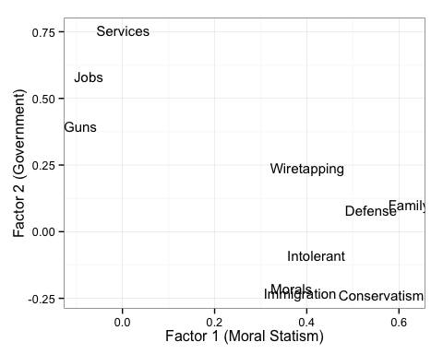

Factor plot shows two main dimensions

It is important to note that we should not expect adequate overall model fit, for two reasons. First, we are not arguing that a misarchist dimensionality should explain so much of the variation in these nine variables as to be a fully adequate model of them. We are only arguing that these nine variables should contain certain identifiable, non-trivial latent factors, consistent with Nietzsche's diagnosis, which will explain a unique portion of Tea Party support. Second, the survey questions refer to diverse political phenomena and likely reflect a great deal of variation admittedly irreducible to our hypothesized factors. At this stage of the analysis we find it satisfactory to observe that the first two factors identified by the factor model capture latent dimensions reflective of our argument above.[8]

Do the latent ideological variables of governmentalism and moral statism help improve our understanding of support for the Tea Party? Table 1 shows results from two logistic regressions modeling the probability that an individual will support the Tea Party. Before analysis, each independent variable was centered to a mean of zero and divided by two standard deviations, including the factor scores, so that all coefficients can be interpreted as the expected change in the log-odds of supporting the Tea Party associated with a two-standard-deviation change in the independent variable (or a one-category change in the case of a categorical variable). Model 1 is a baseline model including predictors from previous research and standard demographic control variables. Model 2 adds each of the latent variables and a term representing the multiplicative interaction of the two. Model 2 does not include *Conservatism* because it was included in the factor analysis and would therefore be redundant.[9]

To begin, consider the argument of Parker and Barretto that opposition to Barack Obama is a key driver of Tea Party support. Given a typical respondent who hypothetically drops from the 90th percentile of positive feelings toward Obama to the 10th, we would expect the probability of them supporting the Tea Party to increase by 13% (sd=3), from 0.03 to 0.16 on average.[10]

In comparison, consider the covariates capturing misarchism. Given a typical respondent who hypothetically changes from the 10th percentile of moral statism to the 90th when governmentalism is equal to zero, we would expect the probability of them supporting the Tea Party to increase by 6% (sd = 2), from 0.04 to 0.1 on average. Given a typical respondent who hypothetically changes from the 90th percentile of governmentalism to the 10th when moral statism is equal to zero, we would expect the probability of them supporting the Tea Party to increase by 7% (sd = 3), from 0.04 to 0.11 on average. To gain a sense of how much governmentalism conditions the effect of moral statism is somewhat more complicated. The coefficient in Model 2 for reflects the estimated effect that a two-standard-deviation increase in governmentalism has on the estimated effect a two-standard-deviation increase in moral statism would have on the log-odds of someone supporting the Tea Party. Because a substantive interpretation of this interactive effect requires us to consider multiple values for both variables all at once, Figure 2 plots the expected effect of moral statism across its range for three different values of governmentalism (the 10th, 50th, and 90th percentiles). Figure 2 reveals strikingly how high the expected probability of supporting the Tea Party reaches when individuals' ideological perspective is characterized by strong moral statism and strong anti-governmentalism. Individuals characterized by the highest observed levels of moral statism also in the 90th percentile of anti-governmentalism (below a value of -.7 on the governmentalism factor) have a probability of supporting the Tea Party around 40%. To be more precise, moving from minimum to maxium moral statism while in the 10th percentile of governmentalism increases the probability of supporting the Tea Party by .39 (sd=.07) more than it would in the 90th percentile of govermentalism, from .01 (sd=.00) to .42, (sd=.07) rather than .05 (sd=.02) to .03 (sd=.02).

Does the misarchist interaction of moral statism and anti-governmentalism also drive Republican Party identification and/or conservative identification? The answer matters for understanding how these model results improve our understanding of American conservatism. If a misarchist perspective is associated with Republican Party identification or identification with conservatism in general, our findings may only reflect a substrate of American conservatism but not necessarily Tea Party support per se. To check this possibility, we run two additional models similar to Model 2 but using ordinary least squares estimation with *PartyID* and *Conservatism* on the left-hand side of the model equation instead of the right-hand side. To save space, we provide only a brief discussion of the results here, with full model results available in the Supplementary Information. Moral statism positively predicts and governmentalism negatively predicts Republican identification with high levels of statistical significance, but the coefficient for the interaction term is nearly zero and statistically insignificant. On the other hand, considering conservative self-identification as the dependent variable, while both moral statism and governmentalism are again signed as expected, the interaction term is positive and significant. These results suggest that the misarchist interaction of moral statism and anti-governmentalism is positively associated with Tea Party support in a fashion irreducible to simple Republican Party identification or conservative identification. A substantive interpretation consistent with these auxiliary models is that the Republican Party is home to morally statist as well as anti-government and pro-government attitudes (a "broad church" encompassing various forms of conservatism). On the other hand, the Tea Party is uniquely associated with the combination of morally statist and anti-government attitudes whereas simple "conservatism" is uniquely associated with morally statist and pro-government attitudes. Because these are not our primary, theoretically motivated arguments, caution should be exercised in making inferences from these auxilliary models. Nonetheless, they strengthen support for our argument and contradict the common interpretation of Tea Party supporters as simply extreme conservatives or extreme Republicans.

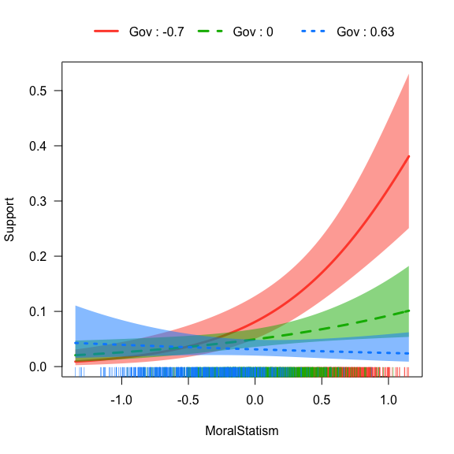

The Effect of Moral Statism Conditional on Govermentalism (Gov)

### Bayesian Model Averaging

Regression results such as those presented above are sometimes sensitive to minor differences in model specification, such as including or excluding one variable. Because we do not know the true model, an idiosyncratic search for optimal model specifications can lead to bias. One risk is publication bias, if researchers prefer models that confirm their hypotheses. Another is loss of efficiency if too many unnecessary variables are included. Finally, an *ad hoc* approach leads to incomplete representations of model uncertainty (J. M. Montgomery and Nyhan 2010, 4). An increasingly widespread solution in political science is Bayesian Model Averaging (BMA), which estimates all possible models from a set of variables provides posterior probabilities for all possible coefficients and models.

In particular, a version of the R package *BMA* modified by Mongtomery and Nyhan was used to search over the entire model space of Model 2.[11] The analysis uses uniform priors for all independent variables and the only restriction is that the interaction term and its two component variables are required to enter or not enter models together.[12] In the end, 4,096 models were selected.

The results show that the misarchist terms are highly robust to model selection, with a posterior probability of inclusion equal to 100% (one minus the cumulative posterior probability of all models excluding them). The expected value of the coefficient for *MoralStatism* is .78 (sd=.29), for *Government* it is -.71 (sd=.26), and for the interaction term it is -1.43 (sd=.31). *Obama* and *FoxNews* also had probabilities of inclusion equal to 100% with expected values not dissimilar to those estimated in Model 2. *Age* and *Race* had probabilities of inclusion greater than 50% but with unstable signs, as indicated by expected values hardly distinguishable from zero. All other variables had probabilities of inclusion less than 50%. More detailed graphical information is reported in Supplementary Information.

In the main models reported above, we have consciously chosen to include a large number of control variables because we are presently most concerned with testing our hypotheses and ruling out rival hypotheses. BMA provides further evidence that the models presented above likely contain superfluous independent variables. Though we believe it is best to rely primarily on the conservative estimates reported above, we briefly report how our coefficients of interest would change under different specifications suggested by the BMA. In a model with just those variables found to be the most robust to model selection (*Fox News*, *Obama*, *MoralStatism*, and *Government*), moving from 10th percentile of *MoralStatism* to 90th within the 90th of *Government*, is associated with the probablitity of supporting the Tea Party increasing from .01 (sd=.00) to .50 (sd=.06). Thus, the results from Bayesian Model Averaging suggest the main results reported above are highly robust and, if anything, conservative estimates of the partial correlation between misarchism and Tea Party support.

### Multiple Imputation

Another possible problem is that listwise deletion of all observations containing missing values may have led to biased estimates, as well as the simple inefficiency of lost information. In particular, if relative misarchists were more (or less) likely to respond to certain questions than other respondents, we may have over-estimated (or under-estimated) the true partial correlation between our misarchist terms and Tea Party support. One solution to this problem is multiple imputation of missing values, which refers to the process of using the information from observed variables to infer the most likely values for all missing cells. The process finishes by producing a set of new datasets each of which samples from the predictive distribution to assign most likely values to each missing cell. After multiple imputation, the models discussed above are re-estimated on each imputed dataset and the results are combined using "Rubin's rules." Specifically, we use the R package *Amelia* (Honaker, King, and Blackwell 2008) to generate 10 versions of the ANES dataset with missing values imputed and *Zelig* to obtain pooled regression results. The multiple imputation algorithm only assumes that missing values are "missing at random," not necessarily "missing completely at random." In this context, "missing at random" only means that missingness is dependent on the observed variables.

After pooling the results, the estimates remain substantially the same. *MoralStatism*, *Government*, and the interaction term remain signed as in Model 2 with high statistical significance (.98, p<.00; -.68, p<.00; -1.35, p<.00, respectively). *FoxNews* and *BornAgain* also remain substantially the same. Graphical diagnostics for overimputation, dispersion, and comparing pre- and post-imputation densities for our main variables suggest no problems or anomolies in the imputation procedures. For the sake of brevity we have placed the full results table and further diagnostic information in Supplementary Information.

### Matching and Sensitivity

To mitigate the risk of bias from non-random assignment into misarchism and guard against parametric model dependence, we employ matching to estimate the effect of misarchism from a subset of highly similar individuals. We use a genetic matching algorithm to identify that subset of the original dataset for which the distribution of each covariate is optimally balanced across both treatment and control groups (Diamond and Sekhon 2012; Sekhon 2011). In other words, the algorithm obtains the matched pairs of those "treated" and not treated to governmentalism and moral statism which are otherwise optimally balanced in the propensity to be treated. The average treatment effect for the treated obtained from this subset will approximate that which we would obtain from a randomized experiment, unless some unobserved factor shapes the propensity to be treated. Although the possibility of omitted variables can never be ruled out, we can quantify the sensitivity of these matching estimates to some potential unobserved source of bias. Thus, we also report sensitivity bounds as developed by Rosenbaum (Rosenbaum 1988).

We generate matching estimates for each of our three independent variables of interest, one at a time, using one-to-one genetic matching with replacement. In each case, "treatment" is defined as having a value above the sample mean of the variable of interest. For each estimate, we balance on all covariates in Model 2 except the two components of the interaction term and including the treatment variable's propensity scores with respect to those covariates. We do not balance on the components of the interaction term, or the interaction term itself, because this would remove the covariation of governmentalism and moral statism the effect of which we wish to test, but we do include the components and the interaction term as covariates.

The average treatment effect on those "treated" with greater than the mean level of moral statism is 0.163, with a standard error of 0.061 and a p-value of 0.01. The Rosenbaum bounds for this effect suggest that for it to become statistically insignificant at the 95% confidence level, the odds of differential assignment to treatment due to an unobserved factor would have to be about 2.03.[13] Thus, the partial correlation between moral statism and Tea Party support when *Governmentalism* is set at its mean, as obtained in Model 2, does not appear to be an artifact of covariate imbalance or parametric modeling assumptions, and would require a fairly large unobserved source of bias to become insignificant.

The average treatment effect on those "treated" with greater than the mean level of governmentalism is 0.004, with a standard error of 0.026 and a p-value of 0.88. Therefore the partial correlation previously estimated between governmentalism and Tea Party support at mean levels of moral statism appears to have been a spurious result of those with high values of governmentalism having significantly different values of some covariate relative to those with low values of governmentalism.

The average treatment effect on those "treated" with greater than the mean level of the interaction term is -0.055, with a standard error of 0.021 and a p-value of 0.01. The Rosenbaum bounds for this effect suggest that for it to become statistically insignificant at the 95% confidence level, the odds of differential assignment to treatment due to an unobserved factor would have to be about 1.43. Our key relationship of interest estimated in Model 2 therefore does not appear generated by systematic assignment into treatment due to any of the observed covariates and, as with the estimated effect of moral statism, would require a fairly large unobserved source of bias to become insignificant.

## Conclusion

This article demonstrates that an ideological constellation first diagnosed by Nietzsche as "misarchism"---a combination of anti-government, pro-state, and moralistic attitudes---helps to predict Tea Party support and generally improves our understanding of the ideological nature of the Tea Party movement. In particular, we leverage the history of political theory to provide a coherent solution to the otherwise inexplicable combination of libertarianism and authoritarianism which scholars have found to co-exist within the Tea Party. While we find additional support for some previous findings---namely, that feelings toward Obama, evangelicalism, and exposure to Fox News are significant and robust predictors of Tea Party support---this article is the first to provide systematic empirical evidence that a particular ideological constellation irreducible to libertarianism or social conservatism is a unique and notably strong driver of Tea Party support.

Our ideological explanation also raises an interesting question about the future of the Tea Party. If opposition to Obama were the primary driver of Tea Party support, then we would expect Tea Party mobilization to subside once Obama’s term as President ends. If however, a significant driver of Tea Party mobilization is a misarchist ideology, then we would expect the Tea Party to continue to play a role in the Republican party by supporting candidates and policies that would be in line with misarchist beliefs long after President Obama leaves office.

There are several questions about misarchism that this study does not answer, but are worthy of further investigation. The first is whether misarchism represents a new ideology within the Republican party, or if it is an ideology that has somehow been a latent feature of American political life. If it is new, then this would raise some interesting questions about how new ideologies form. Did the election of Obama, or a backlash against the Stimulus Act and the Affordable Care Act, somehow crystallize a new constellation of beliefs in the minds of a large bloc of voters? Alternatively, was this a latent worldview held by a large segment of the electorate that was somehow mobilized through and elite branding campaign by Conservative activist groups such as FreedomWorks and media outlets such as Fox News? More generally, our approach, by thinking about the possibility of unique and diverse ideological constellations structuring attitudes within the conventional left-right spectrum, raises questions about what other ideological constellations may mobilize different constituencies in American politics.

## Supplementary Information

#### Contents

1. Scree plot for factor model
2. Numerical factor loadings
3. Including Party ID as a covariate
4. Estimated effects of misarchism on Party ID and Conservatism
5. Probabilities of covariate inclusion from Bayesian Model Averaging
6. Expected value of coefficients from Bayesian Model Averaging
7. Pooled regression results after multiple imputation
8. Multiple imputation diagnostics

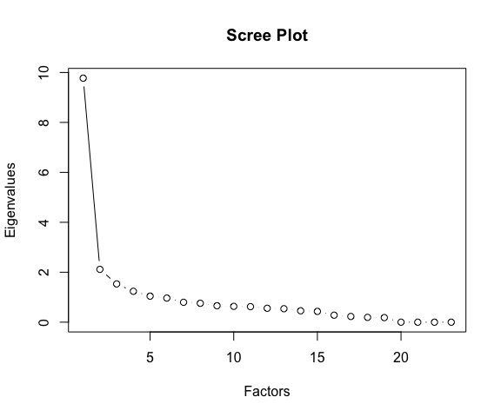

Biplot shows two main dimensions

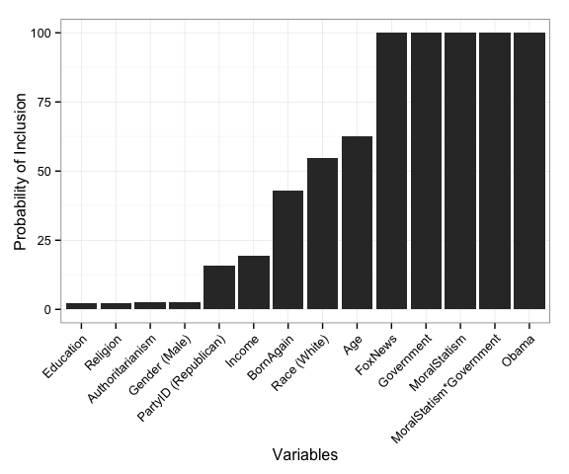

Inclusion Probabilites from Bayesian Model Averaging

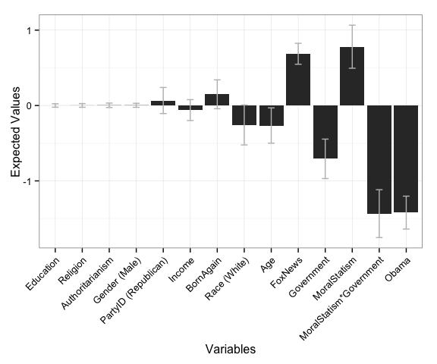

Expected Values from Bayesian Model Averaging

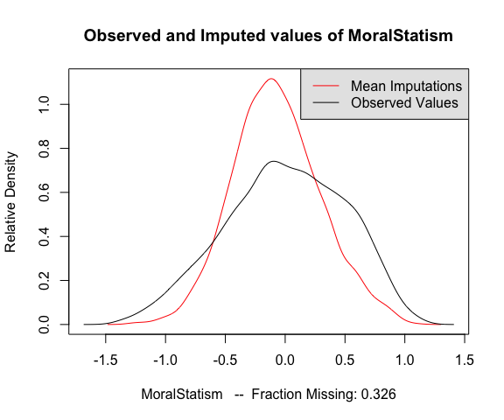

Distributions before and after multiple imputation

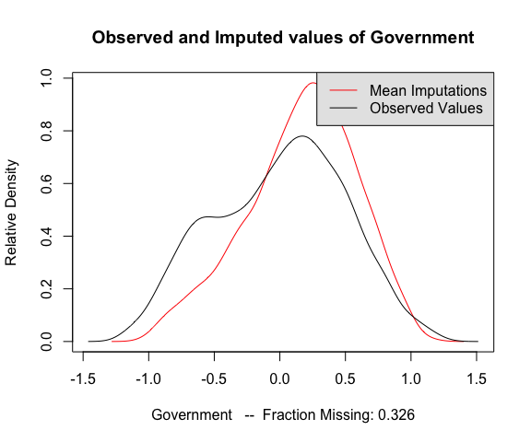

Distributions before and after multiple imputation

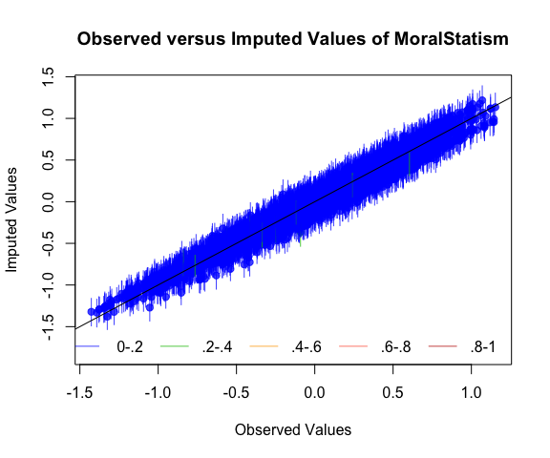

Diagnostic Plot for Overimputation (1)

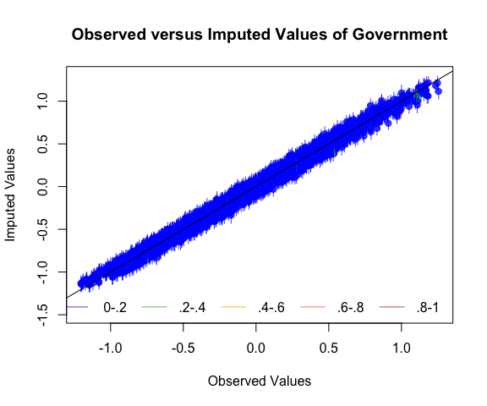

Diagnostic Plot for Overimputation (2)

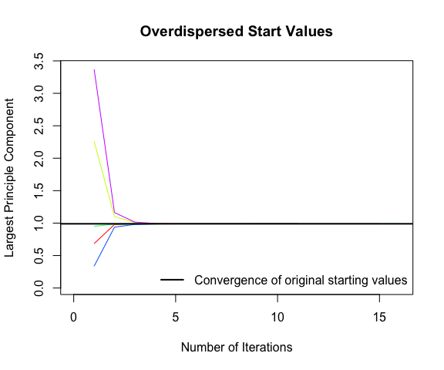

Diagnostic Plot for Dispersion

## References

Abramowitz, Alan I. 2012. “Grand Old Tea Party: Partisan Polarization and the Rise of the Tea Party Movement.” In *Steep: The Precipitous Rise of the Tea Party*, Berkeley, California: University of California Press, 195–211.

Althusser, Louis. 1971. “Ideology and Ideological State Apparatuses (Notes Towards an Investigation).” In *Lenin and Philosophy and Other Essays.*, New York: Monthly Review Press.

Arceneaux, Kevin, and Stephen P. Nicholson. 2012. “Who Wants to Have a Tea Party? The Who, What, and Why of the Tea Party Movement.” *PS: Political Science & Politics* 45(04): 700–710.

Bailey, Michael A., Jonathan Mummolo, and Hans Noel. 2012. “Tea Party Influence: A Story of Activists and Elites.” *American Politics Research* 40(5): 769–804.

Berlet, Chip. 2012. “Reframing Populist Resentments in the Tea Party Movement.” In *Steep: The Precipitous Rise of the Tea Party*, eds. Christine Trost and Lawrence Rosenthal. Berkeley, California: University of California Press, 42–66.

Bradberry, Leigh A, and Gary C Jacobson. 2014. “The Tea Party and the 2012 presidential election.” *Electoral Studies*. <Online only: http://bit.ly/1DsIbv9>.

Brennan, Jason. 2012. *Libertarianism: What Everyone Should Know*. Oxford: Oxford University Press.

Bryson, Maurice C., and William R. McDill. 1968. “The Political Spectrum: A Bi-Dimensional Approach.” *Rampart Journal of Individualist Thought* 4(2). <https://mises.org/journals/rampart/Rampart_summer1968.pdf> (July 21, 2015).

Burack, Cynthia, and R. Claire Snyder-Hall. 2012. “Introduction: Right-Wing Populism and the Media.” *New Political Science* 34(4): 439–54. <http://dx.doi.org/10.1080/07393148.2012.729736> (July 28, 2014).

Campbell, Angus, Philip E Converse, Warren E Miller, and Donald E Stokes. 1960. *The American Voter*. Chicago: University of Chicago Press.

Carmines, Edward G, and Nicholas J D’Amico. 2014. “The New Look in Political Ideology Research.” *Annual Review of Political Science* 18(1): 205–16.

Converse, Philip E. 1964. “The Nature of Belief Systems in Mass Publics.” In *Ideology and Its Discontents*, ed. David E Apter. New York: The Free Press of Glencoe.

Courser, Zachary. 2012. “The Tea ‘Party’ as a Conservative Social Movement.” *Society* 49(1): 43–53. <http://link.springer.com/article/10.1007/s12115-011-9501-0> (July 28, 2014).

Diamond, Alexis, and Jasjeet S Sekhon. 2012. “Genetic Matching for Estimating Causal Effects: A General Multivariate Matching Method for Achieving Balance in Observational Studies.” *Review of Economics and Statistics* 95(3): 932–45.

Disch, Lisa. 2011. “Tea Party Movement: The American ‘Precariat’?” *Representation* 47(2): 123–35. <http://dx.doi.org/10.1080/00344893.2011.581057> (July 28, 2014).

Eysenck, Hans J. 1960. *The Psychology of Politics*. Piscataway, New Jersey: Transaction Publishers.

Fabrigar, Leandre R, Duane T Wegener, Robert C MacCallum, and Erin J Strahan. 1999. “Evaluating the use of exploratory factor analysis in psychological research.” *Psychological Methods* 4(3): 272–99.

Foucault, Michel. 1991. “Governmentality.” In *The Foucault Effect: Studies in Governmentality*, eds. Graham Burchell, Colin Gordon, and Peter Miller. Chicago: University of Chicago Press, 87–104.

Freeden, Michael. 2003. *Ideology: A Very Short Introduction*. Oxford: Oxford University Press.

Gordon, Colin. 1991. “Governmental Rationality: An Introduction.” In *The Foucault Effect: Studies in Governmentality*, eds. Graham Burchell, Colin Gordon, and Peter Miller. Chicago: University Of Chicago Press, 1–52.

Goren, Paul. 2013. *On Voter Competence*. Oxford: Oxford University Press.

Graham, Jesse, Jonathan Haidt, and Brian A Nosek. 2009. “Liberals and conservatives rely on different sets of moral foundations.” *Journal of Personality and Social Psychology* 96(5): 1029–46. <http://psycnet.apa.org/journals/psp/96/5/1029.html>.

Haidt, Jonathan. 2012. *The Righteous Mind: Why Good People are Divided by Politics and Religion*. New York: Pantheon.

Heywood, Andrew. 2007. *Political Ideologies*. 4th ed. Basingstoke: Palgrave Macmillan.

Hoffman, John. 1995. *Beyond the State: An Essay in Interpretation: An Introductory Critique*. Cambridge, UK: Polity Press.

Honaker, James, Gary King, and Matthew Blackwell. 2008. “Amelia II: A Program for Missing Data.” *Journal of Statistical Software* 45(i07).

Huxley, Thomas. 1871. “Administrative Nihilism (1871).” <http://aleph0.clarku.edu/huxley/CE1/AdNil.html> (April 12, 2014).

Imai, Kosuke, Gary King, and Olivia Lau. 2009. “Zelig: Everyone’s Statistical Software.” <http://gking.harvard.edu/zelig>.

Jones, Robert P, Daniel Cox, and Juhem Navarro-Rivera. 2013. “2013 American Values Survey: In Search of Libertarians in America.” *Public Religion Research Institute*. <http://publicreligion.org/research/2013/10/2013-american-values-survey/> (September 18, 2014).

Karpowitz, Christopher F., J. Quin Monson, Kelly D. Patterson, and Jeremy C. Pope. 2011. “Tea Time in America? The Impact of the Tea Party Movement on the 2010 Midterm Elections.” *PS: Political Science & Politics* 44(02): 303–9.

Keele, Luke J. 2014. “rbounds: Perform Rosenbaum bounds sensitivity tests for matched and unmatched data.” <https://cran.r-project.org/web/packages/rbounds>.

Knight, Kathleen. 2006. “Transformations of the Concept of Ideology in the Twentieth Century.” *American Political Science Review* 100(04): 619. <http://www.journals.cambridge.org/abstract_S0003055406062502> (April 30, 2015).

Lewis-Beck, Michael S, William G Jacoby, Helmut Norpoth, and Herbert F Weisberg. 2008. *The American Voter Revisited*. Ann Arbor: University of Michigan Press.

Lo, Clarence Y. H. 2012. “Astroturf Versus Grass Roots: Scenes from Early Tea Party Mobilization.” In *Steep: The Precipitous Rise of the Tea Party*, eds. Lawrence Rosenthal and Christine Trost. Berkeley, California: University of California Press, 98–130.

Lowndes, Joseph. 2012. “The Past and Future of Race in the Tea Party Movement.” In *Steep: The Precipitous Rise of the Tea Party*, eds. Christine Trost and Lawrence Rosenthal. Berkeley, California: University of California Press, 152–70.

Marx, Karl, and Friedrich Engels. 1978. *The Marx-Engels Reader*. 2nd Revised ed. ed. Robert C. Tucker. New York: W. W. Norton & Company.

Maxwell, Angie, and T Wayne Parent. 2012. “The Obama Trigger: Presidential Approval and Tea Party Membership.” *Social Science Quarterly* 93(5): 1384–1401. <http://onlinelibrary.wiley.com.libproxy.temple.edu/doi/10.1111/j.1540-6237.2012.00907.x/full>.

McCalmont, Lucy. 2013. “Poll: Most Libertarians Don’t Identify as Tea Partiers.” *POLITICO*. <http://politi.co/1Lr7tSe> (September 18, 2014).

Montgomery, Jacob M, and Brendan Nyhan. 2010. “Bayesian Model Averaging: Theoretical Developments and Practical Applications.” *Political Analysis* 18(2): 245–70.

Montgomery, Peter. 2012. “The Tea Party and the Religious Right Movements: Frenemies with Benefits.” In *Steep: The Precipitous Rise of the Tea Party*, eds. Christine Trost and Lawrence Rosenthal. Berkeley, California: University of California Press, 242–74.

Nietzsche, Friedrich Wilhelm. 2007. *On the Genealogy of Morality*. ed. Keith Ansell-Pearson. Cambridge, UK: Cambridge University Press.

Parker, Christopher S., and Matt A. Barreto. 2013. *Change They Can’t Believe In: The Tea Party and Reactionary Politics in America*. Princeton University Press.

Raftery, Adrian E et al. 2015. “BMA: Bayesian Model Averaging.” <https://cran.r-project.org/web/packages/BMA/>.

Robin, Corey. 2013. *The Reactionary Mind: Conservatism from Edmund Burke to Sarah Palin*. New York: Oxford University Press USA.

Robinson, William I., and Mario Barrera. 2012. “Global Capitalism and Twenty-First Century Fascism: A US Case Study.” *Race & Class* 53(3): 4–29. <http://rac.sagepub.com/content/53/3/4.abstract>.

Rosenbaum, Paul R. 1988. “Sensitivity Analysis for Matching with Multiple Controls.” *Biometrika* 75(3): 577–81.

Sekhon, Jasjeet S. 2011. “Multivariate and Propensity Score Matching Software with Automated Balance Optimization: The Matching Package for R.” *Journal of Statistical Software* 42(7).

Skocpol, Theda, and Vanessa Williamson. 2012. *The Tea Party and the Remaking of Republican Conservatism*. Oxford: Oxford University Press.

Spencer, Herbert. 1879. *The Data of Ethics*. London: Williams and Norgate.

Weber, Max. 2004. “Politics as a Vocation.” In *The Vocation Lectures*, eds. David Owen and Tracy Strong. Indianapolis: Hackett Publishing, 32–94.

Williamson, Vanessa, Theda Skocpol, and John Coggin. 2011. “The Tea Party and the Remaking of Republican Conservatism.” *Perspectives on Politics* 9(01): 25–43.

Wilson, Angelia R., and Cynthia Burack. 2012. “‘Where Liberty Reigns and God Is Supreme’: The Christian Right and the Tea Party Movement.” *New Political Science* 34(2): 172–90. <http://dx.doi.org/10.1080/07393148.2012.676395> (July 28, 2014).

Zwolinski, Matt. 2015. *Social Darwinism and Social Justice: Herbert Spencer on Our Duties to the Poor*. Social Science Research Network. <http://papers.ssrn.com/abstract=2598818> (May 12, 2015).

1. In the Marxist tradition, the term ideology refers to the way in which existing social institutions justify the material conditions of a society and defend the interests of the dominant class. See Marx and Engels (Marx and Engels 1978) and Althusser (Althusser 1971) for the classic statements on ideology from this perspective
2. Political theorist John Hoffman draws a similar distinction between statism and governmentalism, where the state refers to the use of force to tackle conflict and the government refers to the use of negotiation and arbitration to resolve conflicts of interest (Hoffman 1995)
3. This way of dividing the political spectrum grows out of the work of psychologist Hans J. Eysenck (see (Eysenck 1960)), who was interested in explaining the similarities between the authoritarianism of Nazis and Stalinists. In the late 1960s, libertarians proposed a similar project for understanding the political spectrum, to differentiate libertarianism from the traditional left-right axis (see (Bryson and McDill 1968)). For instance, the website, ``The Political Compass” (www.politicalcompass.org) uses this framework to help visitors identify their own position on the ideological spectrum
4. The Cooperative Congressional Election Survey, used in some previous research on the sources of Tea Party support (Bradberry and Jacobson 2014), has a much larger sample than the ANES but does not include direct measures of moral traditionalism
5. We do not include any measure of racial animosity because the experiment conducted by Arceneaux and Nicholson produces little evidence that racial animosity is independently associated with Tea Party support, even though Tea Party supporters appear more likely to oppose government benefits due to racial resentment
6. These include the programs *Fox Report*, *The Five*, *America's Newsroom,* as well as the eponymous programs featuring Greta Van Susteren, Sean Hannity, Mike Huckabee, Brett Baier, and Bill O'Reilly
7. An oblique rotation allows for factors to be correlated and is appropriate here because, while we argue that moral statism and anti-governmentalism are unique and distinct, they are likely to be correlated. We use maximum likelihood as the factoring method because it has a more formal statistical basis than other methods and is widely seen to be one of the optimal methods. See (Fabrigar et al. 1999)
8. For *N* equal to 5914, a chi-square test of the hypothesis that two factors is sufficient is equal to 900.727 with a p-value of 0, suggesting that two factors are not sufficient, as we would expect. That said, the root mean square of the residuals is 0.044 and the Tucker-Lewis Index for factor reliability score is 0.869, both of which are near the conventional cutoffs of .05 and .9, respectively
9. It may be objected that to fully test our argument that misarchist ideology explains a unique portion of Tea Party support, we would have to do so controlling for liberal-conservative self-placement. We therefore run a separate model similar to Model 2 but including *Conservatism* as a covariate (see Supplementary Information). *Conservatism* is positive and statistically significant and the estimates for *Government* and the interaction term remain substantially the same as in Model 2. *MoralStatism* is no longer statistically significant but has a variance inflation factor of 4.259 suggesting collinearity likely due to the redundancy of *Conservatism*
10. All discussion of effect sizes refer to simulations of Model 2 in Table 1 using the R package *Zelig*. See (Imai, King, and Lau 2009)
11. The analysis was conducted using the function, which is a version of the function in the R package . See (Raftery et al. 2015) and (J. M. Montgomery and Nyhan 2010)
12. Options were set to be least restrictive. No Occam's Window was used to narrow the models selected by the initial leap algorithm run over the entire model space and, following Montgomery and Nyhan (pp. 21), the number of best models of each size returned by the leaps algorithm was set to 100,000
13. Rosenbaum bounds for a binary dependent variable reported in this section are calculated using the function in the R package *rbounds*. See (Keele 2014)