How Does the State Speak of Globalisation? A Quantitative Text-Mining Approach
Justin Murphy
University of Southampton
April 2014
Abstract: Scholars argue that globalisation is strategically deployed by governments (Hay and Rosamond 2011). This article is the first large-scale quantitative assessment of this argument, using text-mining and machine learning techniques to analyze how the government of the United Kingdom has deployed the term ‘globalisation.’ Specifically, this article exploits the newly released United Kingdom Government Web Archive to analyze a random sample of more than 60,000 web pages published across the entire UK government web system.
I requested 150,000 web pages, received 67k and about 1k were errors. Thus, the final sample consists of a corpus of dtm

Descriptive Statistics
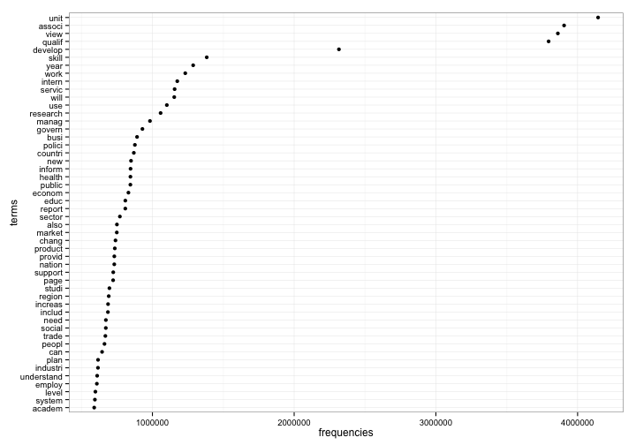

Correlated terms
Terms | Globalis
vision | 0.9
emphasi | 0.87
secondari | 0.84
context | 0.83
legaci | 0.82
implic | 0.81
amongst | 0.8
educ | 0.79
vocat | 0.78
perceiv | 0.76

Cluster analysis
## [1] Cluster 1
## [1] will report can committe increas level offic
## [8] also school need invest busi includ compani
## [15] govern transport use industri number respons
## [1] Cluster 2
## [1] journal intern manag technolog system engin comput
## [8] titl publish onlin euro print intellig busi
## [15] innov enterpris electron scienc sustain price
## [1] Cluster 3
## [1] health public care journal nhs diseas find
## [8] polici author avail articl sourc impact london
## [15] research exclud refin similar add clinic
## [1] Cluster 4
## [1] research skip accesskey esrc social search page
## [8] studi public econom news scienc impact societi
## [15] contact output fund grant guidanc work
## [1] Cluster 5
## [1] eldi websit globalis topic home develop countri
## [8] inform guid what announc profil publish site
## [15] job map event communiti visit new
## [1] Cluster 6
## [1] unit qualif associ view understand skill
## [7] provid design introduct perform listen write
## [13] sport leisur treatment music physic read
## [19] techniqu wale
## [1] Cluster 7
## [1] eldi group develop space communiti member
## [7] interest friend help blog search opinion
## [13] profil home comment livelihood famili secur
## [19] name aid
## [1] Cluster 8
## [1] oper countri procur organis non specif servic
## [8] tel profit project search india result programm
## [15] africa support govern china fund aid
## [1] Cluster 9
## [1] academ year breakdown geograph coverag articl region
## [8] pdf labour econom market review countri statist
## [15] filter economi trend releas book sep
## [1] "Cluster Membership"
##
## 1 2 3 4 5 6 7 8 9
## 46337 907 2235 5459 3535 2345 2121 779 2696
## [1] "Within cluster sum of squares by cluster"
## [1] 383.976905 0.009232 18.591247 36.403308 28.291523 4.239123
## [7] 14.269600 21.928006 55.741371

Appendix
This is the appendix.
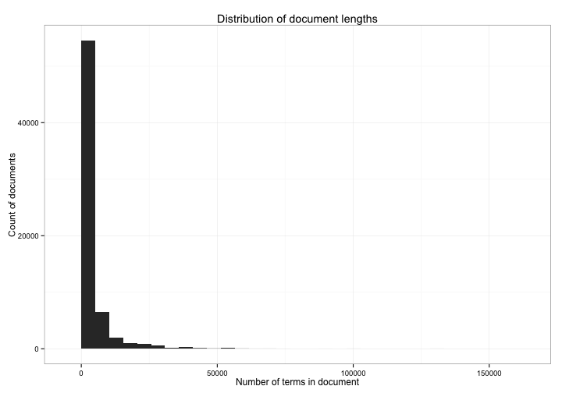
## Length Class Mode
## cluster 66414 -none- numeric
## centers 17640 -none- numeric
## totss 1 -none- numeric
## withinss 9 -none- numeric
## tot.withinss 1 -none- numeric
## betweenss 1 -none- numeric
## size 9 -none- numeric
## iter 1 -none- numeric
## ifault 1 -none- numeric
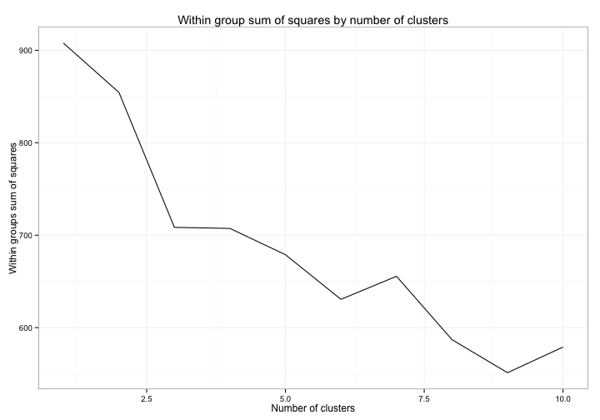
## Topic 1 Topic 2 Topic 3 Topic 4 Topic 5
## [1,] "skill" "school" "globalis" "financi" "product"
## [2,] "develop" "use" "websit" "market" "per"
## [3,] "educ" "educ" "global" "intern" "year"
## [4,] "globalis" "teacher" "eldi" "globalis" "countri"
## [5,] "countri" "ict" "polici" "capit" "price"
## [6,] "dfid" "can" "new" "bank" "world"
## [7,] "also" "learn" "home" "develop" "cost"
## [8,] "train" "dfid" "unit" "economi" "market"
## [9,] "sector" "project" "europ" "global" "industri"
## [10,] "research" "student" "relationship" "econom" "export"
## [11,] "need" "technolog" "intern" "risk" "increas"
## [12,] "cultur" "peopl" "busi" "countri" "trade"
## [13,] "nation" "work" "inform" "increas" "cent"
## [14,] "econom" "communiti" "trade" "growth" "import"
## [15,] "world" "activ" "countri" "system" "develop"
## [16,] "global" "experi" "world" "will" "govern"
## [17,] "poverti" "comput" "state" "polici" "period"
## [18,] "women" "develop" "tel" "servic" "even"
## [19,] "increas" "also" "work" "benefit" "exchang"
## [20,] "privat" "teach" "secur" "invest" "howev"
## Topic 6 Topic 7 Topic 8 Topic 9
## [1,] "pay" "develop" "develop" "develop"
## [2,] "plus" "relat" "countri" "impact"
## [3,] "fair" "skill" "trade" "research"
## [4,] "intern" "strategi" "intern" "agricultur"
## [5,] "institut" "level" "govern" "increas"
## [6,] "concern" "govern" "work" "servic"
## [7,] "commerc" "globalis" "will" "report"
## [8,] "encourag" "countri" "polici" "product"
## [9,] "certain" "term" "world" "rural"
## [10,] "popul" "polici" "peopl" "food"
## [11,] "import" "nation" "import" "use"
## [12,] "cent" "market" "poverti" "also"
## [13,] "constitu" "requir" "poor" "may"
## [14,] "assur" "key" "globalis" "health"
## [15,] "programm" "global" "effect" "popul"
## [16,] "public" "educ" "invest" "water"
## [17,] "accord" "two" "price" "migrat"
## [18,] "social" "differ" "inflat" "area"
## [19,] "parti" "state" "can" "growth"
## [20,] "term" "competit" "increas" "poverti"

References

Hay, Colin, and Ben Rosamond. 2011. “Globalization, European Integration and the Discursive Construction of Economic Imperatives.” dx.doi.org.libproxy.temple.edu 9(2): 147–67. http://www.tandfonline.com/doi/abs/10.1080/13501760110120192.

