[Lab-Python] Boolean Logic basics
(True/False)

Get Started:
Using nano (or another editor of your choice), create a script called week6-boolean.py Make sure to set the permissions to allow python to execute.

To Do:
Add a line or lines of python code to your script that will test the following and print them to the screen:

Example: We can get the True/False result from any expression using the bool function
print(bool(1 == 1))

Expression | Result
True and True | True
False and True | true
1 == 1 and 2 == 1 | false
0 | false
“” | false
0.0 | false
not 0 | true
"test" == "test" | true
1 == 1 or 2 != 1 | true
True and 1 == 1 | true
False and 0 != 0 | false
True or 1 == 1 | true
"test" == "testing" | False
1 != 0 and 2 == 1 | False
"test" != "testing" | True
"test" == 1 | False
1 == 1 and not ("testing" == 1 or 1 == 0) | True
"chunky" == "bacon" and not (3 == 4 or 3 == 3) | False
3 == 3 and not ("testing" == "testing" or "Python" == "Fun") | False

Submission:
When you have completed your script and tested that the output matches the directions above, add, commit and push your changes to GitHub. It’s always a good idea to check that your files/changes uploaded to GitHub correctly, by looking at them in GitHub with your browser.

- Create an Issue in GitHub to signal you are ready for grading:
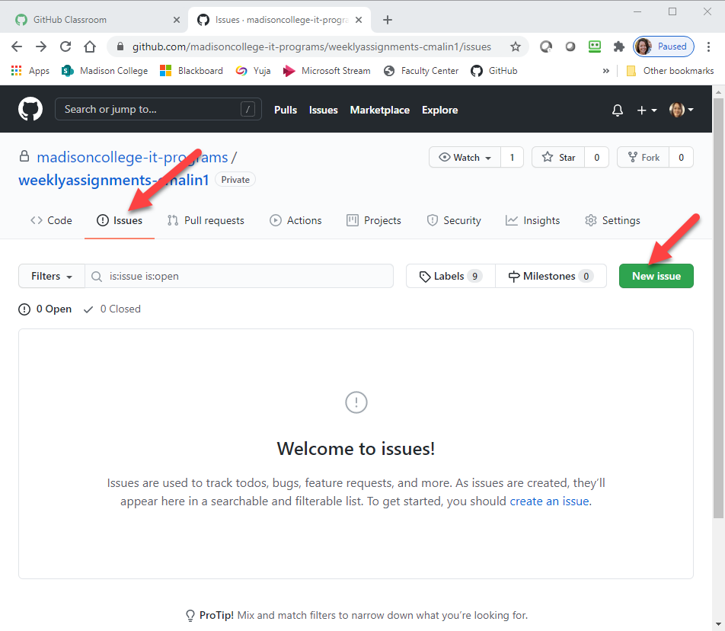

- Give your issue a meaningful title and include any comments about things you want specific feedback on or questions you may have about the assignment.

